Volume Measurements: Supplemental Figures

5.1) The HTDIC program open in MATLAB with code “folded.”
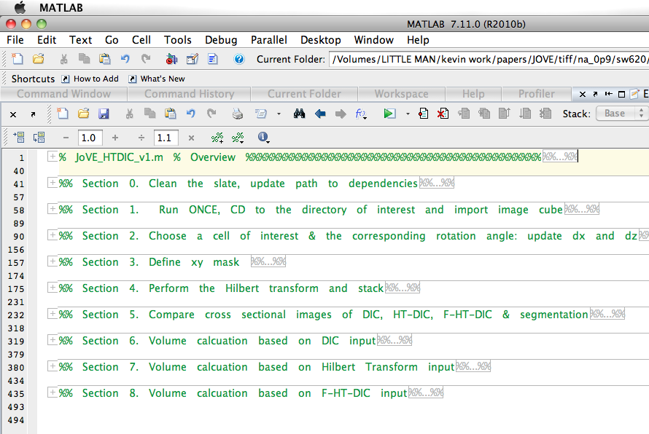

5.2) Section 0 unfolded with the code described in protocol shown in detail.
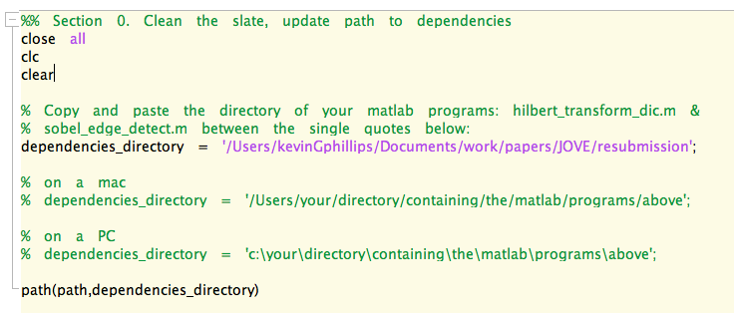

5.3) Section 1 unfolded with the code described in protocol shown in detail.
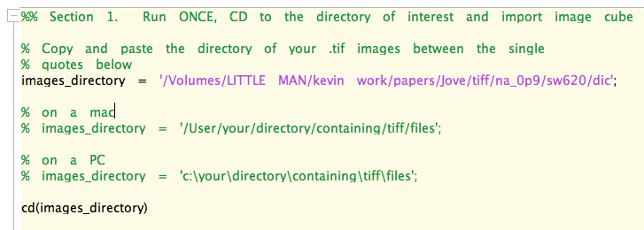

5.4) Section 2 dialog box defining the image features.

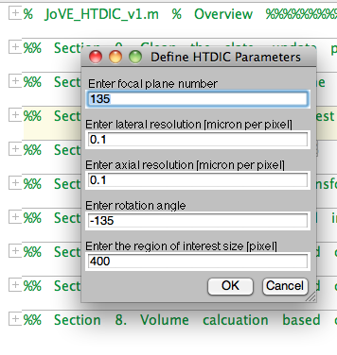

5.5) Image appears with box. Box can be dragged over the region of interest (ROI).
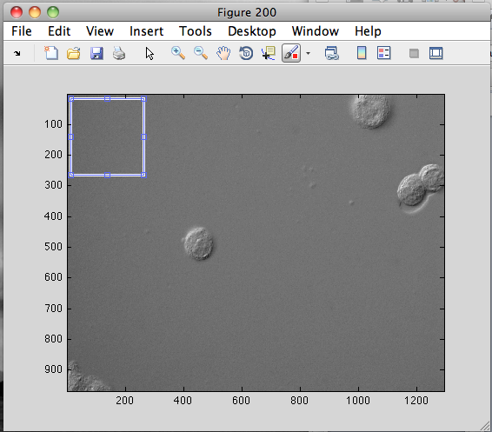
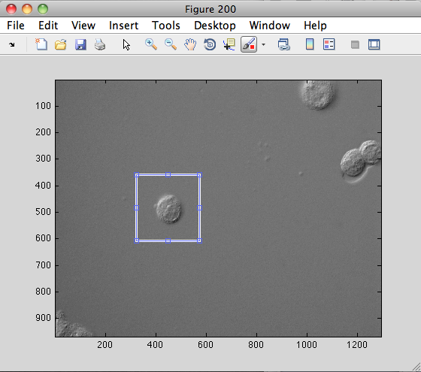

5.6) A rotated view of the ROI appears. The user should check to make sure that the dark-to-bright variation of the pixel values is as horizontal as possible. The blue box should be dragged around and resized to select the final ROI.

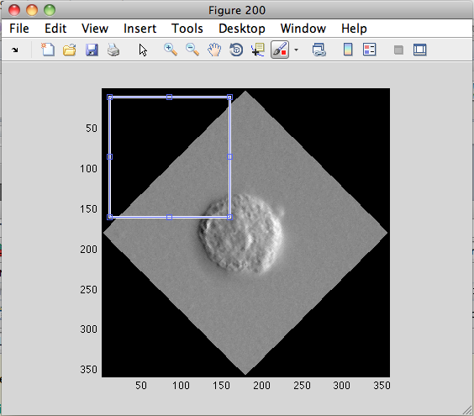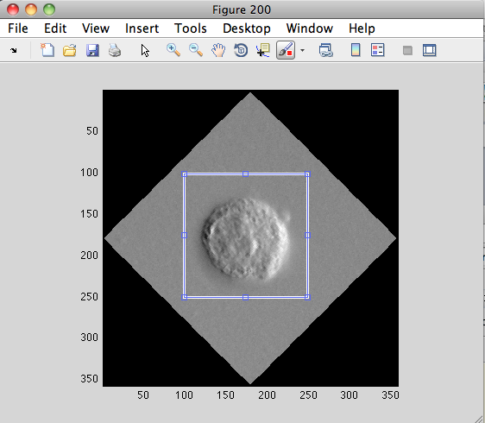
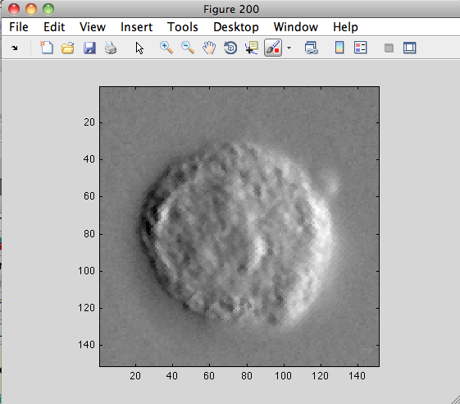

5.8) Section 3 defining a rectangular mask to eliminate background pixel values.

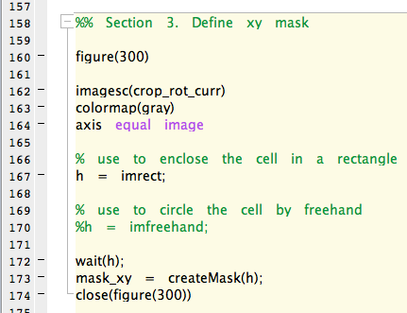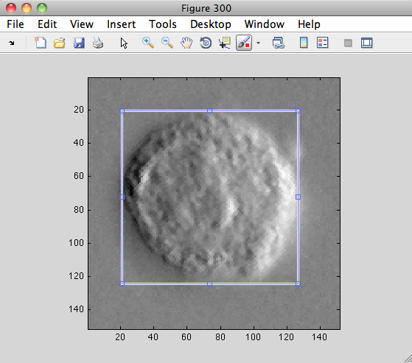

5.9) Section 3 defining a hand drawn mask to eliminate background pixel values.

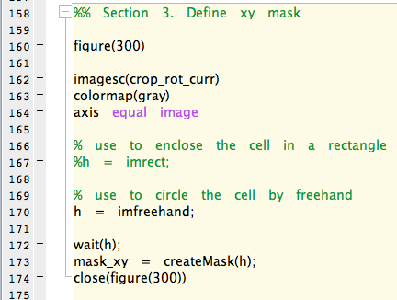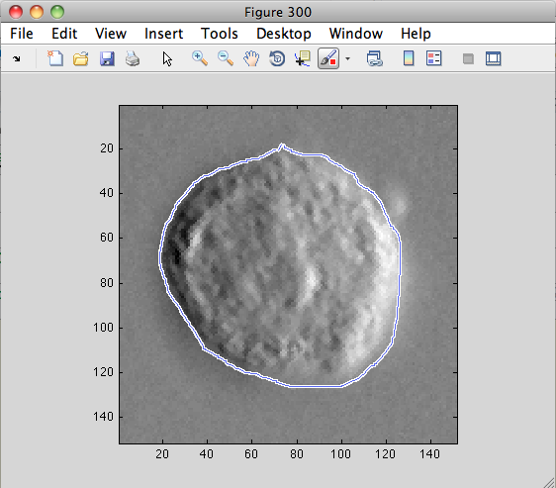

5.11) Section 5 allows the user to evaluate different segmentation strategies.
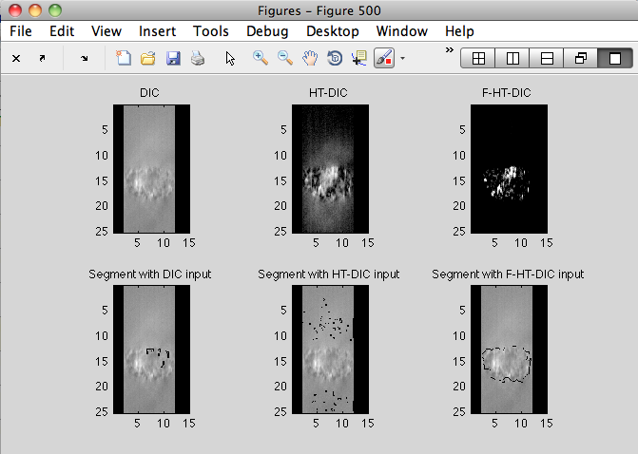

5.12) Performing the volume measurement using Section 8. An intermediate image (these will be really fun to watch live) and the final image with volume reported in the title of the image right sub-image.

