Mass Measurements: Supplemental Figures

6.1) The NIQPM program open in MATLAB with code “folded.”

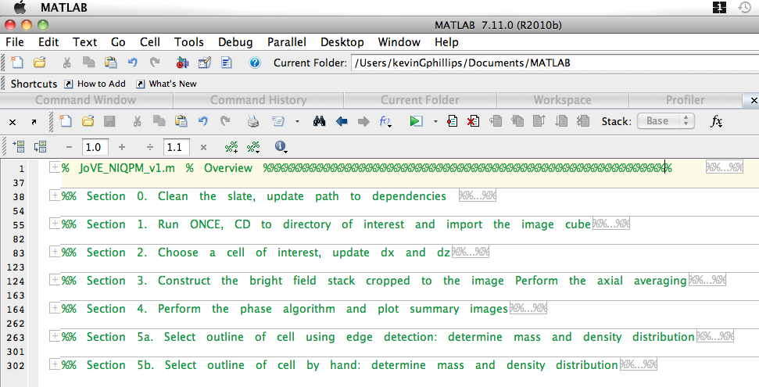

6.2) Section 0: update all of the directories.

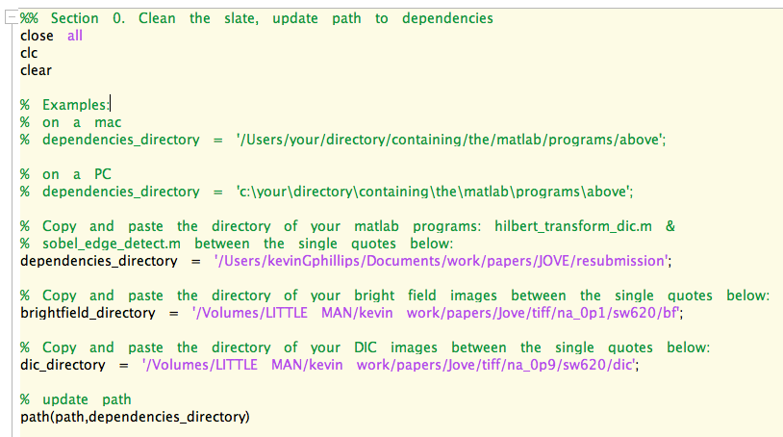

6.4) Section 2 dialog box defining the image features.
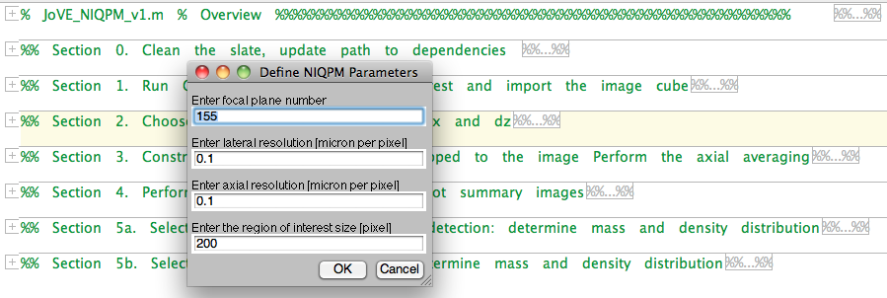

6.5) Image appears with box. Box can be dragged over the region of interest (ROI). Double click on the box to create the cropped image of the cell.

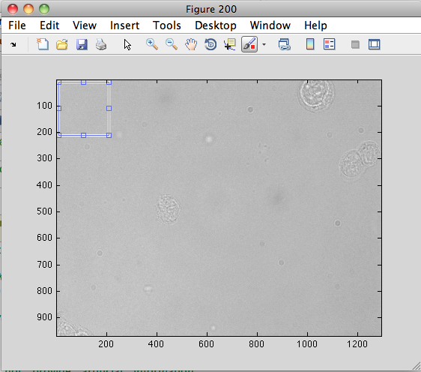

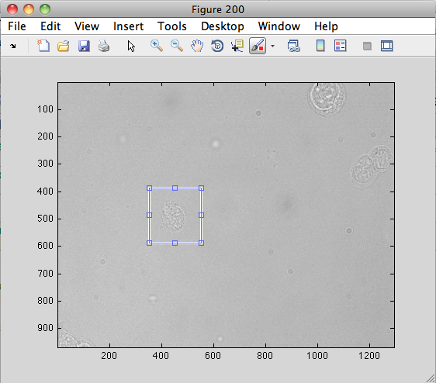

6.5) Continued -
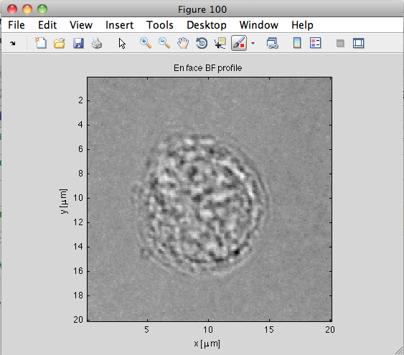

6.7) Resulting collection of images from Section 4. These include the bright field, phase map, pseudo DIC, and true DIC images.

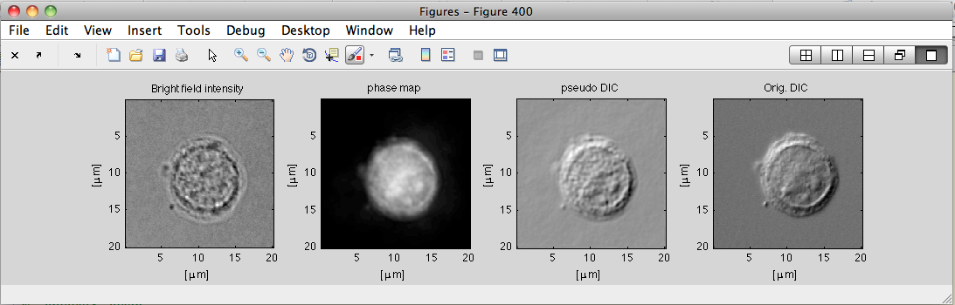

6.8) Optimal segmentation and mass calculation using Section 5a of the code.

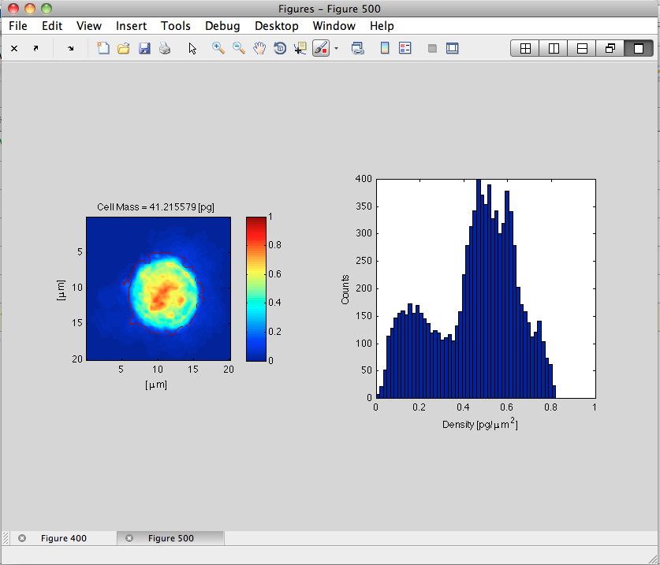

6.8) Section 5b allows the user to outline the cell by hand using the mouse. Here is the outline being drawn.

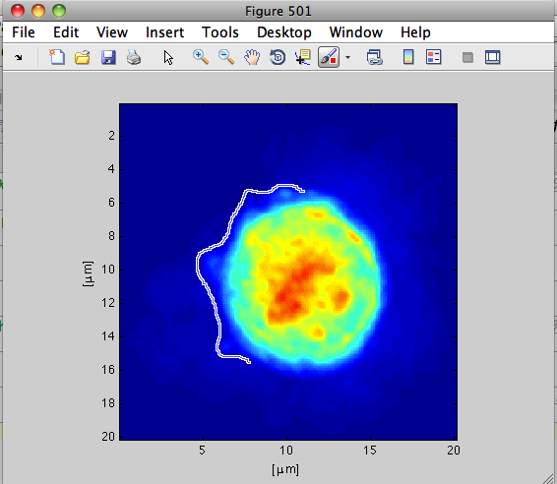

6.8) After circling the cell by hand the final image containing the mass density map, the outline, density histogram, and total mass is presented.

