Image acquisition: Supplemental Figures
2. Differential Interference Contrast (DIC) Z-Stack Acquisition

2.1) Open the SlideBook software and create a new slide for image collection by selecting the white paper icon in the top left.

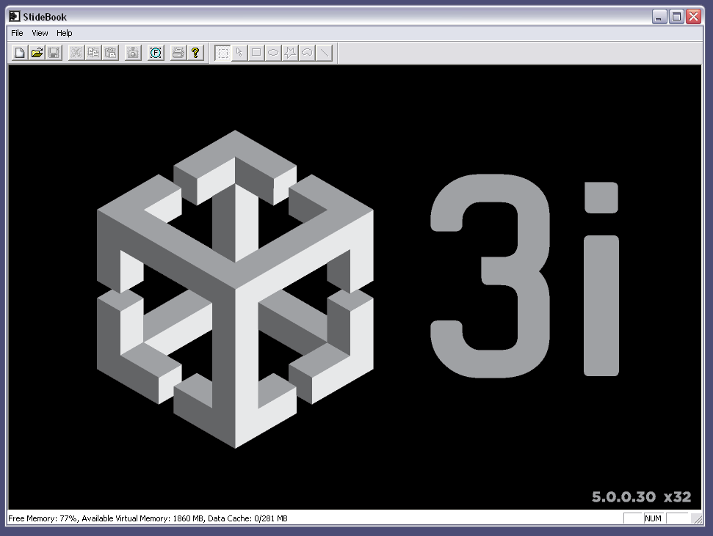

2.1) Cont’d: The new slide will look like the following:

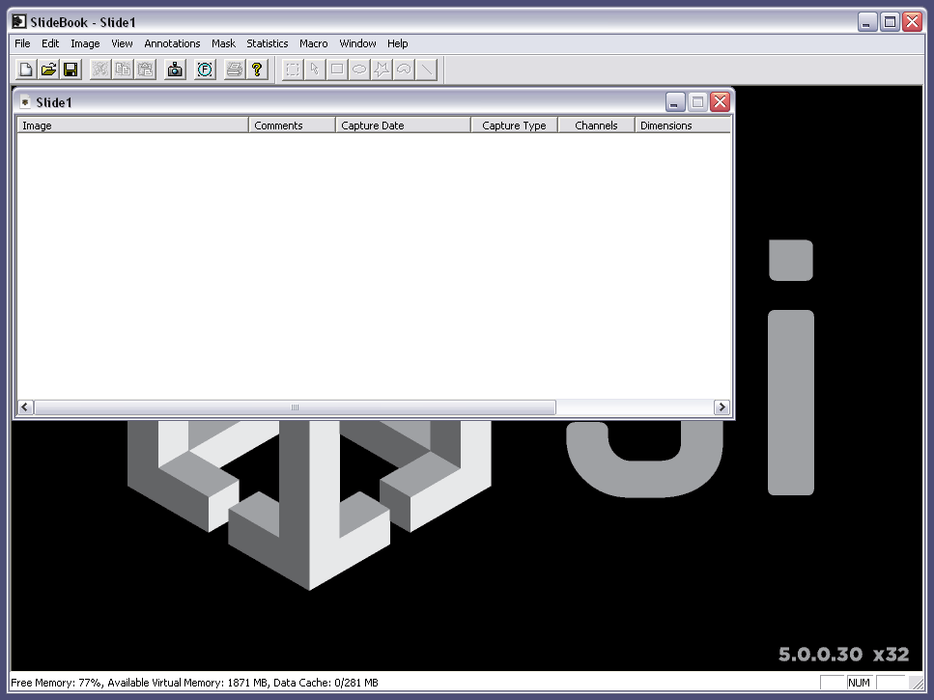

2.2) Next, open the Focus Window on SlideBook by selecting the Focus icon.

2.2) Continued: The Focus Window will look like the following:

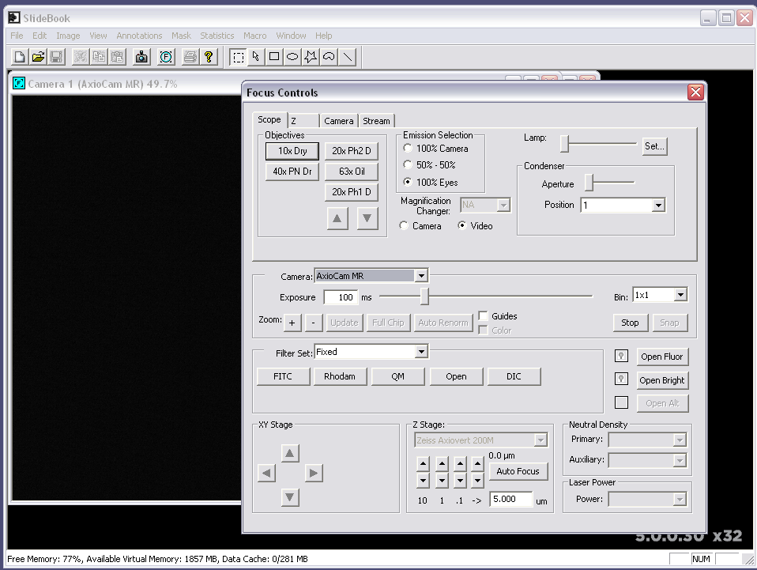

2.2) Continued: In the Focus Window, under the Filter Set section, select DIC.

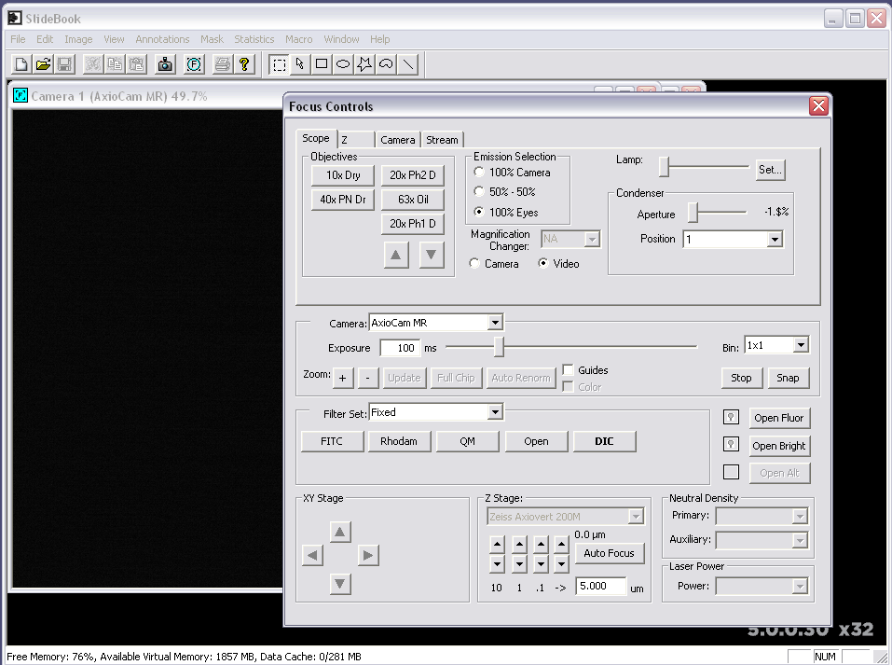

2.2) Continued: On the Scope tab, under the Condenser section, adjust the Aperture slide bar to the furthest right position. This provides high numerical aperture illumination and enhances optical sectioning of the specimen.

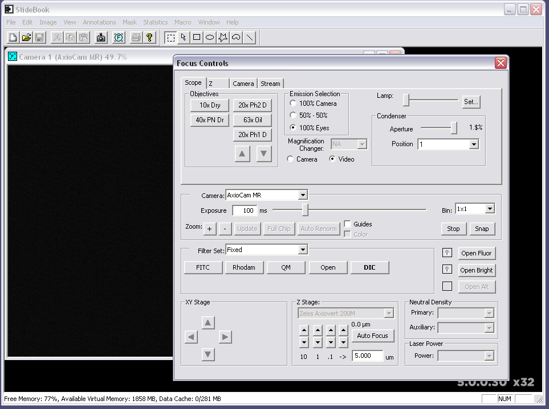

2.3) Focus on the sample using a DIC objective. Adjust the halogen lamp intensity until the sample is easily visible. To ensure the camera is not being saturated, select the Camera tab in the Focus Window and check that the histogram of pixel intensities is within the dynamic range of the camera.

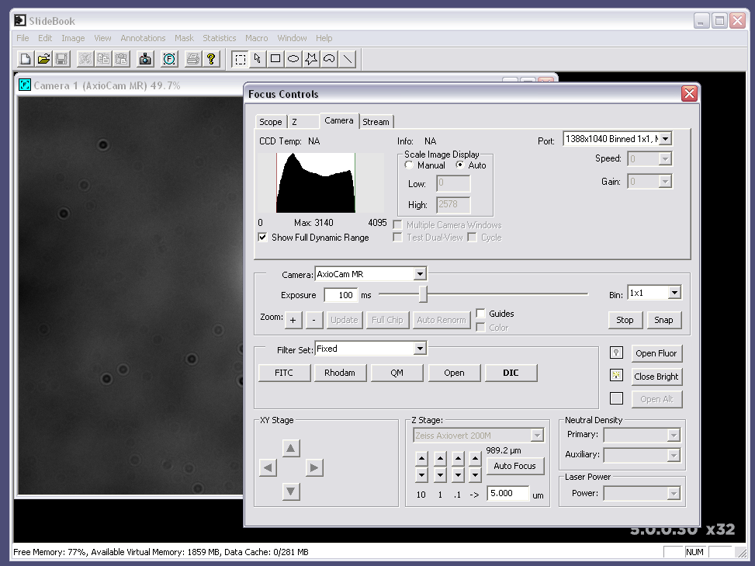

2.4) Open the Image Capture window by selecting the camera icon.

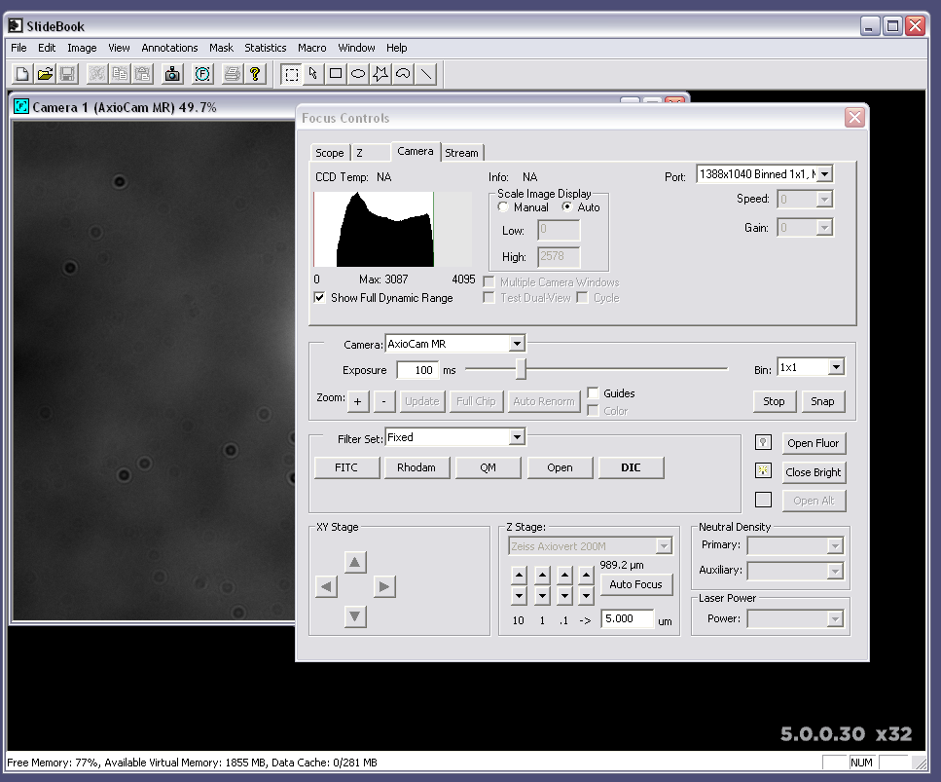

2.4) Continued: The Image Capture window will look like the following:

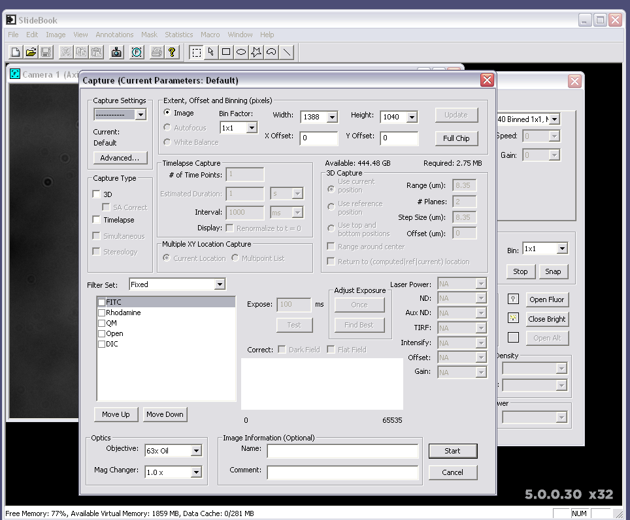

2.4) Continued: In the Capture Type section, check the 3D box.

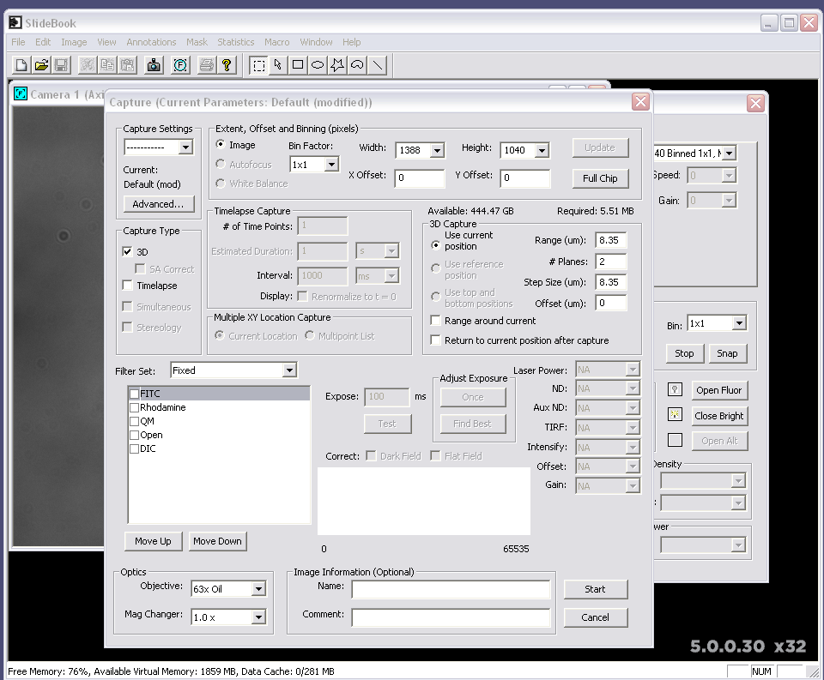

2.4) Continued: In the 3D Capture section, select the Range around center and Return to current location boxes and specify the Z-direction range, number of planes, and step size. The Z-direction range should incorporate the entire sample.

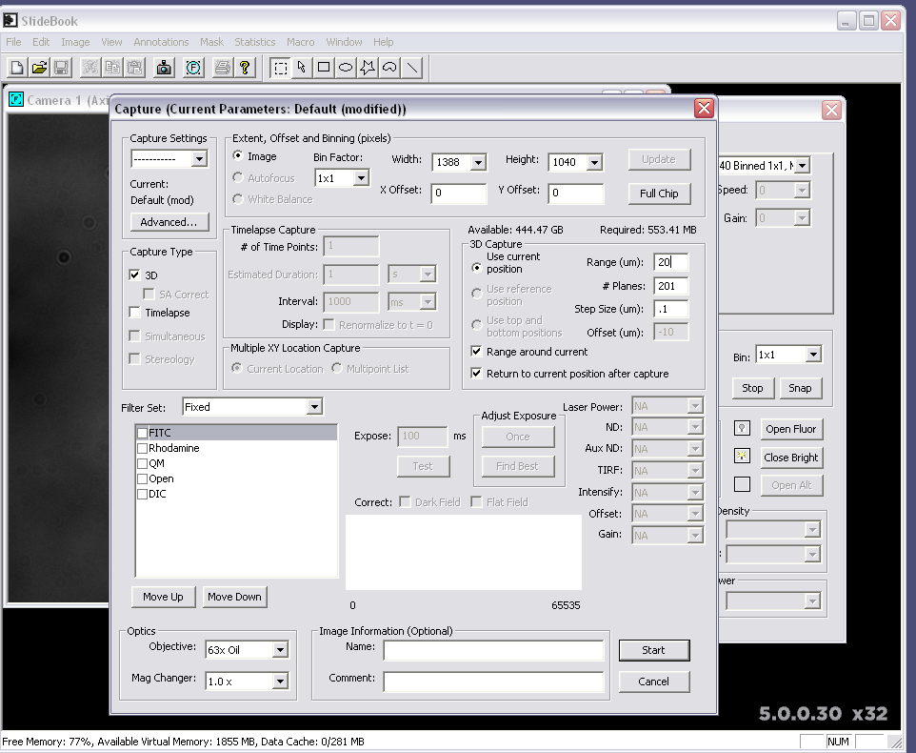

2.5) In the Filter Set section of the Image Capture window, check the DIC box and specify exposure time.

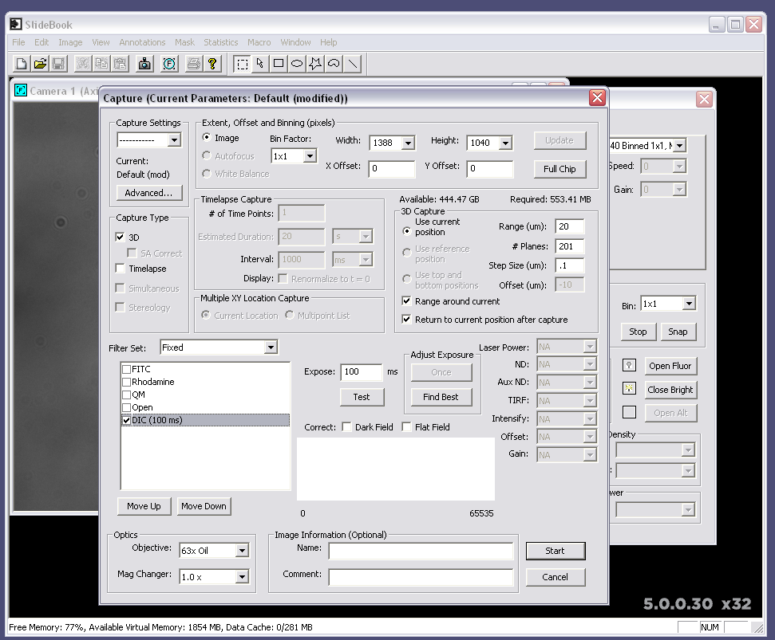

2.5) Continued: In the Image Information section, name the image (optional), and select Start to initiate the imaging.

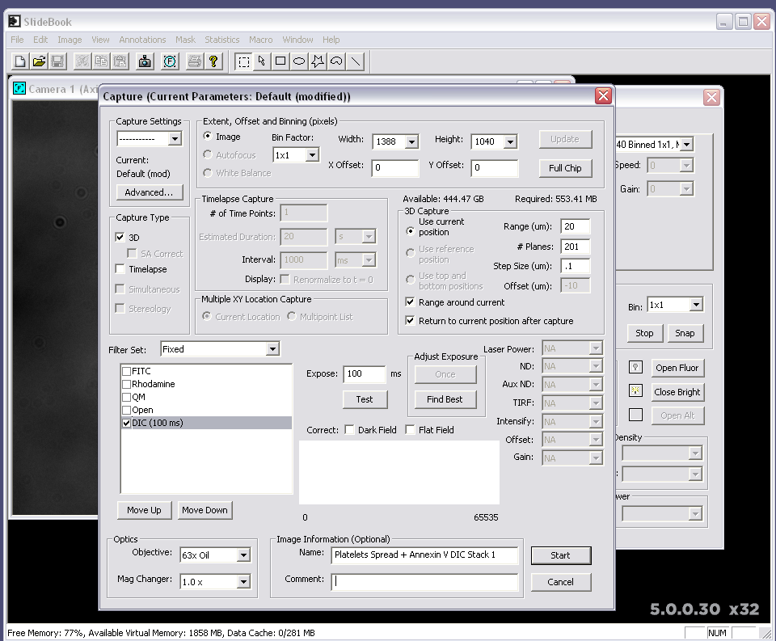

3. Bright Field (BF) Z-Stack Acquisition

3.1) Once the microscope has finished collecting the DIC Z-stack of the sample, open the Focus Window and select Open under the Filter Set section.

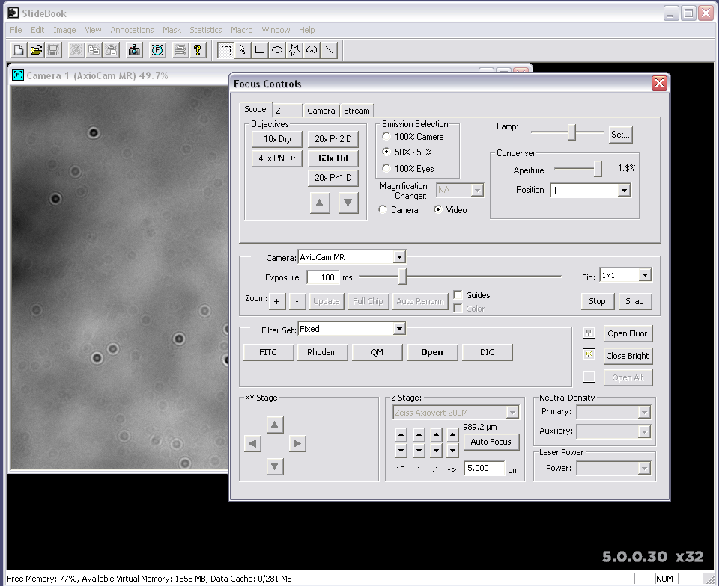

3.1) Continued: Adjust the Aperture slide bar to the furthest left position.

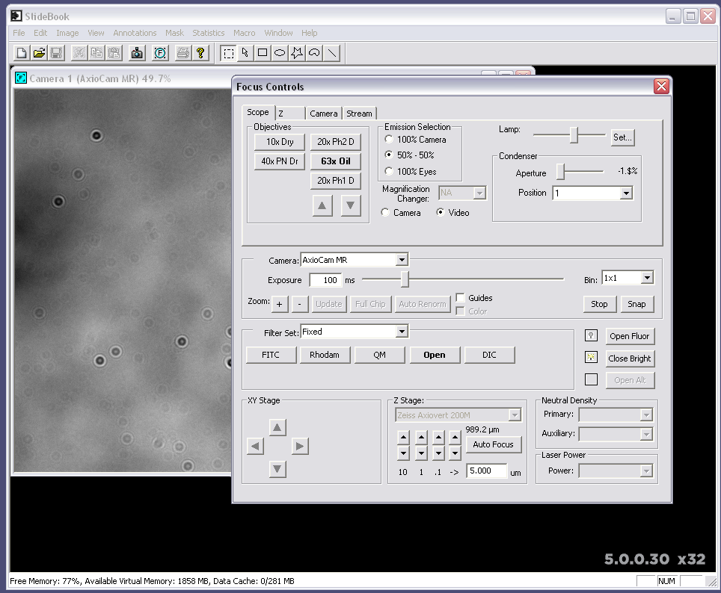

3.2) Change the microscope light-path filter to green. Adjust the halogen lamp intensity until the sample is visible. Ensure there is no saturation of the camera by selecting the Camera tab in the Focus Window and checking that the histogram of pixel intensities is within the specified range.

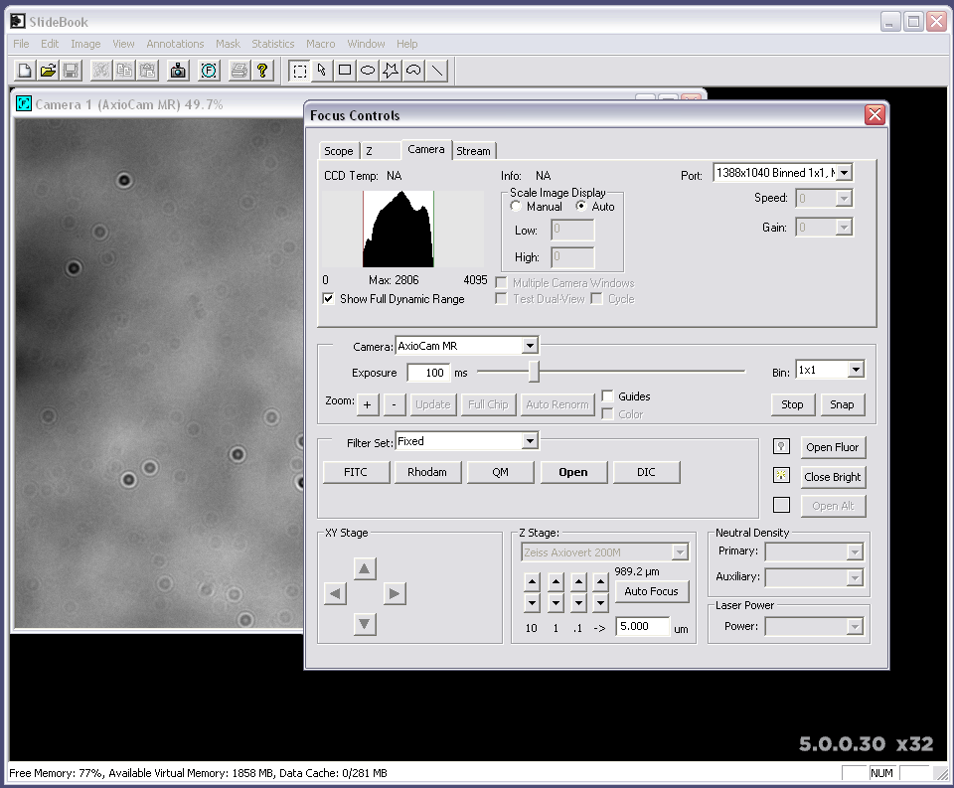

3.3) Open the Image Capture window. The 3D Capture settings from the DIC Z-stack acquisition will be displayed.

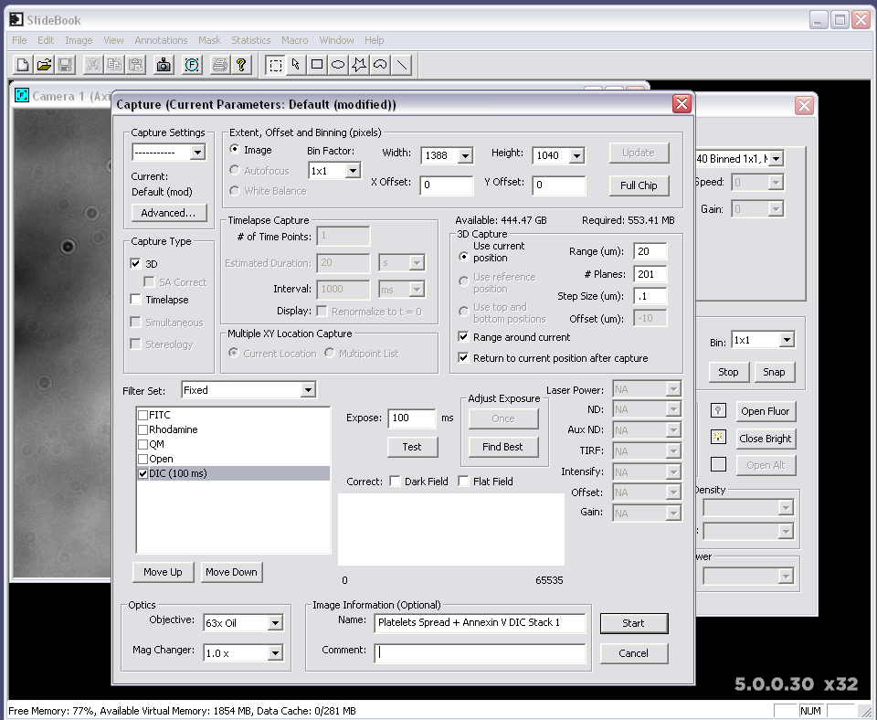

3.4) In the Filter Set section of the Image Capture window, check the OPEN box and specify exposure time.

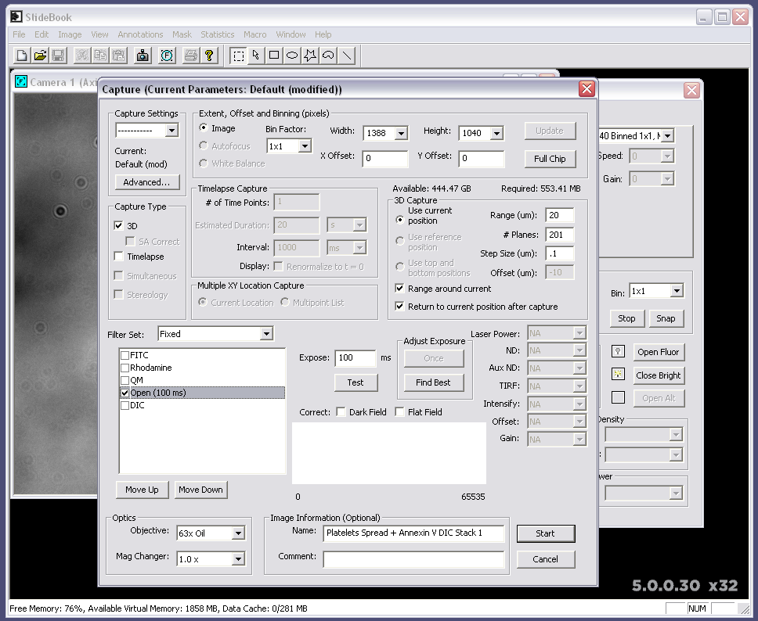

3.4) Continued: In the Image Information section, name the image (optional), and select Start to initiate Z-stack image acquisition.

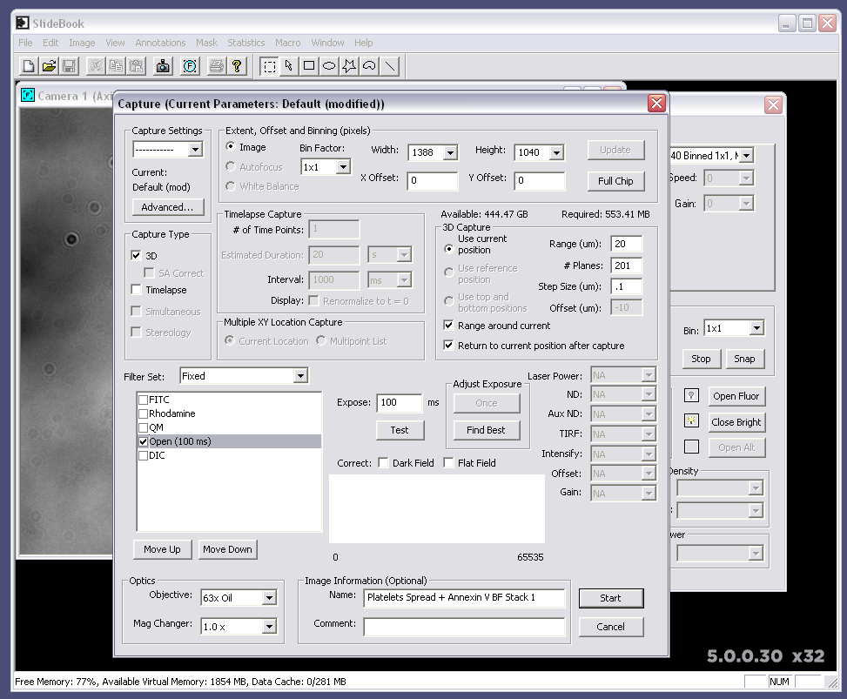

4. Exporting Z-Stack Images

4.1) Open a Z-stack capture by double clicking a capture file on your slide.

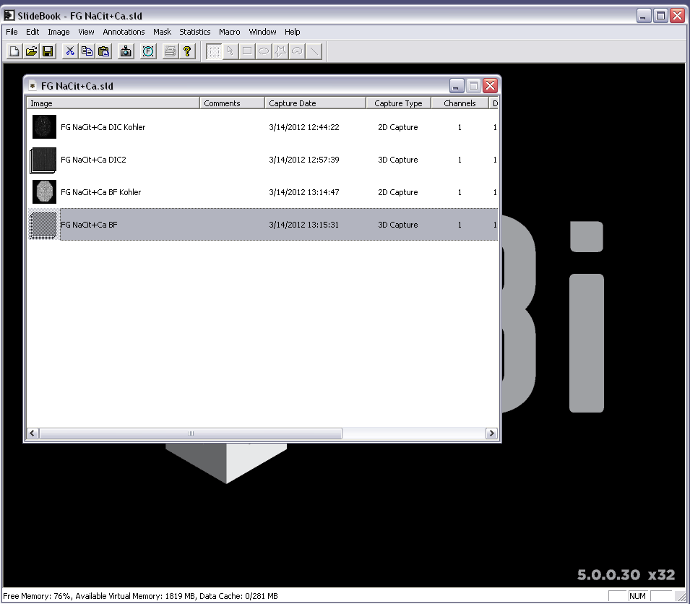

4.1) Continued: The Z-stack capture will look like the following:

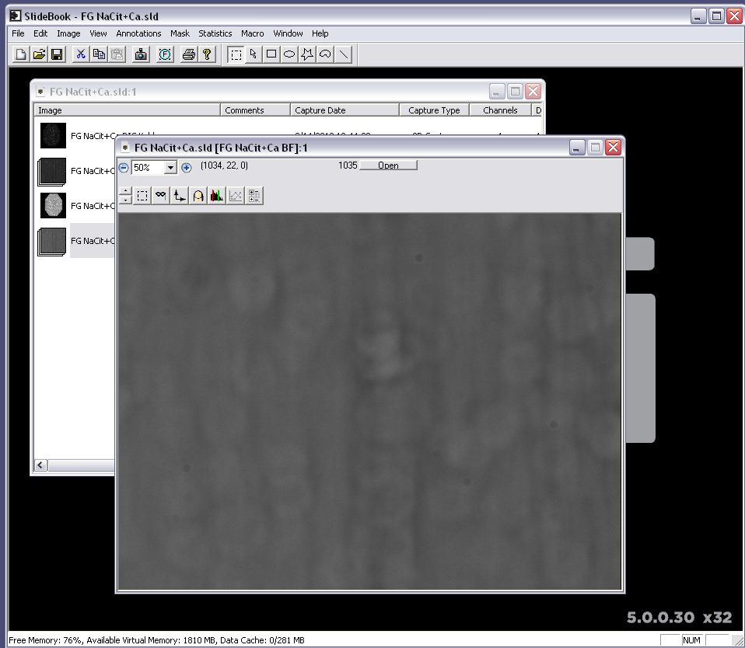

4.1) Continued: Change the view to 100%.

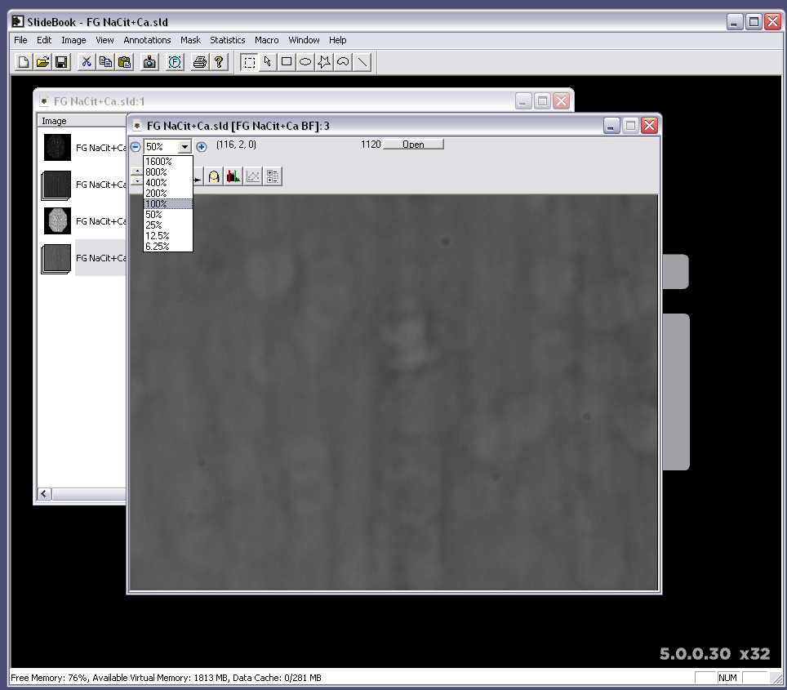

4.1) Continued: Adjust the histogram of the pixel values to be displayed between 0 and the maximum pixel value of your camera (4095 for 12 bit cameras, 65535 for 16 bit.)

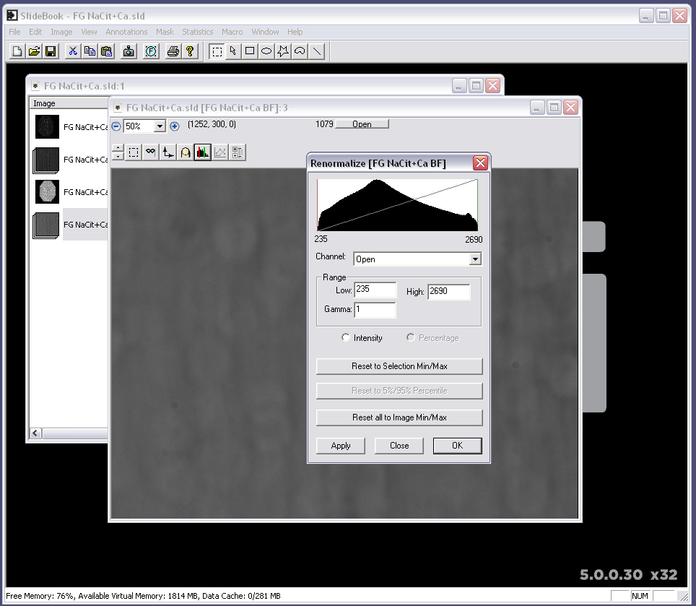

4.2) Select View > Export > TIFF Series. This will export the Z-stack as a series of TIFF images (one for each Z plane).

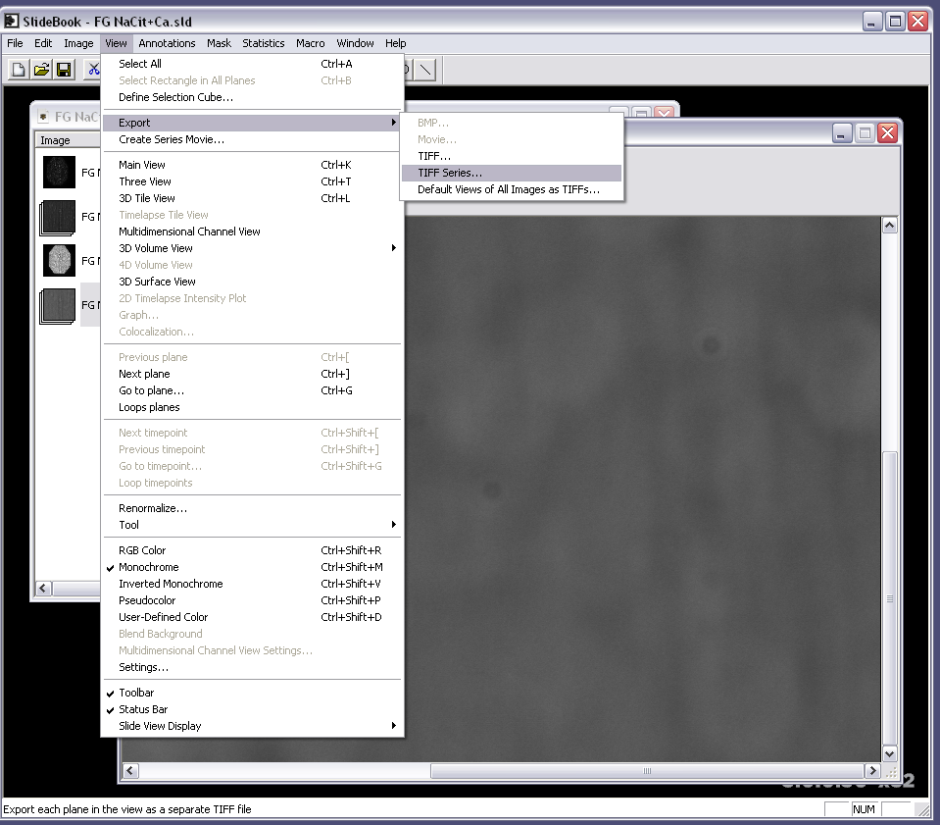

4.2) Continued: Save the TIFF series in a separate folder with a name that has an underscore at the end (i.e., “DIC Stack 1_”). Repeat this with each DIC or BF Z-stack.

