Lab Manual: Physics

Lab: Buoyancy

Scriptwriter Name: Margaret (Peggy) Piper

Video A: Instructor’s Guide to Setup – (Buoyancy)

- List of Materials (assuming a lab group of 10 students working in pairs)
- Caliper x 5
- 500 ml beaker x 15
- 300 ml water x 5
- 200 grams salt to make 300 ml saturated saltwater x 5
- 300 ml isopropyl alcohol x 5
- 1”x1” piece of HDPE or LDPE plastic to be submerged x 5
- Solid metal cylinder – 200-gram balance mass x 5
- 1”x1” piece of plastic cut from a plastic bag x 5
- 12”x12” sheet of aluminum foil x 5
- Wireless force measuring device x 5
- 8“ string x 5
- Scale x 5
- Laptop with data acquisition software x 5

- Set-up (No Title Slide)

  - In advance of the lab, prepare enough saturated salt water for all groups [1]. Using plain tap water [2], add salt and stir until the water is saturated and no additional salt will dissolve [3].

    - WIDE: Talent approaches lab bench/sink with empty container for preparing salt water and container of salt.
    - MED: Talent fills empty container with water.
    - CU/MED: Talent adds salt while stirring.

  - Immediately prior to lab, prepare 3 beakers for each group [1]. Start by labeling beakers for water, salt water and isopropyl alcohol [2]. Then, fill the beaker labeled water with plain tap water [3] Fill the beaker labeled salt water with salt water [4]. Fill the beaker labeled isopropyl alcohol with isopropyl alcohol [5-TXT] [6].

    - WIDE: Talent approaches lab bench/sink showing 3 empty beakers, container of salt water and container of isopropyl alcohol, aluminum sheets, and plastic bags.
    - MED: Talent labels beakers as spoken in narrative; W, SW, IP.
    - MED – over the shoulder: Talent fills one beaker with plain tap water.
    - MED: Talent fills one beaker with salt water.
    - MED: Talent fills one beaker with isopropyl alcohol.
    - ECU: Zoom into warning symbol on isopropyl alcohol container. TEXT: keep isopropyl alcohol away from flames and voltage sources

  - Next loosely crumple sheets of aluminum foil into spherical shapes for each group [1]. This should allow pockets of air to be trapped within the aluminum foil, effectively reducing its density [2].

    - MED: Talent crumples aluminum foil into ball.
    - MED/WIDE: Talent gently tosses aluminum foil ball into air and catches it show its light weight.

  - Additionally, cut a 1” x 1” square of plastic bag for each group [1].

    - MED – over the shoulder: Talent cuts plastic bag into 1x1 squares.

  - Now set the necessary equipment at each student workstation [1]. Each student group will need: 3 beakers of fluids, a spherical aluminum foil ball, a piece of plastic from a plastic bag, a caliper, a solid metal cylinder, a string, a wireless force sensor and a laptop with data acquisition software [2].

    - MED: Talent carries a tray containing; prepared beakers, aluminum foil ball and 1x1 cut plastic bag for 1 workstation to a table top that contains the rest of the equipment; a caliper, solid metal cylinder, string, wireless force sensor and a laptop with data acquisition software.
    - MED: Talent places items from tray on the table top.

  - Pair each group’s sensor with their laptop by removing the wireless receiver from the back of the sensor and plugging it into a USB port on the computer [1]. Open the data acquisition software, turn on the sensor and wait for it to pair [2].

    - MED – over the shoulder: Talent removes receiver from the back of sensor and plugs it into laptop
    - MED: Talent opens software on laptop and turns on sensor

Video B: Student Laboratory Exercise – (Buoyancy)

- Experiment 1 – Fluid Dependence

  - In the first part of the lab [1], you will place a small plastic object in three different fluids [2] and make qualitative observations about buoyancy due to different fluids [3].

    - See storyboard

  - You have been provided with a beaker of plain water, salt water, and isopropyl alcohol [1]. Isopropyl alcohol is very flammable. Keep it away from flames and voltage sources [2-TXT]

    - WIDE: Talent approaches workstation that contains all materials.

    - CU: Zoom in on beaker of isopropyl alcohol. TEXT: keep isopropyl alcohol away from flames and voltage sources

  - Start by looking up the values for the density of each of the fluids as well as the density of the piece of plastic that will be using [1]. Record these values in your lab notebook [2].

    - MED – over the shoulder: Talent uses the laptop to look up density values.
    - MED: Talent records values in a lab notebook.

  - Predict whether the plastic will [1] float or sink in each fluid [2] and write your prediction in your lab notebook [3].

    - MED/CU: Talent holds small piece of plastic near 3 beakers.
    - CU panning: Zoom in and pan across 3 beakers.
    - MED: Talent records prediction in the lab notebook.

  - Now, to test your prediction, first place the small piece of plastic in the water beaker and push it down the surface of the water to make sure it is not being held afloat due to surface tension [1]. Observe the plastic to see if it floats or sinks [2].

    - MED: Talent places the small piece of plastic in water and pushes it below the surface.
    - CU: Show the plastic in the water beaker.

  - Next, place the small piece of plastic in the salt water beaker and push it down [1]. Observe the plastic to see if it floats or sinks [2]. Finally, place the plastic in the isopropyl alcohol beaker, push it down the surface [3] and see if it floats or sinks [4]. Record your observations in your lab notebook [5].

    - MED: Talent places the small piece of plastic in the salt water and pushes it below the surface.
    - CU: Show the plastic in the salt water beaker.
    - MED: Talent places the small piece of plastic in isopropyl alcohol and pushes it below the surface.
    - CU: Show the plastic in the isopropyl alcohol beaker.
    - MED: Talent records the results in the lab notebook.

- Experiment 2 – Material Dependence

  - In this part of the lab, [1] you will place three different materials in water [2] and make qualitative observations about buoyancy [3] due to the material of the object being submerged [4].

    - See storyboard

  - To do this you will use the beaker of water [1] and the small piece of plastic from the previous experiment as well as a solid metal cylinder and a piece of plastic bag [2].

    - MED/WIDE: Talent moves the beaker of water into frame.
    - MED: Talent places the small piece of plastic, a solid metal cylinder and a 1x1 piece of plastic bag next to the beaker of water.

  - Start by looking up the densities of the solid metal cylinder and the piece of plastic bag [1]. Based on their densities, predict whether each object will float or sink [2] and write your predictions in your lab notebook [3].

    - MED – over the shoulder: Talent looks up densities using a laptop.
    - CU panning: Zoom in and pan across 3 materials, solid metal cylinder, small piece of plastic, and 1x1 piece of plastic bag.
    - MED: Talent writes predictions in lab notebook.

  - Now, to test your prediction, first place the small piece of plastic in the water beaker and push it down the surface of the water to make sure it is not being held afloat due to surface tension [1]. Observe the plastic to see if it floats or sinks [2].

    - MED: Talent places the small piece of plastic in water and pushes it below the surface.
    - CU: Show the plastic in the water beaker.

  - Next, place the solid metal cylinder in the water beaker and push it down [1]. Observe the cylinder to see if it floats or sinks [2]. Finally, place the piece of plastic bag in the water beaker, push it down the surface [3] and see if it floats or sinks [4]. Record your observations in your lab notebook [5].

    - MED: Talent removes piece of plastic and places solid metal cylinder in water and pushes it below surface.
    - CU: Show the cylinder in the water beaker.
    - MED: Talent removes solid metal cylinder and places 1x1 piece of plastic bag in water and pushes it below surface.
    - CU: Show the piece of plastic bag in the water beaker.
    - MED: Talent records the results in the lab notebook.

- Experiment 3 – Shape Dependence
  - In this part of the lab, you will make qualitative observations [1] about buoyancy due to the shape of the object being submerged [2].

    - See storyboard

  - To test how shape affects buoyancy, you will use the aluminum foil ball and the water beaker [1].

    - MED/WIDE: Talent places the foil ball next to the beaker of water.

  - First look up the density of aluminum [1]. Then use a caliper to measure the diameter of the ball [2] and use a scale to measure its mass [3]. Record these values in your lab notebook [4].

    - MED – over the shoulder: Talent looks up densities using the laptop.
    - CU: Talent uses a caliper to measure diameter of the foil ball.
    - MED/CU: Talent uses a scale to measure the mass of the foil ball.
    - MED: Talent records results in the lab notebook.

  - Predict whether the aluminum ball will float or sink [1] and write your prediction in your lab notebook [2].

    - Product CU: Zoom in on the beaker of water and the foil ball.
    - MED: Talent records results in the lab notebook.

  - Now test your prediction by placing the aluminum ball in the beaker of water [1]. Push the ball below the surface of the water to make sure it is not being held afloat due to surface tension [2]. Observe the buoyancy of the foil ball [3] and record your observations in your lab notebook [4].

    - MED: Talent places the foil ball in the beaker of water
    - MED: Talent pushes the foil ball below surface of the water.
    - CU: Show the cylinder in the water beaker.
    - MED: Talent records results in lab notebook.

- Experiment 4 – Quantitative Measurement

  - In the final part of the lab, you will use a force sensor [1] to quantitatively measure the buoyant force on an object [2].

    - See storyboard

  - To get ready, use a string to attach the solid metal cylinder to the force sensor. This will allow you to quantitatively measure [1] the change in the downward force on the cylinder as the cylinder is submerged in water [2].

    - MED – over the shoulder: Talent attaches one end of a string to the solid metal cylinder and attaches other end to a force sensor.
    - MED: Talent holds force sensor high enough so that cylinder hangs down from force sensor, with water beaker in background.

  - Next use a caliper to measure the diameter and the height of the solid metal cylinder [1]. Record these values in your lab notebook [2].

    - MED/CU: Talent uses a caliper to measure the diameter and the height of the cylinder.
    - MED: Talent records the measurements in the lab notebook.

  - Knowing that the cylinder will sink in water, predict the buoyant force that will act on it [1] and write this value in your lab notebook [2].

    - CU: Talent holds the solid metal cylinder in hand.
    - MED: Talent writes prediction in the lab notebook.

  - Before you start your measurement, place the cylinder and the sensor on a flat surface, [1] making sure the string is not pulling on the sensor and there are no other forces on the sensor [2].

    - MED: Talent places the sensor and the cylinder on the table top.
    - MED – over the shoulder: Talent adjusts cylinder so that the string is not pulling on the sensor.

  - Check that the force sensor is turned on [1] and begin collecting force data by pressing the “Record” button in the data acquisition software [2].

    - MED: Talent turns the force sensor on.
    - SCREEN: Screenshot of talent using data acquisition software to press the record button.

  - Now, steadily pick up the force sensor until the solid metal cylinder hangs straight down from the sensor [1]. Hold the sensor steady to get a constant force reading [2].

    - MED: Talent steadily picks up force sensor until solid metal cylinder is hanging straight down.
    - SCREEN: Screenshot of data acquisition force vs time plot showing steady force reading

  - Next, slowly lower the solid metal cylinder into the beaker of water until the cylinder is completely submerged [1]. Again, hold the sensor steady to get a constant force reading [2].

    - MED – over the shoulder: Talent moves the force sensor directly over water and slowly lowers the metal cylinder into water until it is fully submerged
    - SCREEN: Screenshot of data acquisition force vs time plot showing steady force reading at this reduced force

  - Now lift the sensor to remove the cylinder from the beaker [1] and stop data collection in the data acquisition software [2].

    - MED: Talent steadily lifts force sensor to remove the cylinder from water.
    - SCREEN: Screenshot of talent using data acquisition software to press stop button

  - A force vs. time plot should appear in the data acquisition software [1]. To export this data choose the “Export to File” icon and press the “Export to CSV” button [2].

    - SCREEN: Screenshot of data acquisition showing force vs time plot
    - SCREEN: Screenshot of talent clicking export button

- Results

  - Begin by analyzing the data from Experiment 1 – Fluid Dependence [1]. In this experiment you placed a small piece of plastic in three different fluids [2] [3].

    - Reuse 3.1.1.
    - Reuse 3.1.2.
    - Reuse 3.1.3.

  - To get started [1], look at the density that you recorded for the plastic object and the three fluids that you used [2].

    - See storyboard
    - See storyboard

  - When you placed the plastic object in the water and the salt water [1], you saw that the plastic floated in the fluid [2]. But when you placed the plastic object in the isopropyl alcohol, you saw that it sank [3].

    - See storyboard

  - These results serve to demonstrate [1] how relative densities determine whether something floats [2] or sinks [3].

    - See storyboard

  - The three fluids that you tested have three different densities [1].

    - See storyboard

  - Because the plastic is less dense than both water and salt water, it floated in these two fluids [1].

    - See storyboard

  - Because the plastic is more dense than isopropyl alcohol, it sank in this fluid [1].

    - See storyboard

  - Objects whose average densities are higher than that of a fluid, will sink in the fluid, and those with lower densities will float in a fluid [1].

    - Show split screen showing shot 3.6.1 on the left and shot 3.7.3 on the right.

  - Now turn to the affect that the type of material being submerged [1] had on buoyancy in Experiment 2 – Material Dependence [2]. In this experiment you placed three different materials in a beaker of water [3].

    - Reuse 4.1.2
    - Reuse 4.1.3
    - Reuse 4.1.4

  - You recorded the density of [1] the three objects and the fluid that you used [2].

    - See storyboard

  - You observed that both the small piece of plastic and the piece of plastic bag floated in the water [1]. But the metal cylinder sank in the water [2].

    - See storyboard

  - Because both types of [1] plastic are less dense than water, they floated [2].

    - See storyboard

  - Because the metal cylinder is denser than water it sank [1].

    - See storyboard

  - Once again, objects whose average densities are higher than that of a fluid sink in the fluid, and those with lower densities float in a fluid [1].

    - Show split screen showing shot 4.4.1 on the left and shot 4.5.1 on the right.

  - To further consider the effect of shape of the object, [1] look at the results from Experiment 3 – Shape Dependence [2]. Here you will see example values [3] for density, [4] diameter [5] and mass [6].

    - Reuse 5.1.1
    - Reuse 5.1.2
    - See storyboard
    - See storyboard
    - See storyboard
    - See storyboard

  - You observed that the aluminum foil ball floated in the water [1]. This happens even though aluminum foil [2], is much denser than water [3].

    - See storyboard

  - To explain this, you need to calculate [1] the average density of the aluminum ball using the diameter and the mass that you measured [2].

    - See storyboard

  - Start with the diameter that you visually determined to the closest millimeter [1], and the associated uncertainty due to using a caliper [2].
    - See storyboard

  - Then use the equation for the volume of a sphere [1] and error propagation to calculate [2] the volume of the aluminum ball and its uncertainty [3].

    - See storyboard

  - Now consider the mass that you measured [1] and the uncertainty given by the scale that you used [2].

    - See storyboard

  - Use this mass and volume [1] to calculate the density [2] of the aluminum ball [3]. Again, use error propagation to calculate [4] the uncertainty of the density [5].

    - See storyboard

  - Note that the aluminum ball has [1] an average density that is much smaller than [2] the density of water [3]. The aluminum ball floats [4] because its average density is smaller than the [5] density of the fluid it is placed in [6].

    - See storyboard

  - Even if a material is very dense, such as aluminum [1], it can be shaped in such a way that it will take up a larger volume and have a lower density [2]. This larger volume will [3] displace a large volume of water [4] and thus experience a large buoyant force [5].

    - See storyboard

  - Finally look at your results from Experiment 4 – Quantitative measurement [1]. In this experiment you measured the force on the cylinder in and out of the beaker of water [2].

    - Reuse 6.1.1
    - Reuse 6.1.2

  - As expected, this very dense metal cylinder [1] sank in the beaker of water [2].

    - See storyboard

  - Start your analysis by using the values of diameter [1], and height that you measured [2] and the known density of water to calculate the theoretical buoyant force [3].

    - See storyboard

  - First calculate the volume [1] and its uncertainty [2]. This volume represents the amount of water that is displaced [3].

    - See storyboard
  - Next, calculate the mass of the water displaced by multiplying the volume by the density of water [1]. Since there is no error associated with the given density of water, the error for mass is simply the mass times the uncertainty of the volume [2].

    - See storyboard

  - Then use this mass [1] times the acceleration due to gravity to calculate the weight and uncertainty of the displaced water [2]. This gives you the theoretical buoyant force [3].

    - See storyboard

  - To compare this theoretical value to the buoyant force you measured, start by using a spreadsheet program to open the CSV file that you exported from the data acquisition software [1].

    - SCREEN: Screen shot of talent opening cvs file in spread sheet program

  - The first column of data that you are interested in appears as “time” [1]. This represents the time increments over which data was collected [2].

    - SCREEN: Screen shot of spreadsheet showing “time” column highlighted
    - SCREEN: Add text “Time increments” to the screenshot

  - The second column of data you are interested in appears as “cal[0]” [1]. This column represents force values that were collected at each time increment [2].

    - SCREEN: Screen shot of spreadsheet showing “cal[0]” column highlighted
    - SCREEN: Add text “Force values” to screenshot

  - Now, create a plot of force vs time [1] and visually determine which points in time represent the cylinder out of the water as opposed to when it was in the water [2].

    - SCREEN: Screen shot of talent creating force vs. time plot
    - SCREEN: Screen shot adding circle to designate part of plot that represents the greater force when the cylinder was out of the water like in this example:

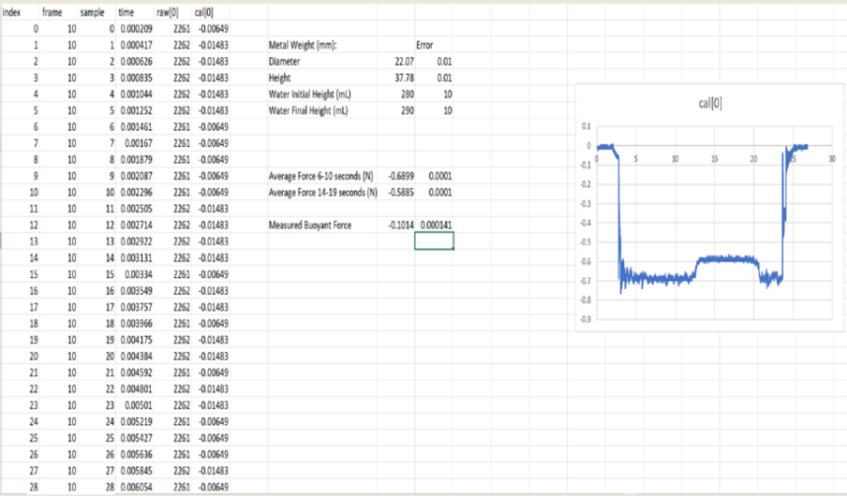

  - Then use the spreadsheet program to calculate the average force for this interval [1]. This value is the weight of the cylinder due to the force of gravity [2].

    - SCREEN: Screen shot of talent calculating the average force for this interval
    - SCREEN: Screen shot adding text “Force out of water = -0.6899 Newtons”

  - Next, choose an interval of the force data that accurately represents the force detected with the cylinder submerged in the water [1].

    - SCREEN: Screen shot adding circle to designate part of plot that represents the greater force when the cylinder was in the water like in this example:

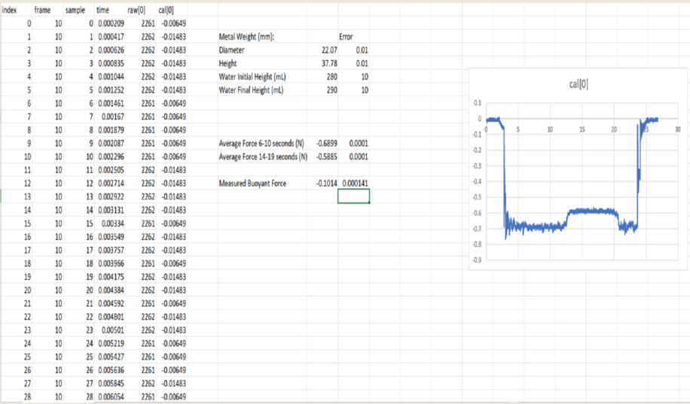
  - Again, use the spread sheet program to calculate the average force for this interval [1]. This value is the net force on the cylinder when it is submerged in the water [2].

    - SCREEN: Screen shot of talent calculating the average force for this interval
    - SCREEN: Screen shot adding text “Force out of water = -0.5885 Newtons”

  - Finally, calculate the buoyant force on the cylinder [1]. The net force on the cylinder is the sum of the downward force due to gravity and the upward buoyant force of the fluid [2].

    - See storyboard

  - To find the buoyant force, subtract [1] the weight of the cylinder from the net force [2]. This is the upward buoyant force acting on the object [3].

    - See storyboard

  - Compare the measured buoyant force to the theoretical force that you calculated [1]. You can see that the theoretical value is slightly higher even when accounting for the calculated uncertainty [2]. This higher value may be attributed to ignoring the recess in the neck of the cylinder when measuring diameter [3].

    - See storyboard

  - Both of these values show that, even when an object sinks, there is still an upward buoyant force on the object and that force is equal to the weight of the displaced liquid [1].

    - See storyboard

