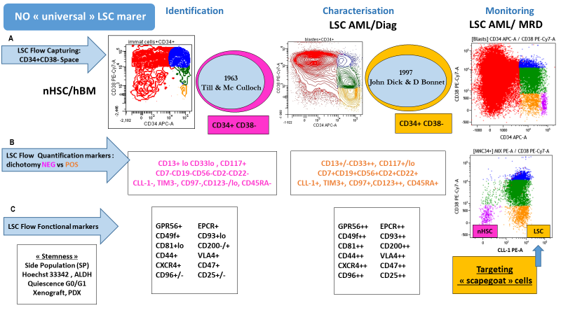

Supplemental Figure S1: CD34⁺CD38⁻ LSC-enriched populations in AML. (A) Identification of normal hematopoietic stem cells (nHSCs) in healthy bone marrow and LSC-enriched cells in AML samples within the CD34⁺CD38⁻ space. (B) Quantification of LSC-enriched cells at diagnosis based on dichotomic LSC marker expression, shown as CLL1⁺ LSC-enriched cells (orange) and CLL1⁻ nHSCs (purple), followed by monitoring at MRD time points. (C) Additional LSC-associated functional markers.

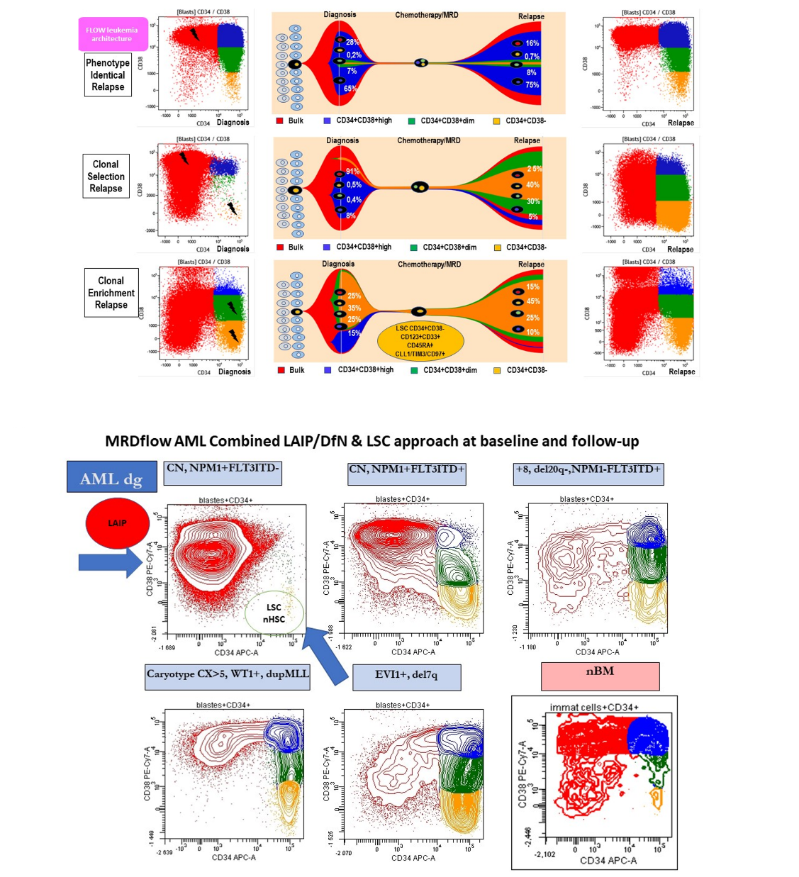

Supplemental Figure S2: Genotype- and phenotype-associated heterogeneity of relapse and leukemic hierarchy in AML. (A) Dynamics of relapse based on the combined LAIP/DfN and LSC approaches. Representative examples show immunophenotypic fractions and LSC dynamics between diagnosis and relapse in three patients with different genotype and phenotype heterogeneity. In the first patient, relapse shows an identical phenotype arising from committed progenitors (AML “LSC^{low}”). In the second patient, relapse shows a phenotype arising from a small selected subclone from more primitive cells (LSC) (AML “LSC^{low}”). In the third patient, relapse shows enrichment of a phenotype arising from initially more primitive cells (LSC), similar to that observed at diagnosis (AML “LSC^{high}”).
(B) Heterogeneity of LAIP and LSC patterns at diagnosis. Representative examples in the CD34/CD38 space show bulk blast patterns from different patients at diagnosis compared with normal healthy bone marrow. From more differentiated to more immature patterns: the first plot shows a patient with isolated NPM1⁺ favorable-risk AML, with blasts in the CD34⁻ compartment; the second plot shows a patient with additional FLT3-ITD, with accumulation of a CD34⁺ fraction and a CD34⁺CD38⁻ LSC subclone, corresponding to intermediate-risk AML; the third plot shows an adverse-risk patient with accumulation of blasts showing an LSC-associated pattern.
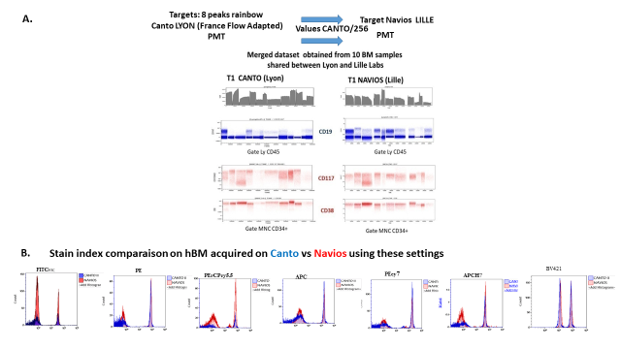

Supplemental Figure S3: Interplatform mirroring between two flow cytometer platforms. (A) Mirroring performed on 10 healthy bone marrow (hBM) samples tested in parallel on two cytometer platforms, showing comparable marker-expression levels in different gated populations, including CD19⁺ lymphocytes (blue) and CD117 and CD38 expression in MNC CD34⁺ cells (red). (B) Comparison of staining index values between the two cytometer platforms on mononuclear cells for each channel.

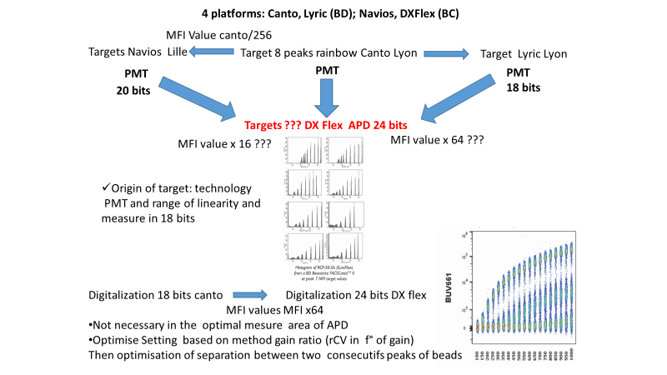

Supplemental Figure S4: Schematic representation of interplatform mirroring between PMT- and APD-based cytometers. The figure illustrates the strategy used to establish mirroring between PMT- and APD-based cytometers with different optical configurations, signal detection technologies, and digitization systems.

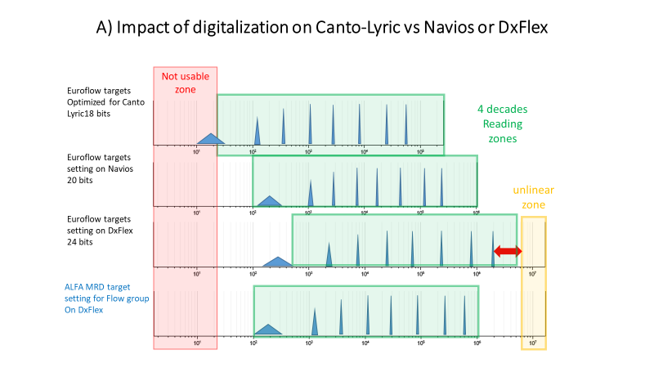

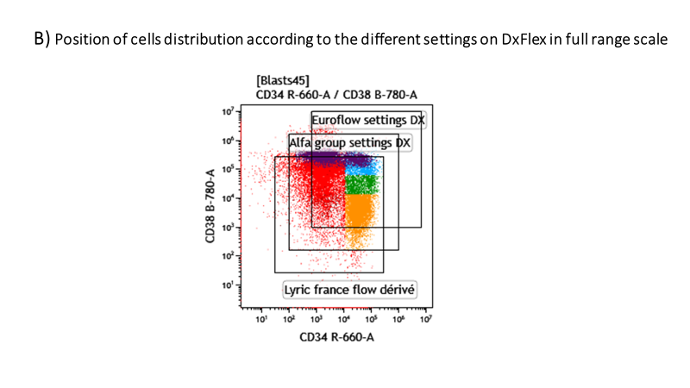

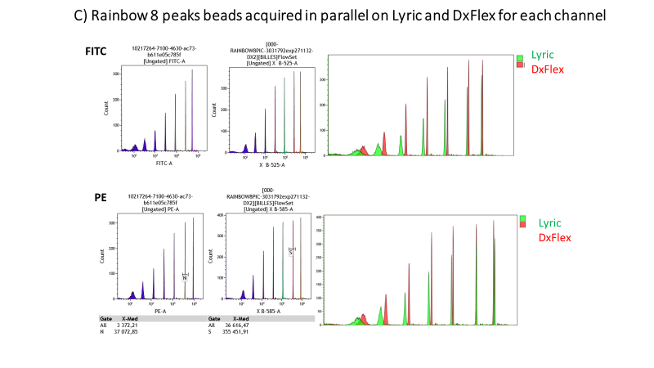
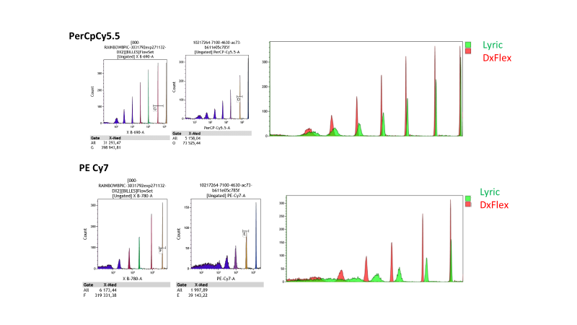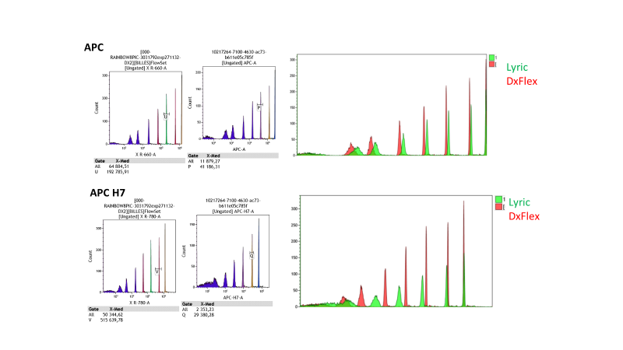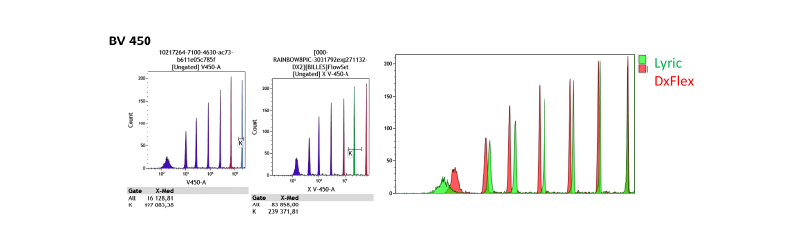
Supplemental Figure S5: Optimization of platform mirroring across cytometers with different digitization ranges. (A) Effect of direct transposition of EuroFlow settings on cytometer platforms with different digitization ranges, including 18-bit, 20-bit, and 24-bit systems. (B) Distribution of cell populations on the DxFlex platform according to different settings displayed on the full-range scale. (C) Acquisition of 8-peak rainbow beads in parallel on the Lyric platform (top row) and the DxFlex platform (middle row), with overlap after scale adjustment for each channel (bottom row).

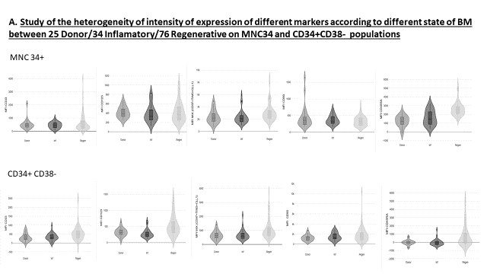
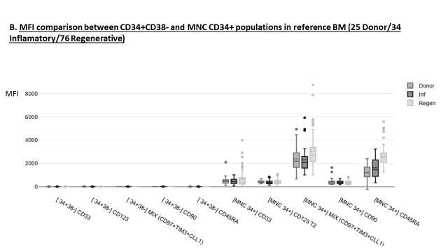

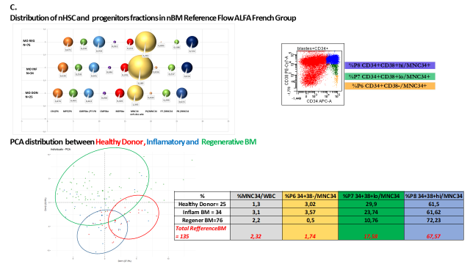

Supplemental Figure S6: Reference bone marrow marker-expression profiles and progenitor distributions. (A) Variation in marker-expression MFI for CD33, CD123, MIX (CLL1/TIM3/CD97), CD90, and CD45RA according to bone marrow status in 25 healthy donor, 34 inflammatory, and 76 regenerating bone marrow samples. The first row shows MNC CD34⁺ cells, and the second row shows the CD34⁺CD38⁻ fraction. (B) Comparison of the expression intensity of CD33, CD123, MIX (CLL1/TIM3/CD97), CD90, and CD45RA between the CD34⁺CD38⁻ and MNC CD34⁺ populations. (C) Distribution of progenitor populations and reference values in bone marrow samples. Frequencies are shown for CSH in P6 (orange), MPP-like in P6 (green), GMP-like in P7+P8 (blue), CMP-like in P7+P8 (purple), MEP-like in P8 (red), MNC CD34⁺ in WBC45⁺ (yellow), P6 (CD34⁺CD38⁻) in MNC CD34⁺ (orange), P7 (CD34⁺CD38^{low}) in MNC CD34⁺ (green), and P8 (CD34⁺CD38^{high}) in MNC CD34⁺ (blue). Principal component analysis (PCA) shows the distribution of progenitor populations among healthy donor, inflammatory, and regenerating bone marrow samples. The accompanying table shows the mean values observed for each population in healthy donor (n = 25), inflammatory (n = 34), and regenerating bone marrow (n = 76) samples.

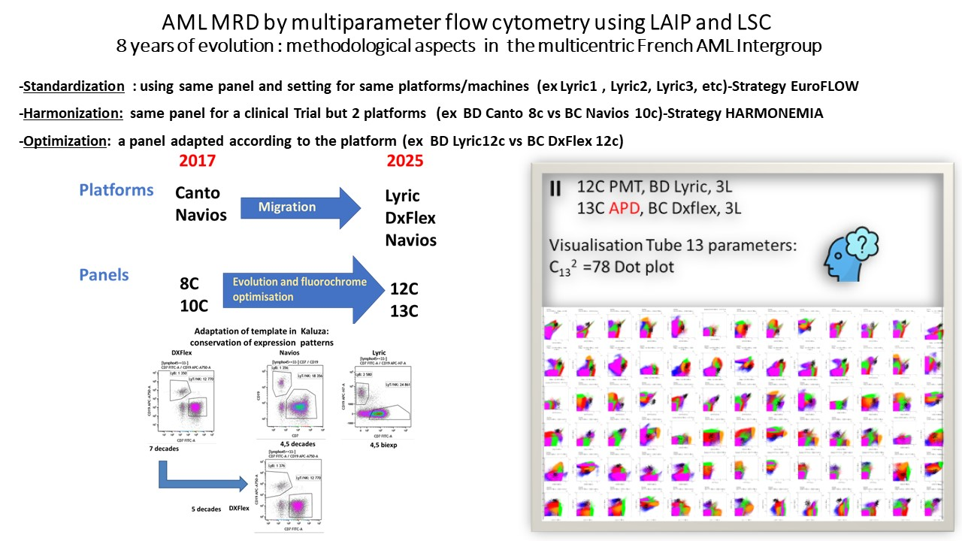

Supplemental Figure S7: Longitudinal platform and panel evolution in the LabFlow network. The figure summarizes the longitudinal evolution of clinical cytometers in the LabFlow network and the adjustment of instrument settings using standardization, harmonization, and optimization methods. Migration from 8-color to 12-color panels increased specificity for LAIP detection and improved interpretation by adding cleanup markers that help eliminate cells contaminating the MRD gate. This increase in marker number also increased analysis complexity, as a 13-parameter tube requires review of 78 bivariate histograms.

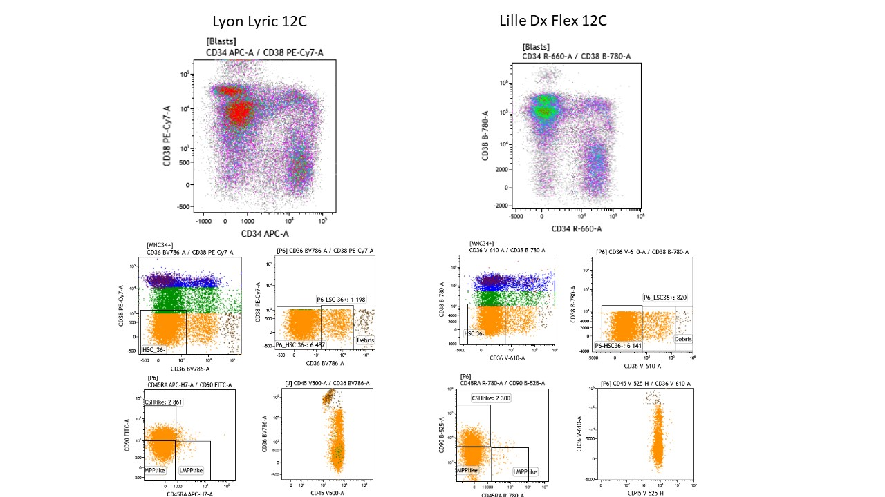

Supplemental Figure S8: Example of platform-specific panel optimization. The figure shows an example of optimization using a panel adapted to each platform, comparing a 12-color Lyric panel with a 12-color DxFlex panel. Optimization preserved the staining index and improved specificity through the inclusion of cleanup markers, such as CD36, to reduce contamination of the MRD gate.

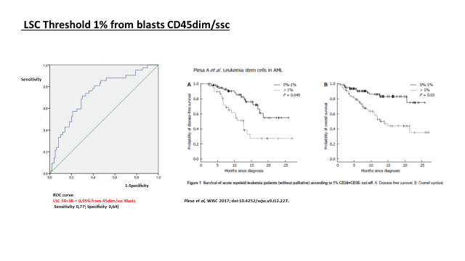
Supplemental Figure S9: Prognostic threshold for LSC quantification at diagnosis. The ROC curve (left) was used to determine the LSC clinical threshold at diagnosis with prognostic significance. A threshold of 1% LSCs among CD45/SSC blasts was evaluated. Survival curves show disease-free survival (DFS) and overall survival (OS) according to the 1% LSC threshold.

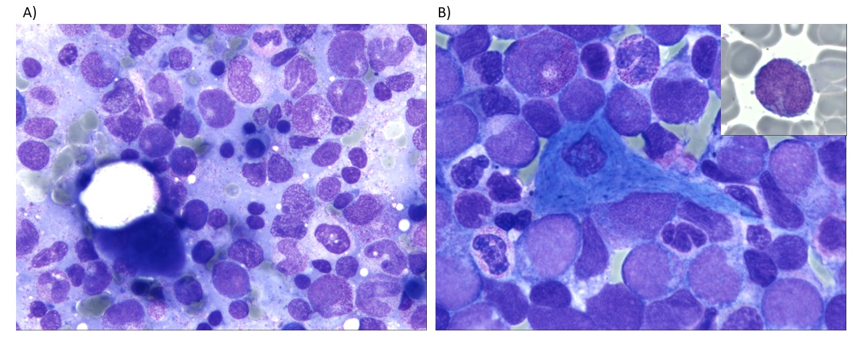Supplemental Figure S10: Bone marrow smear A) Healthy regenerating marrow and B) AML patient (AML2 subtype). May-Grünwald-Giemsa 100x magnification.

