Note:
I changed the numbering of the script (4.10.1 – 5.4.1) to make it more clear and structured, if you have any questions, please reach out to me.

Scatter Settings:
4.10.1 + 2 SCREEN: Forward Scatter (FSC) and Side Scatter (SSC) are adjusted and a trigger set to exclude debris. Is done with a unstained sample.
Acquisition ICC sample:
4.10.3 SCREEN: Start to acquire the ICC sample together with the corresponding Express Mode (sets the necessary measurement information and annotations + does the gating automatically)
Data analysis ICC: (only one PDF with the complete gating)
PDF 5.1 Show the gating to evaluate viability (Debris exclusion / CD45+ /Viable), Cluster of Differentiation 3 expression + and viable Cluster of Differentiation 3 expression Count (Debris exclusion / CD45+ / Viable / CD3+)
If possible: use only this area within the PDF and remove the unecessary information on the top and bottom of the pdf
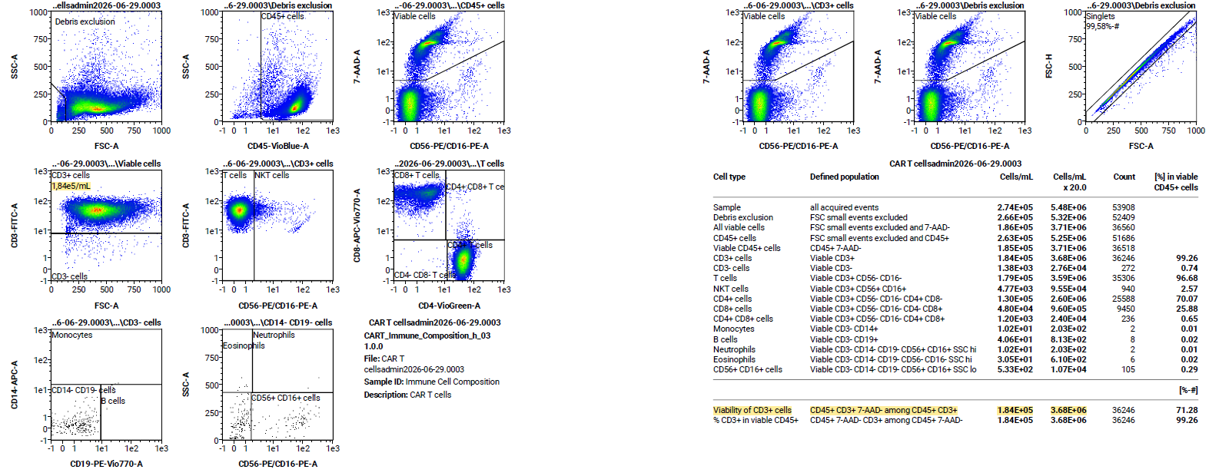
Acquisition CAR T Transduction sample: Should be the matching SCREEN to 4.11.1 in the changes of the protocol that Jakob sent to you
6.1 SCREEN Start to acquire the CAR T transduction sample sample together with the corresponding Express Mode (sets the necessary measurement information and annotations + does the gating automatically)
Data analysis CAR T Transduction sample:
PDF 7.1 Show the gating to evaluate viability (Debris exclusion / CD45+ /Viable), to evaluate Cluster of Differentiation 3 expression (Debris exclusion / CD45+ / Viable / CD3+) and the gating to evaluate CAR expression (Debris exclusion / CD45+ / Viable / CD3+ / CAR+)
If possible: use only this area within the PDF and remove the unecessary information on the top and bottom of the pdf
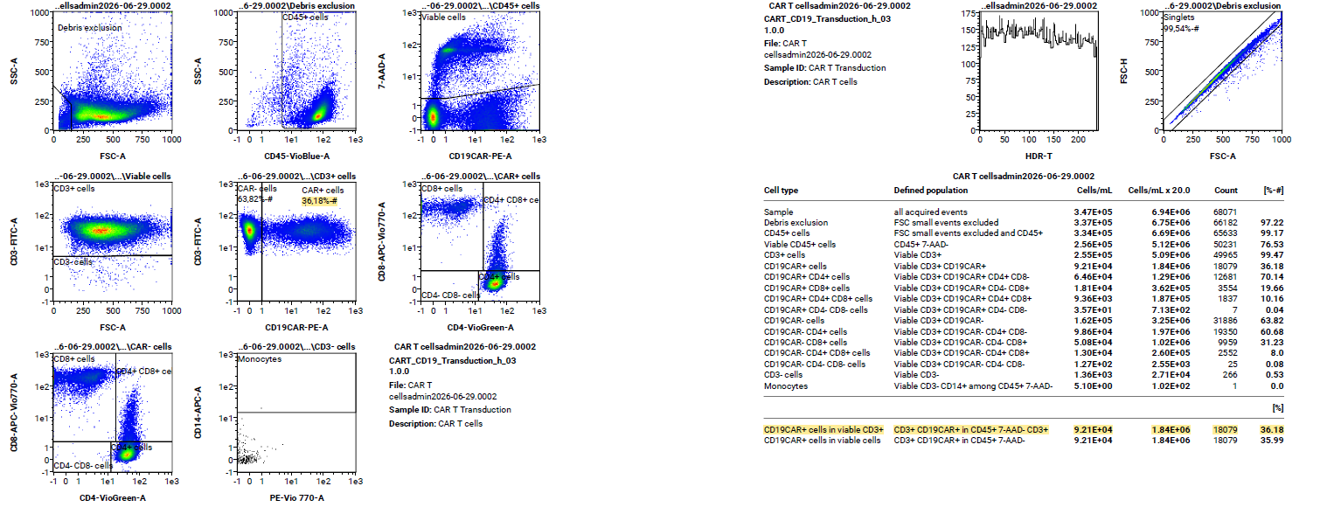
PDF 7.2 Calculate CAR T cell concentration (see text box within the PDF)
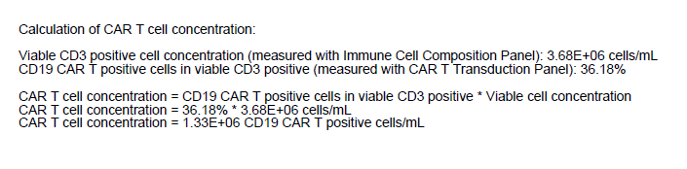

SCREEN of 4.2.1, 4.3.1 and 4.3.2 were not recorded seperately on the device. Shots from the video day can be used. If more videos of that steps are needed, please contact us.

