Autocycler Plasmid Assembly Workflow
This workflow walks through each step of a long-read plasmid assembly pipeline built around Autocycler. Steps are presented individually so users can follow along, understand what's happening at each stage, and manually inspect results.

A scripted version of this pipeline that handles all of this automatically is available at https://github.com/CaisonWarner/plasmid-assembly-workflow.

4.0.1 Software Installation
This workflow requires several bioinformatics tools. Installation is simplified using Conda and the provided environment YAML file. Located here: https://github.com/CaisonWarner/plasmid-assembly-workflow
Install Miniconda if it is not already installed:
https://docs.conda.io/en/latest/miniconda.html
Create the analysis environment using the provided YAML file:

conda env create -f autocycler_environment.yml

Activate the environment:

 conda activate autocycler_env

Additional documentation for major tools:
Autocycler
https://github.com/rrwick/Autocycler
Medaka
https://github.com/nanoporetech/medaka
Bandage
https://github.com/rrwick/Bandage
DNAapler
https://github.com/gbouras13/dnaapler

4.0.2 Recommended Directory Structure
Create a working directory structure before beginning the analysis.
mkdir -p raw_reads qc filtered_reads subsampled_reads assemblies autocycler_out
Example directory layout:
project/
├── raw_reads/
│ └── sample.fastq.gz
├── qc/
├── filtered_reads/
├── subsampled_reads/
├── assemblies/
└── autocycler_out/
Place the FASTQ file corresponding to a single barcode/sample inside:
raw_reads/sample.fastq.gz

4.1 Assess Sequencing Run Quality
Assess read quality and read length distribution using Nanoq.
nanoq raw_reads/sample.fastq.gz --stats
Important metrics to evaluate include:
- total read count
- mean read length
- N50 read length
- mean Q-score
Proceed if read lengths and yield are consistent with a good quality run and necessary length.

Optional: 4.2 Remove Barcode Adapters (If Necessary)
If barcode trimming was not performed during basecalling, remove adapters using Porechop.

porechop \
-i raw_reads/sample.fastq.gz \
-o filtered_reads/trimmed.fastq.gz \
--threads 16

If barcodes were already removed during basecalling, proceed directly using the raw FASTQ file.

4.3 Trim and Filter Reads
Apply light read filtering using Filtlong to remove the lowest-quality reads while retaining ~90% of the dataset.

filtlong --min_length 500 --keep_percent 90 raw_reads/sample.fastq.gz > filtered_reads/reads.fastq


Compress the filtered reads:
gzip filtered_reads/reads.fastq
Filtered reads will now be located at:
filtered_reads/reads.fastq.gz

Optional: Aggressive Filtering
If assemblies later show evidence of chimeric contigs, increase filtering stringency:

filtlong --min_length 3000 --keep_percent 90 raw_reads/sample.fastq.gz > filtered_reads/reads.fastq


4.4 Subsample Reads for Autocycler
Autocycler requires multiple subsampled read sets to generate independent assemblies. A genome size estimate is required to control the subsampling depth from the reads.
First determine genome size automatically:

threads=16 # change this to accommodate your CPU

genome_size=$(autocycler helper genome_size \
--reads filtered_reads/reads.fastq.gz \
--threads $threads)
Generate four subsampled read sets:
autocycler subsample \
--reads filtered_reads/reads.fastq.gz \
--out_dir subsampled_reads \
--genome_size $genome_size

This will generate:
subsampled_reads/sample_01.fastq
subsampled_reads/sample_02.fastq
subsampled_reads/sample_03.fastq
subsampled_reads/sample_04.fastq

4.5 Generate Input Assemblies
Each read subset is assembled using multiple assemblers recommended by the Autocycler workflow. By using multiple assemblies and assemblers, regions of disagreement are discovered and corrected by autocycler.

threads=16 # change this to accommodate your CPU

for assembler in canu flye miniasm myloasm necat plassembler raven; do
for i in 01 02 03 04; do
autocycler helper "$assembler" \
--reads subsampled_reads/sample_"$i".fastq \
--out_prefix assemblies/"$assembler"_"$i" \
--threads "$threads" \
--genome_size "$genome_size"
done
done


Each assembler produces a .gfa assembly graph and a corresponding contig .fasta file.

4.5.1 Inspect Assemblies Using Bandage (Manual Step)
Open each .gfa assembly graph in Bandage.
Evaluate assemblies for:
- circular plasmid contigs
- consistent plasmid sizes across assemblers
- absence of chimeric joins
Assemblers capable of reporting circular contigs include:
- Raven
- Flye
- Miniasm
- Myloasm
- Plassembler
Assemblies from Canu and NECAT produce linear contigs; identify plasmid candidates based on size similarity to circular assemblies.
If assemblies contain only linear contigs, remove those assemblies from the assemblies/ directory.
If assemblies contain small unsupported contigs, remove those contigs prior to consensus generation.
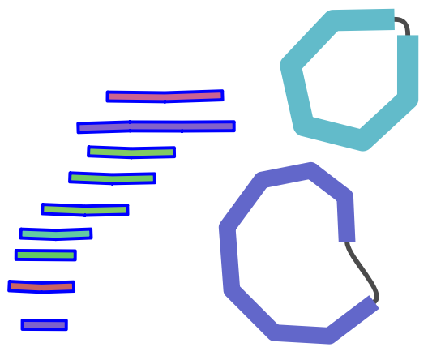
If many assemblies show chimeric joins, return to Step 4.3 and increase filtering stringency.
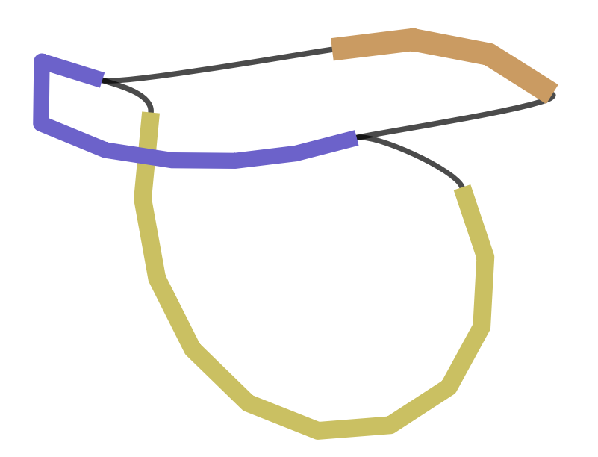

4.6 Generate Autocycler Consensus Assembly
Once assemblies have been manually curated, generate the final consensus assembly.
Autocycler builds a consensus assembly through five sequential steps.
- Compress
  - converts all input assemblies into a unified sequence graph representation.
- Cluster
  - groups contigs across assemblers by sequence similarity, so that each cluster represents one distinct replicon (e.g., one plasmid).
- Trim
  - removes unaligned overhangs at contig ends within each cluster, ensuring all sequences share the same boundaries.
- Resolve
  - generates a per-cluster consensus sequence by performing a multiple sequence alignment of the trimmed contigs and taking the majority-rule base at each position.
- Combine
  - merges all resolved clusters into a single multi-FASTA output representing the final assembly.
Compress assemblies:

autocycler compress -i assemblies -a autocycler_out

Cluster assemblies:

autocycler cluster -a autocycler_out


Trim clusters:

for c in autocycler_out/clustering/qc_pass/cluster_*; do
autocycler trim -c "$c"
done


Resolve clusters:

for c in autocycler_out/clustering/qc_pass/cluster_*; do
autocycler resolve -c "$c"
done

Combine resolved clusters into final assembly:

autocycler combine \
-a autocycler_out \
-i autocycler_out/clustering/qc_pass/cluster_*/5_final.gfa

The final assembly will be produced in:
autocycler_out/

4.6.1 Rotate Plasmid to repA Using DNAapler
Rotate the plasmid so that the sequence begins near the replication gene repA.

dnaapler plasmid -i autocycler_out/consensus.fasta -o dnaapler_out -p sample


4.7 Final Polishing Using Medaka
Polish the assembly using the filtered long reads. The command below will guess your flowcell version, but it's best to provide it with the flowcell using -m .

medaka_consensus \
-i filtered_reads/reads.fastq.gz \
-d naapler_out/sample_reoriented.fasta \
-o medaka_out \
-t 16 \

The final polished assembly will be located at:
medaka_out/consensus.fasta

4.8 Validate Final Assembly
Verify final assembly statistics using SeqKit.

seqkit stats medaka_out/consensus.fasta


Confirm that:
- Plasmid is represented by a single contig
- Contig length is consistent with expectations.
This file represents the final circular plasmid assembly ready for downstream analysis.

