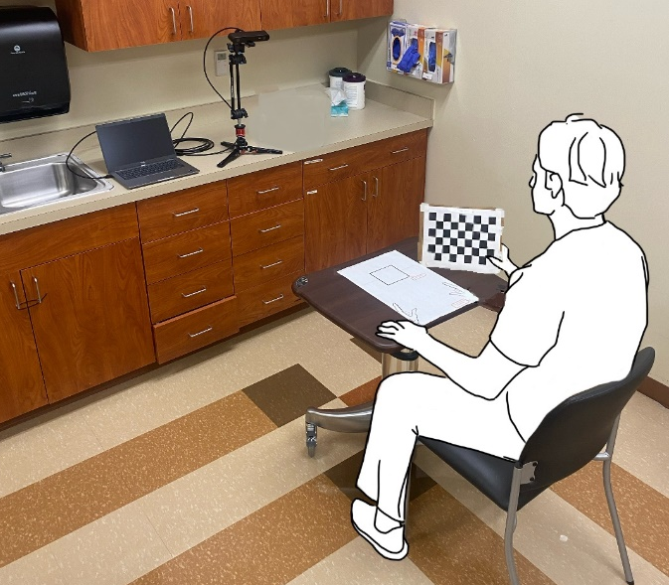
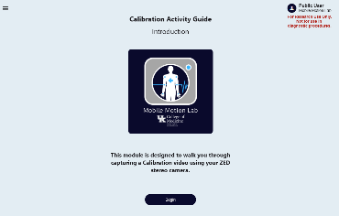
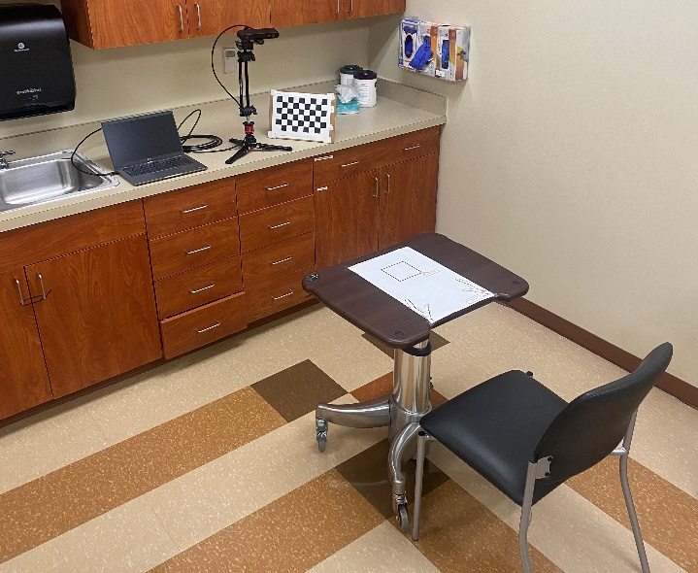
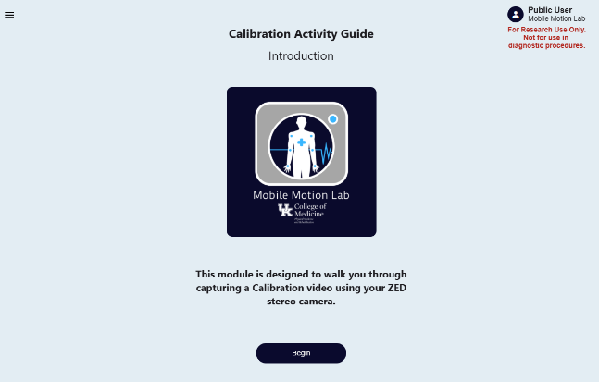
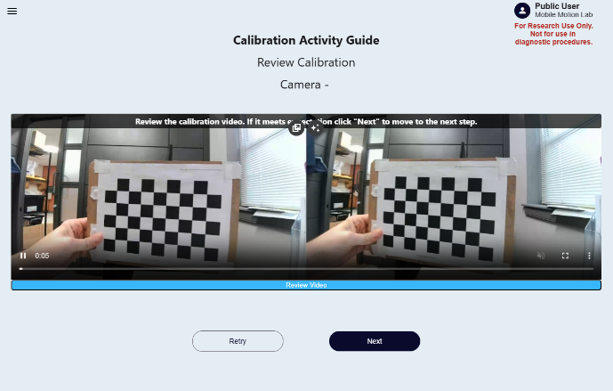
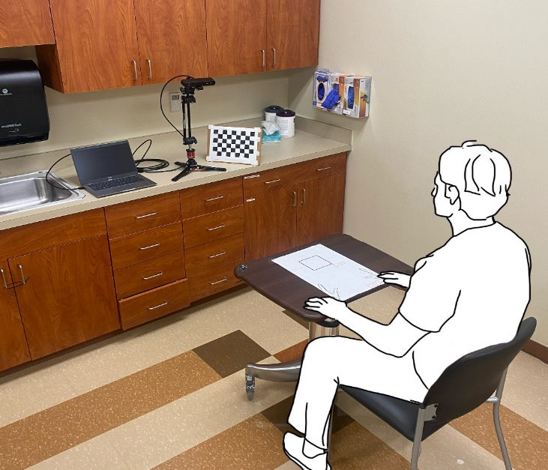
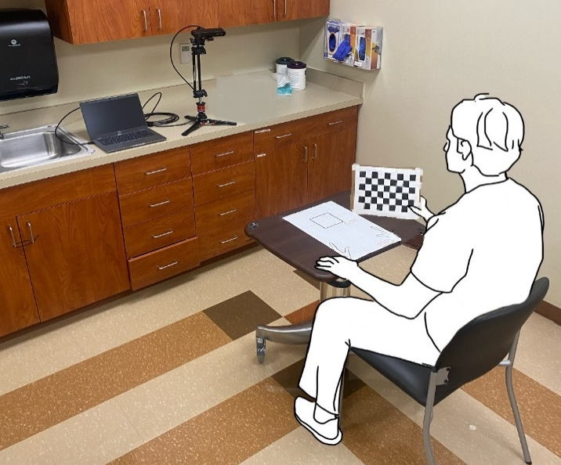
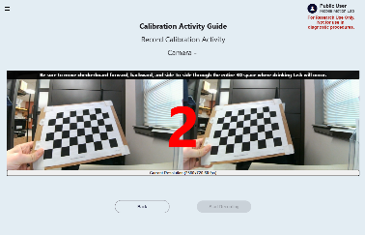
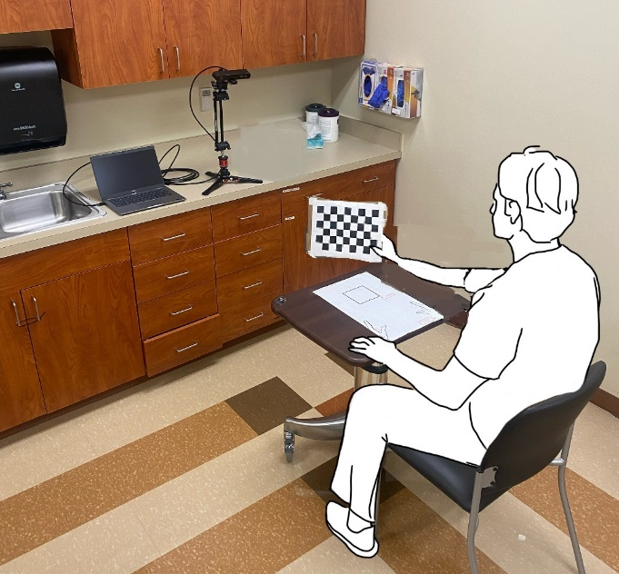
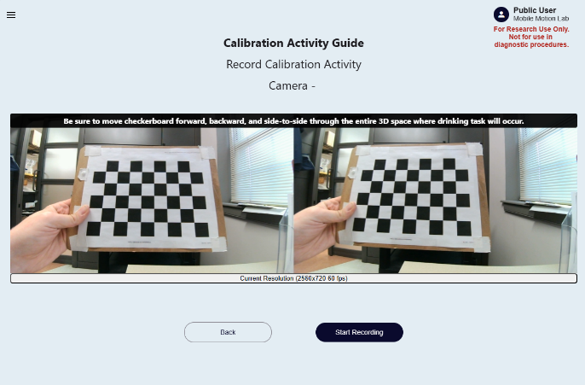
2.3.1 Review the recorded calibration
2.3.1.1 Image quality: Ensure the entire checkerboard
pattern is fully visible throughout the video.
2.3.1.2 Clear visibility: Make sure the lighting is adequate
2.2.5 When cued to begin the calibration activity, move the checkerboard pattern forward through the workspace area (toward the camera) in a smooth/controlled manner, then reverse motion to move the pattern backward (away from the camera) in a smooth/controlled manner. Repeat this forward and backward motion of the checkerboard pattern until image capture is complete.
2.2.3 Before initiating the recording, position the checkerboard in its starting position. Based on an individual sitting at the table as previously described, the start position of the checkerboard involves holding the pattern at approximately chest level and perpendicular to the tabletop surface
minimized
2.2.4 Initiate recording by clicking the Start Recording icon in the web-app.
2.2.1 Open the calibration activity module (Calibration Activity Guide) located in the web-app dashboard menu (https://mobile-motion-lab-public.web.app/calibrationActivity).
minimized
2.2 Capturing calibration images

