2.1.1. Talent aspirating the medium from each well using a pipette. 00:00-00:15
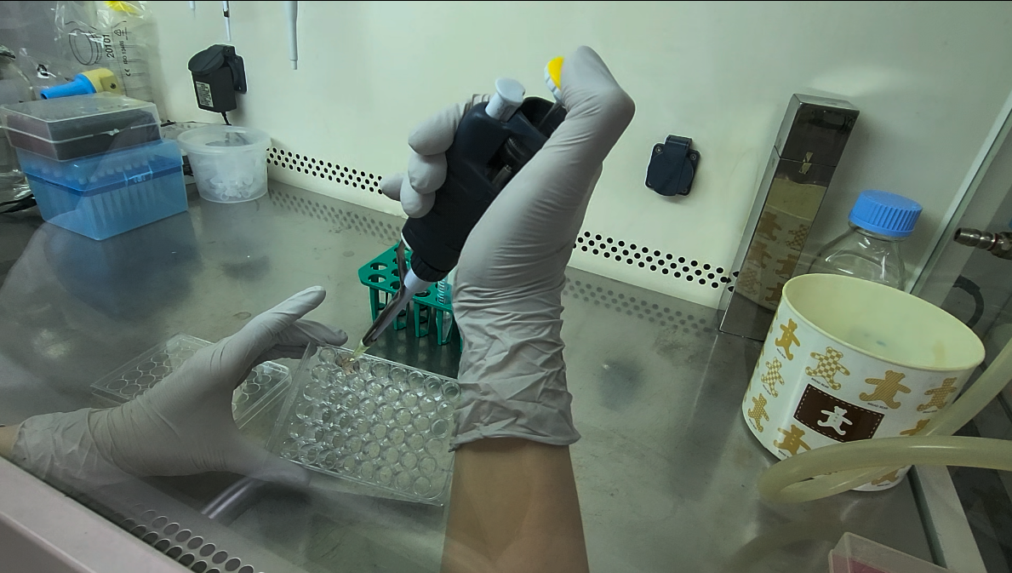
2.1.2. Talent dispensing cell recovery solution into each well. 00:00-00:23
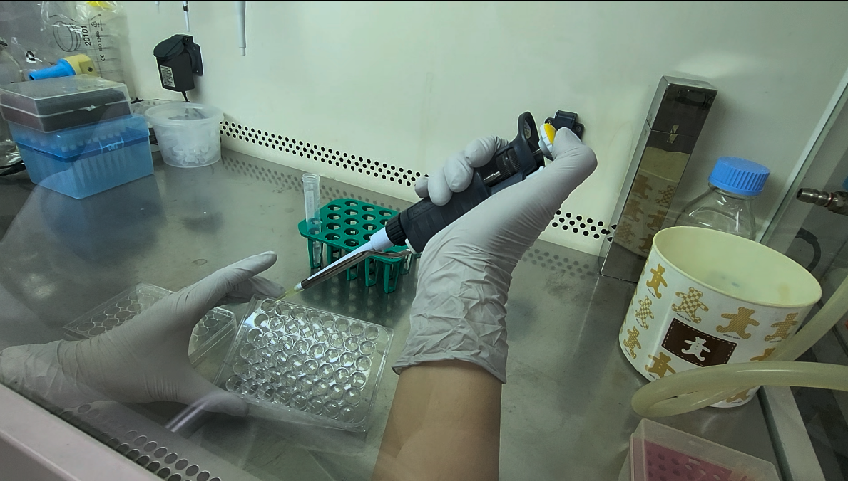
2.1.3. Talent placing the plate on ice. 00:00-00:10
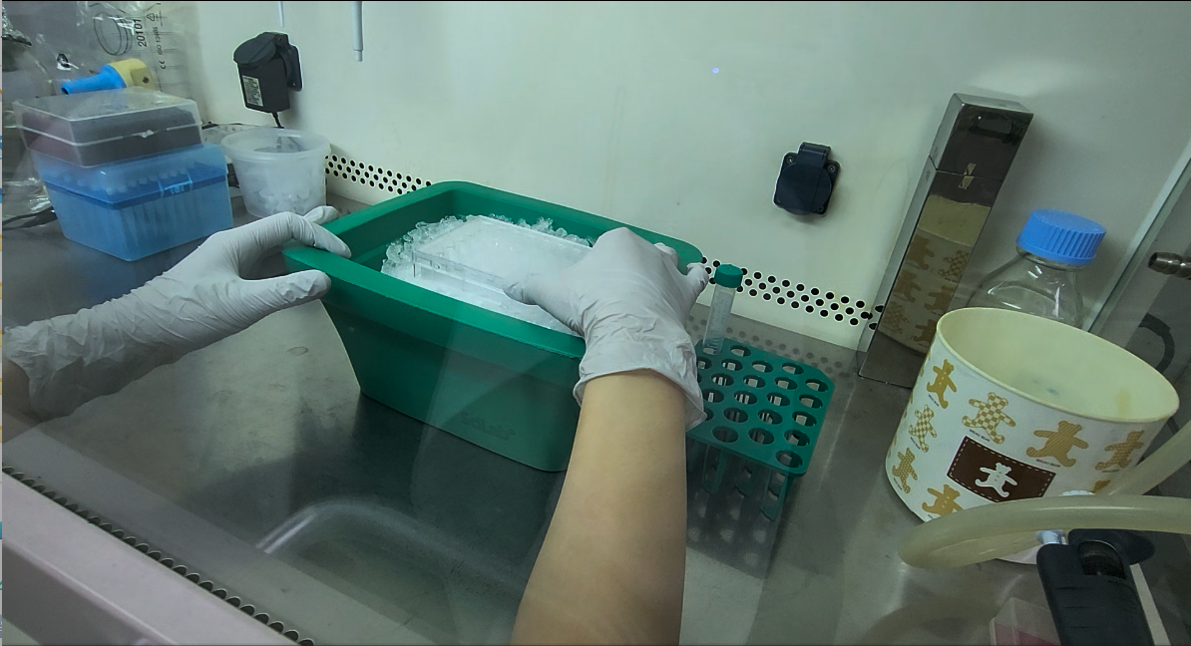
2.2.1. Talent collecting organoids by gentle pipetting and transferring them into a microcentrifuge tube. 00:00-00:30
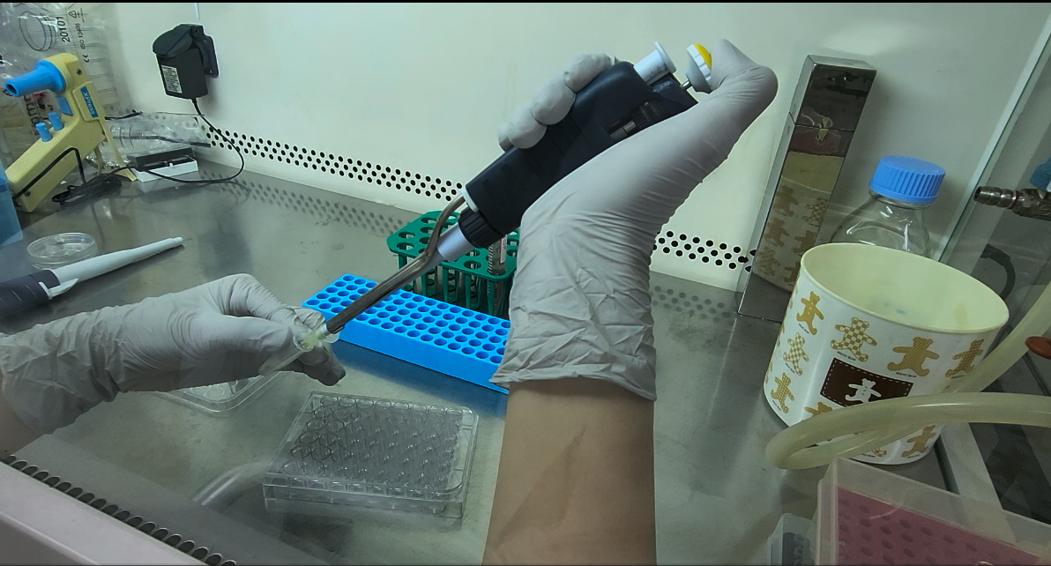
2.2.2. Talent placing the tube in the centrifuge. 00:00-00:20
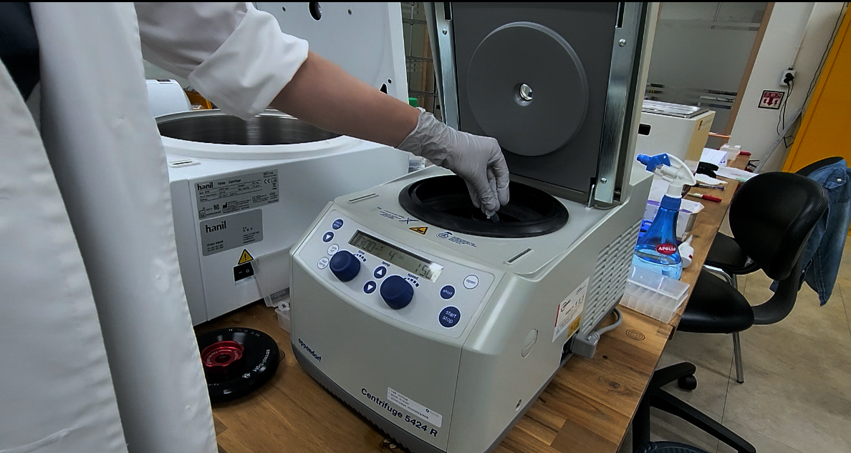
2.2.3. Talent removing the supernatant. 00:00-00:24
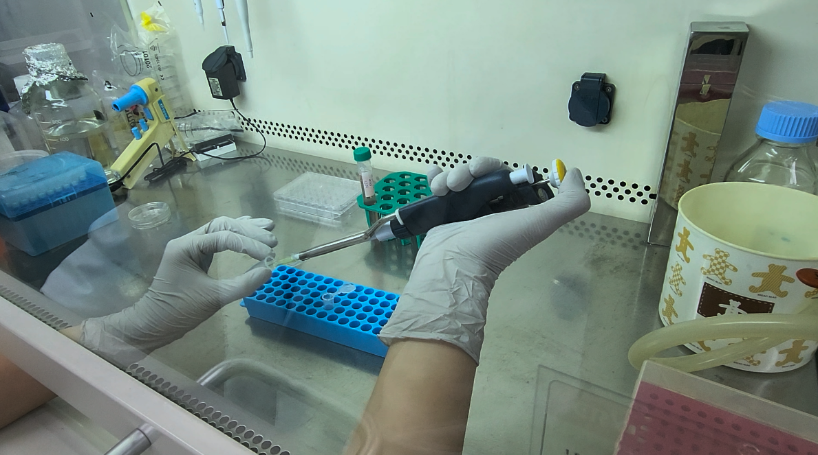
2.3.1. Talent adding culture medium to the pellet in the microcentrifuge tube, resuspending the pellet, and mixing the suspension by pipetting up and down. 00:20-01:00
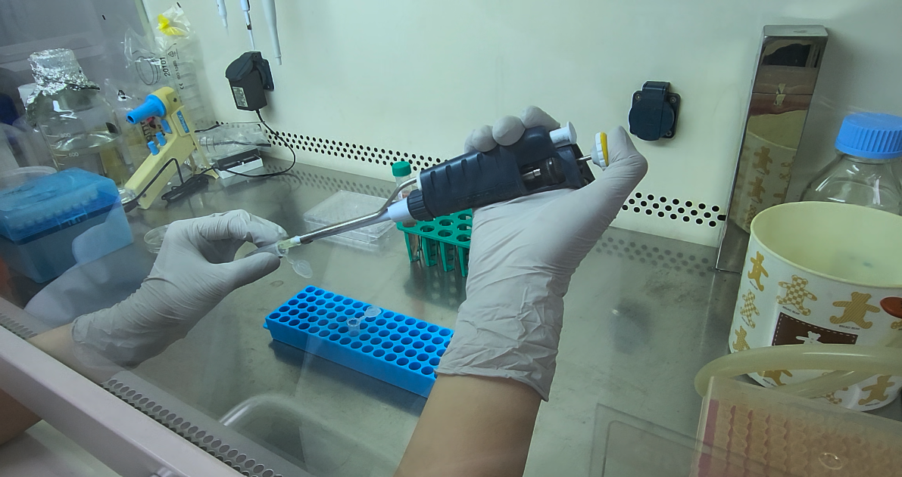
2.3.2. Talent placing the tube in the centrifuge. 00:00-00:23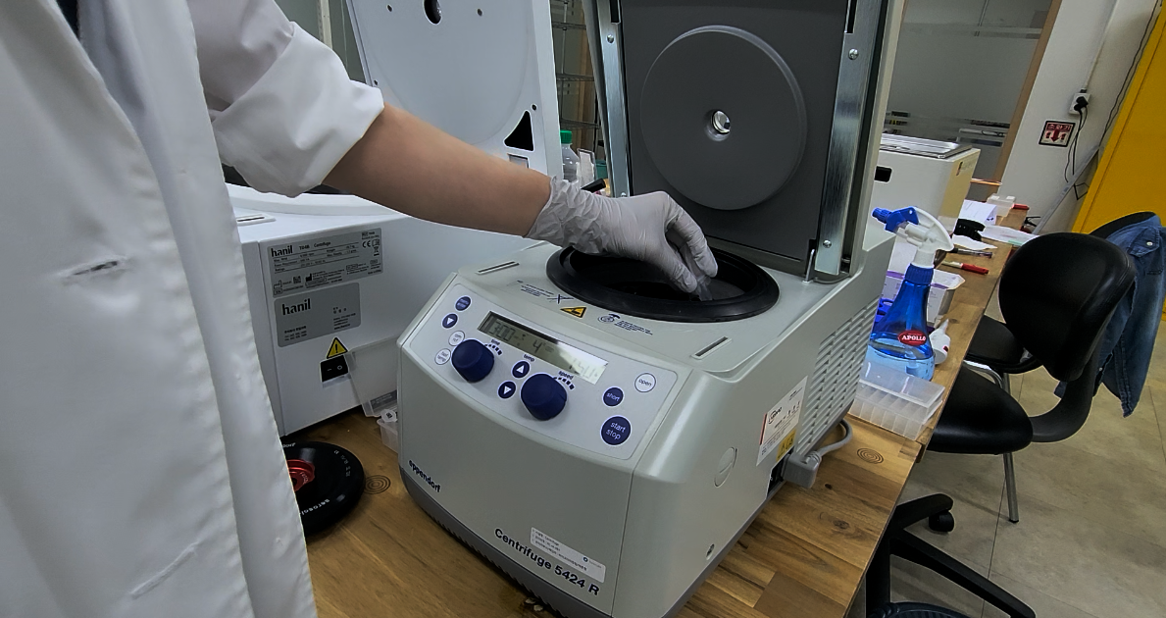

2.4.1. Talent adding ECM and medium to the pellet and pipetting to mix thoroughly. 00:00-00:30
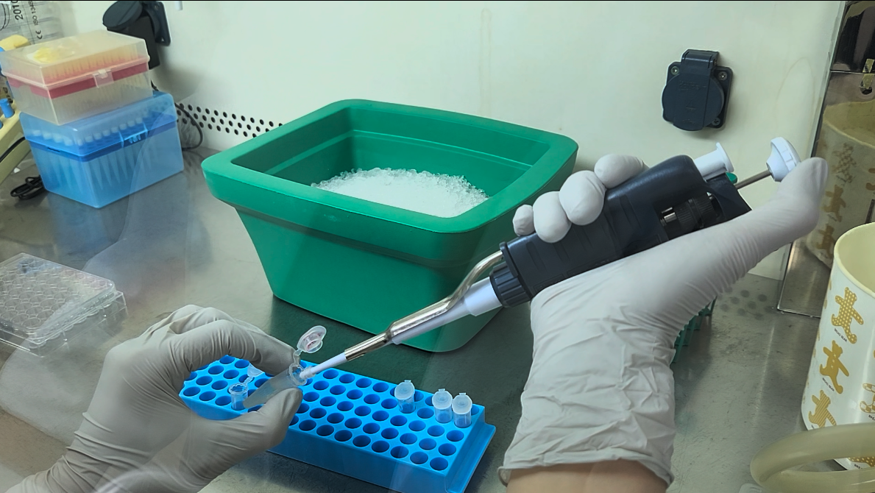
2.4.2. Talent dispensing the mixture per dome into the wells of a 48-well plate.
00:00-00:15
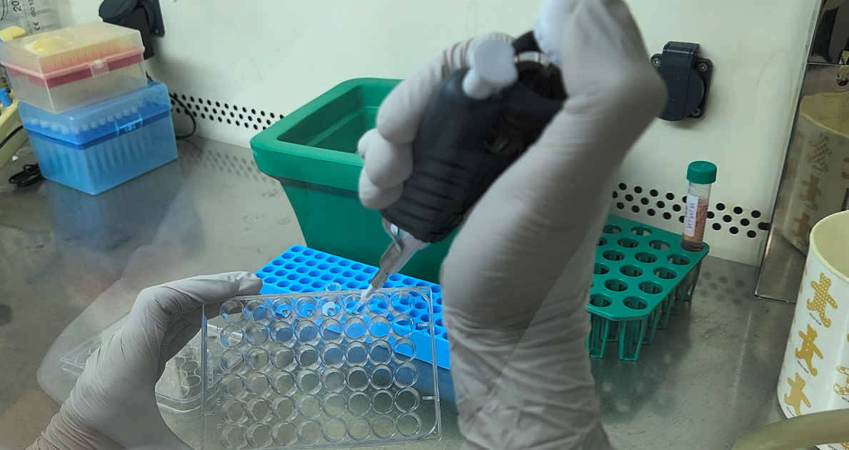
2.5.1. Talent inverting the plate and placing it inside the incubator. 00:00-00:19
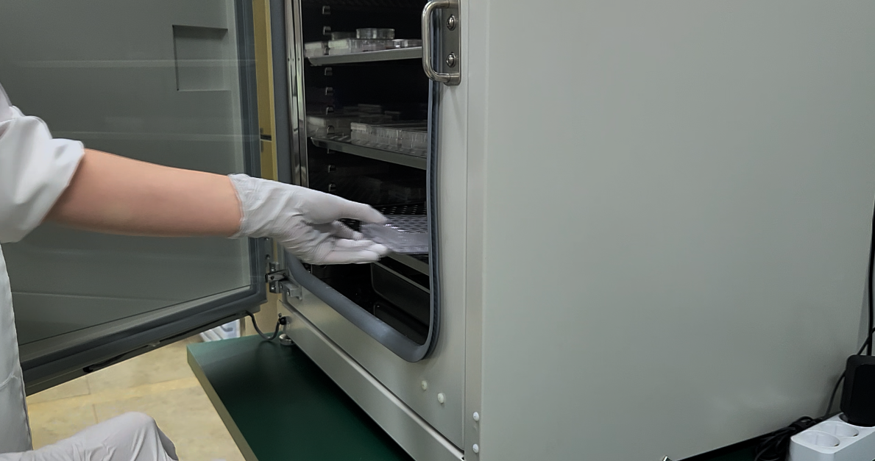
2.6.1. Talent pipetting culture medium into the wells. 00:13-00:53
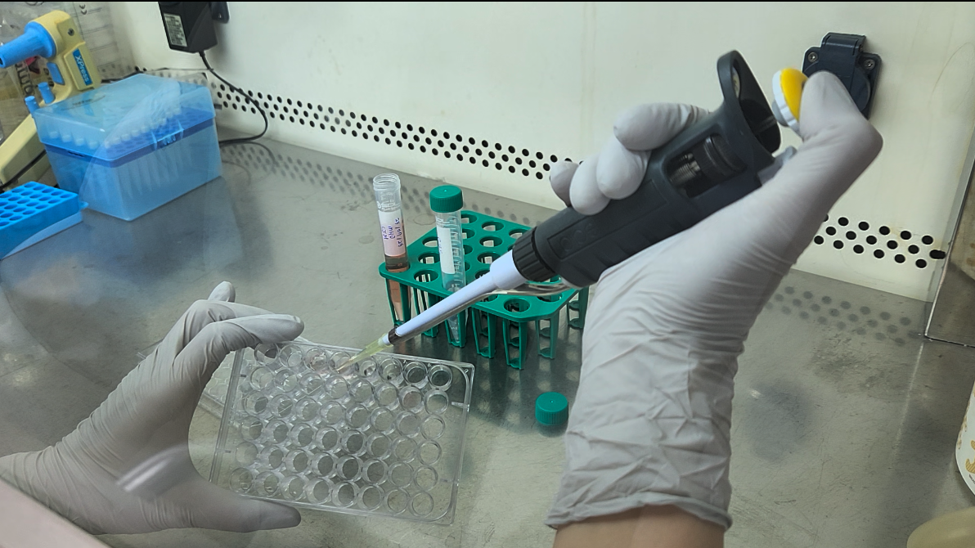
2.6.2. Talent filling the empty outer wells with PBS. 01:31-02:09
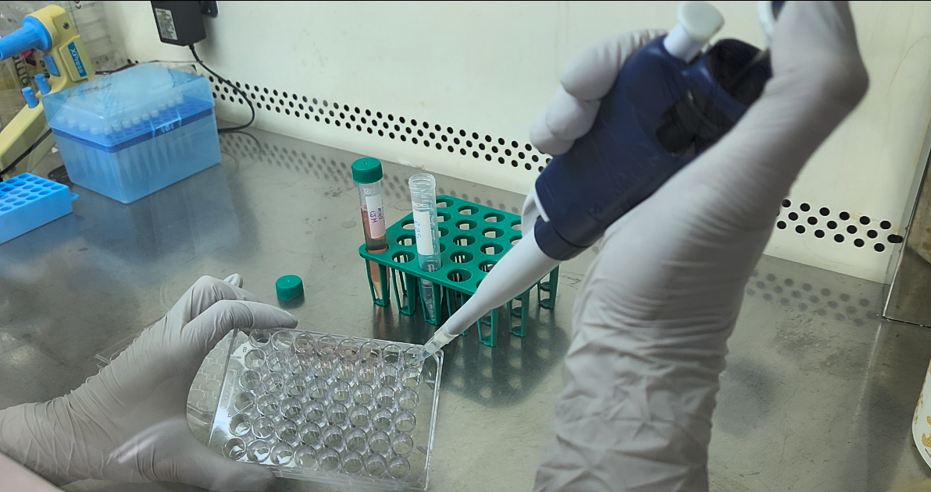
3.1.1. Talent dispensing organoid-ECM mixture onto a coverslip-bottom dish. 00:00-00:30
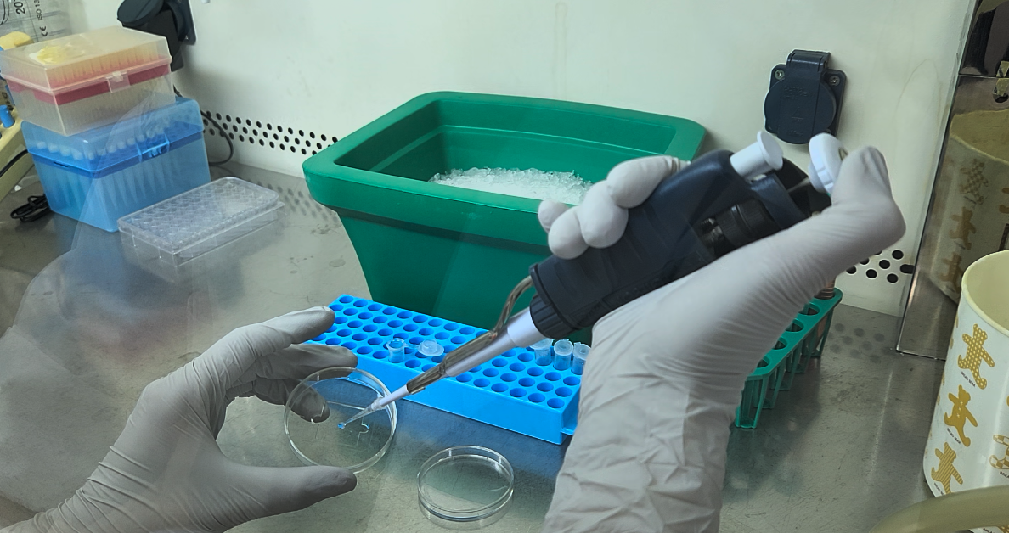
3.2.1. Talent inverting the dish and placing it in the incubator. 00:00-00:23
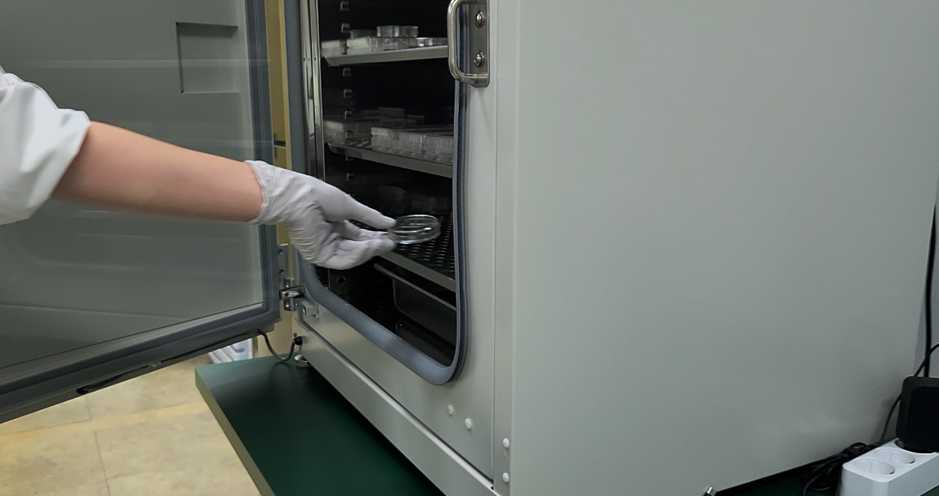
3.2.2. Talent pipetting culture medium over the ECM domes to submerge them. 00:00-00:11
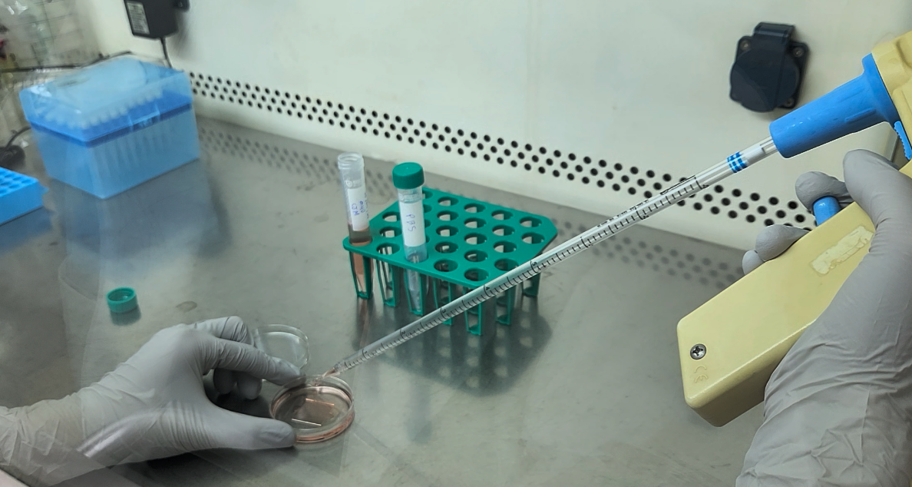
3.3.1. Talent washing the sample with PBS. 00:00-00:24
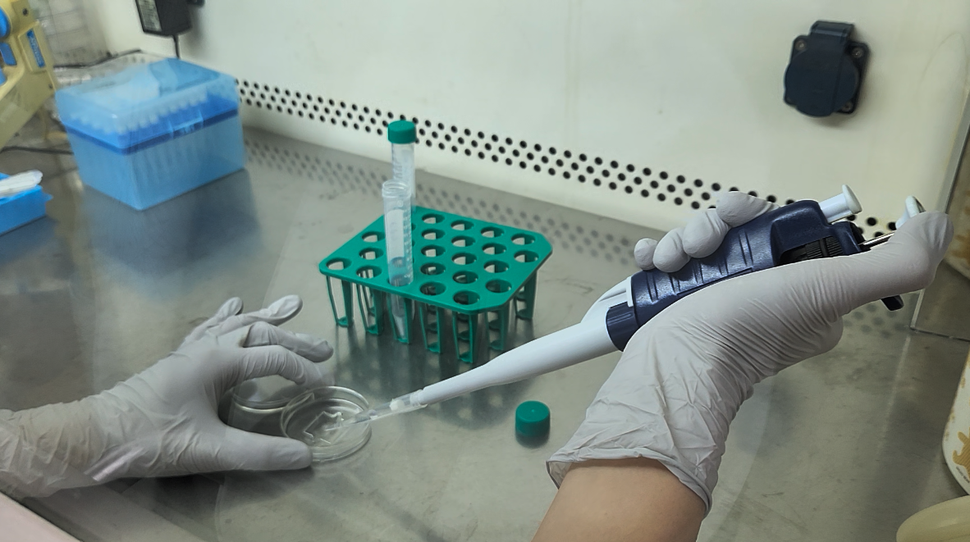
3.4.1. Talent pressing the power button on the environmental controller and the chamber controller unit automatically sets the temperature and carbon dioxide percentage. 00:00-00:06
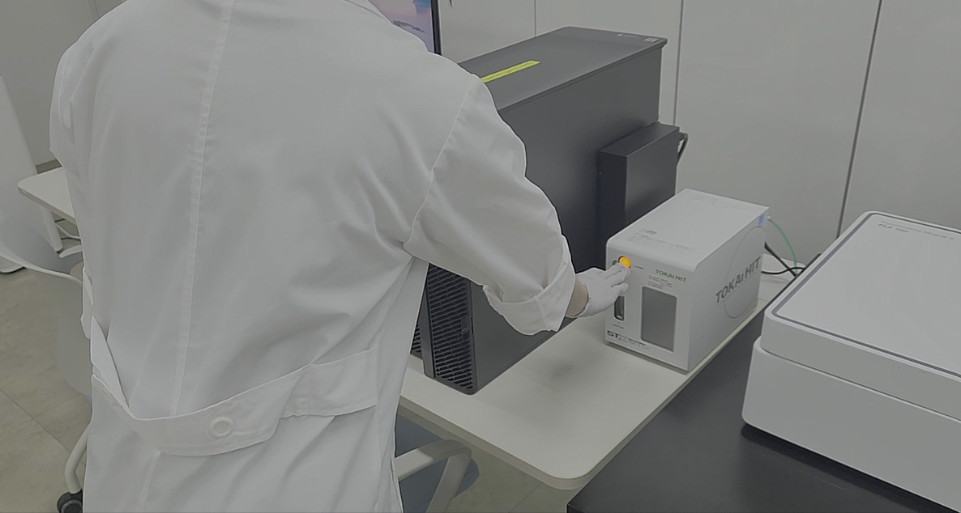
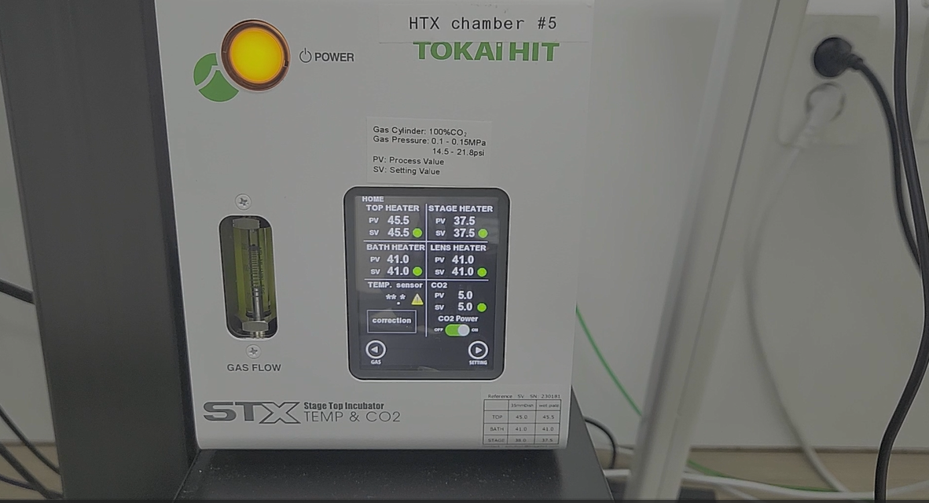
3.5.1. Talent pressing the door button to open the door. 00:00-00:03
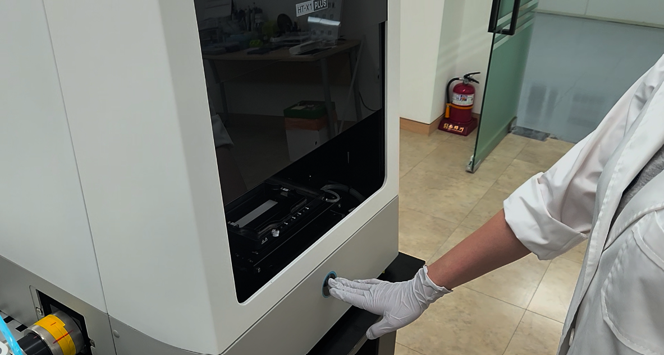
3.5.2. Talent pipetting water to create a thin layer inside the chamber well. 00:00-00:10
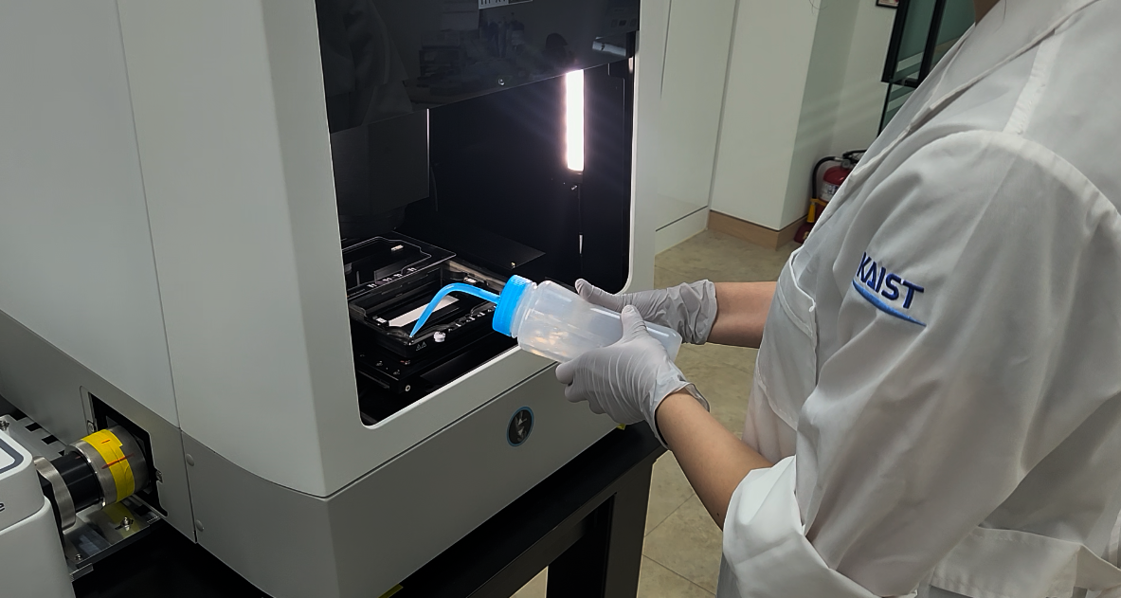
3.6.1. Talent placing the dish in the holder and inserting it into the imaging chamber. 00:00-00:04
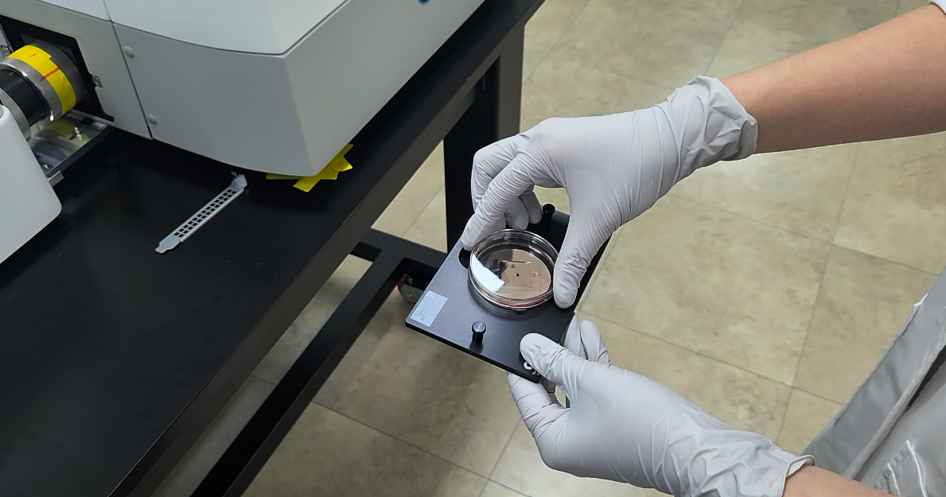

3.6.2. Talent securing the dish to the holder with a pin. TXT: Ensure the dish is firmly attached to the vessel holder without tilting. 00:00-00:06
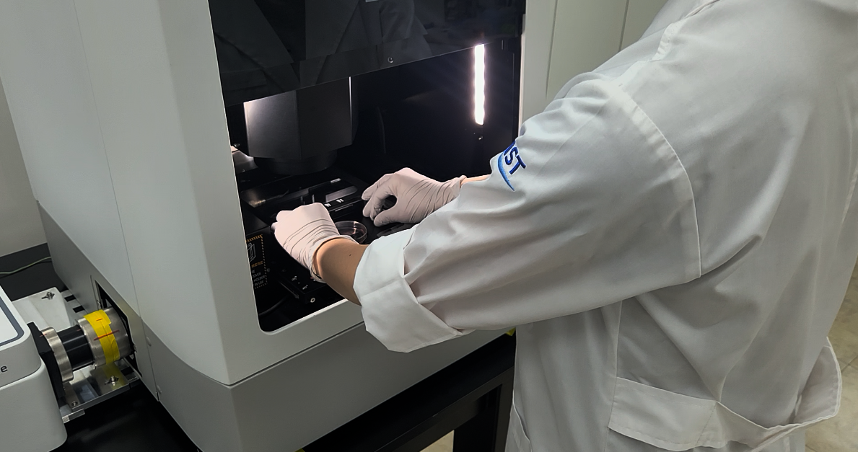
3.7.1. Talent gently closing the door using door button. 00:06-00:08
