- 68529_screenshot_1.mp4
  - 3.8.1 (The TomoStudio X being launched and the talent logging in.) 00:00-00:27
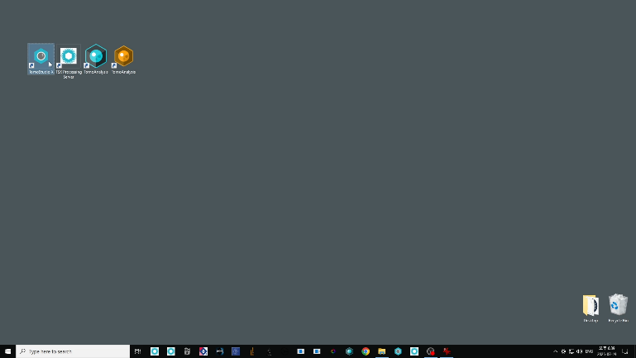
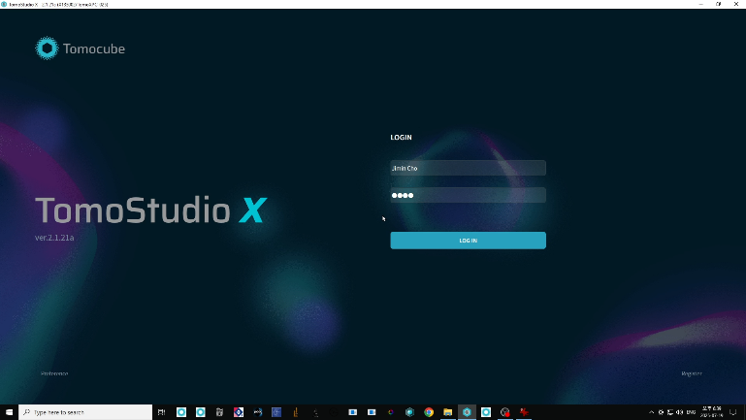
- 68529_screenshot_2.mp4
  - 3.8.2 (The main window loading after clicking Start. Clicking Add Project, typing the experiment name, and checking the medium type.) 00:00-00:44
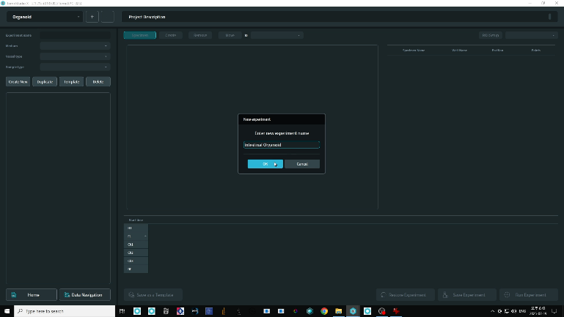
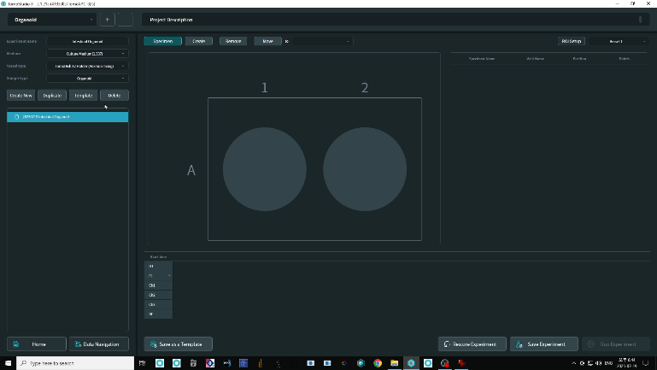
  - 3.9.1 (Clicking on a well in the panel and clicking Create to register it.) 00:45-00:58
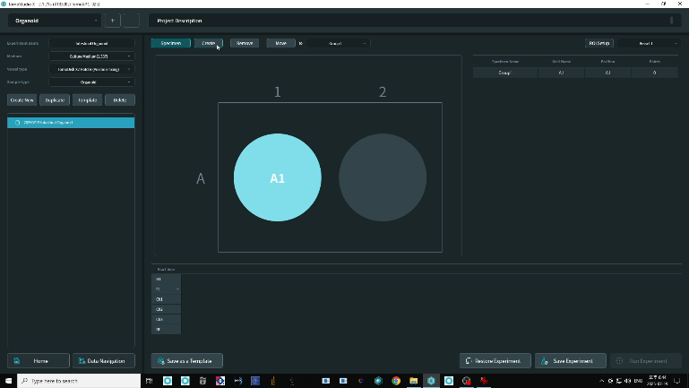
- 68529_screenshot_3.mp4
  - 3.10.1 (Defining ROI in the Preview panel.) 00:00-00:38
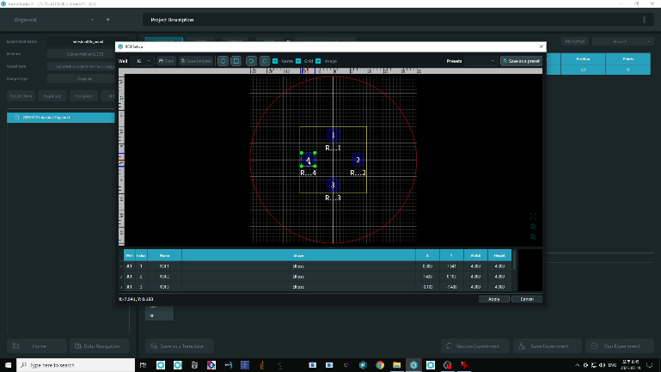
  - 3.10.2 (Clicking Run Experiment and the image acquisition window opens.) 00:40-00:50
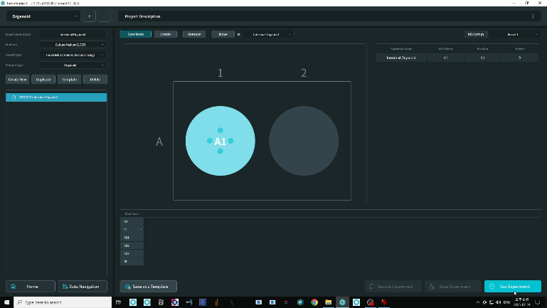

- 68529_screenshot_4.mp4
  - 3.11.1 (Brightfield image appearing after clicking Load Vessel.) 00:00-01:39
  - 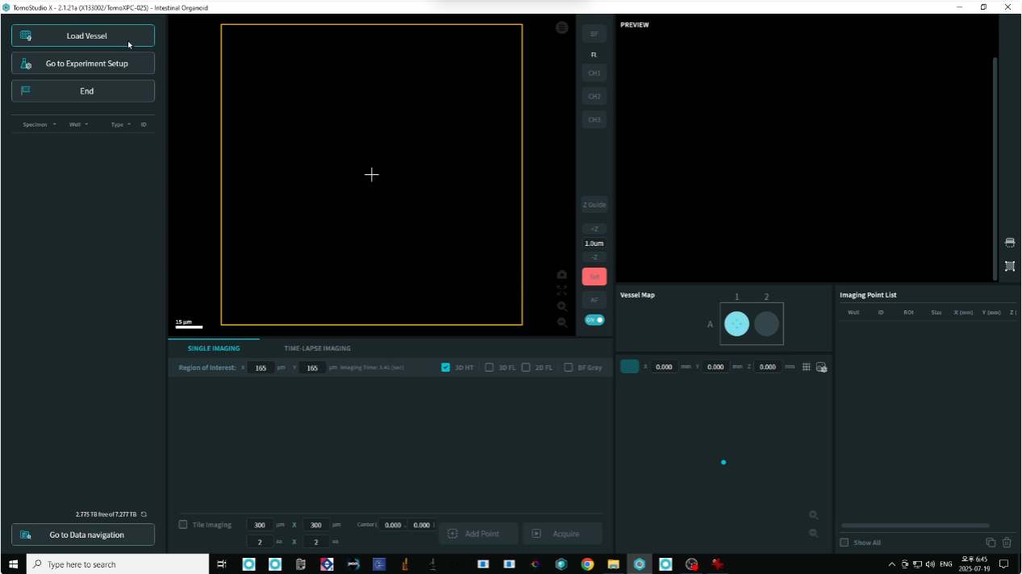
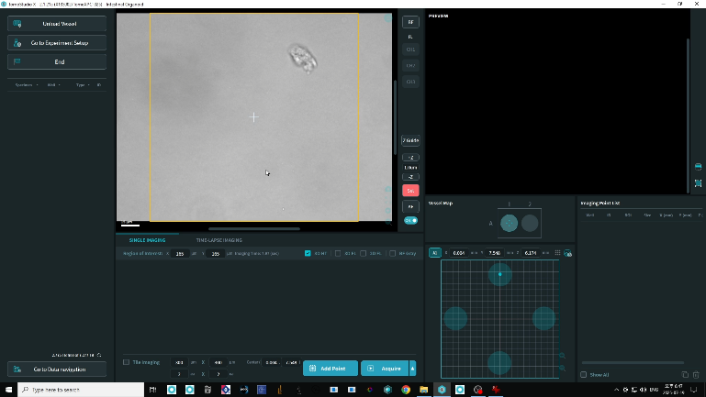
- 68529_screenshot_5.mp4
  - 3.11.2 (Adjusting focus using Z-position buttons.) 00:00-00:32
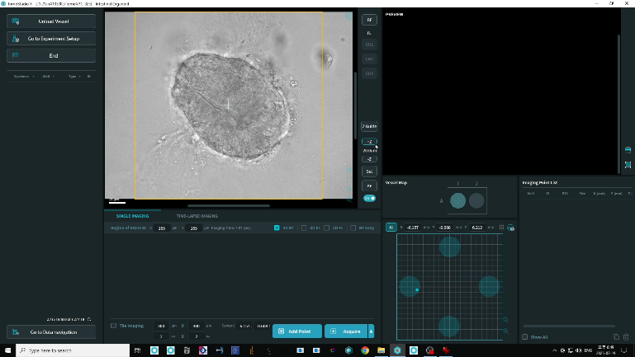
- 68529_screenshot_6.mp4
  - 3.12.1 (ROI size adjusted in the Single Imaging tab. Field of view and Z-depth being configured.) 00:00-00:10
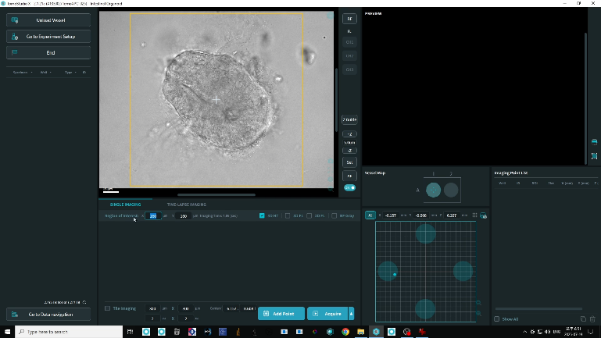

- 68529_screenshot_7.mp4
  - 3.13.1 (Selecting Time Lapse Imaging tab. Inputting duration and interval settings.) 00:00-00:33
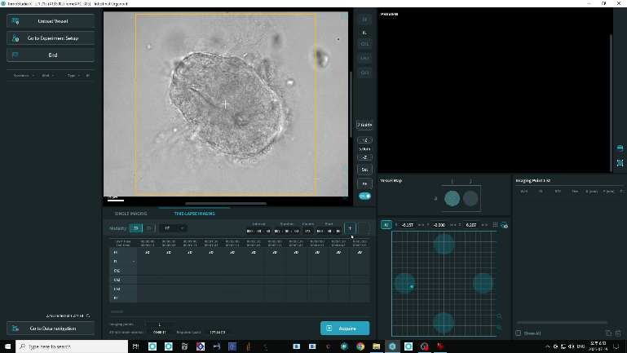
- 68529_screenshot_8.mp4
  - 3.14.1 (Clicking Scan to lock the current ROI.) 00:00-04:41
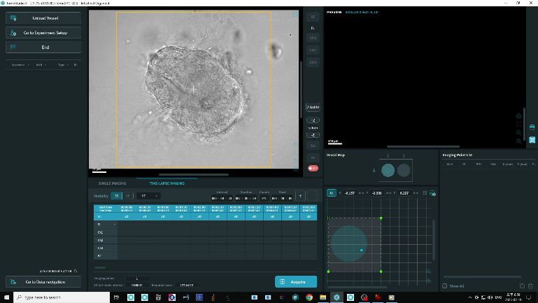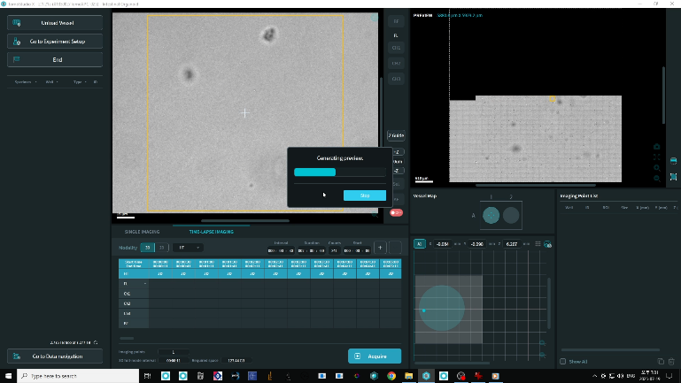

- 68529_screenshot_9.mp4
  - 3.14.2 (Centering the ECM dome using brightfield imaging.) 00:00-00:09
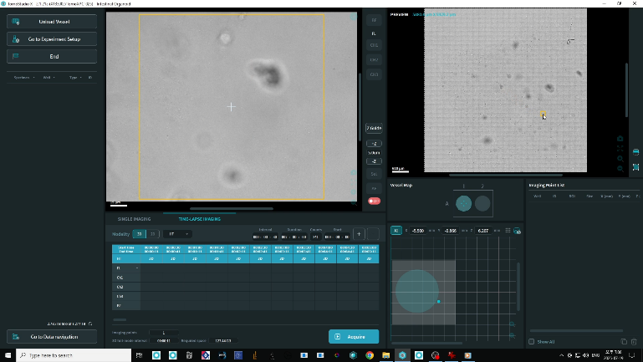
- 68529_screenshot_10.mp4
  - 3.14.3 (Adjusting brightfield settings via the BF panel.) 00:00-00:11
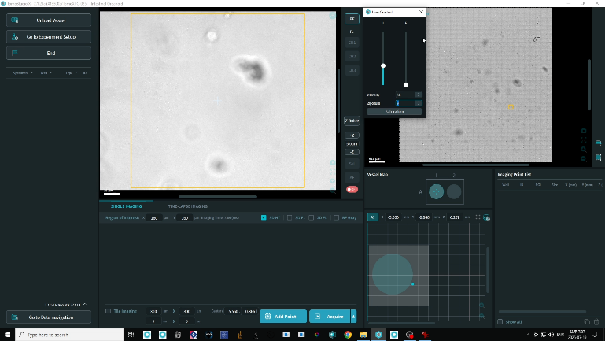
- 68529_screenshot_11.mp4
  - 3.15.1 (User moving the ROI box and selecting the ROI.) 00:00-00:30
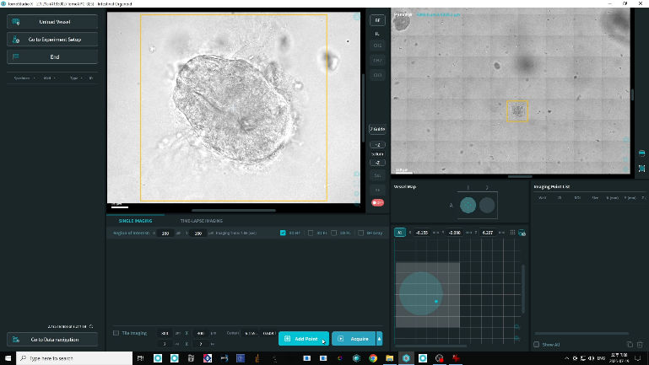

  - 3.15.2 (Clicking Add Point to register. Imaging point list being displayed.) 00:30-00:55
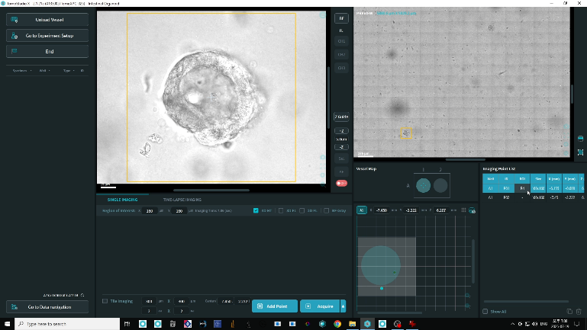
- 68529_screenshot_12.mp4
  - 3.16.1 (Clicking Acquire and raw image capture in progress.) 00:00-01:09
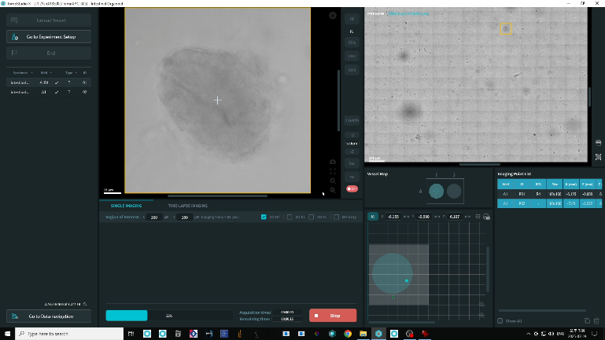
- 68529_screenshot_13.mp4
  - 3.17.1 (Clicking HTX processing server icon on the desktop.) 00:00-00:20
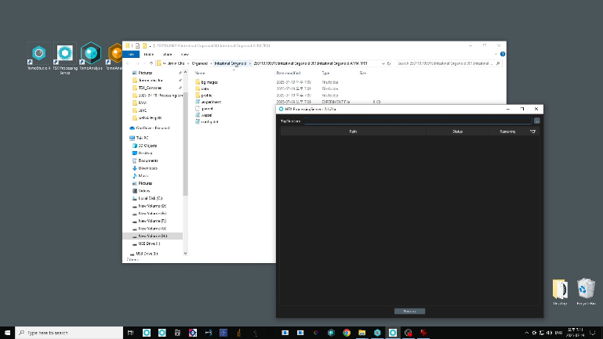

  - 3.17.2 (Drag and drop raw image file to server and clicking Process to generate the TCF file.) 00:20-02:09
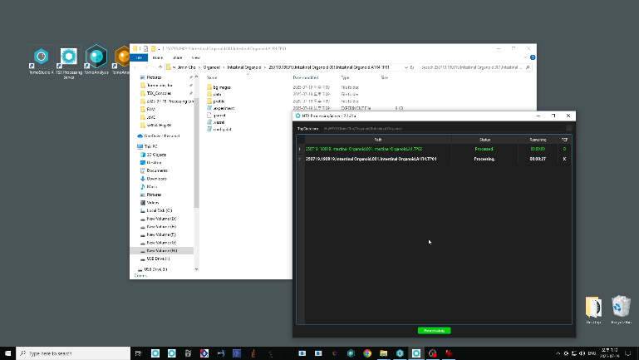
- 68529_screenshot_14.mp4
  - 3.18.1 (Clicking the TomoAnalysis Viewer icon on the desktop.) 00:00-00:07
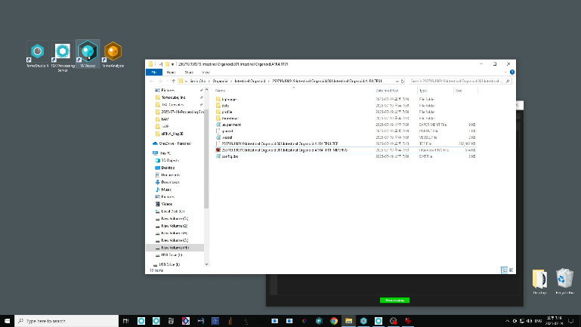
  - 3.18.2 (Drag and drop TCF files from Windows Explorer into the Viewer interface.) 00:07-00:15
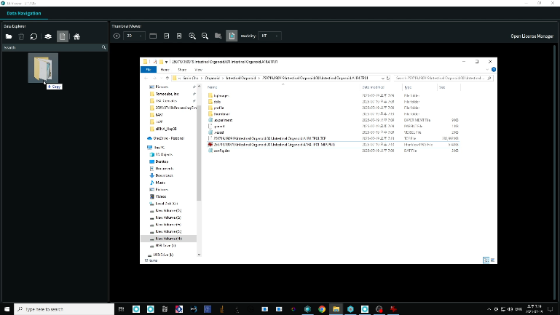

- 68529_screenshot_15.mp4
  - 3.19.1 (Double-click a file thumbnail to open the RI tomogram.) 00:00-00:07
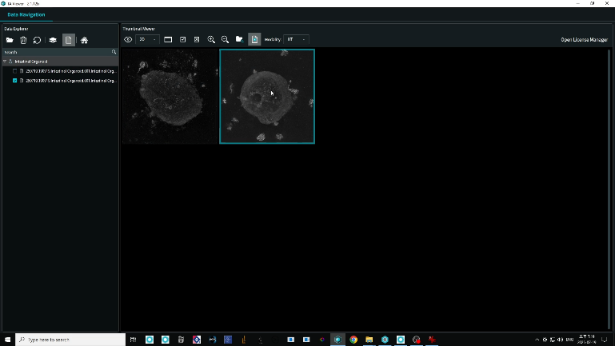
  - 3.19.2 (Examining the 2D view by navigating through the XY-Z planes using zoom, pan, and scroll controls.) 00:07-00:48
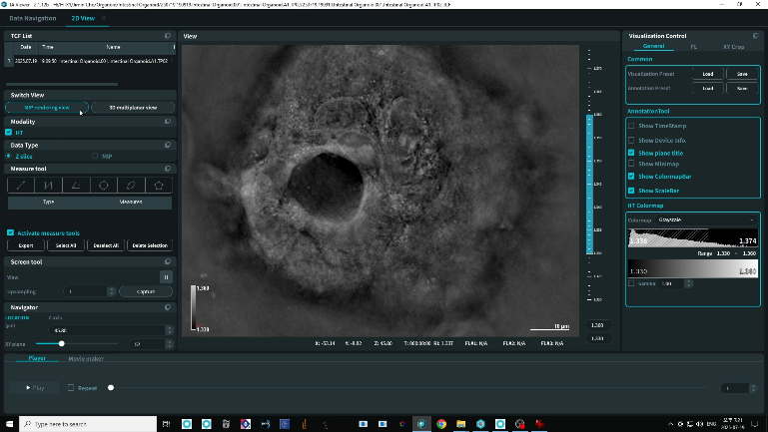
- 68529_screenshot_16.mp4
  - 3.20.1 (Clicking the MIP Rendering View icon. Interact with the 3D rendering using rotation, zoom, and pan controls.) 00:00-00:42
