- 68529_screenshot_4.1.1_mp4
- 4.1.1 (Exporting the TCF image file to HDF5 format.) 00:35-00:55
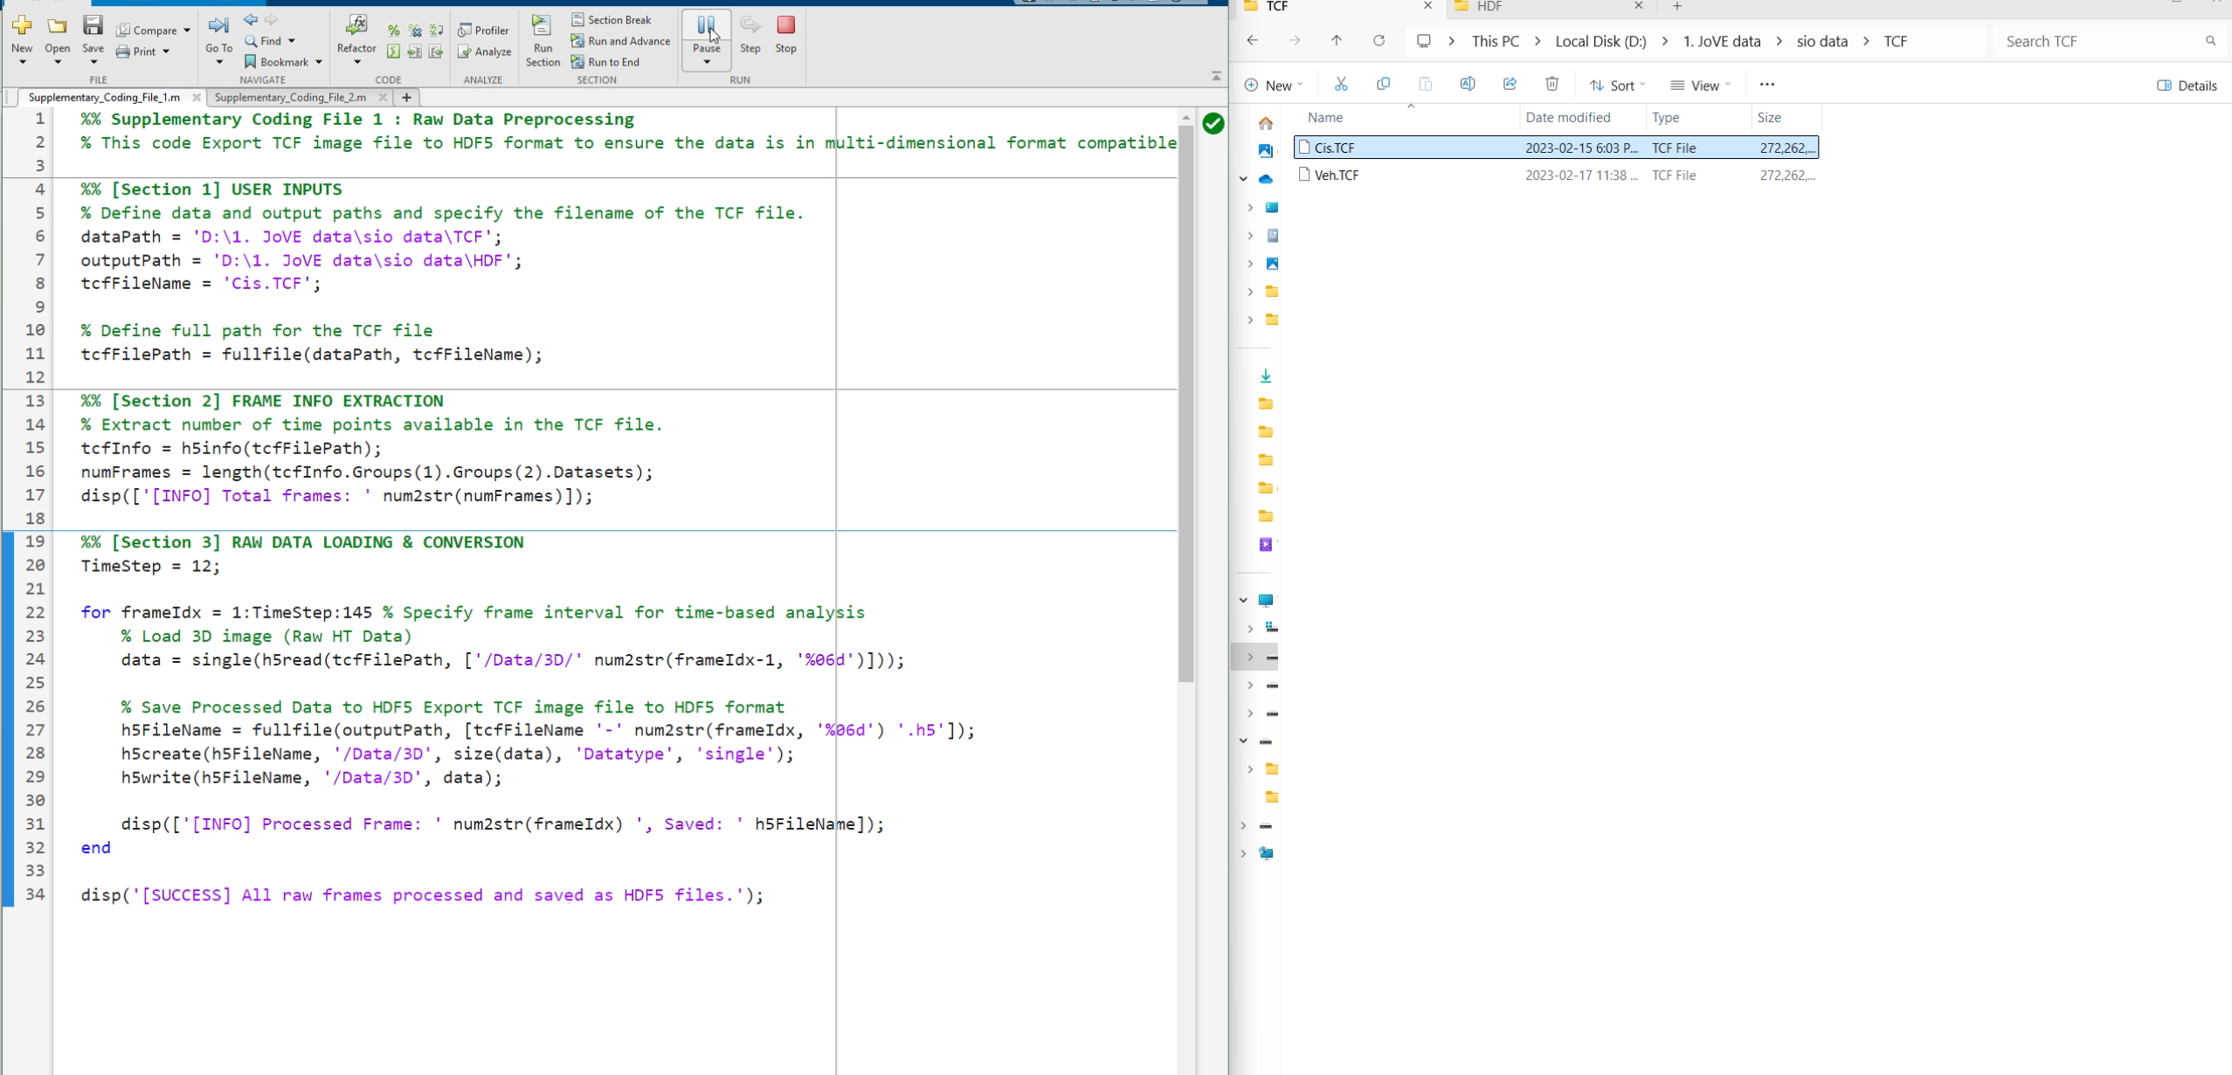
- 68529_screenshot_4.2.1-4,7.1_mp4
- 4.2.1 (Launching ilastik and navigating to New Project to create a new project.)00:00-00:01 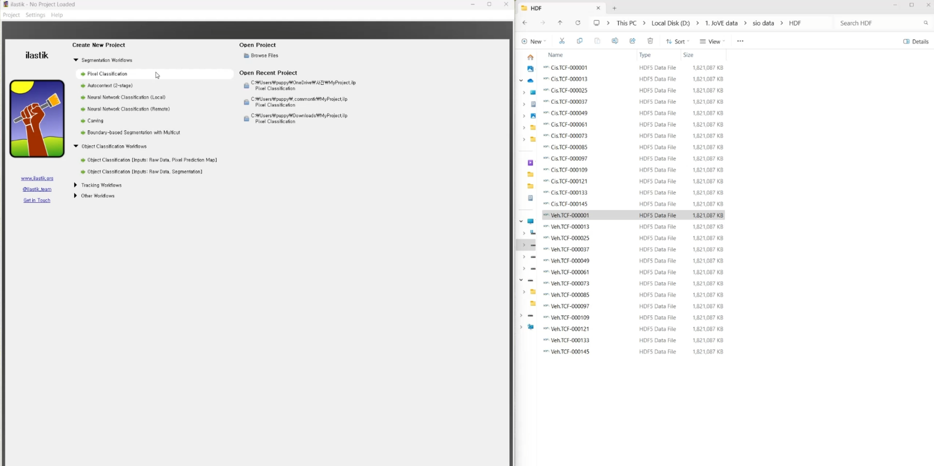
- 4.2.2 (Selecting Pixel Classification under the Segmentation Workflows section and saving the project file.) 00:02-00:03 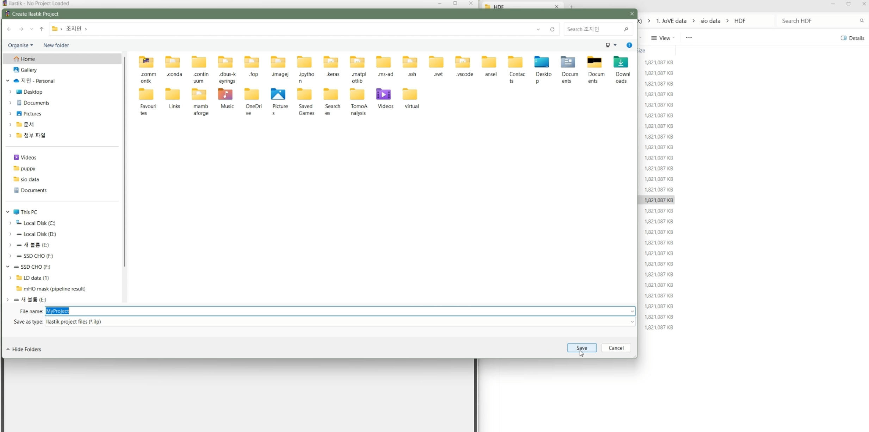
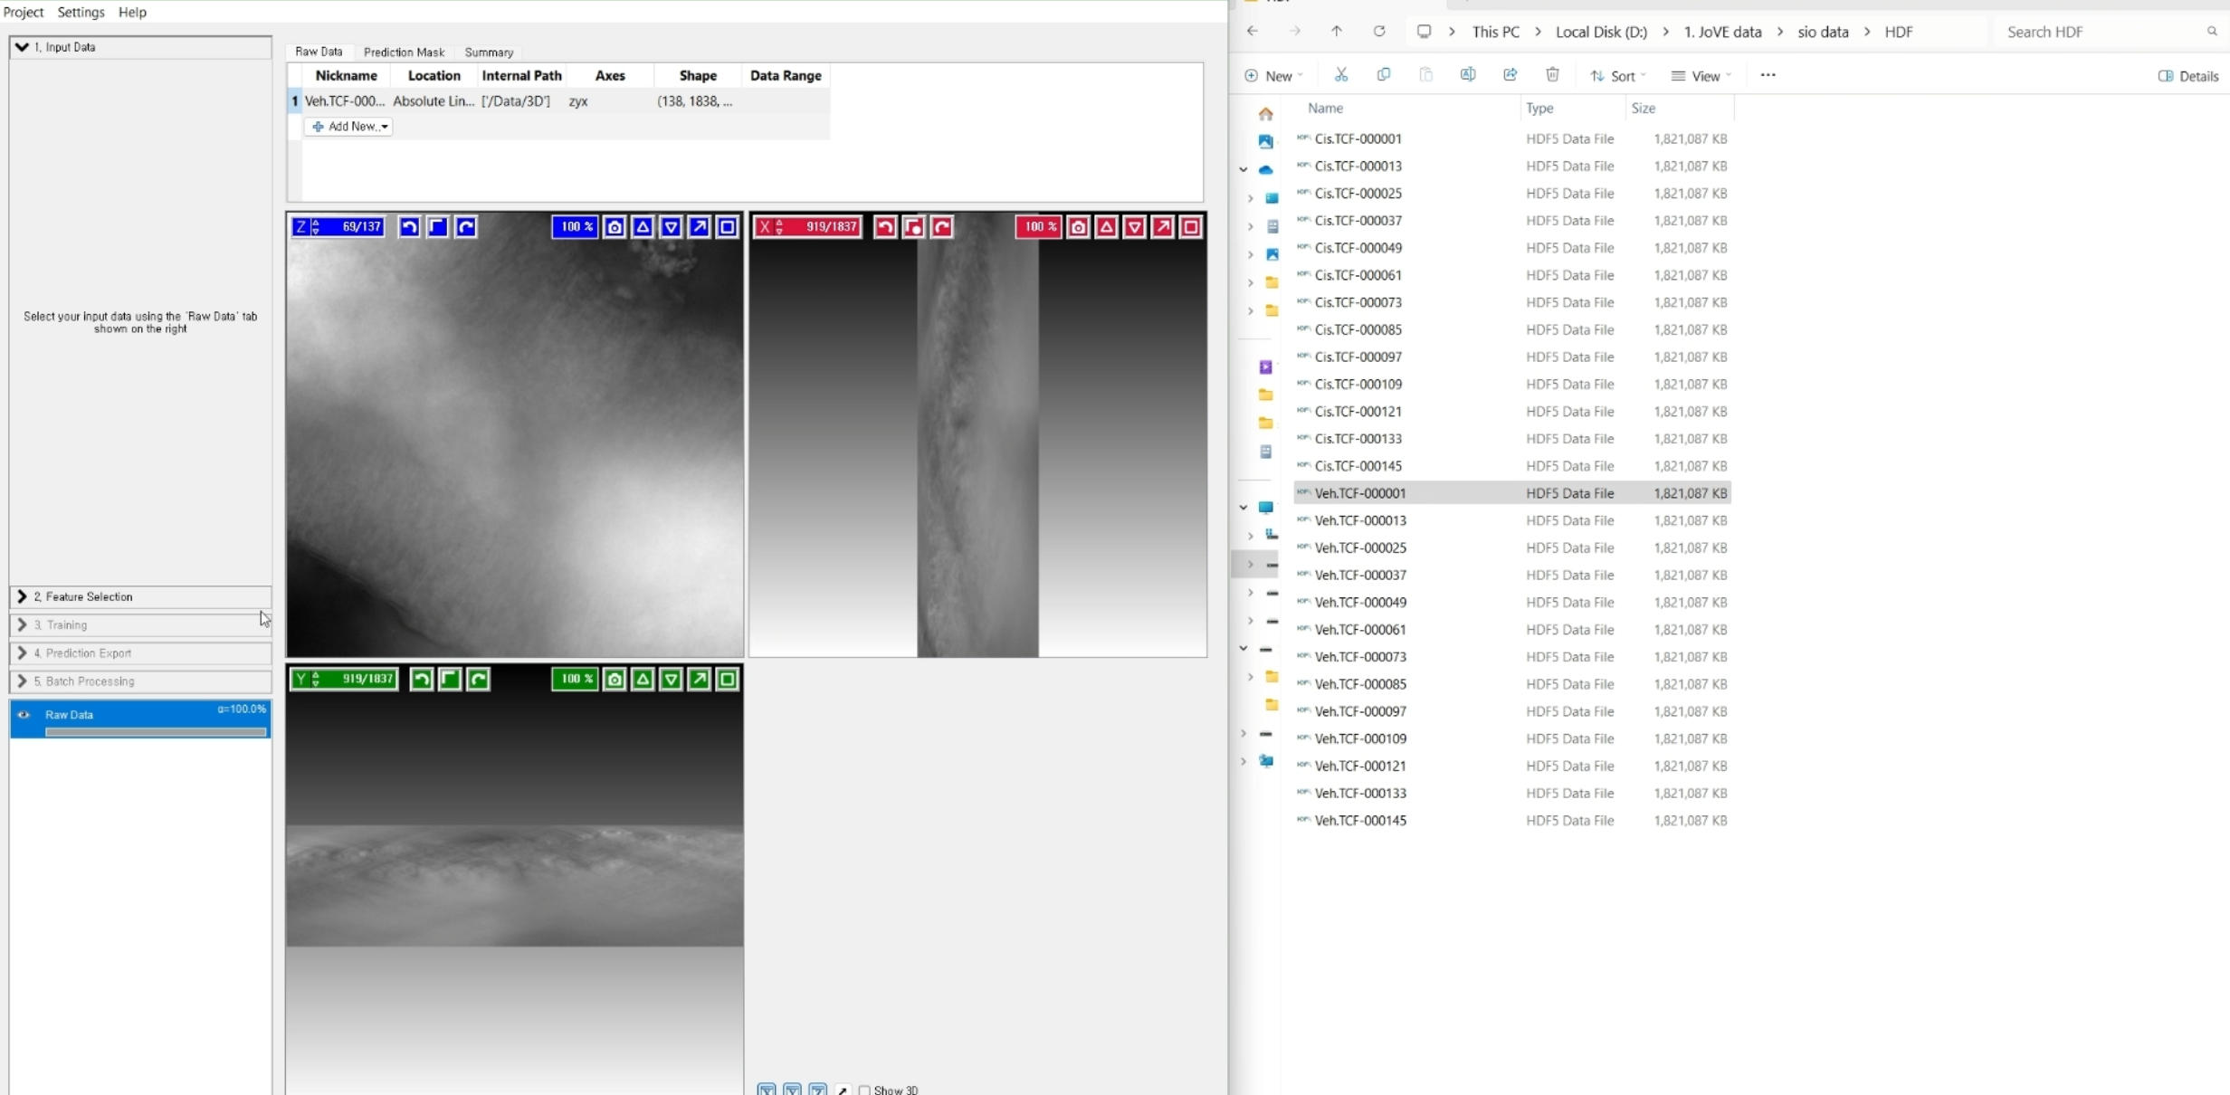
- 4.3.1 (Loading the HDF5 file and showing the image channel assignments.) 00:06-00:08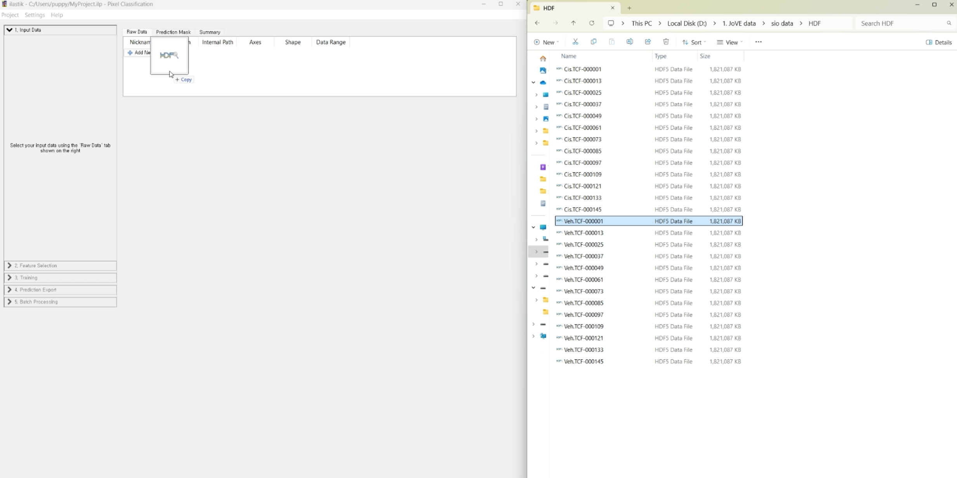
- 4.4.1 (Navigating to the Feature Selection tab and choosing features.) 00:08-00:16
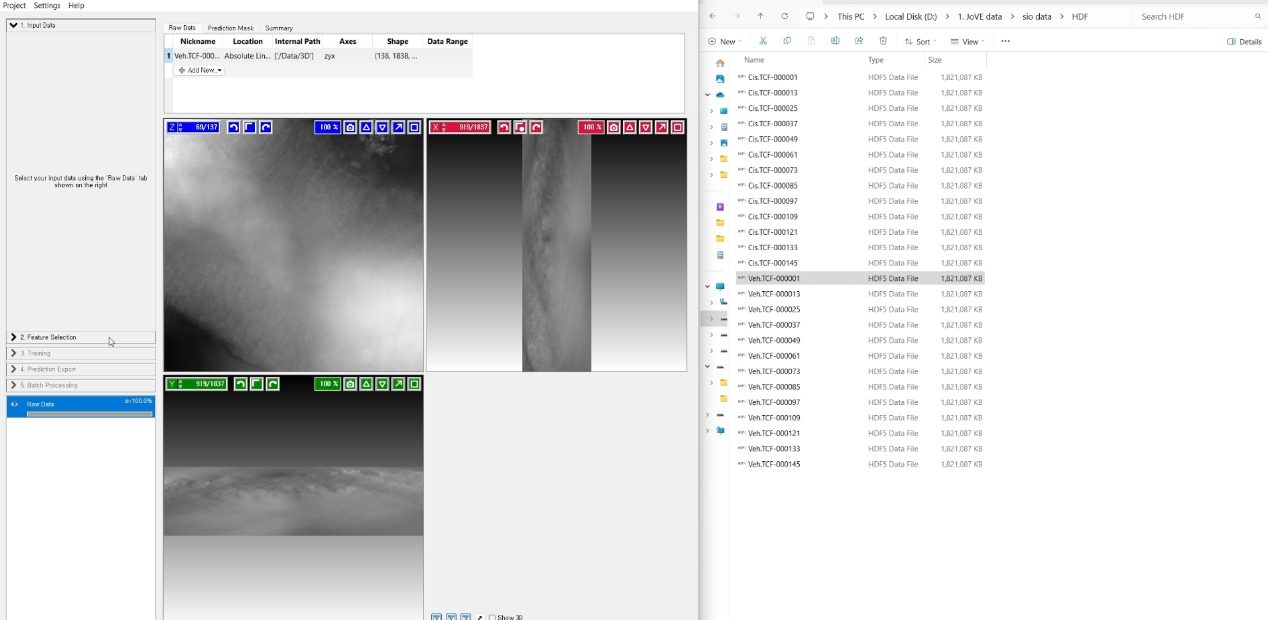
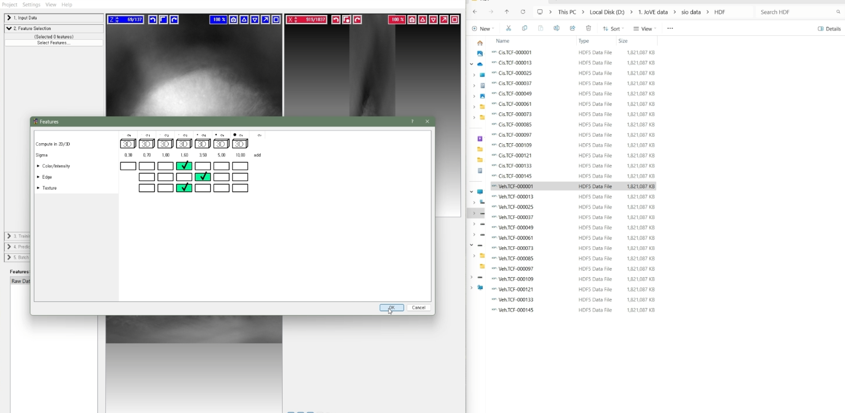
- 4.5.1 (Applying different color brush strokes on organoid and non-organoid regions.) 00:17- 00:49
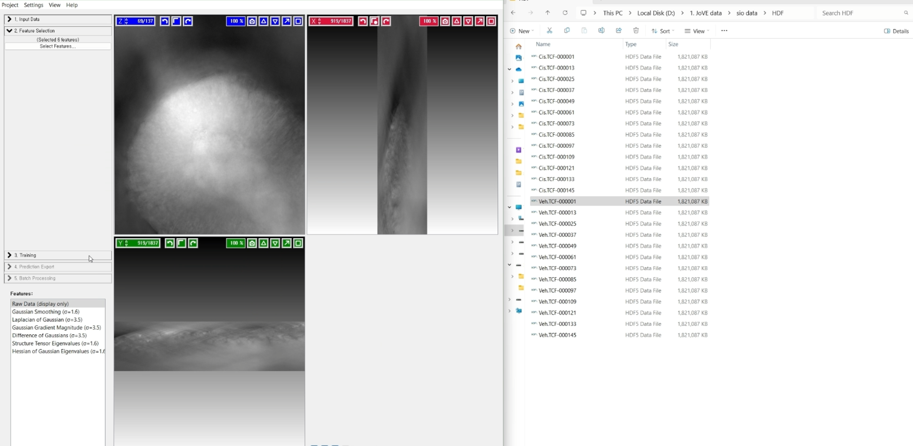
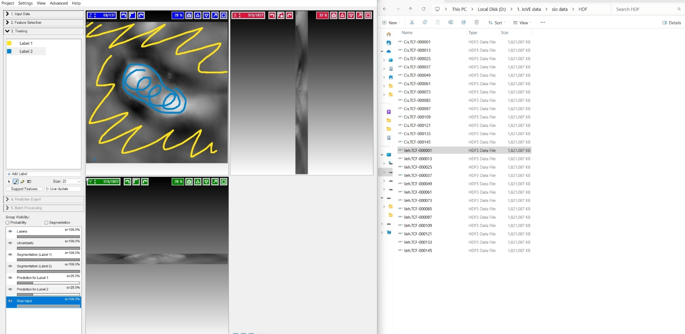
- 4.6.1 (Live Update being clicked for a dynamic preview of the segmentation and adjustments being made.) 00:49-00:51
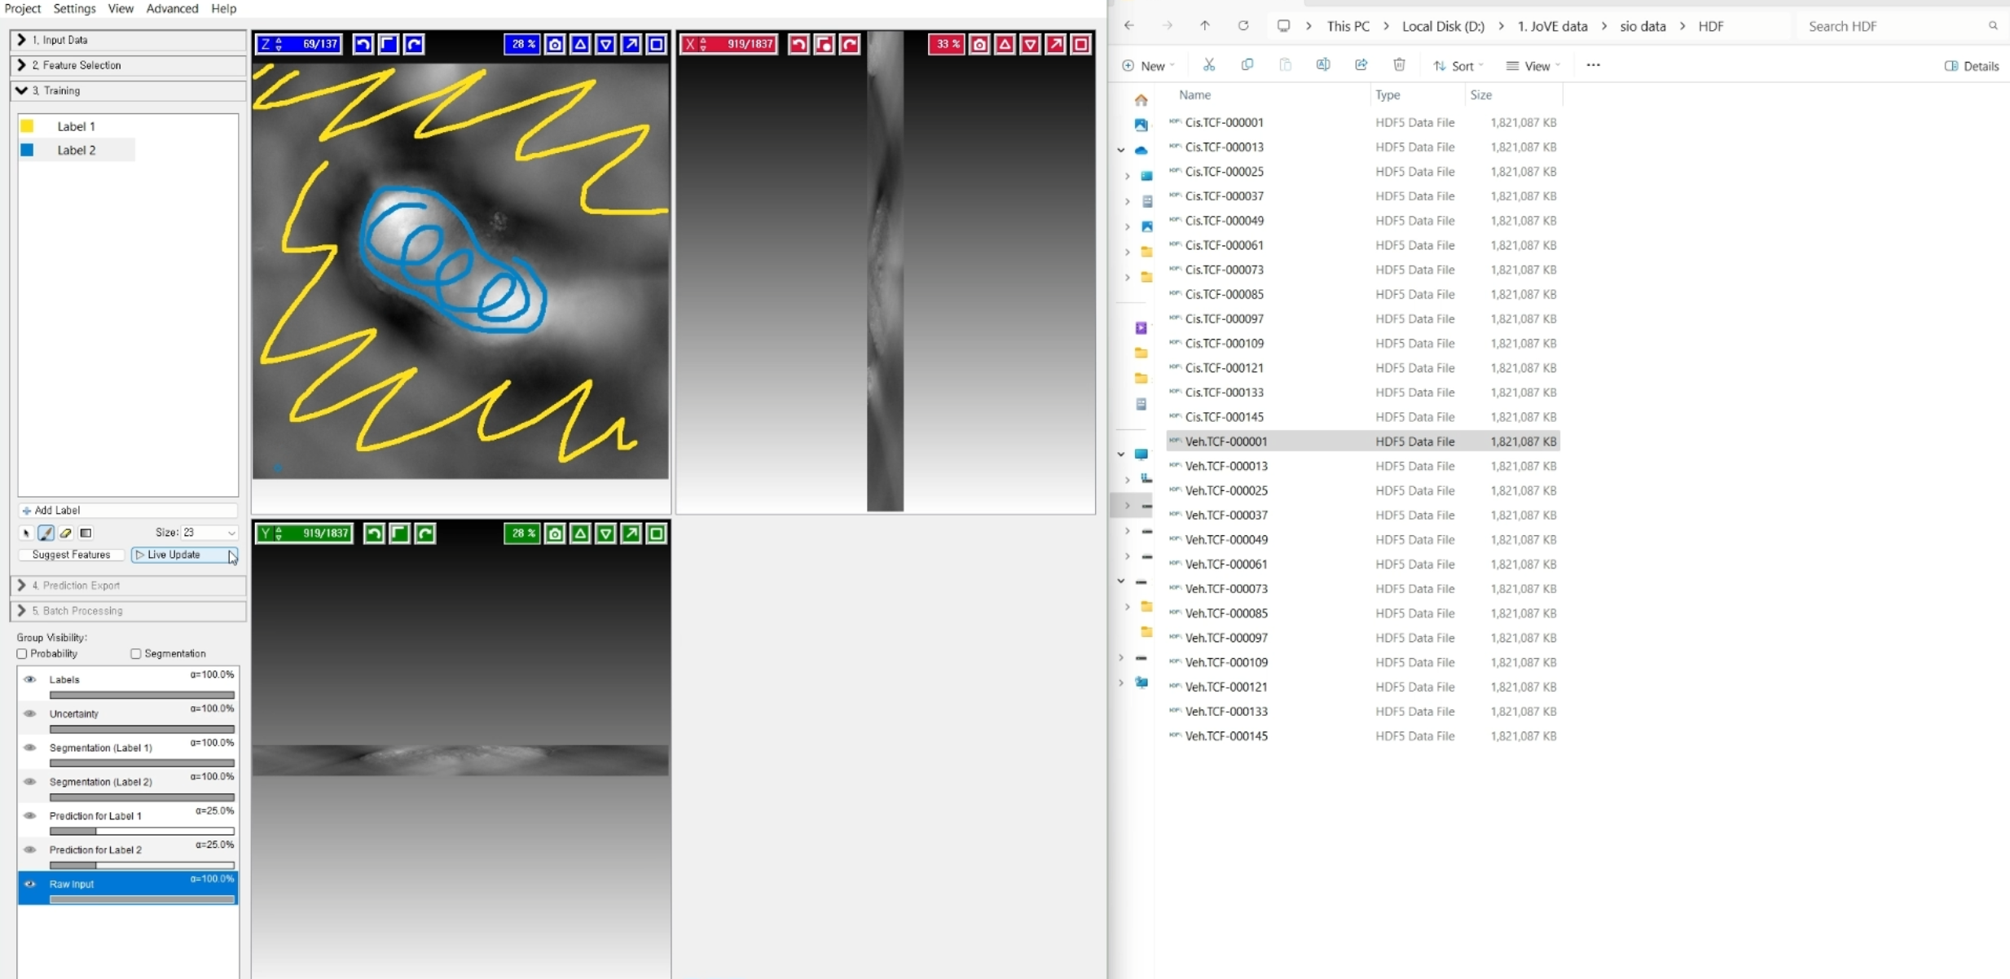
- 4.7.1 (In the Prediction Export tab, choosing Simple Segmentation and clicking Export All. Saving export as .h5 or .tiff format.) 1:56-2:08
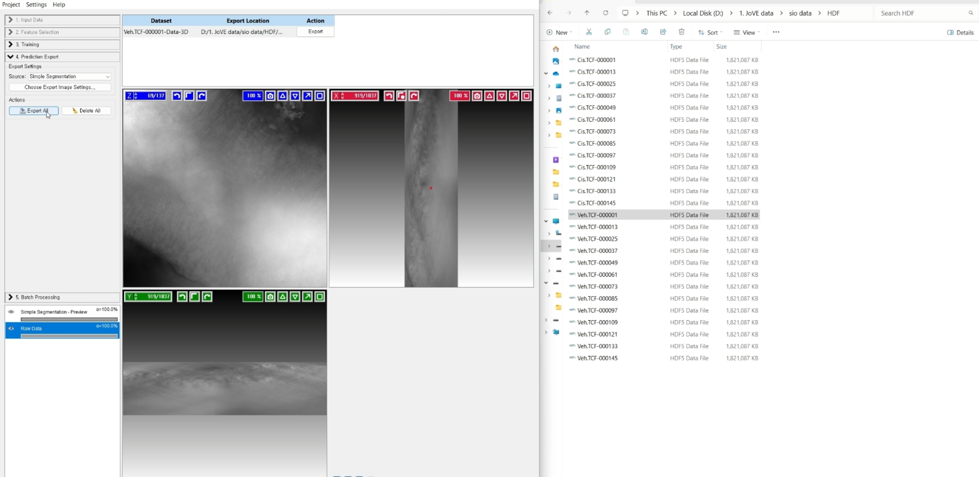

- 68529_screenshot_4.8.1-4.8.2_mp4
- 4.8.1 (Opening the supplementary coding file 2. Specifying the appropriate folder paths for the mask file and TCF file.) 00:26-00:33
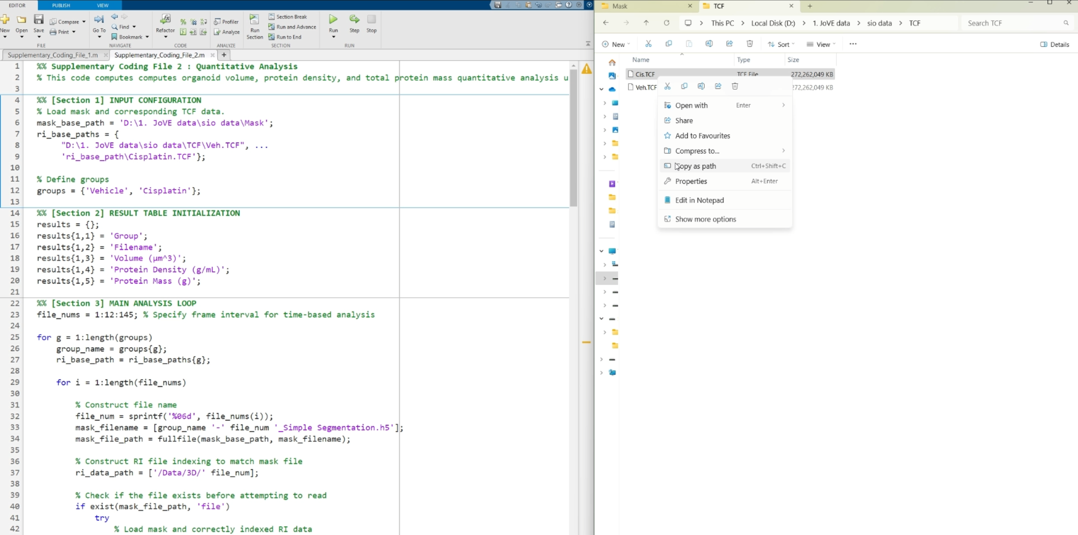
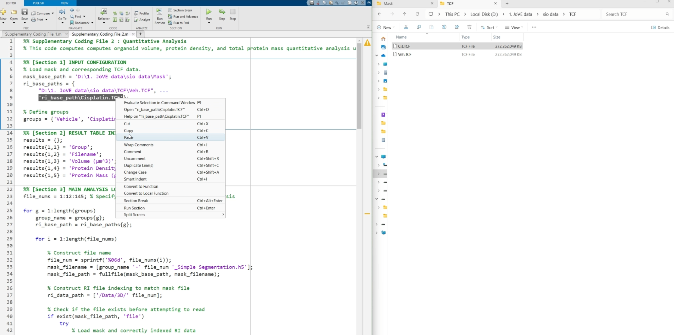
- 4.8.2 (Executing the code.) 00:43-00:53
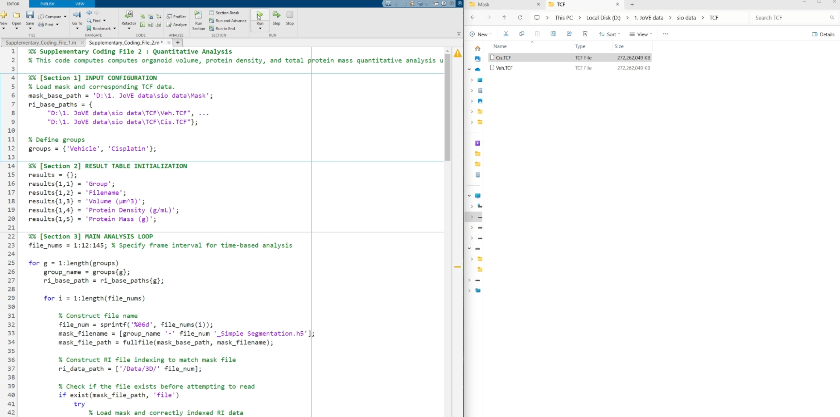
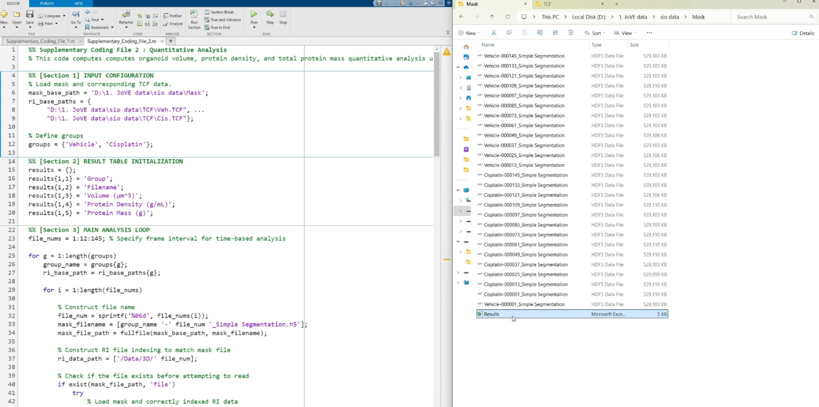
- 68529_screenshot_4.9.1_mp4
- 4.9.1 (Results file showing organoid volume, protein density, and total protein content.) 00:00- 00:04
