TITLE:
Multifractal Spectrum Analysis for Assessing Pulmonary Nodule Malignancy

AUTHORS AND AFFILIATIONS:
Baixin Wang¹, YaWen Xu², Fangliang Xing³, Tengxiao Liang^{2*}

¹Dongzhimen Hospital, Affiliated to Beijing University of Chinese Medicine, Beijing, China
²Fever Outpatient Clinic, Dongzhimen Hospital, Affiliated to Beijing University of Chinese Medicine, Beijing, China
³Beijing Intelligent Entropy Science& Technology Co Ltd., Beijing 100176, China

Email addresses of co-authors:
Baixin Wang (18801203766@163.com)
YaWen Xu (18230469491@163.com)
Fangliang Xing (wordnet@163.com)

Corresponding author：
Tengxiao Liang (13601133923@163.com)

KEYWORDS:
pulmonary nodules malignancy; multifractal spectrum; non-invasive diagnosis;

SUMMARY:
This study introduces multifractal spectrum analysis for assessing pulmonary nodule malignancy. Using CT-DICOM data, the method calculates fractal dimensions across multiple voxel scales, revealing significant differences between early-stage and late-stage pulmonary nodules.

ABSTRACT:
Non-invasive assessment of pulmonary nodule malignancy remains a critical challenge in lung cancer diagnosis. Traditional methods often lack precision in differentiating benign from malignant nodules, particularly in the early stages. This study introduces an approach using multifractal spectrum analysis to quantitatively evaluate pulmonary nodule characteristics.

A fractal-based protocol was developed to process computed tomography (CT)-digital imaging and communications in medicine (DICOM) data, enabling three-dimensional (3D) visualization and analysis of pulmonary nodule's multifractal spectrum. The method involves 3D volume reconstruction, precise ROI delineation, and calculation of fractal dimensions across multiple scales. Multifractal spectra were computed for both early-stage and late-stage lung adenocarcinoma nodules, with comparative analysis performed using data tip tool quantification.

Analysis revealed that the fractal dimension of a pulmonary nodule's 3D digital matrix varies continuously with different voxel scales, forming a distinctive multifractal spectrum. Significant differences were observed between early-stage and late-stage nodules. Late-stage nodules demonstrated a wider scale range (longer X-axis) and higher extreme points in their multifractal spectra. These distinctions were quantitatively confirmed, indicating the method's potential for precise staging.

The multifractal spectrum analysis provides a highly significant and precise quantitative method for staging pulmonary nodules, effectively differentiating between benign and malignant cases. This non-invasive technique shows promise for improving early diagnosis and accurate staging of lung cancer, potentially enhancing clinical decision-making in pulmonary oncology.

INTRODUCTION:
Lung cancer remains one of the leading causes of cancer-related deaths worldwide, with early detection and accurate diagnosis playing crucial roles in improving patient outcomes¹. Pulmonary nodules, often detected incidentally or through screening programs, present a significant diagnostic challenge for clinicians. The ability to differentiate between benign and malignant nodules, particularly in their early stages, is paramount for timely intervention and appropriate management².

Traditionally, the criterion standard for diagnosing pulmonary nodule malignancy has been histopathological examination through invasive procedures such as biopsy or surgical resection. While these methods provide definitive diagnoses, they carry inherent risks, including pneumothorax, bleeding, and infection³. Moreover, the invasive nature of these procedures can lead to patient discomfort and anxiety, as well as increased healthcare costs. Additionally, biopsy procedures themselves are subject to sampling accuracy issues, with the potential for obtaining non-representative tissue samples that may lead to misdiagnosis. Consequently, there is a pressing need for non-invasive diagnostic techniques that can accurately assess nodule malignancy without subjecting patients to unnecessary invasive procedures⁴.

Computed Tomography (CT) imaging has emerged as a powerful tool in the detection and characterization of pulmonary nodules⁵. However, the interpretation of CT images for nodule assessment remains challenging, with considerable inter-observer variability among radiologists. Current guidelines and expert consensus statements on CT-based nodule evaluation primarily rely on morphological features such as size, shape, and growth rate. While these criteria provide valuable information, they often lack the precision necessary for definitive diagnosis, particularly in cases of small or indeterminate nodules⁶.

In recent years, there has been growing interest in utilizing quantitative imaging features, often referred to as "radiomics," to enhance the diagnostic accuracy of CT-based nodule assessment⁷. Among these approaches, fractal analysis has shown promise in capturing the complex structural characteristics of pulmonary nodules⁸. Fractal dimension, a measure of an object's complexity across different scales, has been applied to various medical imaging problems, including the characterization of pulmonary nodules⁹.

However, existing fractal-based methods for nodule analysis typically employ a single-scale approach, calculating a single fractal dimension for each nodule¹⁰. While this approach has shown some utility in differentiating between benign and malignant nodules, it often results in significant overlap between the two categories, limiting its diagnostic precision. The inherent limitation of single-scale fractal analysis lies in its inability to capture the full spectrum of structural complexities that may exist within a nodule across different spatial scales¹¹.

To address these limitations, this study introduces a novel approach, multifractal spectrum analysis, for pulmonary nodule assessment. This method extends beyond traditional single-scale fractal analysis by computing fractal dimensions across multiple voxel scales, thereby generating a comprehensive spectrum that characterizes the nodule's structural complexity at various levels of detail¹². This approach is rooted in the understanding that biological structures, including tumors, often exhibit different fractal properties at different scales, a characteristic that single-scale methods fail to capture¹³.

The development of this multifractal spectrum analysis is motivated by the need for more precise, quantitative, and non-invasive methods for assessing pulmonary nodule malignancy. By leveraging advanced image processing techniques and mathematical models, this approach aims to extract a richer set of features from CT images, potentially revealing subtle differences between benign and malignant nodules that may not be apparent through conventional analysis or single-scale fractal methods¹⁴.

The significance of this research lies in its potential to enhance the accuracy of early-stage lung cancer diagnosis and staging. By providing a more nuanced and comprehensive characterization of nodule structure, the multifractal spectrum analysis may enable clinicians to make more informed decisions about patient management, potentially reducing the need for unnecessary invasive procedures in cases of benign nodules while ensuring timely intervention for malignant ones¹⁵.

In summary, this research introduces multifractal spectrum analysis for assessing pulmonary nodule malignancy, addressing the limitations of current diagnostic approaches and single-scale fractal methods. By providing a more comprehensive and precise quantitative assessment of nodule characteristics, this non-invasive technique aims to improve early diagnosis and accurate staging of lung cancer, ultimately enhancing clinical decision-making in pulmonary oncology and contributing to improved patient outcomes¹⁶.

PROTOCOL:
This study was approved by the Ethics Committee of Dongzhimen Hospital, affiliated with the Beijing University of Chinese Medicine (2024DZMEC-165-02). The patient was recruited from the Fever Outpatient Clinic, Dongzhimen Hospital. The patients provided informed consent for their diagnosis through digital modeling and authorized the use of their data for scientific research purposes. The model reconstruction function is derived from a commercially available software tool (see Table of Materials).

- Data preparation and visualization 67990_Screenshot_Step1.mp4

  - Navigate to the folder containing the patient's CT scan DICOM data files.
67990_Screenshot_Step1.mp4: 00:00:03-00:00:13

  - Generate a 3D volume matrix from the DICOM files using the following MATLAB code:
f=dir(‘*.dcm’);
for i=1:length(f)
V(:,:,i)=dicomread(f(fidx(i)).name);
end

  - Visualize the image sequence using MATLAB's sliceViewer function: (Figure1)
figure;
H=sliceViewer(V);
colormap(gray(1024));
set(gcf, 'Toolbar', 'figure');

  - Interact with the 3D volume visualization.

Use the scroll bar at the bottom of the graphical user interface (GUI) to browse through different slices in the CT sequence (Figure 1). Note the presence of a 22 mm malignant pulmonary nodule in the left lung at frame 325. 67990_Screenshot_Step1.mp4: 00:00:15-00:00:25

    - Find the icons for zooming in, zooming out, and returning to the global view in the upper-right corner of the GUI in Figure 3. Use the Data Tip icon to mark the coordinates of the pixel selected. Use the Zoom function to observe the local features of the lesions and their relationships to surrounding tissues. 67990_Screenshot_Step1.mp4: 00:00:35-00:00:58

    - The default color bar is the gray colormap, which means that blue to red represents values from low to high. Right-click the Color Bar in the pop-up menu to select the common gray colormap and reset the whole GUI. 67990_Screenshot_Step1.mp4: 00:01:15-00:01:25

    - If the filter effect is not satisfied, use the left mouse button to drag up and down in the middle of the figure to adjust the window level. Drag left and right to adjust the window width, and the corresponding accurate filtering range will be displayed on the color bar.
67990_Screenshot_Step1.mp4: 00:00:25-00:00:35

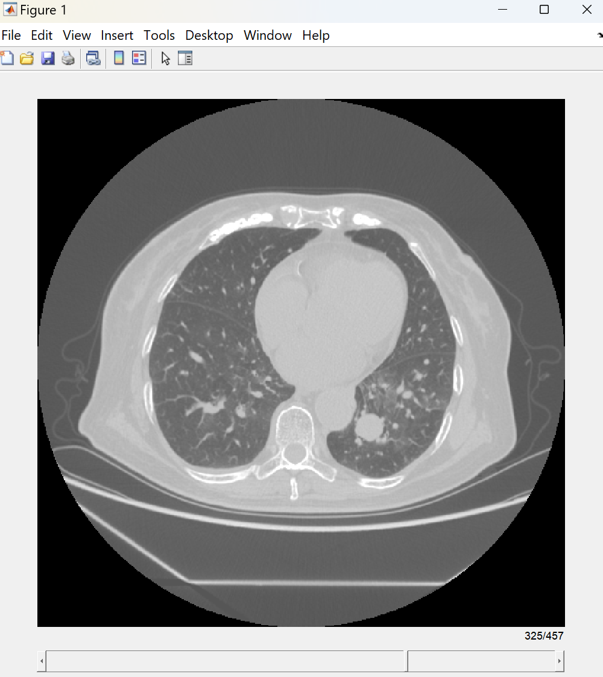

Figure 1: 3D reconstruction and visualization of pulmonary nodule CT data

NOTE: These interactive controls enable flexible inspection of CT-DICOM data characteristics across both intensity space and sequence location.

- Local 3D matrix visualization of pulmonary nodule lesions
67990_Screenshot_Step2.mp4

NOTE: After locating the sequence position of the pulmonary nodule in the GUI shown in Figure 1, use the Data Tip tool to precisely delineate the nodule's position. This step is necessary before calculating the 3D matrix of the grayscale space for the lesion area.

2.1. Use the Data Tip tool to precisely identify the pixel coordinates of the pulmonary nodule.

    - In the GUI shown in Figure 1, navigate to the slice containing the nodule (frame 325).

    - Click the Data Tip icon in the upper-right corner of the GUI.

    - Click on the edges of the nodule to mark its boundaries (Figure 2).

    - Note the X and Y coordinates displayed in the data tip pop-up.
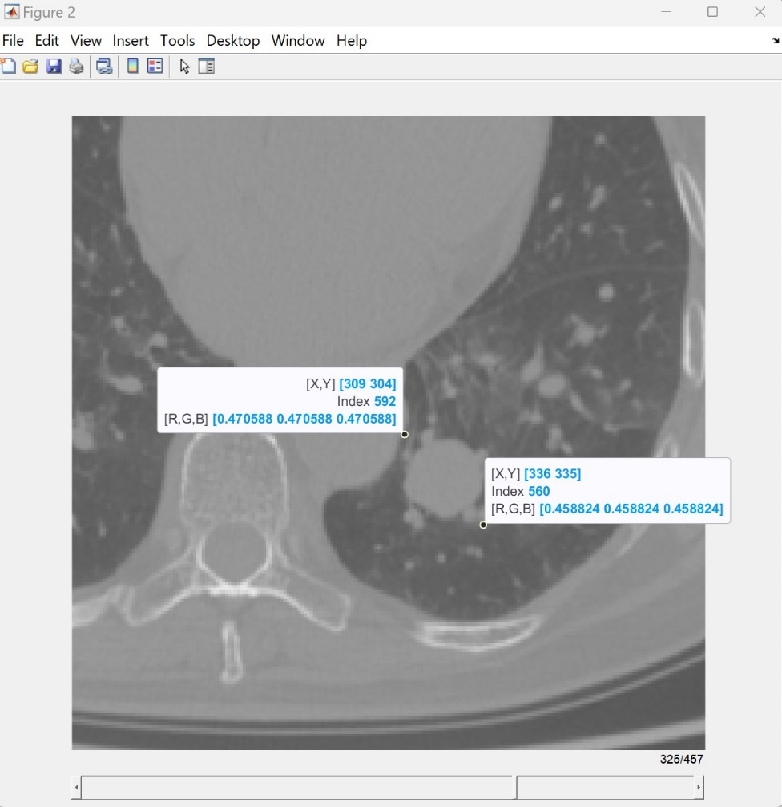

Figure 2: CT image slice with Data Tip markers showing the precise coordinates of the pulmonary nodule

  - Extract the grayscale matrix of the pulmonary nodule.
67990_Screenshot_Step1.mp4: 00:00:02-00:00:13

    - Based on the coordinates obtained, define the region of interest (ROI) in the MATLAB command window: M = V (304:335, 309:336, 325);

NOTE: Adjust the coordinates (304:335, 309:336, 325) according to the specific nodule location in the image.

  - Visualize the local 3D matrix of the nodule:

    - Enter the following MATLAB command to create a 3D surface plot: figure; surf(M);

    - Observe the resulting 3D visualization of the nodule's grayscale intensities (Figure 3).

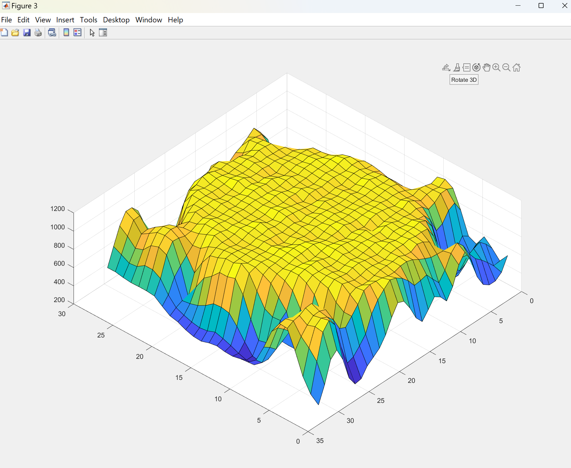

Figure 3: 3D surface plot visualizing the local grayscale matrix of the pulmonary nodule.

  - Interact with the 3D visualization GUI.
67990_Screenshot_Step2.mp4: 00:00:13-00:00:50

NOTE: The X and Y axes represent the spatial dimensions of the nodule in pixels. The Z axis represents the grayscale intensity values.

2.4.3. Find the tools for zooming in, zooming out, rotating, and returning to the default initial view (Restore View) in the upper-right corner of the GUI. Use these tools for precise examination of the 3D digitized pulmonary nodule.

- Calculating the multifractal spectrum of pulmonary nodule
67990_Screenshot_Step3.mp4

NOTE: The fractal dimension is not unique across different scales but rather forms a multifractal spectrum that varies with different computational scales.

3.1. Call the function Pix_size, fractal_dimension = PN_fractal_feature(M) with the previously obtained M matrix as input. This will yield the fractal dimensions (fractal_dimension) at different scales (Pix_size). 67990_Screenshot_Step3.mp4: 00:00:08-00:00:15

3.2. Visualize the Multifractal Spectrum (Figure 4) of the pulmonary nodule using the following code: 67990_Screenshot_Step3.mp4: 00:00:15-00:00:29
figure;
plot (Pix_size, fratal_dimention,’linewidth’,2);
xlabel('Fractal scale')
ylabel('Fractal Dimension')

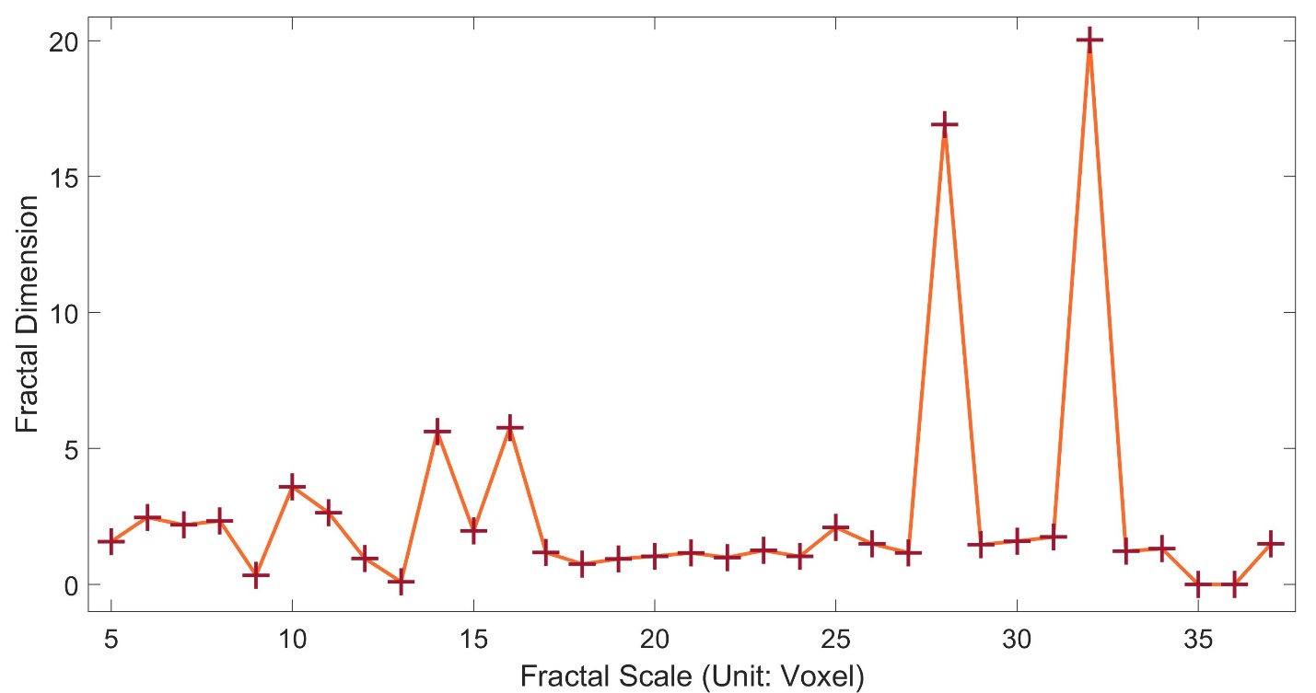

Figure 4: Multifractal Spectrum of Pulmonary Nodule
67990_Screenshot_Step3.mp4: 00:00:29-00:01:33

3.3. Using the same steps as in 1.1–3.2, calculate for another benign pulmonary nodule and plot it in the same coordinate system using a different color for comparison. This will produce Figure 5. 67990_Screenshot_Step3-3.MP4

3.4. To more precisely compare the multifractal spectra of different benign and malignant pulmonary nodules, use the Data Tip tool to mark the coordinates of key extrema points in Figure 5. 67990_Screenshot_Step3-3.MP4

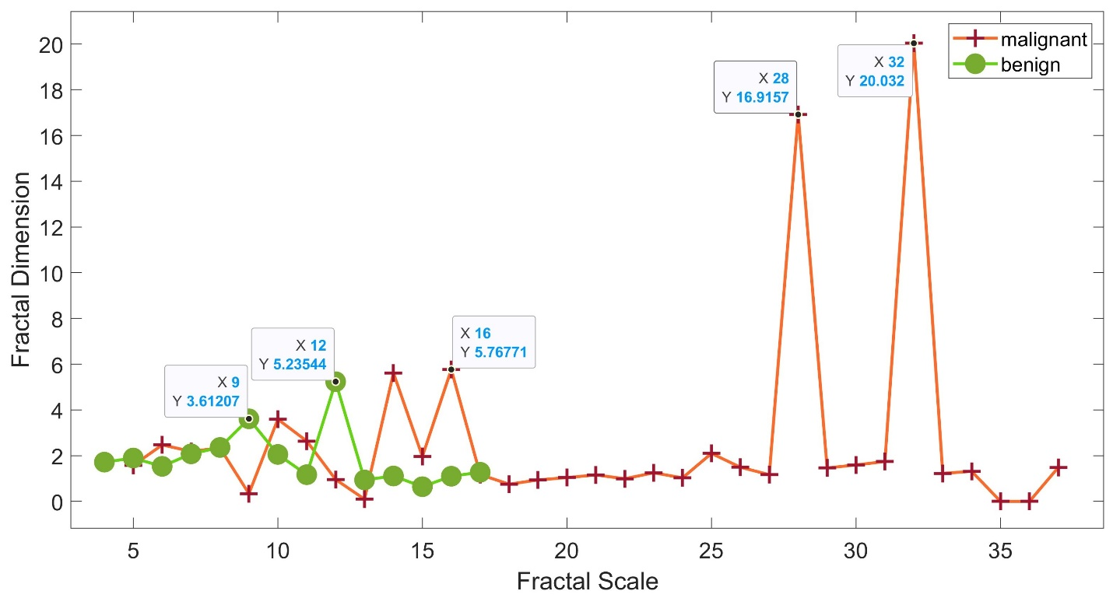

Figure 5: Multifractal Spectrum comparison between different Pulmonary Nodule

NOTE: The MATLAB code used for this protocol is available as Supplementary File 1.

REPRESENTATIVE RESULTS:
Figure 1 uses a 3D-volume reconstruction of the patient's thoracic CT sequence, allowing for convenient viewing and localization of the subject's pulmonary nodules. The Data Tip tool can effectively outline the Region of Interest (ROI) of the nodule of interest (Figure 2). Figure 3 provides a digitized structure of the nodule's 3D intensity space.

This study found through practical experimentation that the fractal dimension is not unique across different voxel scales but rather forms a multifractal spectrum that varies with different computational scales. Figure 4 shows the multifractal spectrum of a nodule (Figure 2) from a stage III lung adenocarcinoma patient.

Figure 5 compares the multifractal spectrum of an early-stage lung adenocarcinoma patient. On one hand, it can be seen that the late-stage patient's nodule has a longer X-axis, indicating a larger scale range. On the other hand, most of the extreme points of the late-stage patient are significantly higher than those of the early-stage patient. This significance is also quantitatively compared using the Data Tip tool in Figure 5.

These results demonstrate the robust capability of the multifractal spectrum analysis in differentiating and staging pulmonary nodules. the observed differences in spectrum characteristics between early-stage and late-stage nodules provide a quantitative basis for non-invasive malignancy assessment. This novel approach not only offers a precise method for nodule staging but also opens new avenues for early detection and monitoring of lung cancer progression, potentially enhancing clinical decision-making in pulmonary oncology.

FIGURE AND TABLE LEGENDS:
Figure 1: 3D reconstruction of pulmonary nodule CT sequence. Interactive 3D volume rendering of the patient's CT scan, enabling convenient viewing and localization of pulmonary nodules.

Figure 2: CT image with ROI delineation of a pulmonary nodule. A Transverse CT slice showing the pulmonary nodule with Region of Interest (ROI) outlined using the data tip tool.

Figure 3: 3D grayscale matrix visualization of a pulmonary nodule. Surface plot representing the digitized 3D grayscale space structure of the isolated nodule, providing insight into its internal density variations.

Figure 4: Multifractal spectrum of a stage iii lung adenocarcinoma nodule. Plot showing the relationship between fractal dimension and fractal scale, illustrating the multifractal nature of the advanced-stage pulmonary nodule.

Figure 5: Multifractal spectrum comparison between different pulmonary nodules. Comparative plot of multifractal spectra from early-stage and late-stage lung adenocarcinoma nodules, with key extrema points marked using the data tip tool. The graph demonstrates significant differences in scale range and fractal dimensions between stages.

Supplementary File 1: MATLAB code for the protocol.

DISCUSSION:
The multifractal spectrum analysis presented in this study represents a significant advancement in the non-invasive assessment of pulmonary nodule malignancy. This method offers important advantages and addresses key limitations in existing approaches to pulmonary nodule diagnosis and staging¹⁷.

Critical steps in the protocol include precise 3D reconstruction of CT-DICOM data (Figure 1), accurate delineation of the region of interest (Figure 2), and the novel application of fractal analysis across multiple voxel scales (Figure 4). The use of data tip tools for ROI identification ensures precise isolation of nodule structures, which is crucial for accurate analysis. The computation of fractal dimensions at various scales, forming the multifractal spectrum, is a key innovation that provides a more comprehensive characterization of nodule complexity compared to single-scale fractal analysis¹⁸.

Potential modifications to enhance the method could include automation of ROI selection using machine learning algorithms, which would reduce operator dependency and improve reproducibility. Troubleshooting may be necessary in cases of low-contrast nodules or those adjacent to other structures. In such instances, advanced image segmentation techniques could be employed to ensure accurate nodule isolation¹⁹.

While this method shows promise, it is important to acknowledge its methodological considerations. This approach actually leverages grayscale variations as meaningful indicators in the analysis process. The three-dimensional voxel-based computation allows us to simultaneously capture both morphological characteristics through spatial shape and tissue heterogeneity through grayscale variations along the Z-axis. More severe and diffusive nodules typically exhibit both greater grayscale heterogeneity and increased morphological dimensionality, which are reflected in higher fractal dimensions. While CT images acquired from various manufacturers or models may have distinct grayscale domains, these variations are inherently incorporated into the analytical framework rather than serving as limitations. The method's use of relative grayscale variations rather than absolute values helps maintain consistency across different scanning devices, though standardization of acquisition parameters remains an important consideration for future research².

The significance of this method lies in its ability to provide a quantitative, non-invasive assessment of nodule malignancy. Compared to traditional methods that often rely on size and visual characteristics alone, the multifractal spectrum analysis offers a more nuanced evaluation of nodule complexity. This approach has the potential to reduce the need for invasive biopsies, particularly in cases where traditional imaging methods are inconclusive⁷.

The importance of this technique extends to several key areas in oncology research and clinical practice. In the realm of early detection, the method's sensitivity to subtle structural differences could lead to improved identification of malignant nodules at earlier stages, potentially improving patient outcomes. For treatment monitoring, the multifractal spectrum could provide a quantitative measure of nodule changes over time, offering insights into treatment efficacy¹⁴.

Furthermore, this method opens new avenues for research into the relationship between tumor heterogeneity and malignancy. The software may serve as a quantitative measure of intratumoral heterogeneity, a factor increasingly recognized as important in cancer progression and treatment response⁹.

In conclusion, the analysis software presents a promising tool for enhancing the accuracy of pulmonary nodule assessment. Its non-invasive nature, coupled with its ability to provide detailed quantitative information, positions it as a valuable complement to existing diagnostic and AI-based methods. Future work will focus on developing comprehensive diagnostic parameters across various nodule types and stages, establishing standardized protocols, and integrating this approach with existing AI and radiomics frameworks. As research in this area progresses, integration of this technique into clinical workflows could significantly impact lung cancer diagnosis, staging, and treatment planning, ultimately contributing to improved patient care in pulmonary oncology¹.

ACKNOWLEDGMENTS:
This research was supported by the Clinical Research and Achievement Transformation Capacity Enhancement Pilot Project (DZMG-MLZY-23008) from the Dongzhimen Hospital of Beijing University of Chinese Medicine.

DISCLOSURES:
The software tool for multifractal spectrum for assessing pulmonary nodules, Multifractal Spectrum V1.0, is a product of Beijing Intelligent Entropy Science & Technology Co., Ltd. The intellectual property rights of this software tool belong to the company. The authors have no conflicts of interest to declare.

REFERENCES:
- Naik, A., Edla, D. R., Dharavath, R. Prediction of malignancy in lung nodules using a combination of deep, fractal, and gray-level co-occurrence matrix features. Big Data. 9 (6), 480–498 (2021).
- Al-Kadi, O. S. Prediction of FDG-PET stage and uptake for non-small cell lung cancer on non-contrast enhanced CT scans via fractal analysis. Clin Imaging. 65, 54–59 (2020).
- Ferreira-Junior, J. R. et al. CT-based radiomics for prediction of histologic subtype and metastatic disease in primary malignant lung neoplasms. Int J Comput Assist Radiol Surg. 15 (1), 163–172 (2020).
- Ryan, S. M. et al. Radiomic measures from chest high-resolution computed tomography associated with lung function in sarcoidosis. Eur Respir J. 54 (2),1900371 (2019).
- Kravchenko, V. F., Ponomaryov, V. I., Pustovoit, V. I., Rendon-Gonzalez, E. Classification of lung nodules using CT images based on texture features and fractal dimension transformation. Dokl Math. 99 (2), 235–239 (2019).
- Digumarthy, S. R., Padole, A. M., Lo Gullo, R., Sequist, L. V., Kalra, M. K. Can CT radiomic analysis in NSCLC predict histology and EGFR mutation status? Medicine (Baltimore). 98 (1), e13963 (2019).
- Xiao, X. et al. An automated segmentation method for lung parenchyma image sequences based on fractal geometry and convex hull algorithm. Appl Sci (Basel). 8 (5), 832 (2018).
- Xue, X. et al. Use of a radiomics model to predict tumor invasiveness of pulmonary adenocarcinomas appearing as pulmonary ground-glass nodules. Biomed Res Int. 2018, 6803971 (2018).
- Kiryu, S. et al. Impact of hepatocellular carcinoma heterogeneity on computed tomography as a prognostic indicator. Sci Rep. 7, 12689 (2017).
- Bashir, U., Siddique, M. M., Mclean, E., Goh, V., Cook, G. J. Imaging heterogeneity in lung cancer: techniques, applications, and challenges. Am J Roentgenol. 207 (3), 534–543 (2016).
- Niehaus, R., Raicu, D. S., Furst, J., Armato, S., III. Toward understanding the size dependence of shape features for predicting spiculation in lung nodules for computer-aided diagnosis. J Digit Imaging. 28 (6), 704–717 (2015).
- Feng, C., Zhang, J., Liang, R. A method for lung boundary correction using split Bregman method and geometric active contour model. Comput Math Methods Med. 2015, 789485 (2015).
- Alic, L., Niessen, W. J., Veenland, J. F. Quantification of heterogeneity as a biomarker in tumor imaging: a systematic review. PLoS One. 9 (10), e110300 (2014).
- Miwa, K. et al. FDG uptake heterogeneity evaluated by fractal analysis improves the differential diagnosis of pulmonary nodules. Eur J Radiol. 83 (4), 715–719 (2014).
- Liu, G., Chen, N., Ou, C., Liao, Y., Yu, Y. Image feature extraction based on multifractal theory. 2014 IEEE Workshop on Electronics, Computer and Applications, Ottawa, ON, Canada. 1023–1026 (2014).
- Lin, P., Huang, P., Lee, C., Wu, M. Automatic classification for solitary pulmonary nodule in CT image by fractal analysis based on fractional Brownian motion model. Pattern Recognit. 46 (12), 3279–3287 (2013).
- Ganeshan, B., Miles, K. A. Quantifying tumour heterogeneity with CT. Cancer Imaging. 13 (1), 140–149 (2013).
- Huang, P., Lin, P., Lee, C., Kuo, C. A classification system of lung nodules in CT images based on fractional Brownian motion model. 2013 IEEE International Conference on System Science and Engineering (ICSSE), Budapest, Hungary. 37–40 (2013).
- Wang, H. et al. Multilevel binomial logistic prediction model for malignant pulmonary nodules based on texture features of CT image. Eur J Radiol. 74 (1), 124–129 (2010).

