Submission ID #: 67944

Scriptwriter Name: Poornima G

Project Page Link: https://review.jove.com/account/file-uploader?src=20722968

Title: Grossing of Non-Neoplastic Globes, Including Fetal Eyes

Authors and Affiliations:

Martina C. Herwig-Carl^{*,1}, Leticia Ussem¹, Frank G. Holz¹, Annette M. Müller², Karin U. Loeffler¹

¹Department of Ophthalmology, Division of Ophthalmic Pathology, University Hospital Bonn

²Center of Pediatric Pathology and Pathology, University Hospital Cologne

☒ All author names and affiliations are correct (city/state/country information not included in video title page).

Corresponding Authors:
Martina C. Herwig-Carl martina.herwig-carl@ukbonn.de

Email Addresses for All Authors:
Leticia Ussem leticiaussem@gmail.com
Frank G. Holz Frank.Holz@ukbonn.de
Annette M. Müller Annette.mueller@uk-koeln.de
Karin U. Loeffler Karin.Loeffler@ukbonn.de
Martina C. Herwig-Carl martina.herwig-carl@ukbonn.de

Author Questionnaire
1. Microscopy: Does your protocol require the use of a dissecting or stereomicroscope for performing a complex dissection, microinjection technique, or something similar? Yes
If Yes, can you record movies/images using your own microscope camera?
No
If your protocol involves microscopy but you are not able to record movies/images with your microscope camera, JoVE will need to use our scope kit.
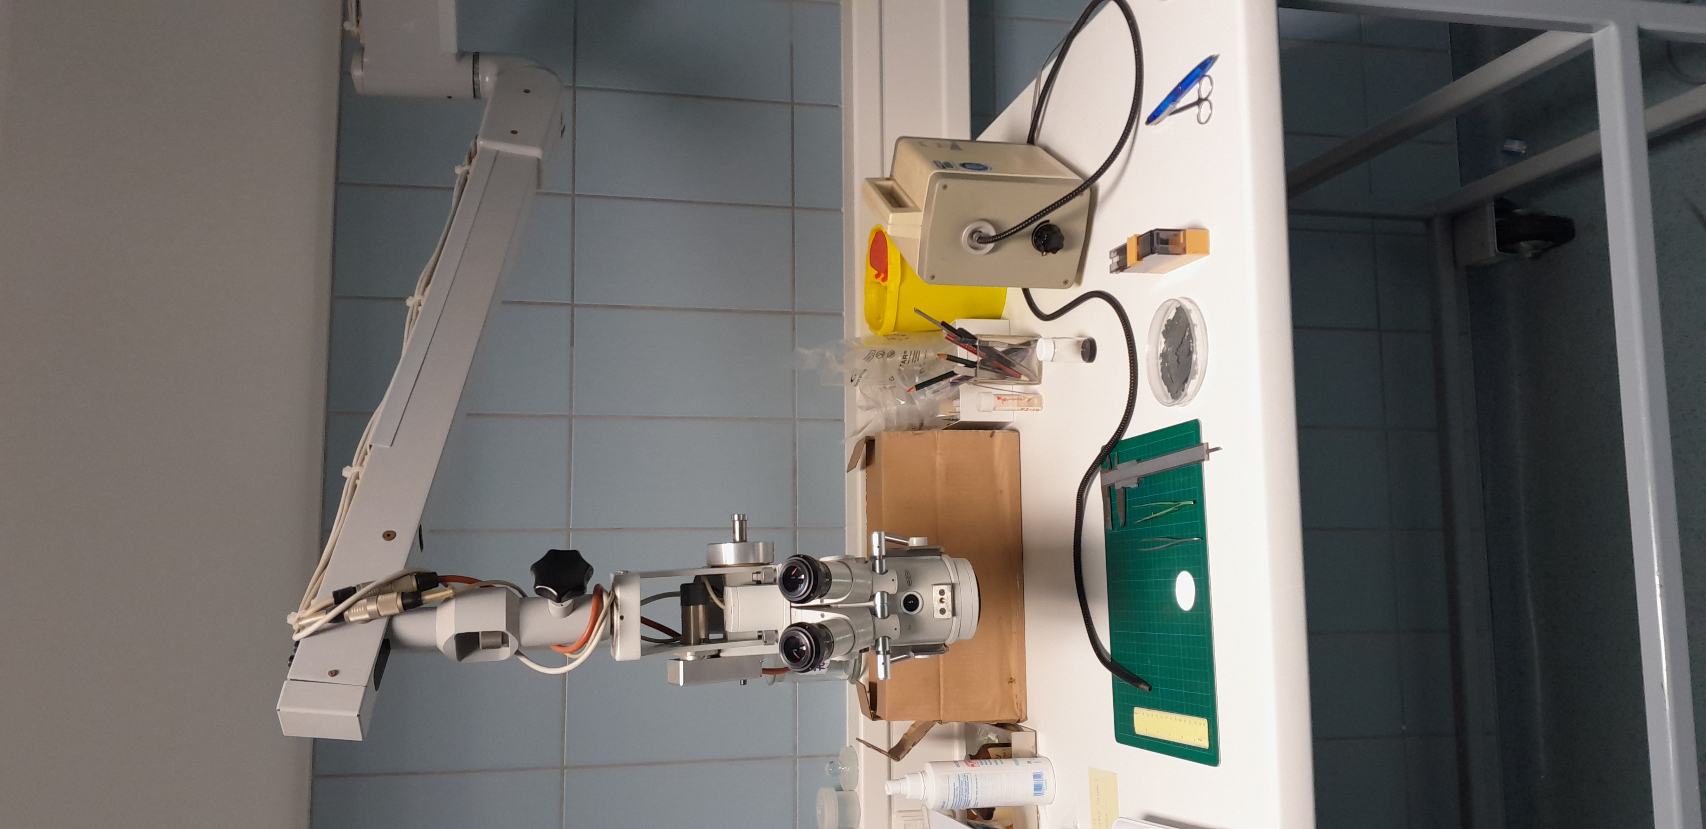
If your microscope does not have a camera port, the scope kit will be attached to one of the eyepieces and you will have to perform the procedure using one eye.
Understand – it is a very old surgery microscope and will probably not have a camera port. The image to the right covers the microscope which we use.

If a dissection or stereo microscope is required for your protocol, please list all shots from the script that will be visualized using the microscope (shots are indicated with the 3-digit numbers, like 2.1.1, 2.1.2, etc.).
All except for 2.4 (some shots can be done with or without the microscope and it depends on the specimen if we use the surgery microscope).

2. Software: Does the part of your protocol being filmed include step-by-step descriptions of software usage? No
If Yes, we will need you to record using screen recording software.
We recommend using the screen capture program OBS. JoVE’s tutorial for using OBS Studio is provided at this link: https://review.jove.com/v/5848/screen-capture-instructions-for-authors?status=a7854k
As these files are necessary for finalizing your script, please upload all screen-captured video files to your project page as soon as possible.

3. Filming location: Will the filming need to take place in multiple locations? Yes
If Yes, how far apart are the locations? Two rooms away

To ensure that your script can be filmed in one day, the protocol sections are cumulatively restricted to 55 shots (shots are the 3-digit numbers like 2.1.1, 2.1.2…etc)

Current Protocol Length
Number of Steps: 19
Number of Shots: 33

Introduction
Videographer: Obtain headshots for all authors available at the filming location.

Answers to these questions will become interview statements that you will deliver on camera.
- Answer the 1st REQUIRED question and at least 2 other questions (1.2 – 1.10) below. Up to 5 interview statements will be included in the video.
- Enter the full name of the author who will deliver the statement.
- If possible, each author should deliver no more than two statements.
- Answer in full sentences, in a style suitable for being spoken aloud.
- Limit the length of each statement to 30 words or fewer.
- Answers will be edited for length, clarity, and consistency with journal style guidelines.

REQUIRED: What is the scope of your research? What questions are you trying to answer?
Please rephrase: This is neither research nor an experiment! This protocol is part of a special issue on ophthalmic pathology. We illustrate a routine procedure of grossing non-tumor globes for diagnostic purposes.

  - Martina Herwig-Carl: Click here to answer question. Please write in a style that you will be comfortable memorizing and speaking aloud. Limit length to 30 or fewer words.

What are the most recent developments in your field of research?
  - Enter author name: Click here to answer question. Please write in a style that you will be comfortable memorizing and speaking aloud. Limit length to 30 or fewer words.
What technologies are currently used to advance research in your field?
  - Enter author name: Click here to answer question. Please write in a style that you will be comfortable memorizing and speaking aloud. Limit length to 30 or fewer words.
What are the current experimental challenges?
  - Enter author name: Click here to answer question. Please write in a style that you will be comfortable memorizing and speaking aloud. Limit length to 30 or fewer words.

What significant findings have you established in your field?
  - Enter author name: Click here if you choose this question. Please write in a style that you will be comfortable memorizing and speaking aloud. Limit length to 30 or fewer words.

What research gap are you addressing with your protocol?
  - Enter author name: Click here if you choose this question. Please write in a style that you will be comfortable memorizing and speaking aloud. Limit length to 30 or fewer words.

What advantage does your protocol offer compared to other techniques?
  - Enter author name: Click here if you choose this question. Please write in a style that you will be comfortable memorizing and speaking aloud. Limit length to 30 or fewer words.
How will your findings advance research in your field?
  - Enter author name: Click here if you choose this question. Please write in a style that you will be comfortable memorizing and speaking aloud. Limit length to 30 or fewer words.
What new scientific questions have your results paved the way for?
  - Enter author name: Click here if you choose this question. Please write in a style that you will be comfortable memorizing and speaking aloud. Limit length to 30 or fewer words.
What research questions will your laboratory focus on in the future?
  - Enter author name: Click here if you choose this question. Please write in a style that you will be comfortable memorizing and speaking aloud. Limit length to 30 or fewer words.

Videographer: Obtain headshots for all authors available at the filming location.

Testimonial Questions (OPTIONAL):

Answers to these questions will not appear in the video but may be featured in our journal's promotional materials.
- Enter the full name of the author who will deliver the statement.
- Answer in full sentences, in a style suitable for being spoken aloud.
- Answers will be mildly edited for clarity.
- Limit the length of each statement to 50 words or fewer.

How do you think publishing with JoVE will enhance the visibility and impact of your research?
  - Martina Herwig-Carl: Grossing of non-tumour eyes is challenging in particular if not carried out by an ophthalmic pathologist. It is crucial to familiarize yourself with the ocular history and any previous ocular surgical procedures. Based on this information and the macroscopic findings, the globe can be sectioned in such a way that the most important ocular structures are represented in the PO section. Publishing with JoVE will hopefully help to improve grossing of globes for diagnostic purposes by increasing visibility of a our standardized procedure.
Can you share a specific success story or benefit you’ve experienced—or expect to experience—after using or publishing with JoVE? (This could include increased collaborations, citations, funding opportunities, streamlined lab procedures, reduced training time, cost savings in the lab, or improved lab productivity.)
  - Martina Herwig-Carl: As we have experienced in the past that globes received for a second opinion are often mis-sectioned, preventing a proper evaluation, I hope we can encourage pathologists to use our protocol. We are, of course, open to providing special training.

Ethics Title Card
This research has been approved by the Institutional Animal Care and Use Committee (IACUC) or equivalent body at (insert Institutional Name)
OR
This research has been approved by the Institutional Review Board (IRB) or equivalent body at (insert Institutional Name)

Authors, if the work doesn’t require an ethics statement, please leave this section blank

Protocol
Please review this section to make sure that it accurately describes your protocol. Use Track Changes when making edits or revisions.
- The two-digit steps (e.g., 2.1., 2.2.) are the narration. JoVE is responsible for the narration of the protocol and results.
- Red italics are pronunciation guides indicating how the word will be spoken.
- Filming should take no more than 10 minutes per step. If a step takes more than 10 minutes, prepare the product for that step in advance.
- The three-digit shots (e.g., 2.1.1., 2.2.2.) are the actions that the videographer will capture.

- Orienting and Grossing the Eye Globe
Demonstrator: Martina Herwig-Carl

First step: Identify the four rectus muscles (please add to the protocol)
  - To begin, gather all the required items for the procedure [1]. Identify the superior oblique muscle by its tendinous appearance [2]. It inserts into the sclera on the posterotemporal surface of the globe near the insertion of the superior rectus muscle [3].
    - WIDE: Talent gathering the required materials on the procedure table.
    - Talent exploring to locate to the superior oblique muscle on the globe.
    - Talent pointing to the superior oblique muscle, showing its tendinous insertion near the superior rectus.

  - Next, identify the inferior oblique muscle, which inserts temporal inferiorly into the sclera between the lateral rectus muscle and the optic nerve [1].
    - Talent pointing to the inferior oblique muscle.

  - After identifying the long posterior ciliary artery [1], determine the laterality of the globe accurately based on the positions of the superior oblique, inferior oblique, and long posterior ciliary artery [2].
    - Talent locating and pointing to the long posterior ciliary artery on the specimen.
    - Talent orienting the globe and based on anatomical landmarks.

  - Using a caliper, measure the anterior-posterior, horizontal, and vertical diameters of the globe in millimeters [1]. Examine and describe any abnormalities on the external surface of the globe, including scars, sutures, foreign materials or deformations [2].
    - Talent measuring the globe dimensions.
    - Talent inspecting and writing the observations down on the ophthalmic pathology submission form.

  - Next, measure the cornea in its horizontal and vertical diameters in millimeters [1]. Describe the corneal characteristics including transparency, presence of scars, signs of keratoplasty, sutures, or vascularization [2].
    - Talent using a caliper to measure the corneal dimensions.
    - Close-up of cornea with talent pointing to any character.

  - Describe the visible iris in terms of color, pupil configuration, and abnormalities [1] and use transillumination to detect iris defects from trauma or congenital issues [2].
    - Talent noting the iris features.
    - Talent transilluminating the iris and examining further.

Depending on the specimens, I will highlight additional findings. This is important for the entire investigation to be flexible in order to address the full complexity of the specimen.

  - Measure the optic nerve for its length and note any abnormalities such as hemorrhages in the sheaths [1].
    - Talent measuring the optic nerve.

  - Make a cross section through the optic nerve if possible [1], and submit it separately for histological examination [2].
    - Talent cutting a cross section of the optic nerve.
    - Talent placing the optic nerve into a labeled container.

  - Now, transilluminate the globe using an LED pipe to highlight iris defects [1] and scleral shadows potentially indicating tumors, hemorrhages, or foreign bodies [2].
    - Talent transilluminating the globe.
    - Talent pointing to shadows or defects on the sclera.

  - Perform photo documentation of the entire globe [1].
    - Talent capturing high-resolution images of the intact globe. Note: This usually performed at another microscope in a separate room – but we can do this before we investigate the globe and start filming the grossing procedure. This means that we start in the separate room (just with a regular camera, no microscope)

- Sectioning of Routine Specimens from Eye Globe

Demonstrator: Martina Herwig-Carl

  - Place the globe cornea side down on a stable surface [1].
    - Talent positioning the globe cornea-down on a cutting board.

  - Using a pen, mark the horizontal meridian or desired section plane so that the section passes close to the optic nerve and peripheral cornea [1-TXT]. Using a microtome blade, section the globe along the marked line while securing it with the other hand [2].
    - Talent marking the section line along the horizontal meridian. TXT: Avoid cutting through areas of interest
    - Talent carefully slicing the globe along the marked path.

  - Remove the calotte and inspect for abnormalities [1]. Store it in formalin or submit for histological processing [2-TXT].
    - Talent removing the calotte and examining it.
    - Talent placing the sample in formalin. TXT: If silicon oil is present, take precautions due to its sticky nature

We
  - Now, inspect internal ocular structures including the anterior chamber, lens status, iris, ciliary body, choroid, retina, optic nerve, [1] and sclera for abnormalities like atrophy or thickening [2].
    - Talent systematically examining internal structures with a probe.
    - Talent pointing to thickened sclera.
Note: In some cases, we perform photodocumentation at this stage (before the 2nd calotte is removed). This depends on the intraocular findings. Anatomical structures may be better visualized on the photo at this stage.

  - Next, remove the other calotte to obtain a proper posterior-optic section [1] and place the opened globe with the cut side facing down [2].
    - Talent removing the second calotte.
    - Talent positioning the globe for the next cut.

  - Hold the now opened globe and section it parallel to but above the optic nerve, again aiming through the peripheral cornea [1-TXT].
    - Talent making the final section while stabilizing the specimen. TXT: Maintain stability as the globe is more fragile

  - Then, remove the calotte and inspect for any remaining abnormalities [1]. Store or submit the sample for histological analysis [2].
    - Talent removing and examining the final calotte.
    - Talent placing the sample in formalin.

  - Finally, perform photo documentation of the posterior-optic section and submit it for further processing [1].
    - Talent taking images of the posterior-optic section. Note: this will be performed in a separate room (please see comment above)

Results
Please review this section to make sure that it accurately reflects your findings.
- This section will not be recorded by the videographer. It only includes the figures/tables from your manuscript (called LAB MEDIA).
- Use Track Changes when making edits or revisions. Ensure the voiceover length is below 200 words. Current word count: 63.
- Please note that the video cannot include voiceover without an accompanying visual.

- Representative Results

  - Multiple external foreign material applications for historic retinal detachment surgery was performed for sample consisting of plates and several scleral buckles [1].
    - LAB MEDIA: Figure 4C

  - The corresponding Hematoxylin and Eosin stained section showed the intrascleral location of a buckle [1] as well as the negative image of an extra-scleral plate [2].
    - LAB MEDIA: Figure 4D Video editor: Please highlight the area pointed by the big thick black arrow
    - LAB MEDIA: Figure 4D Video editor: Please highlight the area pointed by the asterisk

  - The target result of the sectioning was a proper pupil-optic nerve section [1].
    - LAB MEDIA: Figure 5 and Figure 6.

