Flavonoid Content During the Growth and Floral Development of Calendula officinalis L.
Published: Not Published doi: 10.3791/67741
Mariana Palma-Tenago^{1,2}, Marcos Soto-Hernández³, Rubén San Miguel-Chavez³, Araceli Gaytán-Acuña⁴, Víctor A. González-Hernández¹
¹Posgrado en Fisiología Vegetal. Recursos Genéticos y Productividad, Colegio de Postgraduados-Campus Montecillo, ²Facultad de Ciencias, Universidad Nacional Autónoma de México, Ciudad Universitaria, ³Posgrado en Botánica, Colegio de Postgraduados-Campus Montecillo, ⁴Posgrado en Fruticultura, Colegio de Postgraduados-Campus Montecillo
Abstract
Pot marigold (Calendula officinalis L.) is a plant with multiple uses, notably its medicinal applications due to its richness and diversity in secondary metabolites, such as flavonoids, which possess anti-inflammatory and antioxidant properties. This study analyzed the plant growth, biomass distribution, and total flavonoid concentration in tubular flowers, ligulate flowers, and flower heads throughout the floral development. Floral initiation and differentiation occurred five weeks after transplantation, following a sigmoid pattern of biomass accumulation in its organs as well as in plant height. Aerial organs reached maximum biomass of 76 g/plant on day 69. The maximum absolute growth rate was 2.38 g/day at 62 days, while the highest relative growth rate was recorded in reproductive organs on day 48 (0.137 g/g/day). Flavonoids, expressed as quercetin equivalents, showed higher concentrations during stages ranging from flower buds about to open to fully opened flower heads (145-177 mg/g of dry matter). These findings emphasize the importance of harvesting at optimal stages to maximize flavonoid content, and leverage their potential for therapeutic and commercial applications.
Introduction
The growing interest in secondary metabolites from medicinal plants is driven by their diverse applications on pharmaceutical, therapeutic, cosmetic, and other industries. Among them, Calendula officinalis L., an annual herbaceous plant of the Asteraceae family native to the Mediterranean region¹ but widely cultivated worldwide, has gained recognition due to the various uses of its flowers, including ornamental, medicinal, industrial, and culinary applications². Currently, England is the world's largest producer of this C. officinalis³.
The flower heads are the most utilized organ of this plant as they contain bioactive compounds such as flavonoids, carotenoids, terpenoids, essential oils, tannins, coumarins, carbohydrates, and fatty acids^{3,4,5,6}. These natural compounds contribute to its pharmacological properties, including anti-inflammatory, antioxidant, antimicrobial, and wound-healing effects⁷. Historically, C. officinalis, commonly known as pot marigold has been used in traditional medicine systems such as ayurveda and homeopathy for alleviating a wide range of ailments, from skin wounds and gastrointestinal disorders to menstrual irregularities and inflammatory conditions⁸. Modern applications extend to the pharmaceutical, food, and cosmetic industries, where calendula extracts are incorporated into creams, serums, tinctures, and drug delivery systems⁹. Despite extensive research, challenges remain in fully exploiting the therapeutic potential of C. officinalis. Variability in the concentration of bioactive compounds due to environmental and cultivation factors highlights the need for standardized in extraction and formulation processes. The biological activity of flavonoids and their identification in plant tissues are essential aspects of quality control^{10,11}.
In Mexico, pot marigold cultivation often occurs without a detailed understanding of its growth processes and floral development, thus limiting its physiological performance, yield, and the correlation between bioactive compounds and agronomic factors. The concentration and distribution of flavonoids in plant tissues are influenced by growth and cultivation conditions, emphasizing the importance of studying the physiological and developmental processes of this species.
This study aimed to analyze biomass distribution and sink-source relationships in vegetative and reproductive organs of C. officinalis, for identifying key floral development events, and quantify the total flavonoid concentration in flower heads by means of a microspectrophotometric method proposed here. The findings aim to optimize agricultural practices and enhance the quality of products derived from this plant.
Protocol
1. General materials and methods
- Field experiment for detecting floral initiation
  - Set up the experiment under field conditions. Transplant calendula seedlings over an area of 153 m² with a planting density of plants per square meter, spaced 60 cm apart.
  - Establish the localized drip irrigation system with 16/8000-gauge NOTE: The seed lot used in this experiment was harvested from a single genotype,then selected by the mass selection breeding method across three previous cultivation cycles. For a temperate climate, sowing time is best at the Spring season, followed by transplanting approximately 2 months later, when the seedlings are ready. Irrigation is recommended once a week. Pests and diseases should be avoided, and agronomic management should be carried out based on the crop's needs.
- Collect samples from selected plants every other day, starting 14 days after transplanting. Look for the apical meristem under a stereoscopic microscope (about 40 X) in order to determine the date of inflorescence primordium appearance.
NOTE: When the floral meristem (FM) appears in at least half of the samples, then this date can be recorded as the proper age for FM. The experimental unit to observe floral initiation was five meristems in singleplant, with eight replications (plants).
- Growth and floral development analysis
  - Collect the apical capitulum when the floral bud opens.
NOTE: Make sure the ligulate flowers are visible.
  - Carry out floral organ collections during the last seven floral stages¹² (Figure 1).
NOTE: In this experiment, five capitulums from eight different plants were used at each phenological stage. In all cases, the flowers were collected from the apical part of the plant.
  - Sample whole plants at six times through the biological cycle.
  - Dry the collected samples for 48 h. Measure the dry weight of vegetative and reproductive organs.
NOTE: Drying is recommended at 40 °C in an air-circulating oven.
  - Calculate the Sink Strength (SS) and Sink Activity (SA) for both vegetative and reproductive organs¹³.
NOTE: Use the formulas equivalent to the Absolute Growth Rate (AGR) and Relative Growth Rate (RGR), respectively for SS and SA.
  - Plot growth curves using a spreadsheet.
2. Quantification of total flavonoids¹⁴
- Dry the plant material in a forced-air oven at 40 °C, for 48 h.
- Store the dried material in paper bags. Keep them in darkness at room temperature (RT).
- Freeze the plant material using liquid nitrogen to prepare it for grinding.
- Grind the frozen material in a porcelain mortar until it reaches a uniform texture.
NOTE: Be cautious when handling liquid nitrogen, as it may splash upon contact with the plant material.
- Sample preparation: Weigh 25 mg of pulverized dry matter from each sample. Add 500 µL of methanol 80%.
- Extraction of flavonoids: Incubate the mixture in ultrasound at 70 °C for 1 h. Then centrifuge it at 731 g for 13 min¹⁵.
- Prepare aliquots: Take 150 µL of the obtained extract and add 37 µL of methanol 80%.
- Mix 50 µL of the extract, 100 µL of aluminum chloride 10% and 100 µL of 1 M potassium acetate. Bring the total volume up to 5 mL with distilled water.

- Allow the solution to rest for 30 min at room temperature.
- Use a spectrophotometer to measure the absorbance at 415 nm.

- Generate calibration curve: Prepare a series of 5 quercetin solutions ranging from 50, 100,175, 250 and 350 µL. volumetric to 10 mL.

- Prepare calibration samples: For each quercetin solution (500µL), add 100 µL of aluminum chloride 10% and 100 µL potassium acetate 1 M,1.5mL of methanol 80% and 2.8 distilled water.
- Let the solution rest for 40 min at room temperature.
- Measure the absorbance of the calibration samples at 415 nm with the spectrophotometer. Record the absorbance values to construct the calibration curve.
NOTE: Compare the total flavonoid concentration in ray flowers, tubular flowers, and whole flower heads. In this experiment, a completely randomized experimental design was used with five repetitions per treatment. The response variable was the concentration of flavonoids; the treatment means were compared with the Tukey test (SAS Institute, 2003).
Representative Results
Growth of C. officinalis exhibited sigmoid biomass accumulation kinetics throughout the plant and its organs. This observation aligns with reports from other authors, which consistently display a sigmoid growth curve. Among the aerial organs, stems accumulated the most biomass (Figure 3). Initial growth in all aerial organs was slow, with flowering and bud development starting on day 41. The plant reached its maximum biomass on day 69, averaging 76 g per plant.
The kinetics behavior of sink strenght (SS) for the main plant's organs was evaluated from pollination up to 77 days after transplant (Figure 3). Results show that vegetative organs (root, stem, leaf) continued to grow while flower heads were developing. Therefore, there was competition for nutrients between vegetative and reproductive organs. Vegetative organs demonstrated a significantly higher SS than the flower heads. Vegetative organs reached their maximum SS (2.2 g/day) on day 50, whereas reproductive organs attained their highest growth rate (0.64 g/day) on day 62.
The relative growth rate (RGR) of the pot marigold plant and its organs (Figure 4) decreased as the crop matured. This decline is attributable to the proportional reduction of the plant's meristematic tissue. Peak RGR values were observed on day 48 in reproductive organs showed the fastest growth rate (0.137 g/g/day), while vegetative organs showed the fastest growth rate (0.16 g/g/day) much earlier, on day 21. The reproductive organs were able to surpass the vegetative organs only after day 44. From this day forward, the plant progressively reduced meristematic activity for generating, leaves , while increasing the activity of reproductive meristems.
Floral initiation represents the transition of a meristem from vegetative (producing only leaves) to reproductive (forming floral primordia that will develop into flower heads ). Morphologically, this transition occurs rapidly and is visually identifiable under a microscope by the change from a small dome-shaped vegetative apex to a larger, pointed reproductive apex with small lateral protrusions¹⁶. Such differentiation involves histological, physiological, and biochemical changes in the apices¹⁷.
In pot marigold plants, whose flower heads are the primary organs harvested for medicinal and ornamental purposes, floral initiation occurred in the fifth week after transplant when is grown in the central high valleys of Mexico (Table 1).
Differences in total flavonoid concentration (expressed as quercetin equivalents) were detected among stages of floral development. The highest contents were observed between the stages eight and eleven, corresponding to buds with separated sepals to fully opened flower heads. These findings suggest that harvesting calendula flower heads for therapeutic purposes should be done during these stages to maximize flavonoid content. In earlier stages (buds with united sepals) or later stages (senescent flower heads), flavonoid concentrations were 22% to 27% lower compared to fully opened flower heads.
When considering the flavonoid production per plant (Table 2), stages seven and eight yielded the highest flavonoid content in the flower heads. This information is significant for commercial pot marigold production, as it facilitates not only maximum yields of flavonoids, but also standardization for elaborating phytopharmaceuticals.
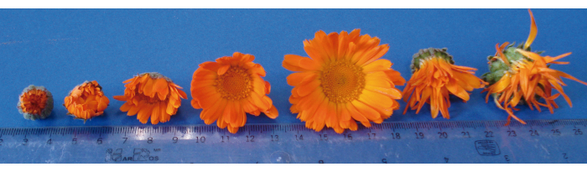
Figure 1: Stages of floral development in calendula. The figure illustrates the stages of floral development in Calendula officinalis L., commonly known as pot marigold. It provides a visual representation of the progression from the initial bud stage to the senescence of the flower head and the onset of fruit (achene) formation. Please click here to view a larger version of this figure.
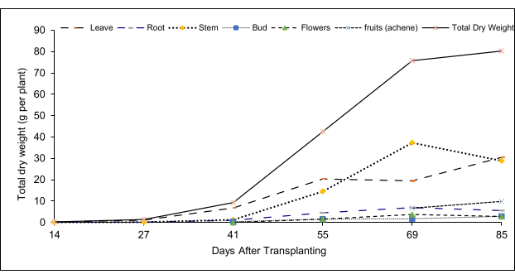
Figure 2: Biomass distribution kinetics in calendula. This figure illustrates how biomass is allocated among different plant organs over time, highlighting changes in biomass accumulation in various parts of the plant, such as stems, leaves, flowers, and roots. Please click here to view a larger version of this figure.
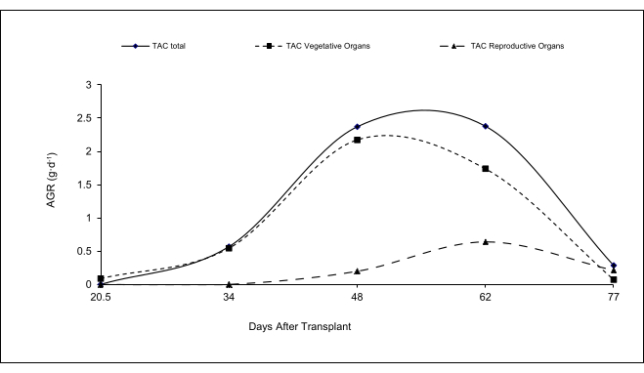
Figure 3: Sink strength kinetics (SS) of vegetative and reproductive organs in calendula across its cycle. This figure shows how the sink strength varies among the plant organs, such as stems, leaves, and flowers, from the beginning to the end of the plant's life cycle. Please click here to view a larger version of this figure.
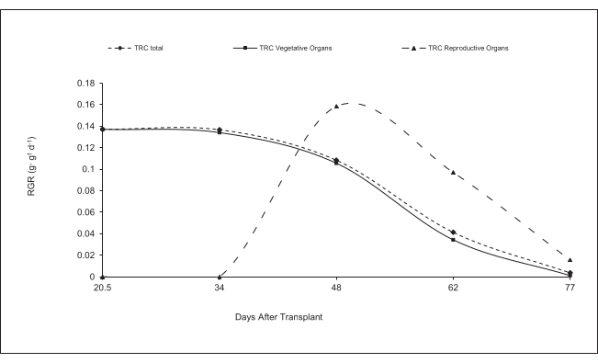
Figure 4: Kinetics of sink activity (SA) in vegetative and reproductive organs of calendula along its cycle. The figure illustrates how the level of activity associated with resource demand changes over time for different plant parts, such as stems, leaves, and flowers. It reflects the plant's shifting sinks from early growth stages to maturity and reproductive development. Please click here to view a larger version of this figure.
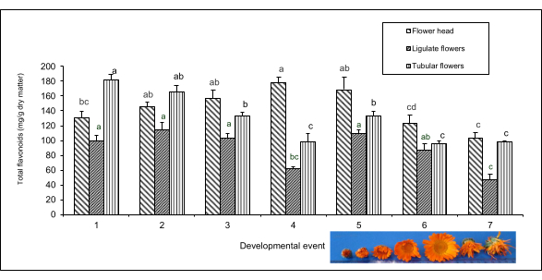
Figure 5: Total flavonoid concentration (mg/g of dry matter) during the floral development of calendula. The figure shows the amounts of flavonoids present in the dry matter of marigold flowers at different the development stages. This metric helps to learn how the flavonoid content evolves as flowers mature. Results are the means compared by the Tukey's HSD test (p > 0.05) n=5. Bars represent standard error. Different letters indicate significant differences. Please click here to view a larger version of this figure.
Table 1: Sequence of floral development events in calendula. This table helps to understand the progression of floral development in calendula, describing the stages from the initial bud formation to full bloom and fruit (achene) development. *Results are shown as mean ± standard error (n = 5). There were significant differences between treatments according to the analysis of variance (p ≤ 0.05).The different different letters indicate significant differences between the Tukey means test ( α = 0.05, n = 5). ND:Not detected.. Please click here to download this Table.
Table 2: Total flavonoid content in calendula flower heads throughout floral development. This table shows how the flavonoid concentration varies from the initial bud formation to full bloom and fruit (achene) development. The data highlights the optimal stages for harvesting and maximizing flavonoid content. Flavonoid production (g/plant) = [Dry weight of floral organ (g/plant) × Flavonoid concentration (mg/g) Please click here to download this Table.
Discussion
Two types of flowers, ligulate and tubular (Figure 5). We found that ligulate flowers contain a lower concentration of flavonoids than tubular flowers, with differences ranging from 11% to 53%. This indicates that tubular flowers accumulate more flavonoids than ligulate flowers, because the tubular flowers have more biomass and a higher concentration of these compounds.
When floral stages of l development were compared, it was found that the flavonoids concentration in ligulate flowers tended to remain constant, except at stages 10 and 13 in which, significant decreases were observed. In contrast, tubular flowers showed a continuous decline in flavonoid concentration throughout floral development, so that wilted flower heads barely had half the flavonoids found in younger flower buds with united sepals. These differences in flavonoid concentration across floral development stages suggest that maximum flavonoid synthesis occurs in stage eleven (mature flower head), possibly as a defense against herbivores^{18,19}. If flavonoid accumulation in the flower head were a result of importation from other organs (i.e., if synthesized elsewhere),probably the flower head could be accumulating flavonoids during fruit formation, as seeds require more metabolites than flowers. Differences in quercetin content between reproductive stages were found in guava (Psidium guajava), where flower buds had higher levels than the fruits²⁰.
Calendula exhibited sigmoid biomass accumulation kinetics both in the whole plant and in its organs. Stems accumulated the largest portion of the biomass produced by the plant, representing 46%, followed by leaves with 25%, fruits (achene)12%, roots 8.7%, floral buds 3.5%, and flower heads 4.6%.
In calendula the highest sink strength in the vegetative organs, while the sink activity is higher in the reproductive organs. The maximum leaf area was reached at 69 days after transplantand floral differentiation occurred in the fifth week after transplant. The highest concentration of total flavonoids in calendula flower heads was found between stages eight and eleven of floral development, which correspond to buds with separated sepals up to fully opened flower heads. The tubular flowers contributed more flavonoids to the flower head than ligulate flowers.
Critical steps in the protocol include ensuring relialable drying of plant material at 40 °C to prevent degradation of flavonoids, an accurate weighing of 25 mg of each pulverized sample, and careful handling of the reagent aluminum chloride to ensure accurate colorimetric reactions.
Modifications, such as adjusting incubation times for methanol extractions from specific plant tissues, were implemented to optimize flavonoid yield. Troubleshooting involved standardizing centrifugation speeds to ensure clear supernatant recovery for spectrophotometric analysis.
The technique, while robust, has limitations. It does not differentiate individual flavonoids and relies on a single wavelength measurement (415 nm), which could overlook compounds with overlapping absorbance spectra. Additionally, variations in tissue composition across developmental stages may influence the uniformity of flavonoid extraction, thus suggesting the convenience of further refinement¹⁴.
Compared to existing methods, such as HPLC or mass spectrometry, the aluminum chloride colorimetric method offers simplicity and cost-effectiveness. However, it sacrifices specificity for accessibility, making it suitable for high-throughput preliminary studies but less so for detailed flavonoid profiling.
Future applications of this technique include its integration into breeding programs for selecting calendula varieties with higher flavonoid content. It could be adapted also to screen for environmental stressors influencing flavonoid biosynthesis, providing insights into optimizing cultivation conditions for medicinal or commercial purposes. These adaptations would extend the utility of the method beyond calendula to other flavonoid-rich crops.
Disclosures
The authors have nothing to disclose.
Acknowledgments
We want to express our sincere gratitude to Dr. Manuel Jiménez Vasquez for his invaluable support in maintaining the plants in the field. His assistance was crucial to the success of this research.
Materials
Name | Company | Catalog Number | Comments
Air-circulating oven | Precision 17 GCA Corp. | N/A | Equipment
Bug clean | Alternagro | N/A | Control of agricultural pests with plant oils and extracts
Methanol analytical grade | merck | 822283 | Reagent
Nitrofoska special 12+12+17+2 MgO+8 S | EUROCHEM | 7/548/CEE,1999/45/CE | NPK - granular fertilizer contains: ammonium nitrate, ammonium salts, phosphates, calcium salts, potassium, in some cases magnesium and trace elements. 1H-Pyrazole, 3,4-dimethyl-,phosphate (1:1)
PHC Healthy Start | PHC Mexico | N/A | PHC Healthy Start 12-16-12 is a fertilizer to improve plant nutrition, color and vigor.
Quercetin | Sigma-Aldrich | 204-187-1 | Standard substance
DOWNLOAD MATERIALS LIST
References
- Vârban, D. A. N., Duda, M. M., Vârban, R., Muntean, S. The influence of the nutrition space upon the production, at Calendula officinalis L. in the conditions of Cluj. Napoca. At <https://agricultura.usab-tm.ro/Simpo2008pdf/Volumul%201/Sectiunea%201/50%20Varban%20Dan.pdf> (2006).
- Hindle, V. A., Mathijssen-Kamman, A.A., Stockhofe, N., Cone, J.W. The performance of young pigs fed different amounts of marigold (Calendula officinalis) meal; a pilot study. Netherlands J Agric Sci. 50, 83-94 (2002).
- Acosta De La Luz, L., Rodríguez, F. C., Sánchez, G. E. Instructivo técnico de Calendula officinalis. Rev Cuba Plantas Med. 6, 23-27 (2001).
- Komissarenko, N. Y., Chernobai, V. T.,Derkach, A. I. Flavonoids of inflorescences of Calendula officinalis. Chem Nat Compd. 24, 675-680 (1988).
- Neukirch, H., Ambrosio, M.D., Via, J.D., Guerriero, A. Simultaneous quantitative determination of eight triterpenoid monoesters from flowers of 10 varieties of Calendula officinalis L. and characterisation of a new triterpenoid monoester. Phytochem Anal. 15 (1), 30-35 (2004).
- Muley, B.P. et al. Phytochemical constituents and pharmacological activities of Calendula officinalis Linn (Asteraceae): a review. Trop J Pharm Res. 8, 455-465 (2009).
- Vella, F.M., Pignone, D., Laratta, B. The Mediterranean species Calendula officinalis and Foeniculum vulgare as valuable source of bioactive compounds. Molecules. 29, 1-23 (2024).
- Sapkota, B., Kunwar, P.A. A review on traditional uses, phytochemistry and pharmacological activities of Calendula officinalis Linn. Nat Prod Commun. 19(6), 1-22 (2024).
- Ejiohuo, O., Folami, S., Maigoro, A.Y. Calendula in modern medicine: advancements in wound healing and drug delivery applications. Eur J Med Chem Rep. 12, 100199 (2024).
- Olennikov, D.N., Kashchenko, N.I. New isorhamnetin glycosides and other phenolic compounds from Calendula officinalis. Chem Nat Compd. . 49, 833-840 (2013).
- Kurkin, V.A., Sharova, O.V. Flavonoids from Calendula officinalis flowers. Chem Nat Compd. 43, 216-217 (2007).
- Zhang, T., Elomaa, P. Development and evolution of the Asteraceae capitulum. New Phytol. 242, 33-48 (2024).
- Hunt, R., Causton, D.R., Shipley, B., Askew, A.P. A modern tool for classical plant growth analysis. Ann Bot. 90, 485-488 (2002).
- Chang, C., Yang, M., Wen, H., Chern, J. Estimation of total flavonoid content in propolis by two complementary colorimetric methods. J Food Drug Anal. 10 (3), 3 (2002).
- Meneses, R.J. et al. Optimización del proceso de extracción de flavonoides de flor de manzanilla (Matricaria recutita L.). Agrociencia. 42, 425-433 (2008).
- Albani, M.C., Coupland, G. Comparative analysis of flowering in annual and perennial plants. Curr Top Dev Biol. 91, 323-348 (2010).
- Bernier, G. The control of floral evocation and morphogenesis. Annu Rev Plant Physiol Plant Mol Biol. 39, 175-219 (1988).
- Chaves, N., Escudero, J.C. Variation of Flavonoid Synthesis Induced by Ecological Factors. In Principles and Practices in Plant Ecology.CRC Press, Boca Raton (1999).
- Treutter, D. Significance of flavonoids in plant resistance: a review. Environ Chem Lett. 4, 147-157 (2006).
- Vargas, D. et al. Cinética de acumulación y distribución de flavonoides en guayaba (Psidium guajava L.). Agrociencia. 40, 109-115 (2006).

