Submission ID #: 67563

Scriptwriter Name: Nilesh Kolhe

Project Page Link: https://review.jove.com/account/file-uploader?src=20606763

Title: Application of Microwave Ablation in Laparoscopic Partial Splenectomy

Landing Page Title (not for video use): Reducing Bleeding in Laparoscopic Partial Splenectomy with Microwave Ablation

☐ The Landing Page Title is correct. (Character limit with spaces: 80)

Authors and Affiliations: Zhiwei Chen, Zhilong Liu

Department of Hepatobiliary Surgery, The First Affiliated Hospital, Jinan University

☐ All author names and affiliations are correct (city/state/country information not included in video title page).

Corresponding Authors:
Zhilong Liu eddyliu1982@163.com

Email Addresses for All Authors:
eddyliu1982@163.com

maxczw@163.com

Author Questionnaire
1. We have marked your project as author-provided footage, meaning you film the video yourself and provide JoVE with the footage to edit. JoVE will not send the videographer. Please confirm that this is correct.
√ Correct
☐ Incorrect

2. Microscopy: Does your protocol require the use of a dissecting or stereomicroscope for performing a complex dissection, microinjection technique, or something similar? No
If a dissection or stereo microscope is required for your protocol, please list all shots from the script that will be visualized using the microscope (shots are indicated with the 3-digit numbers, like 2.1.1, 2.1.2, etc.).
Click here to list microscope shots, using the shot numbers from the protocol section of the video script.

3. Software: Does the part of your protocol being filmed include step-by-step descriptions of software usage? No
If Yes, we will need you to record using screen recording software.
We recommend using the screen capture program OBS. JoVE’s tutorial for using OBS Studio is provided at this link: https://review.jove.com/v/5848/screen-capture-instructions-for-authors?status=a7854k

As these files are necessary for finalizing your script, please upload all screen captured video files to your project page as soon as possible.

4. Proposed filming date: To help JoVE process and publish your video in a timely manner, please indicate the proposed date that your group will film here: 10/11/2024

DO NOT use this draft script for filming. Please wait until your script is finalized to begin the filming process.

When you are ready to submit your video files, please contact our China Location Producer, Yuan Yue.

To ensure that your script can be filmed in one day, the protocol sections are cumulatively restricted to 55 shots (shots are the 3-digit numbers like 2.1.1, 2.1.2…etc)

Current Protocol Length
Number of Steps: 14
Number of Shots: 28

Interviews
- Video 1: Author Spotlight: Title (Filled by scriptwriter during script finalization)
Ethics Title Card
This research has been approved by the Medical Ethics Committee of the First Affiliated Hospital of Jinan University. Informed consent was obtained from the patient

Answers to these questions will become interview statements that you will deliver on camera.
- Answer the 1st REQUIRED question and at least 2 other questions (1.2 – 1.10) below. Up to 5 interview statements will be included in the video.
- Enter the full name of the author who will deliver the statement.
- If possible, each author should deliver no more than two statements.
- Answer in full sentences, in a style suitable for being spoken aloud.
- Limit the length of each statement to 50 words or fewer.
- Answers will be edited for length, clarity, and consistency with journal style guidelines.

REQUIRED: What is the scope of your research? What questions are you trying to answer?
  - Zhilong Liu: The scope of my research is how to reduce bleeding and postoperative complications in laparoscopic partial splenectomy.We found microwave ablation to be an effective adjunct to hemostasis.

What are the most recent developments in your field of research?
  - Zhilong Liu: The treatment of benign splenic tumors is gradually treated with laparoscopic surgery, and laparoscopic partial splenectomy is increasingly recognized because of its lack of trauma.
What technologies are currently used to advance research in your field?
  - Zhilong Liu: Microwave ablation can quickly coagulate tissues and reduce bleeding during parenchymal tumor resection, and is suitable for laparoscopic partial dermatomectomy.
What are the current experimental challenges?
  - Zhilong Liu: At present, many surgeons are still not proficient in microwave ablation, which limits the use of this technique in laparoscopic partial splenectomy.

What significant findings have you established in your field?
  - Zhilong Liu: When using a microwave ablation needle, it is important to pay attention to the position of the needle tip, as the penetration of the needle tip into the target tissue can easily cause thermal damage to the surrounding organs.

What research gap are you addressing with your protocol?
  - Zhiwei Chen: At present, there are still few hospitals that use microwave ablation to assist laparoscopic partial splenectomy, and we have accumulated a lot of experience to make full use of this technique.

What advantage does your protocol offer compared to other techniques?
  - Zhiwei Chen: Our method achieves almost zero bleeding during splenectomy.
How will your findings advance research in your field?
  - Zhilong Liu: Our experience will be passed on to more peers through publications and academic conferences to advance the development of this technology.
What new scientific questions have your results paved the way for?
  - Zhilong Liu: Our results reconfirm the safety and efficacy of laparoscopic partial splenectomy
What research questions will your laboratory focus on in the future?
  - Zhilong Liu: We will further investigate whether microwave ablation is suitable for the surgical treatment of benign tumors of the pancreas

Protocol Videos
Each video will include a section of your protocol and accompanying results, if applicable. Use Track Changes when making edits or revisions.
- The two-digit steps (e.g., 2.1., 2.2.) are the narration. Professional voiceover artists will narrate the video.
- Red and italics are pronunciation guides (how the word will be spoken).
- Filming should take no more than 10 minutes per step. If a step takes more than 10 minutes, prepare the product from that step in advance.
Protocol:
- The three-digit shots (e.g., 2.1.1., 2.2.2.) are the actions that you/your videographer will capture.
Representative Results:
- The three-digit numbers (e.g., 2.3.1., 2.3.2.) are the figures/tables from your manuscript. These will not be recorded by the videographer.
- Please review the result section to make sure it logically follows the video.
- Please note that the video cannot include voiceover without an accompanying visual.

- Video 2: Laparoscopic Splenectomy with Microwave Ablation for Splenic Hemangioma
Demonstrator: Zhilong Liu
Ethics Title Card
Procedures involving human subjects have been approved by the Medical Ethics Committee of the First Affiliated Hospital of Jinan University. Informed consent was obtained from the patient
Protocol
  - To begin, review the MRI (M-R-I) image of the selected patient to assess the tumor's location, size, and nearby blood vessels [1].
    - WIDE: Establishing shot of talent observing the MRI image of the patient on a computer with a monitor/screen visible in the frame.
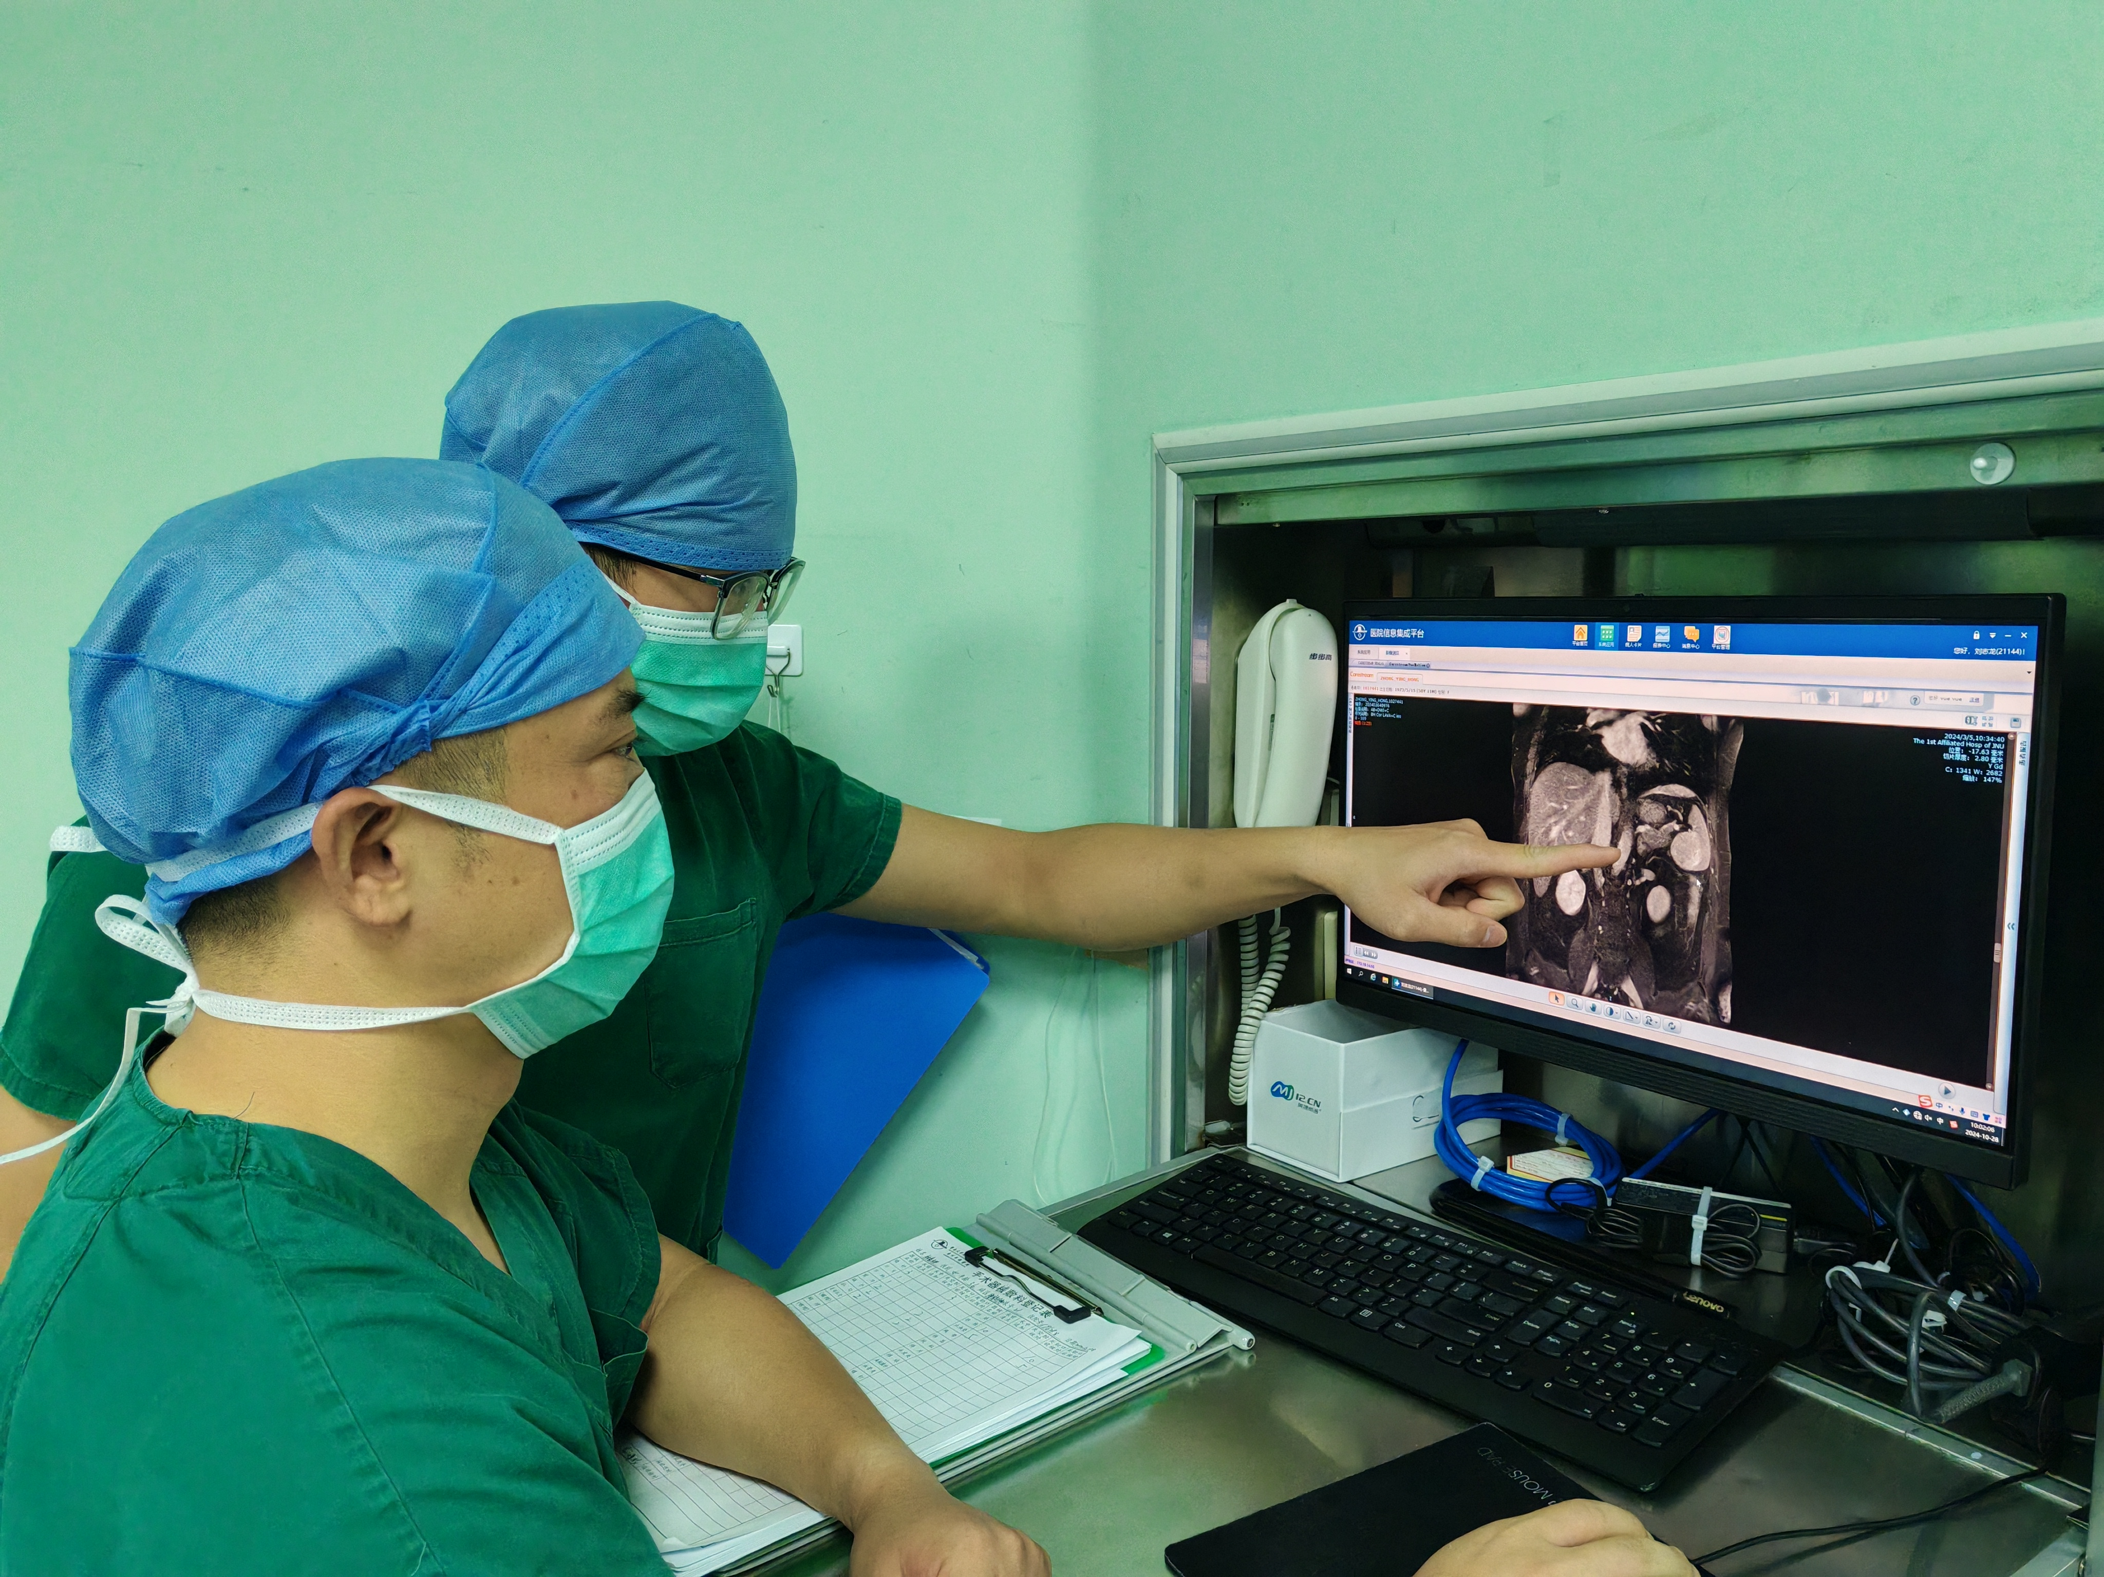

  - After anesthetizing the patient, perform an internal jugular venipuncture to place a 7 French intravenous catheter with ultrasound guidance [1]. Puncture the radial artery using a 21 gauge arterial indwelling needle for arterial pressure detection [2].
    - Talent creating an internal jugular venipuncture and placing a 7 French intravenous catheter.
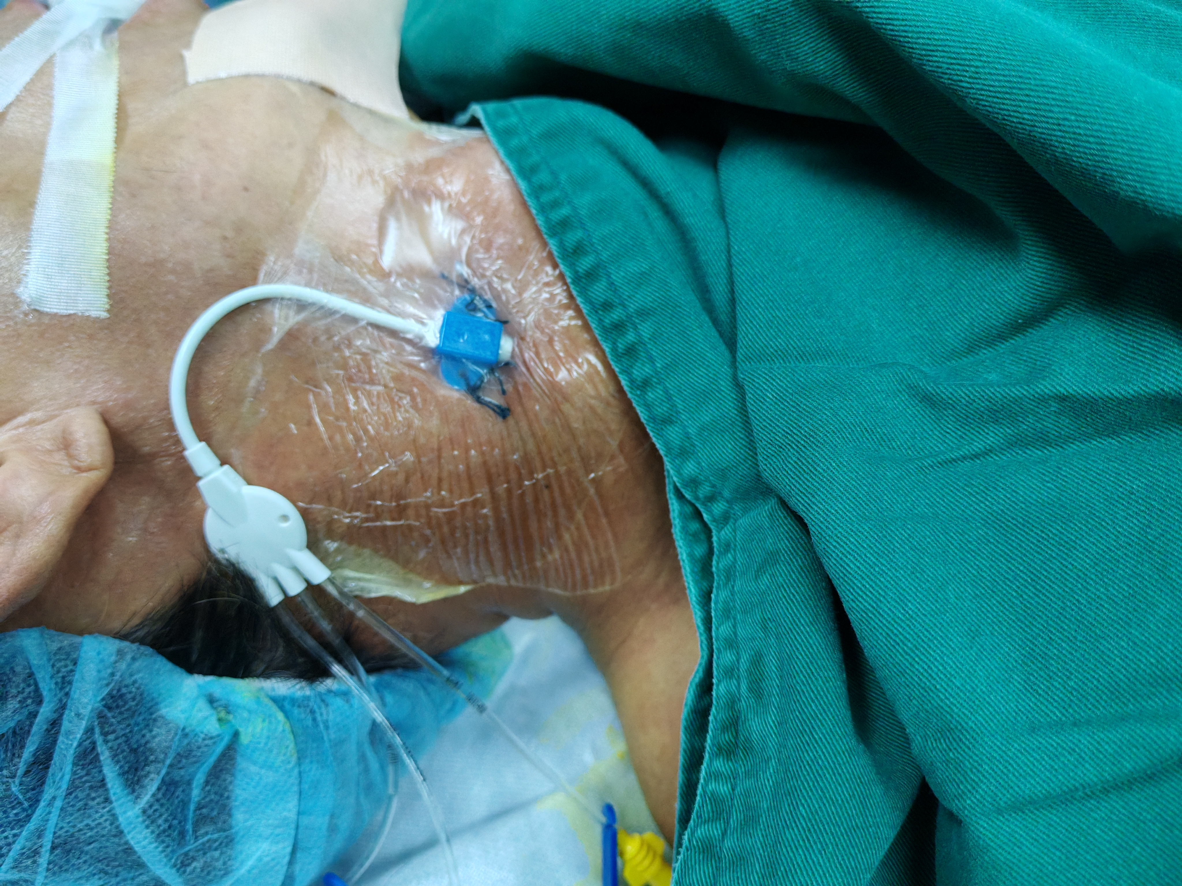
    - Talent puncturing the radial artery with the 21 gauge indwelling needle.
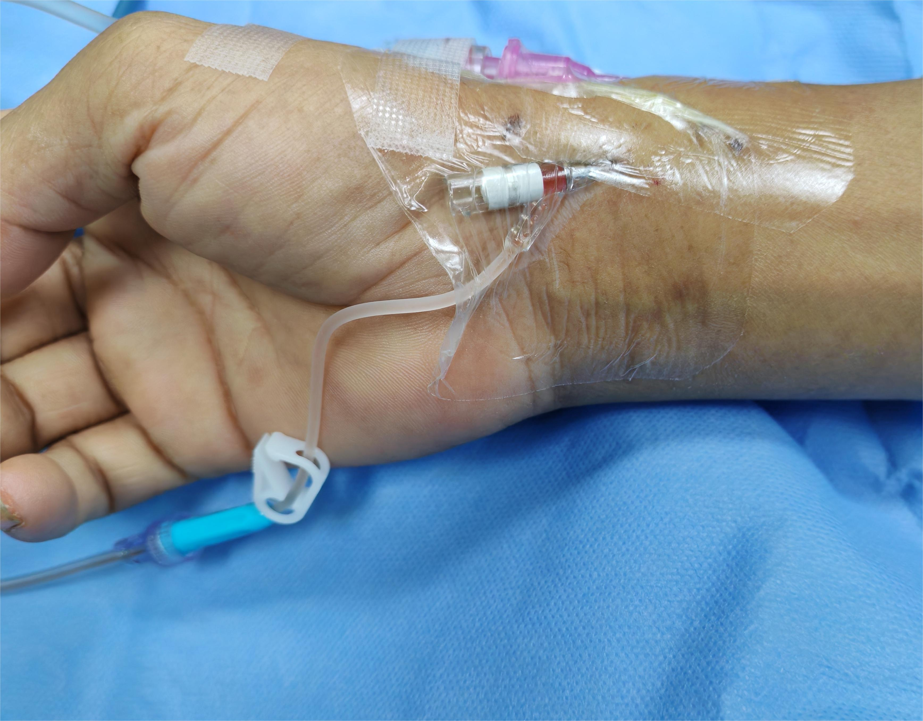

  - Insert a 16-French gastric tube and a 16-French urinary tube into the patient [1]. Administer 1 gram of Latoxef (/luh-TOX-ef/) antibiotics 30 minutes before surgery to prevent infection [2].
    - Talent inserting a 16-French gastric tube and a 16-French urinary tube into the patient.
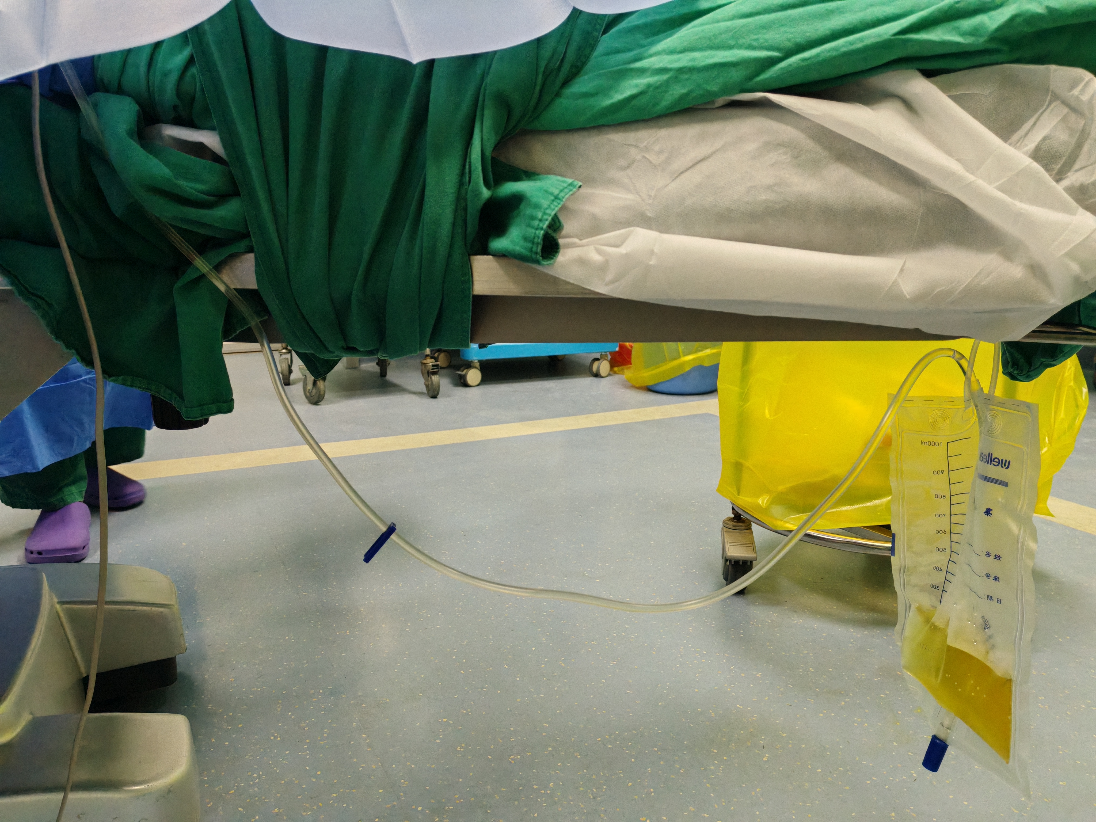
    - Talent administering 1 gram of Latoxef antibiotics through the intravenous catheter.
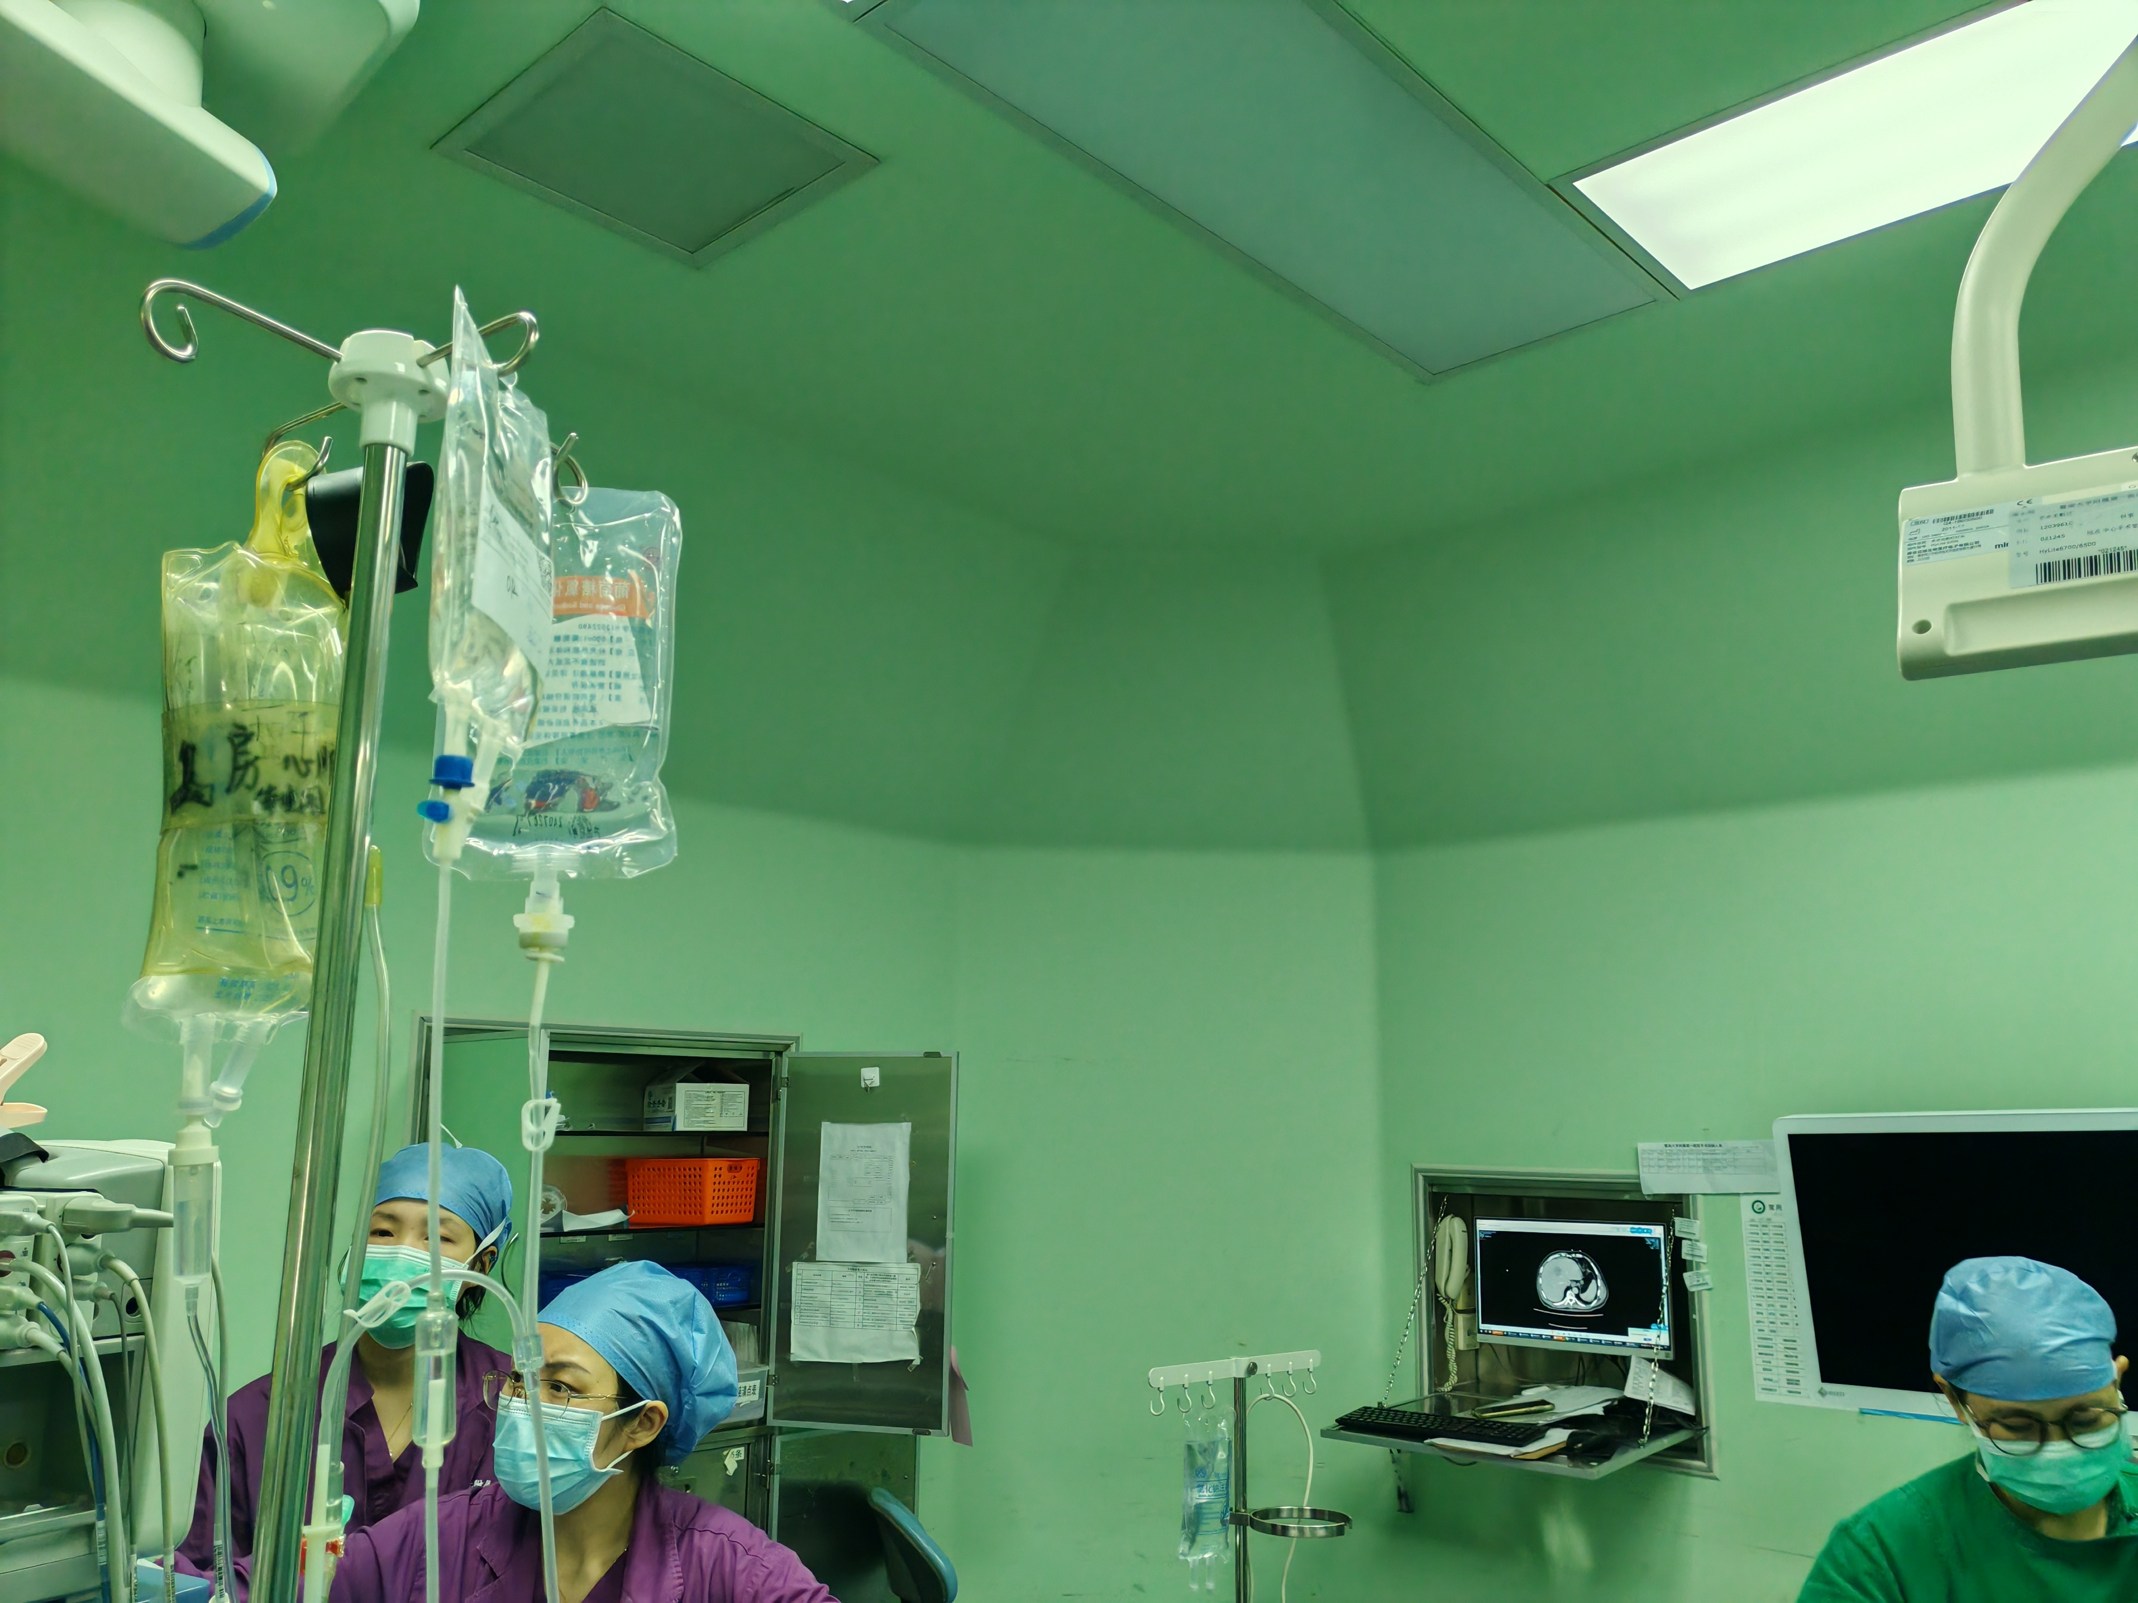

  - Ask the patient to lie down in a right-inclined position, ensuring the head is 10 to 30 degrees lower than the feet, and the thighs are 50 to 60 degrees apart [1-TXT].
    - Talent positioning the patient in the right inclined position with the head inclined downward and thighs apart. TXT: Adjust the position based on the intraoperative situation
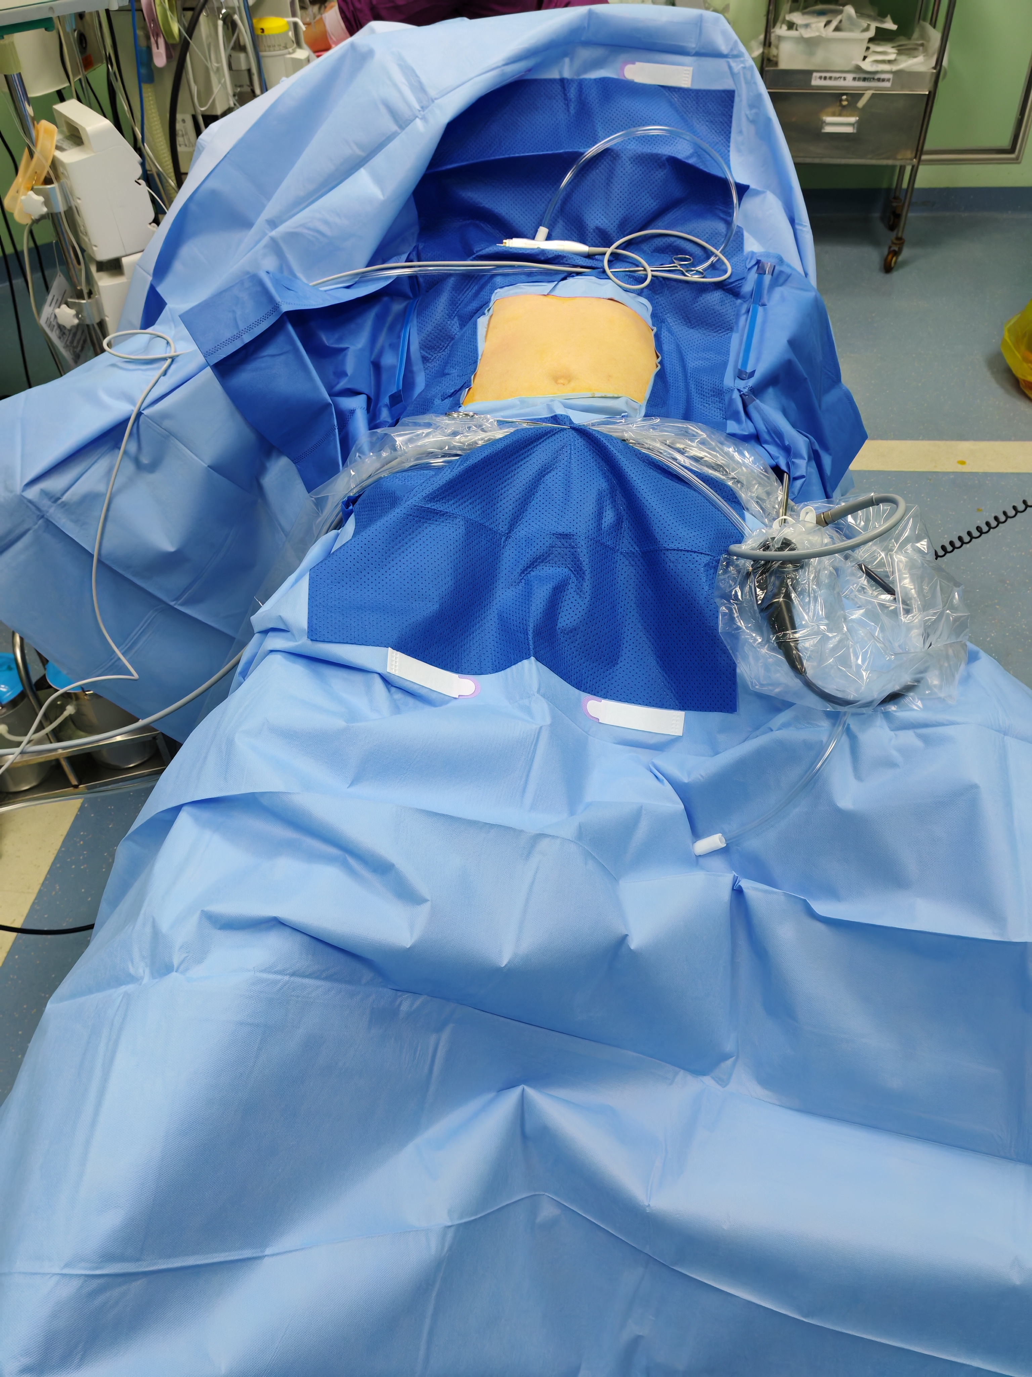

  - Position the operators with the first surgeon standing on the patient’s right side, the second surgeon on the opposite side, and the camera operator positioned between the legs [1].
    - Shot of the operating room showing the positions of the first surgeon, second surgeon, and the camera operator around the patient.
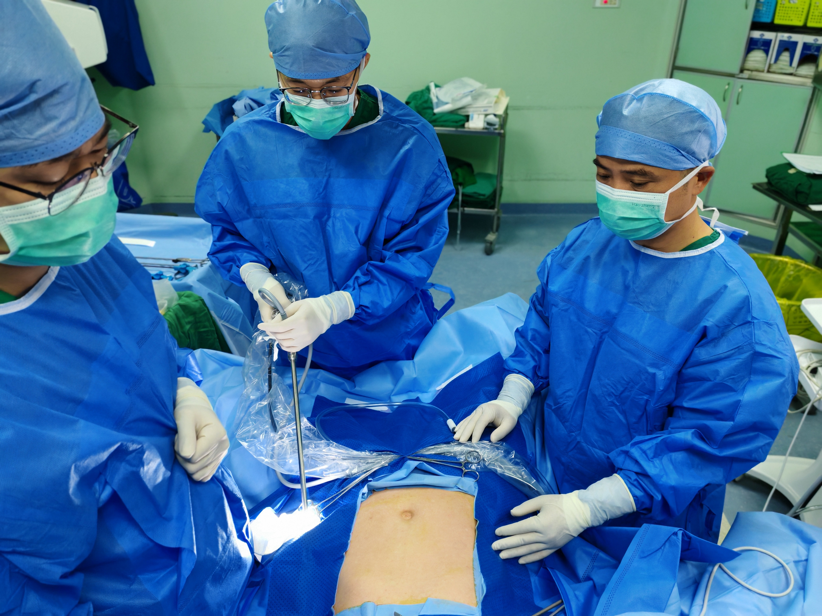

  - Next, set the pneumoperitoneum (/noo-mo-per-i-toh-NEE-um/) pressure of 12 millimeters of mercury [1]. Using the 5-hole method, create a 10-millimeter observation hole at the lower umbilical margin [2] and insert a 30-degree laparoscope [3].
    - Monitor showing pneumoperitoneum pressure being set to 12 millimeters of mercury.
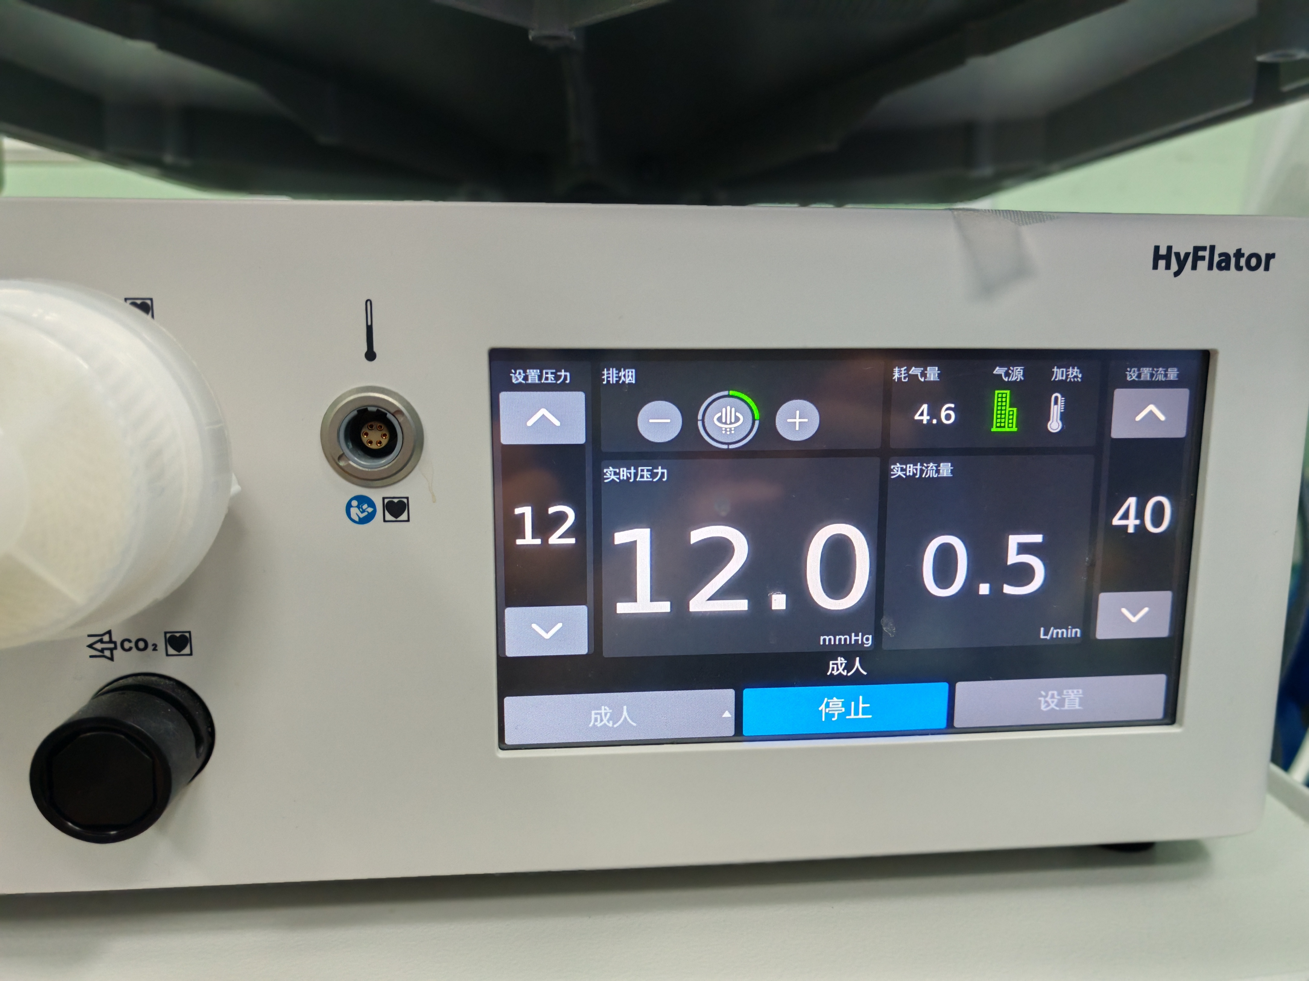
    - Talent creating the 10-millimeter observation hole.
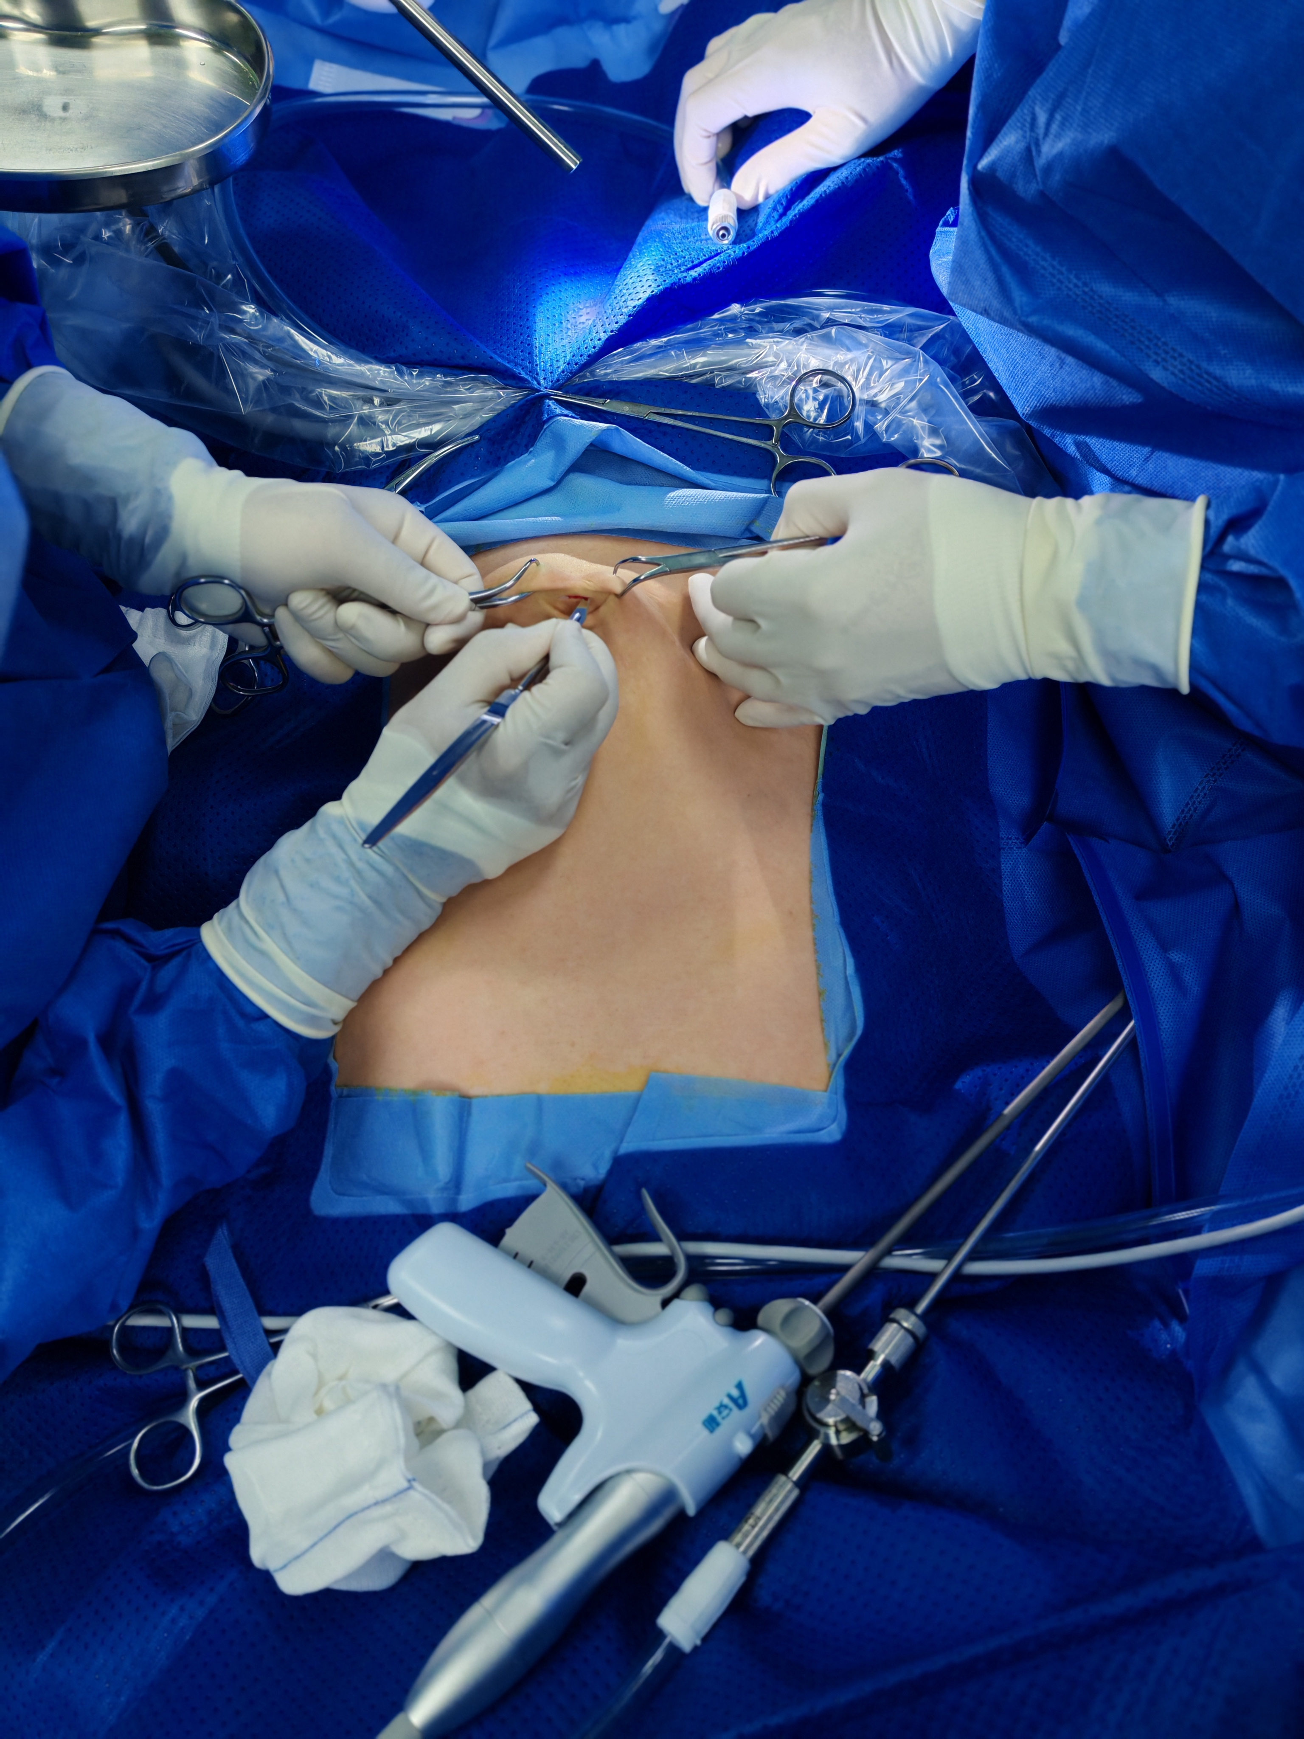
    - Talent inserting the laparoscope.
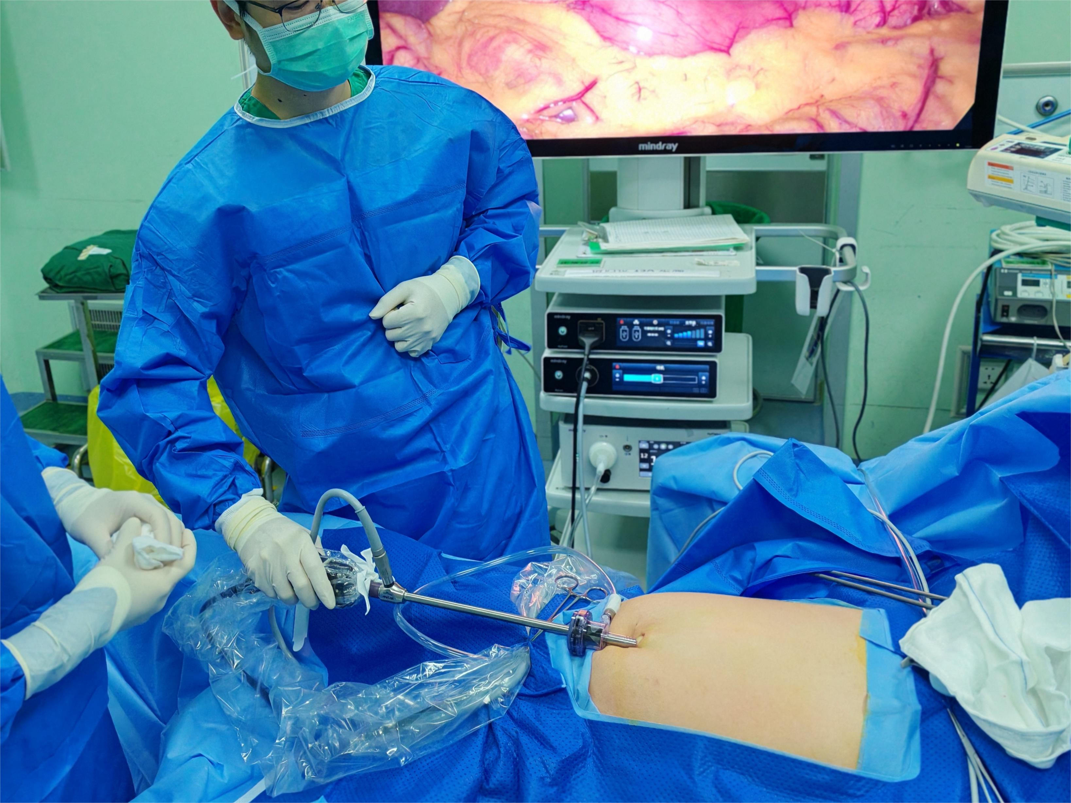

  - Then, establish a 12-millimeter primary operating hole at the right linea pararectalis (/LIN-ee-uh par-uh-REK-tal-iss/) umbilicus (/uhm-BIL-ih-kuhs/) level [1]. Create 5-millimeter auxiliary holes at the right mid-clavicular line below the costal margin, the left anterior axillary line below the costal margin, and the left linea pararectalis umbilicus level [2].

    - Talent creating a 12 mm primary operating hole at the right linea pararectalis umbilicus level.
    - Talent creating the auxiliary operating holes at specified anatomical points.
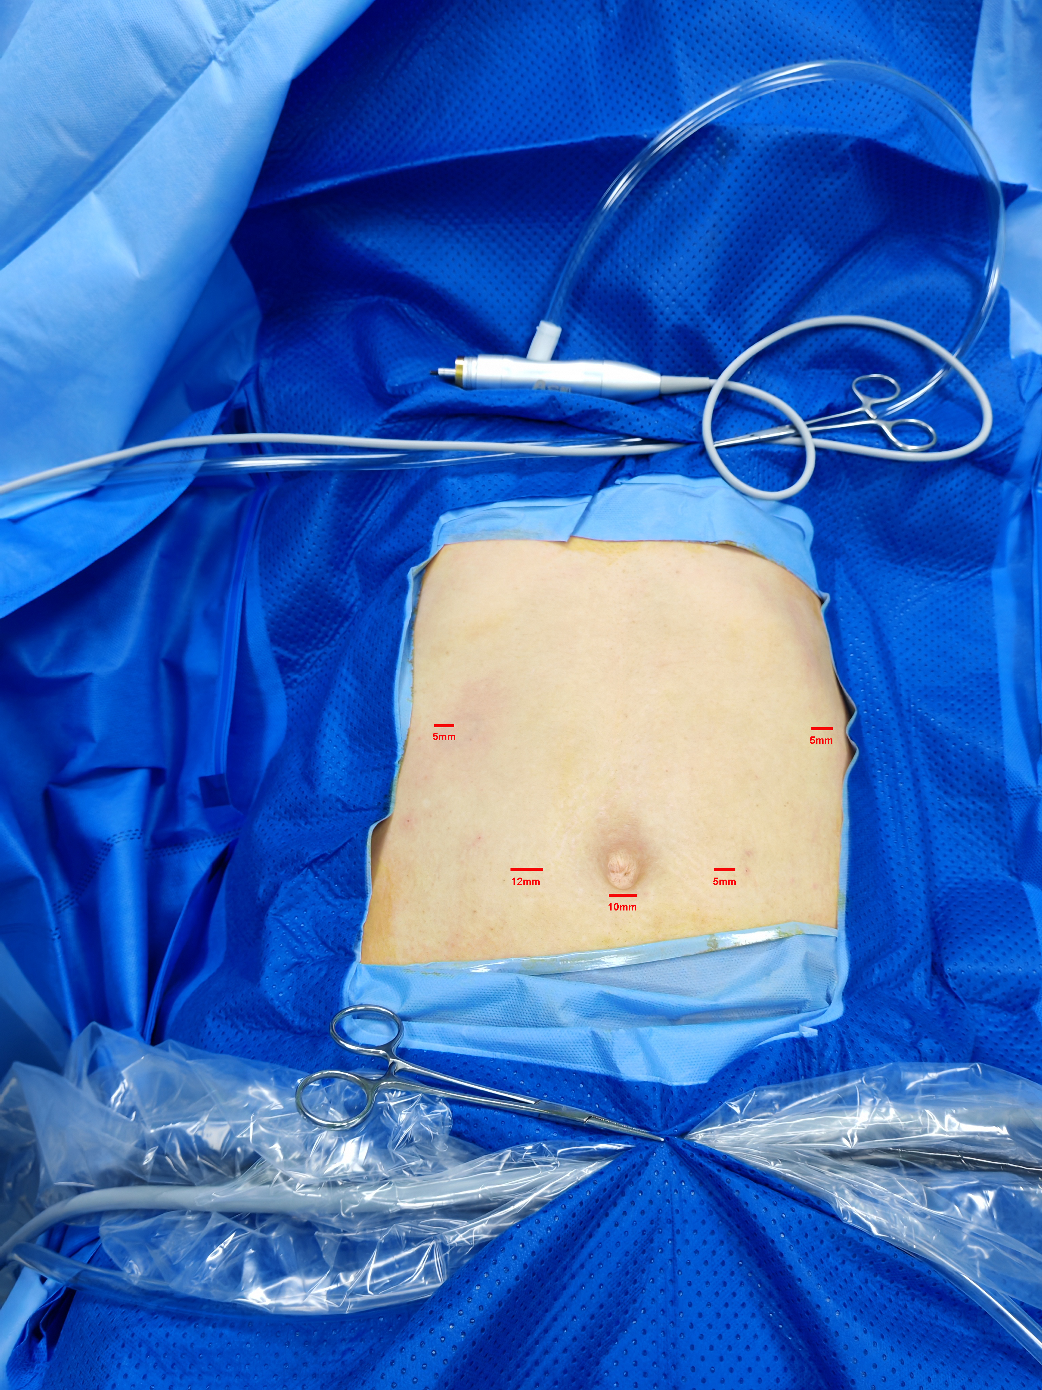
Surgical Procedure
  - Use an ultrasonic knife to open the left gastrocolic ligament [1]. Separate the gastrosplenic ligament to reveal the splenic portal [2] while ligating the short gastric arteries during dissection [3].
    - Talent using the ultrasonic knife to open the left gastrocolic ligament.
*Video 1 from 06:30 to 19:50
    - SCOPE: Separating the gastrosplenic ligament.
*Video 1 from 20:06 to 28:25

    - SCOPE: Ligating the short gastric arteries.
*From 28:25 to 29:30 in video 1

  - Isolate the lower pole branch of the spleen pedicle and ligate them with Hem-o-Lok clamps [1]. Dissect the splenic artery to identify the branches supplying blood to the tumor [2].
    - SCOPE: Isolating the lower pole branch of the spleen pedicle and Hem-o-lock clamps being placed on the branches.
*Starts at 1:37 on video 1 and ends at 21:10 on video 2
    - SCOPE: Dissecting the splenic artery and identifying tumor-supplying blood vessels.
*From 35:54 to 42:58 in video 2

  - Next, reveal the splenic hemangioma (/hee-man-jee-OH-muh/) [1]. Separate the splenocolic (/splee-noh-KOH-lik/) ligaments from the lower outer side of the spleen [2], and then separate the splenorenal (/splee-noh-REE-nuhl/) ligaments from behind the spleen to fully free the target area [3].
    - SCOPE: Splenic hemangioma being exposed.
*From 21:40 to 22:15 in video 2

    - SCOPE: Separating the splenocolic ligaments from the spleen.
*From 22:15 to 27:15 in video 2

    - SCOPE: Detaching the splenorenal ligaments from the back of the spleen to free the area.
*From 28:50 to 30:35 in video 2

  - Identify the ischemic line between the normal spleen tissue and the fraction lacking blood supply [1].
    - SCOPE: Shot of identified ischemic line between the normal spleen tissue and the fraction lacking blood supply.
*From 34:25 to 36:00 in video 3

  - Next, insert a percutaneous microwave ablation needle [1]. Coagulate the spleen tissue in phases with microwave ablation, using 60 to 80 watts of power for 3 minutes. Ensure the needle tip does not penetrate the spleen parenchyma, and that the ablation area remains in the same plane [2].
    - SCOPE: Needle being inserted along the ischemic line.
*From 36:20 to 36:45 in video 3

    - SCOPE: Performing phased ablation, adjusting the needle depth, and a shot of tissue ablation.
*Starts at 36:45 on video 3 and ends at 14:20 on video 4

  - Divide the spleen along the coagulation zone [1]. Check for bleeding in the splenic section and observe the blood supply to the residual spleen [2].
    - SCOPE: Cutting along the coagulated zone to divide the spleen.
*From 16:00 to 25:52 in video 4
    - SCOPE: Checking for bleeding in the splenic section and showing blood supply to the remaining spleen.
*From 26:30 to 31:20 in video 4

  - Finally, insert a splenic fossa drainage tube [1]. Remove the splenic tumor specimens from the extended umbilical incision [2]. Suture the surgical incision in layers to complete the surgery [3].
    - Talent placing the splenic fossa drainage tube.
*From 41:05 to 43:40 in video 4
    - SCOPE: Extracting splenic tumor specimens through the umbilical incision.
*There is no record
    - Talent performing layered sutures to close the incision.
*There is no record
Representative Results
  - Hematoxylin and eosin staining showed splenic tissue with infarction [1], while CD34 (C-D-thirty-four) immunohistochemistry staining confirmed the diagnosis of splenic hemangioma [2].
    - LAB MEDIA: Figure 4B
    - LAB MEDIA: Figure 4C

  - Postoperative computed tomography scans 1 month after surgery showed good residual blood circulation in the spleen [1].
    - LAB MEDIA: Figure 4D-E Video Editor: Highlight the outlined region in red from all images

