PROTOCOL TITLE:
Climbing Behavior of Drosophila melanogaster Larvae in Response to Hypoxia

AUTHORS AND AFFILIATIONS:
Siddarth Gunnala¹, Nafisa M. Jadavji^{2,3,4}

¹Department of Biomedical Sciences, Midwestern University, Glendale, AZ, USA
²Division of Integrative and Molecular Physiology, Department of Biomedical Sciences, Southern University of Illinois, Carbondale, IL, USA
³Department of Child Health, College of Medicine Phoenix, University of Arizona, Phoenix, AZ, USA
⁴Department of Neuroscience, Carleton University, Ottawa, ON, Canada

Email address of the co-author:
Siddarth Gunnala (siddarth.gunnala@midwestern.edu)

*Email address of the corresponding author:
Nafisa M. Jadavji (nafisa.jadavji@siu.edu)

PROTOCOL OVERVIEW:
Drosophila melanogaster have oxygen-sensing regulation systems, which allow the study of hypoxia-based pathologies in humans using a fly model. They are an effective model for studying hypoxia pathways due to their centralized brain. Prior literature has established an escape behavior that occurs in fly larvae in the absence of oxygen. In conditions of normal levels of oxygen (normoxia), larvae burrow downward into food using their mouth hooks until they have burrowed beyond their ability to get surface-level oxygen. At this point, they return to the surface to re-oxygenate before repeating this process again. The climbing behavior is observed when larvae rapidly respond to hypoxic conditions by leaving their normal feeding positions and initiating exploratory behaviors^{1,2}. In conditions of hypoxia, there is a lack of oxygen even from resurfacing, causing the larvae to express an escape climbing behavior out of the food. These changes in behavior are governed by sensory neurons to activate physiological and behavioral responses in the larvae. There are alterations in cell signaling pathways that have been described in the literature^{1,2}. This protocol shows a method to test hypoxia in Drosophila melanogaster larvae by assessing their climbing behavior out of the fly food. Using this technique, researchers can confirm that fly larvae are experiencing oxygen deprivation. The example protocol demonstrated the setup for this assay.

PROTOCOL:

1. Experimental preparation

1.1 Prepare fly food ahead of time and add it in equal portions to fly vials.

1.2 Store the portioned fly food vials in a designated fridge until the beginning of the experiment.

NOTE: Standard fly food consists of a mixture of corn syrup, molasses, agar, soy flour, and yeast³.

1.3 Set up experimental Drosophila melanogaster in a controlled environment that has standard temperature, humidity, and light-dark cycles.

1.4 Place Drosophila melanogaster flies in vials with food for at least 7 days to a maximum of 9 days in the incubator.

NOTE: This gives adequate time for larvae to develop in the fly food at the bottom of the vial. Flies in the same vial for more than 10 days cannot be used, as the progeny will likely be mixed with parents.

2. Hypoxia incubator preparation

2.1 Prior to incubator calibration of oxygen levels, place flies with their food vials into the chamber.

2.2 Place LED flashlights in the chamber to illuminate the incubator

NOTE: This is to help visualize the escape behavior within the chamber, as well as regulate the Drosophila melanogaster’s circadian rhythm.

3. Hypoxia chamber calibration

3.1 Pre-set the hypoxia chamber to a temperature of 26 °C and a carbon dioxide concentration of 0% to 0.1% CO₂.

3.2 Set the desired oxygen concentration to 1% O₂.

3.3 Allow the hypoxia chamber to equilibrate the selected parameters.

NOTE: It can take approximately 20–30 min for the chamber to reach 1% oxygen, as nitrogen gas needs to be pumped into the chamber to reduce the levels of oxygen.

4. Larvae escape visualization

4.1 Once the chamber reaches 1% O_{2,} open the outer chamber door.

NOTE: The O₂ levels will not decrease with the main chamber door being opened, as there is an inner transparent door that maintains the oxygen levels in the chamber.

4.2 Start a timer when the chamber door opens; this will be time 0 min.

NOTE: The beginning of the experiment (time 0) starts post-calibration of the chamber when the desired oxygen (1%) concentration is present.

4.3 While using the transparent door to maintain hypoxia in the chamber, count the number of larvae climbing out of the fly food along the walls of the vial.

NOTE: The fly food has a fairly flat surface and can be used as a border to distinguish between larvae out of the food and in the food.

4.4 Through the use of the timer, count the number of larvae again at the 10 min mark.

5. Normoxia experiment

5.1 Repeat step 1 and step 2.

5.2 Do not activate the hypoxia chamber and allow it to sit in normal atmospheric conditions (21% O₂ levels).

5.3 Wait the same amount of time as it takes for the chamber to equilibrate to hypoxia.

5.4 Perform larvae counts at time 0 and time 10, similar to before.

REPRESENTATIVE RESULTS:
Representative images of larvae in fly vials under normoxic and hypoxic conditions are shown in Figure 1A. Under a condition of hypoxia, larvae escape the food at the bottom of the vial and continue to climb up the sides of the vial. Figure 1B shows an image of the chamber set up during the hypoxia experiment and how data was collected using the transparent door.

The number of larvae outside of the food in the vials was recorded after the chamber was calibrated to 1% O₂⁴. The number of larvae was recorded at time 0 min (Figure 2A, p = 0.0001) and time 10 min (Figure 2B, p = 0.0002) for both normoxic and hypoxic conditions. At both time points, there were significant increases in the number of larvae outside of the food for hypoxic fly groups compared to normoxic fly groups; this is a positive result. For data collected at times 0 and 10, hypoxia exposure resulted in a notable number of larvae climbing outside the fly food compared to normoxia, per the experiment parameters.

FIGURES:

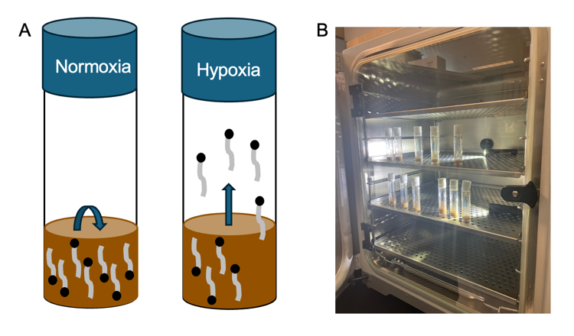

Figure 1
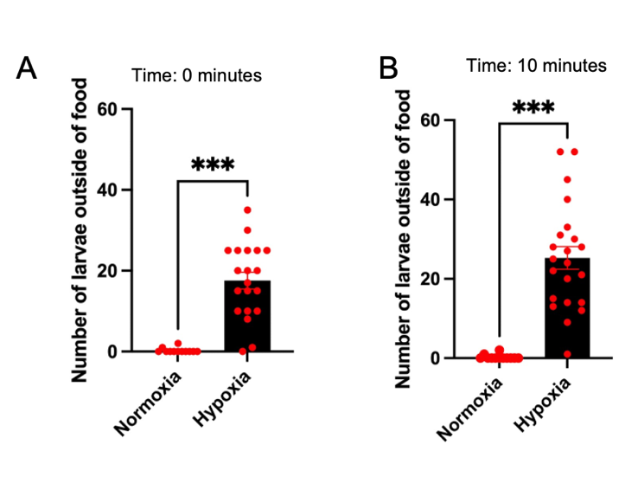

Figure 2

FIGURE LEGENDS:

Figure 1: Representative images of flies in vials and a chamber. Flies in vials with food under normoxic (A) and hypoxic (B) conditions. Image of larvae in the hypoxia chamber during hypoxia experiments using the clear transparent door to take measurements of larvae outside of food at timed points.

Figure 2: Representative data of the number of larvae outside food at time 0 (A) and 10 (B) min. ***p < 0.0001, unpaired t-test. This demonstrates a significant presence of larvae outside of the fly food for flies subjected to hypoxia compared to flies kept in normoxia. This figure is adapted from Gunnala et al.⁴.

DISCUSSION:
This protocol uses the behavioral response to changes in environmental oxygen to confirm that Drosophila melanogaster larvae and/or adults are being exposed to hypoxia. Maintaining room temperature and humidity levels ensures that significant changes in either of these metrics are not the primary drivers of this larval behavior above hypoxia. However, the protocol can be adjusted and used to test how changes in temperature and/or humidity can affect this larva's response to hypoxia. These potential future studies could even be correlated with existing epidemiological studies to better understand how hypoxia sensitivity is different in dry/humid or hot/cold regions of the world. This could help public health understand the different risks of stroke in different regions of the world.

The time point of development at which larvae are exposed to hypoxia is set such that they are beyond initial instar stages, developed enough to articulate around the fly vial, but not too late to where they are about to hit pupation. However, using different larval stages in this protocol could also elucidate at what stage of development in the larvae they are the most/least sensitive to changes in oxygen.

The lowest level of CO₂ that the chamber can achieve is 0.1%, which is still higher than atmospheric carbon dioxide levels at 0.04%⁵. The effects of hypercapnia on Drosophila melanogaster have shown that there is no change in gene expression, fly life cycle, or cell viability^{6,7}. Furthermore, the absolute concentration of available CO₂ depends on the ratio of CO₂ and O_{2.} Levels of CO₂ greater than 35% are used to anesthetize flies.

The behavioral measurement can be applied to different experimental questions. In the presented data, we confirmed that adult flies were being exposed to hypoxia⁴, in order to confirm that experimental manipulations could be studied.

TABLE OF MATERIALS:

Name of Material/ Equipment | Company | Catalog Number
C170i, Std, Right, O2, 120 V US/JP | Eppendorf | NC1942454
Narrow Plastic Vials, Drosophila Closures | Genesee | 49-102
Narrow Drosophila Vials, | Genesee | 32-116
LED Pocket Light | Fisher Scientific | 19012018
Four Channel Timer | Fisher Science | 1464917

REFERENCES:
1. Morton, D. B. Behavioral responses to hypoxia and hyperoxia in Drosophila larvae: Molecular and neuronal sensors. Fly. 5 (2), 119–125 (2011).
2. Wingrove, J. A., O’Farrell, P. H. Nitric oxide contributes to behavioral, cellular, and developmental responses to low oxygen in Drosophila. Cell. 98 (1), 105–114 (1999).
3. Bloomington Drosophila Stock Center. Bloomington Drosophila Stock Center. at <https://bdsc.indiana.edu/information/recipes/index.html>.
4. Gunnala, S. et al. Increased dietary levels of folic acid reduce survival and alters climbing behaviors 24 hours after hypoxia in male and female Drosophila melanogaster. Behav Brain Res. 115941, doi: 10.1016/j.bbr.2025.115941 (2025).
5. Carbon dioxide in Earth’s atmosphere. Wikipedia. at <https://en.wikipedia.org/w/index.php?title=Carbon_dioxide_in_Earth%27s_atmosphere&oldid=1219299948#cite_note-www.noaa.gov-2022-1> (2024).
6. Helenius, I. T. et al. Elevated CO₂ suppresses specific Drosophila innate immune responses and resistance to bacterial infection. Proc NatlAcadSciUSA. 106 (44), 18710–18715 (2009).
7. Krishnan, K. S., Chakravarty, S., Rao, S., Raghuram, V., Ramaswami, M. Alleviation of the temperature-sensitive paralytic phenotype of shibire(ts) mutants in Drosophila by sub-anesthetic concentrations of carbon dioxide. J Neurogenet. 10 (4), 221–238 (1996).

