Submission ID #: 66853

Scriptwriter Name: Poornima G

Project Page Link: https://review.jove.com/account/file-uploader?src=20390213

Title: Construction and Application of Cerebral Functional Region-Based Cerebral Blood Flow Atlas using Magnetic Resonance Imaging-Arterial Spin Labeling

Landing Page Title (not for video use): MRI-Arterial Spin Labeling Integration to Detect and Monitor Cerebral Blood Flow Distribution of Cerebral Functional Region

☐ The Landing Page Title is correct. (Character limit with spaces: 80) MRI-Arterial Spin Labeling Integration to Detect and Monitor Cerebral Blood Flow Distribution of Cerebral Functional Region

Authors and Affiliations:

Zhongjian Tan¹, Fangliang Xing^{2*}, Liping Zhang^{1*}

¹Department of Radiology, Dongzhimen Hospital, Beijing University of Chinese Medicine

²Beijing Intelligent Entropy Science& Technology Co Ltd

☐ All author names and affiliations are correct (city/state/country information not included in video title page). Yes

Corresponding Authors:
Liping Zhang 10000@163.com

Fangliang Xing wordnet@163.com

Email Addresses for All Authors:
Zhongjian Tan tzj_1120@163.com
Liping Zhang 10000@163.com

Fangliang Xing wordnet@163.com

Author Questionnaire
1. Microscopy: Does your protocol require the use of a dissecting or stereomicroscope for performing a complex dissection, microinjection technique, or something similar? No
If Yes, can you record movies/images using your own microscope camera?
Enter Yes or No.
If your protocol involves microscopy but you are not able to record movies/images with your microscope camera, JoVE will need to use our scope kit.
If your microscope does not have a camera port, the scope kit will be attached to one of the eyepieces and you will have to perform the procedure using one eye.
Enter make and model of microscope.
If a dissection or stereo microscope is required for your protocol, please list all shots from the script that will be visualized using the microscope (shots are indicated with the 3-digit numbers, like 2.1.1, 2.1.2, etc.).
Click here to list microscope shots, using the shot numbers from the protocol section of the video script.
2. Software: Does the part of your protocol being filmed include step-by-step descriptions of software usage? Yes
If Yes, we will need you to record using screen recording software.
We recommend using the screen capture program OBS. JoVE’s tutorial for using OBS Studio is provided at this link: https://www.jove.com/v/5848/screen-capture-instructions-for-authors?status=a7854k
As these files are necessary for finalizing your script, please upload all screen captured video files to your project page as soon as possible.

3. Filming location: Will the filming need to take place in multiple locations? No
If Yes, how far apart are the locations? Click to enter distance between locations.

To ensure that your script can be filmed in one day, the protocol sections are cumulatively restricted to 55 shots (shots are the 3-digit numbers like 2.1.1, 2.1.2…etc)

Current Protocol Length

Number of Steps: 12
Number of Shots: 20 (19 SC)

Interviews
- Video 1: Author Spotlight: Title (Filled by scriptwriter during script finalization)

Ethics Title Card
This research has been approved by the Institutional Review Board of Beijing Dongzhimen Hospital
Videographer: Obtain headshots for all authors.

Answers to these questions will become interview statements that you will deliver on camera.
- Answer the 1st REQUIRED question and at least 2 other questions (1.2 – 1.10) below. Up to 5 interview statements will be included in the video.
- Enter the full name of the author who will deliver the statement.
- If possible, each author should deliver no more than two statements.
- Answer in full sentences, in a style suitable for being spoken aloud.
- Limit the length of each statement to 50 words or fewer.
- Answers will be edited for length, clarity, and consistency with journal style guidelines.

REQUIRED: What is the scope of your research? What questions are you trying to answer?
  - Zhongjian Tan: The CBF Atlas based on MRI provides a noninvasive way to give out the cerebral blood flow distribution in every functional brain region, potentially serving as an important diagnostic tool in the field of brain disorders.

What are the most recent developments in your field of research?
  - Zhongjian Tan: Integrating high-value clinical indicators from imaging with physiological structures and biochemical markers provides clinicians with more precise diagnostic information.
What technologies are currently used to advance research in your field?
  - Zhongjian Tan: Cross-sequence multimodal fusion, AI-based image recognition, and medical image processing in radiological imaging.
What are the current experimental challenges?
  - Enter author name: Click here to answer question. Please write in a style that you will be comfortable memorizing and speaking aloud. Limit length to 50 or fewer words.

What significant findings have you established in your field?
  - Enter author name: Click here if you choose this question. Please write in a style that you will be comfortable memorizing and speaking aloud. Limit length to 50 or fewer words.

What research gap are you addressing with your protocol?
  - Zhongjian Tan: Noninvasively measuring the CBF distribution in patients' every functional brain region is a first in the clinical diagnosis and application of brain disorders.

What advantage does your protocol offer compared to other techniques?
  - Zhongjian Tan: Cerebral Functional Region-Based Cerebral Blood Flow Atlas using Magnetic Resonance Imaging-Arterial Spin Labeling offers the technical advantages of noninvasively, rapidly, and accurately obtaining detailed CBF information in patients' functional brain regions.
How will your findings advance research in your field?
  - Enter author name: Click here if you choose this question. Please write in a style that you will be comfortable memorizing and speaking aloud. Limit length to 50 or fewer words.
What new scientific questions have your results paved the way for?
  - Enter author name: Click here if you choose this question. Please write in a style that you will be comfortable memorizing and speaking aloud. Limit length to 50 or fewer words.
What research questions will your laboratory focus on in the future?
  - Enter author name: Click here if you choose this question. Please write in a style that you will be comfortable memorizing and speaking aloud. Limit length to 50 or fewer words.

Videographer: Obtain headshots for all authors.

Protocol Videos
Each video will include a section of your protocol and accompanying results, if applicable. Use Track Changes when making edits or revisions.
- The two-digit steps (e.g., 2.1., 2.2.) are the narration. Professional voiceover artists will narrate the video.
- Red and italics are pronunciation guides (how the word will be spoken).
- Filming should take no more than 10 minutes per step. If a step takes more than 10 minutes, prepare the product from that step in advance.
Protocol:
- The three-digit shots (e.g., 2.1.1., 2.2.2.) are the actions that the videographer will capture.
Representative Results:
- The three-digit numbers (e.g., 2.3.1., 2.3.2.) are the figures/tables from your manuscript. These will not be recorded by the videographer.
- Please review the result section to make sure it logically follows the video.
- Please note that the video cannot include voiceover without an accompanying visual.

- Video 2: Region-Specific Cerebral Blood Flow Analysis Using Atlas Developed from Magnetic Resonance Imaging-Arterial Spin Labeling
Demonstrator:
Ethics Title Card
This study was approved by the Institutional Review Board of Beijing Dongzhimen Hospital
Protocol
  - To begin, obtain patient data in Neuroimaging Informatics Technology Initiative or NIFTI (nif-ty) format [1]. Copy all NIFTI data to a customized working directory [2].
    - WIDE: Talent taking a seat at the computer system. Videographer: Please take a still image of talent performing this action. Make sure that it is at least a half-body shot with the talent's face visible and zoom out so we have room for cropping.
    - SCREEN: All NIFTI data being copied to a customized working directory.
Authors: Please create screen capture videos of the shots labeled as SCREEN, create a screenshot summary, and upload the files to your project page as soon as possible: https://review.jove.com/account/file-uploader?src=20390213

  - Go to the directory housing the data within MATLAB's current working directory [1] and using the niftiread (nif-ty read) function, load the fluid-attenuated inversion recovery or FLAIR (flair) into the workspace. With the size function, check the dimensions of the FLAIR sequence. Call the Flair_Slice (Flair Slice) command to view the FLAIR sequence [2-TXT]. 66853_screenshot_1.mp4
    - SCREEN: MATLAB's current working directory being accessed.
0: 00:00--0: 00:03
    - SCREEN: FLAIR data being loaded using the niftiread function, dimensions being viewed with the size function, and the FLAIR sequence being viewed using Flair_Slice(FLAIR_XLF). TXT: Use the commands: FLAIR_XLF = niftiread('FLAIR_XFL.nii'), size(FLAIR_XLF) and Flair_Slice(FLAIR_XLF)
0: 00:05--0: 00:52
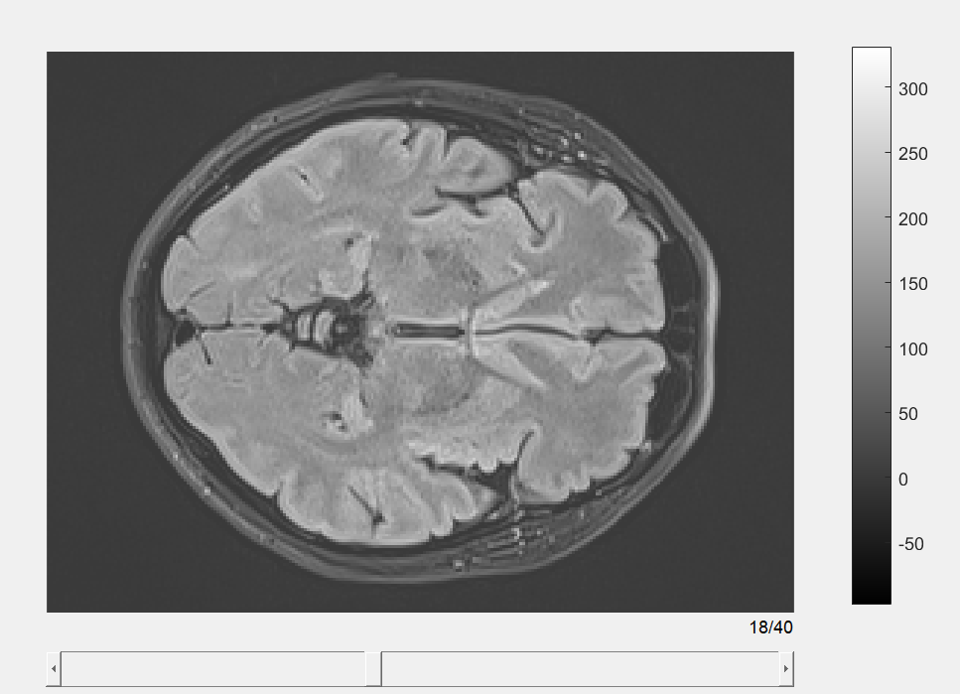

Figure 1. Interactive graphical user interface for FLAIR slice view

  - Using the bottom scroll bar, quickly browse the different sequences [1]. Then, similarly load and assess cerebral blood flow or CBF (C-B-F) sequences [2-TXT].
    - SCREEN: The bottom scroll bar being used to browse different sequences.
    - SCREEN: Interactive GUI of the CBF sequence being shown with the bottom scroll bar being used to browse different sequences. TXT: Use the commands: CBF_XLF = niftiread('CBF_XFL.nii’), size(CBF_XLF) and CBF_Slice(CBF_XLF)
0: 01:01--0: 01:42

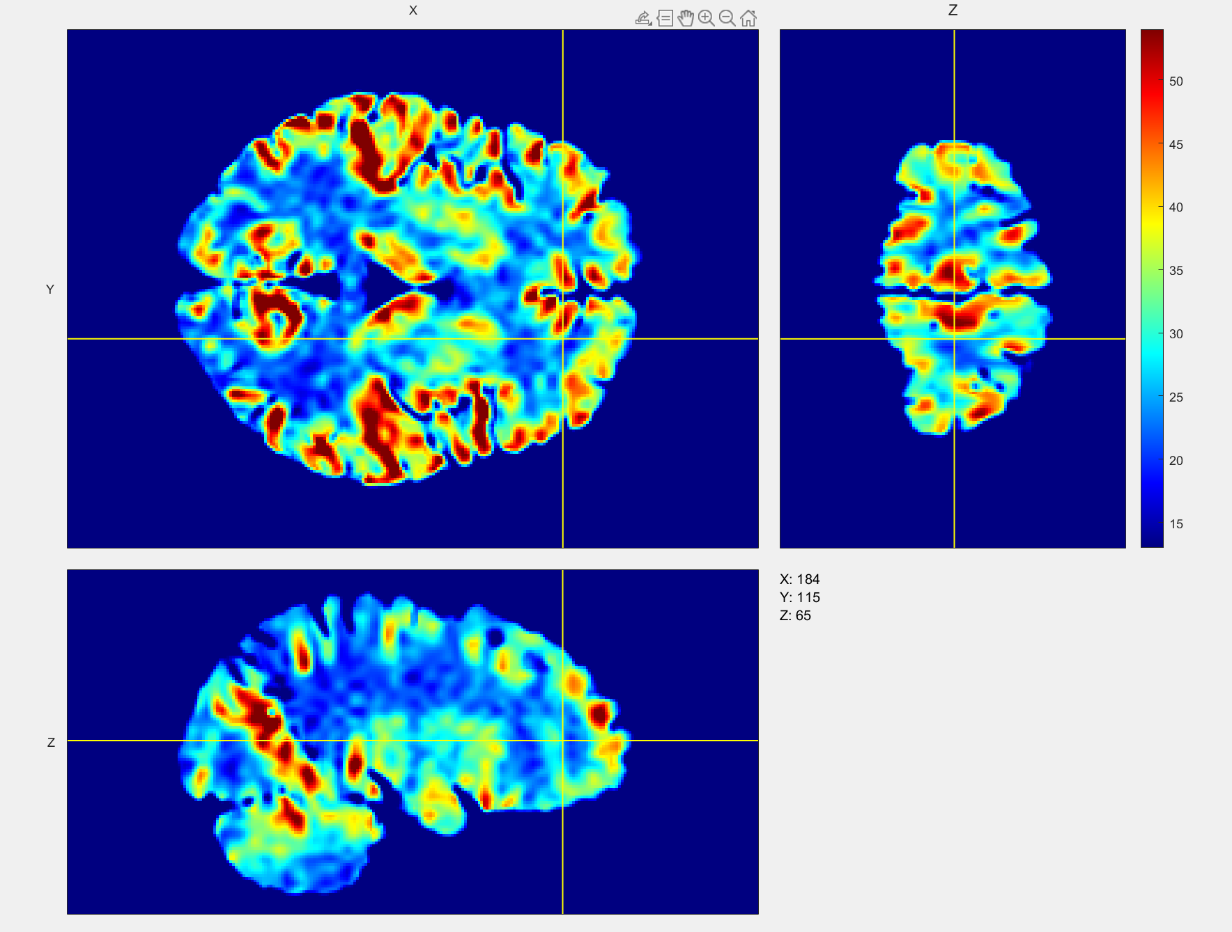
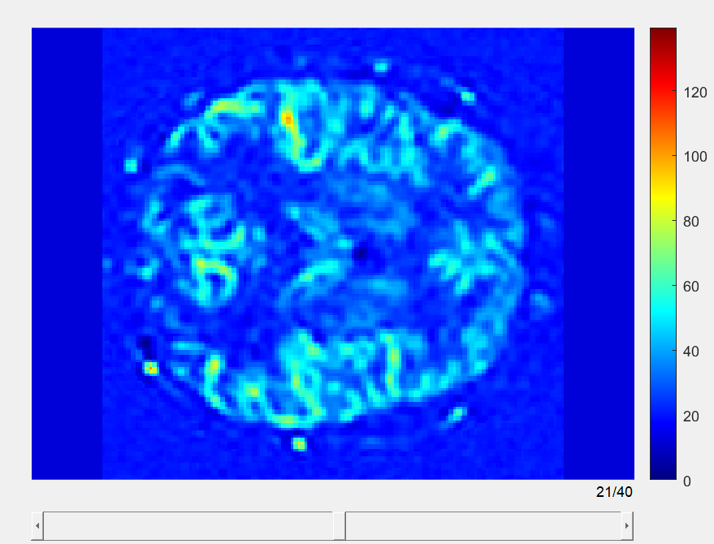

Figure 2. Interactive graphical user interface for CBF slice view

Segmentation of Cerebral Functional Regions from FLAIR Sequence
  - In the workspace, call the FLAIR_Segment (FLAIR Segment) function and run the pretrained 3-D U-Net-based image segmentation program to automatically generate triplanar views of cerebral functional regions segmentation [1]. Each color represents a distinct functional region [2]. 66853_screenshot_2.mp4
    - SCREEN: FLAIR_Segment function being called in the workspace, running the pretrained 3-D U-Net-based image segmentation program to generate triplanar views of cerebral functional regions segmentation.
0: 00:02--0: 00:10
SCREEN: Cursor hovering over different colors in the triplanar views of cerebral functional regions segmentation. 0: 00:11--0: 00:51
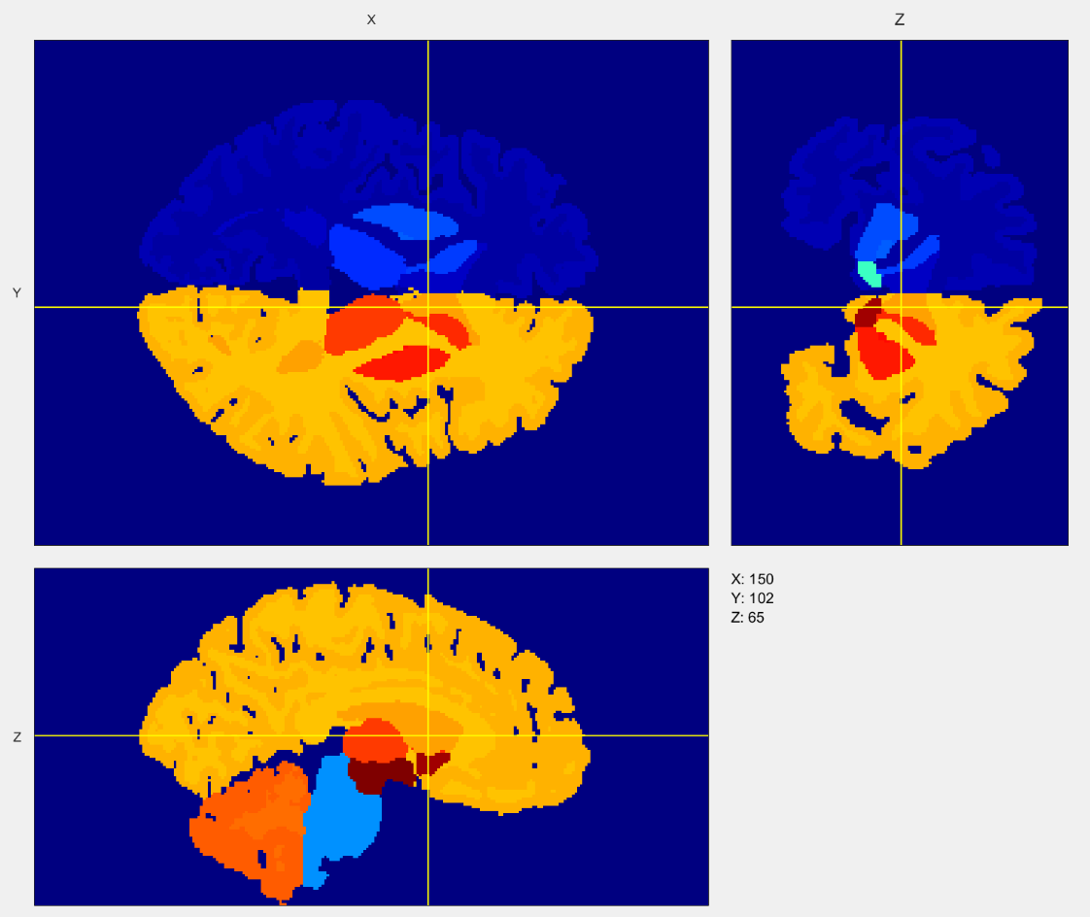

Figure 3 Segmentation of cerebral functional regions based on FLAIR imaging sequence
  - For real-time inspection of different cerebral functional regions, click and drag the center of the crosshair for an arbitrary 3D examination of the reconstructed brain anatomy [1].
    - SCREEN: The center of the crosshair being clicked and dragged for an arbitrary 3D examination of the reconstructed brain anatomy.
0: 00:11--0: 00:51
  - Press and drag the left mouse button over any region of the images for real-time modification of brightness and contrast levels. Release the mouse button to confirm and finalize the adjustments [1].
    - SCREEN: Brightness and contrast levels being adjusted by pressing and dragging the left mouse button over any region of the images, and the adjustments being finalized.
0: 00:52--0: 01:15
Triplanar Views of CBF Distribution Across Cerebral Functional Regions
  - Call the CBF_triplanar (C-B-F triplanar) function to generate the triplanar graphic user interface view, displaying CBF spatial distribution across functional regions [1]. Move the crosshair to allow examination of CBF distribution in regions of interest [2]. 66853_screenshot_3.mp4
    - SCREEN: CBF_triplanar function being called and the triplanar GUI view showing CBF spatial distribution across functional regions being generated.
0: 00:02--0: 00:10
    - SCREEN: The crosshair being moved to examine CBF distribution in regions of interest. 0: 00:11--0: 00:25

Figure 4 Triplanar views of CBF spatial distribution across cerebral functional regions
  - Click the Data Tips button on the top right corner of the interface to display the CBF values at any position [1]. Press and drag the left mouse button over any region of the images for real-time modification of brightness and contrast levels. Release the mouse button to confirm and finalize the adjustments [2].
    - SCREEN: Data Tips button on the top right corner of the GUI being clicked to display CBF values at any position. 0: 00:29 --0: 00:56
    - SCREEN: Brightness and contrast levels being adjusted by pressing and dragging the left mouse button over any region of the images, and the adjustments being finalized. 0: 01:20 --0: 01:36

CBF Atlas Across Major Cerebral Functional Regions
  - Call the CBF_Atlas (CBF Atlas) function to convert the CBF spatial distribution into a CBF Atlas [1]. Click the Zoom In/Out (In-out) button on the top right of the interface to scale partial images [2]. 66853_screenshot_4.mp4
    - SCREEN: CBF_Atlas function being called and the displayed CBF spatial distribution being converted into a CBF Atlas. 0: 00:03 --0: 00:20
    - SCREEN: Zoom In/Out button on the top right of the GUI being clicked to scale partial images. 0: 00:21 --0: 01:03
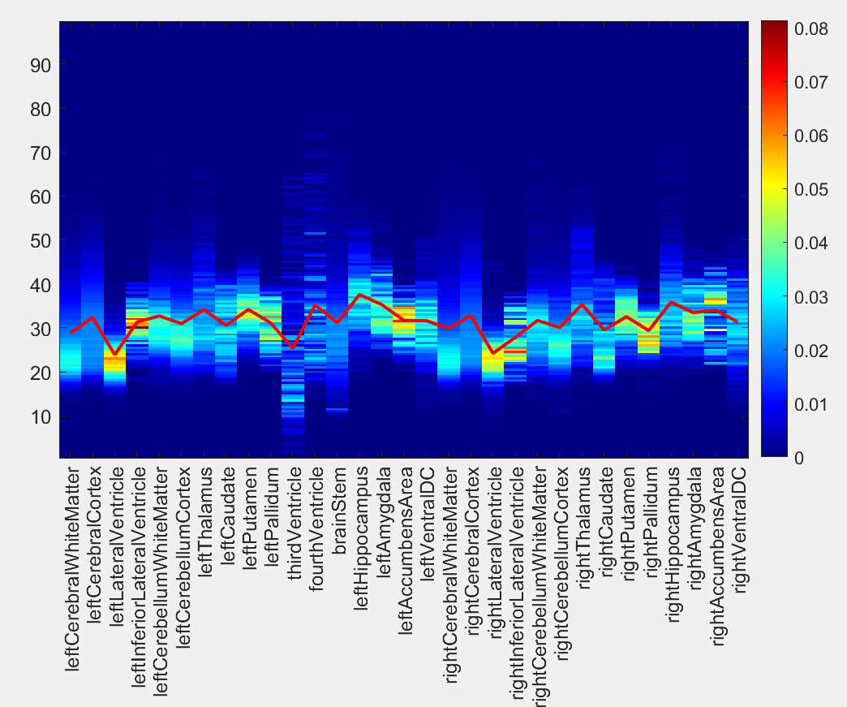

Figure 5 Cerebral Functional Regions CBF Atlas

Significant Differences in CBF Atlas Between Healthy Subjects and Chronic Cerebral Ischemia Patients
  - Utilizing the CBF_Compare (CBF Compare) function, generate a comparative plot of the CBF curve from a healthy subject versus a Chronic Cerebral Ischemia or CCI (C-C-I) patient [1]. 66853_screenshot_5.mp4
    - SCREEN: CBF_Compare function being utilized to generate a comparative plot of the CBF curve from a healthy subject versus a CCI patient
  - Observe the significant differences between the patient's CBF curve and the healthy curve to identify the functional regions with more pronounced CBF drops in the patient [1]. After modifying brightness and contrast levels, re-examine the regions where the patient performed worse than the other regions [2].
    - SCREEN: Cursor hovering over the significant differences between the CBF curves of a patient and a healthy subject. 0: 00:04--0: 00:12
    - SCREEN: Cursor hovering over or zooming into the region with more pronounced CBF drops in certain functional regions of the patient.
0: 00:12--0: 00:54
  - Finally, using the icons in the upper right corner, access functions such as zooming out, zooming in, returning to the global view, and marking the coordinates of the selected pixel [1].
    - SCREEN: Icons in the GUI's upper right corner being clicked and zooming out, followed by returning to the global view, and marking coordinates of selected pixels. 0: 01:01--0: 01:31
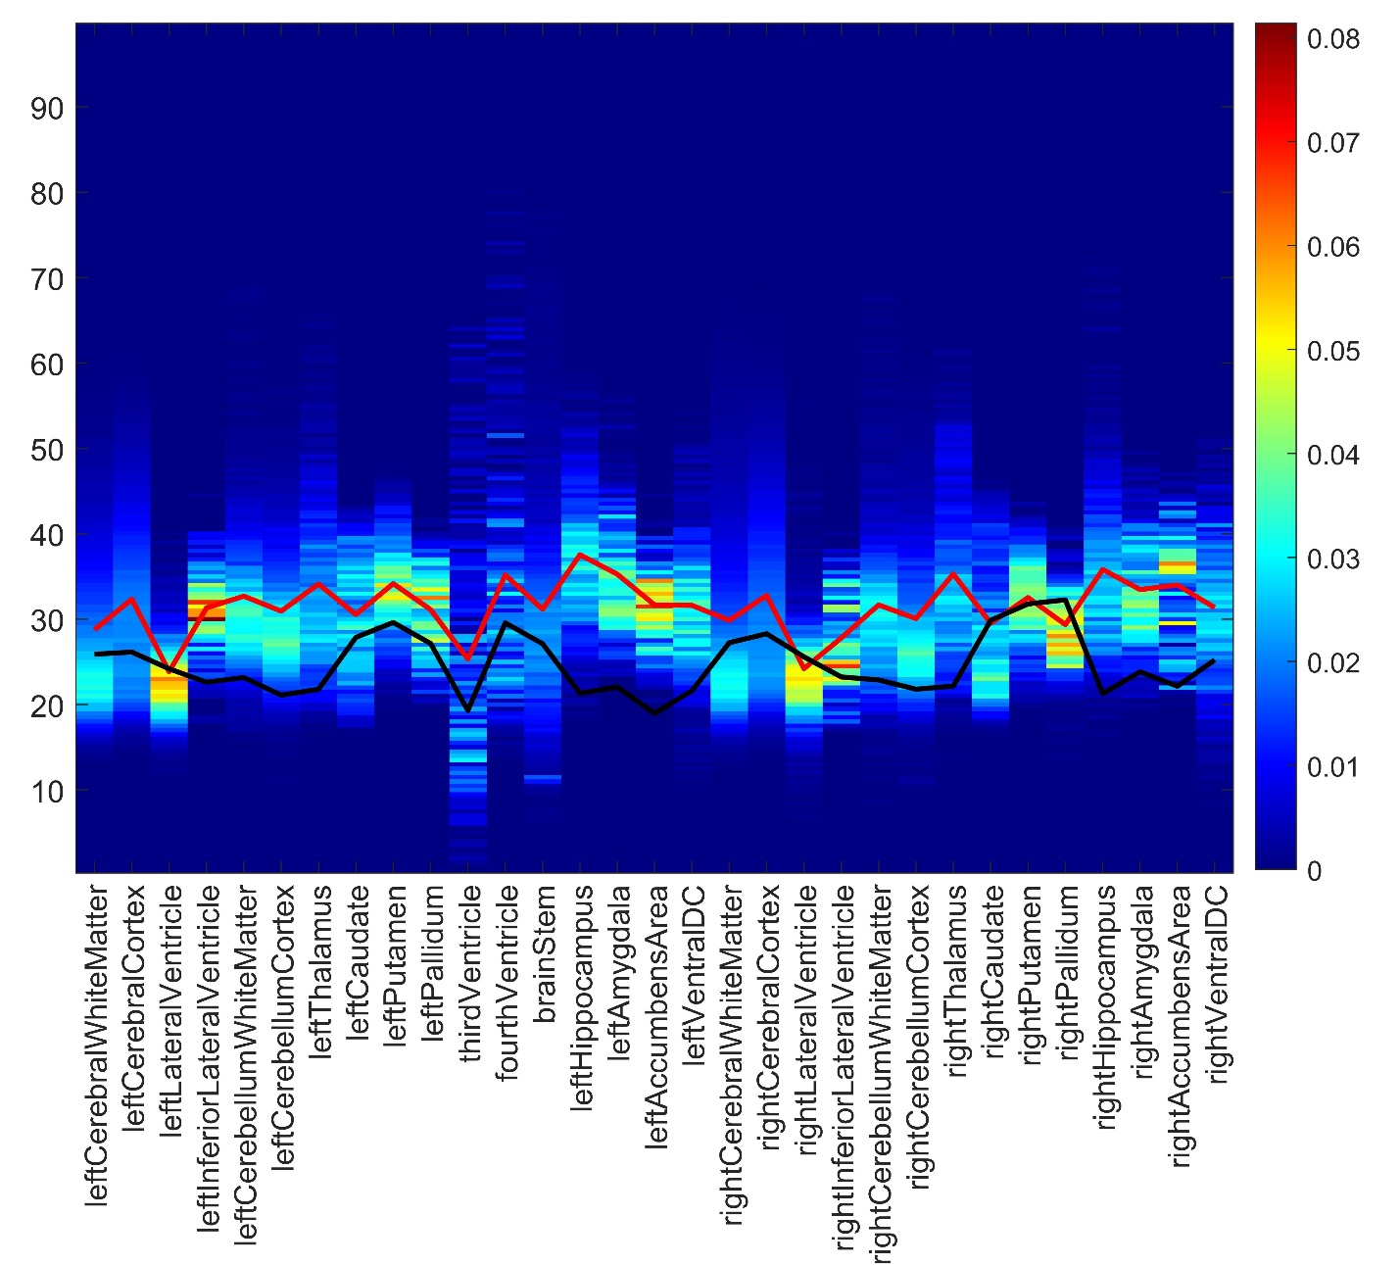

Figure 6 Comparison of Cerebral Functional Regions CBF Atlas
Representative Results
  - Comparing the two CBF atlases revealed a significant reduction in CBF across all cerebral functional regions in the CCI patient [1] compared to the healthy subject [2].
    - LAB MEDIA: Figure 6 Video editor: Please emphasize the black zik-zak line graph
    - LAB MEDIA: Figure 6 Video editor: Please emphasize the red zik-zak line graph

