66596_screenshot_1:
- Double-click to open the spss software.
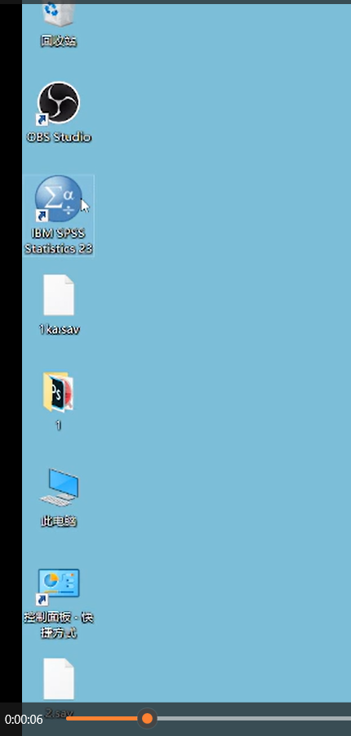

- Import the needed data.
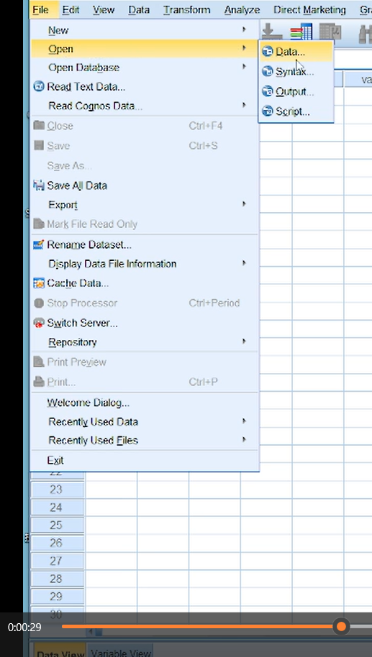
- Click the “Transform” and “Compute Variable”.
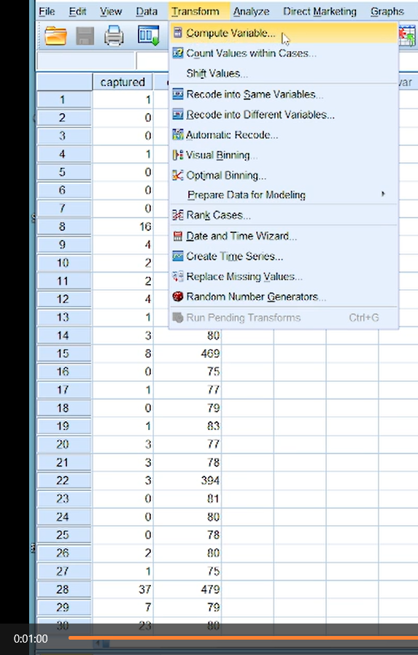
- In the “Target Variable” enter “T”. The letter “T” is for the relative abundance of rodents.
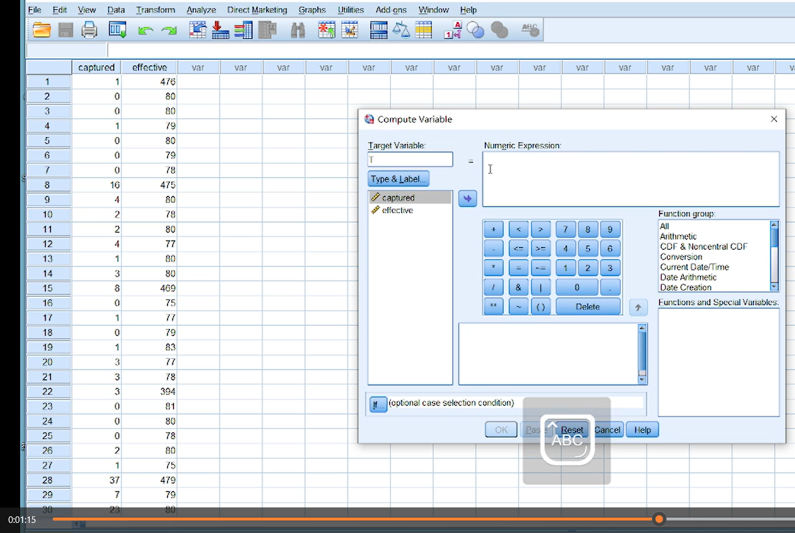
- In the “Numeric Expression” enter the equation. The word “captured” is for the number of captured rodents. The word “effective” is for the effective number of traps.
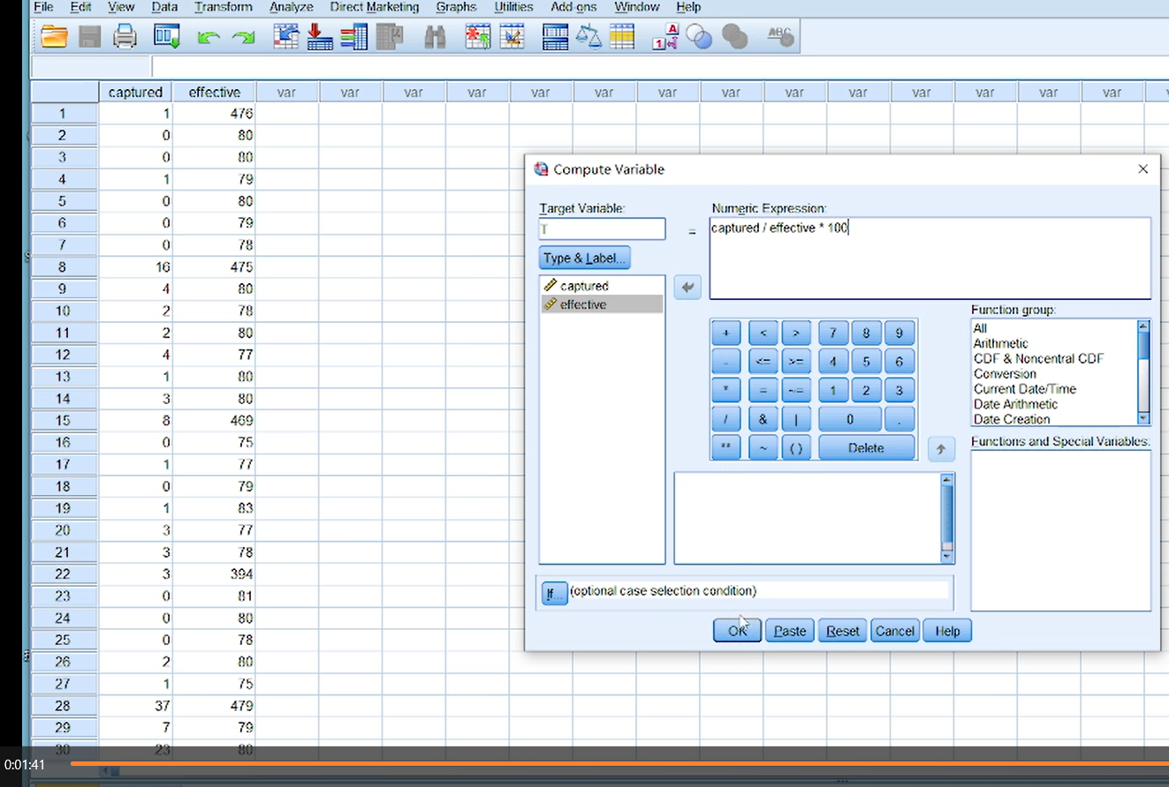

- Finally, the value of “T” is automatically calculated in the table.
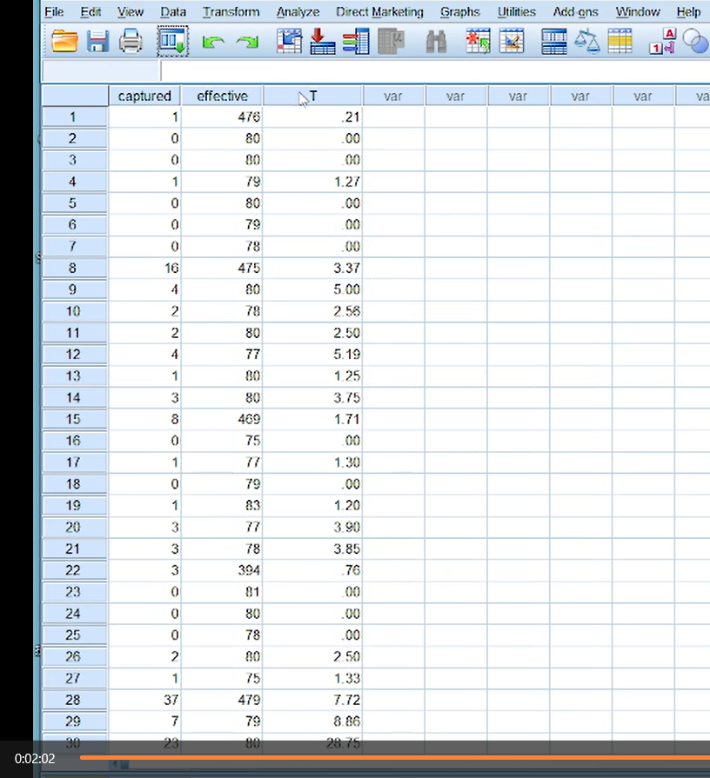

66596_screenshot_2:
2.1 Double-click to open the spss software.
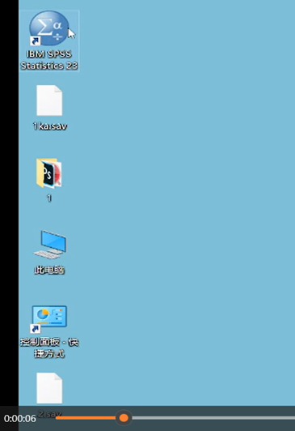
2.2 Import the needed data.
2.3 Click the “Transform” and “Compute Variable”.
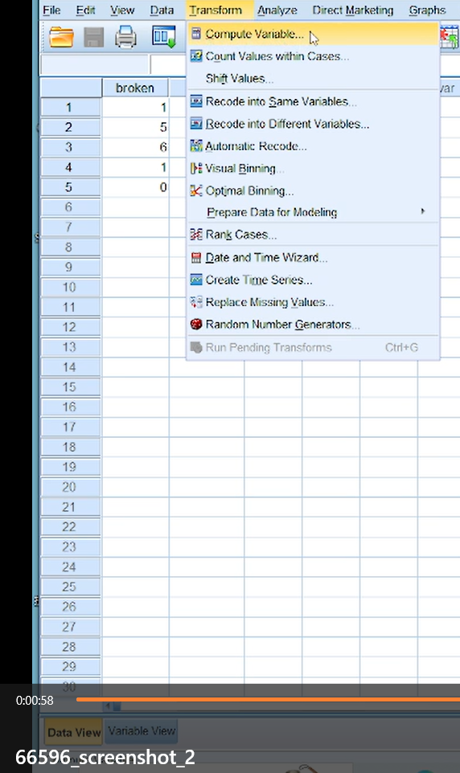
2.4 In the “Target Variable” enter “a”. The letter “a” is for the damage rate.
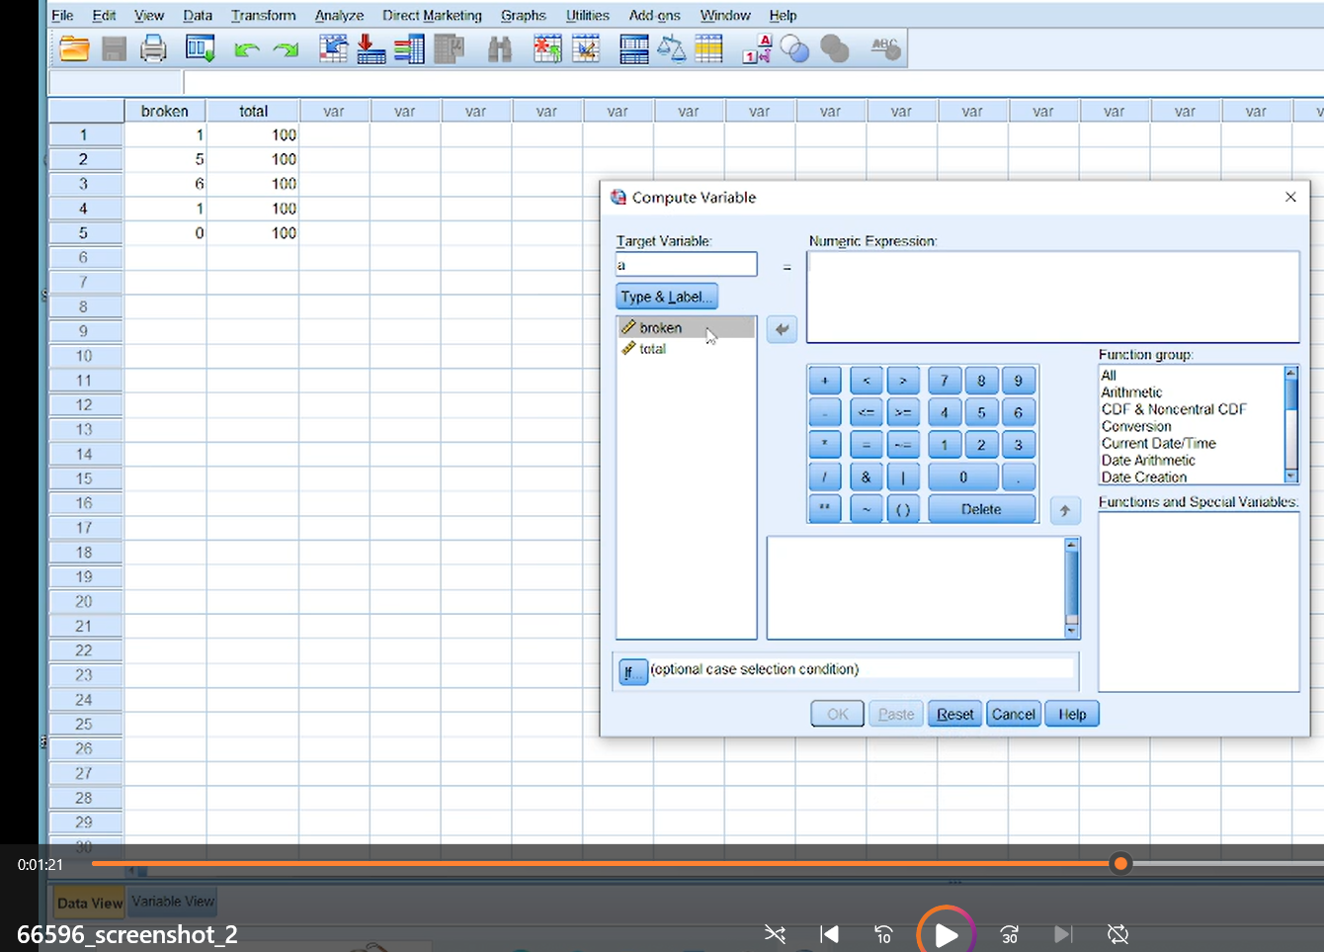
2.5 In the “Numeric Expression” enter the equation. The word “broken” is for the number of seedlings broken by the rodents. The word “total” is for the total number of seedlings.
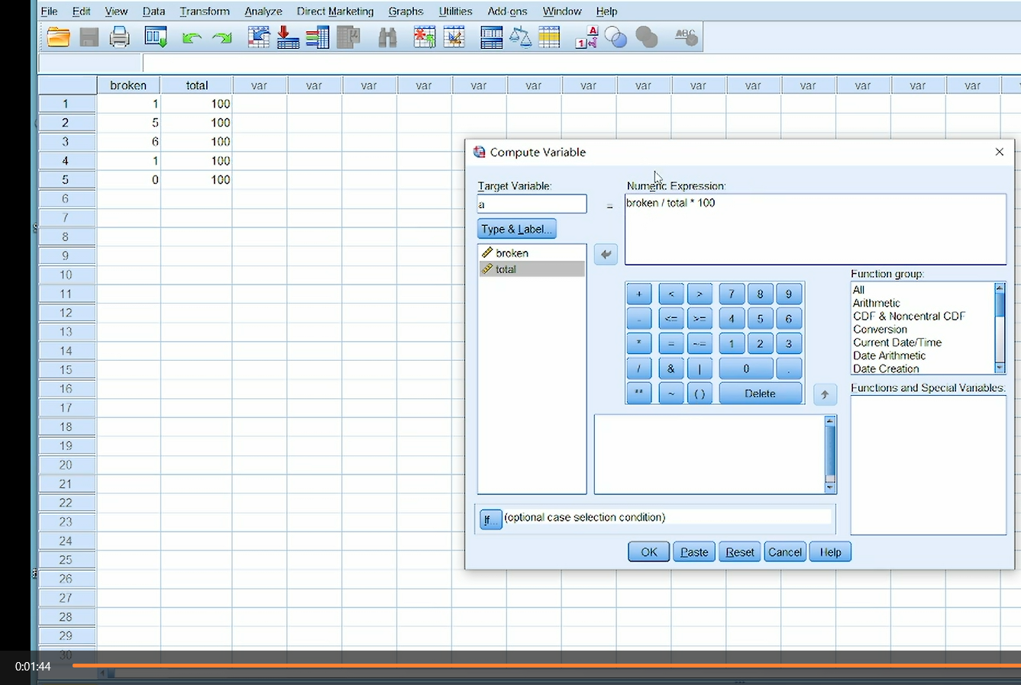
2.6 Finally, the value of “a” is automatically calculated in the table.
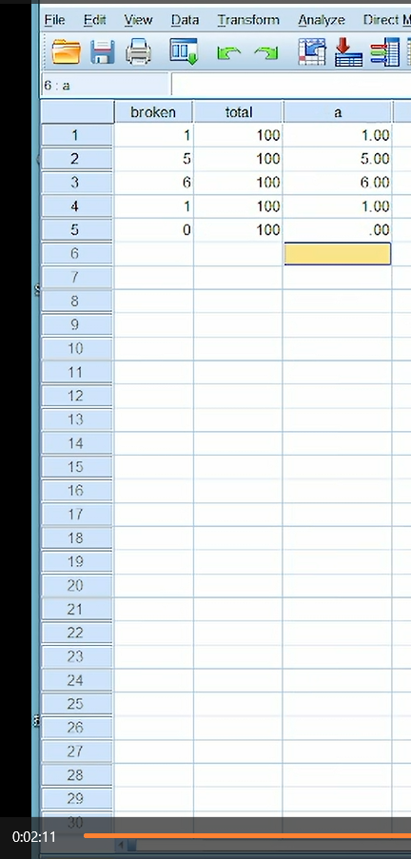
66596_screenshot_3:
3.1 Double-click to open the spss software.
3.2 Import the needed data.

3.3 Click the “Data” and “Weight Cases”.
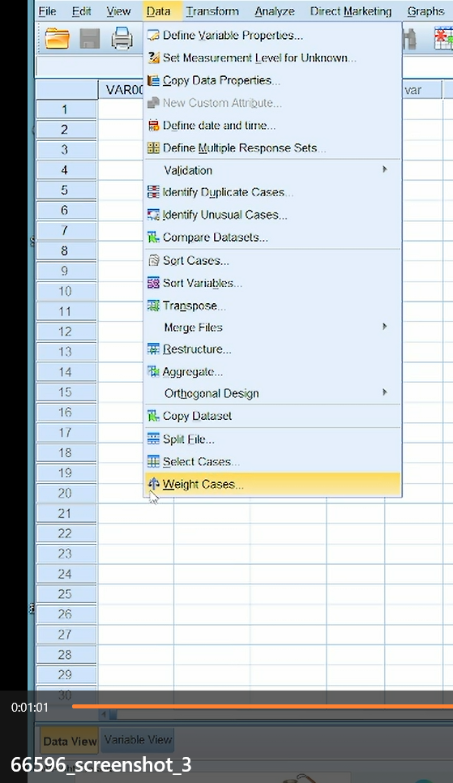
3.4 Click the “Weight Cases by”. Add the desired values to the “Frequency Variable”, Click the “Ok”.
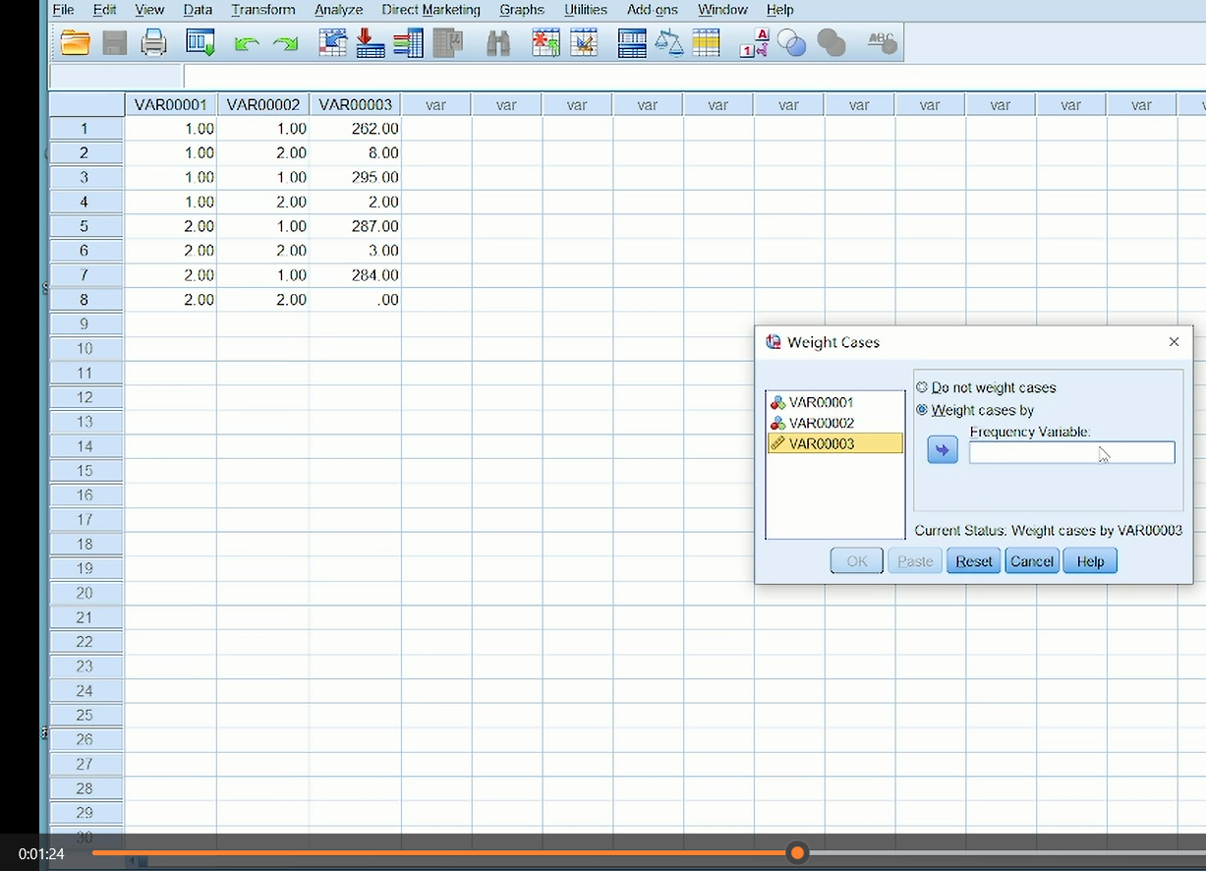
3.5 Click the “Analyze” and “Descriptive Statistics” and “Crosstabs”.
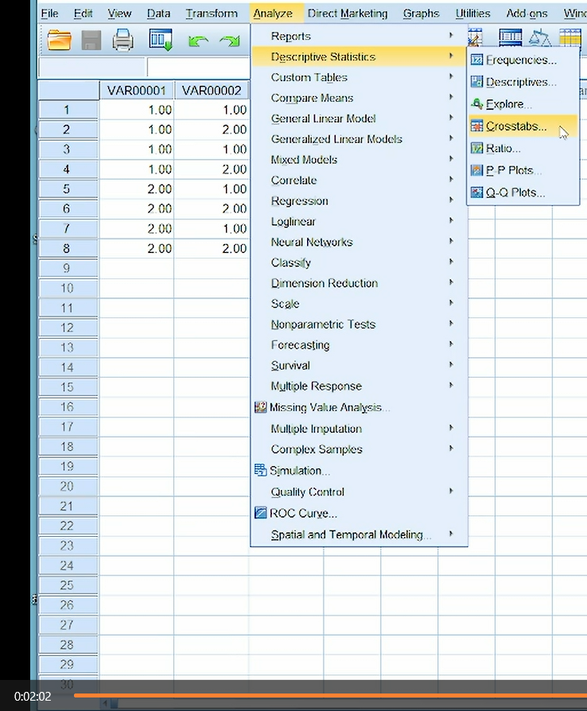
3.6 Add the desired values to the “Row(s)” and “Column(s)”.
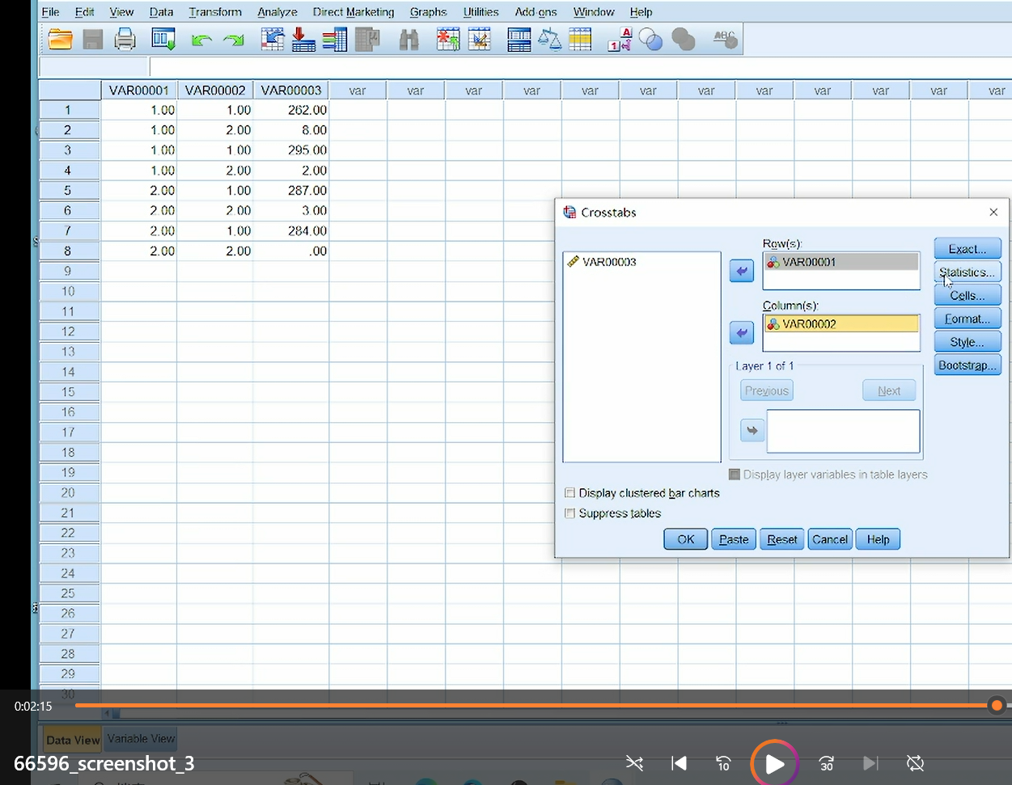
3.7 Click the “Statistics” and choose the “Chi-square”. Click the “Continue”. Finally, click the “Ok”.
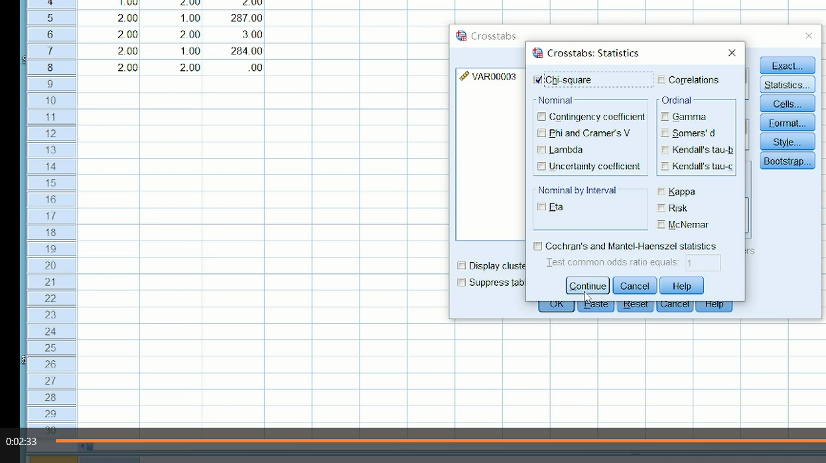
3.8 Finally, the value of the χ² and the value of the P will in the table “Chi-square Tests”. 