Authors: Please create screen capture videos of the shots labeled as SCREEN, create a screenshot summary, and upload the files to your project page as soon as possible: https://review.jove.com/account/file-uploader?src=20008048
    - SCREEN: 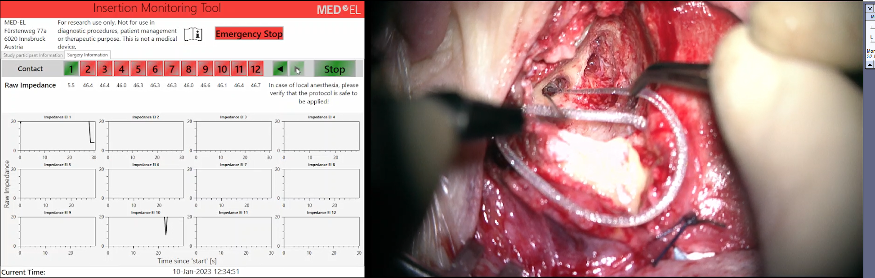Status buttons are being changed in succession.
    - SCREEN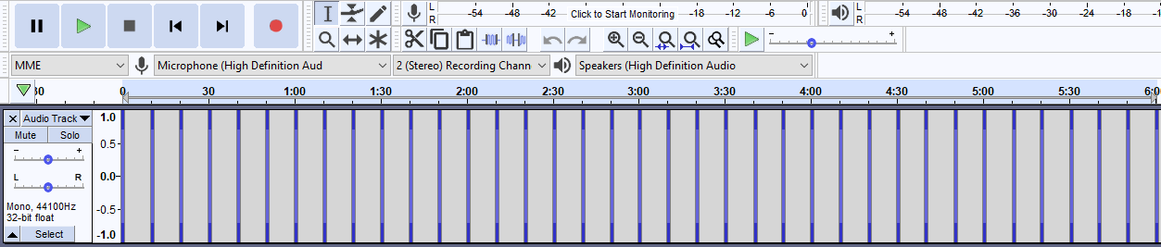: Pulsing Sine wave audio signal of 500 Hertz is being applied. TXT: Maintain a constant interval between signal and pauses
    - SCREEN: 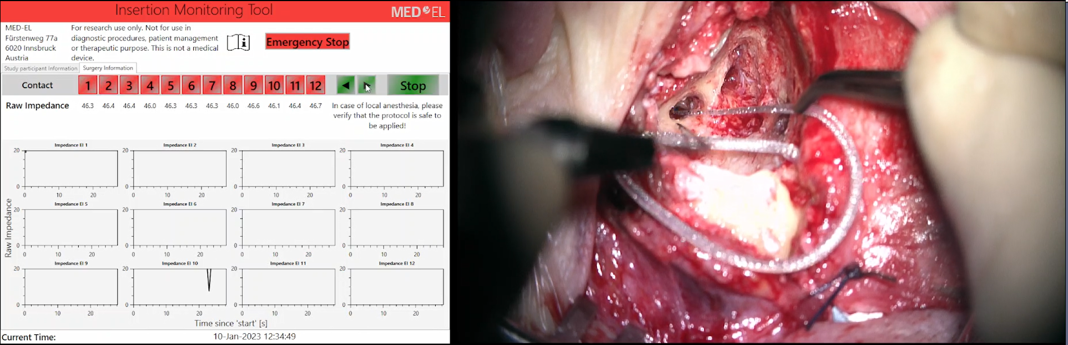The accurate information of the number of contacts is being shown in the IM software.
    - SCREEN: 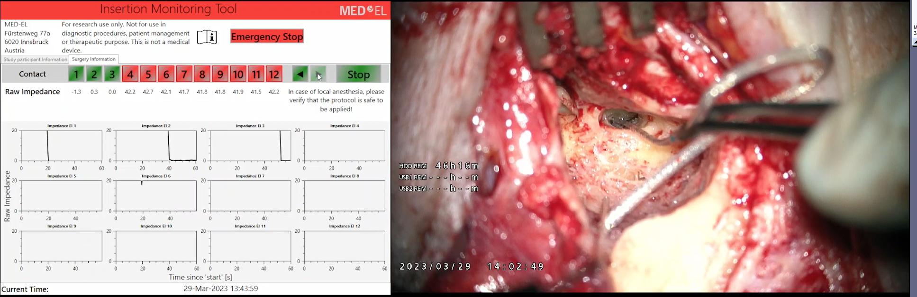 The number of inserted electrode contacts are being input into the software.
    - SCREEN: Measurements are being seen until impedance drops.

