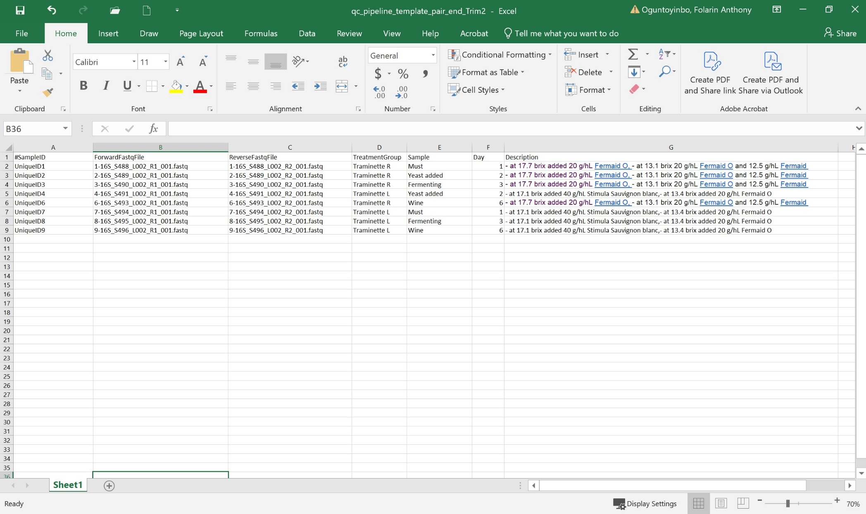
3.13.1 Spreadsheet -Mapping metadata file
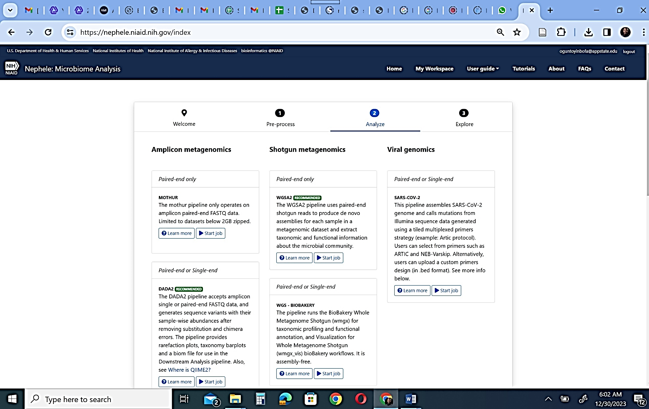
3.13.2 Nephele

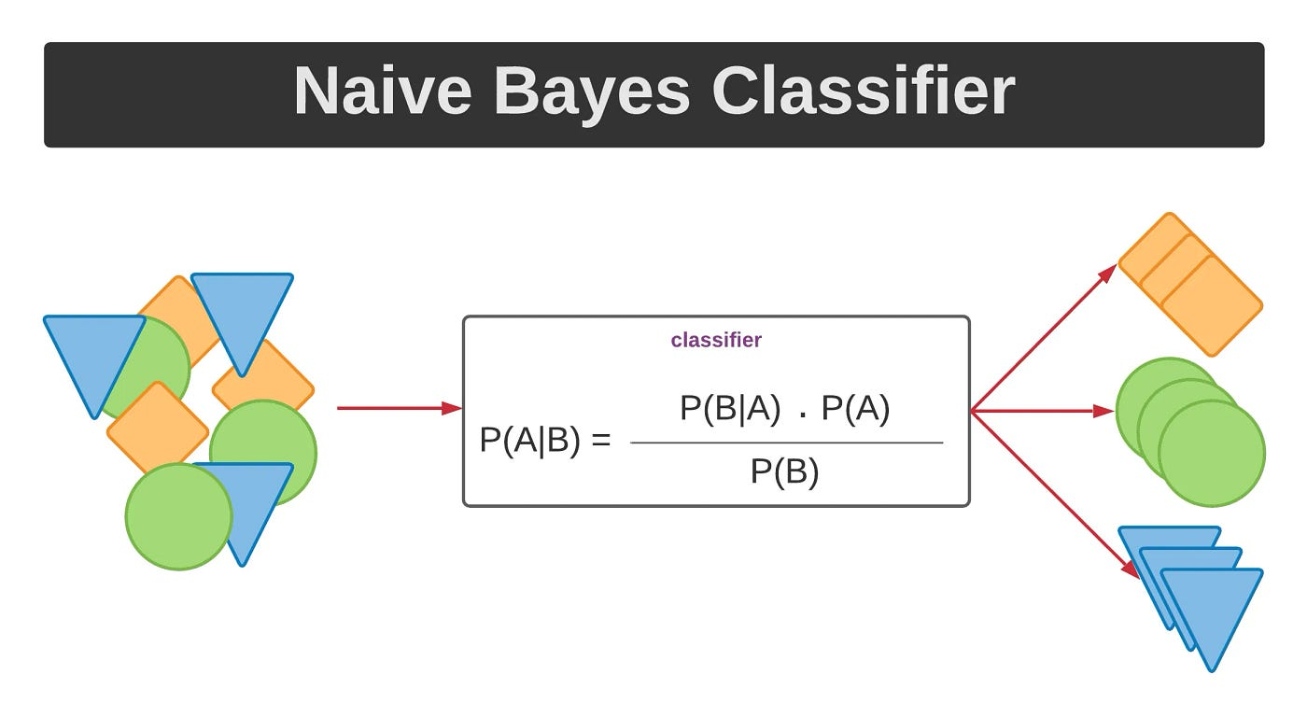

3.14.2 The Naïve Bayes classifier is a popular supervised machine learning algorithm used for classification tasks such as text classification. It belongs to the family of generative learning algorithms, which means that it models the distribution of inputs for a given class or category

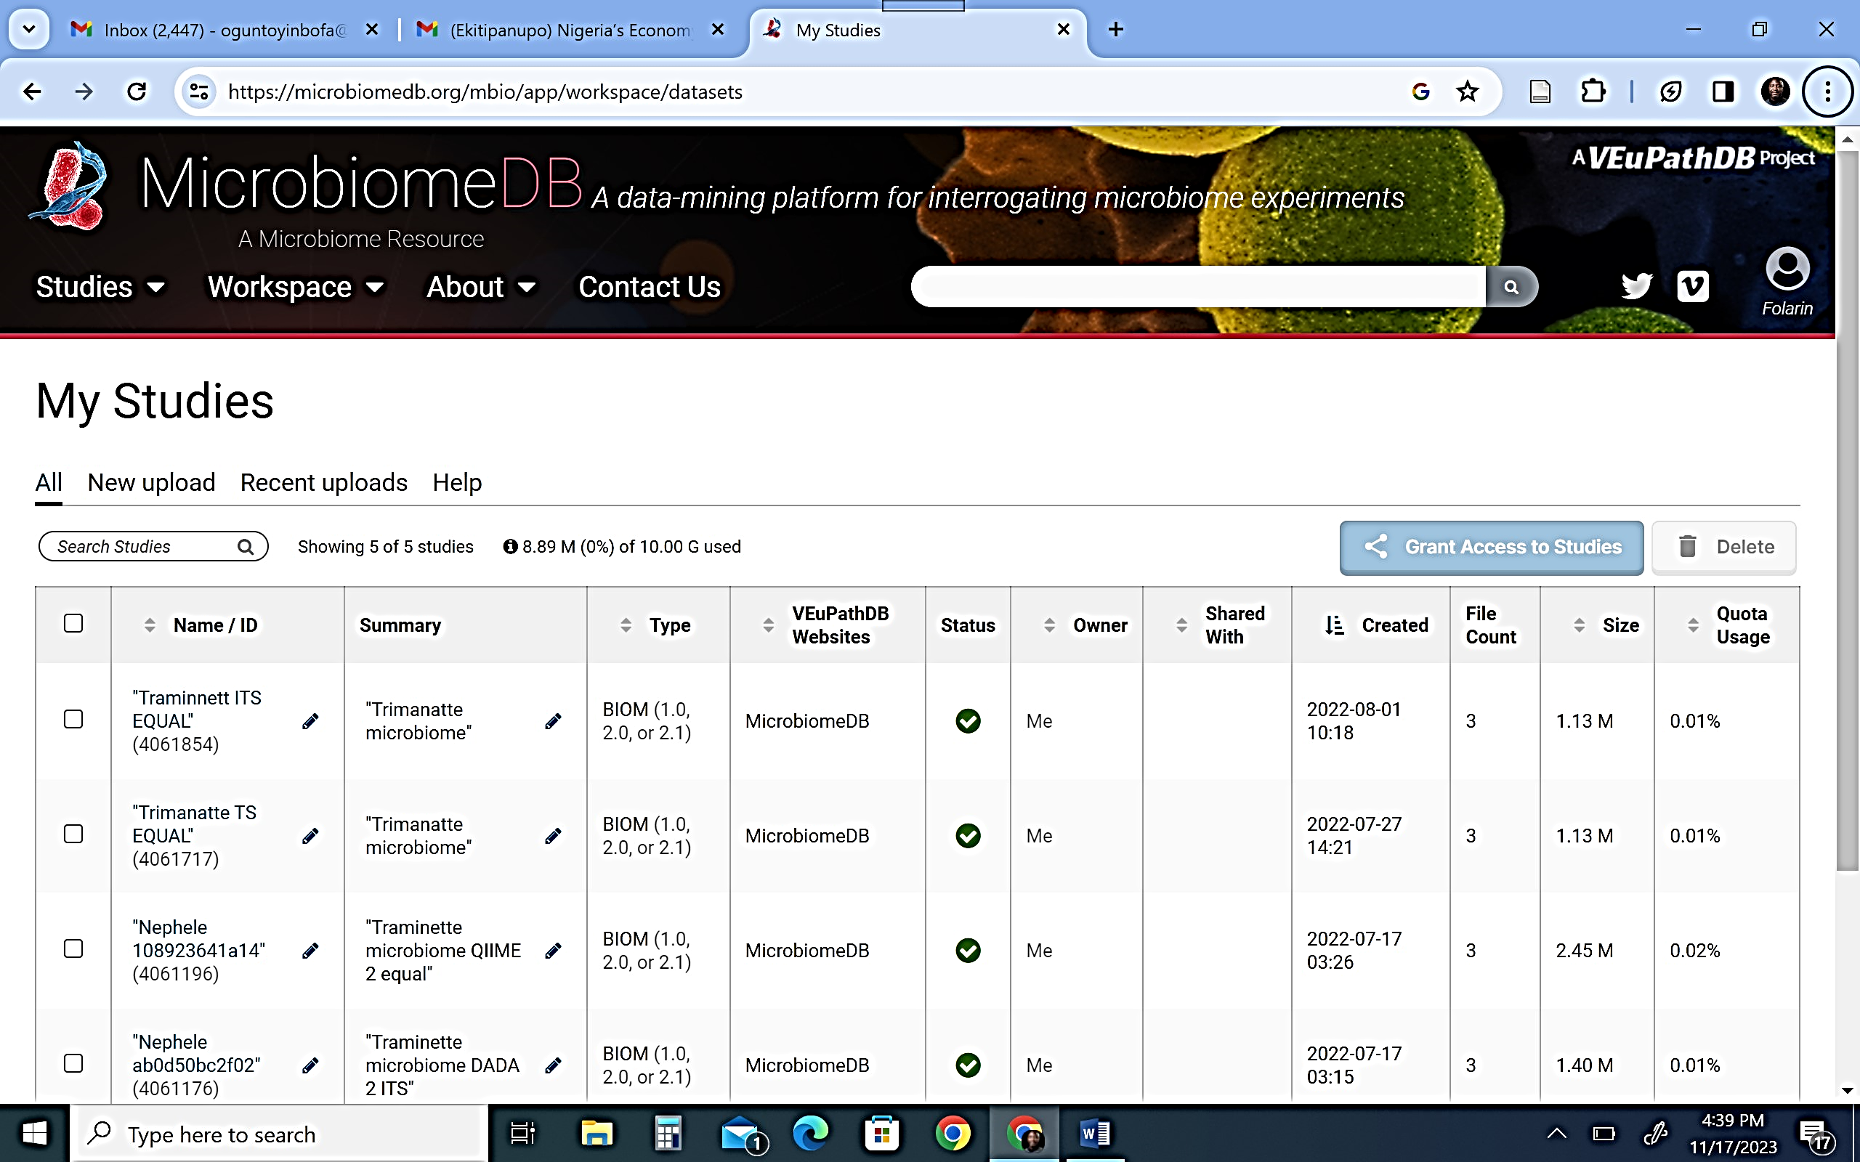
3.15.1 MicrobiomeDB

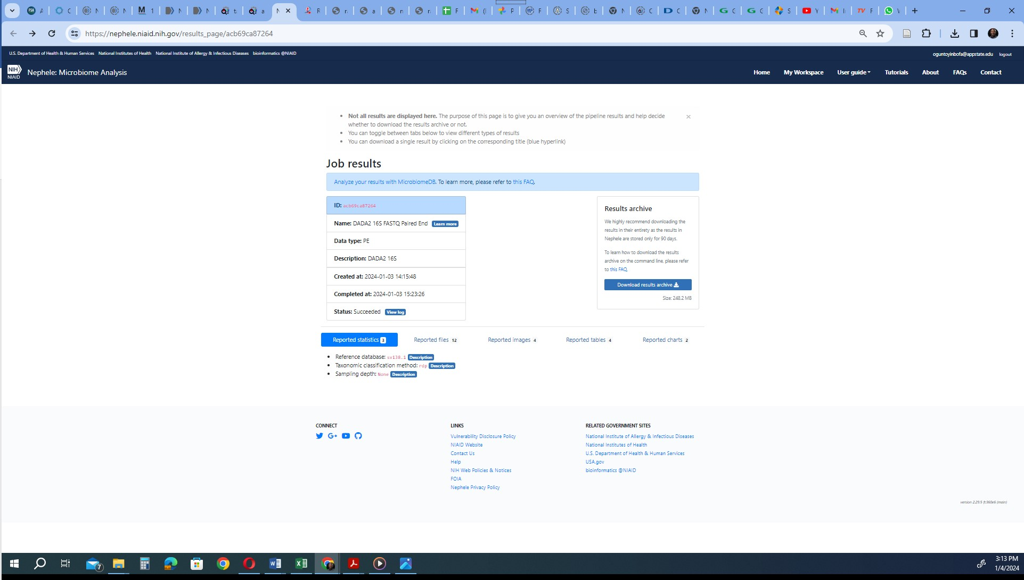
3.15.2 DADA output in Nephele

