- Start Software: Turn on your computer and the instrument. Open the Celigo software on your desktop.
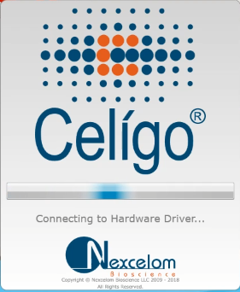
- Create a New Scanning Task: Within the Celigo software, create a new scanning task.
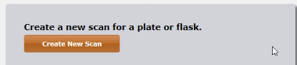
- Select Plate Type: Choose the plate type as "96-well."
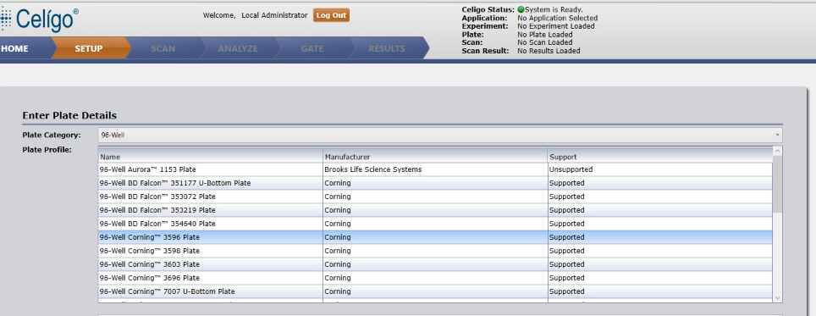
- Enter Plate ID or Select Existing: Enter the Plate ID or select an existing Plate ID.
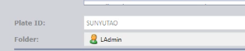
- Load Plate: Click on "Load Plate" and place the plate on the loading stage, ensuring that well A1 is in the top-left corner.

- Click "OK" and close the plate door.
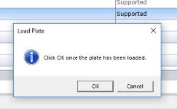

- Choose Application: In the "Application" section, select "Expressior Analysis" and choose "Target 1+2."
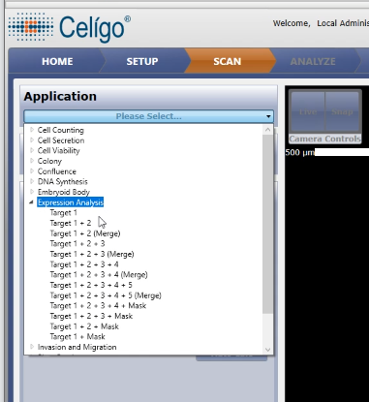
- Assign Channels: Click on the icon in the upper right corner to open a dropdown menu. Assign the two channels as Hoechst and Sytoxgreen. Click "OK."
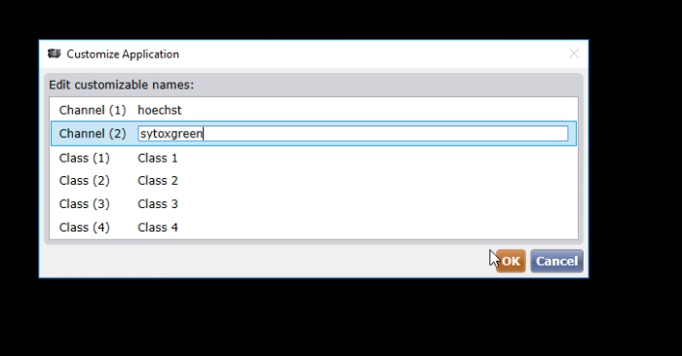
- Select a Well: In the well navigation area, choose any well containing stained cells in the center.
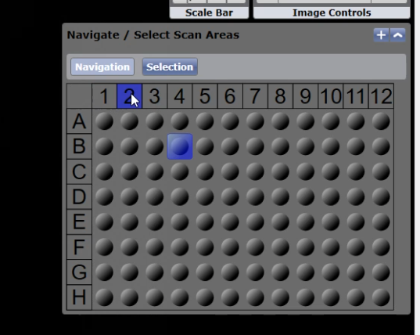
- Switch to SYTOXGREEN Channel: Select the HOECHST channel and set the illumination to "Blue 377/447." Adjust Exposure Times: For HOECHST, set the exposure time to 300,000 microseconds.
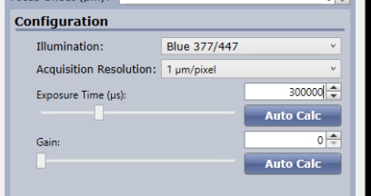
- Focus: Click on "Focus Setup" and then click "Register Auto" to automatically adjust the focus.
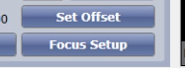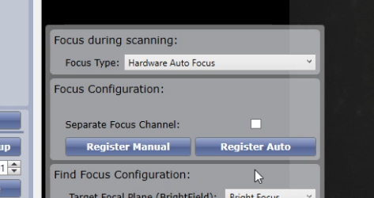
- Switch to SYTOXGREEN Channel: Select the SYTOXGREEN channel and set the illumination to "Green 483/536."
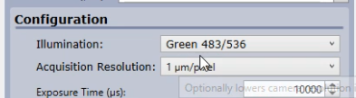
- Adjust SYTOXGREEN Exposure Time: Set the exposure time for SYTOXGREEN to 30,000 microseconds.
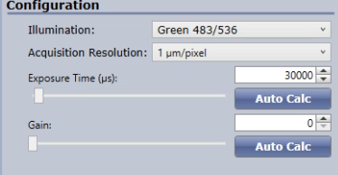
- Select Wells: Click on "Selection" and use the left mouse button to drag-select all the wells you want to scan in the well navigation area.
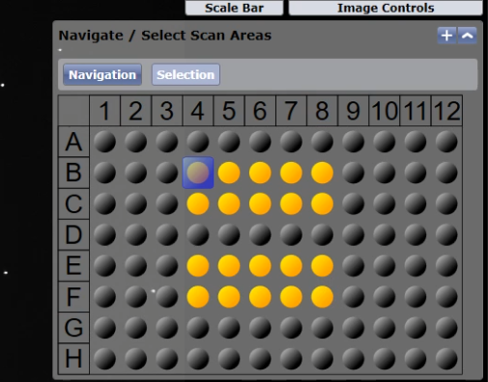
- Start Scanning: Click "Start Scan" to begin the scanning process.
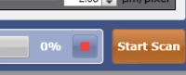
NOTICE: Ensure you follow these steps carefully to perform the cell staining and imaging process accurately.

