2.2.1 - Green readings is recorded for fully connected wells. Ninety-six well plate configuration.
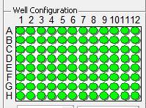

2.2.2 - Unconnected wells display a red color.
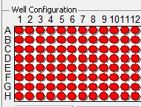

2.2.4 - Click Setup to evaluate whether the wells are connected (to be shown as green) or not (to be shown as red).
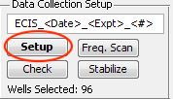

2.3.2 - To stabilize the wells and prepare them for experiments, click Setup, then click Check, and then, click Stabilize.
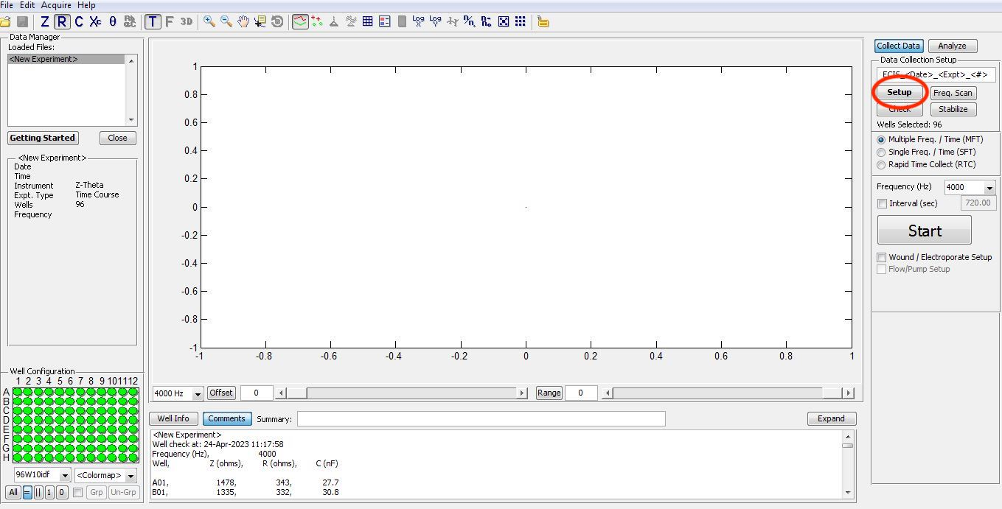
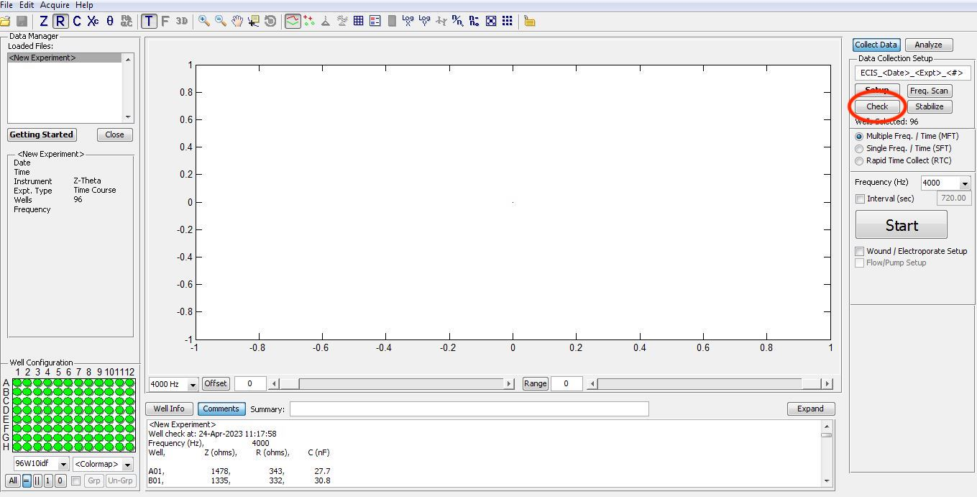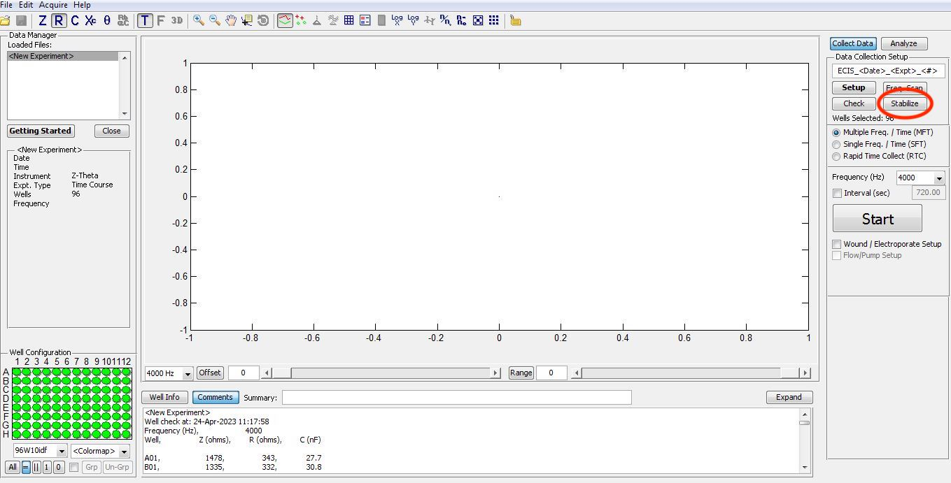

2.5.- Click Check to ensure all the electrodes are being read by the sensors.
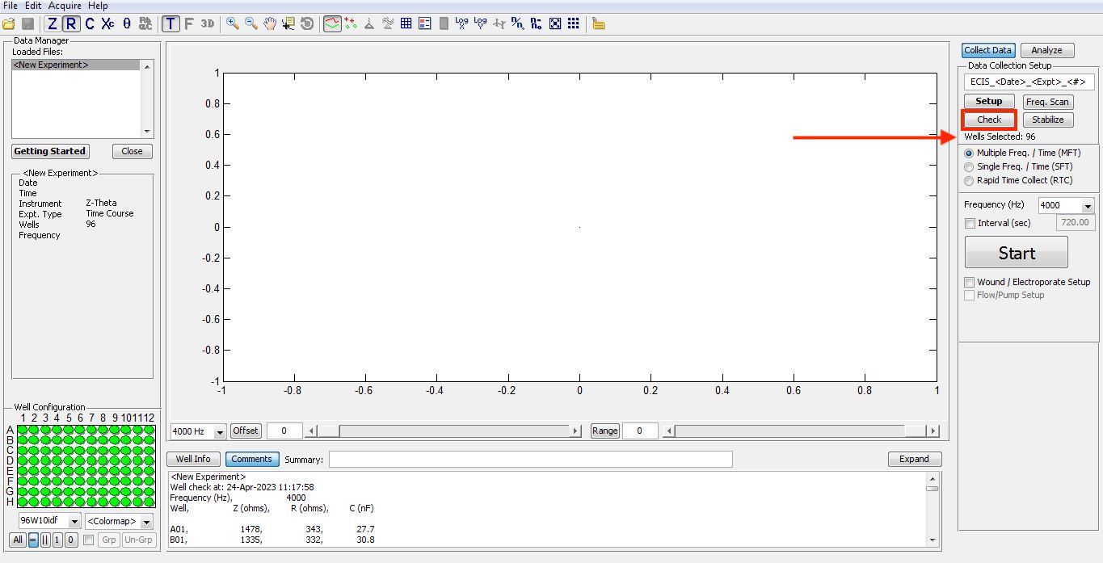

2.6 - Multiple Frequency-Time to measure each electrode at 7 different frequencies.

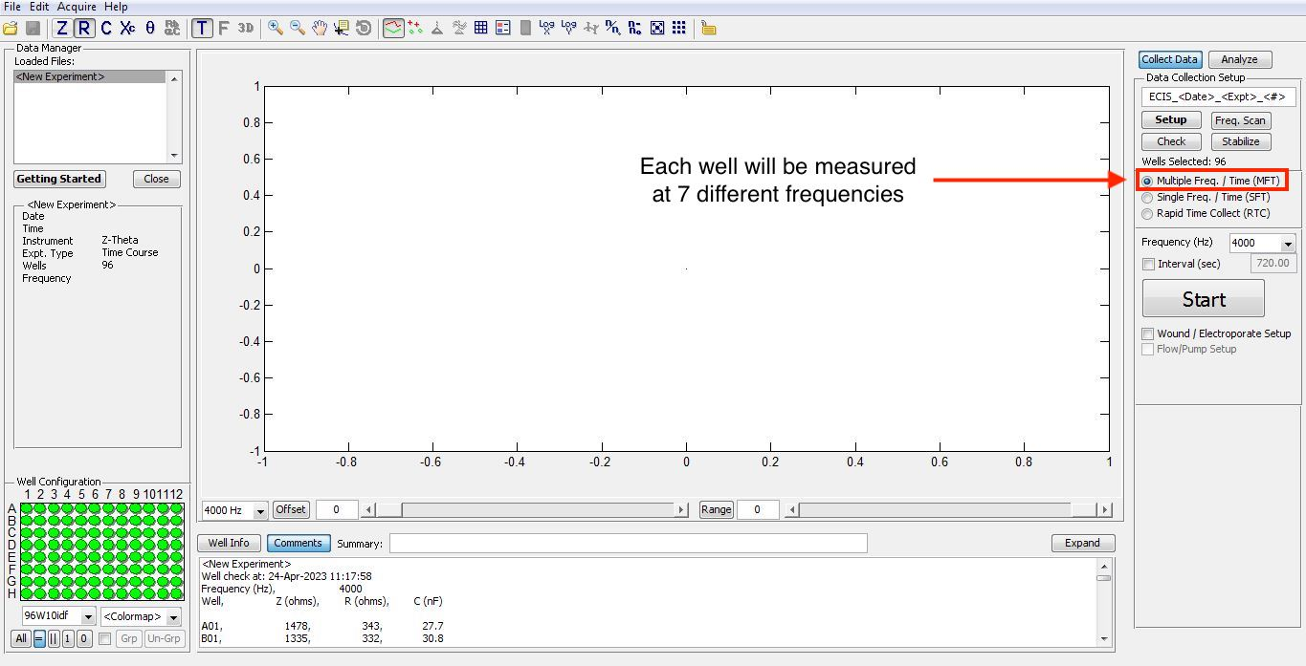

2.7 – Click Start to begin the experiment.
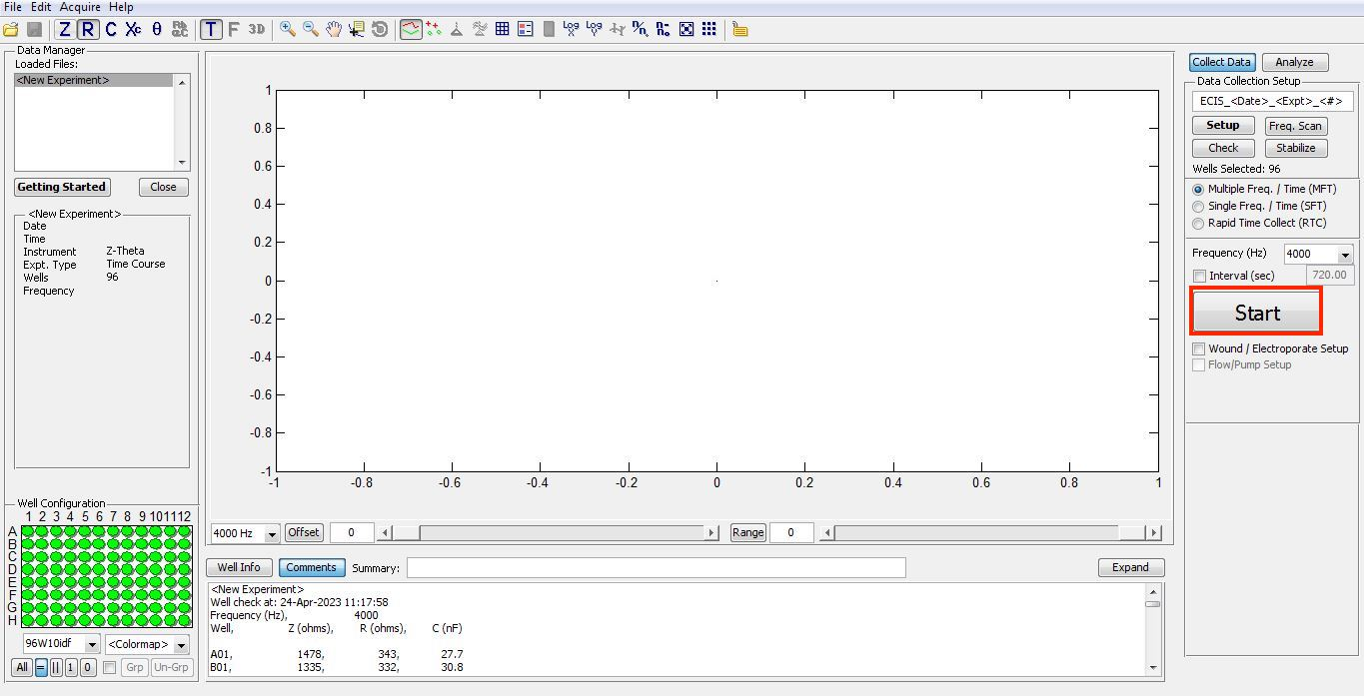
2.7- Cells form a confluent monolayer. Every well’s reading is displayed in a different color.

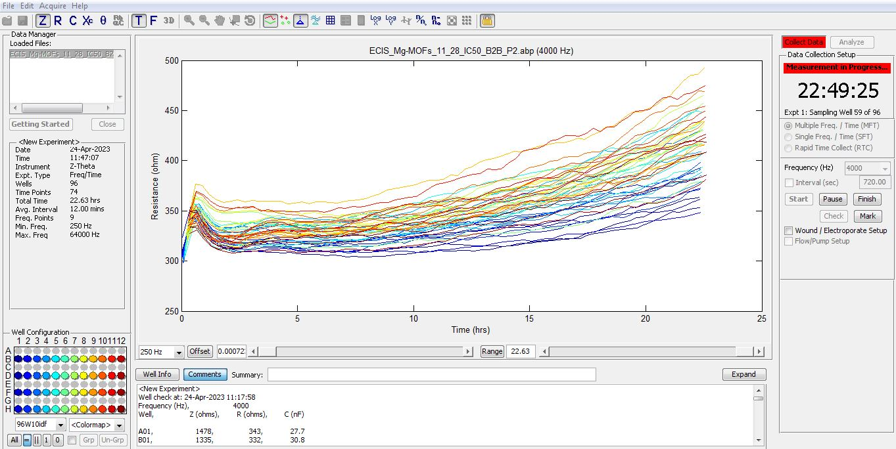

2.8.- Pause could be clicked for the data collection to be interrupted as needed (e.g., for media changes, for reagents addition, etc.).
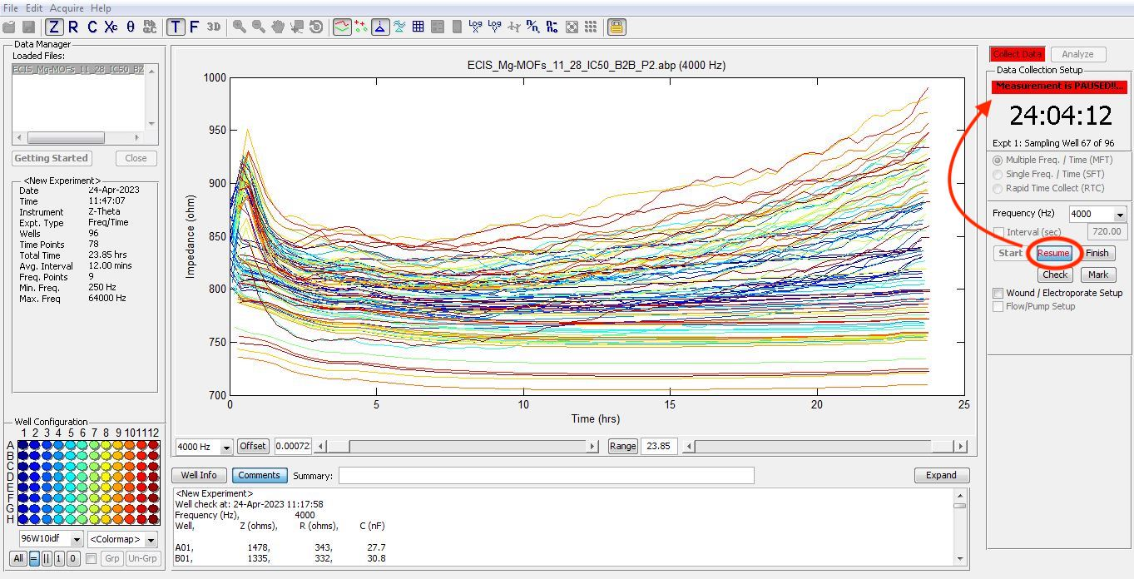
2.9.3 – To evaluate whether all electrodes are recording, click check.
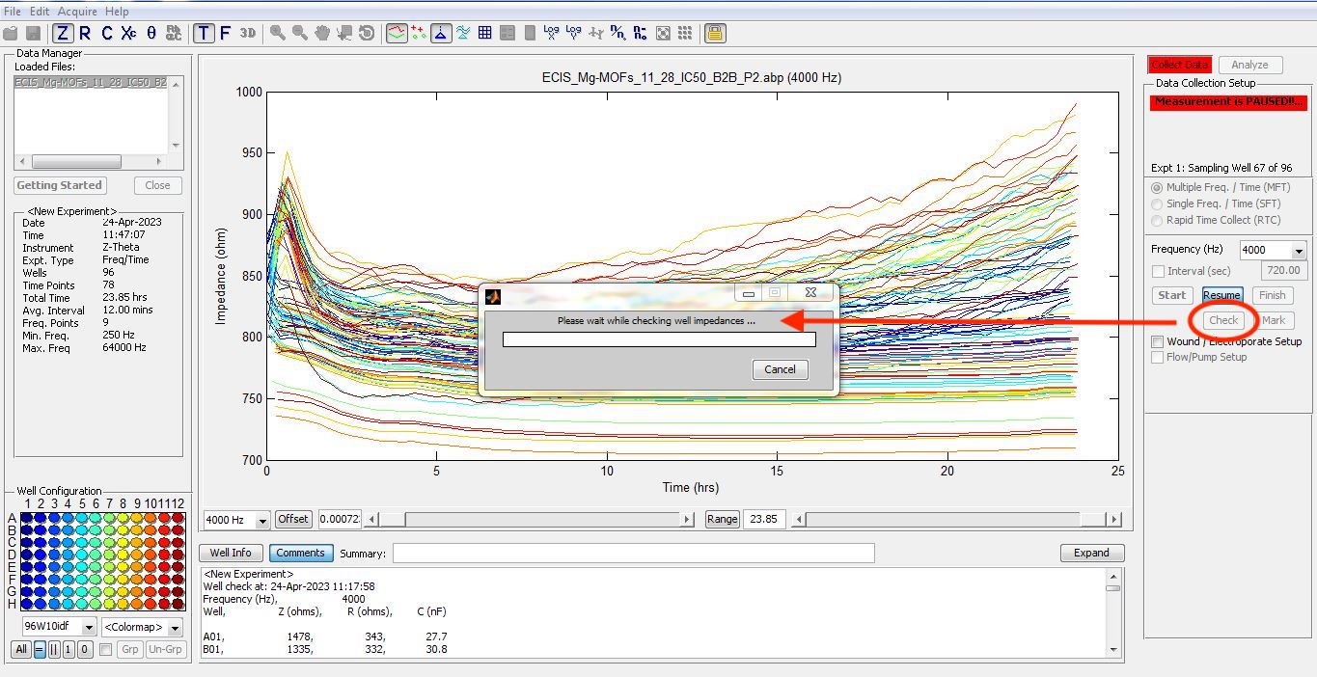

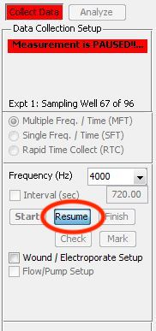
2.9.4 – To resume the experiments after any chosen pause click Resume.

2.10.1 – When the experiment is completed, click Finish and save the file as a spreadsheet file.
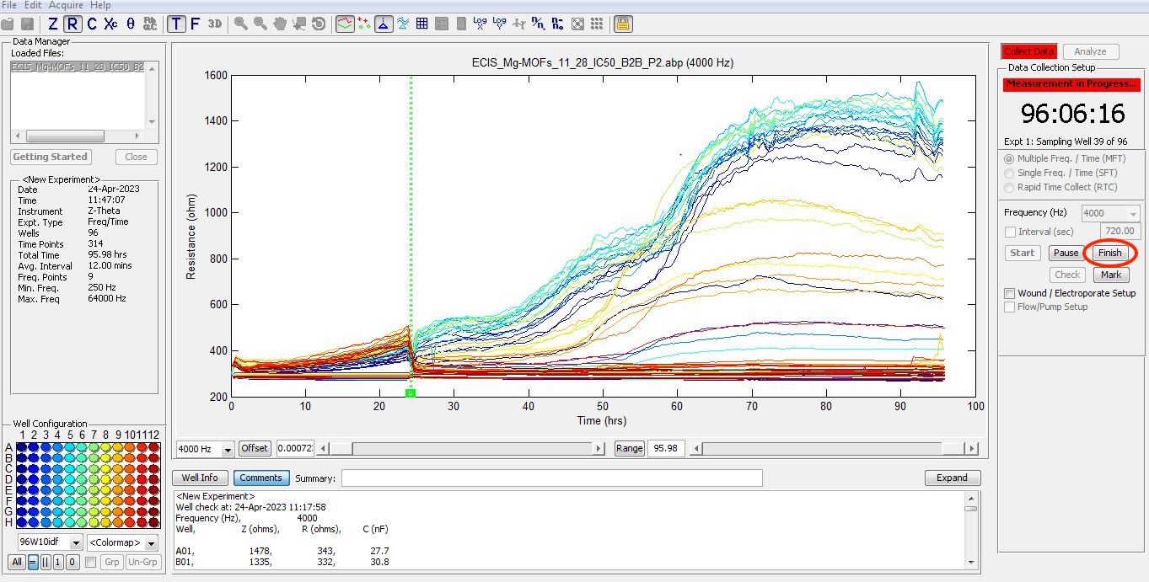

2.10.2– Select Model and then Media-Only Well to fit the data.
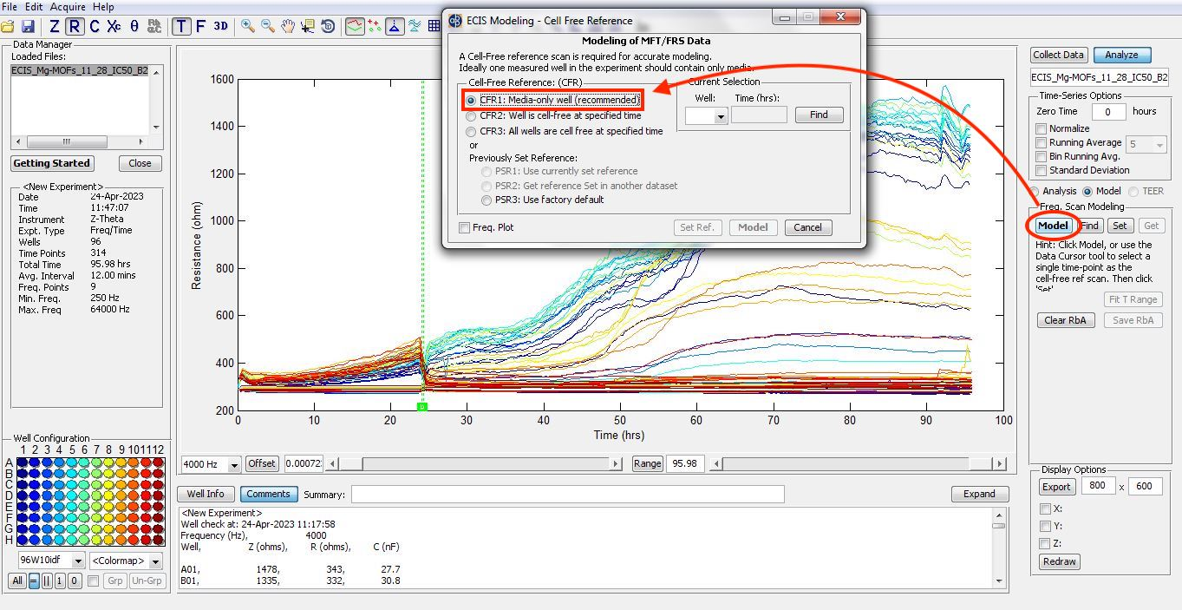
2.10.3 - Set Reference for data evaluation. Select the reference as related to the control experiment.
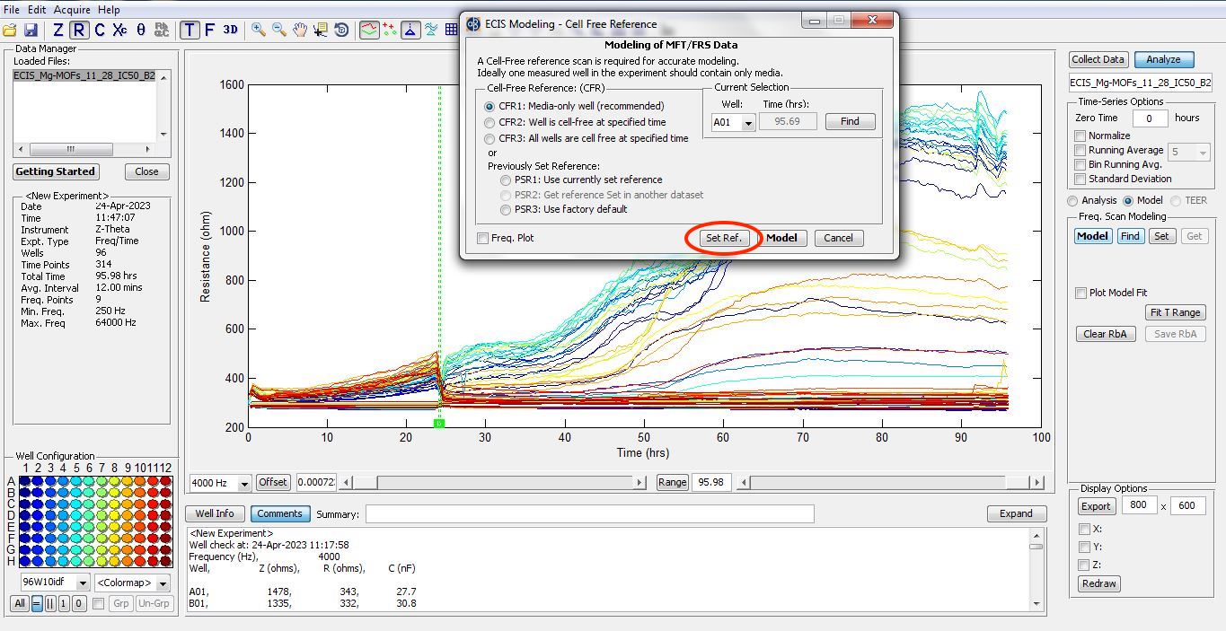

2.10.4 – Select Find to start reference fitting.
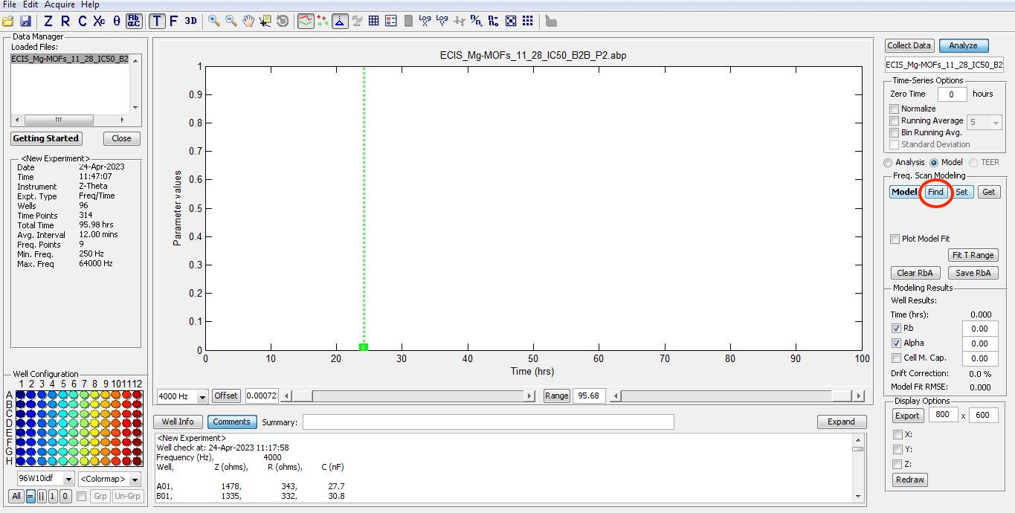
2.11.1.- Select Set and then Fit T-Range to process the data relative to the selected reference.
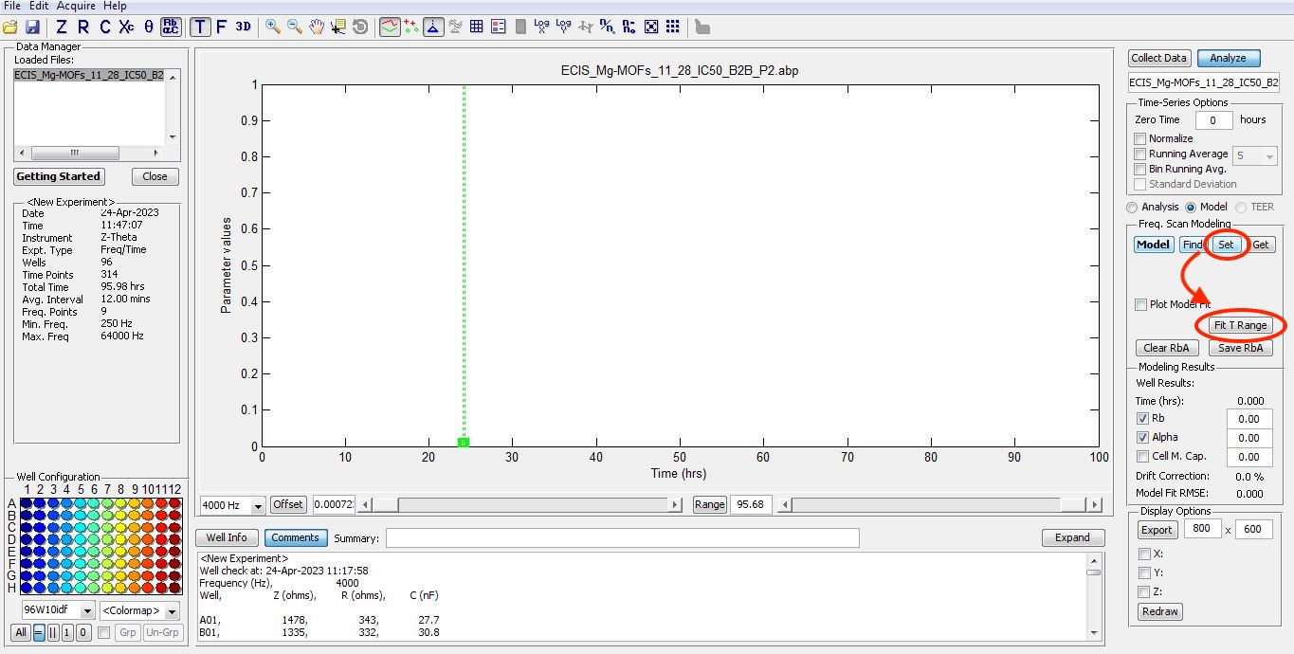

2.11.2- To evaluate cell attachment select Alpha.
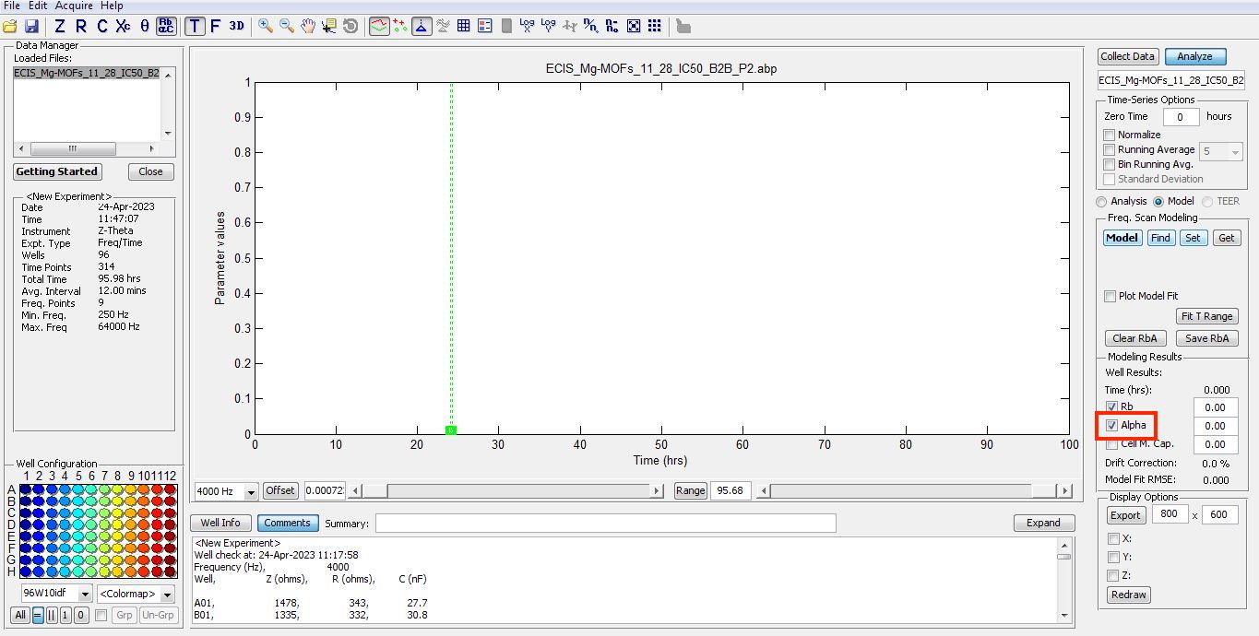
2.11.3 - Save RbA being selected, and the parameters being saved as a spreadsheet file.
