Submission ID #: 65210

Scriptwriter Name: Pradnya Kedari

Project Page Link: https://review.jove.com/account/file-uploader?src=19889098

Title: Active Probe Atomic Force Microscopy with Quattro-Parallel Cantilever Arrays for High-Throughput Large-Scale Sample Inspection

Short Title: Parallel Active Cantilever Arrays in AFMS to Enable High-Throughput Inspections

☐ The Short Title is correct. (Character limit with spaces: 80)

Authors and Affiliations:
Fangzhou Xia¹, Ivo W. Rangelow^{2,3}, Thomas Sattel⁴, Eberhard Manske⁵, Kamal Youcef-Toumi¹

¹Mechatronics Research Lab, Department of Mechanical Engineering, Massachusetts Institute of Technology
²Nanoscale Systems Group, Institute of Process Measurement and Sensor Technology, Ilmenau University of Technology
³nano analytik GmbH
⁴Mechatronics Group, Department of Mechanical Engineering, Ilmenau University of Technology
⁵Production and Precision Measurement Technology Group, Institute of Process Measurement and Sensor Technology, Ilmenau University of Technology

☐ All author names and affiliations are correct (city/state/country information not included in video title page).

Corresponding Authors:
Fangzhou Xia xiafz@mit.edu

Email Addresses for All Authors:
ivo.rangelow@tu-ilmenau.de
thomas.sattel@tu-ilmenau.de
eberhard.manske@tu-ilmenau.de
youcef@mit.edu
xiafz@mit.edu

Author Questionnaire
- Microscopy: Does your protocol require the use of a dissecting or stereomicroscope for performing a complex dissection, microinjection technique, or something similar? Enter Yes or No.
NO
If a dissection or stereo microscope is required for your protocol, please list all shots from the script that will be visualized using the microscope (shots are indicated with the 3-digit numbers, like 2.1.1, 2.1.2, etc.).
Click here to list microscope shots, using the shot numbers from the protocol section of the video script.

2. Software: Does the part of your protocol being filmed include step-by-step descriptions of software usage? Enter Yes or No.
NO
If Yes, we will need you to record using screen recording software.
We recommend using the screen capture program OBS. JoVE’s tutorial for using OBS Studio is provided at this link: https://www.jove.com/v/5848/screen-capture-instructions-for-authors?status=a7854k
As these files are necessary for finalizing your script, please upload all screen captured video files to your project page as soon as possible.

3. Proposed filming date: To help JoVE process and publish your video in a timely manner, please indicate the proposed date that your group will film here: MM/DD/YYYY

DO NOT use this draft script for filming. Please wait until your script is finalized to begin the filming process.
NO

When you are ready to submit your video files, please contact our Content Engineer, Devon Halley.

Yes I will contact yur Content Engineer. We have already some videos ready.

To ensure that your script can be filmed in one day, the protocol sections are cumulatively restricted to 55 shots (shots are the 3-digit numbers like 2.1.1, 2.1.2…etc)

Current Protocol Length

Number of Steps: 14
Number of Shots: 25

Interviews
- Video 1: Author Interviews

Answers to these questions will become interview statements that you will deliver on camera.
- Answer at least 4 of the questions below. Up to 7 interview statements will be included in the video.
- Enter the full name of the author who will deliver the statement.
- If possible, each author should deliver no more than two statements.
- Answer in full sentences, in a style suitable for being spoken aloud. The questions will not appear in the video.
- Limit the length of each statement to 50 words or fewer.
- Answers will be edited for length, clarity, and consistency with journal style guidelines.

What is the scope of your research? What questions are you trying to answer?
  - Enter author name.: Click here to answer question. Please write in a style that you will be comfortable memorizing and speaking aloud. Limit length to 50 or fewer words.

Ivo Rangelow:
Scanning Probe microscopy based on novel MEMS probes. We called such probes: ACTIVE CANTILEVER: cantilevers with integrated actuation and sensing provide several advantages over passive cantilevers which rely on piezoelectric excitation and optical beam deflection measurement.

What are the most recent developments in your field of research?
  - Enter author name: Click here to answer question. Please write in a style that you will be comfortable memorizing and speaking aloud. Limit length to 50 or fewer words.
Ivo Rangelow:
Realisation of Arrays of Active Cantilever for high throughput parallel SPM imaging
What technologies are currently used to advance research in your field?
  - Enter author name: Click here to answer question. Please write in a style that you will be comfortable memorizing and speaking aloud. Limit length to 50 or fewer words.
Ivo Rangelow:
MEMS-Technology

What are the current experimental challenges?
  - Enter author name: Click here to answer question. Please write in a style that you will be comfortable memorizing and speaking aloud. Limit length to 50 or fewer words.

Ivo Rangelow:
Optimisation of the SPM-control system. Every cantilever is an autonomous AFM and everyone has to be controlled and synchronized with other cantilevers.

What significant findings have you established in your field?
  - Enter author name: Click here if you choose this question. Please write in a style that you will be comfortable memorizing and speaking aloud. Limit length to 50 or fewer words.

Ivo Rangelow:
We significantly improved the sensitivity of the piezoresistive sensors integrated on the cantilever and now we are competitive to optical read-out methods.

What research gap are you addressing with your protocol?
  - Enter author name: Click here if you choose this question. Please write in a style that you will be comfortable memorizing and speaking aloud. Limit length to 50 or fewer words.

Ivo Rangelow:
SPM-Parallelization has to be a reliable and widely used technique.

What advantage does your protocol offer compared to other techniques?
  - Enter author name: Click here if you choose this question. Please write in a style that you will be comfortable memorizing and speaking aloud. Limit length to 50 or fewer words.

Ivo Rangelow:
The mine advantage is the SPM imaging with high throughput on large surfaces.

How will your findings advance research in your field?
  - Enter author name: Click here if you choose this question. Please write in a style that you will be comfortable memorizing and speaking aloud. Limit length to 50 or fewer words.
Ivo Rangelow:
Investigating large samples (nanoelectronic chis) in a short time.

What new scientific questions have your results paved the way for?
  - Enter author name: Click here if you choose this question. Please write in a style that you will be comfortable memorizing and speaking aloud. Limit length to 50 or fewer words.
Ivo Rangelow:
Operation and building of parallel MEMS systems

What research questions will your laboratory focus on in the future?
  - Enter author name: Click here if you choose this question. Please write in a style that you will be comfortable memorizing and speaking aloud. Limit length to 50 or fewer words.

Ivo Rangelow:

How to operate faster and reliable massively parallel active cantilever systems.

Protocol Videos
Each video will include a section of your protocol and accompanying results, if applicable. Use Track Changes when making edits or revisions.
- The two-digit steps (e.g., 2.1., 2.2.) are the narration. Professional voiceover artists will narrate the video.
- Red and italics are pronunciation guides (how the word will be spoken).
- Filming should take no more than 10 minutes per step. If a step takes more than 10 minutes, prepare the product from that step in advance.
Protocol:
- The three-digit shots (e.g., 2.1.1., 2.2.2.) are the actions that you/your videographer will capture.
Representative Results:
- The three-digit numbers (e.g., 2.3.1., 2.3.2.) are the figures/tables from your manuscript. These will not be recorded by the videographer.
- Please review the result section to make sure it logically follows the video.
- Please note that the video cannot include voiceover without an accompanying visual.

- Video 2: Sample Preparation, Instrument Calibration, Experimental Setup, and Parameter Tuning for Topography Imaging Using AFM
Demonstrator: Click here to enter name of demonstrator(s)
Fabian Dietrich, Hans-Georg Pietscher, and Aditya Suryadi Tan
Protocol
  - Begin by polishing the extreme UV mask sample [1], ensuring the topography variation is below 10 micrometers within any 10 by 10-millimeter area to track the topography accurately [2].
    - WIDE: Talent polishing the EUV mask sample.
    - A close-up view of the polishing of the sample. Videographer: Please capture a close-up shot here focusing on the polishing of the sample and the surface of the sample.
  - Clean the sample from the contaminants by blowing it with a compressed nitrogen spray gun or rinsing it with deionized water [1]. Keep the samples inside a clean room or low-dust environment, such as a vacuum chamber or a nitrogen-purged cabinet [2].
    - Talent blowing the sample with a compressed nitrogen spray gun. OR Talent rinsing the sample with deionized water.
    - The sample placed in a clean room on a clean platform being seen. OR Talent placing the sample in a vacuum chamber or a nitrogen-purged cabinet

  - To begin calibration and experiment setup of the AFM (A-F-M) instrument, switch on the main power of the AFM controller and wait for the system to initialize [1-TXT]. After switching on the host computer, open the AFM system software [2].
    - Talent switching on the main power of the AFM controller. TXT: AFM: Atomic force microscopes
    - Talent looking at the monitor and opening AFM system software. Videographer: Please also capture the action performed on the monitor while the talent is performing the action.

  - For cantilever probe installation, raise the probe scanner by clicking on the Active Cantilever Installation [1]. Wait for the probe holder to be raised from the sample stage and stop automatically [2].
    - SCREEN: To be provided by the authors: The Active Cantilever Installation is clicked on the monitor.
Author: Please refer to the Screen-capture guidelines to capture all the SCREEN shots and upload all screen-captured video files to your project page as soon as possible. https://review.jove.com/account/file-uploader?src=19889098
1_Cantilever_ Check_Video – Mit Clipchamp erstellt (1).mp4
The probe holder is getting raised from the sample stage and stops automatically.

  - Then, mount and secure the AFM cantilever probe array on the probe holder [1]. Click on the Probe Auto Settings and load the probe information [2].
https://review.jove.com/account/file-uploader?src=19889098
(MG_9978.MOV-represents the mount the cabtilever into system)
    - Talent securing the AFM cantilever probe array on the probe holder.
    - SCREEN: To be provided by the authors: The Probe Auto Settings is clicked, and the probe information is loaded.

  - Load and secure the sample in place, ensuring the bottom surface in contact with the sample is parallel to the top surface with the features to be imaged [1]. Fine-tune the sample stage tilt using the micrometer knobs [2].
    - Talent loading the sample in place.
    - Talent using the micrometer knobs and fine-tuning the sample stage tilt.
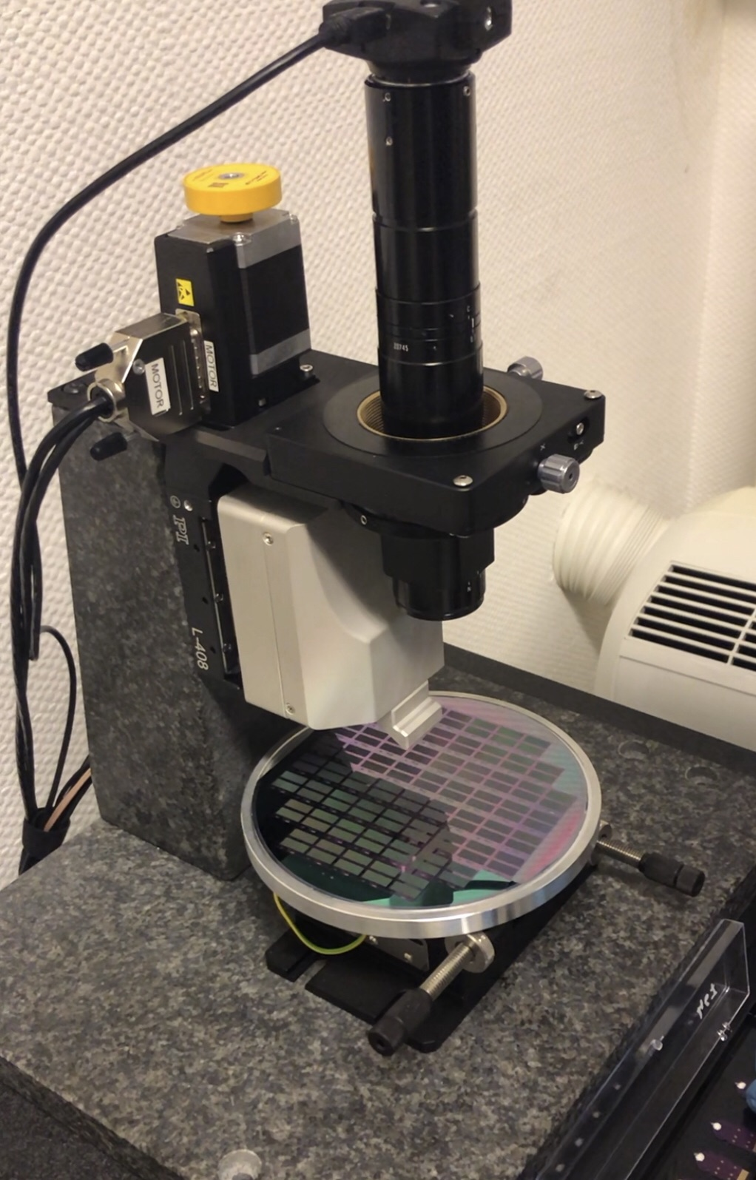

  - Adjust the in-plane XY (Ex-Y) position of the sample using the micrometer on the AFM stage [1] before locating the area of interest using an optical microscope image [2]. Select the relative position of the cantilever array onto the first area of interest to be imaged [3].

https://review.jove.com/account/file-uploader?src=19889098
4Canti_2023_P1050318.png

    - Talent adjusting the plane position using the micrometer on the AFM stage.
    - SCREEN: To be provided by the authors: The area of interest being located using an optical microscope.

    - SCREEN: To be provided by the authors: Selection of the relative position of the cantilever array onto the first area of interest being seen.

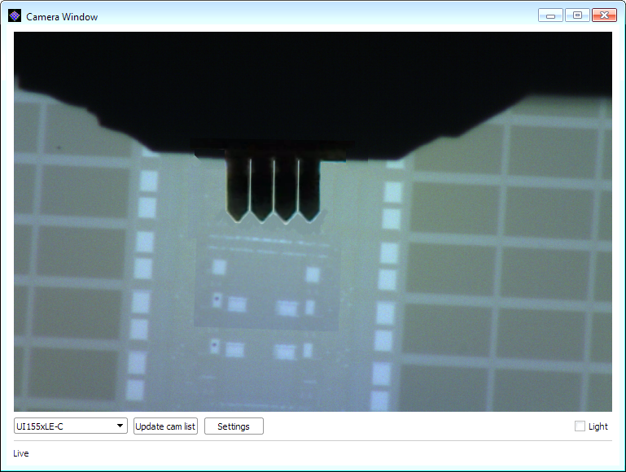

  - Next, establish a global coordinate by clicking the XYZ (Ex-Y-Zee) Zero button [1]. Close and seal the acoustic shield [2].

    - SCREEN: To be provided by the authors: The global coordinates being established.

    - SCREEN: To be provided by the authors: Closing and sealing the acoustic shield.

  - Select the Imaging Parameter Setup tab to begin the topography imaging and parameter tuning. Enter the top left corner coordinates of the image and the scan size for a single panoramic image [1].

Will be introduced on Thursday, 23.05.2023

    - SCREEN: To be provided by the authors: The tab Imaging Parameter Setup being clicked. The top left corner coordinates and the scan size of the image being entered.
Will be introduced on Thursday, 23.05.2023

  - Then, enter the desired in-plane pixel resolution and use the default recommended line scan speed from the software for imaging [1].

- Will be introduced on Thursday, 23.05.2023
    - SCREEN: To be provided by the authors: The in-plane pixel resolution of 26,000 pixels/line is entered, and the default recommended line scan speed is selected.
Will be introduced on Thursday, 23.05.2023

  - For tapping mode operation, use the default tapping drive amplitude, frequency, and setpoint in the software obtained from the cantilever characteristics or manually input the setpoint for each cantilever on the array [1].
Will be introduced on Thursday, 23.05.2023
    - SCREEN: To be provided by the authors: Default tapping drive amplitude, frequency, and setpoint being entered in the software.
OR Talent manually entering the setpoint for each cantilever on the array.

Will be introduced on Thursday, 23.05.2023

  - Click on Initialize Cantilever to pre-bend the cantilever before imaging. Then, click on Start Non-Contact Drive to excite the cantilever resonance [1]. Next, click Engage to let the system automatically bring the sample and the probe into contact [2].
Will be introduced on Thursday, 23.05.2023
    - SCREEN: To be provided by the authors: Initialize Cantilever being clicked, then Start Non-Contact Drive being clicked.
Will be introduced on Thursday, 23.05.2023

    - SCREEN: To be provided by the authors: Engage being clicked followed by starting of the imaging.
Will be introduced on Thursday, 23.05.2023

  - Adjust the proportional-integral-derivative controller parameters for each cantilever based on the scanned trace per image [1]. Save the current data on the screen by clicking the Save button [2] and stop imaging by clicking the Stop button [3].
Will be introduced on Thursday, 23.05.2023

    - SCREEN: To be provided by the authors: The proportional-integral-derivative controller parameters being adjusted.
Will be introduced on Thursday, 23.05.2023

    - SCREEN: To be provided by the authors: The current data present on the screen is being saved.
Will be introduced on Thursday, 23.05.2023

    - SCREEN: To be provided by the authors: The stop button being clicked to stop imaging.
Will be introduced on Thursday, 23.05.2023

  - Remove the probe and the sample carefully and turn off the system [1].
    - Talent removing the probe and the sample.
Video

Representative Results
  - The effectiveness of AFM using parallel active cantilevers was demonstrated by capturing the stitched images of a calibration grating with four cantilevers operated in parallel [1].
    - LAB MEDIA: Figure 2.

  - It revealed that the silicon wafer calibration structure had 45-micrometer-long features with a height of 14 nanometers. Each cantilever covered an area of 125 by 125 micrometers, which gave a stitched panoramic image of 500 by 125 micrometers [1].
    - LAB MEDIA: Figure 2.

  - To verify the spatial resolution of the active cantilever array, high-resolution images of highly oriented pyrolytic graphite were captured, with a small in-plane image range of 5 by 5 micrometers and 1028 by 1028 pixels. The analysis demonstrated the sub-nanometer out-of-plane and in-plane resolutions at several nanometers [1].
    - LAB MEDIA: Figure 3.

  - Imaging an extreme UV lithography mask for creating semiconductor features showed an overall stitched panoramic image with a 5-nanometer spatial resolution covering an area of 505 by 130 micrometers [1].
    - LAB MEDIA: Figure 4.

  - The height of the structure pattern was around 60 nanometers, with various areas of the circuit clearly shown in the image. At 10 lines per second, the 101,000 by 26,000 pixels were captured within around 40 minutes, which is significantly faster than conventional AFM systems [1].
    - LAB MEDIA: Figure 4.
    - LAB MEDIA: Figure 4.

