64591 Screenshot summary
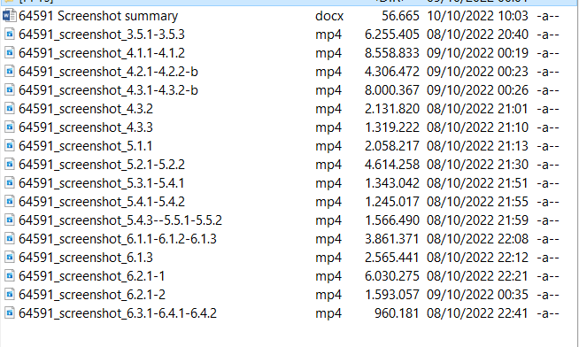

3.4.2. SCREEN: talent scanning the selected parts – will be shown on video
3.4.3. SCREEN: opening the image analysis system - will be shown on video

64591_screenshot_3.5.1.-3.5.3
3.4.3. SCREEN: opening the image analysis system -00:00:03
3.5.1. SCREEN: using a graphics editing program 00:00:07
3.5.2. SCREEN: checking the quality and adjusting the parameters 00:00:14
3.5.3. SCREEN: saving the images

64591_screenshot_4.1.1.-4.1.2
4.1.1. SCREEN: starting an image analysis system 00:00:03
4.1.2. SCREEN: opening the image and setting the calibration 00:00:21

64591_screenshot_4.2.1.-4.2.2-b
4.2.1. SCREEN: pointing towards the first tree ring measured 00:00:10
4.2.2. SCREEN: clicking on tree ring boundaries 00:00:19

64591_screenshot_4.3.1.-4.3.2-b
4.3.1. SCREEN: measuring all tree ring widths 00:00:05
4.3.2. SCREEN: saving the data with each tree ring width recorded for a specific relative year 00:00:51
00:01:19

64591_screenshot_4.3.2
4.3.2. SCREEN: saving the data with each tree ring width recorded for a specific relative year 00:00:02

64591_screenshot_4.3.3
4.3.3. SCREEN: showing the output of the measurement - table of tree-ring widths vs. time (relative years) 00:00:06

64591_screenshot_5.1.1
5.1.1. SCREEN: opening the data file, showing the graph 00:00:06

64591_screenshot_5.2.1-5.2.2
5.2.1. SCREEN: opening the two tree rings series 00:00:03
5.2.2. SCREEN: running the cross dating 00:00:28

5.3.1. SCREEN: cross dating parameters being displayed 00:00:34

5.4.2. SCREEN: Position of the series being saved 00:00:41
5.4.3. SCREEN: Repeating for another tree ring series 00:00:54

64591_screenshot_5.3.1-5.4.1
5.3.1. SCREEN: cross dating parameters being displayed 00:00:01
5.3.2. SCREEN: TBVP and TVH values being shown 00:00:10
5.3.3. SCREEN: Glk% being shown 00:00:21
5.4.1. SCREEN: Overlap being shown 00:00:31

64591_screenshot_5.4.1-5.4.2
5.4.1. SCREEN: Overlap being shown 00:00:01
5.4.2. SCREEN: Position of the series being saved 00:00:10

64591_screenshot_5.4.3--5.5.1-5.5.2
5.5.1. SCREEN: graphs of the measurements from different parts of the top being displayed 00:00:02
5.5.2. SCREEN: average being calculated to form a chronology of a violin 00:00:26

64591_screenshot_6.1.1-6.1.2-6.1.3
6.1.1. SCREEN: the chronology of the violin being opened 00:00:03
6.1.2. SCREEN: reference chronology being opened 00:00:20
6.1.3. SCREEN: cross dating being performed and parameters being checked 00:00:35

64591_screenshot_6.1.3
6.1.3. SCREEN: cross dating being performed and parameters being checked 00:00:03

64591_screenshot_6.2.1-1
6.2.1. SCREEN: a successful dating being shown with statistically significant parameters 00:00:03

64591_screenshot_6.2.1-2
6.2.1. SCREEN: a successful dating being shown with statistically significant parameters 00:00:03 - 00:00:20

64591_screenshot_6.3.1-6.4.1-6.4.2
6.4.1. SCREEN: Number of years being estimated 00:00:03
6.3.1. SCREEN: end date being reported 00:00:03

6.4.2. SCREEN: date of manufacture being calculated 00:00:08

