Submission ID #: 64232

Scriptwriter Name: Sulakshana Karkala
Project Page Link: https://review.jove.com/account/file-uploader?src=19590808

Title: A Common Marmoset Model of Mother-Infant Intervention for Breastfeeding Disorders in the Presence of Paternal Inhibition and Maternal Neglect

Authors and Affiliations:
Mayuko Yoda^{1,2}, Yoshimasa Kamei³, Hayato Sakurai⁴, Hiroko Kakei⁴, Ting Tao^{1,2,4}, Hideo Yamanouchi⁴, Tetsuya Kunikata⁴, Masanori Hariyama⁵, Ricki Colman⁶, Mamiko Koshiba^{1,4,5}

¹ Graduate School of Sciences and Technology for Innovation, Yamaguchi University
² Faculty of Health Sciences and Nursing, Juntendo University
³ Obstetrician, Medical Department, Saitama Medical University
⁴ Pediatrics, Medical Department, Saitama Medical University
⁵ Graduate School of Information Sciences, Tohoku University
⁶ Department of Cell and Regenerative Biology and Wisconsin National Primate Research Center, University of Wisconsin

☐ All author names are spelled correctly, and the affiliations are correct (city/state/country information not included in video title page).

Corresponding Author:

Mamiko Koshiba koshiba@yamaguchi-u.ac.jp

Email Addresses for All Authors:

Mayuko Yoda mayukomaru@icloud.com
Yoshimasa Kamei ykamei@saitama-med.ac.jp
Hayato Sakurai toyaha@saitama-med.ac.jp
Hiroko Kakei korohi@saitama-med.ac.jp
Ting Tao taoting@yamaguchi-u.ac.jp
Hideo Yamanouchi yhideo@saitama-med.ac.jp
Tetsuya Kunikata tekunika@saitama-med.ac.jp
Masanori Hariyama hariyama@tohoku.ac.jp
Ricki Colman rcolman@primate.wisc.edu

Mamiko Koshiba koshiba@yamaguchi-u.ac.jp

Author Questionnaire
1. Microscopy: Does your protocol demonstrate the use of a dissecting or stereomicroscope for performing a complex dissection, microinjection technique, or similar? NO
If a dissection or stereo microscope is required for your protocol, please list all shots from the script that will be visualized using the microscope (shots are indicated with the 3-digit numbers, like 2.1.1, 2.1.2, etc.).
Click here to list microscope shots, using the shot numbers from the protocol section of the video script.

2. Software: Does the part of your protocol being filmed demonstrate software usage? NO
If Yes, we will need you to record using screen recording software.
We recommend using the screen capture program OBS. JoVE’s tutorial for using OBS Studio is provided at this link: https://www.jove.com/v/5848/screen-capture-instructions-for-authors?status=a7854k
As these files are necessary for finalizing your script, please upload all screen captured video files to your project page by your script return date or as soon thereafter as possible.

3. Interview statements: Please select one.
If you select option 2, please do not enter names in introduction and conclusion statements
√ 1. Interviewees self-record interview statements.
☐ 2. Interview Statements are read by JoVE’s voiceover talent.

4. Proposed filming date: To help JoVE process and publish your video in a timely manner, please indicate the proposed date that your group will film here: 09/05/2023
DO NOT use this draft script for filming. Please wait until your script is finalized to begin the filming process.

Scriptwriter: If authors are from China, please use the second note to connect them with Yuan. Please remove the statement that does not apply before sending the draft script.

When you are ready to submit your video files, please contact our Content Engineer, Devon Halley.

- To ensure that your video paper meets our publication requirements, the protocol is restricted to 55 shots.

Protocol Length
Number of Steps: 16
Number of Shots: 32

Introduction
- Introductory Interview Statements

Your answers to these questions will become author interview statements, which will be incorporated into the script. Authors will memorize the statements and then deliver them on camera.
- Enter the full name of the author who will deliver the statement on camera.
- Each author should deliver no more than two statements.
- Fill out both required statements. Additional optional statements may also be selected.
- Please answer in full sentences in a style suitable for being spoken aloud.
- Limit the length of each statement to 30 words or fewer.
- Answers will be edited for length, clarity, and consistency with journal style guidelines.

REQUIRED: Why is your protocol significant? OR What key questions can this method help answer?
  - Mayuko Yoda: This video introduces a nonhuman primate model protocol of mother-Infant intervention for breastfeeding disorders in the presence of paternal inhibition and maternal neglect.

REQUIRED: What is the main advantage of this technique?

  - Mamiko Koshiba: We identified a common marmoset spontaneous case of breastfeeding failure in which the father inhibited his neonatal infant’s feeding and the mother appeared to abandon nurturing leading to clinically significant weight loss in the infant. The mother was trained to allow the infant to spontaneously explore her breast. Initially, the mother refused to display the feeding pose potentially due to pain associated with breast engorgement. Massage was used to soften the breast and feeding was re-introduced. We hypothesize that activation of instinctive attachment formation mechanisms by encouraging spontaneity in each parent and child is key to successful feeding intervention.

OPTIONAL: Do the implications of this technique extend toward the therapy (or diagnosis) of a particular disease, disability, or challenge? How so?
  - Mayuko Yoda: The primate model video may be a substitute for human caregiver’s education.

OPTIONAL: Are there any specific areas of research that this method could provide insight into? OR Can this method be applied to any other systems?

  - Mamiko Koshiba: The increase of child abuse and neglect cases, most likely by inexperienced and insufficiently knowledgeable parents, necessitates education of childcare and intervention techniques in nursing and midwifery training.
OPTIONAL: How would you expect an individual who has never performed this technique to struggle? Do you have any advice to offer to somebody who is trying this technique for the first time?

  - Mamiko Koshiba: The symptoms and treatment effects are indicated by increase or decrease in body weight relative to the survival limit of our colony history, referring to the previously published criteria of Dr. Ziegler et al and Dr. Tardif et al ^{16,17}.

OPTIONAL: Why is visual demonstration of this method critical?

  - Mamiko Koshiba: Although this is a case report, these comprehensive intervention techniques may provide an example of realistic parent-child interactions that may be used as educational material and reference data for inexperienced caregivers.

Introduction of Demonstrator on Camera

Complete this statement ONLY if any of the individuals who will be demonstrating the procedure on camera will not be delivering an Introductory Interview Statement.

  - Enter name of author who will introduce demonstrator: Demonstrating the procedure will be Click here to enter name of demonstrator(s)., a Click here to enter demonstrator job title. from my laboratory. Include additional demonstrators as needed.[1][2].

    - INTERVIEW: Author saying the above
    - The named demonstrator(s) looks up from workbench or desk or microscope and acknowledges the camera

Ethics Title Card

  - Procedures involving animal subjects have been approved by the Institutional Animal Care and Use Committee (IACUC) at Saitama Medical University.

Protocol
Please review this section to make sure that it accurately describes your protocol. Use Track Changes when making edits or revisions.
- The one-digit numbers represent sections of the video. The text will appear as a title onscreen.
- The two-digit numbers (e.g., 2.1., 2.2.) represent steps of your protocol. The text will be recorded by JoVE’s voiceover talent.
- The three-digit numbers (e.g., 2.1.1., 2.2.2.) represent the shots that your videographer will capture in your lab.

Please use this draft script to help you prepare for filming day.
- If a step will take more than 10 minutes, we recommend preparing the product for that step in advance.
- Callithrix jacchus Animal Behavior Characterisation

  - Begin by housing a pair of healthy common marmoset parents with their first-time infants, in a light-sealed incubated cage [1-TXT].
    - WIDE: Talent in front of a cage with healthy marmoset parents and their first time infants. TXT: Refer the manuscript for general diagnosis and intervention flow chart
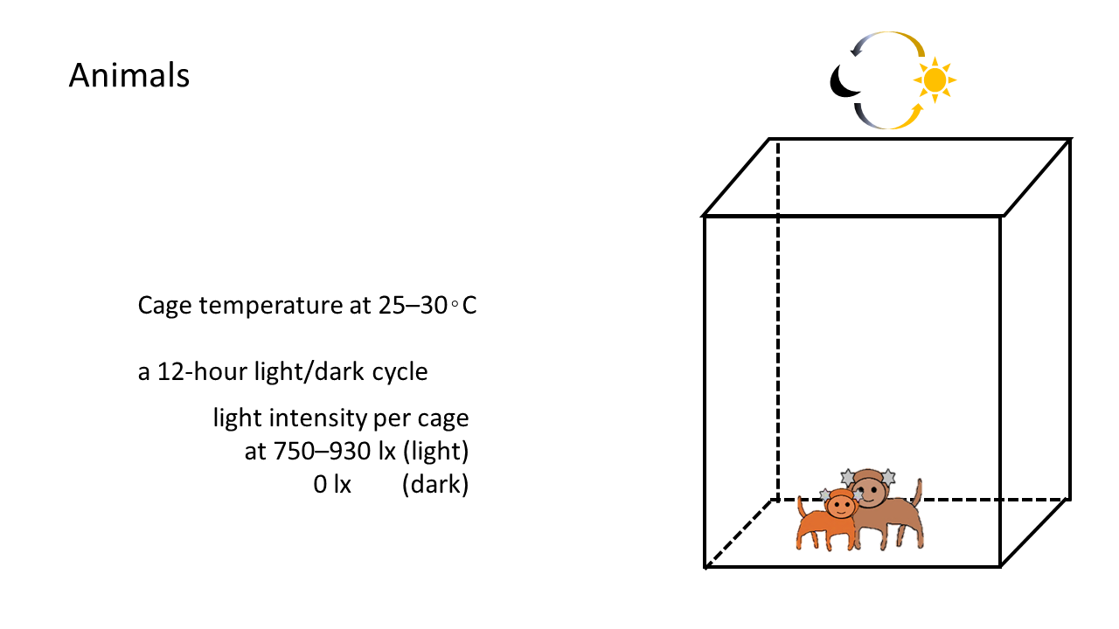
  - Take note of the full-term gestation period at birth, which is typically 140 to 150 days [1]. Next, define birthdays as postnatal day 0 or PD 0 (P-D-Zero) [2]. Then, determine the sex of the infant marmoset by examining its external genitalia [3].
    - Talent notes the full-term gestational period.
    - Talent notes down the birth-day as PD 0.
    - Shot of the infant sex being checked.
  - To check the feeding volume, first tare a clean tissue lined-plastic box on a weighing scale [1]. Next, place the infant in the prepared box to record its body weight [2].
    - Talent places a clean plastic box a weighing scale to tare.
    - Talent places the infant on a weighing scale to record its weight. TXT: Weight daily at the same time for standard comparison
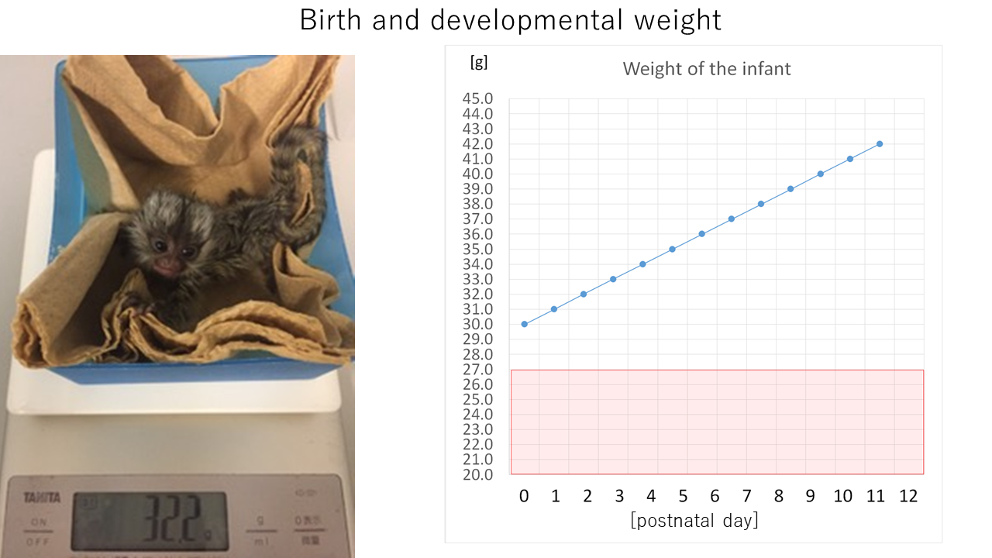
  - Display a graph that shows the daily body weight gain [1]. The newborn's weight between Day 0 to 2 should surpass 27 grams, and increase by 1 gram per day as documented for survival [2]. Authors: Please create screen capture videos of the shots labeled as SCREEN, create a screenshot summary, and upload the files to your project page as soon as possible:
https://review.jove.com/account/file-uploader?src=19590808
    - SCREEN: A graph of body weight gain per day is being created.
    - LAB MEDIA: Figure 2
  - Evaluate the milk intake volume by measuring the infant's weight before [1] and after feeding [2-TXT].
    - Shot of infant feeding
    - Shot of feeding infant being removed and placed on a weighing balance.
TXT: Reduce weigh-in frequency to once daily, to reduce separation stress
Video Editor: Please play the 2 shots side by side
  - Next, measure the crown-rump length by positioning the infant prone against a ruler [1] and determine the length from the top of the head to the base of the tail [2].
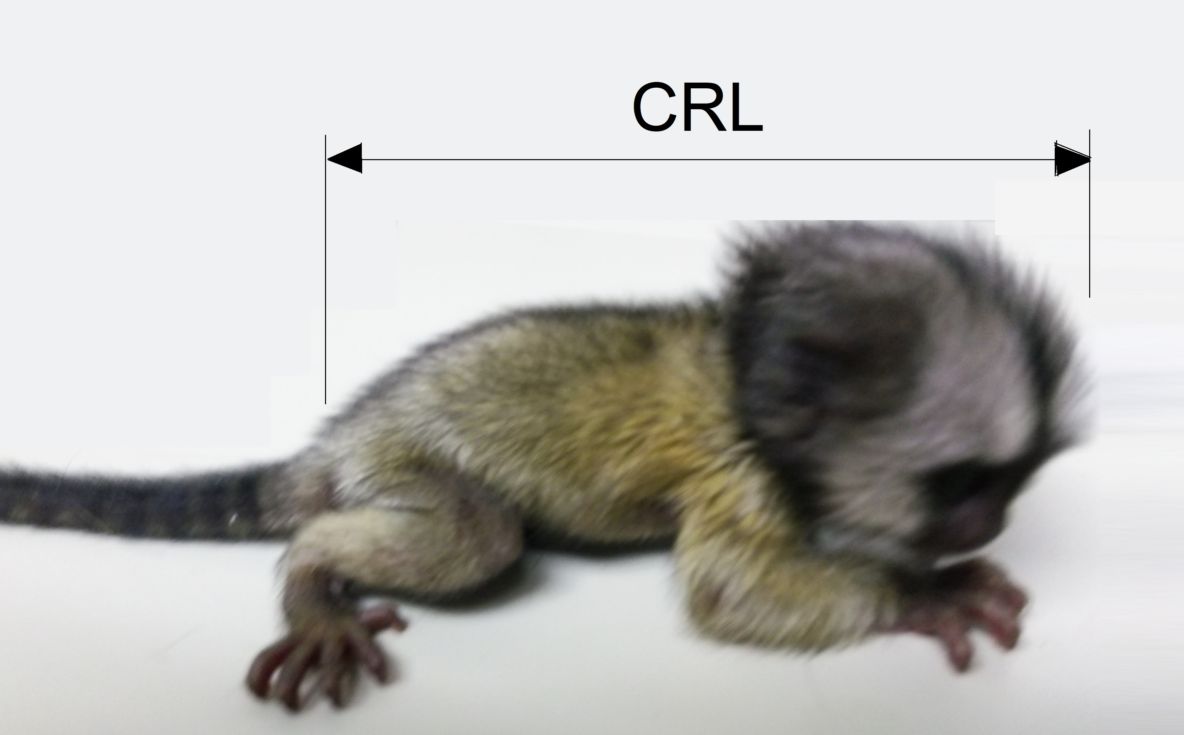
    - Shot of the infant being placed in a prone position against the ruler.
    - Talent measures the length from the head to the tail base.
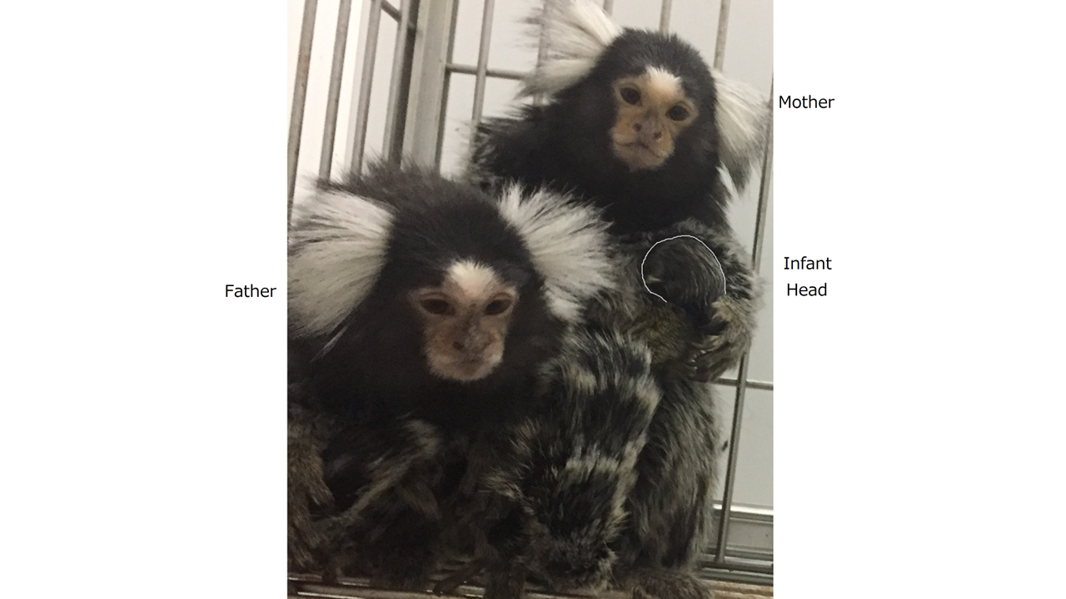
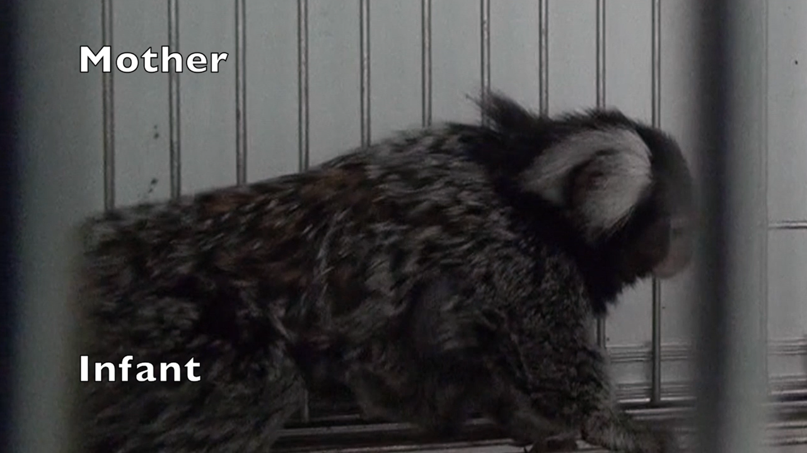
  - To check the breastfeeding of the infant, first check if the infant is sufficiently clinging to the mother’s body [1]. Next, verify if the infant's head leans towards the mother's body on its own body muscle tension [2].
    - Shot of the infant clinging to its mother.
    - Shot of the infant’s head leaning towards the mother’s body.
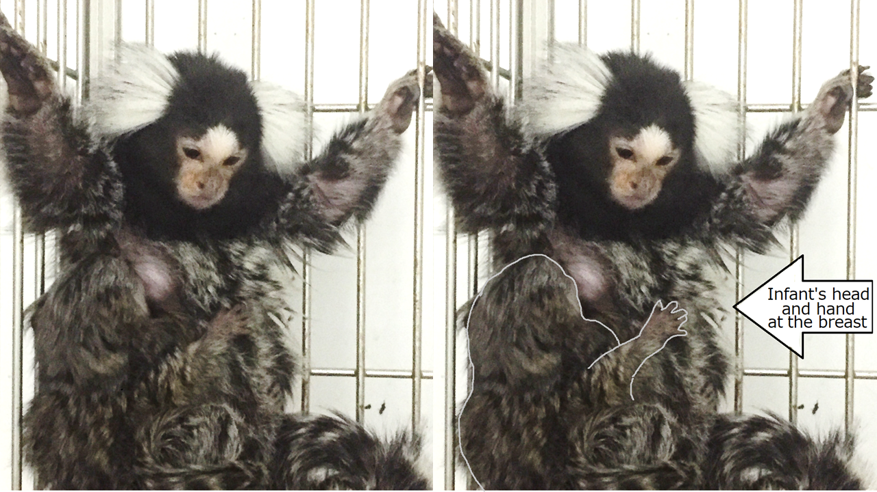
  - Observe if the infant independently tries to reach the mother’s nipple as a part of the sucking reflex with some parental help [1]. Finally. check if the infant vocalizes a “phee” call loudly, when detached from its parents [2].
    - Shot of the infant reaching out to the mother’s nipple.
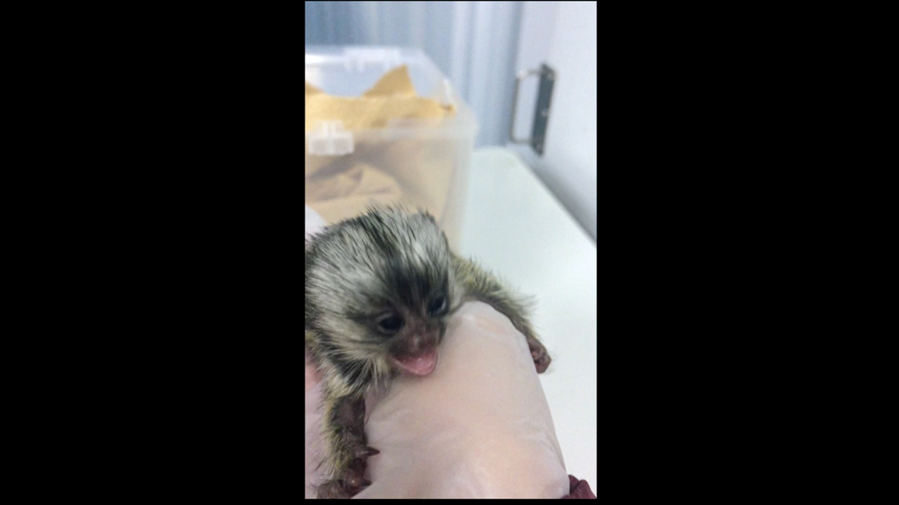
    - Shot of the infant crying when being pulled away from the parents.
Video Editor: Please keep the video sound on for this shot
  - To characterize the mother’s breastfeeding behavior, check if she cooperatively accepts the newborn for breastfeeding [1]. Next, verify if she encourages the infant to suckle when her breast gets taut [2-TXT].
    - Talent introduces the infant to the mother for breastfeeding.
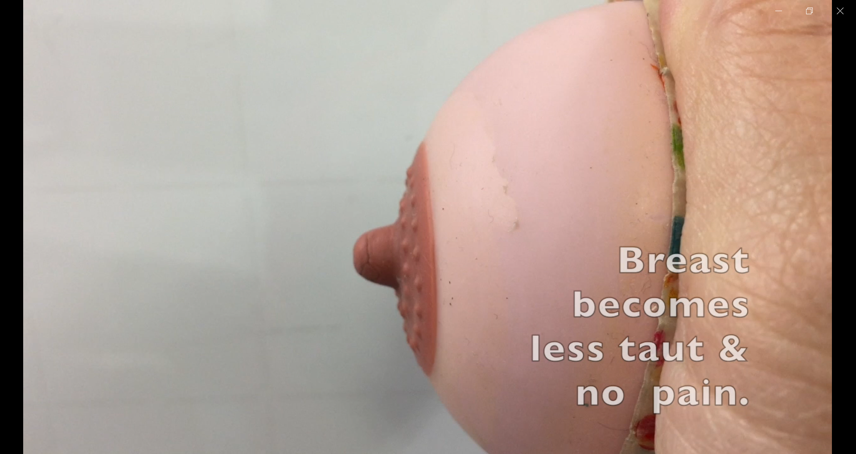
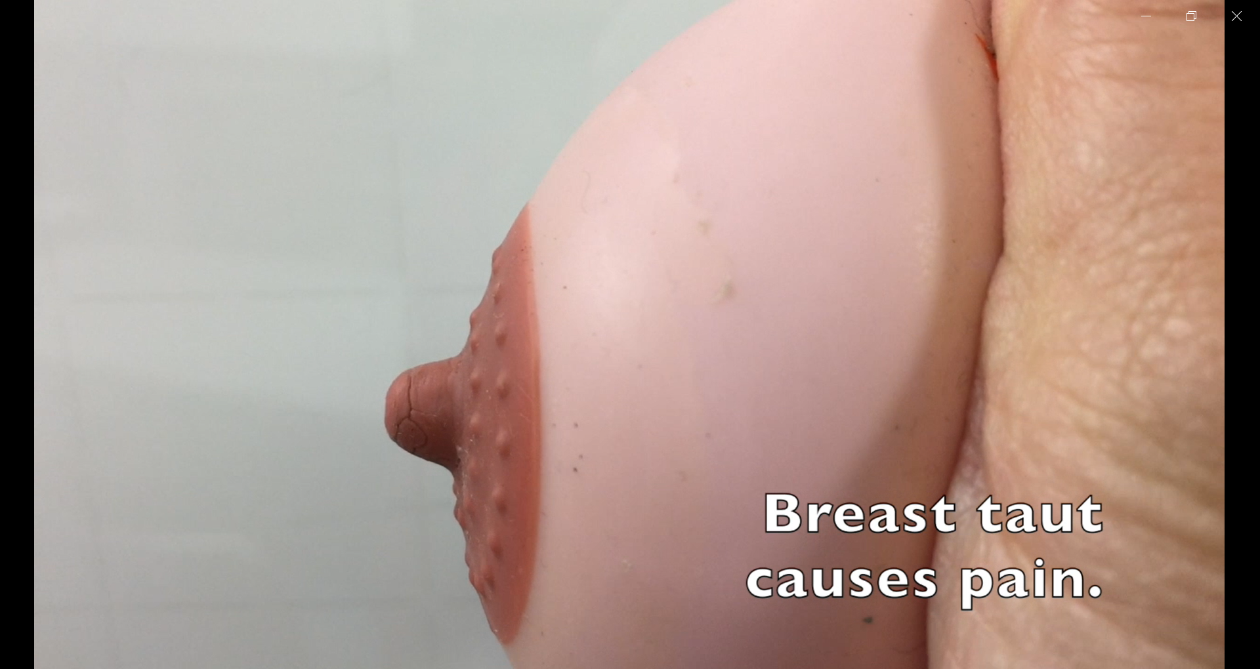
    - Shot of the mother encouraging the infant to suckle when breasts get taut. TXT: Feeding reduces tautness and causes teat protrusion
AUTHORS: If possible, please capture the the breast tautness before and after suckling.
  - Now, assess the mother's breastmilk secretion by gently pressing the sides of the breast with fingers, ensuring the breast is not overly firm or engorged [1]. Observe the mother's facial expressions for any signs of pain [2].
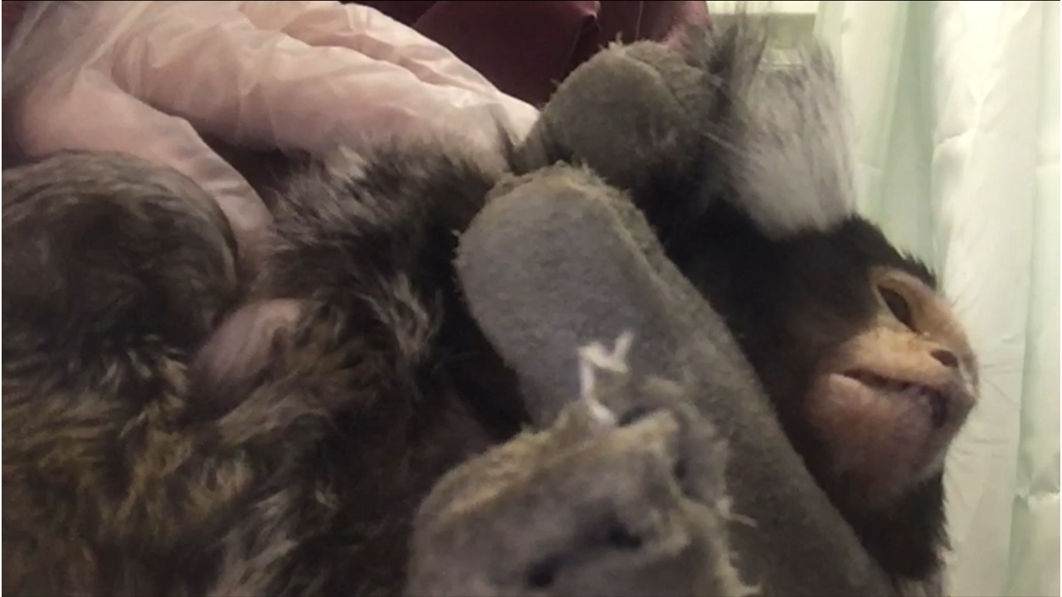
    - Shot of the breast being gently pressed.
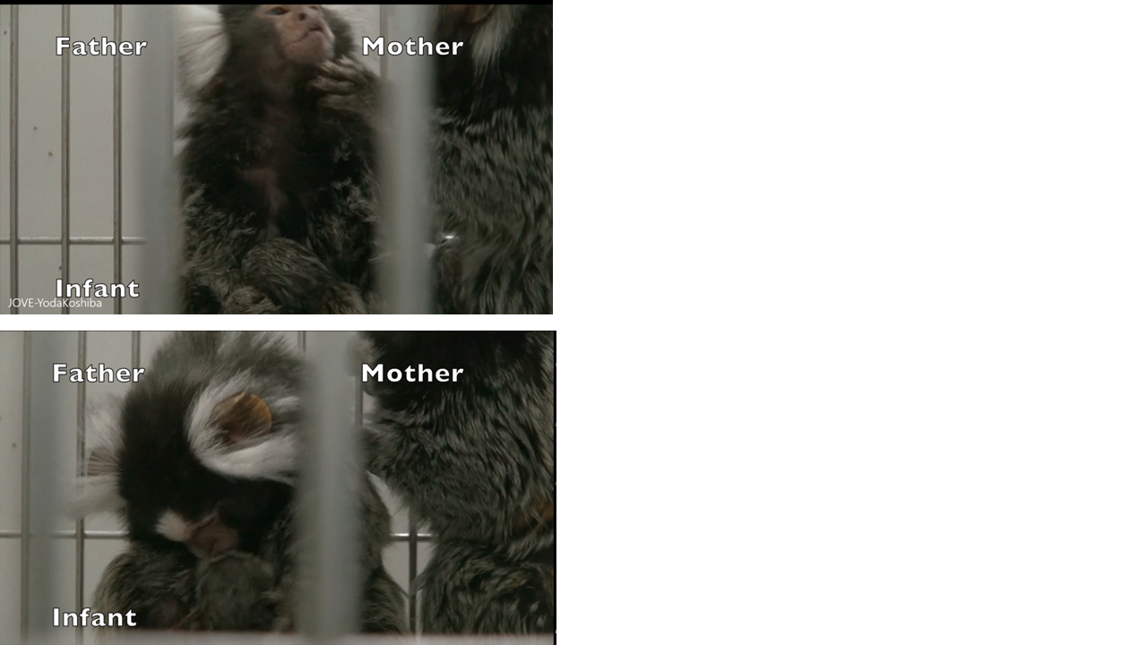
    - Shot of the mother’s facial expressions.
  - Next, check if the father shows signs of excessive carrying of the infant which may interfere with nursing [1-TXT].
    - Shot of the father carrying the infant. TXT: If father is inhibiting feeding, separate him until infant’s development improves
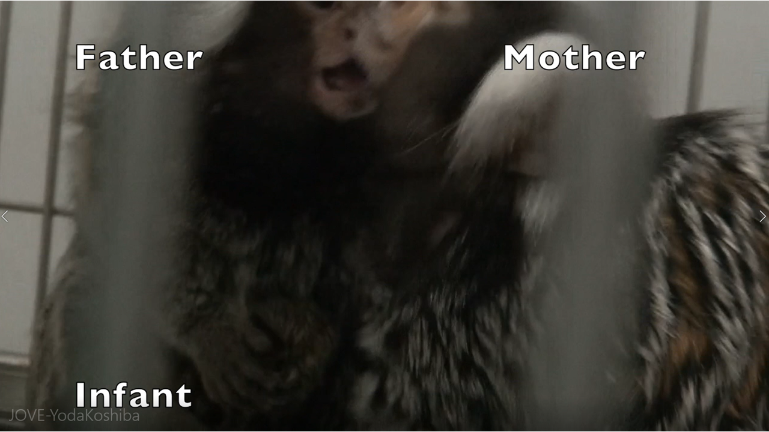
  - In an intervention to re-establish spontaneous breastfeeding, identify any underweight infants [1]. Keenly observe the family dynamics to identify any abnormal infant-rearing behavior among the parents, that could pose a high risk to the infant [2].
    - Talent points at the underweight infants.
    - Shot of any abnormal infant-rearing behavior.
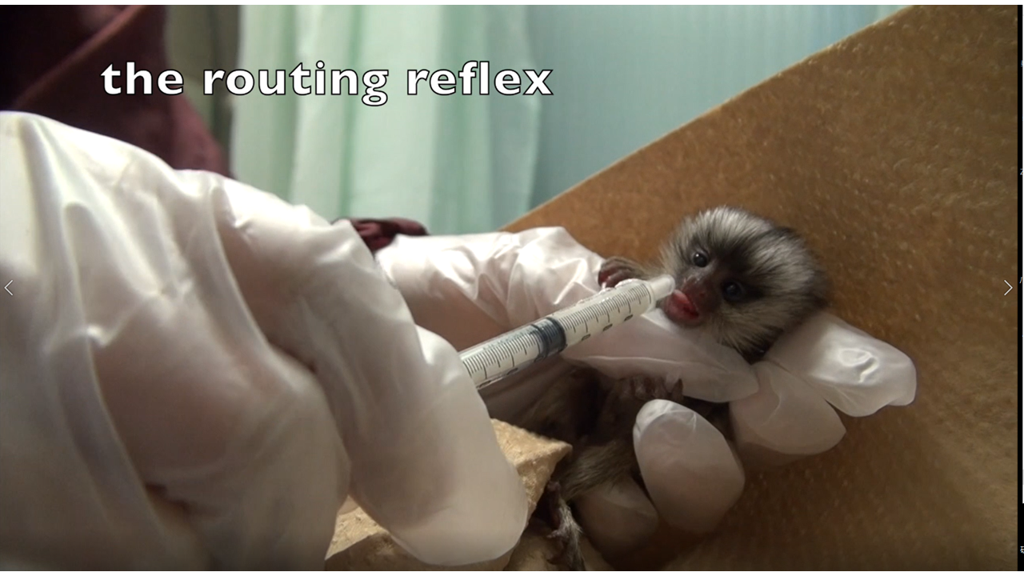
  - If the infant is too weak to explore independently or grasp onto the mother to initiate nursing, isolate it from the mother [1]. Then, feed it a minimal amount of formula, administered through an oral syringe [2].
    - Talent separates a weak infant from its mother.
    - Shot of the weak infant being fed formula through a syringe.
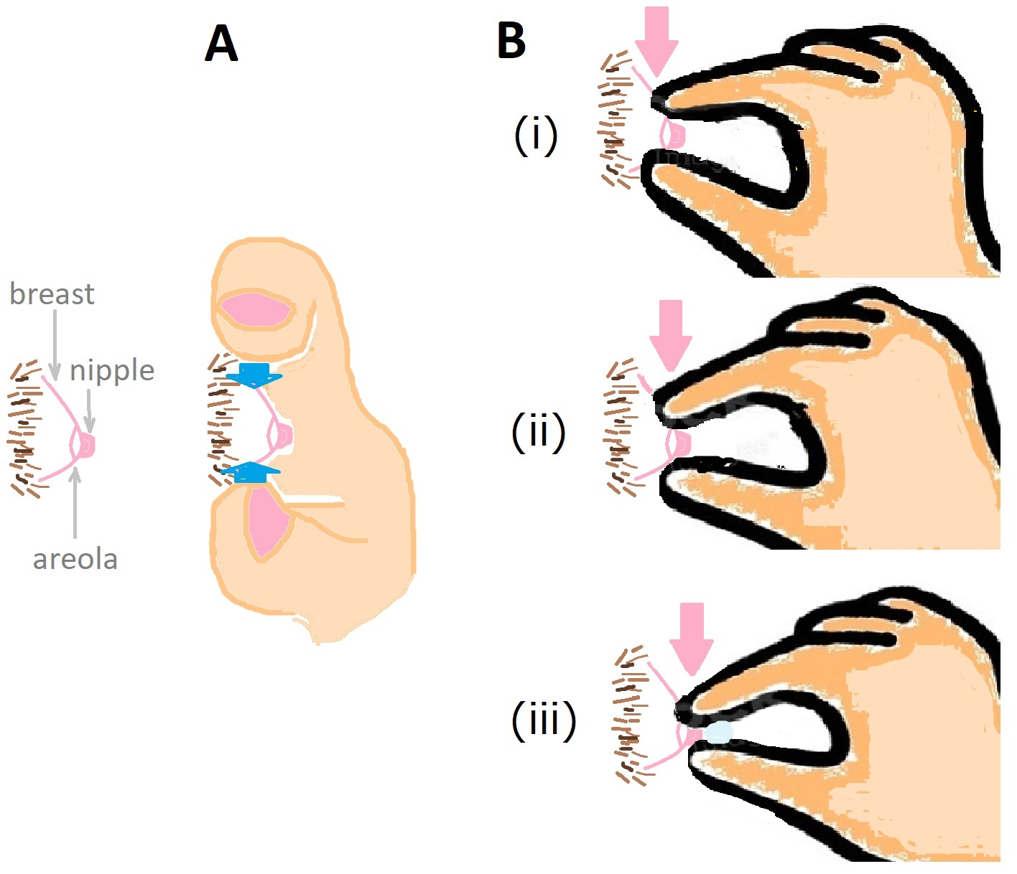
  - Help the mother soften the hardened nipple area through a three-step massaging technique, moving from the base of the areola towards the nipple [1-TXT]. Exude some milk slightly for the odor to stimulate the infant's exploration [2].
    - Talent gently massages the hardened breast from the areola base to the nipple. TXT: Massaging helps to open the milk duct
    - Shot of teat exuding milk.
  - Now hold the mother's body softly [1] and position the infant near her breast to encourage it to search for the nipple [2]. Then, guide the mother to raise her arms to enhance nipple accessibility for the infant [3]. After the nipple is located by the infant, continue the breast massage to assist milk secretion [4-TXT].
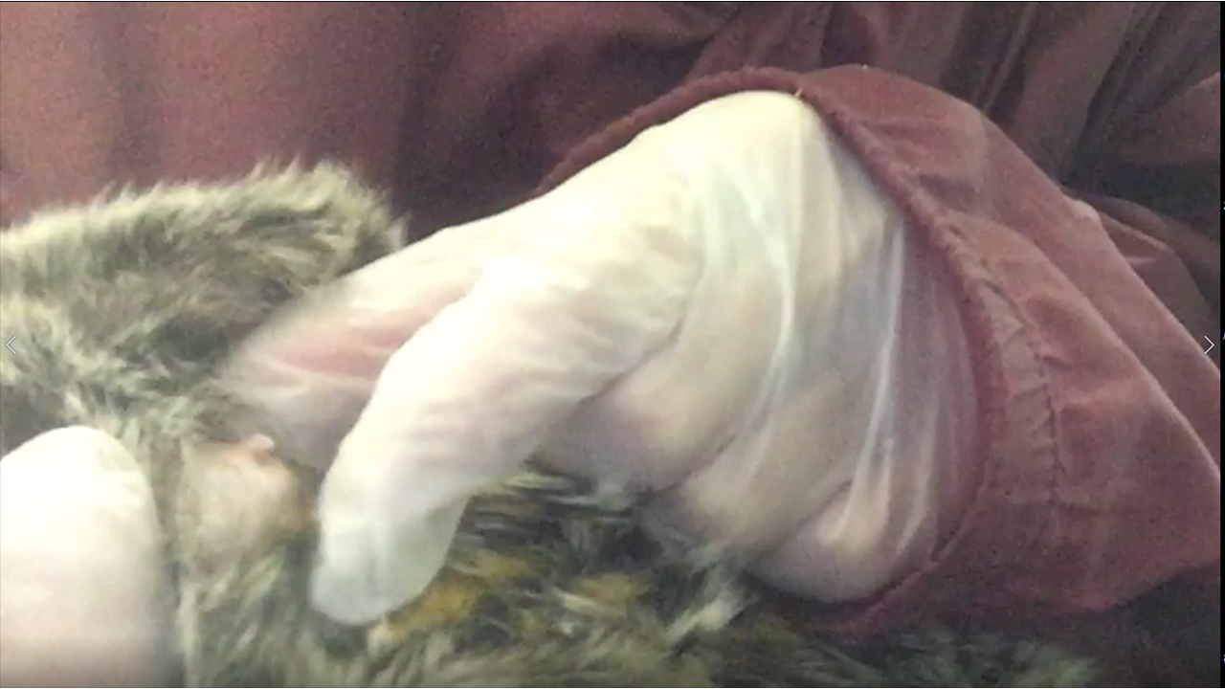
    - Talent holds the mother softly.
    - Shot of infant being positioned near the mother’s breast.
    - Talent guides the mother to raise her arms.
AUTHORS: Please pan to the infant locating the nipple.
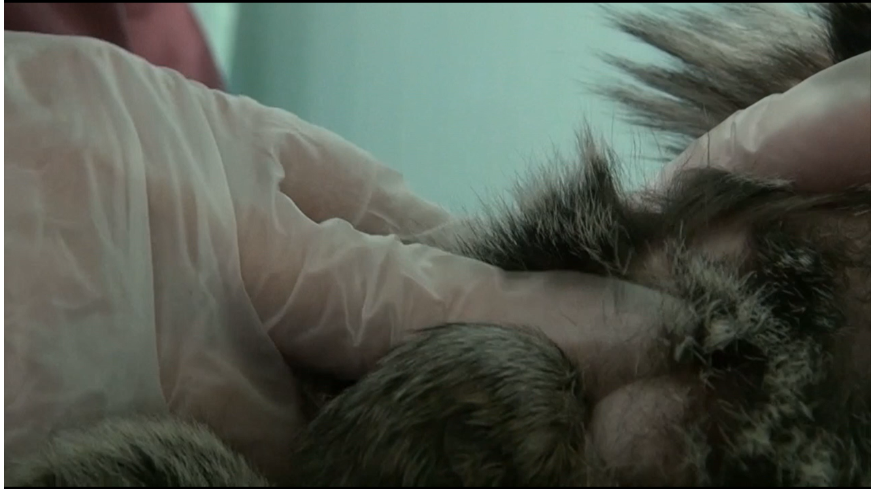
    - Talent continues to massage the breast. TXT: Confirm that the teat is protruding, indicative of pressure relief
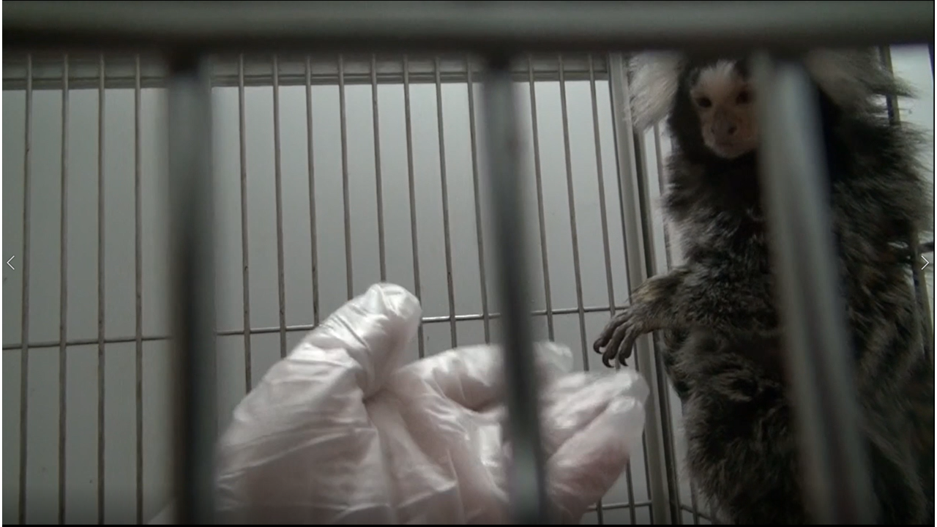
  - Occasionally handle and work on building rapport with the family during the intervention [1-TXT].
    - Talent occasionally supports the mother and infant in feeding. TXT: Repeat intervention until mother allows voluntary feeding

Results
Please review this section to make sure that it accurately reflects your findings.
- Use Track Changes when making edits or revisions.
- If you would like the video to include different results, please revise this section.
- When revising, please keep the length of the voiceover below 200 words. Current word count:98. (Voiceover is the text that follows the two-digit numbers.)
- Please note that the video cannot include voiceover without an accompanying visual.
- Notes in blue italics are for JoVE’s video editor.

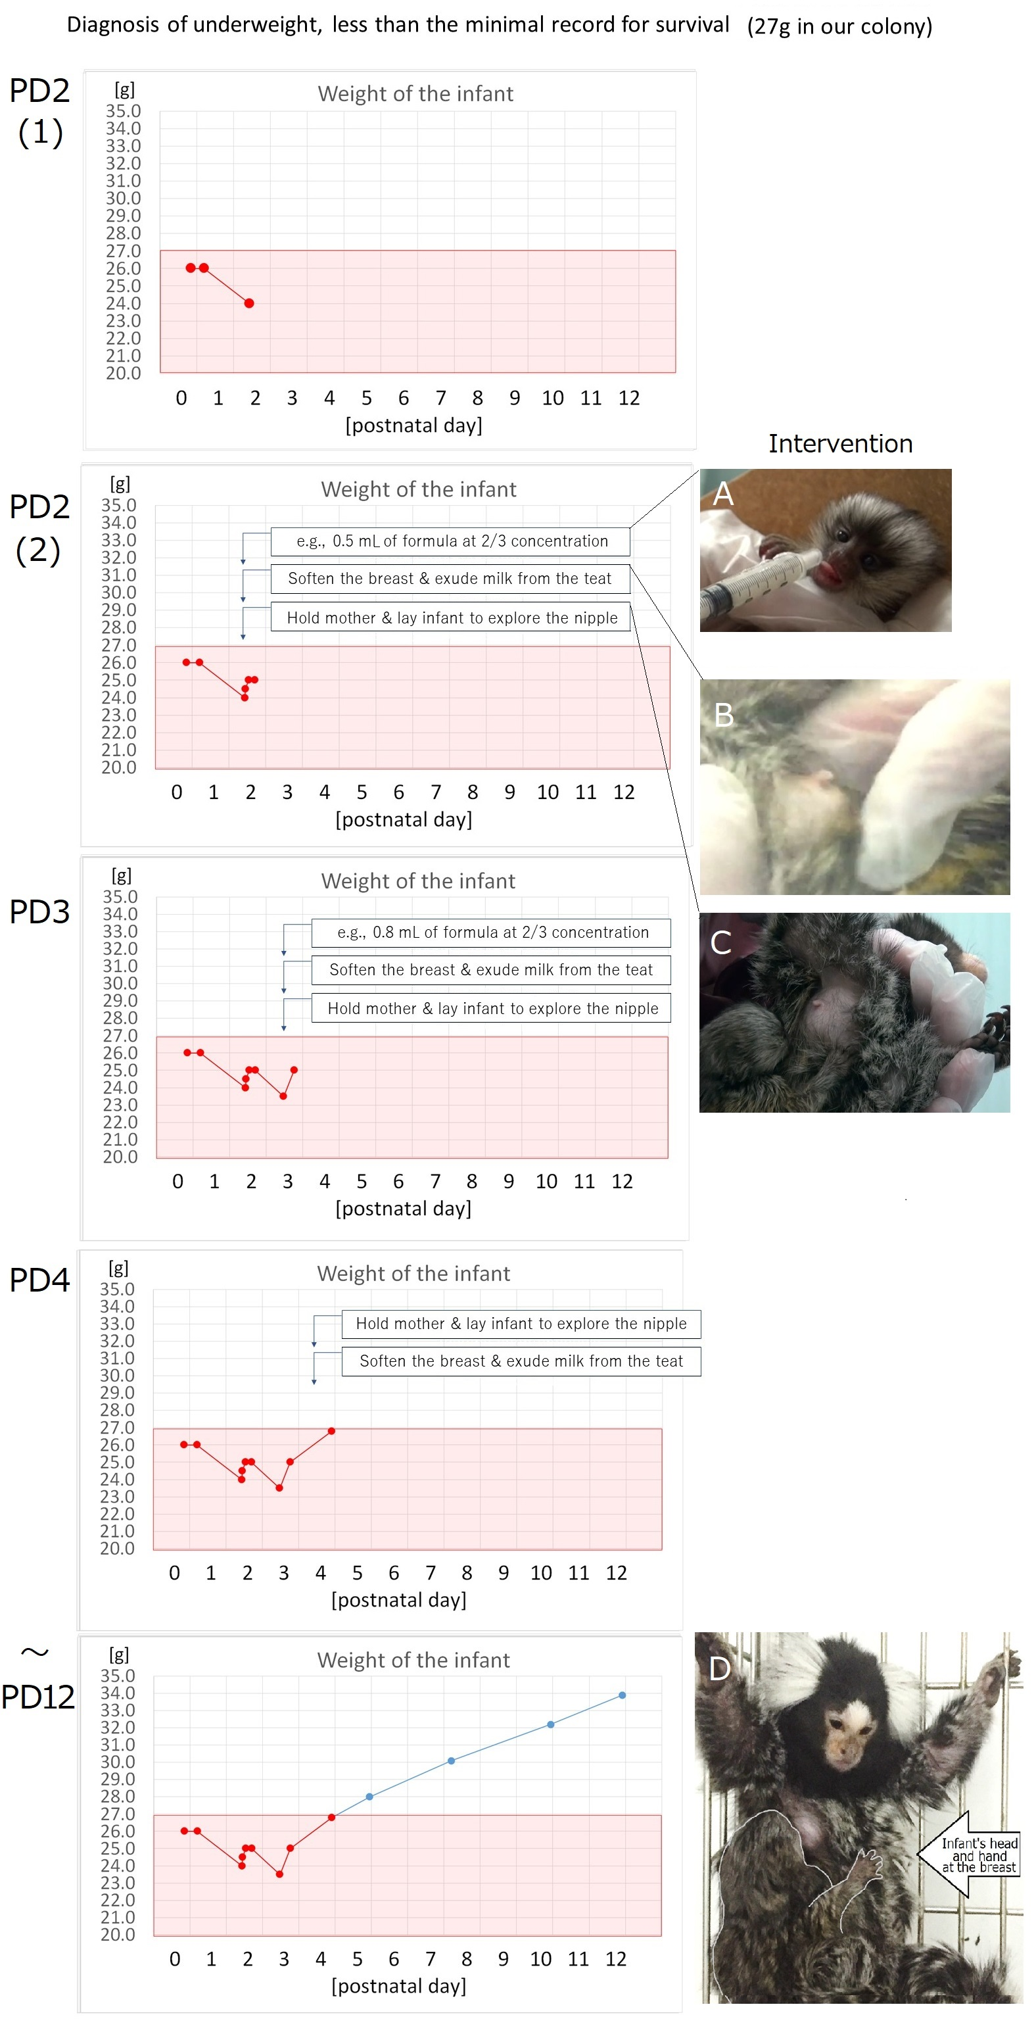
- Results: Analysis of Abnormal Breastfeeding Behavior and Paternal Rearing in Common Marmoset
  - The infant lost weight by Day 2, reaching about 23 to 24 grams [1]. Three feeding interventions on Day 2 helped the infant increase its weight by 1 gram [2]. On Day 3, the infant lost 2 grams, due to excessive paternal interference [3].
    - LAB MEDIA: Figure 4 PD(1)
    - LAB MEDIA: Figure 4A and PD(2)
    - LAB MEDIA: Figure 4 PD(3) Video Editor: Please highlight the downward red line between postnatal day 2-3
  - After paternal separation and feeding intervention, the infant weighed 25 grams by the evening of the same day [1]. Without any feeding intervention, the infant weight increased to 26.8 grams on Day 4 and 28 grams on Day 5 [2].
    - LAB MEDIA: Figure 4 PD(3) Video Editor: Please highlight the upward red line between postnatal day 3-4
    - LAB MEDIA: Figure 4 PD(4) Video Editor: Please highlight the 2 upward red lines between postnatal day 3-4
  - Regular breast massage and infant exploration encouragement resulted in steady weight gain over the next 8 days [1].
    - LAB MEDIA: Figure 4 PD 12 Video Editor: Please highlight the blue slope

Conclusion
- Conclusion Interview Statements

Below are prompts for interview statements that can be used to further emphasize the significance of your protocol.
- Please answer one or two of the statements.
- Each statement is limited to 30 words or fewer.
- Answer the questions in full sentences; you will need to memorize and deliver the sentences as spoken interview statements during filming.
- Indicate the full name of the author who will give each statement.

What is the most important thing to remember when attempting this procedure? Please indicate the steps (e.g., 2.4., 2.5.) in the Protocol section of the script that this advice applies to.
  - Mayuko Yoda: (１) The primate model video may be a substitute for human caregiver's education in Breastfeeding disorders with parental problems.

Following this procedure, what other methods can be performed? What questions would these additional methods answer?
  - Mamiko Koshiba: Because the claims in this video are derived from the observations of only one case of a single family unit, with a single infant in the multiparous species being different from human, further studies are required to compare such results with observations in humans.
  - Mamiko Koshiba: However, further research would be very difficult to validate. In contrast, our video must propose a preliminary but indeed hypothetical intervention for crutial cares to be discussed.

Thank you for addressing our questions. We will incorporate your answers and suggestions and send you the final script before your filming day. You will also receive detailed preparation instructions in the email accompanying the final script.

