Screenshot Summary:
Manuscript number: 64022

- 64022_screenshot_1.mp4
  - 4.2.2. (Eye-tracking parameters being adjusted on goggles)
TXT: Left/Right and Up/Down Centering 00:00:00 - 00:00:09
TXT: Focus 00:00:09 - 00:00:16
  - 4.2.3. (Eye-tracking parameters being adjusted in software)
TXT: Thresholds and Iris Radius 00:00:16 - 00:00:30
TXT: Calibrate orientation and Reset iris reference pattern 00:00:30 - 00:00:37

- 64022_screenshot_2.mp4
  - 5.2.1. (Start recording being pressed in eyetracking software) 00:00:00 - 00:00:05

- 64022_screenshot_3.mp4
  - 5.2.3. (Stop recording being pressed) 00:00:00 - 00:00:07

- 64022_screenshot_4.mp4
  - 8.1.2 (Run being pressed, participant and run information being entered in MATLAB script) 00:00:00 - 00:00:10

- 64022_screenshot_5.mp4
  - 8.1.3 (Automatic start of Recording of Eyetracking) 00:00:00 - 00:00:05

- 64022_screenshot_6.mp4
  - 8.2.1 (Record being pressed in Magnetometer software, measurement of rising strength of magnetic field) 00:00:06 – 00:01:03

- 64022_screenshot_7.mp4
  - 8.2.2 (measurement of eye movements of participant while entering the magnetic field) 00:00:09 – 00:01:06

ONLY THIS PART SHOULD BE SEEN (WITHOUT MARKERS IN THE EYES [at the beginning of the video] AND UNDERNEATH TRACKING [when switching to the second view]. THE TRACKING WAS NOT POSSIBLE WHILE ALSO SCREENCASTING AND THE QUALITY IS TOO LOW TO SHOW IT IN THE VIDEO.

ALSO THE VIDEOGRAPHER FILMED THE ENTERING OF THE PARTICIPANT IN THE BORE. SO MAYBE THIS DATA AND/OR THE MAGNETOMETER DATA COULD BE COMBINED WITH THIS SHOT.

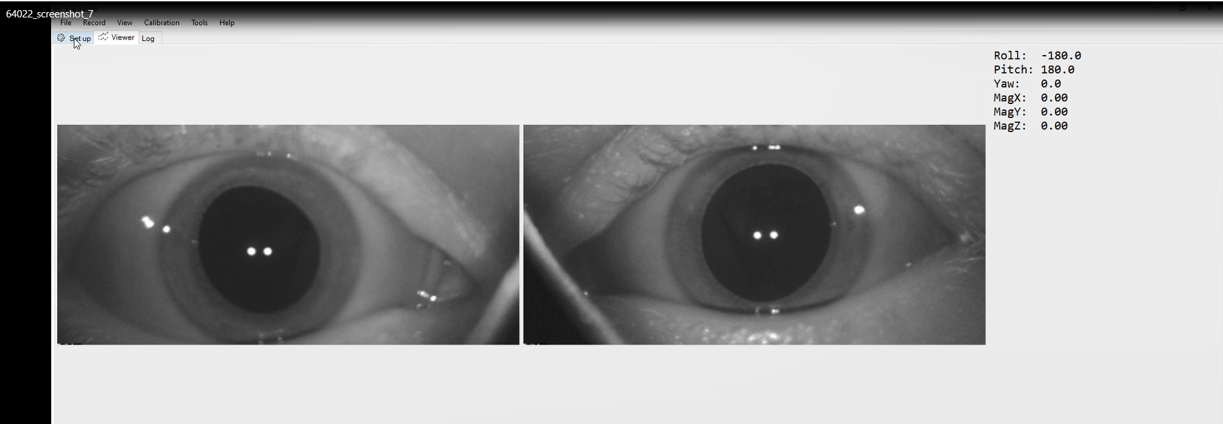

- No screenshot
  - 8.4.1 (Self-motion perception questionnaire and button presses) recorded by videographer

- No screenshot
  - 10.2.2 (CISS sequence) recorded by videographer

