3.4.1 Screen: Parameters are being set
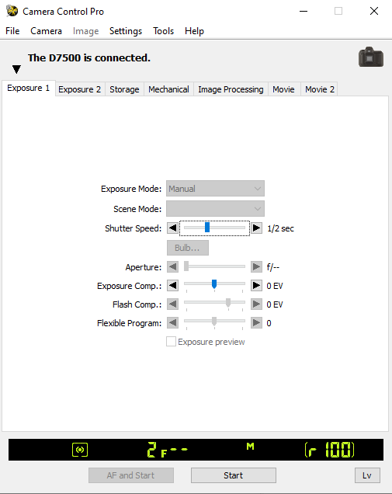
Screen 3.4.1 A: A user interface of the camera software. In this tab ‘Exposure 1’, the shutter speed/exposure time is adjusted to 0.5 seconds.
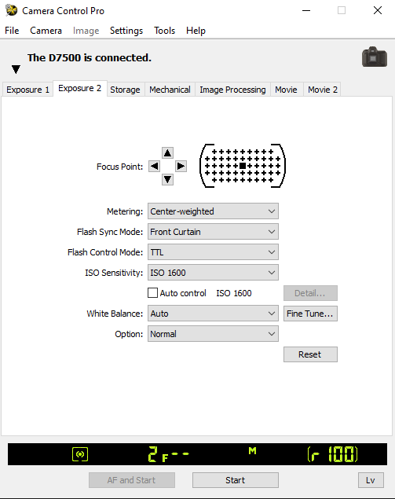
Screen 3.4.1 B: Another tab to adjust the CCD sensitivity/ISO Sensitivity to 1600.
The ‘Lv’ button on the bottom right is to switch to the Live view of the field of view under the microscope. The ‘Start’ button is to capture an image. It captures the whole field of view.
3.5.3 SCREEN: Homogenizer is being started.
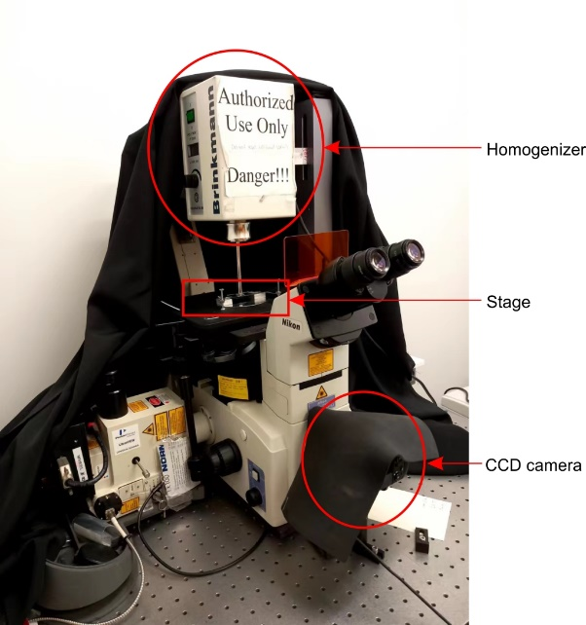
Screen 3.5.3. A: The assembly of shear microscope. The homogenizer is mounted top of the stage with the dispersing tip facing perpendicularly towards the lens under the stage. The CCD camera is at the bottom which can be switched to connect to the objective lens. The camera is connected to the computer through a USB.
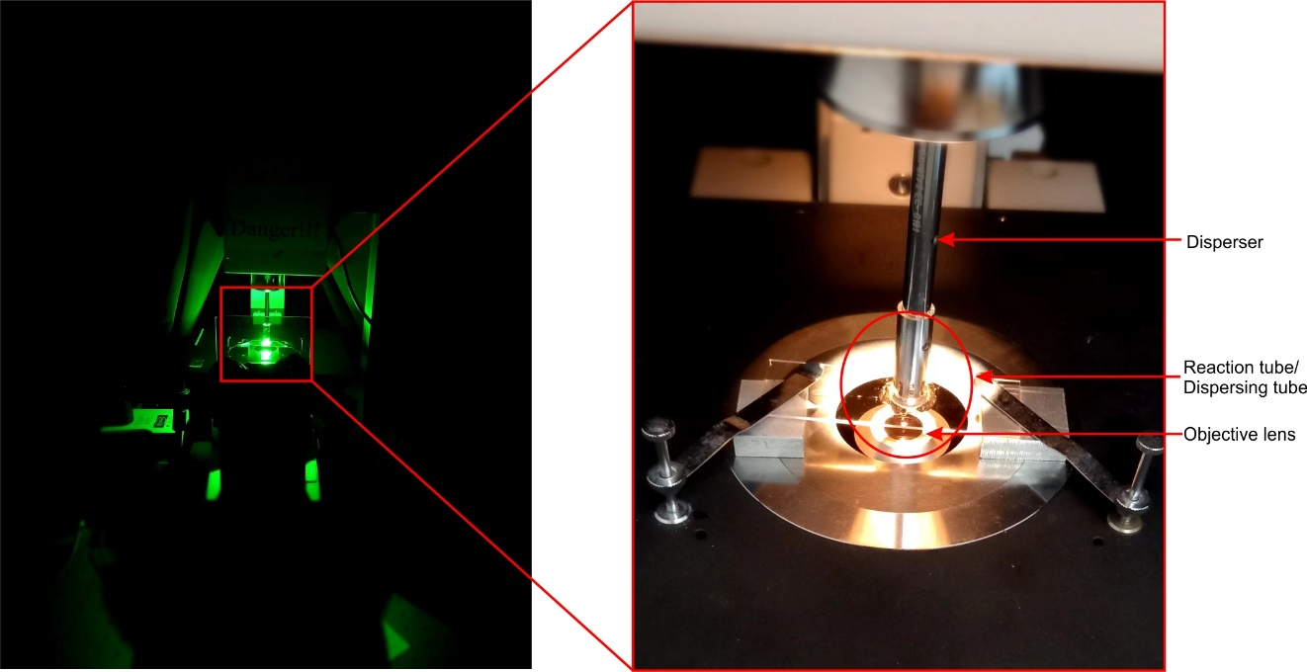
Screen 3.5.3. B: The shear microscope with green luminescence (left). Blow-up image of the homogenizer tip under brightfield light (right).

