We thank the reviewers for their constructive feedback and recognizing the utility of cDICE for encapsulating cytoskeletal proteins to be useful to the scientific community. We have addressed the reviewers’ comments point-by-point below.
Reviewer #1:
Manuscript Summary:
The manuscript describes a variation of the traditional cDICE method, where the authors dispense pre-formed water-in-oil droplets to the setup and obtain GUVs. Overall, the manuscript is clearly written and contains enough information to reproduce the method. This variation can be definitely useful to the scientific community. I have a few suggestions and comments for the authors to address, after which the manuscript can be accepted for publication.
Comments:
* Introduction (line 66): There is a considerable amount of new microfluidic techniques that have been recently developed to generate GUVs. The two references currently given are relatively old. I would suggest adding some new relevant references.
Response: Relevant articles were added as suggested.
* Introduction (line 76): The authors have mentioned the problem of oil retention with certain methods. However, the same oil retention problem can also be valid for cDICE. Authors should expand on this and explain why oil-in-the-bilayer is not a problem for cDICE, if indeed that is the case.
Response: The review’s point is correct. Oil retention could be a potential issue in many GUV encapsulation techniques including cDICE. We modified the statement as our method does not offer an advantage over other techniques regarding oil retention.
“We corrected the statements as follow: ”The complexity of experimental setup and device in microfluidic techniques such as pulsed jetting impose an additional challenge ²⁰. Further, concerns about possible oil retention in bilayers impede the adoption of microfluidic jetting and emulsion-based GUV generation techniques ²⁰. Continuous droplet interface crossing encapsulation (cDICE) is a method derived from similar principles governing emulsion transfer and may also have some oil retention^{21, 22}.”
* Protocol (line 109): I assume that the design of the 3D-printed shaft be shared during the final publication?
Response: We added a subpanel, Fig.1E, to show the design and dimensions of the chamber. A bottom view of the chamber, where it connects to the 3D printed shaft is shown in the panel. The design of the shaft depends on the stir plate. We now include a statement that the design of both the shaft and chamber in .SLDPRT format will be provided upon request.
* Protocol (line 140): Dispense using what? Just a regular pipette? How much volume at a time and at what speed? I think this is a crucial part of the experiment and this is where it differs from the traditional cDICE, so this should be explained very clearly.
Response: In steps 7 and 8, we added the necessary information suggested by the reviewer.
“6. Transfer ABPs into the actin solution and, using a regular 100-1000 µL pipette, immediately transfer the 700 μL of lipid-oil mixture into the actin-ABP mixture (Fig. 1D, left). Pipette up and down 8 times to generate cell-sized lipid-monolayer droplets with diameter in the range of 7-100 μm (Fig. 1D, middle).
Note: Step 6 should take place in a few seconds to avoid any actin network assembly taking place before encapsulation. Thus, prior to performing step 6, make sure that pipette tips are already inserted into the pipettes and ready to transfer the mixtures.
8. Using the same 100-1000 µL pipette, immediately dispense the entire emulsion into the rotating chamber. Droplets will acquire a second leaflet of lipids, by crossing the lipid monolayer at the oil-outer solution interface, thereby forming GUVs (Fig. 1D, right).”
* Protocol: Step 10 is not very clear, but I guess this becomes clear to the users after watching the video.
Response: We will demonstrate and explain this step clearly during the video production.
* Representative results (line 200): Does 'this' approach mean traditional cDICE? Please make it clear because it is a bit confusing. Fig. 3 is then added purely for the comparison with modified cDICE (Fig. 2)? In that case, why is not the same experiment (actin-fascin) carried out so that it can be compared better? Right now, it is a bit hard to compare these two images.
Response: We replaced the image in Fig. 3 with actin images of fascin-actin bundles encapsulated using the traditional cDICE technique. It should be noted that the advantage of the modified technique over the traditional technique is rapid encapsulation of reconstituted actin and actin bundling reactions in GUVs. The yield using either technique is high. We actually did not intend to compare these methods or the results and have modified the text to not draw such comparison.
* Fig. 1: The image resolution is quite low and will be necessary to have it in a higher resolution for the final print.
Response: We improved the resolution of images in Fig. 1A
* Fig. 2: While the third image is labelled 3D, it basically seems to be a maximum intensity projection, summing up all the z-planes. The image construction should be properly explained to avoid confusion.
Response: We agree with the reviewer that our description was confusing. We now explain better what we mean by 2D (confocal z-slice) and 3D (maximum projection of a stack of confocal z-slices).
* General remark: The manuscript is devoid of any analyses. For example, the authors talk about expeditious production of GUVs but there is no mention on the total number of GUVs produced, efficiency of production, the rate of production, etc. Also, there is a mention of polydisperse samples, but without any quantification. I am not sure if this is necessary for a JoVE publication, but authors should consider quantifying these important aspects of their variation and comparing it with the traditional setup.
Response: We thank the reviewer for the suggestions. We added the information about the number, size, and yield of GUVs as a note in the last step of ‘Vesicle generation’: “Note: Following this protocol, a total of about 2×10⁵ GUVs are released in the outer solution inside the chamber. We have not quantified GUV dispersity, however, the diameter of about 90% of GUVs is in the range of 12-25 µm. GUVs with any diameter in the range of 7-50 µm can be found in the population. Depending on the amount of encapsulated OptiPrep, GUV size, and solution depth in the well plate, it takes 2-15 minutes for GUVs to settle down on the surface. The yield of GUVs with reconstituted actin bundles is about 90%“.
It should be noted that the modified method of GUV generation presented in this protocol significantly speeds up both the encapsulation of actin bundling reactions and production of GUVs. Both the traditional and modified methods (as shown in the figure below) can generate cytoskeletal GUVs with high yield.
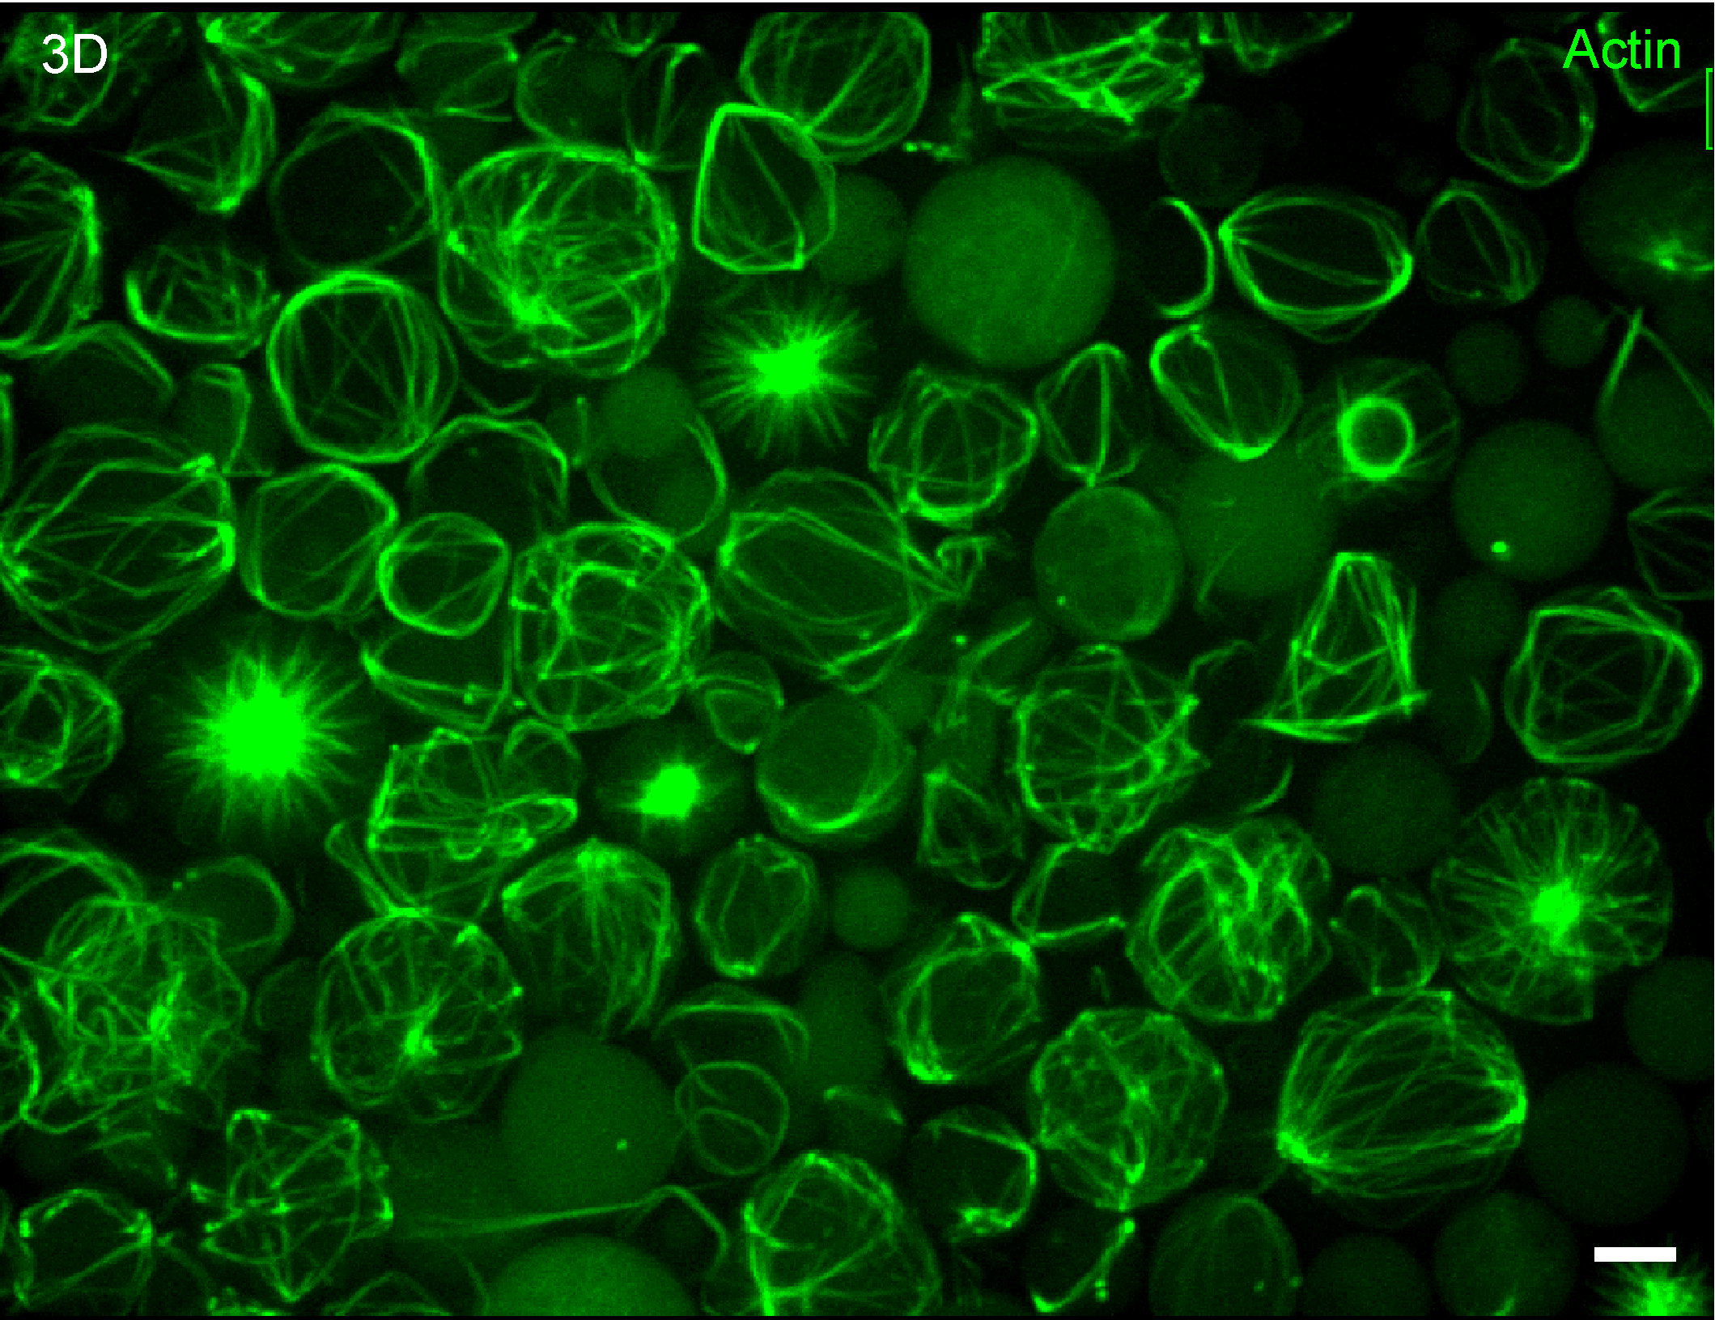
Figure 1. A high yield of actin bundle networks is obtained using the modified cDICE technique presented in the current protocol.

Reviewer #2:
Manuscript Summary:
The authors describe efficient encapsulation method of cytoskeletal proteins in giant unilamellar vesicles (GUVs). They simplify the conventional method, called continuous droplet interface crossing encapsulation (cDICE) method, without loss of vesicle yield. The revised method significantly shortens the vesicle formation time, which will enable us to observe the assembly process of the cytoskeletal networks within the vesicles under an optical microscope. Overall, the manuscript is well-organized and clearly describes the protocols. I would highly recommend publication in JoVE, but the following concerns should be addressed before publication.
Major Concerns:
1) Spinning chamber: I think the most innovative part of this study is engineering of the spinning chamber. It will be worth to describe detailed information of the chamber, in particular, the inner diameter and height, and the resin (cat. no., company name) used for fabrication. I would highly recommend including diagrams of the spinning chamber (top view and cross section) to show dimensions in Figure 1.
Response: We thank the reviewer for the suggestions, and we have included Figure 1E showing the top view and the section view with key dimensions included. The chamber is designed with these dimensions so they are compatible with the volumes used for the inner solution, the outer solution and the oil-lipid mix used to make GUVs. Other details are subject to change by user depending on specific spinner used and will not affect GUV generation.
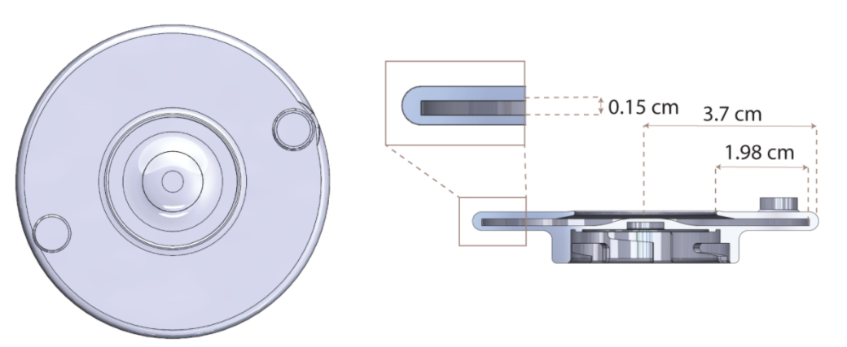

We also included the information about the resins in the text.
” 1. Mount the 3D-printed shaft made from black resin (Formlabs, catalogue# RS-F2-GPBK-04) on the benchtop stir plate and set rotational speed to 1200 rpm.
2. Mount the cDICE chamber, 3D-printed from clear resin (Formlabs, catalogue# RS-F2-GPCL-04), on the shaft.”
2) Lines 193-202: The authors show the representative image of actin-encapsulated GUVs prepared by the traditional cDICE method in Figure 3, then briefly explain and compare the encapsulation method with the newly proposed one. I cannot find any reasons why the authors include this image, because ABPs used for Figure 2 and Figure 3 are different and the actin concentration is not identical between two figures. Aster-like bundles are formed in Figure 2, but ring-shaped bundles are formed in Figure 3. Therefore, it is hard to discuss encapsulation efficiency of the two methods by comparing these images. If the authors want to compare the methods, they should provide images of GUVs prepared by the same molecular components.
Response: We thank the reviewer for the suggestion. We have now removed figure 3 and added image of fascin bundled actin network GUVs generated using the traditional cDICE method. We do not intend to compare these methods or the results and have modified the text to not draw such comparison.

Minor Concerns:
1) Line 117: Doesn't F-buffer contain any buffer solutions such as Tris-HCl like G-buffer? Please provide complete composition of F-buffer.
Response: The buffer used for F-Buffer is 100 mM Tris, pH 7.5 and we have now included this information.
2) Lines 137 and 138: "Step 6" should be "Step 7".
Response: We have made changes to, previously, Step 6 and Step 7 for better clarity.
3) Line 187: Please describe how to prepare fascin in the main text, or put the catalog number and company name if it was purchased.
Response: Fascin was purchased and we have added details including catalog number in the table of materials.
4) Reference 10: Please provide the journal name, and the volume and page numbers.
Response: We thank the author for spotting the error in the reference. We corrected the reference.
5) Table of Materials: The catalog numbers of DOPC and Rhodamine-PE include garbled characters. Please revise them.
Response: We thank the reviewer for flagging the error. We have made the correction and all characters should appear correctly.
6) Table of Materials: Sucrose will not be used in the protocol. Please check again and remove from the table if it is not necessary.
Response: It is correct that sucrose is not used anywhere in the process and we have now removed sucrose from the table of materials.
Reviewer #3:
Manuscript summary:
This manuscript titled "Rapid encapsulation of reconstituted cytoskeleton inside giant unilamellar vesicles" from Bashirzadeh et. al, describes in detail a very efficient method to generate GUVs that encapsulate cytoskeletal proteins. It has been a great challenge to generate GUVs with desired lipids and physiologically relevant salt buffers while at the same time fill with proteins of interests. This manuscript and the video will thus be a great advance for the scientific community. The manuscript describes a method based on cDICE. In this method, proteins of interests are first encapsulated in water-in-oil emulsions covered with lipids; then, these emulsions are passed through a lipid monolayer by centrifugation to obtain the second lipid layer, resulting in the formation of cell-sized unilamellar vesicles. Overall, the experimental details provided by the manuscript is sufficient.
Comments
1. Line 49, it should be "allows us to observe the dynamic evolution of the time-sensitive reactions".
Response: We thank the reviewer for the suggestion. We modified the sentence as follow: “This method not only simplifies the overall procedure of encapsulation within GUVs, but also speeds up the process and thus allows us to confine and observe the dynamic evolution of network assembly inside lipid bilayer vesicles.”
2. Line 76-77, the issue of oil being trapped in the membranes is not only for the jet-based method but for all the emulsion-based method, including the current cDICE method. This should be clearly stated.
Response: The review’s point is correct. Oil retention could be a potential issue in many GUV generation techniques including cDICE. We corrected the statements as follow: ”The complexity of experimental setup and device in microfluidic techniques such as pulsed jetting impose an additional challenge ²⁰. Further, concerns about possible oil retention in bilayers impede the adoption of microfluid jetting and emulsion-based GUV generation techniques ²⁰. Continuous droplet interface crossing encapsulation (cDICE) is a method derived from similar principles governing emulsion transfer and may also have some oil retention ^{21, 22}.”
3. Along the same line as in 2, recent studies have showed that by using octanol as an agent, one can limit the amount of oil present in the membranes. It would be information for the readers if the authors could mention these studies.
DOI: 10.1038/ncomms10447
https://doi.org/10.1038/nprot.2017.160
Response: We thank the author for the suggestion. This is indeed a useful information for readers. We added the following statement to address it: “However, the amount of oil remained in the membrane may be reduced by the use of organic agents such as 1-octanol, which have been used for generation of vesicles^{13, 21}, although this has not been tested in cDICE.”
4. Line 85, the time required to perform the current cDICE method should be specified.
Response: We revised the statement and included the suggested information as follow: “With our modified method, we combine the high vesicle yield typical for cDICE with a significantly shorter encapsulation time (a few seconds) and GUV generation time that allow for the observation of time-dependent processes (e.g., actin cytoskeletal network formation). The protocol takes about 15-20 min from the start to GUV collection and imaging”.
5. Line 92, it is important to mention that chloroform must be handled in a chemical hood.
Response: We thank the author for reminding this important note. We modified the beginning of the step 1 as follow, “1. Inside a fume hood and following other safety guidelines for handling chloroform, put 0.5 ml chloroform in a 15 ml glass vial.”
6. Line 93, what is the reason to have cholesterol in the mixture?
Response: We use several methods for generation of GUVs in our lab and established that 20-30 mol% cholesterol is an optimized concentration for membrane fluidity and GUV stability. We have used 30 mol% cholesterol, as described in the protocol, for consistency across our experiments. Physiologically, this value is well within the range of cholesterol concentration found in plasma membranes of mammalian cells.
We provided this information at the end of the step 1 of ‘oil-lipid-mixture’ section.
7. Line 102, what is the speed?
Response: The maximum speed of the vortexer is 3,000 rpm. We added this value in the text as well.
8. Line 104, is this step done by a bath sonicator or a tip sonicator. It would be informative to specify the speed/strength of the sonication step. Or if possible, provide the company name and category number of the sonicator.
Response: This information was added to text.
“4. Put the lipid-in-oil dispersion in a bath sonicator (FS20, Fisher Scientific) with ultrasonic power of 80 W and operating frequency of 40 kHz at room temperature for 30 minutes. Use the mixture immediately or store at 4°C.”
9. Line 104, at which temperature the sonication step is done?
10. Line 104, should be "Use the mixture immediately…"
Response: Sonication step is done at room temperature. We added this information in the text.
“4. Put the lipid-in-oil dispersion in a sonicator at room temperature for 30 minutes. Use the mixture immediately or store at 4°C.”
11. Line 109, it would be very helpful to provide the dimensions of the shaft and the chamber. Or even better, with the design drawings if possible.
Response: We added a subpanel, Fig.1E, to show the design and dimensions of the chamber. A bottom view of the chamber, where it connects to the 3D printed shaft is shown in the panel. The design of the shaft depends on the stir plate. We included the design of both the shaft and chamber in .SLDPRT format in the supplementary information.
12. Line 114, conventionally, G-buffer states for "Globular actin buffer".
Response: We corrected our mistake. We should point out that Cytoskeleton market G-buffer general actin buffer.
13. Line 117, it should be mentioned that performing this step in ice is to slow down actin polymerization
Response: We thank the reviewer for the suggestion, and we have added a sentence to describe the need for the addition of F-buffer in ice.
“Keeping solutions on ice will help slow down actin polymerization prior to addition of a crosslinker”.
14. Line 122, any specific reason for using a PCR tube here?
Response: Volumes of ABPs are very small and easier to handle in small micro test tubes. We now however refer to them more generally as “microtubes” in the manuscript, which might be a better description of the tubes we use.
15. Line 123, is it known if the OptiPrep solution influence actin polymerization and ABPs binding to actin?
Response: Multiple actin network encapsulation in GUVs with and without Optiprep showed no difference in the assembly of networks. Optiprep is only used to induce density gradient for fast sedimentation of GUVs. In vitro cell studies using similar contrast media has also shown that Optiprep does not affect cellular cytoskeleton ¹. Reference below.
1. Franke, R.-P., Scharnweber, T., Fuhrmann, R., Mrowietz, C., Jung, F. Effect of radiographic contrast media (Iodixanol, Iopromide) on the spectrin/actin-network of the membranous cytoskeleton of erythrocytes. Clinical hemorheology and microcirculation. 54 (3), 273–285 (2013).
2. Pautot, S., Frisken, B.J., Weitz, D.A. Engineering asymmetric vesicles. 100 (19), at <www.pnas.orgcgidoi10.1073pnas.1931005100> (2003).
16. Line 137 and 138, it should be step "7"
Response: We have made changes to, previously, Step 6 and Step 7 for better clarity as shown below.
17. Line 145, it is not clear to me where the "large opening" is. It is hard to image how this step is done.
Response: We thank the reviewer for their comment. We have rephrased this to better clarify the sentence as quoted below. Furthermore, the newly added Figure 1E may better demonstrate what is referred to as “large opening”.
“Remove the chamber from the stir plate and discard most of the lipid-oil mixture in the chamber by tilting the chamber in the waste container so that a large portion of lipid-oil mixture is drained from the large opening at the center of the chamber”.
We will also demonstrate and explain this step clearly during video production.
18. Line 184, what did the authors want to say when mentioned that fascin is a "short" crosslinker? What does "short" refer to?
Response: this is a rather common description and refers to the length of the crosslinker and indicates how closely filaments are bundled. We have clarified this in the manuscript.
19. Line 212, for 3D image, is it maximum intensity projection? It should be specified.
Response: We thank the reviewer for the suggestion. We have now revised the figure caption as follow:
“(A) Encapsulation of actin bundle structures using the presented protocol. The images show representative fluorescence confocal slices of GUVs (left) and maximum projections of a confocal z-stack of actin and lipid channels (right). Fascin, 2.5 μM; actin, 5 μM (including 10% ATTO 488 actin). Scale bar, 10 μm. (B) Encapsulation of actin bundle structures using conventional cDICE. The image shows a representative maximum projection of confocal fluorescence images of encapsulated actin bundles formed in the presence of fascin. Fascin, 0.9 µM; Actin, 6 µM; Scale bar, 10 µm.”

20. Line 216, it says "2D" in the figure. This should be corrected to the right one
Response: Per other reviewer’s comments, we have now replaced actin images of encapsulated talin-vinculin-actin bundles with fascin-actin bundles generated using the traditional cDICE method. We also combined Figures 2 and 3 into one figure.
21. In the Discussion, the authors should comment on the potential oil being trapped in the membranes for this modified cDICE method.
Response: Emulsion-based methods suffer from potential oil retention in bilayers and we have explicitly mentioned it in the introduction and discussion per reviewer’s suggestions. Quoted below.
“Furthermore, the cDICE method, as an emulsion-based technique, does not eliminate potential bilayer oil retention. Future modifications to the method, possibly by changing solvent composition, need to be investigated.”
22. In the Discussion, the authors should discuss how "rapid" their method is compared to the others, especially this is one of the key points in the title of this manuscript
Response: We thank the reviewer for the suggestion. We believe that we have sufficiently discussed how rapid our method by eliminating the need for using microfluidic nozzle to generate aqueous droplets. We have quoted part of the section where this is discussed below
“However, with the intent to reduce the time taken to prepare injection platform, especially critical for fast reactions, such as actin network assembly, and potential clogging of the microcapillary, we now generate aqueous droplets with lipid monolayers by adding the inner solution (created by pipetting up and down) directly to the oil-lipid mixture. This approach eliminates the time lag in GUV encapsulation for a fast reaction experiment.”
We also quote a part of the introduction that is now added to address the reviewer’s point.
“The cDICE approach is, in our experience, a robust technique for GUV encapsulation. With our modified method, we combine the high vesicle yield typical for cDICE with a significantly shorter encapsulation time (a few seconds) and GUV generation time that allow for the observation of time-dependent processes (e.g., actin cytoskeletal network formation). The protocol takes about 15-20 min from the start to GUV collection and imaging.”

23. In the Discussion, could the authors comment on the potential application of the cDICE method in generating asymmetric membranes?
Response: We agree with the reviewer’s comment, and we have added this to the discussion to elaborate.
“Furthermore, like some microfluidic GUV generation methods ²⁸, our modified cDICE can potentially permit the generation of asymmetric GUVs. Different lipid composition can be used for the inner leaflet and the outer leaflet since monolayer droplets are formed separately (inside a microtube by pipetting up and down) before zipping the bilayer inside the cDICE chamber.”

