Screen shots in chronological order corresponding to steps in the script.

Script line 4.2.2 (time code 1 minute 3 seconds)
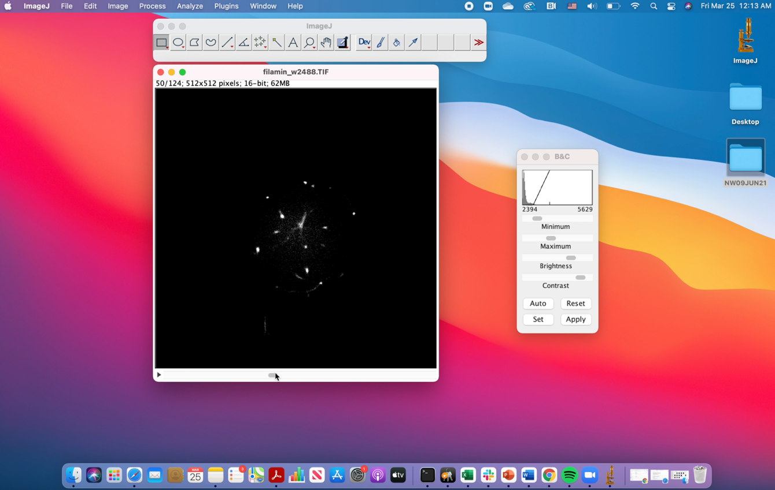

Script line 4.3.1 (time code 1 minute 30 seconds)
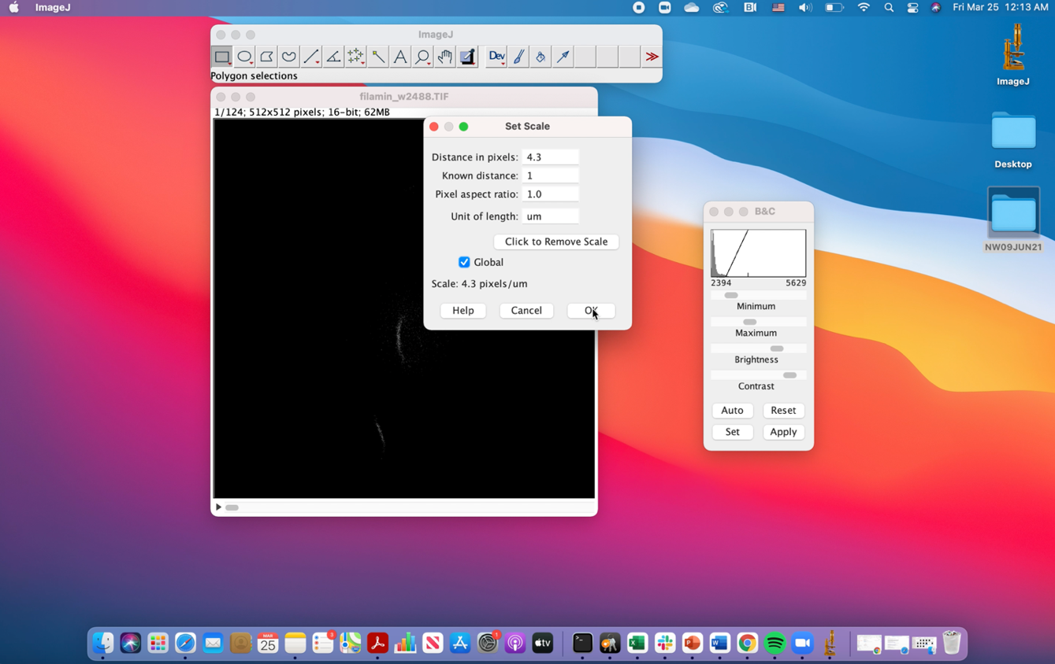

Script line 4.4.1 (time code 1 minute 48 seconds, 2 minute 08 seconds)
