03-Jan-2022

Journal: JoVE
Manuscript ID: 63301_R1
Title: "Pneumatically driven microfluidic platform for micro-particle concentration"
Author(s): Hong Jin Choi, Jong Hyun Lee and Ok Chan Jeong

Editorial comments

Changes to be made by the Author(s):
1. Please take this opportunity to thoroughly proofread the manuscript to ensure that there are no spelling or grammar issues.
[Response] We provide the revised manuscript that is thoroughly proofread.

2. Please reword the following lines to avoid previously published work: 72-76, 151-153.
[Response] The revised manuscript is thoroughly proofread.
- Ln 79-83:
Note: The fluid network is interconnected with the space of the curved oil channels in the anterior part and the rectangular chamber in the posterior part. The inlet is blocked by Vs, and particles accumulate in the collection area of the curved fluid channel. Particle-free fluids (particle-free liquids) are exited through the Qf outlet and the concentrated particles through the Qp outlet (see Figure 3).
- Ln 202-203:
3.5. Observe platform operation through an inverted system microscope for all platform operation and measure the operating flow rate over time at the outlet by a liquid flow meter.

3. Please revise the text to avoid the use of any personal pronouns (e.g., "we", "you", "our" etc.).
[Response] The personal pronouns have been revised.
- Ln 27, 54: we introduce -> this article introduces
- Ln 30: Our devices operate -> This device operates
- Ln 305: Our platform -> This platform

4. JoVE cannot publish manuscripts containing commercial language. This includes trademark symbols (™), registered symbols (®), and company names before an instrument or reagent. Please remove all commercial language from your manuscript and use generic terms instead. All commercial products should be sufficiently referenced in the Table of Materials.
For example: µFlucon, Spherotech, SLI 1000, Olympus
[Response] The revised manuscript is thoroughly proofread and all commercial languages are removed from our revised manuscript.

5. Please revise the Introduction to include all of the following:
a) A clear statement of the overall goal of this method
b) The rationale behind the development and/or use of this technique
c) The advantages over alternative techniques with applicable references to previous studies
d) A description of the context of the technique in the wider body of literature
e) Information to help readers to determine whether the method is appropriate for their application
[Response] Introduction steps have been modified carefully as advised.

6. Please note that your protocol will be used to generate the script for the video and must contain everything that you would like shown in the video. Please ensure you answer the “how” question, i.e., how is the step performed? Alternatively, add references to published material specifying how to perform the protocol action. There should be enough detail in each step to supplement the actions seen in the video so that viewers can easily replicate the protocol.
[Response] Protocol steps have been modified carefully as advised.

7. Please add more details to your protocol steps:
Step 1: Please provide an image of the CAD file of the microfluidic device used along with the dimensions as a Supplementary Figure to help the readers understand the exact architecture of the device. Please a reference the figure in the manuscript and provide a legend having Title and description in the Figure/Table label section.
[Response] It has been modified. And, Figure 4 and Table 1 have been added in the revised manuscript.
- Ln 74: The microfluidic channel network is designed with a CAD program.^{18,19}
- Ln 88-90: (see Figure 4 and Table 1). The four types of molds mentioned are fabricated using common photolithography processes. This mold making consists of a SU-8 mold on a silicon wafer. ^{18,19}
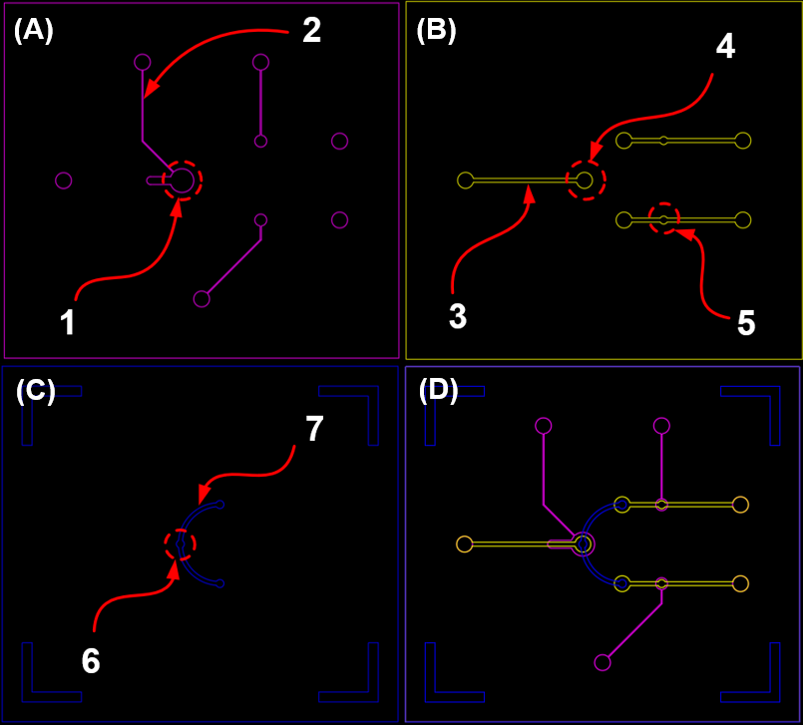
Figure 4. CAD image of the pneumatic microfluidic platform for microparticle concentration. (a) Pneumatic channel valve, (b) Main fluid channel, (c) Interconnection fluid channel, and (d) Cross image of each channel. (Dimensions of 1 to 7 in Figure 4 see Table 1).

Table 1. Pneumatic microfluidic platform detail dimensions of 1 to 7 in Figure 4.
Number | Structure | Width (W) or diameter (D), (μm)
1 | Pneumatic chamber | 1200 (D)
2 | Pneumatic channel | 50 (W)
3 | Fluid channel | 200 (W)
4 | Fluid chamber for Vs | 800 (D)
5 | Fluid chamber for Vp (Vf) | 400 (D)
6 | Interconnection chamber | 400 (D)
7 | Interconnection channel | 200 (W)

Step 1.3: Please mention how the SU-8 molds are created. Please include citations from published references. Also please include the details of SU-8 in the Table of Materials.
[Response] It has been modified. And, one reference has been added in the revised manuscript.
- Ln 74: The microfluidic channel network is designed with a CAD program.^{18,19}
- Ln 88-90: (see Figure 4 and Table 1). The four types of molds mentioned are fabricated using common photolithography processes. This mold making consists of a SU-8 mold on a silicon wafer. ^{18,19}
18. Jang, J.H., Jeong, O.C. Fabrication of a pneumatic microparticle concentrator. Micromachines. 11, (1), 40 (2020).
19. McDonald, J. C., et al. Poly(dimethylsiloxane) as a material for fabricating microfluidic device. Accounts of chemical research. 35, (7), 491-499 (2002).

Step 2.1.3/2.1.7: Please mention how the punching was done. If commercial punctures are used, please include the details in the Table of Materials.
[Response] It has been inserted. See the Step 2.1.3 and 2.1,9. However, puncture is not commercial, it is not included details in the Table of Materials.
- Ln 107-108: 2.1.3. Punch three 1.5 mm pneumatic ports (Vs, Vf and Vp) into the pneumatic valve channel manufactured according to step 2.1.2, using a 1.5 mm puncher.
- Ln 124-126: 2.1.9. Punch a 1.5 mm diameter hole in the fluid channel inlet (Qfp) and fluid channel outlets (Qf and Qp) within the pneumatic channel part to which the thin diaphragm layer is bonded, using a 1.5mm puncher.

Step 2.1.6/2.2.8: How was the alighment done? Was any mask aligner used? If yes, then please include that in the Table of Materials.
[Response] It has been inserted. See the Step 2.1.6 ~ 2.1.8/2.2.8 ~ 2.2.10.
- Ln 117-122:
2.1.6. Treat the atmospheric plasma to PDMS structures made in step 2.1.3 and 2.1.5.
2.1.7. Align directly plasma-treated PDMS structures according to the channel structure with checking by microscope.
2.1.8. Bond the aligned PDMS structures by heat-activate at 90°C for 30 min.
- Ln 164-169:
2.2.8. Treat the atmospheric plasma to PDMS structures made in step 2.2.3 and 2.2.7.
2.2.9. Align directly plasma-treated PDMS structures according to the channel structure with checking by microscope.
2.2.10. Bond the aligned PDMS structures by heat-activate at 90°C for 30 min.

Step 4.2: Please mention how much and how the pressure was applied.
[Response] It has been modified. See Step 4.2.
- Ln 213: 4.2. Apply pressure to Vs at 15 kPa and Vp at 18 kPa to actuate the valve.

8. Please include one line space between the protocol steps and highlight in yellow up to 3 pages of the Protocol (including headings and spacing) that identifies the essential steps of the protocol for the video, i.e., the steps that should be visualized to tell the most cohesive story of the Protocol. Remember that non-highlighted Protocol steps will remain in the manuscript, and therefore will still be available to the reader.
[Response] It has been modified and inserted highlight in yellow about the essential steps of the protocol for the video.

9. Please ensure that the highlighted steps form a cohesive narrative with a logical flow from one highlighted step to the next and also is in-line with the Title of the manuscript. Please highlight complete sentences (not parts of sentences). Please ensure that the highlighted part of the step includes at least one action that is written in the imperative tense. However, the NOTEs cannot be filmed, so please do not highlight them.
[Response] Ensured.

10. Please modify the Result section to include all the observations and conclusions you can derive from the Figures. The Results section should focus on the effectiveness of your technique backed up with data.
[Response] It has been modified at representative result section
- Ln 226-249: Figure 8 shows the flow rate of the fluid rates for a four-stage platform operation as shown in Table 2. The first stage is the loading state, where the platform is supplied with fluid with all valves open, and the working fluid (Qf) and particles (Qp) are almost identical as the microfluidic channel network exhibits structural symmetry. In the second stage (b state), compressed air was delivered to Vs to block the particles, and as the Vs diaphragm deformed, the flow path narrowed and the flow rate measured at the outlet port was reduced by hydraulic resistance. The flow rates of Qf and Qp were very similar, and the difference was less than 2.67 %. In the third stage (c state), compressed air was delivered to Vs and Vp for particle concentration, with Vs and Vp closed and Vf open. The measured Qp was close to zero and the Qf was about 1.42 times that of the b state. In most cases, the flow rate doubles when both dissipation channels are in operation, but the platform has different types of hydraulic resistance in the main fluid channels and Vs, so the total flow of the working fluid is reduced. Finally (d state), compressed air was delivered only to Vf to collect the concentrated particles, and the flow rates of Qf and Qp were reversed. Because Qf was blocked by Vf, the flow was zero, and Qp was about 1.42 times the b state. The concentration ratio of the particles at this time (Qp/(Qf+Qp) × 100) was 3.96 - 4.53. This shows that the sequential actuation programmed with the pneumatic valve works well with the result of the change in flow. Figure 9 shows the screen capturing concentrated particles. Figure 9a shows the flow state of the fluid with the three pneumatic valves not actuated, Figure 9b shows the method used to trap the particles, Figure 9c shows the sieve method, and Figure 9d shows the ejection of the concentrated beads. Particles were concentrated and accumulated in the collection area when Vs and Vp were closed, and all collected concentrated particles were released within 4 seconds when only Vf was closed. Therefore, the device successfully collects a significant number of particles, making it a suitable platform for particle collection and concentration.

11. As we are a methods journal, please ensure that the Discussion covers the following in detail in 3-6 paragraphs with citations:
a) Critical steps within the protocol
b) Any modifications and troubleshooting of the technique
c) Any limitations of the technique
d) Significance with respect to existing methods
e) Any future applications of the technique
[Response] we revised the discussion part, and Reference.
- Ln 307-320: This device, only the results for the concentration of particles of three sizes are presented. However, the operating pressure, the time required for concentration, and the concentration rate may vary depending on the device dimensions, particle size magnification, and the pressure at Vs.^{18,20,21} Compared with previous studies, this platform has some advantages and disadvantages. In dielectrophoretic method, fewer target particles are used.²² An additional process was required to prepare particles to enhance the physical interaction between particles and external forces.^{22,23} In order to increase the separation efficiency in magnetophoretic separation systems, complex design issues must be considered.^{5,22} This platform showed higher separation efficiency than the ultrasonic method, which can separate samples at high flow rates.24 In addition, because this platform does not have a passive structure, no clogging effect^{25,26,27} was observed when beads were trapped and accumulated, unlike the passive method.^{7,10} This platform can be used for water pretreatment when concentrating and extracting suspended bio-particles, as the operation is not affected by the properties of the physical particles.^{18,21}
5. Jung, Y., et al. Six-stage cascade paramagnetic mode magnetophoretic separation system for human blood samples. Biomedical microdevices. 12, (4), 637–645 (2010).
7. Lin, Y.H., Lee, G.B. Optically induced flow cytometry for continuous microparticle counting and sorting. Biosensors and Bioelectronics. 24, (4), 572–578 (2008).
10. Yin, D., et al. Multi-stage particle separation based on microstructure filtration and dielectrophoresis. Micromachines. 10, (2), 103 (2019).
18. Jang, J.H., Jeong, O.C. Fabrication of a pneumatic microparticle concentrator. Micromachines. 11, (1), 40 (2020).
20. Brivio, M., et al. A MALDI-chip integrated system with a monitoring window. Lab on a Chip. 5, (4), 378-381 (2005).
21. Jeong, O. C., Konishi, S. The self-generated peristaltic motion of cascaded pneumatic actuators for micro pumps. Journal of Micromechanics and Microengineering. 18, (8), 085017 (2008).
22. Taff, B.M., Voldman, J. A scalable addressable positive dielectrophoretic cell-sorting array. Analytical chemistry. 77, (24), 7976–7983 (2005).
23. Pamme, N., et al. On-chip free-flow magnetophoresis: Separation and detection of mixtures of magnetic particles in continuous flow. Journal of magnetism and magnetic materials. 307, (2), 237-244 (2006).
24. Harris, N.R., et al. Performance of a micro-engineered ultrasonic particle manipulator. Sensors and Actuators B: Chemical. 111, 481-486 (2005).
25. Yoon, Y., et al. Clogging-free microfluidics for continuous size-based separation of microparticles. Scientific reports. 6, (1), 1-18 (2016).
26. Beattie, W., et al. Clog-free cell filtration using resettable cell traps. Lab on a Chip. 14, (15), 2657–2665 (2014).
27. Cheng, Y., et al. A bubble- and clogging-free microfluidic particle separation platform with multi-filtration. Lab on a Chip. 16, (23), 4517–4526 (2016).

12. Figure 4: Please include a scale bar.
[Response] The scale bar for images has been inserted.

13. Figure 5/7: Please label the figure panels (A), (B), (C), etc., in capital letters. Accordingly, please upload revised Figures in your editorial manager account.
[Response] we revised the Figure 5/7 panels in capital letters.

14. Please upload each figure individually in the Editorial Manager account. Please ensure a high resolution for each figure.
[Response] It has been modified as advised.

15. Please upload Table 1 as xls/xlsx file instead of embedding it in the manuscript text.
[Response] We provide the additional Tables which are formed with .xlsx.

16. Please ensure that the Table of Materials includes all the supplies (reagents, chemicals, instruments, equipment, software, etc.) used in the study.
[Response] Ensured.

Reviewers' comments

Reviewer #1
In this article, authors have reported a Pneumatically driven microfluidic platform for micro-particle concentration.
My review decision is to accept with revisions as per the comments.
1. I would suggest authors to do more in-depth analysis along with different operation configurations in detail.
[Response] It has been modified at representative results
- Ln 226-249: Figure 8 shows the flow rate of the fluid rates for a four-stage platform operation as shown in Table 2. The first stage is the loading state, where the platform is supplied with fluid with all valves open, and the working fluid (Qf) and particles (Qp) are almost identical as the microfluidic channel network exhibits structural symmetry. In the second stage (b state), compressed air was delivered to Vs to block the particles, and as the Vs diaphragm deformed, the flow path narrowed and the flow rate measured at the outlet port was reduced by hydraulic resistance. The flow rates of Qf and Qp were very similar, and the difference was less than 2.67 %. In the third stage (c state), compressed air was delivered to Vs and Vp for particle concentration, with Vs and Vp closed and Vf open. The measured Qp was close to zero and the Qf was about 1.42 times that of the b state. In most cases, the flow rate doubles when both dissipation channels are in operation, but the platform has different types of hydraulic resistance in the main fluid channels and Vs, so the total flow of the working fluid is reduced. Finally (d state), compressed air was delivered only to Vf to collect the concentrated particles, and the flow rates of Qf and Qp were reversed. Because Qf was blocked by Vf, the flow was zero, and Qp was about 1.42 times the b state. The concentration ratio of the particles at this time (Qp/(Qf+Qp) × 100) was 3.96 - 4.53. This shows that the sequential actuation programmed with the pneumatic valve works well with the result of the change in flow. Figure 9 shows the screen capturing concentrated particles. Figure 9a shows the flow state of the fluid with the three pneumatic valves not actuated, Figure 9b shows the method used to trap the particles, Figure 9c shows the sieve method, and Figure 9d shows the ejection of the concentrated beads. Particles were concentrated and accumulated in the collection area when Vs and Vp were closed, and all collected concentrated particles were released within 4 seconds when only Vf was closed. Therefore, the device successfully collects a significant number of particles, making it a suitable platform for particle collection and concentration.

2. More data from experimental analysis should be included.
[Response] It has been modified at representative results and discussion. More data from experimental results has inserted in the additional result part, and comparative analysis in the discussion part.

3. A comparative graph of the authors system to that of already existing system should be mentioned. Also, should explain how this system performance is better compared to the already existing system.
[Response] It has been modified at discussion for compare of this system to that of already existing system.
- Ln 308-318: Compared with previous studies, this platform has some advantages and disadvantages. In dielectrophoretic method, fewer target particles are used.²² An additional process was required to prepare particles to enhance the physical interaction between particles and external forces.^{22,23} In order to increase the separation efficiency in magnetophoretic separation systems, complex design issues must be considered.^{5,22} This platform showed higher separation efficiency than the ultrasonic method, which can separate samples at high flow rates.24 In addition, because this platform does not have a passive structure, no clogging effect^{25,26,27} was observed when beads were trapped and accumulated, unlike the passive method.^{7,10}

Reviewer #2
Manuscript Summary:
The authors describe the fabrication of a microfluidic device on a PDMS-based platform that makes use of a deformable membrane to block the flow of particles carried by a flow stream. This effectively results in a sieving mechanism that concentrates the particles in the main channel. The particles can be released into a channel different from the discharge channel by differential valve actuation. This is likely a useful device for particle and cell separation applications.

Major Concerns:
1. It is necessary to provide black and white, 2-dimensional drawings with specifications for each of the mold layers. The objective of the article is to facilitate construction; provide the masks' drawings to prepare the SU-8 molds. This is the main obstacle for someone to replicate a functional device when following the instructions.
[Response] It has been inserted. See the Figure 4 and Table 1.
Figure 4. CAD image of the pneumatic microfluidic platform for microparticle concentration. (a) Pneumatic channel valve, (b) Main fluid channel, (c) Interconnection fluid channel, and (d) Cross image of each channel. (Dimensions of 1 to 7 in Figure 4 see Table 1).

Table 1. Pneumatic microfluidic platform detail dimensions of 1 to 7 in Figure 4.
Number | Structure | Width (W) or diameter (D), (μm)
1 | Pneumatic chamber | 1200 (D)
2 | Pneumatic channel | 50 (W)
3 | Fluid channel | 200 (W)
4 | Fluid chamber for Vs | 800 (D)
5 | Fluid chamber for Vp (Vf) | 400 (D)
6 | Interconnection chamber | 400 (D)
7 | Interconnection channel | 200 (W)

2. The number 2 section of the instructions is naturally complicated. It would probably be useful to assign numbers to the layers to make it clearer when referring to each one of them.
[Response] The number 2 section has been modified to assign numbers to the step layers to make it clearer when referring to each one of them.

3. Use of the precision pressure controller is only lightly explained. Perhaps an image of the set up is necessary.
[Response] It has been inserted at Figure 7.

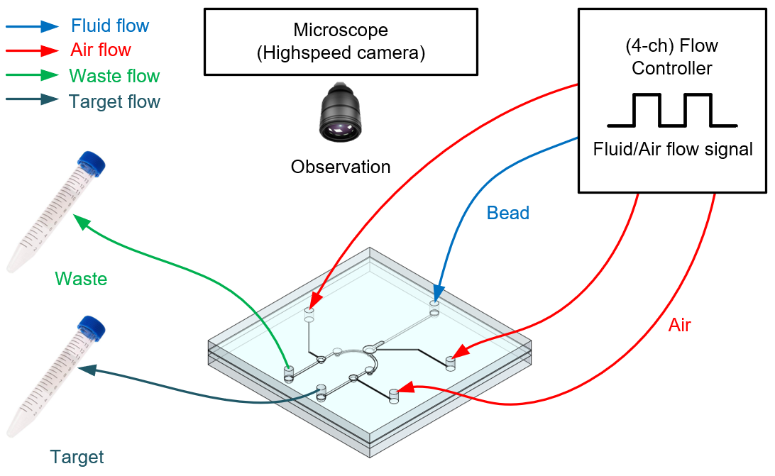
Figure 7. Schematic of pneumatic microfluidic platform set up for micro-particle concentration.
Minor Concerns:
1. Phrasing in some instances can be improved to ensure proper communication and understanding by the reader (e.g. line 227-228) Overall, is understandable.
[Response] It has been revised the discussion part, and reference.
- Ln 307-320: This device, only the results for the concentration of particles of three sizes are presented. However, the operating pressure, the time required for concentration, and the concentration rate may vary depending on the device dimensions, particle size magnification, and the pressure at Vs.^{18,20,21} Compared with previous studies, this platform has some advantages and disadvantages. In dielectrophoretic method, fewer target particles are used.²² An additional process was required to prepare particles to enhance the physical interaction between particles and external forces.^{22,23} In order to increase the separation efficiency in magnetophoretic separation systems, complex design issues must be considered.^{5,22} This platform showed higher separation efficiency than the ultrasonic method, which can separate samples at high flow rates.24 In addition, because this platform does not have a passive structure, no clogging effect^{25,26,27} was observed when beads were trapped and accumulated, unlike the passive method.^{7,10} This platform can be used for water pretreatment when concentrating and extracting suspended bio-particles, as the operation is not affected by the properties of the physical particles.^{18,21}
5. Jung, Y., et al. Six-stage cascade paramagnetic mode magnetophoretic separation system for human blood samples. Biomedical microdevices. 12, (4), 637–645 (2010).
7. Lin, Y.H., Lee, G.B. Optically induced flow cytometry for continuous microparticle counting and sorting. Biosensors and Bioelectronics. 24, (4), 572–578 (2008).
10. Yin, D., et al. Multi-stage particle separation based on microstructure filtration and dielectrophoresis. Micromachines. 10, (2), 103 (2019).
18. Jang, J.H., Jeong, O.C. Fabrication of a pneumatic microparticle concentrator. Micromachines. 11, (1), 40 (2020).
20. Brivio, M., et al. A MALDI-chip integrated system with a monitoring window. Lab on a Chip. 5, (4), 378-381 (2005).
21. Jeong, O. C., Konishi, S. The self-generated peristaltic motion of cascaded pneumatic actuators for micro pumps. Journal of Micromechanics and Microengineering. 18, (8), 085017 (2008).
22. Taff, B.M., Voldman, J. A scalable addressable positive dielectrophoretic cell-sorting array. Analytical chemistry. 77, (24), 7976–7983 (2005).
23. Pamme, N., et al. On-chip free-flow magnetophoresis: Separation and detection of mixtures of magnetic particles in continuous flow. Journal of magnetism and magnetic materials. 307, (2), 237-244 (2006).
24. Harris, N.R., et al. Performance of a micro-engineered ultrasonic particle manipulator. Sensors and Actuators B: Chemical. 111, 481-486 (2005).
25. Yoon, Y., et al. Clogging-free microfluidics for continuous size-based separation of microparticles. Scientific reports. 6, (1), 1-18 (2016).
26. Beattie, W., et al. Clog-free cell filtration using resettable cell traps. Lab on a Chip. 14, (15), 2657–2665 (2014).
27. Cheng, Y., et al. A bubble- and clogging-free microfluidic particle separation platform with multi-filtration. Lab on a Chip. 16, (23), 4517–4526 (2016).

2. From Abstract, this sentence is unclear, does it refer to particle SIZE? "The working pressure, time required for concentration, and rate of concentration depend on the particle magnification"
[Response] The above sentence mentions that when the technology we introduce is applied, the operating pressure, the time required for concentration and the concentration rate may vary depending on the device dimensions and particle size magnification. To avoid confusion, the sentence has been modified, and additional sentences and references related to this content have been inserted in the discussion part.
- Ln 35-37: When this technology is applied, the operating pressure, the time required for concentration, and the concentration rate may vary depending on the device dimensions and particle size magnification.
- Ln 307-310: This device, only the results for the concentration of particles of three sizes are presented. However, the operating pressure, the time required for concentration, and the concentration rate may vary depending on the device dimensions, particle size magnification, and the pressure at Vs.^{18,20,21}

3. The use of the word rubber in line 58 is a bit confusing. Rubber is not mentioned again the document.
[Response] Rubber of line 59 has been modified to PDMS.

4. Step 2.2.4 is somewhat unusual so it needs a good explanation. The choice of colors in figure 5 seems wrong, the green color changing to blue from panel f to the next?
[Response] Previously, in Figure 5, Cured PDMS was shown in blue and Liquid PDMS in green, but the color of F was changed to green to avoid confusion (see Figure 6).

5. The legend in figure 6 has a last sentence in parenthesis referring to figure 7, but without using the number 7, as if figure 7 was part of figure 6.
[Response] The sentence has been modified.
- Ln 287-288: (Figures 8 a–d show the state of the pneumatic microfluidic platform operation according to Table 2).

6. Line 224. There can be confusion with this sentence, since the device seems to concentrate all particles at the same time, with no size discrimination. If this can be changed by changing the pressure at Vs, it should be noted clearly.
[Response] It has been modified the discussion part, and Reference.
- Ln 307-310: This device, only the results for the concentration of particles of three sizes are presented. However, the operating pressure, the time required for concentration, and the concentration rate may vary depending on the device dimensions, particle size magnification, and the pressure at Vs.^{18,20,21}
20. Brivio, M., et al. A MALDI-chip integrated system with a monitoring window. Lab on a Chip. 5, (4), 378-381 (2005).
21. Jeong, O. C., Konishi, S. The self-generated peristaltic motion of cascaded pneumatic actuators for micro pumps. Journal of Micromechanics and Microengineering. 18, (8), 085017 (2008).

7. Table 1 -state d- is wrong. It says that Vs is ON, but it should say OFF.
[Response] Table 2 - State d- Vs pressure has been modified to OFF.

