Editorial comments:

Editorial Changes

Changes to be made by the Author(s):
1. Please take this opportunity to thoroughly proofread the manuscript to ensure that there are no spelling or grammar issues.
>>> Completed.
2. For in-text formatting, corresponding reference numbers should appear as numbered superscripts.
>>> Completed.
3. Please provide suitable citations for the following lines: 83-90.
>>> Completed. The updated version is now: “A significant hurdle to implementing oscillatory flows through a bonded piezo-element is that it requires features to be designed beforehand. Furthermore, the bonded speaker elements are not detachable, and a new element must be bonded to each device¹⁸. However, such devices present the advantage of being compact. An alternative method is using an electromechanical relay valve¹⁴. These valves require pneumatic pressure sources and custom control software for operation and therefore increasing the technical barrier to testing and implementation. Nevertheless, such devices enable the application of a set pressure amplitude and frequency.”
4. Please define all abbreviations upon first use. For example, PDMS, 3D, RF, etc.
>>> Completed
5. Please ensure that all text in the protocol section is written in the imperative tense as if telling someone how to do the technique (e.g., “Do this,” “Ensure that,” etc.). The actions should be described in the imperative tense in complete sentences wherever possible. Any text that cannot be written in the imperative tense may be added as a “Note.”
>>> Completed
6. The Protocol should contain only action items that direct the reader to do something.
>>> Completed
7. Please use SI units as much as possible and abbreviate all units: L, mL, µL, cm, kg, etc. Use h, min, s, for an hour, minute, second.
>>> Completed
8. Please add more details to your protocol steps. Please ensure you answer the “how” question, i.e., how is the step performed?
Step 1.1: Which of the methods mentioned here was used for mold fabrication? Please describe the steps associated. Alternatively, add references to published material specifying how to perform the protocol action. Please remember that our scripts are directly derived from the protocol text. Please include all actions associated with each step.
>>> Completed. We have added an additional section on how to fabricate an SLA based mold.
Step 1.4: What is the thickness of the film? Alternatively, how is the suitable thickness determined?
>>> Completed. We have added: “Pour the resulting mixture onto the mold to produce a film of required thickness. To prevent large channel wall deformation, poured PDMS must be thicker than 5 mm or 3-4 times the maximum feature thickness.”
Step 1.5: How was degassing done? Please provide all associated steps.
>>> Completed. We have added: "Place the mold with poured PDMS into the degas chamber and close the lid. Ensure that the O-ring hermetically seals the chamber. Close exhaust valve and turn on the vacuum rough pump to initiate degassing. Degas the poured mixture in a vacuum pump over 4-6 cycles with each cycle lasting approximately 5 minutes. Remove any remaining bubbles (in corners and trenches) manually with a fine wire.”
Step 1.7: Please specify the device shape and dimensions.
>>> Completed. We have added: “Note that the size of each device must range between 10 mm x 10 mm to 30 mm x 70 mm to be bonded with the glass slide.”
Step 2.5: What are the desired frequency, amplitude, and waveform values?
>>> Completed. We have added: “Actuate the speaker by typing in a desired frequency (5 – 1200 Hz), scrolling the amplitude, clicking on the desired waveform (sine, square or sawtooth) from the dropdown box by typing in the frequency online signal generator application. Use earplugs or other ear protection if using frequencies greater than 400 Hz.”
Step 4.1: What is the concentration used?
>>> Completed. The updated version reads: “Add tracer particles into a vial of liquid sample to produce a suspension with volume fraction 0.01 - 0.1 % polystyrene in liquid.”
Step 4.2: What is the flow rate used here?
>>> Completed. The updated version reads: “Mount the loaded syringe onto an automatic syringe pump. Set the syringe volume and the required flow rate (0 – 1 ml/min) or flow volume (< 1 ml).”
Step 4.5: How were the flow parameters set? Please describe in brief.
>>> Completed. We have added: “Mount the loaded syringe onto an automatic syringe pump and set a required flow rate (0 – 1 ml/min) or flow volume (< 1 ml).”
Step 5.2: Please provide all the microscope settings used. If this step needs to be filmed, please make sure to provide all the details such as “click this”, “select that”, “observe this”, etc. Please mention all the steps that are necessary to execute the action item. Please provide details so a reader may replicate your analysis including buttons clicked, inputs, screenshots, etc. Please keep in mind that software steps without a graphical user interface (GUI) cannot be filmed.
>>> Completed. We have added: “Using an internet browser, navigate to an online tone generator website (eg: https://www.szynalski.com/tone-generator/ ).
Type in the desired frequency (5 – 1200 Hz) in the online application.
Scroll the volume bar to the required amount (eg. 100%).
Click on the wavetype generator symbol and select the desired waveform (sine, square, triangle, sawtooth). Note the default is sine.
Press play to actuate the speaker.”
9. Please remove the embedded figure(s) from the manuscript.
>>> Completed.
10. Please also include the critical steps within the protocol in the Discussion along with suitable citations.
>>> Completed. The protocol is self-contained and explained as clear as possible in the newly revised manuscript. Therefore, we believe that there is no need to mention any specific or critical steps in the discussion.
11. Please include an Acknowledgements section, containing any acknowledgments and all funding sources for this work.
>>> Completed. We have acknowledged Rapid prototyping lab at the University of Illinois. There is no funding to acknowledge.
12. Please ensure that the references appear as the following: [Lastname, F.I., LastName, F.I., LastName, F.I. Article Title. Source. Volume (Issue), FirstPage – LastPage (YEAR).] For more than 6 authors, list only the first author then et al.
>>> Completed.

Reviewers' comments:
Reviewer #1:
Manuscript Summary:
This submission to JoVE by Vishwanathan and Juarez presents a method to generate oscillatory flow in PDMS microchannels using a speaker. The frequency and the waveform can be controlled, resulting in oscillatory flows in the microchannel. One advantage of this method is that it does not require an embedded actuator in the PDMS chip and could thus be used with different experimental setups.
Overall, I found the approach interesting and worth communicating to the scientific community. The resulting article and video should be interesting to different groups who want to generate such flows.

We thank the reviewer for their thoughtful comments and overall positive review of this manuscript and experimental approach. We have addressed all reviewer comments below and we believe that the updated version of the manuscript is now acceptable for publication in JoVE.
Major concerns:
None
Minor concerns:
- abstract: another method to produce a steady flow is through a pressure-driven system. This should be mentioned, and perhaps the limitation also discussed. Currently, most (commercial: Fluigent, Elveflow) pressure-driven systems can only reach oscillation frequency of the order of the hertz

We have updated the abstract and added the following sentence: “Advanced commercial syringe pumps (eg: Elveflow &Fluigent) that can produce oscillatory flow, are often more expensive and only work for frequencies less than a Hertz.”
- "Flow control at shorter time scales unlock a plethora of otherwise inaccessible possibilities due to qualitative changes in flow physics": the authors may want to add a few papers/reviews on why pulsatile flow are interesting

We have added references recent literature (papers and reviews) to justify this statement.
- The authors mention that "At the 1 - 100 kHz frequency range, oscillatory flows are usually generated using piezo-elements that are bonded to a Polydimethylsiloxane (PDMS) micro-channel above a designed cavity". This sentence is not correct since some studies have used a similar approach to generate signals of a few tens of hertz [see, e.g., Geschiere, Sam D., et al. "Slow growth of the Rayleigh-Plateau instability in aqueous two-phase systems." Biomicrofluidics 6.2 (2012): 022007]

We are aware of this and acknowledge this in the very next paragraph about oscillatory flows in 1 – 1000 Hz range that piezo element can also be used for low frequencies but it requires bonding. We have also added the reference to the mentioned manuscript. “For frequencies in the range of 10 – 1000 Hz, both the velocity of the oscillatory component, and its associated steady viscous streaming are considerable in magnitude and useful. Strong oscillatory flows in this frequency range can be used for inertial focusing²², facilitate droplet generation²³ and can generate flow conditions (Womersley numbers) that mimic blood flow for in-vitro studies. On the other hand, streaming flows are useful for mixing, particle trapping and manipulation. Oscillatory flow in this range of frequencies can also be accomplished using a piezo-element bonded to the device as described above²³. A significant hurdle to implementing oscillatory flows through a bonded piezo-element is that it requires features to be designed beforehand. Furthermore, the bonded speaker elements are not detachable, and a new element must be bonded to each device²⁴. However, such devices present the advantage of being compact.”
- The approach described here seems very similar to the one used in the generation of all aqueous emulsions [see e.g., Sauret, Alban, and Ho Cheung Shum. "Forced generation of simple and double emulsions in all-aqueous systems." Applied Physics Letters 100.15 (2012): 154106], although it seems that the present system offers more control. This should be discussed to highlight the novelty of the method and why it's different.

We agree that there are similarities with the mentioned manuscript but that our method does indeed offer more control and has been characterized in more detail. We have added the following statements and the reference to the mentioned article in the introduction and discussion sections, respectively.

“Additionally, compared to previously similar approaches²⁵, our method offers the user selective and independent control of oscillation frequencies and amplitudes, including the modulation between sinusoidal and non-sinusoidal waveforms.”

“Unlike alternative methods for generating oscillatory flow in microfluidic devices²⁵, this method imposes virtually no design constraints and ensures minimal lead time to implementation. Despite its simplicity, our method allows the user surprisingly precise control of oscillation amplitudes while maintaining the fidelity of both sinusoidal and non-sinusoidal oscillatory waveforms.”
- The protocol for the preparation of the PDMS microchannel is very standard (and one could likely use a different SU8 if needed)

We agree with the reviewer and have removed references to SU8 and have written the protocol for 3D printed SLA molds.
- The assembly and description are clear and well written

We thank the reviewer for this comment.
- Perhaps, to help other groups measure the amplitude of the fluctuation, the equation to obtain the particle response time (line 196) could be given as it may be one quantity that others will have to estimate

For clarity and to assist other groups, we have made the edit “The working liquid is deionized water (µ = 1.00 mPa.s) with 0.01% volume fraction of tracer particles which have diameter d = 1 µm and density of \rho = 1.20 kg/m³. The corresponding particle response time given by \rho*d²/18µ = 70 ns which is far less than the corresponding oscillatory time scales (1 – 100 ms).”
- Could some clarification be given on how the speaker volume relates to the amplitude of the pulsation of the speaker to tube adapter?

This precise relationship is complicated and ultimately not very relevant to the operator which is why we avoid it in the text. However, we briefly summarize it in this response:
The voltage in the aux cable (computer/phone output) varies linearly with volume and has a maximum value of 5 V Vpp at 100% volume for all frequencies. The power amplifier takes this as input and gives a max output power of 15 W at 5 V for all frequencies.

The speaker impedance is 4 Ohm across most of the range and rises to 12 Ohm at the resonant frequency of around 180 Hz. This information is obtained from a manufacturer datasheet.
(http://www.loudspeakerdatabase.com/VISATON/FR8WP-4/VISATON_FR8WP-4.pdf).
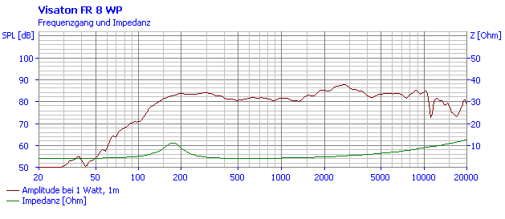
The tube oscillation amplitude is equal to that of the speaker cone. The actual excursion distance or displacement of the speaker cone was not precisely measured for all frequencies. However, we have seen that at 100 % volume, it remains constant at 5 mm for frequencies below 50 Hz and decreases approximately quadratically with frequency beyond this (eg 1.5 mm at 100 Hz). Something similar is seen in this graph taken from Voice Coil Displacement (klippel.de):
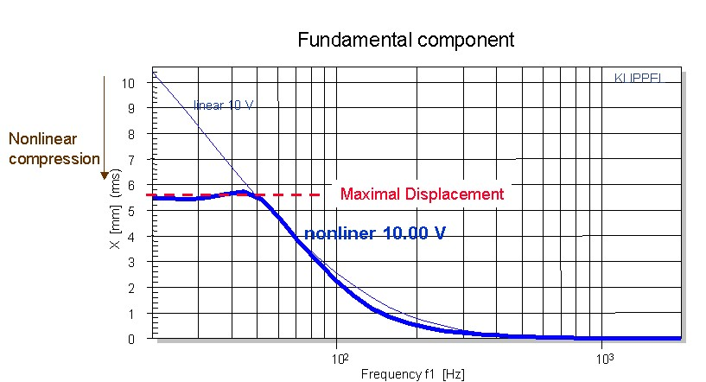
- Figure 3(b): could more information be given instead of "high", "intermediate", "low"? In practice, how should one choose a speaker to implement this?

As mentioned above, at 100 % volume the aux cable voltage which is the input to the amplifier is 5 Vpp. To implement low, medium and high one can use 4.5 V, 3.0 V, 1.5 V Vpp respectively as input to the amplifier. These details have been added to the manuscript and to Figure 3 B.
Overall, I believe that the method developed here will lead to an interesting video that other researchers could then use

Reviewer #2:
Manuscript Summary:
This manuscript presents a convenient and novel methodology to produce harmonic flow that oscillate between 10 and 1000 Hz in microfluidic devices. The proposed idea is based on interfacing a computer-controlled speaker diaphragm to the microfluidics inlet tubing. Overall, the authors propose a low-cost but robust and adjustable method for generating flows that oscillate in microfluidic channels within a frequency range that is not explored as other ranges.
The author have shown that the proposed methodology is useful for the study of New- tonian and non-Newtonian liquids microrheology, but also for important applications as microscopic enhanced mixing. The method proposed also allows for pulsatile flows when combined with a steady flow from a syringe pump: this is discussed to have a potential as a convenient technique to implement such flows also in existing research and industrial systems.
The relevance of this novel methodology is clear to me. The method is low cost and easy to assembly. The draft is easy to read and well written; the figures are all of high quality and clear to understand. I recommend to accept this draft for publication in the Journal of Visualized Experiments.

We thank the reviewer for their support for publication and for their comments. We have addressed all reviewer comments and updated the manuscript accordingly. We believe that the current version has improved in clarity and acceptable for publication in JoVE.
Major Concerns:
none
Minor Concerns:
* I recommend to add a sentence (or a couple of sentences) to motivate better the scientific relevance of the frequency range explored here (10-1000 Hz).

We appreciate the comment, and have added “For frequencies in the range of 10 – 1000 Hz, both the velocity of the oscillatory component, and its associated steady viscous streaming are considerable in magnitude and useful. Strong oscillatory flows in this frequency range can be used for inertial focusing²², facilitate droplet generation²³ and can generate flow conditions (Womersley numbers) that mimic blood flow for in-vitro studies. On the other hand, streaming flows are useful for mixing, particle trapping and manipulation.”
* line 103. Why SU8-2075? I would refer here to general SU8, for other application with thinner or thicker microfluidic devices other SU8 could be used (as SU8-2010 or SU8-2025).

We agree with the reviewer. We have removed references to SU8 and have written the protocol for 3D printed SLA molds. We also acknowledge that any SU8 or KMPR molds can also be used. “1.6 Note that conventional microfluidic mold fabrications with silicon wafers and photolithography with any SU8 or KMPR photoresists can also be used to produce a mold with smaller features.”
* line 127. I suggest that the authors clarify whether the power of the speaker (here 15 W) is or not a key parameter for the method?

We have now clarified this and added: “3.1 Clamp the alligator clip ends of a pair of alligator-to-pin wires to the terminals of a speaker. Note that we use a 15 W speaker with an 8 cm cone for demonstration purposes although other speakers can also be used.”
* lines 170-172. I suggest that the authors clarify why the observation frequency must be larger than 10 times that of oscillation?

We have clarified this further. “To observe oscillatory flow, use a high-speed camera with a frame rate of at least twice the oscillation frequency due to the Nyquist sampling theorem. Note that a practically useful resolution of the waveform often needs at least 10 points per period for which the observation framerate must be > 10 times that of the oscillation frequency”
* I suggest to indicate in a setup figure where the catted micro-pipette tip is (may be figure 1).

We have updated the schematic shown in Figure 1 to include the micro-pipette tip wedge seal.
* lines 193-200. I suggest that the authors clarify how important it is to observe, in this configuration, the moving particles through a thin field of view?

We have added: “To obtain measurements in a well-defined focal plane ensure that the depth of field of the objective lens is smaller than the channel depth by a factor of 5 or more.”

Reviewer #3:
Manuscript Summary:
The authors provided the assembly and operation of a low-cost, plug-and-play type speaker-based apparatus that generates oscillatory flow in microchannels. They found that the precise amplitude of oscillation is dependent on fluid properties and channel geometry.
We thank the reviewer for their comments and suggestions. We have addressed all of the reviewer's comments and modified the manuscript accordingly. The manuscript has improved in clarity and focused on the oscillatory flow component, which is the main contribution and focus of this manuscript and experimental approach.
Major Concerns:
1. Even though "mixing" and "separation" have been considered in "Introduction" section, the authors need to briefly explain micomixing and particles separation using updated review papers, such as: https://doi.org/10.1016/j.cep.2019.107771 and
https://doi.org/10.1016/j.cep.2020.107984.

We thank the reviewer for pointing this out and have now added more references to the introduction, including the papers mentioned by the reviewer.
2. What are the characteristics of speaker volume? for example, Fig. 3B.

The impedance and intensity characteristics for a 4 Ohm 15 W speaker with an 8 cm cone are given in the plot below taken from a manufacturer’s datasheet when operated at 1 W power. The peak-to-peak voltage supplied to the speaker by our apparatus can be estimated as: 0.08 x Volume % (8 V for 100 % volume).
(http://www.loudspeakerdatabase.com/VISATON/FR8WP-4/VISATON_FR8WP-4.pdf).

3. Fig. 4: you examined the effect of tube length, tube diameter and liquid viscosity on oscillatory amplitude. To evaluate the impact of as parameter, you need to use different values of the parameter. In this figure, the value of tube length, tube diameter and liquid viscosity is assumed to be constant.

We agree that we did not completely study the effects of varying the parameters, I.e., we did not measure oscillation amplitude for 10 different liquid viscosities. Instead, we present example cases of how oscillation amplitude changes compared to the “reference” case that was described (Fig 1) and fully characterized (Fig 2 and Fig 3). We present example cases of varying only one parameter at a time and spanning the oscillation frequency from 10 to 800 Hz. We believe that this is still useful, for example, if the user were to increase the dynamic viscosity of the liquid, then they should expect the measured oscillation amplitudes to decrease relative to their “reference” case. It would be up to the reader to perform the measurement of oscillation amplitude as a function of N different liquid viscosities.

In attempts to clarify this, we have removed the use of “examined” in the results section and replaced with “select example cases are presented on the effect of ... with respect to the reference case”.

4. How did you generate square, triangular and sawtooth waveforms?

The square, triangle and sawtooth waveforms can easily be generated using online tone generator applications such as https://www.szynalski.com/tone-generator/. We have clarified it step by step in the revised manuscript.
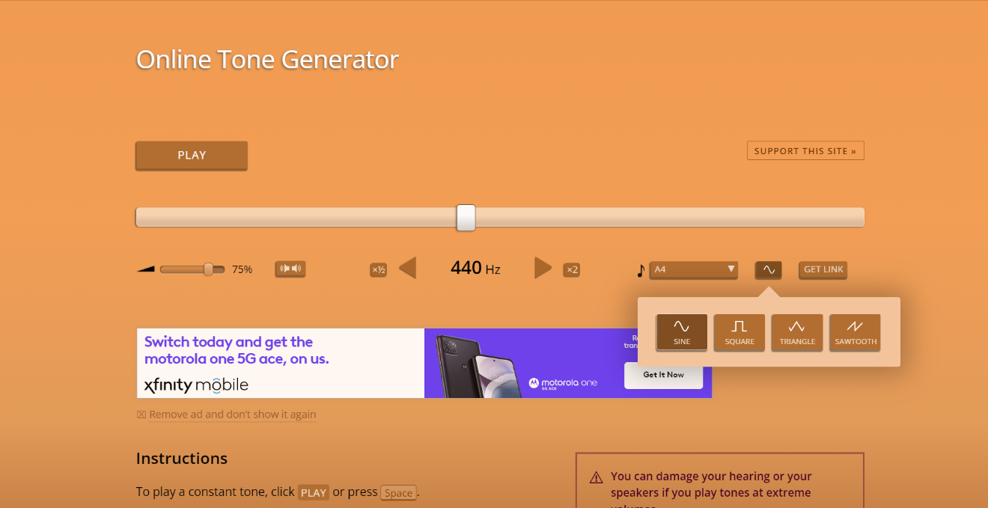
5. What is the effect of inlet flow rate?

The inlet flow rate has no effect on the oscillatory flow amplitude provided the tube is primed with liquid. We have added a point “5.7 Ensure that the outlet tube is primed with liquid. Note that the oscillatory amplitude for a given setting will not vary with steady transport flow if the outlet tube is primed.”
6. In the presence of sheath flow, please explain the oscillatory flow characteristics?

We have not characterized the oscillatory amplitude in complex flow configurations like sheath flow and this would be out of the scope of this fabrication manuscript. However, we have seen that it can be used for oscillation induced mixing in flow focusing configuration of miscible liquids (see Vishwanathan & Juarez, Microfluidics and Nanofluidics 2020: https://doi.org/10.1007/s10404-020-02373-z ) . We have not tried it for droplet generation with two aqueous immiscible phases. We do not expect any change to the oscillatory amplitude compared to a case where only a sheath fluid is used (I.e only continuous phase) without the discrete phase. This is because the oscillatory amplitude depends only on the liquid viscosity but does not depend appreciably on the flow rate.
Minor Concerns:
1. Fig. 4: 2.4 by 1.7 mm is tube diameter!

We have modified Figure 4 and changed the caption as the reviewer suggests.

