Response to Reviewer/Editor Comments
We thank the reviewers and editor for the excellent suggestions for our manuscript "JoVE63257". Below we provide a point-by-point response to each question raised.

Editorial comments:
1. Please take this opportunity to thoroughly proofread the manuscript to ensure that there are no spelling or grammar issues. Please note that the manuscript has been formatted to fit the journal standard. Some comments to be addressed are included within the manuscript. Please review and revise accordingly.
Response to Editor Q1: We have carefully and thoroughly read the manuscript again to correct any potential writing errors. We thank the editor for the comment addressed within the manuscript. We have revised all of them in the new manuscript version.
2. Please ensure that all text in the protocol section is written in the imperative tense as if telling someone how to do the technique (e.g., “Do this,” “Ensure that,” etc.). The actions should be described in the imperative tense in complete sentences wherever possible. Avoid usage of phrases such as “could be,” “should be,” and “would be” throughout the Protocol. Any text that cannot be written in the imperative tense may be added as a “Note.” However, notes should be concise and used sparingly. Please include all safety procedures and use of hoods, etc.
Response to Editor Q2: Thanks for the reminding. We have rechecked the whole manuscript to write the sentences in the imperative tense wherever possible. The usage of phrases such as “could be,” “should be,” and “would be” were removed. We add some more “NOTE” in the text now.
3. Please ensure that each step contains no more than2-3 actions.
Response to Editor Q3: We have simplified the protocols the make each step contains no more than 2-3 actions.
4. Please ensure that the highlighted steps form a cohesive narrative with a logical flow from one highlighted step to the next and fits the 3-page limit.
Response to Editor Q4: We have highlighted the steps as required.
5. As we are a methods journal, please ensure that the Discussion explicitly covers the following in detail in 3-6 paragraphs with citations:
a) Critical steps within the protocol
b) Any modifications and troubleshooting of the technique
c) Any limitations of the technique
d) The significance with respect to existing methods
e) Any future applications of the technique
Response to Editor Q5: The Discussion have already contained all the five details above.
6. Figure 3: Please label 3B and 3C to make them more informative.
Response to Editor Q6: Thanks for the reminding. We have added ischemia area, infarct area and non-ischemia area in the New Figure 3B and added LVID;d , LVID;s in the New Figure 3C.
7. Please ensure that the Table of Materials includes all the supplies (reagents, chemicals, instruments, equipment, software, etc.) used in the study. Please sort the table in alphabetical order.
Response to Editor Q7: We have put all the supplies information in the Table of Materials. We sort the table in alphabetical order now.
Reviewers' comments:
Reviewer #1:
Manuscript Summary:
The authors have addressed most questions raised by the reviewers.
Response to Reviewer #1: Thanks for the summary.
Minor comment
1. Although the authors claimed that the paper has been proofread by professional agencies, there are several hard-to-read sentences and grammar mistakes needed to be fixed. e.g., lines 43-44; lines 63-65; lines 70-72; lines 449-450, etc...
Response to Reviewer #1 Q1: We are sorry for the not good enough overall reading experience cause by writing. The image below is the language editing certificate from Charlesworth. We have polished the manuscript carefully again.
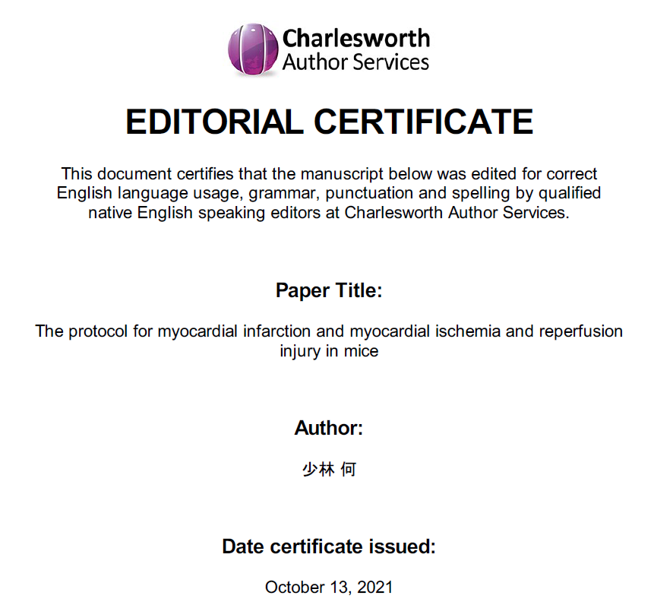

2. In Figure 1A, "Blood Collection for cTnT" and "Testing Time Up to experiment design", please correct the caps to lowercase except the first letter.
Response to Reviewer #1 Q2: Thanks for the suggestion. We have corrected them in the new Figure 1A.
Reviewer #2:
Major Concerns:
The revised manuscript did not address my major concern on novelty (procedures or efficacy) of this study. The protocol reported in this manuscript is not different from numerous reports published in JoVE and other journals. The report does not improve efficacy of MI or MIRI models. There is not data to support the authors' claim that the procedures reported in this manuscript would reduce surgical time or improve animal survival. Also, some of the procedures including fasting and use of anesthetics would not be acceptable by most institutions.
Response to Reviewer #2: Thanks for the bluntly comment. As a well performed experiment model in the past 20 years, we agree that there were numerous reports published in JoVE and other journals. In our last experiment, 50 mice were used. Based on the troponin test result, the success rate for MIRI is 93.3% (14/15) and 94.1% (16/17) for MI. The average surgical time is around 25 minutes per mouse (not including anesthesia recovery). The survival rate is 84% (42/50). An experienced performer should have a success rate higher than 80% in our lab. As far as we know, all these values are better than previous reports. We believe that all these indicators will improve with experience increase. For the issues about fasting and anesthetics, we had accepted the reviewer’s comment and revised them in the previous manuscript version.
Reviewer #3:
Manuscript Summary:
This is a very detailed and adequate description of a widely used technique in murine experiments.
Response to Reviewer #3: Thanks for the summary.
Major Concerns:
None
Minor Concerns:
1. The standard of care therapy for ST-segment elevation myocardial infarction (STEMI) is primary percutaneous coronary intervention, performed in a timely fashion, to induce myocardial reperfusion. During the first 30 to 40 minutes of ischaemia, the myocardial changes are reversible and visible only at the electron microscopy level. Infarction can occur secondary to ischaemic injury. However, the process of reperfusion can itself induce cardiomyocyte death, which is reperfusion injury in the strict sense. My point is that the 30 minutes ischemia time is indeed the standard time in animal experiments but quite short compared to clinical reality. Patients are rarely reperfused within 30 minutes. It should be indicated that this 30 minutes period can be amended.
Response to Reviewer #3 Q1: We totally agree with the reviewer about the differences between animal experiments and clinical reality. We encourage the researcher to arrange the steps according to their experiment design, including 30 mins ischemia time. Only in this way can this protocol be useful for studies of the mechanism of action and treatment of MI/MIRI, as well as for drug discovery. We add this indication in the Discussion:
“Last but not the least, the experimenter should keep in mind about the differences between animal studies and clinical realities. Especially that the 30 minutes ischemia time is indeed quite short for clinical. We encourage the researcher to arrange the steps according to their experiment design, including the ischemia time. Only in this way can this protocol be useful for studies of the mechanism and treatment of MI/MIRI, as well as for drug discovery.”

2. Reference 7 and 8. Prior to this, the model of permanent ligation of the LAD was described in detail in JOVE by Muthuramu et al. PMID: 25489995 PMCID: PMC4354439 DOI: 10.3791/52206
Response to Reviewer #3 Q2: Thanks for the remind. We have added this important paper into the reference.

