Rightslink® by Copyright Clearance Center
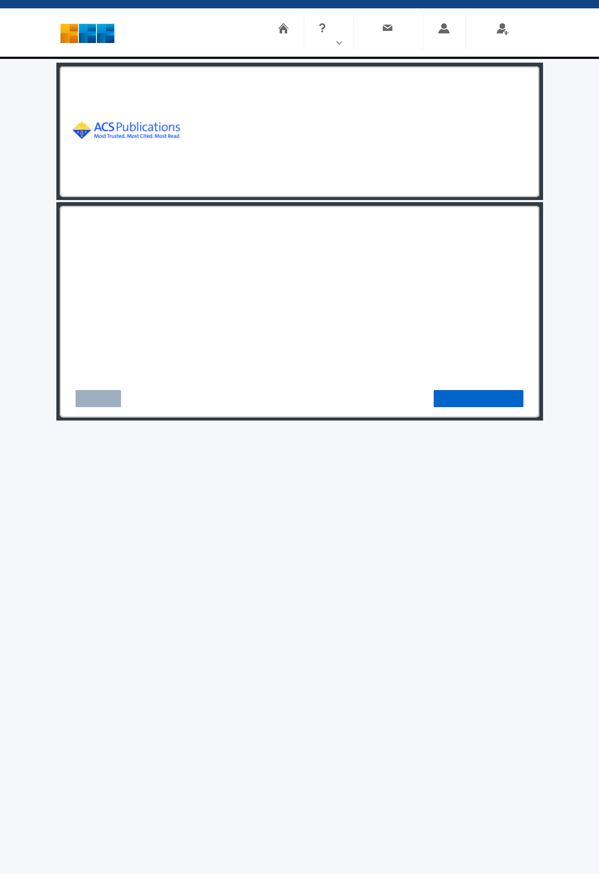

RightsLink

Home

Help

Email Support

Sign in

Create Account

All-Printed In-Plane Supercapacitors by Sequential Additive Manufacturing Process

Author: Myeong-Lok Seol, Inho Nam, Erick L. Ribeiro, et al

Publication: ACS Applied Energy Materials

Publisher: American Chemical Society

Date: May 1, 2020

Copyright © 2020, American Chemical Society

PERMISSION/LICENSE IS GRANTED FOR YOUR ORDER AT NO CHARGE

This type of permission/license, instead of the standard Terms and Conditions, is sent to you because no fee is being charged for your order. Please note the following:

- Permission is granted for your request in both print and electronic formats, and translations.

- If gures and/or tables were requested, they may be adapted or used in part.

- Please print this page for your records and send a copy of it to your publisher/graduate school.

- Appropriate credit for the requested material should be given as follows: "Reprinted (adapted) with permission from {COMPLETE REFERENCE CITATION}. Copyright {YEAR} American Chemical Society." Insert appropriate information in place of the capitalized words.

- One-time permission is granted only for the use specied in your RightsLink request. No additional uses are granted (such as derivative works or other editions). For any uses, please submit a new request.

If credit is given to another source for the material you requested from RightsLink, permission must be obtained from that source.

BACK CLOSE WINDOW

© 2021 Copyright - All Rights Reserved | Copyright Clearance Center, Inc. | Privacy statement | Terms and Conditions

Comments? We would like to hear from you. E-mail us at customercare@copyright.com

https://s100.copyright.com/AppDispatchServlet 1/1

