Response to Referee’s Comments
Manuscript ID: JoVE63234
Title: Elaborate control of inkjet printer for fabrication of chip-based supercapacitors

We appreciate the constructive comments and suggestions from the editor and referees, which were very helpful to improve the clarity of our manuscript. Based on the comments, we have made changes to improve our manuscript. Consequently, we now believe that the quality of the manuscript is considerably improved to be suitable to publish in Journal of Visualized Experiments. We have given a response to each comment, including the detailed changes that were highlighted in the manuscript.

Response to the Editorial Comments:

Comment 1:
Please take this opportunity to thoroughly proofread the manuscript to ensure that there are no spelling or grammar issues.
Answer)
Thank you very much. We revised the manuscript and proofread it.
Comment 2:
Please rephrase the Summary to clearly describe the protocol and its applications in complete sentences between 10-50 words: “Here, we present a protocol to ….”

Answer)
Thank you for your valuable comment. To clarify the topic and applications of our protocol, we have made the following changes in the SUMMARY section.

In Page 1 SUMMARY section
This paper provides a technique for manufacturing chip-based supercapacitors using an inkjet printer. In detail, methodologies are described to synthesize inks, adjusting software parameters, and analyze the electrochemical results of the supercapacitor manufactured through electrochemical tests.
Comment 3:
Please revise the text to avoid the use of any personal pronouns (e.g., "we", "you", "our" etc.).

Answer)
Thank you for your valuable comment. The entire paper has been thoroughly reviewed for the points you mentioned. the revised points are highlighted in the revised manuscript.

Comment 4:
JoVE cannot publish manuscripts containing commercial language. This includes trademark symbols (™), registered symbols (®), and company names before an instrument or reagent. Please remove all commercial language from your manuscript and use generic terms instead. All commercial products should be sufficiently referenced in the Table of Materials.
For example: WYPALL, Voltera, etc.

Answer)
Thank you for your valuable comment. The entire paper has been thoroughly reviewed for the points you mentioned, and they are highlighted in the revised manuscript.

Comment 5:
5. Please ensure that the Introduction includes all of the following:
a) A clear statement of the overall goal of this method
b) The rationale behind the development and/or use of this technique
c) The advantages over alternative techniques with applicable references to previous studies
d) A description of the context of the technique in the wider body of literature
e) Information to help readers to determine whether the method is appropriate for their application

Answer)
To improve the quality of the introduction, the manuscript has been revised as below.

In Page 1 Introduction section
In the past decades, multiple printing methods have been developed for various applications, such as wearable devices¹, pharmaceuticals², and aerospace components³. The printing can be easily adapted for the various devices by simply changing the materials to be used. Moreover, it prevents the wastage of raw materials. To manufacture electronic devices, sorts of printing methods have been developed, such as screen printing⁴, push coating⁵, and lithography⁶. Compared to these printing technologies, the inkjet printing method has multiple advantages, including reduced material waste, compatibility with multiple substrates⁷, low cost⁸, flexibility⁹, low-temperature processing¹⁰, and ease of mass production¹¹. However, the application of the inkjet printing method has barely been suggested for certain sophisticated devices. Therefore, this protocol established detailed guidelines to use the inkjet printing method for a specific electronic device.
Supercapacitors, including pseudocapacitors and electrochemical double-layer capacitors (EDLCs), are emerging as energy storage devices that can complement conventional lithium-ion batteries^{12,13}. Especially, the EDLC is a promising energy storage device because of the low cost, high power density, and long cycle life¹⁴. Activated carbon (AC), having high specific surface area and conductivity, is used as an electrode material for commercial EDLCs¹⁵. These properties of AC allow EDLCs to have high electrochemical capacitance¹⁶. EDLCs have the passive volume in devices when the conventional fixed-size fabrication method is used. However, based on inkjet printing, the EDLCs can be fully integrated into the product design. Therefore, the device manufactured by the inkjet printing method is esthetically and functionally better than fabricated by existing fixed-size methodologies¹⁷. The fabrication of EDLCs using the efficient inkjet printing method could maximize the stability and longevity of EDLCs and provide a free-form factor¹⁸. The printing patterns were designed by using a PCB CAD program and converted all to Gerber files. The designed patterns were printed using an inkjet printer because it has precise control through software, high material throughput, and printing stability.

Comment 6:
Please note that your protocol will be used to generate the script for the video and must contain everything that you would like shown in the video. Please add more details to your protocol steps. Please ensure you answer the “how” question, i.e., how is the step performed? Alternatively, add references to published material specifying how to perform the protocol action. Please add more specific details (e.g. button clicks for software actions, numerical values for settings, etc) to your protocol steps. There should be enough detail in each step to supplement the actions seen in the video so that viewers can easily replicate the protocol.

Answer)
Thank you for your valuable comment. To answer the “how” questions corresponding to the editor’s comments 7-21, we tried to provide a clearer protocol by adding and/or modifying a few steps for each and presenting additional figures.

Comment 7:
Line 58-59: Where are the values of grid size and alt changed? In CAD software? Please include the details of the button clicks/ commands used, if any. Please ensure to bold the button clicks/commands.

In Page 2 line 61 - 67
1.1. To design a pattern by using a PCB CAD program, firstly run the CAD program. Click the 'File' button at the upside of the program window, and to form a new project file, click the 'New' and 'Project' buttons.

1.2. To generate the board file, click the 'File' and 'New' and 'Board' buttons in order. There can set the grid size, multiple, and alt values by clicking the mesh-shaped 'Grid' button at the top left of the created 'Board file' window.

Comment 8:
Line 60-63: Please elaborate on the designing step. Please ensure to include all the details necessary so that the protocol can be repeated/reproduced elsewhere.

In Page 2 line 74 - 98
1.4.1. Since the final pattern consists of a total of three types (Conductive line, EDLC, and GPE), three layers must be set.

1.4.1.1. Click ‘View’ and ‘Layer settings’ in order at the top of the window and create new layers by clicking the ‘New Layer’ button at the bottom left of the ‘Visible Layers’ window.

1.4.1.2. There must be a new window (‘New Layer’) that can set up a name and color of a new layer. For convenience, set the names of each layer to 'Current collector', 'EDLC', and 'GPE', and change the color by clicking the box to the right of 'Color' so that they can be visually distinguished.

1.4.2. Press 'Line' at the bottom left of the screen then click on the main field (black background) and drag to draw a line. To change the thickness of the line, input the value of 'Width' located at the top center in inch scale. (1.0 mm = 0.0393701 inch)

1.4.3. To edit the length of a line, right-click on the line and click 'Properties' at the bottom. On the right side of From and To, there are two input fields, which are the x and y values of the starting and ending points, respectively.

1.4.3.1. To set the reference point of the pattern, set the upper left corner of the pattern shown in Figure 1. to (0, 0), and draw the pattern by inputting the rest based on the above-mentioned information (Protocol 1.4.).

1.4.3.2. To set the layer of the drawn pattern, click 'Layer' in the 3rd line at the bottom of the 'Properties' window mentioned above and set it to the desired layer.

1.4.4. In the case of the current collector pad and GPE, it exists as a rectangular surface rather than a line. To draw them, press 'Rect' at the bottom left of the window, and then click and drag on the screen (main field) where the pattern exists.

1.4.5. Just like editing 'Line', right-click on the rectangular surface and click 'Properties' at the bottom. Input the upper left (x,y) value of the rectangle in 'From', and input the lower right (x,y) value in 'To' to edit. Also, set the desired layer as mentioned in Protocol 1.4.3.2..

Comment 9:
Line 64: How are the files converted?

In Page 3 line 99 - 116
1.5 Convert CAD file of designed pattern into the Gerber file format that can be read by the inkjet printer.

1.5.1. Before converting the designed pattern file, the ‘Board file’ should be saved in ‘.brd’ format.

1.5.2. After saving, click 'File' at the top of the window and click 'CAM processor'. To create a Gerber file of the desired layer, modify the items under 'Gerber' of 'Output Files' on the left side of the window.

1.5.2.1. First, delete the sub-lists such as 'Top Copper' and 'Bottom Copper' by pressing the '-' below.

1.5.2.2. Press '+' and click 'New Gerber output' to create Gerber output.

1.5.2.3. On the right side of the screen, set the layer name in 'Name' and 'Function' to 'Copper' by pressing the gear on the right. Set 'Layer type' to 'Top' and set 'Gerber layer number' of the current collector, EDLC and GPE to 'L1', 'L2', 'L3' respectively.

1.5.2.4. In the 'Layers' window at the bottom of 'Gerber File', click 'Edit layers' at the bottom left, and select each desired layer.

1.5.2.5. To set the name of the output file to be created, set the 'Gerber filename' of 'Output' at the bottom of the window to '%PREFIX/%NAME.gbr'.

1.5.2.6. Finally, click 'Save Job' at the top left of the window to save the settings, and then click 'Process Job' at the bottom right to create a Gerber file.

Comment 10:
Line 68-78: The Protocol should be made up almost entirely of discrete steps without large paragraphs of text between sections. Please simplify the Protocol so that individual steps contain only 2-3 actions per step and a maximum of 4 sentences per step.

In Page 3 line 119 - 132
2.1. For EDLC ink, terpineol, ethyl cellulose, activated carbon (AC), Super-P, polyvinylidene difluoride (PVDF), and Triton-X were used.

2.1.1. Use 2951 μL of terpineol with high viscosity as the solvent and 1.56 g of ethyl cellulose as a thickener. Set the ratio of AC to Super-P to PVDF as 7:2:1 with a total weight of 1.8478 g. In addition, use 49 μL of Triton-X as a surfactant for mixing.

2.1.2. Mix all the materials for 30 min using a planetary mixer. Place the well-mixed electrode material in a cartridge for the inkjet printer and centrifuge it at 115 rcf (relative centrifugal force) for 5 min.

2.2. For the GPE ink, propylene carbonate (PC), PVDF, and lithium perchlorate (LiClO₄) were used.

2.2.1. Use PC as the solvent, PVDF as the polymer matrix, and LiClO₄ as the salt. Weigh all components of GPE to be the resulting molar concentration of LiClO₄ is 1M, and the weight % of PVDF is 5 wt%.

2.2.2. Stir all the components at 140 °C for 1 h until dissolution. After stirring, cool the GPE ink sufficiently and place it into the ink cartridge in the same way as done for the EDLC ink.
Comment 11:
Line 72: Please convert centrifuge speeds to centrifugal force (x g) instead of revolutions per minute (rpm).

In Page 3 line 124-126
2.1.2. Mix all the materials for 30 min using a planetary mixer. Place the well-mixed electrode material in a cartridge for the inkjet printer and centrifuge it at 115 rcf (relative centrifugal force) for 5 min.

Comment 12:
Line 81: Please specify where the “Print” and “Simple” button/clicks are located.

In Page 4 line 135
3.1. Run the printer program, click the “Print” button, select “Simple”, and select the “Flexible Conductive ink” in order as shown in Figure 2.

In Page 9 line 353 – 356
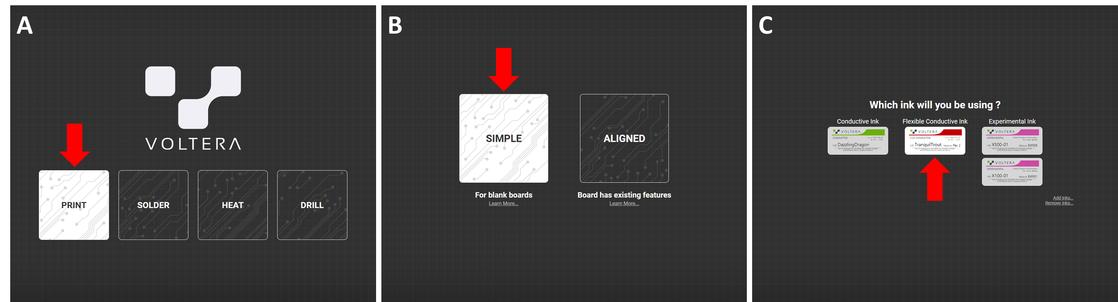
Figure 2. Image of the printer program window. (A) The first screen of the program and red arrow shows where the “Print” button is. (B) The second screen of the program and red arrow shows where the “Simple” button is. (C) The third screen of the program. Red arrow shows which ink should be selected.

Comment 13.
Line 82: How is the file uploaded?

In Page 4 line 137-139
3.2. Upload the designed pattern Gerber file by click the first red arrow of Figure 3., choose the Gerber file of the conductive line as the second arrow, and click the third arrow in order. And click the “Next” pointed to by the 4th arrow.

In Page 9 line 358
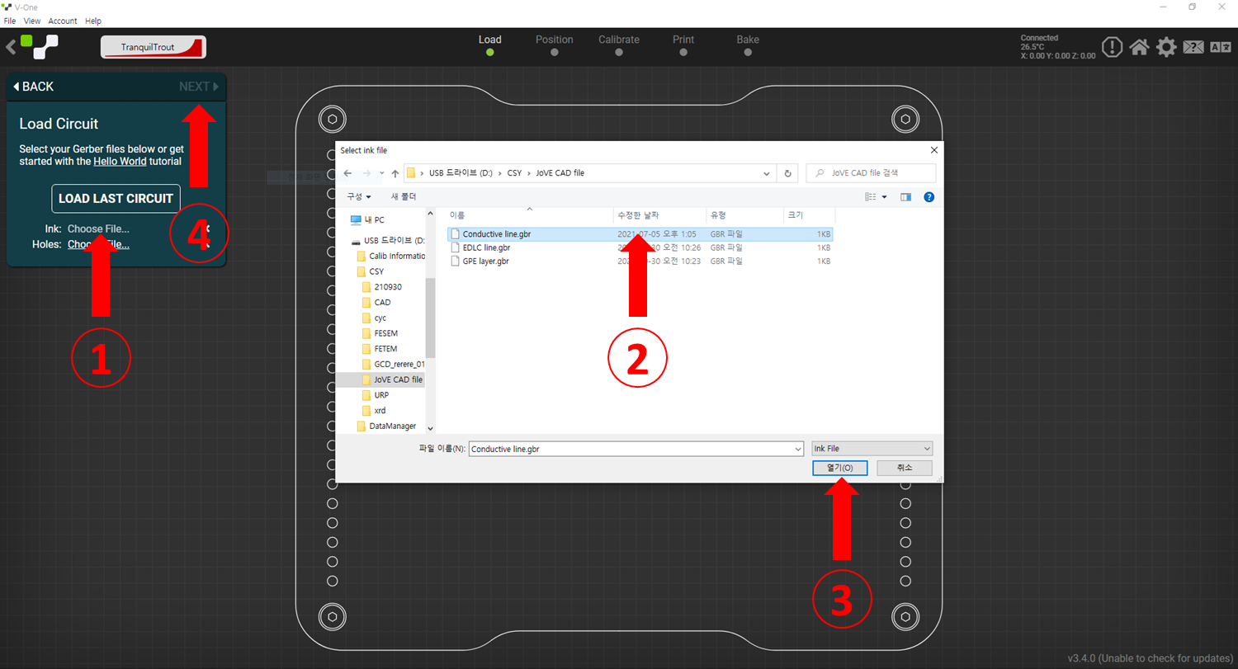
Figure 3. The screenshot image of how to upload the designed pattern Gerber file.

Comment 14:
Line83-84: How is the PCB board fixed? What is set at zero point and how?

In Page 4 line 140
3.3. After placing and fixing the PCB board as shown in Figure 4A., mount the probe (Figure 4B.).

In Page 9 line 360-361
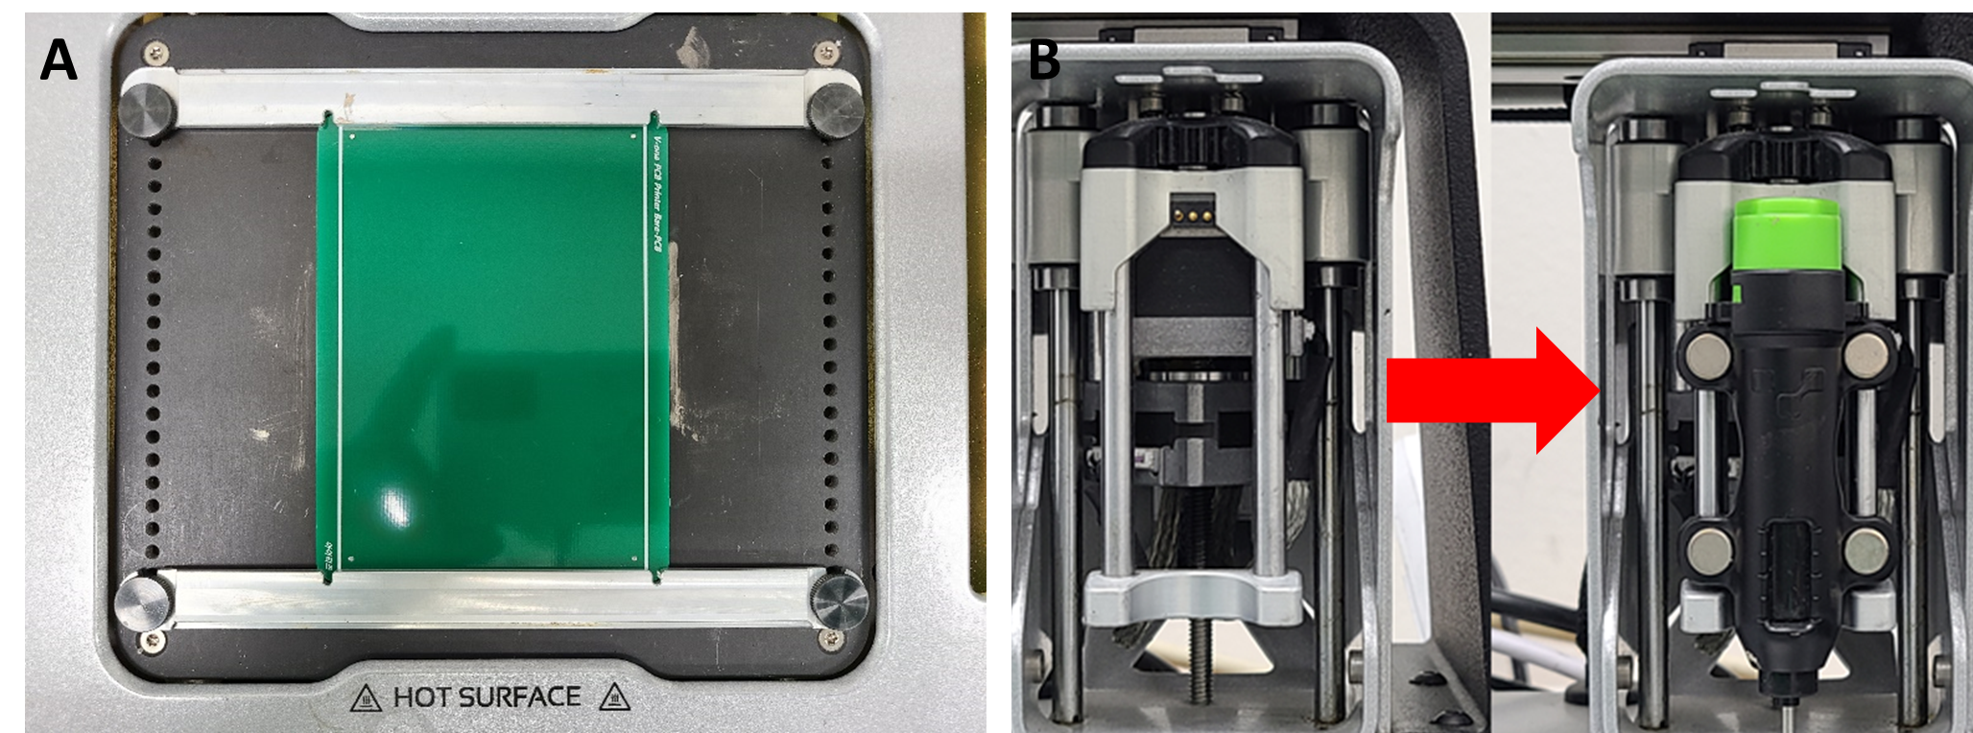
Figure 4. (A) The top view image of the PCB printer which holds the PCB board. (B) The front view image of the PCB printer which mounted the probe.

In Page 4 line 142-144
3.3.1. First, adjust the zero point of the PCB printer through the probe (it is done automatically by clicking the ‘Outline’ button). The probe will be moved over the PCB board while showing the outline of the pattern, as shown at the bottom right of Figure 5.

In Page 9 line 363
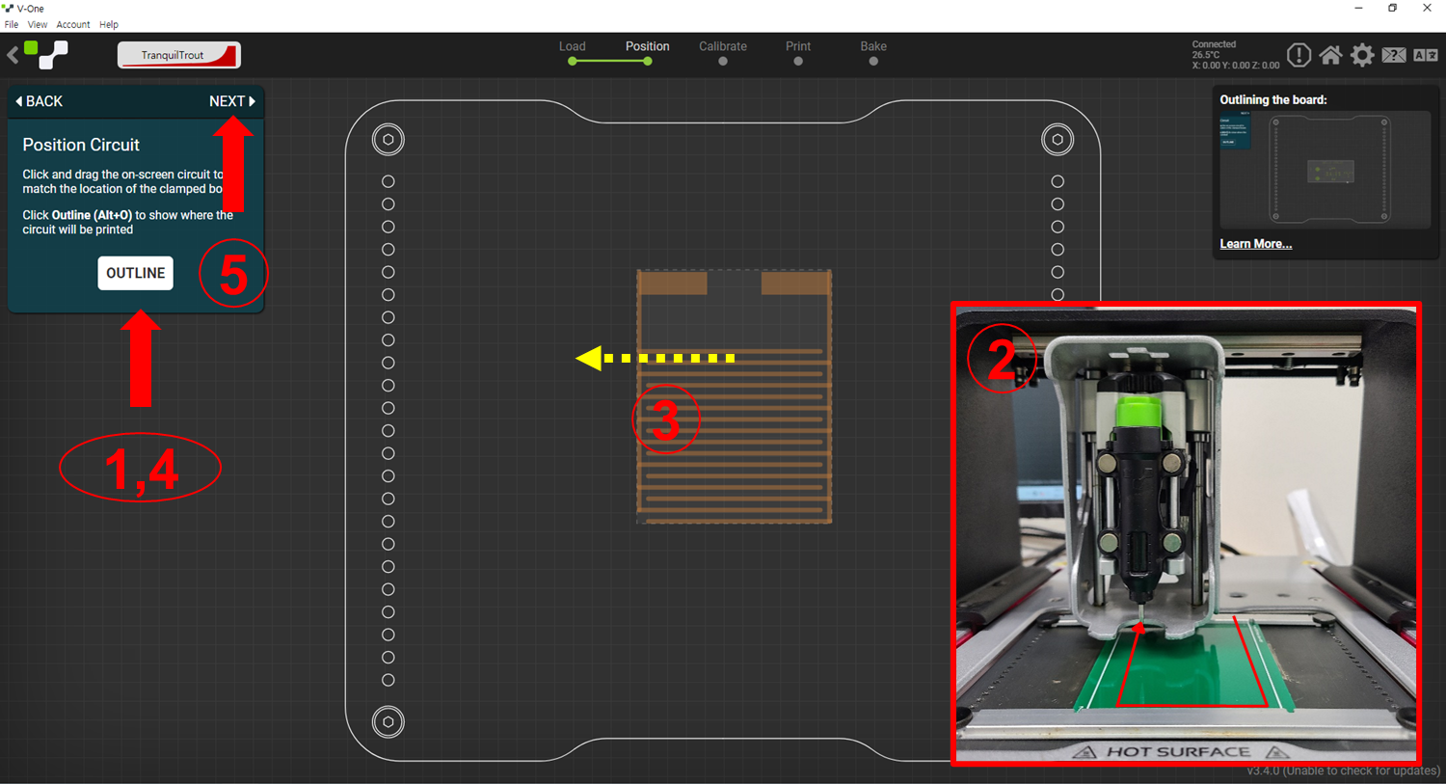
Figure 5. The screenshot image which include the schematic information.
Comment 15:
Line 85: How is it checked? Click “Next” where?

In Page 4 line 145-147
3.3.2. And then move the pattern image through dragging the mouse (yellow dash arrow of Figure 5.). Then click the “OUTLINE” button once more to check the probe move through the desired path and click the “Next”.

In Page 9 line 363
Figure 5. The screenshot image includes the schematic information.

Comment 16:
Line 87-88: How is the height measured?

In Page 4 line 148-149
3.3.3. Measure the height of the substrate to check whether the substrate is flat (whether there is a height difference or not.). Figure 6.

In Page 9 line 365-367
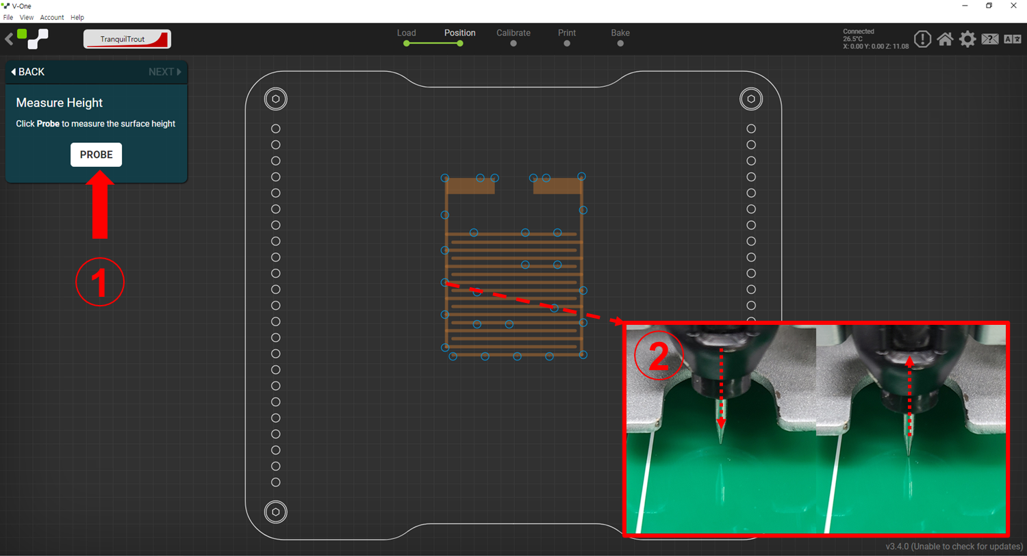
Figure 6. The screenshot image includes the schematic information. Click the “PROBE”, then the probe will move to the spot indicated on the screen and move down and up to check the height of the substrate.
Comment 17:
Line 89-90: Please specify the nozzle size?

In Page 4 line 150-152
3.3.4. When the height measurement is completed, remove the probe, insert the ink cartridge into the ink dispenser, and connect the nozzle (inner diameter: 230μm) to prepare the dispenser.
Comment 18:
Line 91-92: How is the sample pattern printed?

In Page 4 line 153-154
3.4. Mount each ink (conductive, EDLC, GPE) dispenser, and print a sample pattern while adjusting the parameters of each ink. Figure 7.

In Page 9 line 369-373
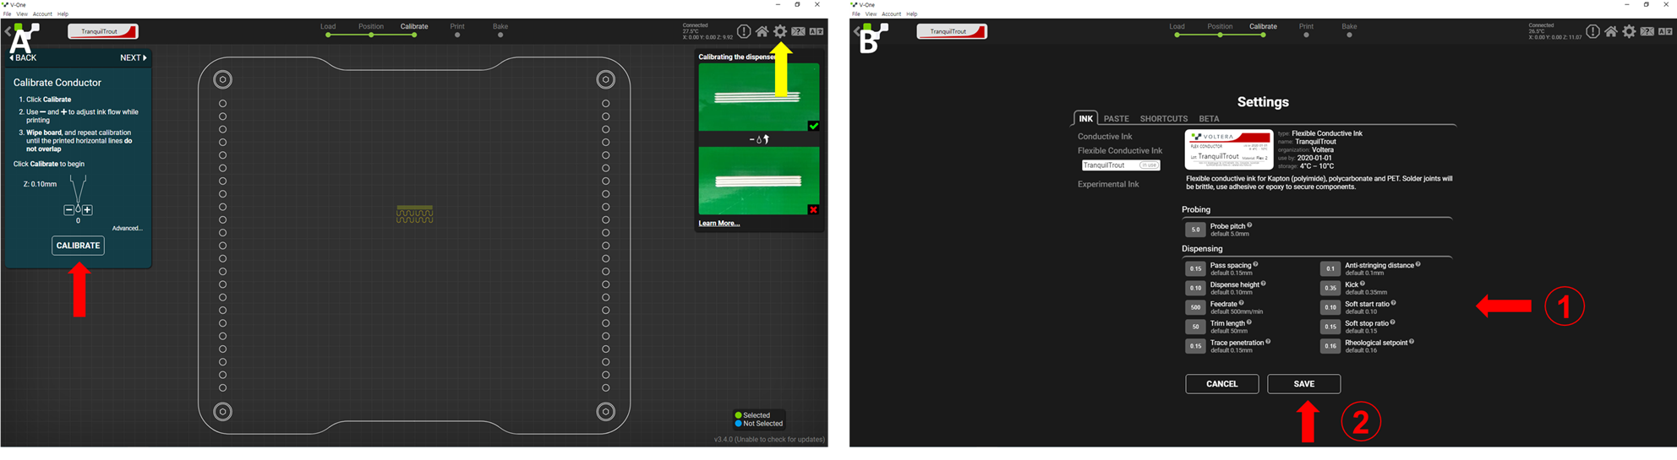
Figure 7. (A) The screenshot image showing the procedure of printing sample pattern. The red arrow indicates the button to print the sample pattern and the yellow arrow indicates the button to control the software parameter. (B) A window that appears when the yellow arrow of (A) is pressed. Software parameters can be modified by changing the values of the first red arrow pointed. Press the second arrow to save the change of the software parameters.
Comment 19:
Line 93: How is the printing result checked visually? Is any instrument used?

In Page 4 line 155-156
3.5. Visually check the printing result and record the parameter values for each ink. NOTE: The details are expressed in REPRESENTATIVE RESULTS.

Comment 20:
Line 95-106: Please ensure that all the button clicks/ options are included in the protocol steps.

In Page 4 line 159-160
NOTE: Since steps 4.1. to 4.7. overlap with those shown in PROTOCOL 3., they are summarized as much as possible.

Comment 21:
Line 117: Change the parameter values to what?

In Page 4 line 166-167
4.6. Change the software parameter of conductive ink by pressing the setting button. (Figure 7. and Table 1.)

In Page 5 line 183
5.4. Change the software parameter values of EDLC inks. (Figure 7. and Table 1.)

In Page 4 line 196
6.4. Change the software parameter values of GPE inks. (Figure 7. and Table 1.)
Comment 22:
Please highlight up to 3 pages of the Protocol (including headings and spacing) that identifies the essential steps of the protocol for the video, i.e., the steps that should be visualized to tell the most cohesive story of the Protocol. Remember that non-highlighted Protocol steps will remain in the manuscript, and therefore will still be available to the reader.

Answer)
We highlighted it as a yellow box.

Comment 23:
As we are a methods journal, please revise the Discussion to explicitly cover the following in detail in 3-6 paragraphs with citations:
a) Critical steps within the protocol
b) Any modifications and troubleshooting of the technique
c) Any limitations of the technique
d) The significance with respect to existing methods
e) Any future applications of the technique

Answer)
Thank you for your valuable comment. I recognized that the contents corresponding to b) and d) were insufficient among the details you mentioned. Therefore, the details of the discussion have been reinforced by adding a paragraph as follows.

In Page 10 line 425-436
In the fabrication of supercapacitors using inkjet printing, one paper reported that there is still a limit to developing a pattern with uniform and high resolution. It has been reported that high-temperature post-treatment is still necessary, and it is also mentioned that the optimization process of the material is indispensable.¹⁹ Also, in another paper, it was reported that to use inkjet printing properly, it is necessary to adjust the viscosity and surface tension in a relatively narrow range that depends on the printer, and for this purpose, the concentration of the active material of the ink is limited. In some cases, it has been noted that multiple prints are necessary to deposit a sufficient amount of material.²⁰ In line with this trend, this protocol can help researchers implement patterns with higher resolution by providing precise methods for handling inkjet printers. In addition, if those who have mastered the software control freely, can simplify the manufacturing process by adjusting the software parameters such as Feedrate and Kick without having to print several times to deposit enough material.
Comment 24:
Please revise the table of the essential supplies, reagents, and equipment. The table should include the name, company, and catalog number of all relevant materials in separate columns in an xls/xlsx file. Please sort the Materials Table alphabetically by the name of the material.

Answer)
Thank you for your valuable comment. According to your comment, the Materials Table has been sorted alphabetically, and the molecular weight of the polymer and additional information has been added according to the reviewers' comments.

Response to the Reviewer 1:
In this manuscript authors tried to provide a repeatable protocol in fabricating super-capacitors based on electrical double layers of active carbons via inkjet method. Details are presented well and it may be helpful for researchers in the field. Some minor points should be added before publishing.

Comment 1:
It is strongly suggested to provide some data regarding structural and rheological properties of the ink.

Answer)
Thank you for your valuable comment. We provide the structural and rheological properties of ink as below. In addition, the following information was added and highlighted in the REPRESENTATIVE RESULTS section of the main content.

In Page 7 line 295-306
The ink was synthesized according to Protocol 2, and the characteristics of the ink could be confirmed according to the referenced paper.¹⁸ Figure 8. shows the structural properties of conductive ink and EDLC ink and the rheological properties of EDLC ink through previous research. It was confirmed that the conductive ink was well sintered to form continuous conducting paths, and the nanoscale roughness is expected to increase the contact area with the EDLC ink (Figure 8A, B). EDLC ink was uniformly distributed on the macroscopic scale but had a very rough surface shape on the micro and nanoscale which possibly provides the high surface area and improving the energy storage capacity. All components are well dispersed and there are no visible elements that could cause clogging during printing (Figure 8C-F). Figure 8G presents the time evolution of the apparent viscosity in the EDLC ink. The viscosity value increased as the shear time increased, and it did not show viscoelastic behavior, which was judged to have shear-thickening behavior without any stress-induced structural extension, stretching, or rearrangement.

In Page 9 line 386-391
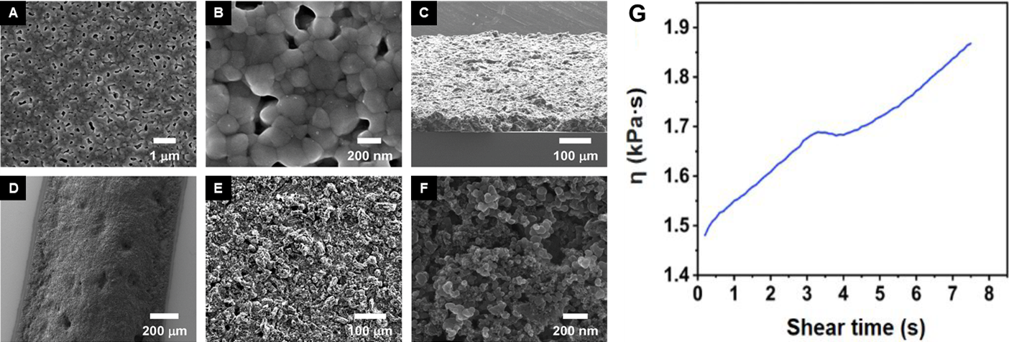
Figure 8. (A-F) SEM images of the inks and printed layers. (A) Top-view image of the current collector (low magnification). (B) Top-view image of the current collector (high magnification). (C) Tilted side-view of the printed EDLC active layer film. (D-F) Top-view images of the EDLC active layer with different magnifications. (G) Apparent viscosity of EDLC ink versus shear time for constant 0.3 s-1 shear rate experiment. Adapted with permission from [ref]18. Copyright (2020) American Chemical Society

Comment 2:
Some reports like (Inkjet-Printing Technology for Supercapacitor Application: Current State and Perspectives) and (Ti-rich TiO2 Tubular Nanolettuces by Electrochemical Anodization for All-Solid-State High-Rate Supercapacitor Devices) could be added to the references.

Answer)
Thank you for your valuable comment. Thanks to the papers you recommended, my views on fields such as supercapacitors and the use of supercapacitors using inkjet printing have been broadened, and I have been able to support the background knowledge that is lacking in the introduction and discussion of this paper. The corrections and additions are as follows.

In Page 2 line 44-47
Supercapacitors, including pseudocapacitors and electrochemical double-layer capacitors (EDLCs), are emerging as energy storage devices that can complement conventional lithium-ion batteries.^{12,13}

13. Qorbani, M., Khajehdehi, O., Sabbah, A. & Naseri, N. Ti-rich TiO2 Tubular Nanolettuces by Electrochemical Anodization for All-Solid-State High-Rate Supercapacitor Devices. ChemSusChem. 12 (17), 4064-4073, (2019).

In Page 10 line 408-410
It has been reported that high-temperature post-treatment is still necessary, and it is also mentioned that the optimization process of the material is indispensable.²⁰
20. Sajedi-Moghaddam, A., Rahmanian, E. & Naseri, N. Inkjet-Printing Technology for Supercapacitor Application: Current State and Perspectives. ACS Applied Materials & Interfaces. 12 (31), 34487-34504, (2020).

Response to the Reviewer 2:
This manuscript presents the protocol of controlling inkjet printer to fabricate supercapacitors. However, I do not think the work is of broad interest to the society. Below are my comments.
Comment 1:
The fabricated supercapacitors are not of good EDLC performance. Although the authors claim (in Line 272) that the CV curves are of typical box shape of an EDLC, the CV curves in Figure 9 actually indicates lens-like shape with not-identified peaks. The obtained gravimetric capacitance of 5.74 F/g is not of significance as compared with many other printed supercapacitors.

Answer)
Thank you for your valuable comment. This paper was written by JoVE’s policy. We focused on how to fabricate the energy storage device with inkjet printing method, not a new or advanced electrochemical performance. The electrochemical results are just an example, and we know that novelty is not a requirement for publication in JoVE. As the reviewer said, its performance is insufficient compared to other supercapacitors up to now. However, the researcher who has an interest in the printing method can refer to this paper.

Comment 2:
The majority of the protocol is for the description of the software operation, even including button clicking. However, in my opinion, such a protocol is of limited interest. In addition, the process parameters may be strongly case-dependent, as all of them need to be changed/optimized once different inks and substrates are used.

Answer)
In this paper, we proposed the optimization steps for the printing of supercapacitor in detail. By editorial comments, it was also required to add more details to the protocol steps. We think that the experimental details are very important for the readership of JoVE. If you try to use different materials for inks and substrates, you can follow the steps in this paper and adjust the values according to your materials.

Comment 3: The key information of many materials is missing, such as the suppliers and molecular weight of polymers. It will greatly reduce the reproducibility of the protocol.

Answer)
Thank you for your valuable comment. JoVE does not include commercial expressions in the manuscript. Therefore, additional information such as the suppliers and molecular weight of polymers are mentioned in the Table of Materials. We mentioned it in more detail in the Comments/Description part in the Table of Materials to reflect your opinions.

Comment 4:
In Line 274, it is claimed the EDLCs attain gravimetric capacitance of 5.74 F/g and areal capacitance of 19.9 F/cm². Does it imply the material loading is about 3 g/cm²? Then how much is the thickness of the printed devices?

Answer)
Thank you for your valuable comment. Thanks to your comment, I found some errors in the calculation of areal capacitance and cell capacitance. As a result of the recalculation, areal capacitance came out to be 142 mF/cm², and cell capacitance came out to be 178 mF/cm². These results have been edited and inserted into the text as follows.

In Page 8 line 340-341

The gravimetric capacitance, areal capacitance, and cell capacitance were 5.74 F/g, 142 mF/cm², and 178 mF/cell, respectively, for a scan rate of 5 mV/s.

Comment 5:

In the title, inkjet printer is mentioned. But in the main text, it looks a direct filament writing printer (Line 53) is used. It is better to explain the inconsistency.

Answer)
Thank you very much. The term ‘direct filament writing’ should be changed to ‘direct ink writing’. As follows the reviewer's comment, the manuscript is revised.

In Page 2 line 56-57
The designed patterns were printed using an inkjet printer because it has precise control through software, high material throughput, and printing stability.

