PD Dr Lukas Anschuetz
Guest Editor
Journal of Visualized Experiments (JOVE)

Bern, September 28, 2021

Dear Dr Anschuetz

We would like to re-submit our revised manuscript titled “Performing Real-time Electrocochleography during Cochlear Implantation” for consideration as full article/ video in Journal of Visualized Experiments (JOVE). We sincerely thank the editor and the two reviewers for their valuable comments, which helped us to improve the manuscript substantially.

We have rewritten our manuscript how ECochG measurements can be performed with all three manufacturers (MED-EL, AB, Cochlear), respectively. We have attached a new Table 1 for this purpose. Furthermore, we have revised our Table 2 according to the comments of the two reviewers.

The present manuscript is not currently under consideration for publication by any other journal nor has it been previously published in whole or in part elsewhere. We attest to the fact that all authors listed on the title page have read the manuscript, attest to the validity and legitimacy of the data and its interpretation, and agree to its submission to JOVE.

Please address your correspondence to PD Dr Stefan Weder, Department of Otorhinolaryngology, Head and Neck Surgery, Inselspital, Bern University Hospital, Freiburgstrasse 18, CH-3010 Bern. E-Mail: stefan.weder@insel.ch.

Sincerely yours,

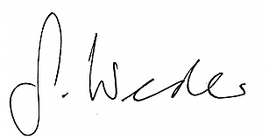
PD Dr Stefan Weder, MD

