The representative results are adapted from ¹, which was published as an open access article. The following links and screenshots indicate the open access policy that allows for the adaptation and distribution of the material, as long as it is appropriately credited and cited. We have made sure to credit and cite the work throughout the JoVE article properly.
https://www.nature.com/articles/s41380-020-00977-z#rightslink
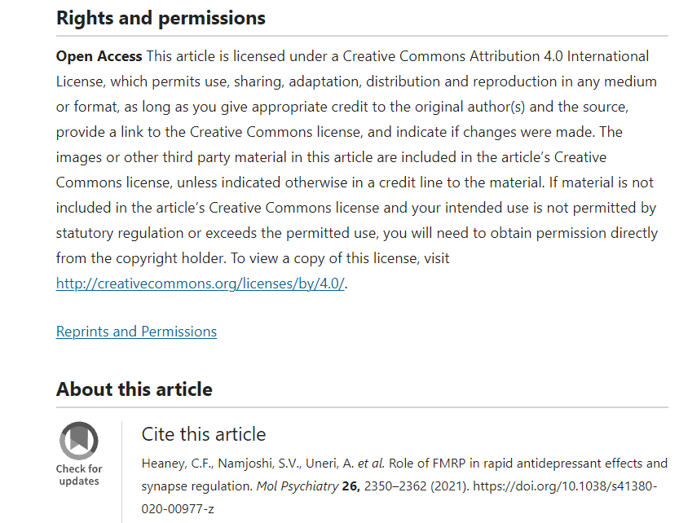

https://s100.copyright.com/AppDispatchServlet?title=Role%20of%20FMRP%20in%20rapid%20antidepressant%20effects%20and%20synapse%20regulation&author=Chelcie%20F.%20Heaney%20et%20al&contentID=10.1038%2Fs41380-020-00977-z&copyright=The%20Author%28s%29&publication=1359-4184&publicationDate=2021-01-1
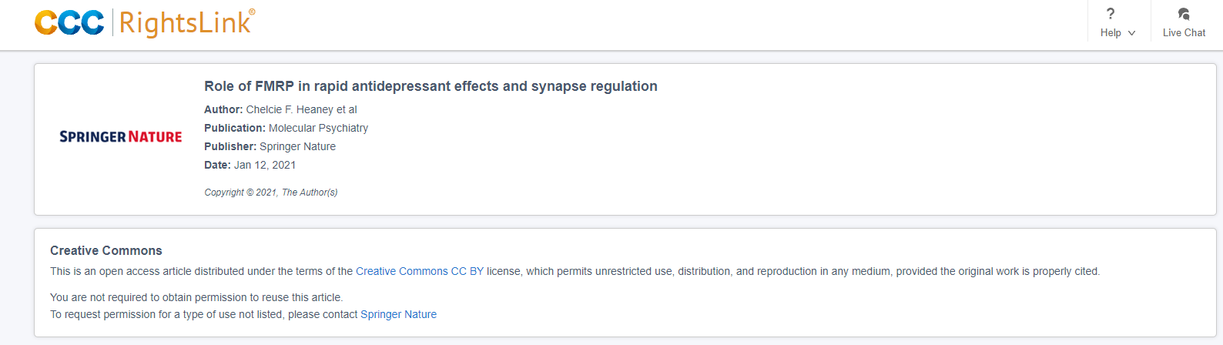

https://creativecommons.org/licenses/by/4.0/
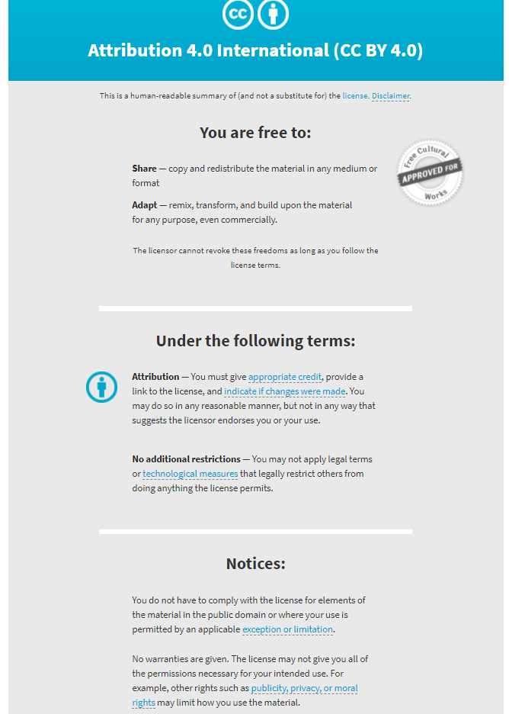

1. Heaney, C.F., Namjoshi, S.V., Uneri, A., Bach, E.C., Weiner, J.L., Raab-Graham, K.F. Role of FMRP in rapid antidepressant effects and synapse regulation. Molecular Psychiatry. 26 (6), 2350–2362, doi: 10.1038/s41380-020-00977-z (2021).

