Editorial comments:
Changes to be made by the Author(s):

1. Please take this opportunity to thoroughly proofread the manuscript to ensure that there are no spelling or grammar issues.
Thank you. This has been done.

2. Please ensure that abbreviations are defined at first usage.
This has been corrected.

3. Please revise the text to avoid the use of any personal pronouns (e.g., "we", "you", "our" etc.).
Manuscript has been checked and this language removed.

4. JoVE cannot publish manuscripts containing commercial language. This includes trademark symbols (™), registered symbols (®), and company names before an instrument or reagent. Please remove all commercial language from your manuscript and use generic terms instead. All commercial products should be sufficiently referenced in the Table of Materials.
For example: Nikon Eclipse Ti2-E, Orca Flash 4.0, Hamamatsu, NIS Elements AR, Natick, MA, GraphPad Prism (San Diego, CA), Sigma-Aldrich CLS430829, Advanced BioMatrix 5015, Selleckchem S1049, McFarlane 33009, PureCol, STEMCELL Technologies 05040, CoolCell LX Cell Freezing Container (Sigma-Aldrich CLS432002), PneumaCult-Ex Plus Medium (STEMCELL Technologies 05040), etc.
All trademark symbols, commercial and company names removed and added to the Table of Materials.

5. Please adjust the numbering of the Protocol to follow the JoVE Instructions for Authors. For example, 1 should be followed by 1.1 and then 1.1.1 and 1.1.2 if necessary. Please refrain from using bullets or dashes.
Numbering amended and bullet points removed.

6. The Protocol should contain only action items that direct the reader to do something. Please move the discussion about the protocol to the Discussion.
Language changed so that all steps are given as actions and discussion removed from protocol.

7. Please ensure that all text in the protocol section is written in the imperative tense as if telling someone how to do the technique (e.g., “Do this,” “Ensure that,” etc.). The actions should be described in the imperative tense in complete sentences wherever possible. Avoid usage of phrases such as “could be,” “should be,” and “would be” throughout the Protocol. Any text that cannot be written in the imperative tense may be added as a “Note.” However, notes should be concise and used sparingly.
Addressed.

8. Please note that your protocol will be used to generate the script for the video and must contain everything that you would like shown in the video. Please ensure you answer the “how” question, i.e., how is the step performed? Alternatively, add references to published material specifying how to perform the protocol action. There should be enough detail in each step to supplement the actions seen in the video so that viewers can easily replicate the protocol.
More detail has been added to protocol steps as described under comment 9 below.

9. Please add more details to your protocol steps.
Line 146: Please include the details of the acquisition software in the Table of Materials.
All software and equipment added to Table of Materials.

Line 150: Why the Kohler illumination was necessary? Please include a brief NOTE on that.
Line 162 has been amended:
“1.1.9 Ensure that the microscope is set up for Kohler illumination so that transmission light source bulb filaments are not in focus at the sample plane, avoiding artefacts in the imaging.”
Line 376: How was the coating done?
This is explained in detail starting from line 293:
“3.0.2 Coat flasks or permeable support inserts with Collagen solution, on a per need basis. Do not store collagen-coated vessels long-term. To do this:

3.0.2.1 Make a 1:100 dilution of Type I Collagen solution (3 mg/ml stock) with phosphate buffered saline (PBS) to an end concentration of 0.03 mg/ml. Mix well.

3.0.2.2 Coat cell culture flasks (Section 6.0) with 160 µl/cm2 (i.e., 4 ml per T25 flask) and permeable support inserts (Section 7.0) with 455 µl/cm2 (i.e., 150 µl per 6.5mm insert) of the prepared Collagen solution.

3.0.2.3 Incubate at 37°C for 2-24 hrs.

3.0.2.4 Remove the Collagen solution by pipette or vacuum aspirator prior to seeding cells. Do not wash the vessel prior to seeding cells.”

Please provide volume of all the solutions added: ROCK inhibitor, fungizone, tobramycin, etc.
Volumes are now indicated in Table 2.

Line 504: How were the cells counted?
Following amendment has been made on Line 417:
“6.0.6 Using a 5 ml serological pipette, take the 1 ml of media from Tube C and transfer into a microcentrifuge tube. Take 10 µl of this cell suspension and add it the microcentrifuge tube pre-aliquoted with 10 µl trypan blue. Mix well and immediately use an automated cell counter to record cell count and viability.”

The details for the automated cell counter that was used in this protocol is provided in the Table of Materials.

Line 564, 616: Please provide all microscope parameters and settings.
Cell culture microscopes do not have any input settings. The steps for operating are simply switching it on and focusing on the sample. Live-cell imaging microscopes require multiple settings which are provided in the protocol.

Following sentences have been added to indicate use 4x objective lens for cell culture microscopes.
Line 430:
“6.1.1 Check cells under the cell culture microscope (4× objective lens) regularly for attachment, contamination, morphology, and confluence.”
Line 573:
“8.2.9 Check the density of organoids under the cell culture microscope (4× objective lens) after plating the first dome. If too dense, add additional 90% ECM to achieve the desired density of ~30 organoids.”

Line 761: How was the aspiration done? A pipette was used?
Following changes made on line 305:
“3.0.2.4 Remove the Collagen solution by pipette or vacuum aspirator prior to seeding cells. Do not wash the vessel prior to seeding cells.”

10. Please provide the outputs of the OME data files (Line 259-273) in a separate Supplementary document. Please remove them from the Protocol as there are no action steps involved.
Removed from protocol. Supplementary File 3 created with outputs of the OME data files.

11. Please mention warming temperature and method for various media like PBS, AODM, etc.
Following notes have been included:
- Line 427: “NOTE: CRC media must be warmed to 37°C by placing it in temperature-controlled laboratory water bath or a bead bath device before it is added to the cells.”
- Line 456: “7.0.4 Every second day until a confluent cell monolayer is formed (usually by Day 4 post seeding), discard media and add fresh expansion medium warmed to room temperature (15-25°C).”
- Line 461: “7.1.1 Warm ALI media (antibiotic-free) to room temperature (15-25°C).”
- Line 528: “8.1.3 Incubate plate at 37°C for 20 min until the ECM solidifies. While the ECM is solidifying, warm AOSM to room temperature (15-25°C) to prevent it causing re-liquification and disintegration of the ECM dome upon addition.”

12. The protocol length is 10-page maximum (with proper formatting). Please revise the protocol to be up to 10 pages.
Manuscript has been thoroughly revised to meet 10-page limit.

13. Please include all the button clicks, command lines, etc. in the softwares and on the instruments. Please also ensure that the button clicks are bolded throughout.
All button clicks for software and instruments checked. Changed all commands to “click ‘X’” to ensure clarity. Bolded the name of buttons to be clicked.

For example, line 177 now reads:
“1.1.10 Using the acquisition software, click ‘L100’ to switch the light path to the port where the camera is mounted. Click the green ‘play’ button to visualise the microscope FOV via the software. Check the cilia is in focus and adjust if required.”

14. Please highlight up to 3 pages of the Protocol (including headings and spacing) that identifies the essential steps of the protocol for the video, i.e., the steps that should be visualized to tell the most cohesive story of the Protocol. Remember that non-highlighted Protocol steps will remain in the manuscript, and therefore will still be available to the reader.
3 pages of essential protocol (including headings and spacing) highlighted for video.

15. Figure 1: For the microscopy images, please include scale bars.
Scale bars added to microscopy images in Figure 1.

16. Please do not abbreviate journal name in references.
Reference list updated to include full journal names.

17. Please provide the details of all materals/reagents/equipments in the Table of materials. Please remove them from the Protocol section.
All materials/reagents/equipment removed from the Protocol section and added to the Table of Materials.

Reviewers' comments:
Reviewer #1:
Manuscript Summary:
"This protocol describes the quantification of CBF in three different airway epithelial cell model systems: 1) native epithelial sheets, 2) three-dimensional organoids and 3) air-liquid interface models. The latter two replicate in vivo lung physiology, with beating cilia and production of mucus."

Major Concerns:
The manuscript is not prepared appropriately. It appears to be an excerpt from a project thesis. It appears that the protocol is highly specialised to this group and would not produce a solution for standardisation of CBF measurements for all. It requires highly prescriptive work up and fails to acknowledge other well described and less involved methods. The authors propose that there are no other definitive protocols to allow for cilia (CBF) analysis of culture airway epithelium, which is not accurate see manuscripts: e.g (spheroids) Jorissen 1989, Castillon 2002, Willems 2004, Marthin 2017, Aydin 2021; e.g. (ALIs) Hirst 2010, Hirst 2014, Rubbo 2019, Coles 2021, Dabrowski 2021. Therefore the protocol presented in not a definitive go to method and I am concerned that the results section is extremely light.

The manuscript has been prepared and revised as per the JoVE author guide.

The following sentences have seen added to the introduction (line 77) to acknowledge other methods as suggested by the reviewer:
Line 77: “CBF has been quantified in nasal epithelial brushings^{4,6,12-16}, airway epithelial organoids^{14,17,18} and ALI models^{3,4,6,13,19-21}. Yet, amongst these protocols there are large variabilities, and often many parameters are not controlled for. For example, in some studies CBF is imaged in situ while the cells of the ALI model remain on the permeable support insert^{3,19-21}, yet others scrape the cells from the permeable support insert and image them suspended in media^{4,6,13}.”

I am also concerned that the protocol includes use of aminoglycosides that are not appropriate for some studies looking at drug effects on cilia, particularly nonsense mutations and are not necessary for non-infected cultures. It appears to be more a specialised procotol for infection-prone CF samples.

While aminoglycosides are used during the expansion CRC reprogramming phase, the differentiation phase is antibiotic free. Following lines have been amended to clarify this further.

Line added (line 433) to note that antibiotics used for stem cell culture from participant are gradually dropped and omitted if not needed during the expansion CRC reprogramming phase:
“6.1.2 Change CRC media every second day. When reprogrammed cells are observed (Figure 1) and there is no contamination present, reduce or withdraw antibiotics.

We have clarified that nasal collection media is antibiotic-free for the purpose of ex vivo CBF imaging.
Line 372 reads:
“NOTE: If collecting nasal turbinate brushings for the purpose of imaging airway epithelial sheets, only use 1 ml of antibiotic-free nasal cell collection media, otherwise epithelial sheets will be too disperse for imaging.”

We have clarified that the 27 days of air-liquid interface culture is antibiotic-free.
Line 442:
“7.0.1 Transfer the Collagen solution coated permeable support inserts (Section 3.0) from the CO2 incubator to the biosafety cabinet. Aspirate the Collagen solution and discard. Add 750 µl expansion medium (antibiotic-free) to the basal compartment of the permeable support inserts.”
Line 461:
“7.1.1 Warm ALI media (antibiotic-free) to room temperature (15-25°C).”

This protocol is arguing that normal CBF at 37oC is 7.6 Hz in healthy cells. With over a decade of post culture analysis in healthy and diseased airway cultures and with the publications described above 7.6 Hz is below normal range and therefore brings into question the heating method.

Source of tissue, type of culture, media, length of culture, and imaging technologies (presence of environmental chamber/controls) and quantification techniques is variable between different labs and could contribute to variability in CBF results. We have created Supplementary File 1 which brings together 18 publications (including those suggested above with CBF data). As evident CBF values ranges from 2.4 Hz to 14.7 Hz. CBF and seem primarily dependent on culture model and its preparation for imaging. The 7.61±0.11 Hz CBF reported by our protocol for ALI cells imaged while on the membrane is within the normal range of CBF reported in the literature with similar protocol (Awatade et al. 2021, Chen et al. 2020, Chioccioli et al. 2019, Bovard et al. 2020; ALI air exposed: 6.78±0.52 Hz).

Supplementary file 1:
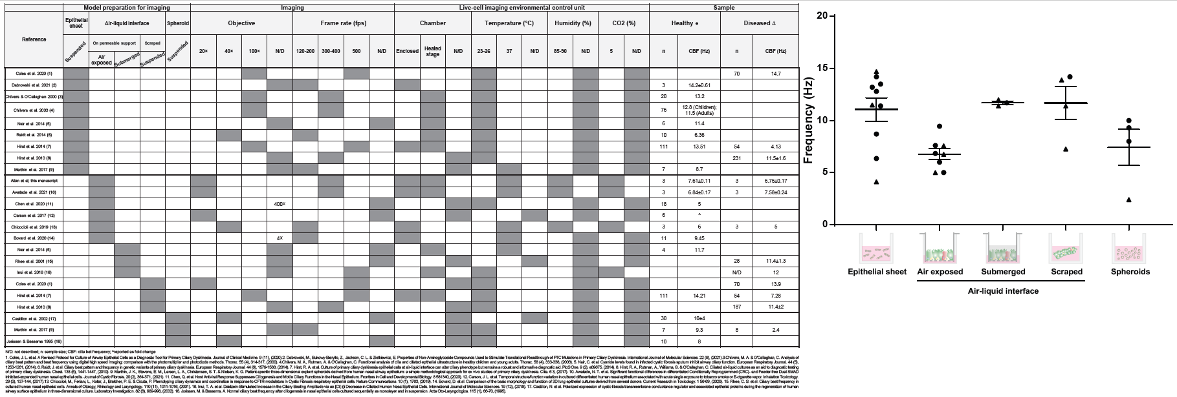

Reviewer #2:
Manuscript Summary:
This manuscript details various acute and culture methods for airway epithelial cells to measure ciliary beat frequency. This is a very specialized technique and more discussion of how to perform such measurements in the literature is worthwhile. Overall, the topic of this manuscript is important. There is a lot of very useful information in the manuscript and I applaud the authors for compiling it.

Major Concerns:
The discussion of the culturing models, cell sampling, etc. are excellent. That's a worthwhile contribution to the literature in and of itself. I have no problems with those protocols. I think that's great.
Thank you for the positive and constructive review.

However, the discussion of CBF acquisition and what the custum scripts are doing is very limited and as a result this part of the protocol is somewhat limited in terms of usefulness.
Supplementary File 4 has been provided to explain how CBF is calculated via algorithm:
“To quantify cilia beating frequency (CBF), image series were analysed using a custom-built script in MATLAB (MathWorks, Natick, MA) as previously described¹.
BeatingCiliaBatchOMEfiles_JOVE.m algorithm uses Open Microscopy Environment (OME) package of scripts (bfmatlab) to load the microscopy files, in this case an .nd2 file. The user has choice to run a single or multiple (batch) processing. User is prompted to input a frame time in seconds and then algorithm proceeds to calculate CBF for each pixel in the field of view (FOV) as well as an average value per FOV.
One of the first and essential steps in the analysis is to use Fourier space filtering to remove the immobile (static) component from each pixel in the time series. This is usually seen as stationary elements of cell bodies and mucus that do not move during the 1000 frames of the acquisition. Next the algorithm proceeds to compute CBF pixel by pixel. At each pixel, a temporal spectrum is computed using Fast Fourier Transforms (FFT). Then peaks in the spectrum are detected using MATLAB function ‘findpeaks’ and setting the allowed peak prominence to 0.05 and peak signal-to-noise cut-off (see MATLAB ‘findpeaks’ for details) at 5, so that noisy peaks in spectrum are filtered out. For each pixel, the main 3-5 peaks with highest amplitudes are saved with their corresponding frequencies. From these 3-5 peaks, the highest amplitude peak within the physiological range of 3-30 Hz is assigned the CBF for this pixel. The average spectrum of all pixels in the FOV is computed.”

There is no discussion of image acquisition rate/sampling frequency in terms of Nyquist sampling. This is critical to acquiring images that arcuately reflect changes in CBF.
Paragraph added to the discussion (line 705) to address image acquisition rate/sampling frequency in terms of Nyquist sampling and choice of camera:
“An important caveat to consider is selecting an appropriate camera and objective lens to fulfill the temporal and spatial Nyquist sampling. The long working distance lens employed in this study protocol allows a relatively large field of view to be captured. This enables CBF to be imaged in intact ALI cultures, with the spatial resolution of ~500 nm (NA0.45). As such, the ciliary bundle can be spatially resolved.”

A OrcaFlash4.0 via USB3 images at approximately 60 fps only if a small quadrant of the chip is used. A OrcaFlash 4.0 with integrated board images ~100 fps, which is considered the bare minimum standard for imaging CBF, but there is no discussion of choosing a camera for imaging or what is needed to make valid measurements. As the low light level sensitivity of an sCMOS camera is not really needed here, this could be replaced with a camera costing ~10% of the Hammamatsu provided it images fast enough.
Paragraph added to the discussion (line 715) which discusses choice of camera:
“Moreover, it is essential to have access to fast speed cameras with frame rate of at least 100 Hz so that any temporal event happening at a rate of 50 Hz can be resolved by Nyquist sampling criterion. A fast sCMOS camera with extremely low noise allowing single molecule measurement is recommended. However, this protocol is not limited by use of this type of camera, so long as the camera fulfills temporal sampling requirements and captures the pixels intensity fluctuations resulting from ciliary beating.”

There was a mistake in the camera description since we have many similar systems in our facility. We used Andor Zyla 4.2 sCMOS camera. This has been amended in the Table of Materials. Both OrcaFlash 4.0 and Zyla 4.2 sCMOS cameras have ~400 fps readout for the 512x512 field of view acquired in this protocol (https://andor.oxinst.com/downloads/uploads/Zyla_hardware_user_guide.pdf).

The steps of image acquisition are also presented as instructions with somewhat limited generalizability due to the lack of explanation of what their MatLab scripts are actually doing. I think more explanation of (1) imaging parameters for CBF and (2) more generalizable description of steps in analyzing the images to better explain what these software scripts are doing. It would not be good for others who read this paper to be using these scripts without a better concept of what or why they are doing what they are doing and thus generating garbage data because they are imaging too slow, analyzing incorrectly, etc. I think what the authors are doing is great, but I think they need better explanation to allow these procedures to translate to those who may have never done CBF analyses before. Otherwise, a simple plug-and-play description without some description of requirements and caveats may result in people using these scripts incorrectly. More basic information is required here for what and why the authors are doing what they are doing to educate the uninitiated who may read this.
Thank you for raising these concerns and for the suggestions made. We believe the supplement document provided to explain how CBF is calculated via algorithm addresses these concerns. Furthermore, we added a paragraph to the discussion (see above) which discusses both temporal Nyquist (frame rate) and spatial sampling (NA lens and lateral resolution) and how this relates to whether we can spatially see beating of separate cilia or bundles of cilia.

A detailed description of the steps for image analysis is given as per the editors request to “Please include all the button clicks, command lines, etc. in the softwares and on the instruments.”

Minor Concerns:
Example datasets should also not be presented on a personal Google Drive site but rather some more stable archived site like the journal site (e.g., supplementary material) or a site like FigShare that is designed to maintain this data in perpetuity. Linking to Google Drive is not ideal.
Thanks for this suggestion. Example datasets have been put on Figshare and link provided in the protocol at the beginning of section 2.0: “NOTE: An example dataset has been provided with examples of the outputs that ought to be acquired by following this protocol. The example dataset and outputs may be accessed here: https://figshare.com/account/home#/projects/123208.”
Reviewer #3:
Manuscript Summary:
This protocol describes the excellent details of the methodology of the cilia beat frequency quantification, nasal epithelium isolation, and its culture in vitro. The protocol is well-outlined, -described in detail, and concise. Except for the major concerns related to the title and the samplings, this reviewer is overall satisfactory. This reviewer also found it challenging to understand the specific terminologies, which the JoVE video production can resolve as a minor concern. It would be great to show the step-by-step videos for the cell cultures and cilia beating measurement.

Major Concerns:
1. Title should be changed because it describes the comprehensive protocol not only for cilia beating measurement but also the collection and culture of the nasal epithelial cells. Otherwise, it should be separately submitted.
Thank you for this suggestion. The title has been changed to be inclusive of the collection and culture of nasal epithelial cells:
“A protocol for collection, expansion and differentiation of primary human nasal epithelial cell models for quantification of ciliary beat frequency”

2. Line416~420: "Describe the procedure to participants as uncomfortable........"; Is there any way to describe those sentences to justify the harmful procedure for the patients? Ex. Under the informed consent of patients and IRB approval, we perform nasal epithelium harvests. Absolute discomfort as if stimulating the deep inside of the nose by seawater shall be felt, necessary for enough sampling from the middle to the posterior part of the inferior turbinate region.
Thank you. We considered your suggestion. However, the written style aligns with the Journal and editorial request to “ensure that all text in the protocol section is written in the imperative tense as if telling someone how to do the technique (e.g., “Do this,” “Ensure that,” etc.). The actions should be described in the imperative tense in complete sentences wherever possible”

3. To understand the required positions described in the Line427~488, it is better to have the additional figure illustrating the anatomical position of the middle to the posterior part of the inferior turbinate region for the readers.
Figure added showing the anatomical position of the collection target, the middle to the posterior part of the inferior turbinate (Figure 5).
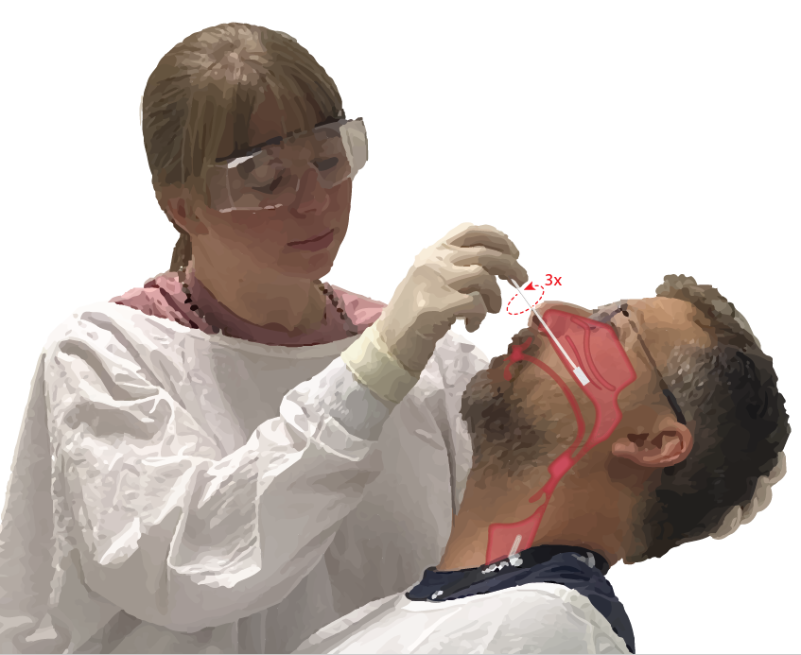
“Figure 5. Collection of nasal epithelial cells. Illustration of the location of the cytology brush at the mid to posterior part of the inferior turbinate. This position is reached by inserting the brush through the nares, pivoting the brush to a 90° angle to the face and guiding the brush along the nasal passage below the inferior turbinate.”

4. To avoid any accidents by following this protocol in section 4.0, it would be great to suggest how to prevent the over-insertion of the nasal brushing, which may cause penetration or rupture of the nasal walls.
Note added line 350:
“NOTE: Avoid over-insertion, if a sudden drop in resistance is felt the nasal pharynx has been entered and the brush should be retracted until resistance is again felt by the proceduralist.”

We believe Figure 5 will further aid the clinician to perform the nasal brushing using the correct technique.

Minor Concerns:
1. Line 177: The incubation time for 10min to stabilize the temperature for live-cell imaging generally seems too short, although it depends on the distance between microscopy and the cell culture incubators. Typically, live-cell imaging requires a minimum of 30min pre-incubation for stabilizing the temperature and other parameters such as humidity and CO2 gas concentrations. Since CBF will be significantly affected by those parameters, it would be great to have some annotations for this matter.
We agree with the reviewer that the standard stabilisation time for equilibrating the environmental chamber for live-cell imaging is typically 30 min.

In this protocol we have recommended pre-stabilisation of the environmental chamber for 30 min prior to placing the cells into the chamber. As such, reducing the time needed to equilibrate the sample once the cells are transferred into the microscope chamber (Section 1.1 microscope set up steps 1- 3). Furthermore, the culture plate is transferred on a heat block or beads equilibrated to 37°C to maintain the sample at a physiological temperature (step 1.1.4 – Line 143).

A note has been included to prompt the user to empirically determine the optimal stabilisation time, and representative data has been provided from an experiment which we have performed to determine how long it takes for our system to stabilise. This time was determined to be 5 min following transfer of the culture plate to the already equilibrated chamber (see Figure 2 stabilisation data).
“NOTE: A shorter equilibration time may be sufficient. This can be determined by performing an experiment to identify the time required for stabilisation of CBF (refer to Figure 2).”
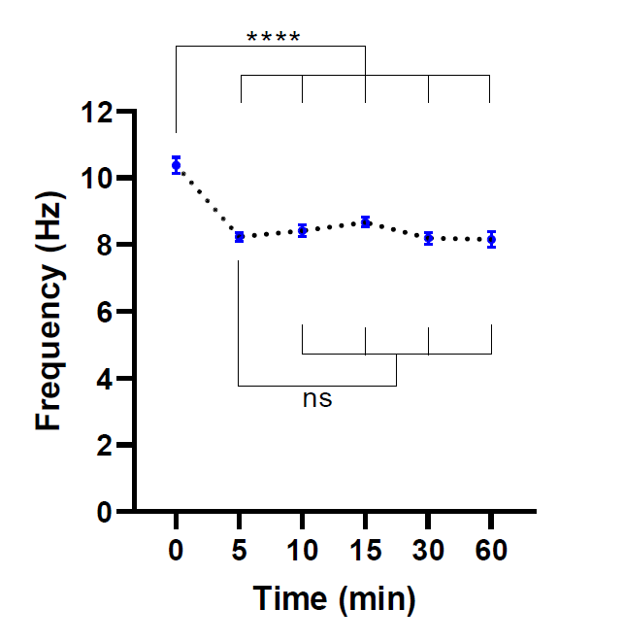
“Figure 2. Stabilisation of ciliary beat frequency in live-cell imaging microscope. Dot plots of mean cilia beat frequency (CBF) in airway epithelial cells at air-liquid interface (ALI models), following transfer into a live-cell imaging microscope with an environmental chamber. Chamber was equilibrated and maintained at 37°C, 5% CO2 and relative humidity of 85% for 30 min prior to opening the chamber door and placing the culture plate into the microscope plate insert. Cell models were imaged for 60 min at indicated intervals. ALI models were derived from two participants with CF. Six field of view (FOV) images were acquired per ALI model. Each dot (blue) represents mean CBF in 12-36 FOV images. Data are represented as mean ± SEM, with mean connected by a dotted line. One-way analysis of variance (ANOVA) was used to determine statistical differences. ****P<0.0001, ns: no significance.”

2. Related to line 77: Any measurement for the humidity during the imaging in this protocol?
Yes, an OKOLAB incubator system was used in this protocol. It has been added to the Table of Materials. In this system, humidity is maintained by CO₂ passing through a bottle of purified water heated to 37°C. The CO₂ is then dispensed into the microscope stage chamber. Relative humidity is measured via a humidity sensor module within the stage chamber. For this protocol, relative humidity was set to 85% and maintained at this level.

A step was added for humidity set up (line 137):
“1.1.2 Top up the humidity module bottle that the CO2 passes through with purified water. Set the relative humidity to 85% via the stage top controller so that the water is heated, and the cells are supplied humidified air. Equilibration of the chamber typically takes 30 min.”

3. Line381: After the incubation, no need to wash out the collagen? How do you store the plastics after the coating?
Collagen solution is removed, but not washed. Storage of collagen-coated vessels is not recommended, rather coat on a per need basis.

Line 293: Section now reads:
“3.0.2 Coat flasks or permeable support inserts with Collagen solution, on a per need basis. Do not store collagen-coated vessels long-term. To do this:

3.0.2.1 Make a 1:100 dilution of Type I Collagen solution (3 mg/ml stock) with phosphate buffered saline (PBS) to an end concentration of 0.03 mg/ml. Mix well.

3.0.2.2 Coat cell culture flasks (Section 6.0) with 160 µl/cm2 (i.e., 4 ml per T25 flask) and permeable support inserts (Section 7.0) with 455 µl/cm2 (i.e., 150 µl per 6.5mm insert) of the prepared Collagen solution.

3.0.2.3 Incubate at 37°C for 2-24 hrs.

3.0.2.4 Remove the Collagen solution by pipette or vacuum aspirator prior to seeding cells. Do not wash the vessel prior to seeding cells.”

CBF acquisition by the camera is described in detail but difficult to follow up because of the specific terminologies (such as MATLAB) lack of robustness that may influence the efficacy of reproducibility of the described protocol. A clear demonstration by video movie would resolve this issue.
Thank you for raising this concern. We have added Supplementary File 4 explaining how CBF is calculated via algorithm. We believe this will aid understanding of the user to give a better idea what is occurring, therefore improving ease of reproducibility. All specific terminologies (e.g. MATLAB) were removed as per editorial instruction. We agree with the reviewer that a clear demonstration by video will also help resolve this.

5. Where can the reader obtain the BeatingCiliaBathOMRfiles JOVE.m scripts? Is it common resources available or specifically designed programs in the lab? If not, is there any open resource available alternatively that can help to standardize the described protocol?
Custom analysis scripts are provided as Supplementary File 2 as instructed in the author guide.
This has been clarified on Line 209:
“Materials: Custom analysis scripts (Supplementary File 2) …”.

The bolded words were added to line 217:
“Copy the custom analysis scripts ‘BeatingCiliaBatchOMEfiles_JOVE.m’ and ‘LoadRawDataExportFilteredMovies_JOVE.m’ and ‘support scripts’ folder to the local drive of the computer.

6. Regarding the nasal epithelium collection, the authors, should briefly state that all human specimens were collected after the IRB approval in section 4.0.
Line 121 includes detailed study approval information as per author guide:
“Study approval was received from the Sydney Children’s Hospital Network Ethics Review Board (HREC/16/SCHN/120). Written consent was obtained from all participants (or participants’ guardian) prior to collection of biospecimens.”

7. In section 8.2, Matrigel is used. Matrigel will come with different concentrations, depend on the lot#. If any, the authors should provide the required range of the Matrigel concentration.
Note on line 494 indicates the recommended Matrigel concentration:
Line 494 “NOTE: Use ECM with protein concentration >10.5 mg/ml for the best culture outcomes is recommended. Lower concentration will accelerate the disintegration of the ECM dome and increase the occurrence of apical-facing-outwards organoids.”

