
María de los Angeles Rodríguez
Postdoctoral Research Associate
Universidad de O'Higgins
Avenida Libertador Bernardo O'Higgins 611
Rancagua, Chile
Email: maria.rodriguez@uoh.cl

October 13, 2021

Dear Dr. Vineeta Bajaj,
I am writing you to clarify that for developing the manuscript submitted to JoVE, we adapted data published in Rodríguez M, Ceric F, Murgas P, Harland B, Torrealba F and Contreras M (2020), “Interoceptive Insular Cortex Mediates Both Innate Fear and Contextual Threat Conditioning to Predator Odor”, Front. Behav. Neurosci. 13:283. The original data were published under a Creative Commons CC-BY license. Please, see the screenshot below which was taken from the final section of the article in Frontiers of Behavioral Neurosciences.
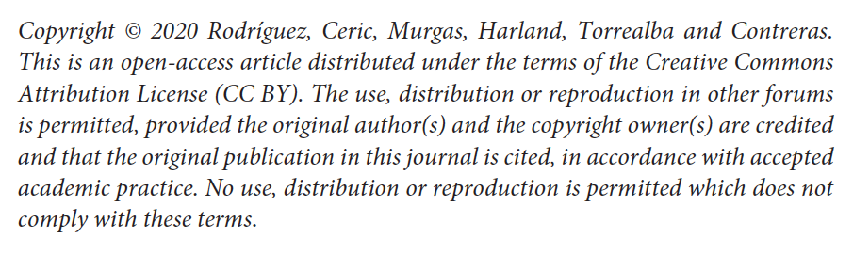

For further information, please click on any of the following links below:

https://www.frontiersin.org/about/policies-and-publication-ethics

https://zendesk.frontiersin.org/hc/en-us/articles/201904552-What-are-Frontiers-copyright-policies-

Please, let me know if you need additional information

Best Regards,
María de los Angeles Rodríguez, Ph.D.

