RESPONSES TO COMMENTS BY REVIEWER #3

We thank the reviewer for his/her thoughtful and constructive examination of our manuscript. We have addressed all the reviewer’s concerns in detail. Our responses to the reviewer’s comments are as follows:
Reviewer #3:
Manuscript Summary:
The authors describe a protocol for the isolation of primary LSECs from mouse liver, based on magnetic bead purification. There is a requirement for highly purified and viable LSECs to facilitate further studies into LSEC biology, so this description in a video format is likely useful.
The methodology described is fair, and explanations adequate. Together with a video demonstration, it is likely to lead to the suggested outcomes.
Major Concerns:
No major issues.
Minor Concerns:
1) Suggest removing NAFLD as a keyword as this is not relevant to the protocol
Response: We have removed NAFLD as a key word as suggested.
2) The authors define LSECs are CD45-/CD146+/Stabilin-2+. I note that there are now several other markers of LSECs used, and this should at least be mentioned in the discussion. The markers include Lyve-1 and CD32b.
Response:
2) Thank you for bringing up these important points. We edited the discussion section and mentioned the other LSEC markers as follows:
Line 327~334
As for purity, the positivity of the same surface marker used for immunomagnetic separation (CD146) support the accuracy of our isolation technique. In addition, there are several well recognized LSEC surface markers, such as lymphatic vessel endothelial hyaluronic acid receptor 1 (LYVE-1), CD32b, and stabilin-2. Controversies still exist around these markers; for example, i) LYVE-1 is present also in lymphatic endothelial cells, and ii) LSECs in a periportal area lack CD32b expression¹⁸. Thus, to examine the purity of these isolated LSECs with flow cytometry, we employed stabilin-2 as an established specific LSEC marker in addition to CD146.
3) Are LSECs isolated in this manner plateable (beyond the 2-hour time-point) used for SEM? If so this description (and a figure demonstrating their endothelial morphology) would be helpful. The major issue in LSEC studies is not necessarily the isolation, but the ability to obtain sufficient numbers of healthy cells that can be maintained in culture.
Response:
The LSECs obtained using the current protocol maintain their viability and morphology for hours to days of culture. However, as primary mouse LSECs show remarkable decrease in their fenestrae after 2 days of normal 2-D culture, we usually plate these cells soon after the isolation and complete the in vitro experiments using these cells within 24 hours. We included representative pictures of SEM for LSECs examined two hours after the isolation. Based on the reviewer’s comment, we included a brightfield picture of isolated LSECs from healthy mouse cultured for 6 hours (Figure 3A) in the revised manuscript as shown below:
Line 252~254,
Morphology of the isolated LSECs. The isolated LSECs were seeded in a 6-well plate at 1x10⁶ cells/well and cultured in complete growth medium (ScienCell Research Laboratories, Carlsbad, CA, USA), and examined by light microscopy after 6 hours of culture (Figure 3A).
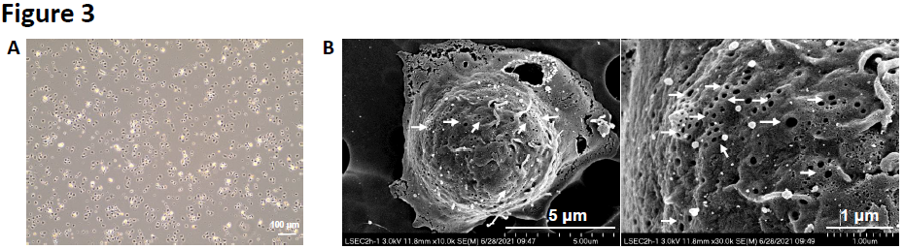
Figure 3. Morphology of isolated LSECs. A, Bright field picture of cultured LSECs. Isolated LSECs were cultured in the complete growth medium for 6 hours and examined by light microscopy. (Scale bar 100 μm), B, LSEC was examined by scanning electron microscope (SEM). White arrows indicate LSEC fenestrae (Scale bar, left panel 5 μm, right panel 1 μm).

