RESPONSES TO COMMENTS BY REVIEWER #2

We thank the reviewer for his/her thoughtful and constructive examination of our manuscript. We have addressed all the reviewer’s concerns in detail. Our responses to the reviewer’s comments are as follows:

RESPONSES TO COMMENTS BY REVIEWER #2
We thank the reviewer for his/her thoughtful and constructive examination of our manuscript. We have addressed all the reviewer’s concerns in detail. Our responses to the reviewer’s comments are as follows:
Manuscript Summary:
Efficient isolation protocol for liver sinusoidal endothelial cells (LSECs) is helpful to move the field forward. Guo et al. described a LSEC isolation protocol using collagenase perfusion and CD146 magnetic beads selection. Overall, this is a well-written protocol. However, the method described does not seem to be very different from those previously published by other investigators (refs #12). The difference should be mentioned. Suggestions below may help to make this protocol more attractive to the liver research community.
Major Concerns:
1. Addition of LSEC isolation method from mice with liver disease such as NAFLD will be informative. In fact, the authors included "NAFLD" in the keyword list.
Response: Thank you for bringing up this key point, we do use this protocol to isolate LSECs from NASH livers and do the downstream analysis and comparison with LSECs from healthy liver. We agree it will be informative for the readers to widely apply this protocol to their studies. We edited and discussed this point in the revised manuscript as follows:
Line 35~36,
Here, we discuss our protocol of LSEC isolation from both healthy and nonalcoholic fatty liver disease (NAFLD) mice.
Line 76~79,
Moreover, with the growing interest in generating big datasets in both clinical research and discovery science, these high quality LSECs isolated from both healthy and diseased liver with nonalcoholic steatohepatitis (NASH) or other conditions can be pooled or used individually allowing multi-omics data generation and comparison between health and disease ^{13,14}.
Line 325~327,
We obtained approximately 2~5x10⁶ cells per mouse from both healthy mice and mice with diet-induced NASH using our current protocol.
Line 360~361,
Moreover, this protocol is efficient and applicable to the liver disease animal models with NASH for big data set generation. ^{13,14}
2. It is unclear what is the major difference, compared to the published protocols by other investigators, as mentioned above.
Response, we summarized three main advantages using our protocol for LSEC isolation. First, the liver perfusion is conducted in the closed, humidified 37 °C chamber with oxygen supply, this device provides the best environment for collagenase digestion. In addition, the perfusion system is closed allowing recovery and reuse of the collagenase solution on multiple mice on the day of the isolation adding a cost-effective advantage. Second, we used positive magnetic beads selection to purify LSECs instead of centrifugal elutriation or selective adhesion-based separation. Immunomagnetic bead selection provides high-throughput isolation of LSECs with high purity and requires less technical expertise. Third, we used CD146 magnetic beads to select CD146-positive LSECs from non-parenchymal cells. As recently reported, CD146 is a more specific and mature LSEC surface marker. When co-stained with another specific LSEC marker Stabilin-2, we obtained >90% purity of isolated LSECs. We edited the discussion section of the revised manuscript as follows,
Line 344~353,
On the other hand, the non-immunomagnetic selection-based methods require high technical expertise and sometimes show inconsistent results on cell yields and purities ¹¹. On the other hand, our immunomagnetic selection-based method holds the advantage of consistent yield and purity over other existing methods. Moreover, for immunomagnetic beads selection-based cell isolation, the specificity of cell surface markers used is always a matter of concern. For example, CD31, which has been used previously as a marker for immunomagnetic LSEC separation, is dominantly expressed on the PV endothelium and capillarized LSECs³. Although CD146 has been reported to be expressed also on natural killer cells and hepatic stellate cells^{30,31},the high purity of LSECs isolated using our protocol mitigates concerns regarding the specificity of the endothelial marker CD146.
3. Purity of LSECs in the final step should checked also by including other liver cell markers. LSECs often attach to other liver cells (Halpern et al., Nature Biotechnology, 36: 962-970, 2018). Thus, it is possible that Stabilin-2 positive cells may be attached to hepatocytes or other liver cells.
Response: There are a couple of key steps to prevent the LSECs from attaching to the other liver cells during the purification. First, the buffer used in the magnetic bead selection steps was ice-cold during the magnetic separation. Second, the CD146 bead-labeled NPCs were loaded through 70 μm pre-separation filter before the cells go through the magnetic column. And third, the LSEC phenotype analyzed by flow cytometry was gated on single cells. We included the detailed gating strategy for flow cytometry shown in Figure 2. All LSECs were gated by singlets and analyzed the viable cells for CD45⁻ cell population, and CD146⁺Stabilin-2⁺ cells were analyzed to show the purity of the isolated LSECs.
The edited Figure 2 shown as follows,
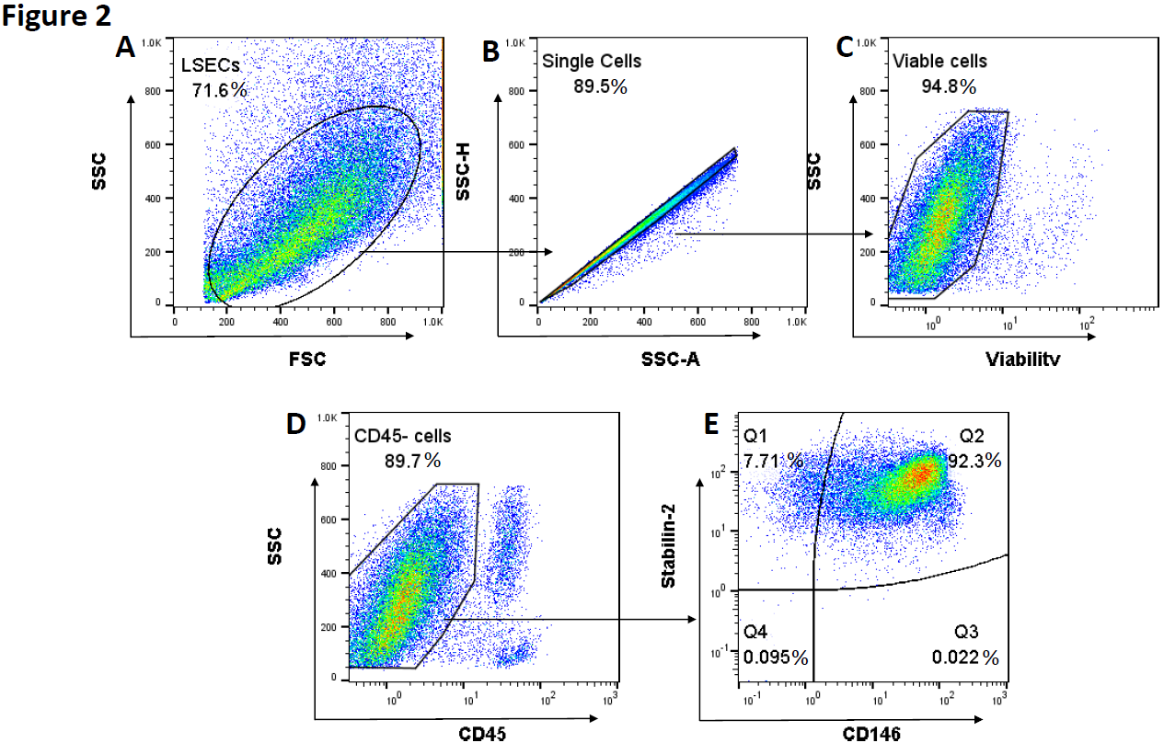
The description of this part of the experiment in the results section was edited accordingly,
Line 246~251,
We gated LSEC population (Figure 2A) and analyzed singlets for the following gating strategy, viable cells were defined using viability dye staining before labeling cells with specific markers (Figure 2B). Then CD45⁻ population was gated to exclude any immune cells contamination. The isolated LSECs reached 94.8% viability (Figure 2C). The percentage of CD45⁻ cells was 89.7% (Figure 2D), and 92.3 % of the cells were CD146 and stabilin-2 double positive (CD45-CD146⁺stabilin-2⁺) LSECs (Figure 2E).
The figure legend for figure 2 was edited as follows:
Figure 2. Assessment of isolated LSECs purity and surface markers by flow cytometry. Data analysis and gating strategy as shown, gated LSECs (A) and singlets (B) based on FSC/SSC. Isolated LSECs were stained with viability dye and a combination of CD45, CD146 and Stabilin-2 antibodies. Singlets were gated and analyzed, viable LSECs (C) were gated on CD45- population (D) and analyzed for (E) CD146 and Stabilin-2 expression. All gates were determined by fluorescence minus one (FMO).
Minor Concerns:
1. The illustrated flowchart needs additional labeling, particularly in Figure 1A, Step 2.
Response: We reedited the flowchart in Figure 1, included more detailed labeling of each step as follows:
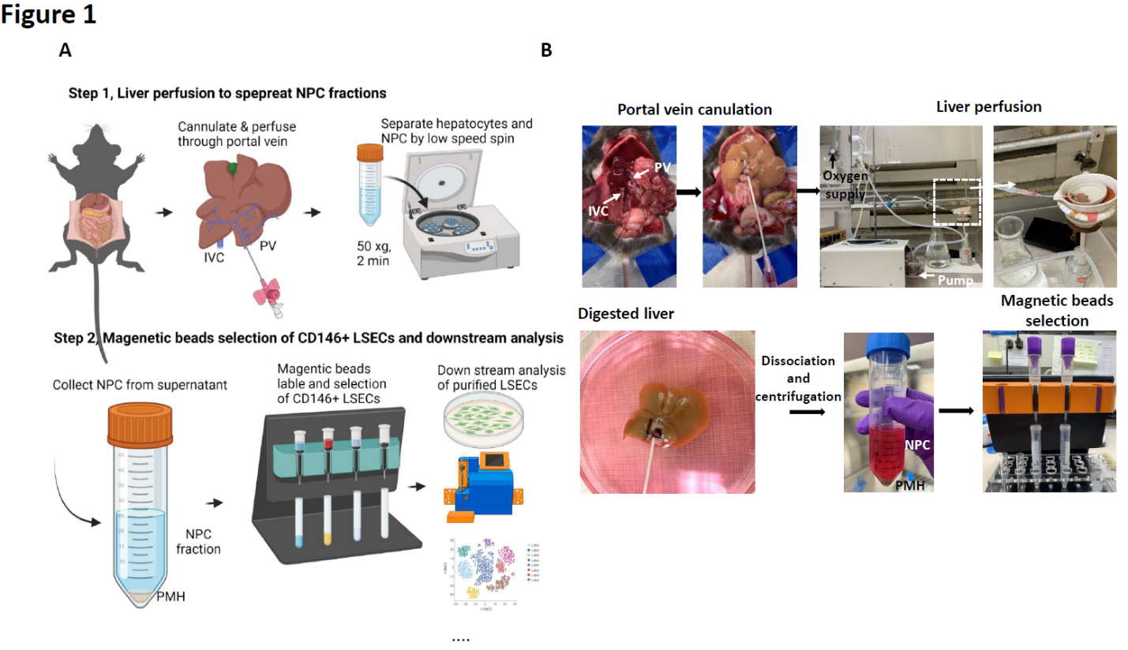
2. While the flowchart with illustrations is helpful, an addition of simple flowchart that summarizes an entire isolation method would be useful.
Response: Thank you for this thoughtful suggestion. Adding a flowchart illustration is not possible, for length and space limitation. However, we clearly covered the step by step approach in the protocol to compensate for that.

