RESPONSES TO COMMENTS BY REVIEWER #1

We thank the reviewer for his/her thoughtful and constructive examination of our manuscript. We have addressed all the reviewer’s concerns in detail. Our responses to the reviewer’s comments are as follows:
1. Please give more detail of the source in the table of materials, for example, state and country.
Response, A new column with details of each material used in the manuscript has been added to the table as recommended and showed as follow:
2. It is better to give a number for "Table os materials".
Response, Table named as Table 2 Table of materials, is now updated in the manuscript and the table title accordingly.
3. Figure 2 The words in the figure are a little smaller. Furthermore, please add % after 94.4% and the others.
Response: The flow cytometry data was re-analyzed and fonts in the figure were edited as recommended and included bellow:
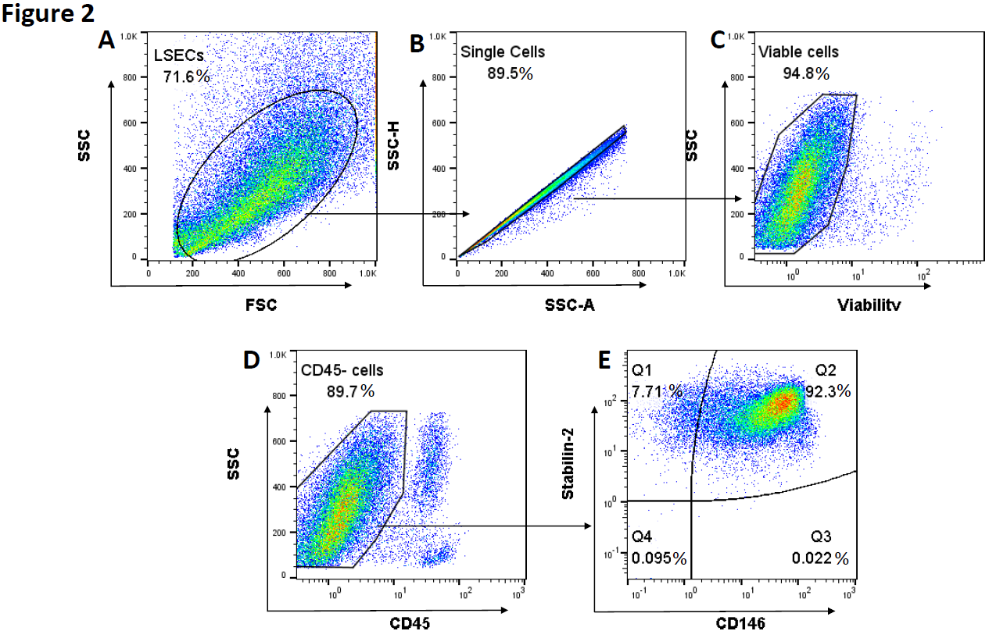
The description of this part of the experiment in the results section was edited accordingly,
Line 246~251,
We gated LSEC population (Figure 2A) and analyzed singlets for the following gating strategy, viable cells were defined using viability dye staining before labeling cells with specific markers (Figure 2B). Then CD45- population was gated to exclude any immune cells contamination. The isolated LSECs reached 94.8 % viability (Figure 2C) The percentage of CD45- cells was 89.7 % (Figure 2D), and 92.3 % of the cells were CD146 and stabilin-2 double positive (CD45-CD146+stabilin-2+) LSECs (Figure 2E).
The figure legend for Figure 2 was edited as follows,
Figure 2. Assessment of isolated LSECs purity and surface markers by flow cytometry. Data analysis and gating strategy as shown, gated LSECs (A) and singlets (B) based on FSC/SSC. Isolated LSECs were stained with viability dye and a combination of CD45, CD146 and Stabilin-2 antibodies. Singlets were gated and analyzed, viable LSECs (C) were gated on CD45⁻ population (D) and analyzed for (E) CD146 and Stabilin-2 expression. All gates were determined by fluorescence minus one (FMO).
4. There are some spelling errors, for example "w/o" in line 108, "os" in Table os materials.
Response: Thank you for bringing this spelling errors to our attention. We edited all the errors to the best of our knowledge. Line 108 is removed as all the materials ans reagents recipes moved to Table 1.

