Response to Editorial comments:

Q1). Please take this opportunity to thoroughly proofread the manuscript to ensure that there are no spelling or grammar issues. Please define all abbreviations at first use.
Response: Thanks for the comment. We have defined all abbreviations at first use, and asked for professional copy-editing services to correct spelling or grammar issues.

Q2). Please reduce the word count of the “short abstract” or SUMMARY to be 10-50 words.
Response: As suggested, the word count of the “short abstract” was reduced to 38 words (underlined, lines 31-34).

Q3). Please revise the following lines to avoid overlap with previously published work: 121-122, 124, 130-134, 181-183, 213.
Response: Thanks for the suggestions. We have revised the indicated lines.

Q4). Please revise the text, especially in the protocol, to avoid the use of any personal pronouns (e.g., "we", "you", "our" etc.).
Response: As suggested, the use of any personal pronouns was avoided in the revised text.

Q5). Please ensure that all text in the protocol section is written in the imperative tense as if telling someone how to do the technique (e.g., “Do this,” “Ensure that,” etc.). The actions should be described in the imperative tense in complete sentences wherever possible. Avoid usage of phrases such as “could be,” “should be,” and “would be” throughout the Protocol. Any text that cannot be written in the imperative tense may be added as a “Note.” However, notes should be concise and used sparingly. Please include all safety procedures and use of hoods, etc.
Response: Thanks for the comment. All text in the protocol section has been described in the imperative tense. We have also included all safety procedures.

Q6). Please note that your protocol will be used to generate the script for the video and must contain everything that you would like shown in the video. Please ensure you answer the “how” question, i.e., how is the step performed? Alternatively, add references to published material specifying how to perform the protocol action. There should be enough detail in each step to supplement the actions seen in the video so that viewers can easily replicate the protocol.
Response: Thanks for the suggestions. We provided enough detail in each step to supplement the upcoming video.

Q7). Please format the manuscript as: paragraph Indentation: 0 for both left and right and special: none, Line spacings: single. Please include a single line space between each step, substep and note in the protocol section. Please use Calibri 12 points and one-inch margins on all the side. Please include a ONE LINE SPACE between each protocol step and then HIGHLIGHT up to 3 pages of protocol text for inclusion in the protocol section of the video.
Response: Thanks for the comment. We have formatted the manuscript as required, and highlighted (in yellow) protocol text for inclusion in the protocol section of the video.

Q8). As we are a methods journal, please add any limitations of the technique to the Discussion.
Response: As suggested, the limitations of the technique have been added in the discussion section to read: “However, a major limitation of this novel method is the limited time allowed for LAD ligation after heart externalization, due to the lack of mechanical ventilation support. Thus, high mortality caused by pneumothorax may be expected for beginners. Based on the authors’ experience, heart externalization for less than 30 seconds is well tolerated by all the tested mice, and this time window is adequate for an experienced technician to finish MI induction with low perioperative mortality (<5%)” (underlined, lines 219-224).

Q9). Please ensure that the references appear as the following: [Lastname, F.I., LastName, F.I., LastName, F.I. Article Title. Source (ITALICS). Volume (BOLD) (Issue), FirstPage–LastPage (YEAR).] For 6 and more than 6 authors, list only the first author then et al. Please include volume and issue numbers for all references, and do not abbreviate the journal names. Make sure all references have page numbers or if early online publication, include doi.
Response: Thanks for the comment. The references have been revised as suggested.

Response to Reviewer #1:
Q1). please state advantages and disadvantages of this method compared to other method. Moreover, manuscript should be checked by a native speaker for grammatical errors and typos.
Response: Thanks for the comments. We have asked for professional copy-editing services to correct grammatical errors and typos. Moreover, advantages and disadvantages of this method compared to others have been added in the revised Discussion section to read: “Compared to conventional methods, the modified protocol presents the following advantages: (1) it is free from ventilation, which is one of the causes of operation-related death in conventional practice; (2) it is timesaving (i.e., it takes approximately 3min from anesthesia, LAD ligation to successful skin suturing); (3) the surgical tools and materials required are readily available in most laboratories. However, a major limitation of this novel method is the limited time allowed for LAD ligation after heart externalization, due to the lack of mechanical ventilation support. Thus, high mortality caused by pneumothorax may be expected for beginners. Based on the authors’ experience, heart externalization for less than 30 seconds is well tolerated by all the tested mice, and this time window is adequate for an experienced technician to finish MI induction with low perioperative mortality (<5%)” (underlined, lines 215-224).

Response to Reviewer #2:
Jiang et al. report a modified method for induction of myocardial infarction in mice. The main advantage proposed by the authors is that the procedure can be performed with readily available materials.
Q1). How is the initial anesthesia in the conscious mice induced? Since the simplified anesthesia equipment is the only difference of this method compared to the procedure reported from Gao et al. (Circ. Res. 2010) the authors should provide more details (also pictures) in this regard.
Response: Thanks for the comment. We have added description for the initial anesthesia to read: “Hold the mouse with the dominant hand after depilation, open the valve in the anesthesia tube and mask the mouse with the tube” (underlined, lines 106-107). Moreover, we added a corresponding picture for initial anesthesia in the revised Figure 1B-a.
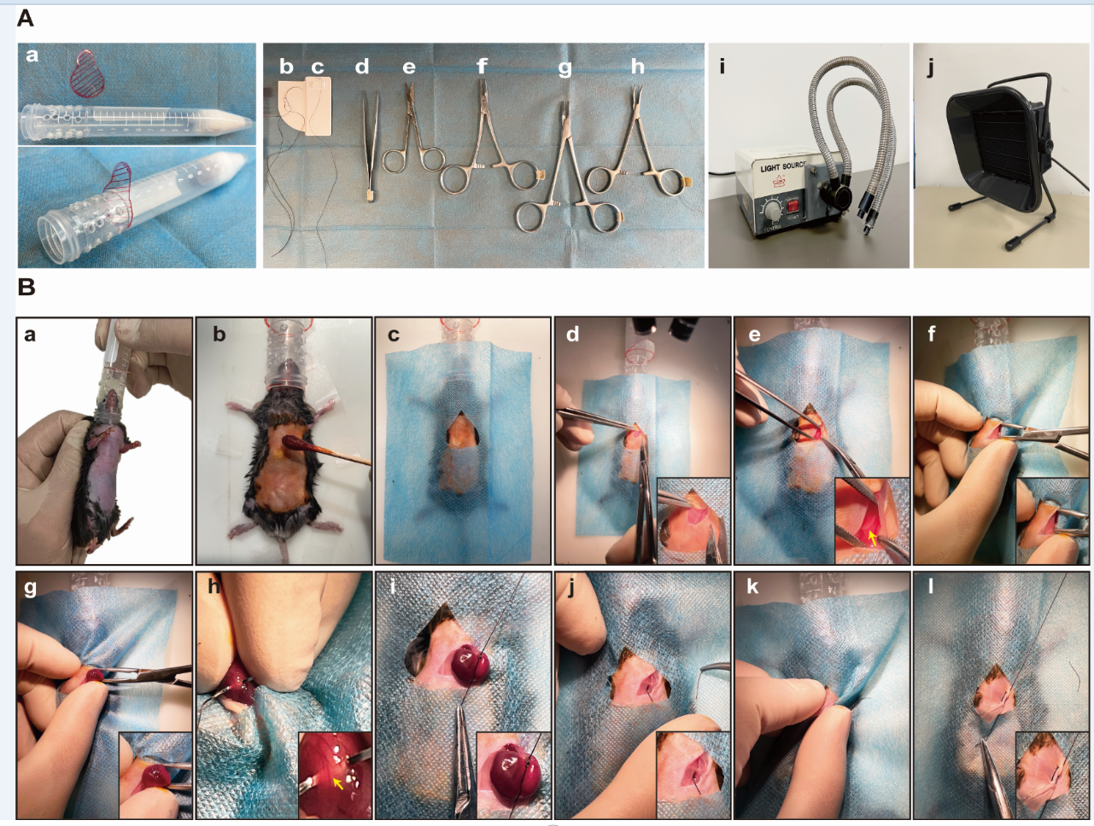
Figure 1. Required materials and key steps in the modified methods for MI induction.
Q2). The authors should also provide more information on the breathing rates with the used anesthesia equipment. How was the variability of the breathing rate within the operated mice? How well can the anesthesia be controlled with the use of one prepared tube (e.g. with 20 holes)? How long will the anesthesia last if the tube is filled with 0.5 ml isoflurane?
Response:
- During operation, the mice were covered by drape and breathing rate is hard to be counted. Instead, we recorded the breathing rate in another batch of mice (n=10) with the prepared tube. As shown in the figure below, the breathing rate varied from 90 to 107 per minute.
- Masking the mice with the tube for about 15s is adequate for initial anesthesia, then observe the breathing rate. A breathing rate less than 10 times/10s suggests excessive anesthesia, and insertion depth of the valve should be adjusted (lines 94-95). With the use of the prepared tube (with 20 holes), all the tested mice exhibited adequate and stable anesthesia.
- If the tube is filled with 0.5 ml isoflurane, the anesthesia would last for 47.3±4.2 min (evidenced by lack of toe pinch response).
Q3). Can the procedure be performed without microscope or magnifying glasses? Since the authors stress the simplified equipment, the manuscript should include all necessary tools. It is hard to imagine that the LAD can be seen/ligated without microscope.
Response: As suggested, we included all necessary tools in the revised manuscript, including a pair of forceps, a micro-mosquito hemostat, a pair of surgical scissors, two pairs of needle holders, 4-0 silk surgical suture, 6-0 silk surgical suture, a gas filter, and a light source (Figure 1A). The LAD can be seen and ligated without a microscope or magnifying glasses, and the illumination of the light source is sufficient for LAD identification (LAD indicated by arrow in Figure 1B-h). After heart externalization, securing the heart with the left hand would lead to temporary congestion of coronary artery, and this may potentiate the visualization of LAD.
Figure 1. Required materials and key steps in the modified methods for MI induction.
Q4). Line 104 Please specifiy which kind of gas filter is necessary.
Response: As suggested, we revised the description for the gas filter to read: “For all the procedures involving anesthesia, gas filter filled with activated charcoal sheets must be used”, and the picture for the gas filter was shown in Figure 1A-j (underlined, lines 96-97).
Q5). Figure 2D The authors should revise the included statistics (e.g. indicate significant differences between each groups rather than one p value and specify which multiple comparison test was used). Also please report sample size or display single data points for each animal.
Response: As suggested, one-way analysis of variance with post-hoc Tukey HSD (Honestly Significant Difference) test was performed for statistical analysis and sample size was reported in the figure legend.
Q6). Figure 2C/D The functional differences in fig 2D are not reflected in the representative m-mode pictures in fig. 2C (e.g. day 3 seems almost like baseline).
Response: As suggested, more representative M-mode pictures were presented.
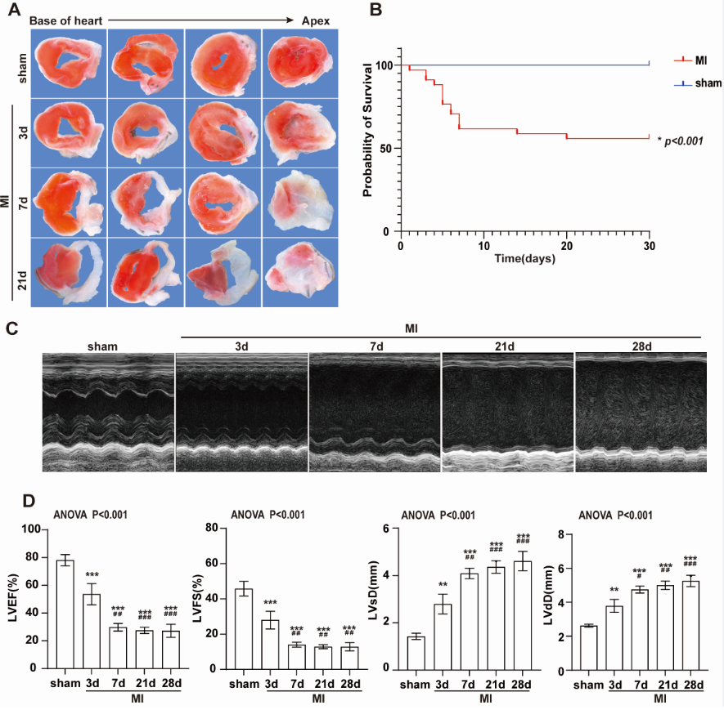
Figure 2. Histological and functional changes after coronary artery ligation
Q7). Figure 2A Please specify if fig2A displays 4 different hearts per each timepoint or 4 slices from the same heart (from base to apex).
Response: Sorry for the confusion. Fig 2A displays 4 slices from the same heart (from base to apex). We have revised Fig 2A.
Q8). Line 168. What were the other reasons for post-MI death?
Response: Cardiac rupture was identified by the presence of blood in the thoracic cavity and signs of ventricular rupture. While some other mice might die due to cardiac arrhythmia or acute heart failure because autopsy showed no blood in the thoracic cavity.

Response to Reviewer #3:
Manuscript Summary:
Jiang and co-workers investigated the utility of a ventilation-free, open-chest surgical procedure in mice undergoing permanent coronary artery ligation to induce experimental myocardial infarction. Such a procedure would not require equipment for mechanical ventilation and vaporizer for anesthetics and would thus significantly cut costs, if proven to be equivalent to the standard procedure using endotracheal intubation and mechanical ventilation. In general, the authors demonstrate feasibility of the procedure, but questions concerning procedural complications/mortality remain.
Q1). Figure 2B shows a 28-day post ligation mortality approaching 50% in the MI group, which is high compared to published studies using coronary artery ligation as a method to experimentally induce myocardial infarction in mice. It is not clear whether the high mortality results from sex- and/or strain-related complications (male C57BL/6J mice are prone to myocardial rupture following permanent LAD artery ligation), from procedure-specific complications (i.e., ventilation-free procedure), or from both. To distinguish between the two, experiments should be repeated in female C57BL/6J mice or in a different mouse strain exhibiting lower rates of myocardial rupture. In line 194, it is stated that the number of mice was 20 per group. Does this number include those mice that died during or immediately following the procedure? Since a ventilation-free approach limits the time that is available for the ligation to <1 min, I would expect the procedural mortality and success to be higher and lower, respectively, than in ventilated mice undergoing ligation.
Response:
(1) The mortality rate in our model may differ compared with some studies, but a search in Pubmed indicated that our model presented similar mortality rate with some published studies using coronary artery ligation to induce MI in mice (PMID: 11489778, PMID: 11375279, PMID: 31792327, PMID: 30233357, PMID: 24718482, PMID: 25121738). The initial infarct size may affect post-MI mortality. As shown in the work by Timothy D O'Connell (PMID: 20692266), mortality was significantly increased in mice with proximal ligation of LAD compared with distal ligation. Thus, the difference in mortality between our model and others may be attributable to the difference in the initial infarct size.
(2) As suggested, we further established MI models in female C57BL/6J mice. As shown in the figure below, female mice (left panel) exhibited lower post-MI mortality rate compared with male mice (right panel).
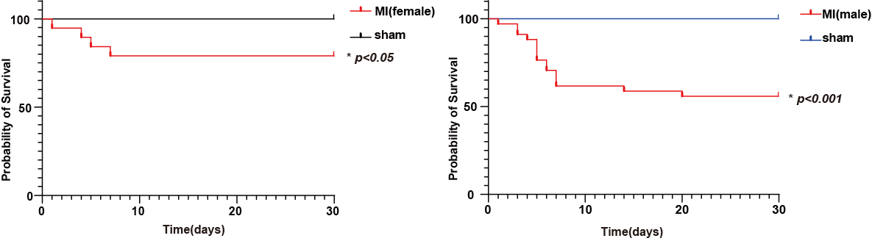
(3) The number of mice (20 per group) includes all the mice that died during or immediately following the procedure. It is natural to think that ventilation-free approach will lead to higher procedural mortality than in ventilated mice undergoing ligation. However, higher procedural mortality is mainly confined to beginners. Once mastered, this novel method is related to high perioperative survival rate (>95%). In fact, all the 20 mice survived during the MI induction procedure in current study. The high perioperative survival by this novel method is possibly attributable to the short operation duration, quick recovery from anesthesia, minimal tissue injury (no intubation, no rib cutting, and blunt dissection of pectoralis major and pectoralis minor muscles). Therefore, high mortality for beginners is a major limitation of current protocol, and this limitation was included in the revised text (underlined, lines 219-224).
Q2). Line 199: ANOVA was used to detect significant differences in echocardiographic outcome. Please indicate which time points differed from each other, using post hoc analyses.
Response: As suggested, one-way analysis of variance with post-hoc Tukey HSD (Honestly Significant Difference) test was performed for statistical analysis, and statistical difference between two groups were indicated in the revised Figure 2 and figure legend.
Q3). Line 120 and 146: supine position instead of prone position.
Response: Thanks for the suggestion. This has been corrected.

