Use of mScarlet-I as reporter protein in cell-free protein synthesis

1. Expression of mScarlet-I protein in E. coli Rosetta cells

mScarlet-I protein was expressed using a workflow with auto-induction media, described by Levine et al. (2020). Please refer to this published manuscript for details about media preparation.

- Transform 20 µL of competent E. coli Rosetta (DE3) pLysS cells with 2 μL of 50 ng/μL pET15b-mScarlet gene, and plate on LB agar with 35 μg/mL chloramphenicol and 100 μg/mL carbenicillin. Grow for 16 h at 37 °C.

- Set up an overnight starter culture by inoculating 6 mL of auto-induction media as follows:
  - Loopful of ~5 colonies
  - 5.76 mL auto-induction media
  - 0.24 mL sugar solution
  - Antibiotics

- Incubate at 37 °C for 16–18 h.

- Set up the expression culture by inoculating the following:
  - 6 mL starter culture
  - 576 mL auto-induction media
  - 24 mL sugar solution
  - Antibiotics

- Incubate at 28 °C for 24 h, 200 rpm

2. Purification of mScarlet-I protein

- During cell growth, prepare the following buffers.

Buffer | Tris-HCl, pH 8.0 (mM) | NaCl (mM) | Imidazole (mM) | Volume (mL)
Binding buffer | 20 | 500 | 5 | 500
Wash buffer I | 20 | 500 | 30 | 500
Wash buffer II | 20 | 500 | 70 | 500
Elute buffer | 20 | 500 | 400 | 500

- Transfer the culture to 1 L centrifuge bottles and place on ice for 20 min.

- Centrifuge at 1469 × g for 15 min at 4 °C.

- Discard the supernatant and re-suspend the pellet with 15 mL of binding buffer.

- Transfer re-suspended cells into a 50 mL tube.

- Place the 50 mL tube in a beaker of ice water for sonication.

NOTE: Due to sensitivity of cell extract to overheating, it is critical to ensure that the tubes do not warm up to prevent protein precipitation and reduced enzymatic activity.

- Use a sonicator probe with a 6 mm diameter tip and clean it with 70% (v/v) ethanol and ddH₂0. Lower the sonicator tip into the cell suspension until it is ~2 cm below the liquid surface.

- Input the following settings into the sonicator: 20 kHz frequency, 65% amplitude, 5 s pulse ON time, 5 s pulse OFF time, total duration of 5 min.

- Transfer the lysed cells to 30 mL centrifuge bottles. Take a 30 µL sample and store on ice for SDS-PAGE analysis.

- Centrifuge the total cell fraction at 16,000 × g for 20 min at 4 °C.

- Resuspend the pellet in 10 mL of binding buffer for SDS-PAGE analysis.

- During centrifugation, wash an empty PD-10 column containing 3 mL of IMAC resin with water.

- Charge the column with 5 mL of 0.1 M nickel sulphate.

- Wash the column with 10 mL of ddH₂O.

- Equilibrate the column with 10 mL of binding buffer.

- After centrifugation in step 9, pool the supernatant and apply to the equilibrated column. Take a 30 µL sample and store on ice.

NOTE: From this point, store each flow-through and elution fractions on ice to minimize degradation of protein.

- Collect the flow-through.

- Apply 50 mL of binding buffer and collect the flow-through.

- Apply 50 mL of wash buffer I and collect the flow-through.

- Apply 25 mL of wash buffer II and collect the flow-through.

- Apply 5 mL of elution buffer and collect 1 mL fractions.

- Combine the elution fractions and dialyze in a buffer containing 50 mM Tris-HCl buffer, 200 mM NaCl and 15% (v/v) glycerol overnight. Use a dialysis tubing with MWCO of 12–14 kDa.

- For SDS-PAGE analysis of the purification fractions, transfer 30 µL of each step of the purification process into 1.5 mL microcentrifuge tubes.

- Dilute the samples with 10 µL of 4x SDS-PAGE reducing buffer and boil for 5 min.

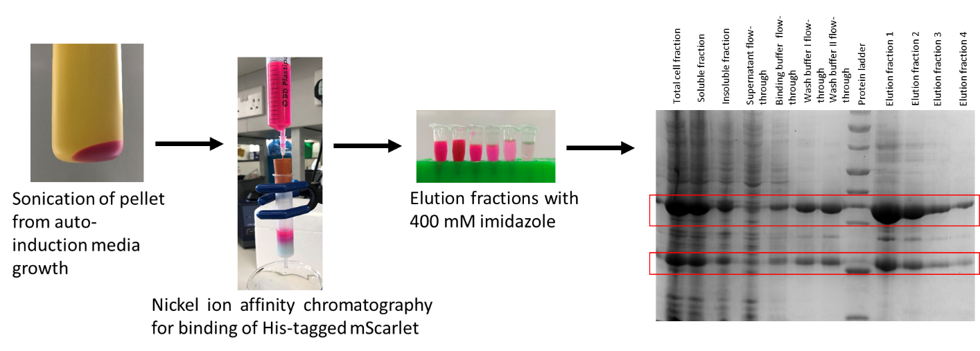
- Run a 12% (v/v) acrylamide gel in Tris-glycine buffer and stain with Coomassie Blue dye.
Figure 1. Example purification of mScarlet-I and SDS-PAGE gels of fractions.

- After dialysis, aliquot the purified protein into 0.5 mL aliquots and store at -20 °C.

3. Estimating mScarlet-I concentration in purified and cell-free reaction samples

Due to variability in different protein quantification assays, it is recommended to conduct the following protein assays to estimate the concentration of purified mScarlet-I with high accuracy. We recommend using mScarlet-I absorbance maxima at 569 nm to estimate protein concentration using the extinction coefficient at that wavelength, although we also verify with SDS-PAGE and a Bradford assay.

A. Bradford assay

- Prepare 20 μL of bovine serum albumin (BSA) standards in disposable cuvettes, making dilutions between 0.2 and 0.9 mg/mL.

- Prepare 1:50 and 1:100 dilutions of purified mScarlet-I and transfer 20 μL to a cuvette.

- Transfer 980 μL of Bradford dye to each cuvette (20 μL of buffer as negative control). Mix well by pipetting up and down.

- Incubate the samples at room temperature for 10 min.

- Measure the absorbance at an optical density of 595 nm.

- Generate a standard curve using the OD₅₉₅ values for the BSA standards.

NOTE: Reject the standard curve if r² < 0.98 and repeat.

- Determine the stock concentration of purified mScarlet-I using the standard curve.

Figure 2. Calibration standard curve using bovine serum albumin for Bradford assay.

B. Absorbance measurement at 569 nm

- Prepare 1:100 dilutions of mScarlet-I in 1 mL in technical triplicates.

- Transfer 1 mL of each dilution to a disposable cuvette.

- Measure the absorbance at 569 nm using an ultraviolet-visible spectrophotometer.

- Calculate the concentration of mScarlet using the extinction coefficient with absorbance maxima at 596 nm and using the formula Concentration in molar = Absorbance/(extinction coefficient*path length).

C. SDS-PAGE of protein standards and mScarlet-I

- Prepare serial dilutions of carbonic anhydrase used as the protein standard.

NOTE: Carbonic anhydrase was chosen as protein standard for SDS-PAGE because of its comparable molecular weight to mScarlet-I protein.

- Dilute the standards with 4x reducing buffer and boil for 5 min.

- Load 5 μL of each protein standard and purified mScarlet-I into the wells of a 12% (v/v) acrylamide gel.

- Run the gel in Tris-glycine buffer and stain with Coomassie Blue dye overnight.

- Destain the gel in ddH₂O until the background stain is minimal.

- Take an image of the gel and measure the intensity of the bands using an image processing software such as ImageJ.

- Estimate the concentration of purified mScarlet-I from the relative intensity of the bands corresponding to carbonic anhydrase standards.

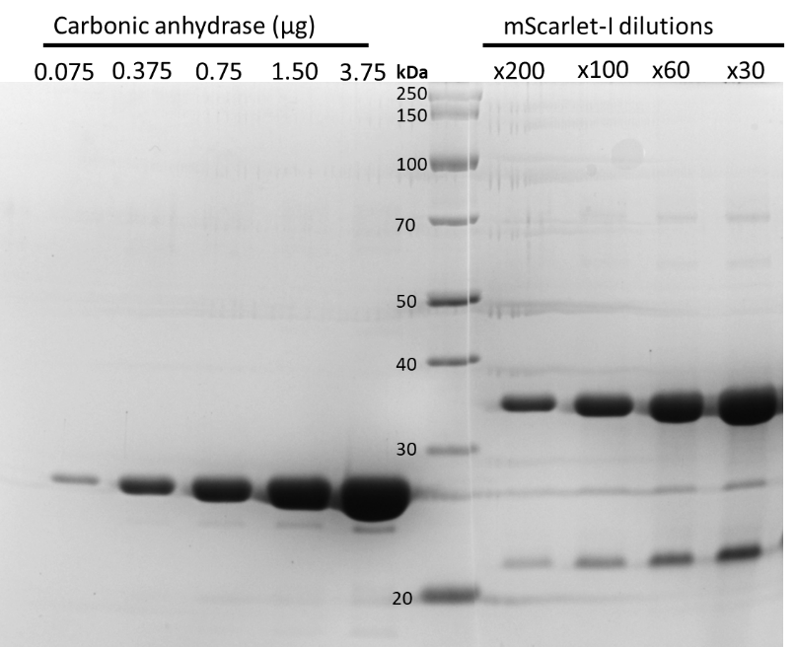
Figure 3. SDS-PAGE gel of carbonic anhydrase protein standards and mScarlet-I dilutions. NOTE: mScarlet-I/RFP proteins show an additional band at around ~22 kDa. We believe this is a fragment cleaved off during boiling for SDS-PAGE. In comparison, a single band/peak is observed on native PAGE or analytical size-exclusion chromatograph.

4. Generating a calibration standard curve for estimating protein yield in cell-free protein synthesis

- Prepare serial dilutions of mScarlet-I (4x final concentration) ranging from 0 μM to 10 μM.

- Transfer 24.75 μL of mastermix into 0.2 mL PCR tube. Optional: To avoid unnecessary use of costly cell-free reagents, the mastermix can be made with crude extract and 50 mM HEPES buffer only.

- Transfer 8.25 μL of mScarlet-I dilution to each tube, and 8.25 μL of water as negative control. Mix by pipetting.

- Transfer the samples in 10 μL technical triplicates in a 384-well plate.

- Seal the plate with an adhesive aluminium foil.

- Briefly centrifuge the plate at 2,000 × g for 10 s to collect the sample at the bottom of the plate.

- Set up the plate-reader to measure the end-point fluorescence at 28 °C. Details for setting up the microplate reader are described below.

- Use standard filters for mScarlet-I when using the Omega plate reader or monochromator settings depending on the type of microplate reader available. Use a gain of 1000.

- Use the RFU values to generate a calibration standard curve as illustrated below.

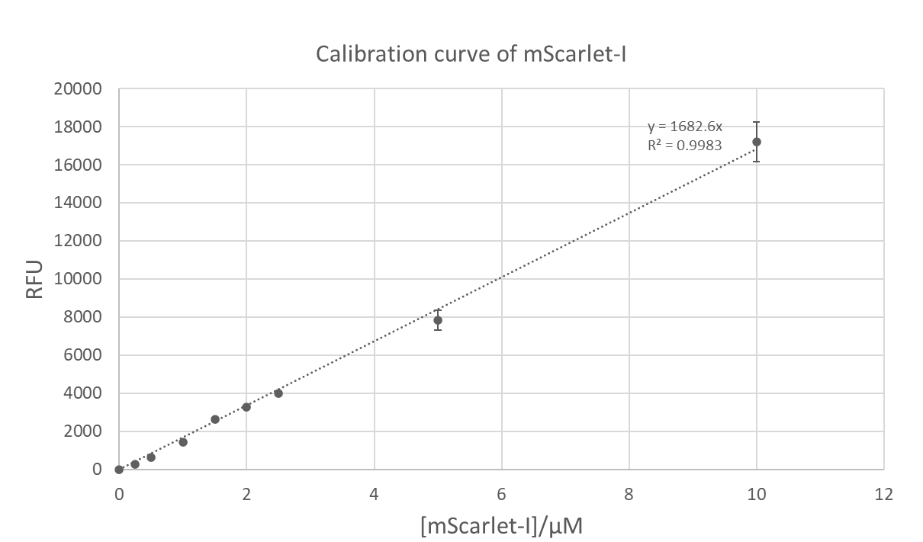
Figure 4. Calibration standard curve of purified mScarlet-I used for estimating the yield of mScarlet-I in cell-free protein synthesis.

5. Real-time fluorescence measurement of mature mScarlet-I protein using the FLUOstar Omega microplate reader

- Prepare 10 μL cell-free reactions as technical triplicate repeats in a 384-well plate (black, clear flat-bottom, low-binding), keeping the plate on ice.

- Seal the plate with an adhesive aluminium foil.

- Briefly centrifuge the plate at 2,000 × g for 10 s to collect the sample at the bottom of the plate.

- Set up a plate-reader to measure fluorescence at 28 °C with 5–10 s of shaking prior to measurements. The parameters and set-up process for “Fluorescence measurement – plate mode” on the plate reader is illustrated below. Optional: Set the number of cycles to 1 for end-point measurements.

- Use standard filters for mScarlet-I when using the Omega plate reader or monochromator settings depending on the type of microplate reader available.

- Measure the fluorescence of a serial dilutions on purified mScarlet-I protein, using the same microplate reader settings. Use this data to estimate the protein concentration of the cell-free reactions.

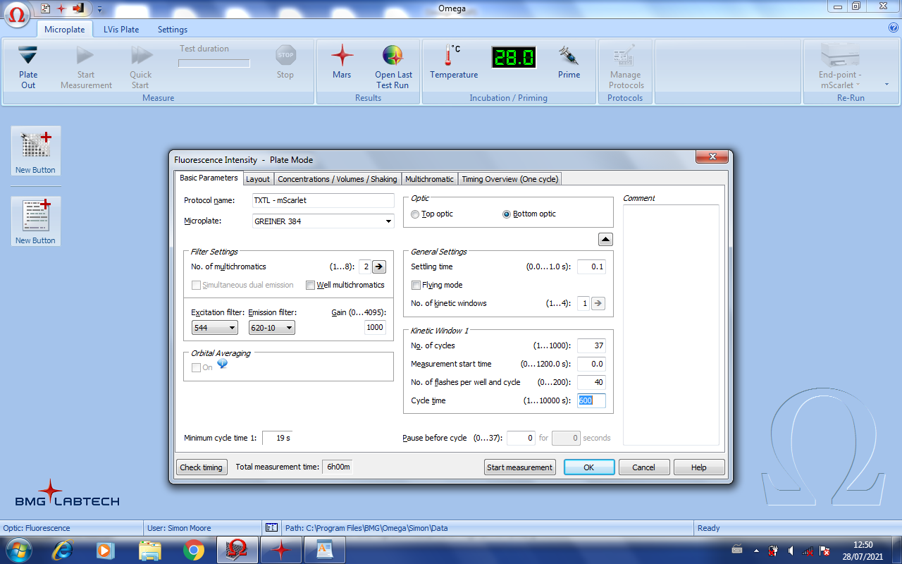
Figure 5. Settings used for a time-course fluorescence measurement.
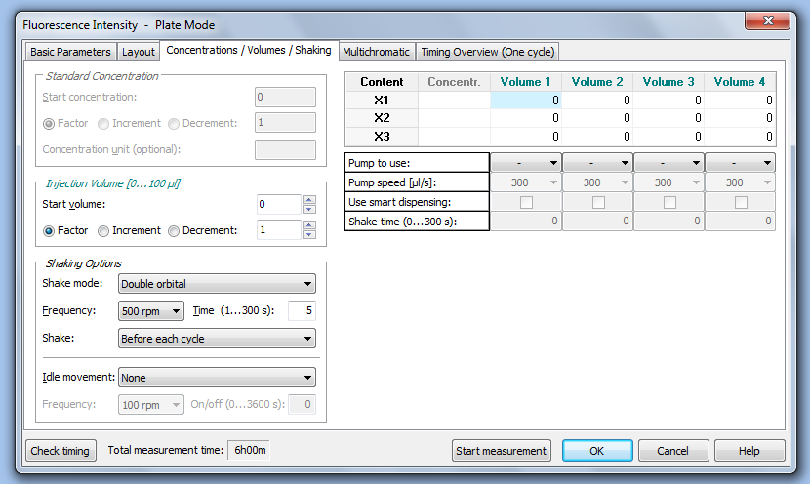
Figure 6. Shaking parameters used during fluorescence measurements.

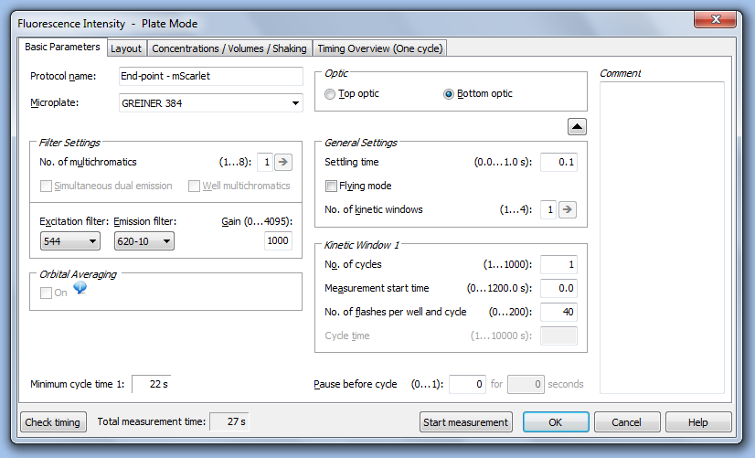
Figure 7. Settings used for an end-point fluorescence measurement.

References:
1. Levine, M. Z. et al. Activation of energy metabolism through growth media reformulation enables a 24-hour workflow for cell-free expression. ACS Synthetic Biology. 9 (10), 2765–2774 (2020).
2. Bindels, D. S. et al. mScarlet: a bright monomeric red fluorescent protein for cellular imaging. Nature Methods. 14 (1), 53–56 (2016).

