The article (https://doi.org/10.1186/s13024-017-0171-2) was published under a CC BY license so authors are not required to obtain permission to reuse this article, as shown here or seen in picture below.

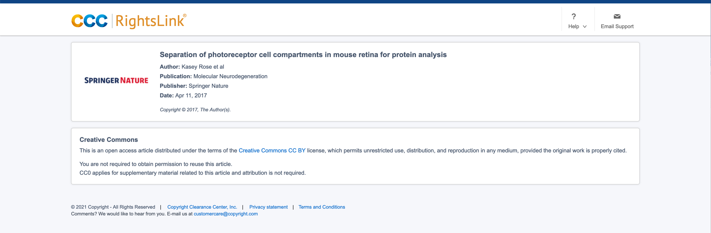

To learn more about copyright and licensing for BMC (a part of Spinger Nature), please visit this page.

