Reviewer #4:
Manuscript summary:
In this paper, a heterogeneous catalyst supported by Co NPs and Co SAs on carbon nanotube (CNT) nanostructure has been demonstrated to have good catalytic activity. At the same time, the results showed that the prepared nanocatalysts had abundant active sites and high defect density. The excellent synergistic effect of NPS and SAs was proved. But there are many inconsistencies in the paper and many holes in the research results. I hope the author can review and think again.
Reply: Thanks, the following concerns are addressed as follows:
1. According to Fig. 5d and Fig. 5f, the Co nanoparticles are coated by several layers of graphite carbon. How does cobalt play its most effective role?
Reply: Thanks for the comments.
Although the Co nanoparticles are covered by several layers of graphitic carbons, this does not affect the reactivity substantially due to high defect intensity, high specific surface area and high pore volume.

According to the Raman spectrum, there are surface defects of the catalysts caused by nitridation by the partial NH₃ atmosphere, which may be used to explain the presence of active sites for the hydrolysis reaction. The intensities of the D band to G band (ID/IG) is 1.13, which is in the high range and is widely believed to favor increasing the number of active sites for many catalytic reaction such as electrocatalytic water splitting. (Ref: Fei, H. et al. Atomic cobalt on nitrogen-doped graphene for hydrogen generation. Nat Commun. 6 8668, doi:10.1038/ncomms9668, (2015).)

Porosity is another factor. Porous carbons are characterized by their highly developed micro- and meso-pore structures. The high porosity and large surface area facilitate the access of active sites and the mass transport of AB and hydrogen. (Ref: Li, Y.-T., Zhang, X.-L., Peng, Z.-K., Liu, P. & Zheng, X.-C. Hierarchical Porous g-C₃N₄ Coupled Ultrafine RuNi Alloys as Extremely Active Catalysts for the Hydrolytic Dehydrogenation of Ammonia Borane. ACS Sustainable Chemistry & Engineering. 8 (22), 8458-8468, doi:10.1021/acssuschemeng.0c03009, (2020).) The present materials with BET surface area: 42.02 m² g⁻¹ and Pore volume 0.25 cm³ g⁻¹ is comparable to the reported Ru_{0.5}Ni_{0.5}/p-g-C₃N₄ catalysts (BET surface area: 43.2 m² g⁻¹ and Pore volume 0.28 cm³ g⁻¹) which is also excellent catalyst towards the AB hydrolysis reaction. (Ref: Li, Y.-T., Zhang, X.-L., Peng, Z.-K., Liu, P. & Zheng, X.-C. Hierarchical Porous g-C3N4 Coupled Ultrafine RuNi Alloys as Extremely Active Catalysts for the Hydrolytic Dehydrogenation of Ammonia Borane. ACS Sustainable Chemistry & Engineering. 8 (22), 8458-8468, doi:10.1021/acssuschemeng.0c03009, (2020).)

In contrast to the traditional view that the transition-metal such as Co nanoparticles embedded in a few-layer graphitic shells would be catalytically inert, they may show higher activities toward some catalytic reaction such as electrocatalysis reactions (ORR, OER and HER). On one hand, the metal nanoparticles not only catalyze the formation of hollow carbon structures such as carbon nanotubes, which could improve electrical conductivity of the whole hybrid structures. On the other hand, the few-layer graphitic shells could prevent the embedded metal nanoparticles from the acid corroding, oxidizing and aggregating during the catalysis processes, resulting in the excellent durability and stability in tough environments. Moreover, the cobalt nanoaprticle@N-doped carbon nanotube may provide an effective pathway to tailor the electronic structure of the catalyst, and thereby greatly decreases the adsorption free energy of the AB substrate, which would promote the adsorption and desorption of reaction intermediates. (Ref: Guo, H. et al. Cobalt nanoparticle-embedded nitrogen-doped carbon/carbon nanotube frameworks derived from a metal–organic framework for tri-functional ORR, OER and HER electrocatalysis. Journal of Materials Chemistry A. 7 (8), 3664-3672, doi:10.1039/c8ta11400e, (2019).) Although the current system may not be the best for optimal reactivity, the optimal number of graphitic layers in the current catalytic system for AB hydrolysis is currently still underway.
2. Is the defect due to the addition of cobalt or due to nitriding? It's not explained in the manuscript.
Reply: Thanks for the comment. To verify that the defect was caused by the NH₃ atmosphere, we have also performed carbonization reaction with lesser amount of DCD-350 (higher wt% of Co). With 3wt% Co precursor (1:33.3), the Raman spectrum show a significant decrease of (ID/IG), which is 0.6. Also, CoN₄ was not observed for the 1:33.3 case from the Raman spectrum. This result implies the nitridation treatments can promote the defect density in the catalysts caused by the anchored implementation of single-atom Co and N dopants in the carbon structure, which is widely believed to favor increasing the number of active sites for many catalytic reaction such as electrocatalytic water splitting. (Ref: Fei, H. et al. Atomic cobalt on nitrogen-doped graphene for hydrogen generation. Nat Commun. 6 8668, doi:10.1038/ncomms9668, (2015).)
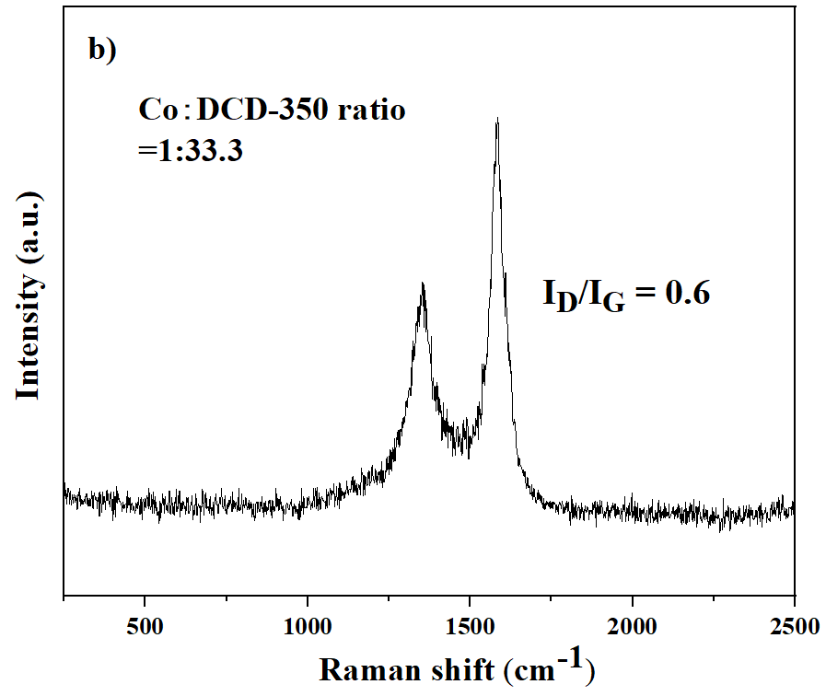
The following texts have been added to the manuscript:
In line 481,
This could explain the defect of the nanotube was due to nitridation.
3. For the amount of cobalt added, the ratio to DCD-350 was increased from 1:200 to 1:33.3. How do you determine this ratio?
Reply: Thanks. According to the Protocol 2.1, the weight ratio of Co(acac)₂ : melem-C₃N₄ = 1:200 was mentioned. This means that nominal Co wt% is 0.5 wt% for 1:200 and Co wt% is 3 wt% for 1:33.3. Of course, according to the ICP-OES, the tru wt% of Co is determined to be 25.1 wt%. It was being further clarified, as in the following texts.
In line 476:
Increasing the nominal ratio of Co precursor to DCD-350 from 1:200 to 1:33.3 greatly impact the final morphology of the CNT catalysts.
4. The manuscript states that the synergies between NPS and SAs on the catalyst carrier are specific to the type of reaction. So what kind of synergy is for the manuscript? What stands out for this type of response?
Reply: Synergies between NPS and SAs on the catalyst carrier are specific to reaction type, and therefore whether using NPs, SAs or both depends on different reactions and different conditions. Recently, more and more attention has been paid to the research of the synergistic effect of single atom sites and nanoparticles. Apart from the example of Pd_{1+NPs}/TiO₂ mentioned in the manuscript, recently, more and more reaction made use of the NPS and SAs synergy to demonstrate superior reactivity. Other examples include the Mo SAs and Mo₂C NPs on CNTs for the N₂ reduction to ammonia, Ru NPs supported on Ni SAs confined nanotube for the highly efficient wet air oxidation of acetic acid, integrated Co SAs and Co₉S₈ NPs on CNT for electrocatalytic water splitting. All of these examples demonstrated the fact that using both SAs and NPs is better than using either one alone. In our system, the mechanism is proposed to be Co SAs responsible for water molecule adsorption and the Co NPs responsible for AB activation. In fact, we have prepared pure Co Sac-doped CNT for the AB hydrolysis and only very slow reactivity was observed. This serves the first example of using NPS and SAs synergy in the field of AB hydrolysis research.
Reference:
Ma, Y. et al. Synergizing Mo Single Atoms and Mo₂ C Nanoparticles on CNTs Synchronizes Selectivity and Activity of Electrocatalytic N2 Reduction to Ammonia. Adv Mater. 32 (33), e2002177, doi:10.1002/adma.202002177, (2020).
Jin, C. et al. Single-atom nickel confined nanotube superstructure as support for catalytic wet air oxidation of acetic acid. Communications Chemistry. 2 (1), doi:10.1038/s42004-019-0239-8, (2019).
Li, Y. et al. Simultaneously Integrating Single Atomic Cobalt Sites and Co9 S8 Nanoparticles into Hollow Carbon Nanotubes as Trifunctional Electrocatalysts for Zn-Air Batteries to Drive Water Splitting. Small. 16 (10), e1906735, doi:10.1002/smll.201906735, (2020).
5. What effect does the addition of nitrogen atoms have on the catalyst? What does it do in the reaction?
Reply:
Nitrogen (N) doped carbon nanomaterials have widely been adopted for highly enhanced (oxygen reduction reaction) ORR activity (Ref: Wei, J. et al. Nitrogen-Doped Nanoporous Carbon/Graphene Nano-Sandwiches: Synthesis and Application for Efficient Oxygen Reduction. Advanced Functional Materials. 25 (36), 5768-5777, doi:10.1002/adfm.201502311, (2015).), because the doped N atoms would produce enriched active sites (e.g. pyridinic N and graphitic N) for ORR, create anchoring accessible sites for metal crystal deposition/coordination, and efficiently modulate the intrinsically electronic property and surface chemistry of carbon structures to make the inert conjugated p electrons active towards ORR (Ref: Lai, Q. et al. Directly Anchoring Highly Dispersed Copper Sites on Nitrogen-Doped Carbon for Enhanced Oxygen Reduction Electrocatalysis. ChemElectroChem. 5 (14), 1822-1826, doi:10.1002/celc.201800058, (2018).). In this case, the N atom is believed to anchor the Co single atom on the carbon nanotube.
On the other hand, the electron transfer from Co₄N nanoparticles to the carbon atoms in N-CNTs then further to the nitrogen atoms, along with the electron transfer from single-atom Co to nitrogen atoms, leads to the Co₄N nanoparticles and single-atom Co being electron-deficient regions, while N-CNTs are electron-rich regions. This may be beneficial for rapid H₂O molecule adsorption by the Co single atom on the catalyst surface. (Ref: Cao, B. et al. Tailoring the d-band center of N-doped carbon nanotube arrays with Co₄N nanoparticles and single-atom Co for a superior hydrogen evolution reaction. NPG Asia Materials. 13 (1), doi:10.1038/s41427-020-00264-x, (2021).)
6. What happened to the morphology after the stability test?
Reply: Thanks for the comments. We have repeated the reaction and analyze the XRD pattern of the catalysts after 15 times of reaction run. It showed that there is no observable changes compared with the original samples before run.
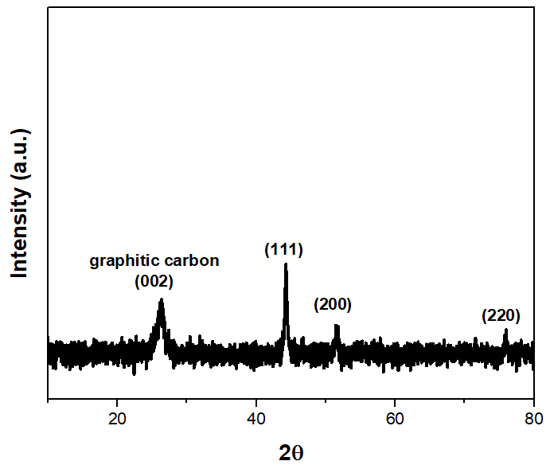
7. How to measure the amount of H₂ produced? The hydrogen generation efficiency should be offered.
Reply:
The measurement of H₂ release from AB hydrolysis was detailed in Protocol 3 and the usual water-filled inverted cylinder system was used, as show below:

The details will be shot in the video as well.
Generally, in the research community of ammonia borane hydrolysis, the term “specific rate of hydrogen generation rate” was commonly used. We believe, in a certain extent, this is equivalent to “hydrogen generation efficiency”.
8. What is the function of Co in the hydrolysis of aminoborane in the composite structure?
Reply: Numerous studies have shown that the nanoparticles are the site for AB activation through the coordination of the B-H bond to the metal centres. While after activated under alkaline media, the Co SAs will adsorb a molecule of H₂O through the oxygen atom and another Co SAs capture the proton from the H₂O. The B-H* and the Co-H* will then combine to desorb the 1st molecule of hydrogen. Consequently, the following H₂O molecules will be further activated and interact with the activated H of the B−H bond in AB, producing 3 equiv of H₂ in total.
Please see, for example:
Li, Z. et al. Atomically Dispersed Pt on the Surface of Ni Particles: Synthesis and Catalytic Function in Hydrogen Generation from Aqueous Ammonia–Borane. ACS Catalysis. 7 (10), 6762-6769, doi:10.1021/acscatal.7b01790, (2017).
Wang, Q. et al. Dramatic Synergy in CoPt Nanocatalysts Stabilized by “Click” Dendrimers for Evolution of Hydrogen from Hydrolysis of Ammonia Borane. ACS Catalysis. 9 (2), 1110-1119, doi:10.1021/acscatal.8b04498, (2018).
Cao, L. et al. Identification of single-atom active sites in carbon-based cobalt catalysts during electrocatalytic hydrogen evolution. Nature Catalysis. 2 (2), 134-141, doi:10.1038/s41929-018-0203-5, (2018).

9. The authors should be added to the latest catalyst to protrude the superiority of the nanostructures Co catalyst in the hydrolysis of aminoborane.
Reply: Thanks for the suggestion. The following texts have been added to the introduction part of the manuscript:
Recently, catalysts with hollow micro/nanostructures have been exploited for AB hydrolysis. These materials are conventionally prepared by hydrothermal methods and have been widely used for lithium-ion batteries, supercapacitors, chemical sensor and heterogeneous catalysis research. Thus, the copper-cobalt synergy towards AB hydrolysis has been demonstrated by the hollow CuMoO₄-CoMoO₄ ²⁵, which give a high TOF of 104.7 min⁻¹. Other highly structural-dependent examples such as the core-shell CuO-NiO/Co₃O₄ ²⁶, the Co_{x}Cu_{1−x}Co₂O₄@Co_{y}Cu_{1−y}Co₂O₄ yolk-shell type ²⁷ and the Ni_{0.4}Cu_{0.6}Co₂O₄ nanoarrays ²⁸ were also found to be active towards AB hydrolysis. Another type of emerging materials known as the heterostructured catalysts such as MXenes and layered double hydroxides (LDHs) are increasingly being exploited for electrocatalytic and photocatalytic reaction ²⁹⁻³². These materials such as the NiFe-layered double hydroxide ^{33,34} and the CoB-N materials having N-doped carbon-cobalt boride heterointerfaces ³⁵ are especially active for oxygen evolution and reduction reaction. In principles, they could be further exploited for hydrogen evolution reaction from hydrogen storage materials such as ammonia borane ³⁶. Maximizing the interaction between the catalysts and substrates is also another strategy for AB hydrolysis. Chiang et al. have utilized the surface oxide group of graphene oxide to form an initiated complex species with AB ³⁷, thus Ni_{0.8}Pt_{0.2}/GO and rGO demonstrated excellent reactivity towards AB hydrolysis. The use of α-MoC as support for Co and Ni single atom catalysts assisted the activation of water molecules and achieved high TOF towards AB hydrolysis, which is four times higher than the commercial Pt/C catalyst ³⁸.

