Reviewer #3:
Manuscript Summary:
In this work, authors proposed the heterogeneous catalyst composed of both Co nanoparticles and Co single atoms supported on N-doped carbon nanotubes, which showed excellent activity and stability towards the hydrolysis reaction of ammonia borane for hydrogen gas production. The authors provided some reasonable explanations on the results they obtained. Therefore, the reviewer approves its acceptance for publication with minor revisions.
Reply: Thanks
Minor Concerns:
(1)In Raman spectrum, the D band (1358 cm-1) and G band (1580 cm-1) are not consistent with Figure 2.
Reply: We are sorry for the careless mistakes. We have amended the value in the manuscript, thus, in line 300:
The D band, which was attributed to the structural deformation of the sp³-hybrizied carbon vibrations, can be assigned to the peak at 1338 cm⁻¹. The G band, which was due to the E_{2g} scattering vibrational mode of first-ordered scattering in a hexagonal lattice by the sp²-hybridized carbon domain, can be assigned to the peak at 1585 cm⁻¹.
(2)"The main body of the carbon nanofiber was endowed with amorphous and porous structure." Note that the porous structure is ambiguous from Figures 5g-i, please check it carefully.
Reply: Thank you for the comment. The sentence has been revised to “The main body of the carbon nanofiber is endowed with graphitic carbon layers of different orientations, as shown in Figures 5g and 5i”.
The below Figure (a) shows the graphitic carbon layers around the Co nanoparticle from the fiber tip (left) to the main body of carbon nanofiber (right), and the below Figure (b) shows the different orientations of the graphitic carbon layers in the main body of the carbon nanofiber.
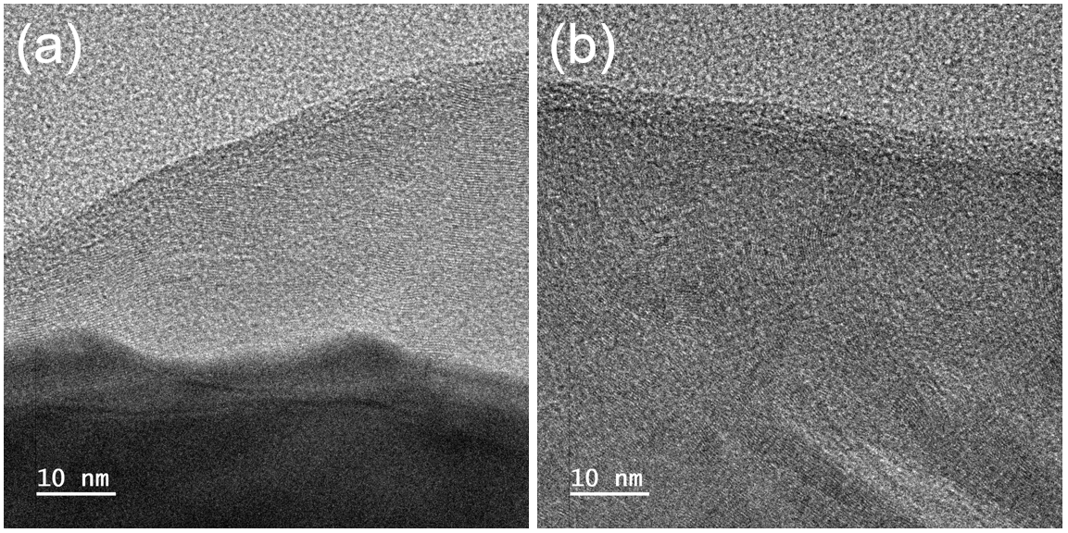
(3)It is suggested to provide ICP-OES experimental results in figure or table.
The description of Figure 10 in the manuscript is inconsistent with the annotations of figures, please check it carefully.
Reply: Thanks for the reminder. The table was listed in the manuscript as Table 1 at line 361:
Actual ICP-OES results | Total Co (wt%) | Co Nanoparticles (wt%) | Co Single Atoms (wt%)
0.5 wt% (nominal) Co/Co-N-CNT | 25.1 | 9.7 | 15.4
For the inconsistent annotations, we have corrected as follows:
In line 424,
Figure 10 (a) Recycling of 0.5 wt % Co/Co SACs catalyst (40 mg) in water (10 mL), with addition of AB (1.30 mmol) to the system at 313 K in each cycle. (b) the TOF ratio at each recycles. (c) the specific generation rate.

