Reviewers' comments:
Reviewer #1:
Manuscript Summary:
Lee et al. have reported the synthesis of metal nanoparticles supported on carbon nanotube with doped Co and N atoms and its catalytic applications in hydrogen production from ammonia borane solution. The manuscript is well organized, I will recommend its publication in Journal of Visualized Experiments after minor revisions.
Reply: Thanks for the comments. The concerns are addressed as follows:
Major Concerns:
Based on the XPS results, the authors claim there are single atoms of Co in their sample. Please provide powerful proof for this, otherwise, please revise this statement.
Reply: Change was made in line 321: The relatively stronger peak at 397.8 eV could be attributed to the presence of the strong interaction of metallic cobalt with nitrogen atoms ^{19,21}, which could be either cobalt nanoparticles or/and cobalt single atoms.
Minor Concerns:
1. Generally speaking, the hydrolysis is a zero-order reaction with respect to ammonia borane. But the result in this work is quite different, please explain this.
Reply: Thanks for the comment. This is due to the slight induction period of AB activation on the catalyst surface. In fact, addition of alkaline ion fastens the reaction, just like most other results reported in the literature. Thus, in line 370, we amended the statement as: The rate showed a slight dependence on ammonia borane and reaction order of the catalyst was about 0.4, which was quite different from most other reported rate law in the hydrolysis of ammonia borane, but is similar to the one reported on the AB hydrolysis by CoP nanoparticles, which was reported as 0.6 due to the longer induction time of AB on the catalyst ²⁵.
2. Can you provides the XRD pattern of the catalyst after 15 catalytic cycles?
Reply: Thanks for the comments. We have repeated the reaction and analyze the XRD pattern of the catalysts after 15 times of reaction run. It showed that there is no observable changes compared with the original samples before run.
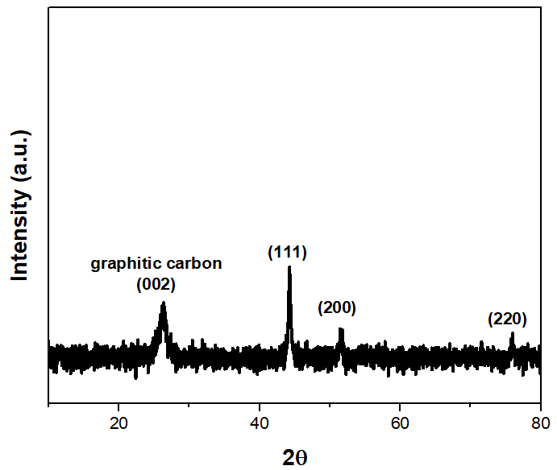
3. Some recent publications related to ammonia borane hydrolysis may help the readers to understand this work well and please cite them. Renewable Energy 2021, 169: 660-669; ACS Applied Energy Materials 2021, 4: 633-642; International Journal of Hydrogen Energy 2020, 45: 8168-8176; Small 2019, 15, 1805460.
Reply: Thanks for the suggestion. The following texts have been added to the introduction part of the manuscript:
Recently, catalysts with hollow micro/nanostructures have been exploited for AB hydrolysis. These materials are conventionally prepared by hydrothermal methods and have been widely used for lithium-ion batteries, supercapacitors, chemical sensor and heterogeneous catalysis research. Thus, the copper-cobalt synergy towards AB hydrolysis has been demonstrated by the hollow CuMoO₄-CoMoO₄ ²⁵, which give a high TOF of 104.7 min⁻¹. Other highly structural-dependent examples such as the core-shell CuO-NiO/Co₃O₄ ²⁶, the Co_{x}Cu_{1−x}Co₂O₄@Co_{y}Cu_{1−y}Co₂O₄ yolk-shell type ²⁷ and the Ni_{0.4}Cu_{0.6}Co₂O₄ nanoarrays ²⁸ were also found to be active towards AB hydrolysis.

