Replies are written in blue.
Editorial and production comments:
Changes to be made by the Author(s):
1. Please take this opportunity to thoroughly proofread the manuscript to ensure that there are no spelling or grammar issues.
We have carefully checked the manuscript.
2. Please expand the Introduction include all of the following with citation:
a) A clear statement of the overall goal of this method
b) The rationale behind the development and/or use of this technique
c) The advantages over alternative techniques with applicable references to previous studies
d) A description of the context of the technique in the wider body of literature
e) Information to help readers to determine whether the method is appropriate for their application
3. Please include citations in the introduction section.
We have extended the introduction section as requested and added citations.
4. Please ensure that all text in the protocol section is written in the imperative tense as if telling someone how to do the technique (e.g., “Do this,” “Ensure that,” etc.). The actions should be described in the imperative tense in complete sentences wherever possible. Avoid usage of phrases such as “could be,” “should be,” and “would be” throughout the Protocol. Any text that cannot be written in the imperative tense may be added as a “Note.”
Done.
5. The Protocol should contain only action items that direct the reader to do something. Please move the discussion about the protocol to the Discussion.
Done.
6. Please adjust the numbering of the Protocol to follow the JoVE Instructions for Authors. For example, 1 should be followed by 1.1 and then 1.1.1 and 1.1.2 if necessary. Please refrain from using bullets, alphabets, or dashes.
Done.
7. The Protocol should be made up almost entirely of discrete steps without large paragraphs of text between sections. Please simplify the Protocol so that individual steps contain only 2-3 actions per step and a maximum of 4 sentences per step.
8. Please revise the protocol text to avoid the use of any personal pronouns in the protocol (e.g., "we", "you", "our" etc.).
We have reformatted the protocol section of the manuscript as requested.
9. JoVE cannot publish manuscripts containing commercial language. Please remove all commercial language from your manuscript and use generic terms instead. All commercial products should be sufficiently referenced in the Table of Materials and Reagents. For example: Hydraharp 400, ChiSurf , Excel, etc.
We have removed the commercial language and replaced e.g. by “data analysis software”.
10. Some of the analysis steps can be moved to a supplementary file.
We have moved few steps of protocol section to supplementary notes, e.g. the coverslip cleaning.
11. Please ensure the results are described in the context of the presented technique e.g., how do these results show the technique, suggestions about how to analyze the outcome, etc. The paragraph text should refer to all of the figures. Data from both successful and sub-optimal experiments can be included. Please do not make points in the representative result section and use paragraph style instead.
We have extended the Representative Results section, also in line with the suggestions from the Reviewers, which points in the data analysis need to be clarified or making readers aware on possible (technical) artifacts.
12. Please obtain explicit copyright permission to reuse any figures from a previous publication. Explicit permission can be expressed in the form of a letter from the editor or a link to the editorial policy that allows re-prints. Please upload this information as a .doc or .docx file to your Editorial Manager account. The Figure must be cited appropriately in the Figure Legend, i.e. “This figure has been modified from [citation].”
13. Please obtain explicit copyright permission to reuse any figures from a previous publication. Explicit permission can be expressed in the form of a letter from the editor or a link to the editorial policy that allows re-prints. Please upload this information as a .doc or .docx file to your Editorial Manager account. The Figure must be cited appropriately in the Figure Legend, i.e. “This figure has been modified from [citation].”
12-13: We have not taken any figures from any previous publication; all data are original and figures were created exclusively for this manuscript.
14. Please do not abbreviate the journal titles in the references section.
We have corrected the same in the revised manuscript. We have downloaded und used the Endnote-style provided on the JOVE website (filehttps://www.jove.com › files › JoVE).
15. Please remove trademark (™) and registered (®) symbols from the Table of Equipment and Materials and sort the table in alphabetical order.
We have removed the symbols from the table and sorted in alphabetical order.
Changes to be made by the Author(s) regarding the video:
1. Please, increase the homogeneity between the video and the written manuscript. Ideally, all figures in the video would appear in the written manuscript and vice versa. The video and the written manuscript should be reflections of each other.
We have added more figures in the written manuscript so that all figures shown in the video also appear in the results section of the written manuscript. However, in the results section more details are shown which are required for a full understanding and the requested discussion / classification of the results. In the video, we focus on the essence the figures as they will be shown for few seconds only.
2. Furthermore, please revise the narration to be more homogenous with the written manuscript. Ideally, the narration is a word for word reading of the written protocol.
We have revised the protocol section of the written manuscript as requested above in the sections 4-8 and added the new voice-over to the video. However, according to the Comment 4 above at some points in the protocol we added some notes, which are crucial to follow the Protocol. In addition, one optional step, step 1.2.3, is not shown in the video but only present in the written protocol.
3. Please, ensure that the protocol subheadings are the same in the text and the video. Please also make a separate representative result section, which will contain all the figures associated with the result. Please make a separate conclusion section title card as well to be placed before the last interview.
We have split the content of the video in an experimental part, a data analysis and the results sections. Additionally, we have added section title cards.
4. Please, capitalize the first letter of every important word in the title of the manuscript.
We have changed the title accordingly:
Dual-color Fluorescence Cross-Correlation Spectroscopy to study Protein-Protein Interaction and Protein Dynamics in Live Cells
5. • Export the next version as 1920x1080, 4K is too high of a resolution
We have exported the video now with the required resolution of 1920x1080.
6. • At 2:00, 2:26, 2:30, 3:31, 8:54, 9:50 there are a few frames of black. They might be gaps in between the footage or an issue in the export of the video. Please either fill the gaps or double check the next exported version.
Done.
7. • Remove the windows task bar at the bottom of the screen capture footage.
Done.
8. • At 5:46 the on screen text graphic transitions out, then pops back in a second later. Please keep it on screen the whole time it's needed.
Done.
9. • At 7:34 there are two black lines on the bottom of the frame, please remove.
Done.
10. • At 10:19 there is a render issue where the lower right part of the screen "glitches" when transitioning from the computer monitor footage to the graphs/charts. Keep an eye on that for the next render.
Done.
11. • At 7:57 the voice over audio starts to sound compressed and echo-y. Please remove the effects on that audio.
Done.
12. • Remove the lab logo at the end of the video
Done.
Once done please ensure that the video is no more than 15 mins in length. Please upload the revised submission at https://www.dropbox.com/request/AzJMSp1stjeYnAdCSNAX?oref=e
Done.
Reviewers' comments:
Reviewer #1:
Manuscript Summary:
The Jove article by Hemmen et al. is a protocol describing the use of dual-color fluorescence cross-correlation spectroscopy (DC-FCCS) to measure dynamics and interactions in cells. The article describes the theory and practical aspects of DC-FCCS and provides a software for the data evaluation. The article is clearly written and very useful for users of DC-FCCS but needs some clarifications.
We thank the reviewer for these positive comments. We agree that our article needs additional information / explanation for the readers. We would like to thank the reviewer for pinpointing where exactly additional content would make most sense. We have carefullly incorporated all the suggestions and answers to the queries of the learned reviewer. Wherever space was limiting in this short protocol, we have referred the readers to other specific sources if higher depth of information is required.
Please find below all the detailed answers and actions.
Major Concerns:
line 153: Please provide some more detail on the exporting option for Symphotime as either the full count rate trace as well as just the correlation functions can be exported. The Data format for ChiSurf seems to indicate a particular text format.
We have added a supplementary note (Supplementary Note 3) on how to export the required data using either Symphotime, Kristine or our self-written scripts. The data format for ChiSurf is explained on bottom of the 1st page of the supporting information concerning the step-by-step fitting with ChiSurf (now Supplementary Note 4).
line 176: If the systems are operated in PIE mode aren't the photons sorted according to excitation and emission? And I assume the correlation functions are corrected for background and after-pulsing by FLCS as the system is equipped with a TCSPC module? This could be explained here.
Yes, the system is operated in PIE-mode and like in any modern counting electronics with software-based correlation post-data acquisition, the TCSPC information is available and could be exploited. We are not doing this here for mainly two reasons:
1) Time: In our first draft of the manuscript / video we had included fitting of the fluorescence decay histograms and a detailed example on how to perform (at least) scatter-filtered FCS by exploiting the TCSPC-information. However, we had to realize that the maximum 15 min of video-material did not allow us to show this much of data analysis and that we had to cut ourselves short to the most important steps.
2) Readership: We would like this video to be helpful also for beginners in the field. The shown strategy in this video seemed us the easiest one, albeit encompassing all absolute essential steps to obtain reliable results.
We have now expanded the results and discussion section, in which we provide the readers with references to the more advanced techniques in FCS.
line 200: Can you actually guarantee a sample with 100% cross-correlation? This is a major assumption that should somehow be verified and problems if this is not true should be pointed out.
Yes, thanks for raising this important points. For synthesized DNA strands, we can assume nearly 100 % double labeling after annealing. This would translate into 100 % co-diffusion in our calibration experiment. However, in a dual color experiments this results usually in less than 100 % cross-correlation amplitude due to different sizes of focal volumes thus the incomplete overlap. In our setup, ~50 % (green ACF) - 70 % (red ACF) cross-correlation would reflect 100 % co-diffusion. This is a typical value. This means that if we observe 50 - 70 % cross-correlation in cells, the binding can be assumed to be “complete” (for 1:1 stoichiometry). We now mention this in the Discussion section of the calibration measurements.
line 223: eGPF is estimated to be only ~80% fluorescent, here also the assumption of 100% co-diffusion does not seem to be realistic. Corrections could be explained.
The reviewer is right that fluorescent proteins (FP) are usually not 100 % fluorescent due to their maturation process.
We now suggest the following correction in the Discussion section in the revised manuscript: If the value would be known exactly, the most straightforward correction would be to multiply N with (100 % / 80 % =) 1.25 and to use this value to determine G₀(t_{c}).
However, even if this information is not available, this should not be overcritical here as the potentially reduced brightness or concentration of fluorescent eGFP would not change during the time course of the experiment, so that the maximal amplitude is not affected. Thus, we consider this sample as our “100 % co-diffusion” standard representing the maximal amplitude, which we can find in this described live cell system. Another source of bias is the high variability within live cell systems, where the fraction of fluorescent FPs might slightly differ from cell to cell. This would be challenging to decouple from general biological variances, which are the larger source of data uncertainty.
Line 236: The explanation of parameter a1 is missing. Perhaps also explain difference between 2D and 3D model? Readers might not be familiar with all FCS concepts.
Thanks for spotting the missing explanation of parameter a1. It describes the fraction of the first diffusion time of the bimodal diffusion model. We have added the explanation now and additionally added a note concerning the key difference between 2D and 3D diffusion models in the protocol, which we also explain in detail in the Representative Results section.
Line 258: The explanation why FRET should lead to negative cross-correlations is not clear. In principle, FRET leads to changed brightness of the fluorophores and thus to changed amplitudes overall (see Müller et al. Biophys J 2005). Could this rather be an issue of the detection card (see the same publication)?
We agree with the reviewer that the description / explanation of the source of the anticorrelated behavior needs adjustment, but also needs to be kept short to not cut any other essential information within the 15 min video time limit. I hope you agree that this section is improved in the revised version. To get an idea of the potential of correlation analysis and FRET we just briefly showed simulated data to give the reader a chance for general understanding and further reading if desired.
It is important to state, that there is conceptually no artefact to be expected as the biophysics of a fluctuating FRET state itself forces this anticorrelation as other groups have even experimentally verified. If a molecule switches between the low and the high-FRET (LF, HF) state at a timescale faster than its residence time in the focal volume, the photons coming from LF versus HF are anticorrelated as the molecule can only be in HF or LF, but never be in both at the same time. This is a classic case of anticorrelation. If there is no such thing as a FRET fluctuation between different FRET states like in DNA, meaning “stationary FRET”, the anticorrelation vanishes and the curve is flat or “plateauing” at fast times (identical to the absence of FRET). Nevertheless, we have expanded the section about FRET-induced changes, complications (general brightness changes, triplet blinking, crosstalk, direct acceptor excitation. etc) and possible artifacts in the Discussion. We have added a CT-SNAP measurement now showing the absence of anticorrelation - although expected - in the CCF_{FRET}. We supplement these experimental results with simulations of different amounts of crosstalk, in the presence and absence of triplet blinking, and either small or large change in FRET efficiency to show the reader the influence of these parameters and the challenge in obtaining the anticorrelation (Figure 6). The new Figure 7 shows how to “rescue” the anticorrelation term if the individual species analyze by species-filtered FCS.
Additionally, we make the reader now aware that at least two detectors of each color should be used to avoid after pulsing artifacts, while four detectors (two detectors of each polarization direction) would be required to also eliminate the effect of detector dead times.
Line 274: The triplet times are quite long, are these numbers reported correctly? See also Fig. 1 where at least the correlation function for A488 seems not to well fit the start of the function at short times.
The reviewer is right, Alexa488 triplet blinking is rather expected in the 2-10 µs range (e.g. Widengren 1995 JPhysChem).
We have carefully checked our data again and have to admit that this it is a simple typo that we have corrected in the revised manuscript and recalculated respective results.
Fig. 2: Why is there a triplet time as long as 170 us in the CCF? The CCF should not contain a triplet time except there is cross-talk? But then the triplet time is independent of the focal volume so why is the CCF triplet twice longer than for the ACFs? Wouldn't that rather indicate that the times denoted as triplet times are rather another diffusive fraction? Note that I interpret tT as triplet relaxation time. This is not defined though in the list of symbols. Only tR is defined regarding photophysics.
Thanks you for spotting that tR is missing so far in our list of symbols. Yes, by tT we mean the triplet relaxation time. We have changed here the tT to tR to not confuse the readers and make them aware of the possible sources.
We re-evaluated the fits for the relaxation time shown in the first version of the manuscript and tested the reviewers hypothesis that this constant should be independent of the focal volume if related to crosstalk, and thus identical for ACFs and CCF. The results are shown in the provided figure below.
Individual fit, average χ² = 10.7
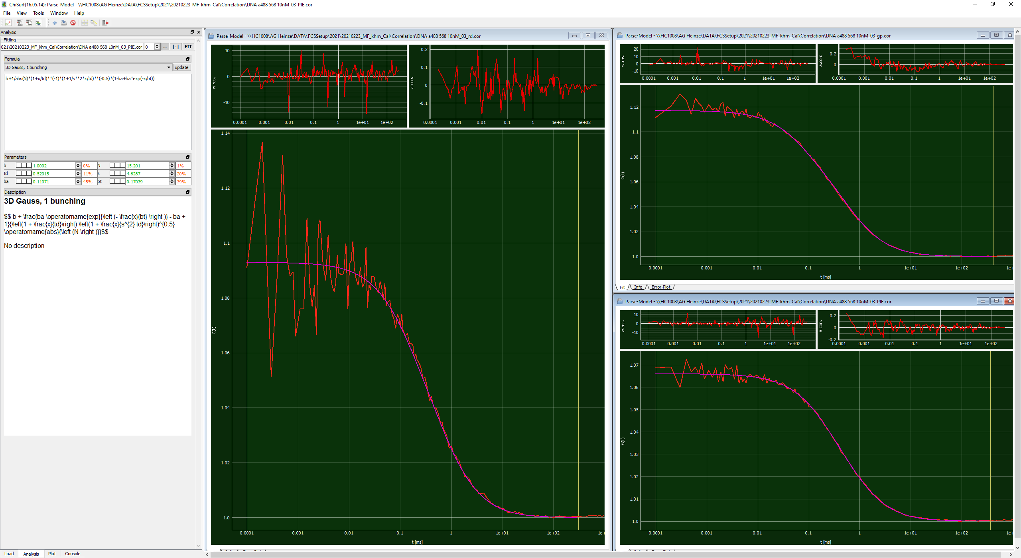
Global fit, average χ² = 8.5
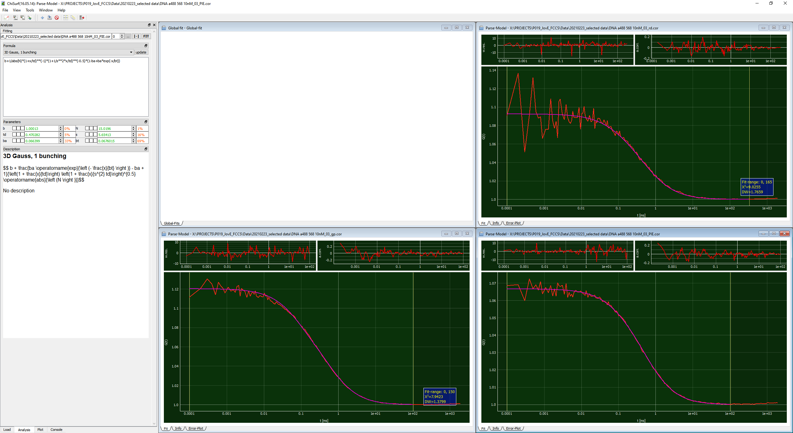
We doubt that the DNA strand shows multiple diffusion times as we excluded the presence of broken strands by agarose gel electrophoresis.
Consequently, we have repeated the data fitting routine with a global, linked tR and now obtained tR ~ 68 µs describing the data equally well when considering the reduced degrees of freedom. Thus, we follow the reviewer’s thoughts and eventually decided to replace the fit result as shown consistent with the most likely scenario.
Line 280: By joint fit, do the authors mean global fit?
Yes, joint fit means global fit here. Both “joint” and “global” are been used frequently in this aspect so that we changed it along your recommendation but link the other term as equivalent to avoid readers confusion.
Line 322: Again the 100% co-diffusion is not a given as the authors already detect a possible free component in the red channel?
As we state also in the respective line “in an ideal case”, we would like to make the reader first aware what would be expected and / or what the construct was designed for. In the next step, we then point to the “real case”, where we have to consider the non-fluorescent fraction of eGFP (see your comment above), freely diffusing SNAP substrate and / or a low degree of SNAP labeling. We have extended and clarified this section in the Representative Results section.
Line 328: If the cell is suboptimal, do they have a better example as well?
Yes, we also have a better example; however, as JOVE guidelines encourage to also show “bad” results we decided to use this example as a showcase for a bad example along with a good example for comparison.
Reviewer #2:
Manuscript Summary:
The authors demonstrate and describe how to perform dual color FCCS in living cells, either by itself or in combination with FRET. Measurements are first performed on dye molecules in solution and then on a double labeled, double stranded DNA oligo in solution, followed by measurements of the transmembrane protein Beta 2 adrenergic receptor, B2AR, in living cells. B2AR is either fused to EGFP on the cytoplasmic side, or SNAP-tag labeled with alexa 568 on the extracellular side, or labeled with both of those two, or fused to EGFP on the cytoplasmic side as well as SNAP-tag labeled by alexa 568 also on the cytoplasmic side. When EGFP as well as alexa 568 are on the cytoplasmic side, dynamic FRET will occurr, which in principle can be analyzed by FRET-FCCS but instead the authors simulate such measurements and analyze the results. The manuscript is well written and easy to follow.
We would like to thank the reviewer for kind appreciation of our work.
Major Concerns:
I may have missed it, but I cannot recall that the authors comment on why they do not analyze any experimental results from FRET-fluctuations of the CT-SNAP and GFP-labeled protein. I assume that these data were too noisy or unsatisfactory in some other way. I realize that the authors themselves would have preferred if such data could have been analyzed, but nonetheless a short clarification regarding why that was not possible would be helpful for the reader.
We agree with the learned reviewer. We considered showing a promising example also for the CT-SNAP.
As the other reviewer requested as well, we have added an experimental example now for the CT-SNAP (Figure 6B) and show how to “rescue” the anticorrelation term with species-filtered FCS if the individual species can be characterized (Figure 7). Additionally, we have expanded the section about FRET-induced changes, complications (general brightness changes, crosstalk, direct acceptor excitation, triplet blinking etc) and possible artifacts in the Discussion making these measurements and explicitly their analysis challenging.
We hope that the Review Editor of JOVE allows us to add this additional information in written manuscript, as we can clearly not show all of this in the video.
Another general comment, which I am sure that the authors already have thought of, is that it would have been nice if cross-correlation had been measured of two interacting proteins on the plasma membrane, instead of detecting cross-correlation of a single, double-labeled protein. I know that FCCS analysis of protein-protein interactions in cells is not trivial, but again, just a short comment on why that was not done would be helpful for the reader.
Again, the reviewer is right, this would be great to show; however, as above this section was again omitted due to the strict length limit of the video given by the publisher. On the other hand, as we do not study Protein-Protein Interactions, thus, we do not have any plasmids which we could transfect and show this effect. We have extended the Representative Results section with the results with a simulation of two molecules with increasing co-diffusion fraction to show the reader what to look for in their data, which complications may arise and refer the readers to previous studies on Protein-Protein Interactions accessed with FCS.
We hope the reviewer find this extension sufficient.
Minor Concerns:
Row
54-55 This sounds like FCS can only study GPCR interactions.
We have extended the introduction section of the written manuscript as also requested by the Review Editor.
124 Incomplete sentence.
The complete protocol section has been rewritten now in imperative tense following the JOVE protocol template as requested by the Review Editor.
160 S should be 1/S
We would like to thank the reviewer to spot that typo and for checking the equations carefully. We have corrected it in revised manuscript. In the data analysis software, this was correct.
Figure 2 State the number of bp in the oligo in the figure.
The fluorophores are 40 bp apart. We have added the sequence in the materials list and added the information to the figure.
Figure 3b Write NT-SNAP in the figure.
We have added the construct names to the figure.
266 "exemplary the results"?
We have rewritten the sentence in less convoluted way.
275 The triplet decay time of 21 us seems too long, and in addition, the fit seems unsatisfactory in the range of a few us where the triplet time of alexa 488 usually is. This indicates that the component of 21 us is due to something other than the triplet process.
The reviewer is right, Alexa488 triplet blinking is rather expected in the 2-10 µs range (e.g. Widengren 1995 JPhysChem).
We have carefully checked our data again and have to admit that this it is a simple typo that we have corrected in the revised manuscript and recalculated respective results.
301 Which figure?
“Figure 3 shows exemplary measurements of the single-label constructs β₂AR-IL3-eGFP (Figure 3A), where the eGFP is inserted into the intracellular loop 3, and NT-SNAP-β₂AR (Figure 3B)”.
We apologize but for whatever technical reason the “3” has disappeared from the JOVE-generated pdf-file. We spotted many mistakes, mainly missing references to figures, in the first version of the pdf. We thought we found all of them but apparently missed this one.
334-336 0.08/0.56=0.14, and 0.12/0.71=0.17. How did you get 0.13 and 0.26?
We apologize, and thank the reviewer for carefully checking all equations including the provided numbers. This number got wrong due to two reasons:
(A) “Copy-and-paste” mistake, on this measurement day r_{RG,DNA} is in fact 0.51, and not 0.71.
(B) Wrong reference in the excel template: For both calculations of the fraction of co-diffusion the value of r_{RG,DNA} was used instead of using the r_{GR,DNA} for the calculation of the green molecules co-diffusing with the red molecules.
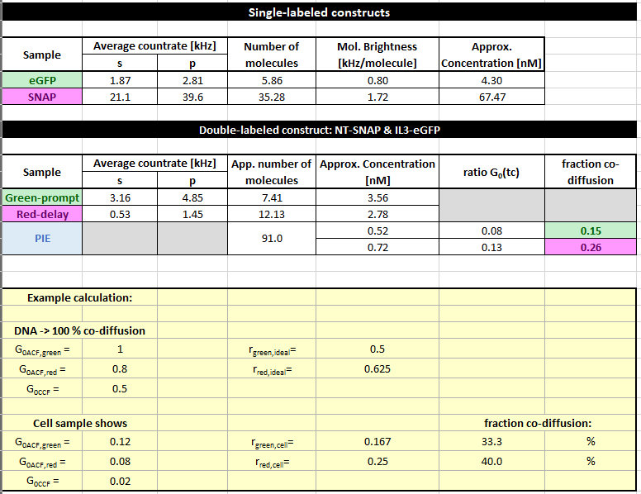
Thus, we are obtaining a value of 0.15 for the fraction of eGFP-labeled molecules co-diffusing with the SNAP-labeled molecules and on the other hand, a fraction of 0.26 SNAP-labeled molecules co-diffusing with an eGFP-labeled molecule. We have corrected the mistakes.
There were a few more errors similar to the one on row 266, so reading thru the manuscript carefully is a good idea.
We carefully checked the manuscript to avoid any orthographic mistakes.

