December 2, 2021
To Whom It May Concern:
Please find, attached, our revised manuscript (JoVE submission JoVE62942). We want to thank reviewers for their helpful insights and comments. Our responses and the corresponding revisions are described, in detail, below.
Editorial and production comments:
Changes to be made by the Author(s):
1. Please take this opportunity to thoroughly proofread the manuscript to ensure that there are no spelling or grammar issues. Please use American English throughout.
The text was proofread by the AJE experts. We have now used American English throughout the manuscript.
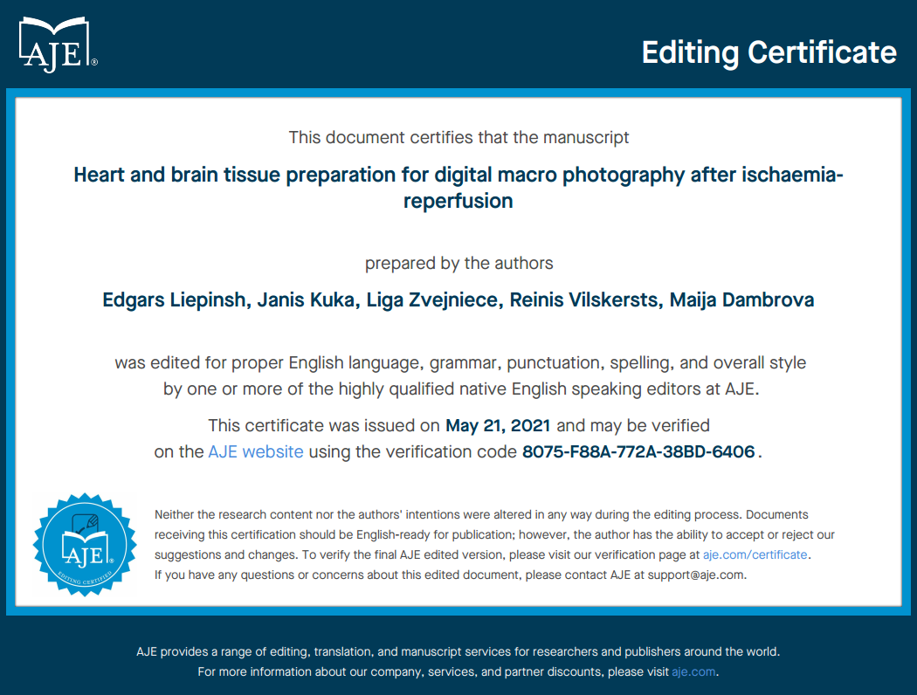
2. For in-text formatting, corresponding reference numbers should appear as numbered superscripts after the appropriate statement(s) without brackets’
The reference format has been changed as suggested.
3. Please ensure the Introduction include all of the following with citation:
a) A clear statement of the overall goal of this method
b) The rationale behind the development and/or use of this technique
c) The advantages over alternative techniques with applicable references to previous studies
d) A description of the context of the technique in the wider body of literature
e) Information to help readers to determine whether the method is appropriate for their application
We believe that all the requested information is present in the Introduction text. We have described the rationale behind the use of improved and up-to-date techniques to get high-quality images for the quantification of infarcted tissues. This is expected to reduce the variability of preclinical data sets and inconclusive results/outcomes. The very detailed previous studies and techniques for heart and brain infarction experiments have been cited, allowing us to concentrate on macro photography and image analysis steps. To help readers to determine whether the method is appropriate for their application, we state that these methods are particularly useful for performing image planimetric analysis in rodent tissues and general scientific macro photography to obtain high-quality images for automated analysis of digital photographs. We also believe that these techniques will help readers to save time, avoid user input and minimize the risk of errors or bias during image analysis. To highlight the information regarding the overall goal of this method, we modified the respective sentence in the Introduction and rewrote the Summary:
The purpose of this study is to provide a step-by-step guide on how to set up a system for photography and standardized analysis of rodent heart and brain tissue specimens after infarction experiments.
Presented here is a protocol for standardized methodology of rodent tissue preparation after the ischemia-reperfusion experiment and guidelines for establishing lighting and camera setups for high-resolution image acquisition. This method is applicable to all experimental small animal organ photography.
4. Please ensure that all text in the protocol section is written in the imperative tense as if telling someone how to do the technique (e.g., “Do this,” “Ensure that,” etc.). The actions should be described in the imperative tense in complete sentences wherever possible. Avoid usage of phrases such as “could be,” “should be,” and “would be” throughout the Protocol. Any text that cannot be written in the imperative tense may be added as a “Note.”
The texts are rearranged and corrected as suggested.
5. Please ensure you answer the “how” question, i.e., how is the step performed?
The texts are corrected as suggested.
6. Age, sex, strain of the rat used in the experiment.
The age, sex, and strain of animals are not relevant for the photography and image analysis techniques. Our contribution is related to the heart and brain tissue preparation for digital macro photography after ischemia-reperfusion, i.e., tissue preparation and subsequent image capture are steps performed immediately after the ischemia-reperfusion experiment. The readers are referred to previous publications that describe all details for the heart infarction and stroke experiments (Botker et al., 2018, Basic Research in Cardiology; Zvejniece et al., 2012, J Neurosci Methods; Bell et al., 2011, J Mol Cell Cardiol; Liu et al., 2011, J Biomed Biotechnol; Kolwicz et al., 2010, J Vis Exp; Herr et al., 2015, J Vis Exp; Liepinsh et al., 2015, Br J Pharmacol.; Nakamura et al., 2005, J Card Surg.; Li et al., 2010, Lab Anim (NY); Wu et al., 2011, J Vis Exp.; Vavers, E. et al. 2016, Pharmacol Res).
7. 1.2: Do you check the depth of anesthesia?
Yes, we check the depth of anesthesia when we do in vivo infarction experiments. All experimental procedures are performed in accordance with the guidelines of the European Community and local laws and policies (Directive 2010/63/EU), and approved by Food and Veterinary Service, Riga, Latvia. However, our present manuscript describes tissue preparation and subsequent image capture techniques performed immediately after the ischemia-reperfusion experiment, and this does not include the anesthesia step.
8. 1. Please describe how big is the incision in each step.
Our contribution is related to the heart and brain tissue preparation for digital macro photography after ischemia-reperfusion, i.e., tissue preparation and subsequent image capture are steps performed immediately after the ischemia-reperfusion experiment. The readers are referred to previous publications that describe all details for the heart infarction and stroke experiments (Botker et al., 2018, Basic Research in Cardiology; Zvejniece et al., 2012, J Neurosci Methods; Bell et al., 2011, J Mol Cell Cardiol; Liu et al., 2011, J Biomed Biotechnol; Kolwicz et al., 2010, J Vis Exp; Herr et al., 2015, J Vis Exp; Liepinsh et al., 2015, Br J Pharmacol.; Nakamura et al., 2005, J Card Surg.; Li et al., 2010, Lab Anim (NY); Wu et al., 2011, J Vis Exp.; Vavers, E. et al. 2016, Pharmacol Res).
9. 3: The Protocol should be made up almost entirely of discrete steps without large paragraphs of text between sections. Please simplify the Protocol so that individual steps contain only 2-3 actions per step.
The description of protocols is simplified and now contains only 2-3 actions per step.
10. Please include at least one paragraph of text to explain the Representative Results in the context of the technique you have described, e.g., how do these results show the technique, suggestions about how to analyze the outcome, etc. The paragraph text should refer to all of the figures. Data from both successful and sub-optimal experiments can be included.
The Representative Results section now describes the obtained example images in Figures in the context of used techniques.
11. Please ensure the results are described in the context of the presented technique.
The results are now described in the context of the presented techniques.
12. Please remove the embedded figure(s) from the manuscript. All figures should be uploaded separately to your Editorial Manager account. Please combine all panels into one image file.
All panels are now combined into one image file and uploaded separately to the Editorial Manager account.
13. Please include all the Figure Legends together at the end of the Representative Results in the manuscript text.
The manuscript file isre- organized as requested.
14. Please obtain explicit copyright permission to reuse any figures from a previous publication. Explicit permission can be expressed in the form of a letter from the editor or a link to the editorial policy that allows re-prints. Please upload this information as a .doc or .docx file to your Editorial Manager account. The Figure must be cited appropriately in the Figure Legend, i.e. “This figure has been modified from [citation].
All figures are prepared for the current publication, no re-used from any previous one.
15. As we are a methods journal, please ensure that the Discussion explicitly cover the following in detail in 3-6 paragraphs with citations:
a) Critical steps within the protocol
b) Any modifications and troubleshooting of the technique
c) Any limitations of the technique
d) The significance with respect to existing methods
e) Any future applications of the technique
We have revised the Discussion text and hope that it now includes all important discussion points related to the applicability of the suggested techniques.
16. Please number the references in the order of citation. Please ensure at least 10 references are cited.
References are now numbered in the order of citation.
Reviewers' comments:
Reviewer #1:
Manuscript Summary:
This text gives some useful guidance on the analysis of infarct size in small animal's hearts such as rats and rodents. These hearts are usually too small to trace directly and require macro photography to get an accurate analysis. They propose that an inexpensive digital camera along with a macro lens to be used.
Concerns:
I agree with this premise but, depending on the camera, an accessory macro lens may not be needed. My old Pentax pocket camera has a super macro setting and I can get a sharp 1000 pixel wide picture of a mouse heart easily without a macro lens. The authors should give a guideline as to what resolution in pixels needs to be achieved so the investigator can determine if his camera is suitable. I shoot for an absolute minimum width of 800. Odds are many of today's cameras would work without a macro lens.
Thank you for pointing this out. We agree that any camera can be used if it fulfills the following criteria: can be fixed on a stand, has remote shutter/shutter delay function; it has live view function; manual mode of focus, exposure and white balance settings; lens can reach magnification of at least 1:2 and has sufficient distance to the object (to not affect the illumination of the object) at high magnification; camera has sufficient dynamic range (to make it possible to capture dark viable tissue and necrotic bright tissue with sufficient detail and color information).
Cheapest setups of a new interchangeable lens camera and macro lens cost around 1000EUR/USD. It is generally the same price as for 1-2 ELISA kits. In contrast to ELISA kits, the camera-lens combo will last at least 10 years in indoor conditions on the stand. Most of the up-to-date interchangeable lens cameras available on the market today have 20+Mpix sensors (see camera selection from B&H store below as an example). Nevertheless, pixels count is not the only or main criteria of a camera. For instance, a modern interchangeable lens camera with a larger and thus “higher quality” pixel size but “only” 20Mpix will capture much more color information and higher dynamic range than any latest smartphone with 50-100Mpix or pocket cameras. Lens quality (resolution across the field, low distortion) often is at least equally important than is the senor of the camera.
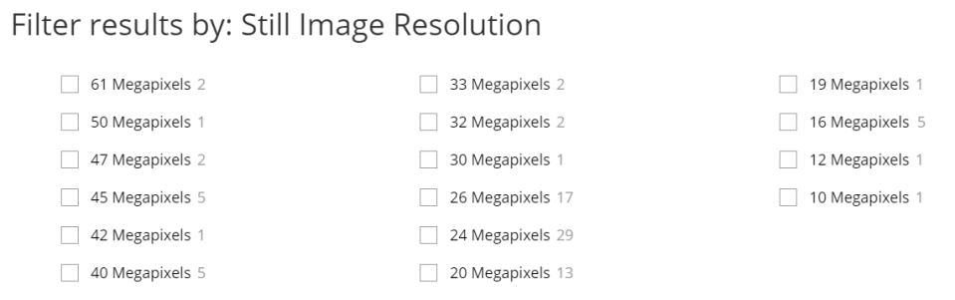
To answer the reviewer's concerns, we have added more details on camera and lens characteristics to the Protocol texts and Discussion.
Compact cameras, which have the above-mentioned features and lens magnification of at least 1:2 also can be used for macrophotography..
The section describing the ischemic insult is inadequate (Lines 98-102). Line 101 says "reocclude the artery" but the original occlusion is not mentioned. You should describe a recovery period of at least 20 minutes normal perfusion, then an occlusion time (the insult) followed by a reperfusion time of at least an hour to allow TTC-reactive enzymes to wash out. Also, temperature must be maintained at 37 degrees, especially during ischemia. Immersion in a temperature controlled bath is best during ischemia when warm buffer is not circulating through the heart. Also, you should warn that the heart is ischemic between the time it is excised from the animal to the start of perfusion. The transfer must be very quick as an ischemic time of more than a couple minutes can precondition the heart (even with cooling) and cause an artifactualy small infarct size.
Our contribution is related to the heart and brain tissue preparation for digital macro photography after ischemia-reperfusion, i.e., tissue preparation and subsequent image capture are steps performed immediately after the ischemia-reperfusion experiment. In the Introduction part the readers are referred to previous publications that describe all details for the heart infarction and stroke experiments (Botker et al., 2018, Basic Research in Cardiology; Zvejniece et al., 2012, J Neurosci Methods; Bell et al., 2011, J Mol Cell Cardiol; Liu et al., 2011, J Biomed Biotechnol; Kolwicz et al., 2010, J Vis Exp; Herr et al., 2015, J Vis Exp; Liepinsh et al., 2015, Br J Pharmacol.; Nakamura et al., 2005, J Card Surg.; Li et al., 2010, Lab Anim (NY); Wu et al., 2011, J Vis Exp.; Vavers, E. et al. 2016, Pharmacol Res).
The text only discusses regional ischemia in a Langendorf perfused heart. Regional ischemia is well suited to open chest models. On the other hand regional ischemia is hardly the optimal choice for an isolated heart. There global ischemia is the best. The risk zone simply becomes the whole heart so the blue dye is not needed. Also, if a balloon is placed in the heart's lumen you can measure the recovery of mechanical function at the end of reperfusion.
Our contribution is related to the heart and brain tissue preparation for digital macro photography after ischemia-reperfusion, i.e., tissue preparation and subsequent image capture are steps performed immediately after the ischemia-reperfusion experiment. We believe that the regional ischemia experiments are relevant for translational research of emerging cardioprotective therapies. We hope that our guide on how to set up a system for photography and standardized analysis of heart and brain tissue specimens after infarction experiments will help to save time, avoid user input and minimize the risk of errors or bias during image analysis to increase the translation of preclinical discoveries into novel antiischemic treatments in clinics.
On line 301 you mention eliminating glare by sandwiching the tissue slices between glass plates. Actually this should be done with accurately measured shims in the 4 corners of the glass plates When the tissue is slightly squashed to ensure good contact with the glass the slice will be distorted to slightly increase its diameter. However, however the shims will allow you to calculate an accurate volume of each slice (the surface area times the thickness of the shims). The glass sandwich can be flipped to photograph the other side. You should also mention that a size standard should be included in the picture such as a mm ruler or a piece of paper of known size so areas and volumes can be calculated in mm.
Thank you for pointing this out. In our laboratory, we are using immersion for the heart slices and aortas mounted on a silicone block, while a polarizing filter is used for the brain without immersion or glass slides. Since we know that many scientists are placing specimens between glass plates, we tried and found that this method of choice may present some problems e.g. challenges with bubbles, specimen unequal thickness, etc. Immersion is therefore much easier without compromising image quality. To answer the reviewer’s comment, we have now included a Note about the alternative methods and placing slices between glass slides in the method description.
Alternative methods include placing slices between glass slides or using a polarizing filter on the lens.
In our laboratory, we do not use a ruler when absolute quantification is not necessary. The infarct size is quantified as % to the area of the left ventricle or area at risk. Stroke also is quantified relatively to the unaffected side of the brain. To answer the reviewer’s comment, we added a sentence to the manuscript:
Size marker such as a mm ruler should be included in the picture when absolute quantification of specimen size is necessary.
The background is also important. A royal blue background is recommended which will allow selection of the infarct and living tissue by color thresholding using an image analysis program such as ImageJ. Blue is not included in colors generated by TTC staining.
Thank you for pointing this out. Ideally, the tray should be in a color not present in the stained specimen. For example, to quantify the area of methylene blue and TTC (red) staining in an automated or semi-automated manner, white, red, blue, yellow, brown, colors of background should be avoided. So green would be preferable. However, color selection depends on the preferences of the operator, who is doing image postprocessing. We like the white background because in image postprocessing you can delete the background and thus make it completely white (RGB white code 255,255,255). Then exclude completely white color from the list of selected colors used for semiautomated analysis and count only pale necrotic area, which is not completely white if not overexposed. For the photography of brain slices and aortas, blue and green is suitable.
We have now referred to our previous publication (Liepinsh et al, 2013) in the Representative Results section.
A tray with blue background is used for brain slice photography (background selection described in details previously⁵).
You should discuss image analysis in sizing the infarcts. For many years infarct size studies have suffered from inaccurate subjective analyses by supposedly blinded observers. Excellent discrimination can be achieved with image analysis programs. Color thresholding settings should be established and then rigorously adhered to throughout any study. That way anybody can analyze the same picture and get the same exact infarct size result. Blinding is no longer required.
Thank you for noting this. We agree with the reviewer that low-quality images and subjective analysis are issues in experimental infarct studies. In our manuscript we describe techniques how to get images usable for image analysis – this protocol works very well and we have shared it with several international collaborators who found it very useful. Our analysis workflow is based on software ImagePro 6.3 that is not available any more (we are not familiar with ImageJ). We are using macro-driven semiautomated analysis by ImagePro software based on a segmentation file with predefined colors of blue, red, and white (+pale pink) for about 15 years. Over the years we also kept the photography setup at a constant output. We changed cameras and lightings but always adjusted settings to get the same colors, WB, and exposure in the image. Still, we cannot avoid manual postprocessing because of 2 issues. First, methylene blue is sometimes not perfectly staining the whole area of non-risk (see example below). Second, since the heart is not cylindrical but the round shape, some slices are conical. These issues and image analysis were discussed in our previous article (Liepinsh et al 2013).
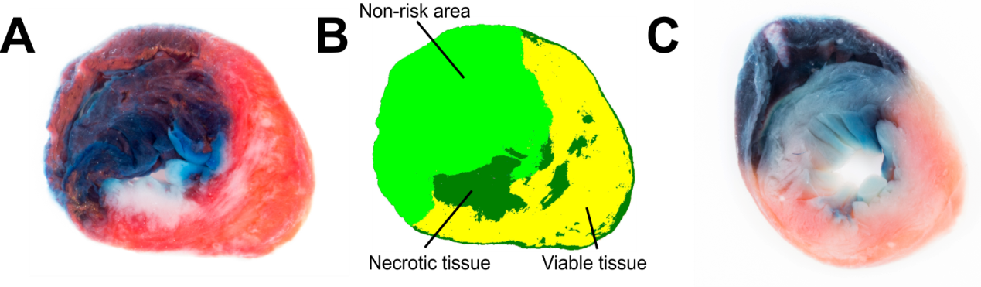
To answer the reviewer's concerns, we have added the Representative results section and an example of planimetric image analysis in Fig. 3B.
I suggest you look at the H.E.L.P files in the International Society for Heart Research's web site (https://www.ishrworrld.org). They have an excellent page discussing these issues (https://www.southalabama.edu/ishr/help/ttc/). I am not sure if you can cite a web page in JOVE, but if it is allowed it would be useful.
Thank you for the information. We have added references to the previously published infarction protocols both to Introduction and Protocol part. We hope that also our manuscript if accepted, will help readers to save time, avoid user input and minimize the risk of errors or bias during image analysis.
Experimental procedures of myocardial^{1,2} and brain^{3,4} infarctions have been described in detail before.
Techniques described in this protocol can be used after both Langendorff-perfused isolated rat or mouse heart ^{6,7} and in vivo rat heart ischemia-reperfusion (IR) injury assays⁸⁻¹¹.
2.1 After the middle cerebral artery occlusion experiment^{3,12} remove the brain, including the brainstem, from the skull, and wash in ice-cold PBS.
Reviewer #2:
Manuscript Summary:
The manuscript introduced a method of macro photography in ischemia-reperfusion-induced damage in the heart and brain with a high-resolution image, which has a standardized methodology and is easy to implement.
We thank the reviewer for the comment!
Reviewer #3:
Manuscript Summary:
Heart and brain tissue preparation for digital macro photography
The authors describe photography using a digital camera with macro lens for qual and quant analysis. Pre photography methods include Tissue prep, Dissection, Slicing, staining. The Standardised photography Set up includes hardware (Lighting, copy stand, camera specifications) and camera settings (ISO, white balance, aperture). This article appears to be based upon the authors previous article ( Liepinsh E, Kuka J, Dambrova M. Troubleshooting digital macro photography for image acquisition and the analysis of biological samples. Journal of Pharmacological and Toxicological Methods. 2013;67:98-106. ) with some updates to equipment. The methods and rationale for method choices are discussed in more detail in the 2013 article. I would suggest the authors refer more frequently to their 2013 article for in depth discussion of method choices that are not so detailed in this 2021 article ( lighting specifications, background selection, avoiding reflection,) or increase the detail in this 2021 article.
Thank you for a suggestion. We have added more technical details to the Protocol texts, Representative results section, and Discussion.
JoVE is a video journal, and Discussion is limited to 3-6 paragraphs. We have already exceeded this limit (10 paragraphs). While participating in the establishment of an international network that will evaluate the effects of cardioprotective compounds and treatment strategies, we noticed that our written instructions (article Liepinsh et al., 2013) are not enough illustrative, and therefore decided to film a video to demonstrate this very efficient process.
Major Concerns:
Nil
Minor Concerns:
Minor Grammar 'ischaemic/ schaemia' British English -JOVE required American English. Overuse of the word 'proper' in most cases this word can be deleted.
Thank you for noting this. We have now used American English throughout the manuscript. We have now corrected the use of “proper”.
Line 2. Consider adding Rodent to the title to be specific to the specimen type.
Thank you for noting this. We have added “Rodent” to the title of this manuscript.
Line 48. Macro photography should be defined. Does the macro refer to macroscopic eg naked eye scale image (compared to microscopic) or methods using a macro lens on the camera?
Macro photography refers to photographing at high magnifications. Macro photography can be achieved when the lens can ensure at least 1:2 magnification, and ideally 1:1 or even greater magnification. Some operation microscopes can be used instead of a macro lens. The magnification ratio indicated the relation of the projection size of the subject on the image sensor of its life-size.
We have now defined macro photography in the Abstract, Introduction, and suggested magnification of the lens in Discussion, in Paragraphs 5 and 6.
In contrast, macro photography (photographing at 1:2 or greater magnification) is frequently performed in an uncontrolled light environment using inappropriate imaging setups.
Line 56; later steps
Thank you for noting this. We have revised the Introduction text, and this part is now deleted.
Line 78: left or right or both axillae?
We have now deleted in vivo part of tissue preparation (references to protocols and techniques provided in the Introduction) to concentrate this manuscript on imaging techniques of various tissue samples. We make two incisions: one is done to the direction to the left axilla and the second to the direction of the right axilla.
Line 79: do you mean muscles of the abdominal wall superficial (not above ) to the xiphoid process? Above could mean superior ie thoracic muscles. Using standardised anatomical terms is recommended.
Thank you for pointing this out. The abdominal muscles were grabbed superficially to the xiphoid process with the forceps. This part is deleted from the manuscript because we have now deleted in vivo part of tissue preparation (references to previously published protocols and techniques provided in the Introduction) to concentrate this manuscript on imaging techniques of various tissue samples.
Line 84. Describe the location of the line of rib cutting, is it para sternal, mid clavicular, anterior axillary or mid axillary? Is the clavicle transected as well?
The line of rib cutting corresponds to the anterior axillary line and the clavicle is not transected. This part is now deleted from the manuscript because we have now deleted in vivo part of tissue preparation (references to previously published protocols and techniques provided in the Introduction) to concentrate this manuscript on imaging techniques of various tissue samples.
Line 86. Do you really recommend using fingers? Fingers are large and imprecise and is opposite to your thesis of promoting quality and precision in methods. Describe the level at which superior and inferior thoracic structures are transected. Eg transect the thoracic aorta at the level of the diaphragm and the great vessels of the heart (describe the level, eg is the aortic arch and pulmonary trunk bifurcation included?) what level is the trachea transected?
Is the oesophagus removed with the heart/lungs. Do you use blunt dissection to separate the heart and lungs from the oesophagus?
This part is now deleted from the manuscript because we have now deleted in vivo part of tissue preparation (references to previously published protocols and techniques provided in the Introduction) to concentrate this manuscript on imaging techniques of various tissue samples.
To cut out the heart, we use two partly similar techniques. In the first method after the opening of the thorax, we grab the lungs and the esophagus with the forceps distally from the heart. Then we cut the esophagus just above the diaphragm and lift everything up. Further, we cut the aorta at the level of 5-6 thoracic vertebrae and proceed with the cutting of the aorta from the posterior wall of the thorax. When the thoracic aorta is separated from the thorax, we cut brachiocephalic, left common carotid, and left subclavian arteries as well as trachea and esophagus proximally to the thymus. Heart together with lungs, thymus and esophagus is put in the ice-cold Krebs-Henseleit buffer solution. Later the heart is separated from other tissues, stained, and cut into slices.
In the case of the second method, after the opening of the thorax, lungs and heart are gently grasped with fingers. The esophagus is cut just above the diaphragm. Aorta is cut at the same level and separated from the posterior wall of the thorax similarly as in the first method. Brachiocephalic, left common carotid, and left subclavian arteries, as well as trachea and esophagus, are cut proximally to the thymus. Afterward, the heart together with the lungs, thymus, and esophagus is put in the ice-cold Krebs-Henseleit buffer solution. In the first version of the manuscript we included the second method as it can be performed much faster and if done properly heart is not squeezed during dissection and gradually stops beating after immersion in ice-cold Krebs-Henseleit solution.
The thoracic part of the esophagus is cut out together with the heart and lungs and later separated from the heart.
Line 90; separate/dissect it (not clean). The non cardiac organs are not 'dirty'.
Thank you for pointing this out. In future we will use correct verbs.
Line 111 rate not pace
Thank you for pointing this out. It is now corrected.
Line 120. What temperature freezer -20 or -80 degrees. Caution against over freezing
Thank you for pointing this out. It is now indicated in the text, that the freezer temperature should not be below -20ºC, and a warning against over-freezing is added. Nevertheless, optimal time in each laboratory should be determined experimentally.
NOTE: At this stage, it is possible to place the mouse heart in a small plastic bag or a 5-ml microtube in the freezer (-20ºC) for up to 5-10 min. Maximal freezing time should be determined experimentally in each laboratory. The short-term freezing of mouse heart can help a novice experimenter to cut it in 1-mm-thick slices. The freezing of rat heart is not recommended. Over-freezing must be avoided.
Line 125 - is cooling (4 degrees ?) of the stainless steel matrix recommended to keep the semifrozen tissue solid?
Since “freezing” of the tissues is optional, we would not recommend cooling the steel matrix as a go-to option for the cutting procedure. Stainless steel matrix can be at room temperature. We would avoid cooling down the matrix because the heart can stick to very cool metal.
Line 126- specify the type of blade used for cutting
Blades from Ziwic instruments or any compatible single edge razor blade (e.g. thickness up to 0.01 inch (0.254 mm)) can be used for slicing rat hearts. For mouse hearts, double edge razor blades are generally used and are usually up to 0.004 inches (0.1 mm) in thickness. This is indicated now in the text.
NOTE: Slicing matrix-compatible razor blades must be used. In general, compatible single edge razor blades (e.g. thickness up to 0.01 inch (0.254 mm)) can be used for slicing of rat hearts. For mouse hearts, double edge razor blades are generally used and are usually up to 0.004 inches (0.1 mm) in thickness.
Line 126 slicing is what you do with hand and blade/knife/scalpel. Sectioning is microtomy. You are slicing. Cut ventricles of the heart transversely into….
Thank you for noting this; corrected.
Line 134 spell out MACO
MCAO now is spelled out in the text: Middle cerebral artery occlusion.
Line 148. Describe razor blades
Blades from Ziwic instruments or any compatible single edge razor blade (e.g. thickness up to 0.01 inch (0.254 mm)) can be used for slicing rat brain. This is now indicated in the text.
NOTE: Slicing matrix-compatible razor blades must be used. In general, compatible single edge razor blade (thickness up to 0.01 inch (0.254 mm)) can be used for rat brain slicing.
Line 156. Slices not slides. Top surface is not an anatomical term, do you mean superior or anterior?
This part has now been described in a bit more detail.
2.6 Arrange the brain slices one by one in a tray (70 ml, 72 x 72 mm). When arranging the slices make sure that the anterior surface of each slice is always facing up.
Line 160 . specify the blue surface which you are using as a background. Is it an acrylic sheet? Cutting mat? Plastic tray?, matt or glossy, washable or disposable?
The blue surface now is specified in the text: 2.8 After incubation in 1% TTC solution, transfer the brain slices to the blue plastic tray to capture images. The brain slices are arranged in sequence order from the frontal to the caudal part, and then, using a scalpel, hemispheres are separated in the sagittal plane. NOTE: The surface should be washable, matt, and at a color that contrasts brain slices (i.e. not red, white, pale pink).
Line 161; in sequence not ascending order
Thank you for noting this. Error in line 161 is now corrected.
The brain slices are arranged in sequence order from the frontal to the caudal part, and then, using a scalpel, hemispheres are separated in the sagittal plane.
Line 163. How do you keep the brain slides from floating off the blue background when immersed in formalin?
Thank you for noting this. Brain slices are not immersed, but reflections are removed by a polarizing filter. The misleading sentence is removed and the reduction of reflections part is now explained in the Representative Results section.
Line 174; LED lights emit hardly any heat, what equipment needs to warm up?
“Warm-up” time is a general term (probably slang) to characterize time when lights reach constant brightness and color temperature. It is suggested that LED lights reach working condition instantly, still, it is recommended by manufacturers of at least a few minutes of “warm-up” time even for the most sophisticated LED lasers used in confocal microscopes. Probably this is an outdated tradition. Warm-up time is necessary if lighting other than LEDs is used. We have explained this in the text now:
NOTE. LED lights reach full brightness in microseconds.
Line 177. Aperture is usually expressed as a f stop fraction eg f/8 or f/11 or F16. It may be better to specify a range, and explain the aperture number is a fraction, the larger the number the smaller the aperture. A small aperture is desirable for this method.
By decreasing aperture, the depth of field increases, which is helpful if the object is not in a single plane, however, aperture decrease has limited benefit, because of diffraction. Diffraction is an optical effect that limits the total resolution of photography. The light begins to disperse or "diffract" when passing through a small opening (such as the camera's aperture). This effect is normally negligible since smaller apertures often improve sharpness by minimizing lens aberrations. However, for sufficiently small apertures, this strategy becomes counterproductive — at which point the camera becomes diffraction-limited. Below are examples of how lens resolution changes in response to aperture. The optimal aperture usually is around f/8, we are suggesting f/10 because resolution drop, in this case, is ~10-15% and it is possible to achieve sufficient depth of field.
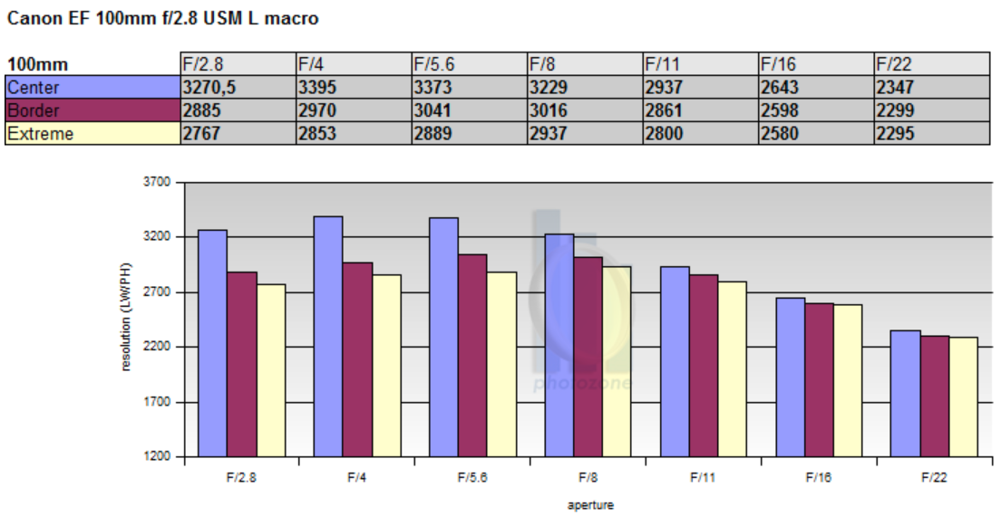
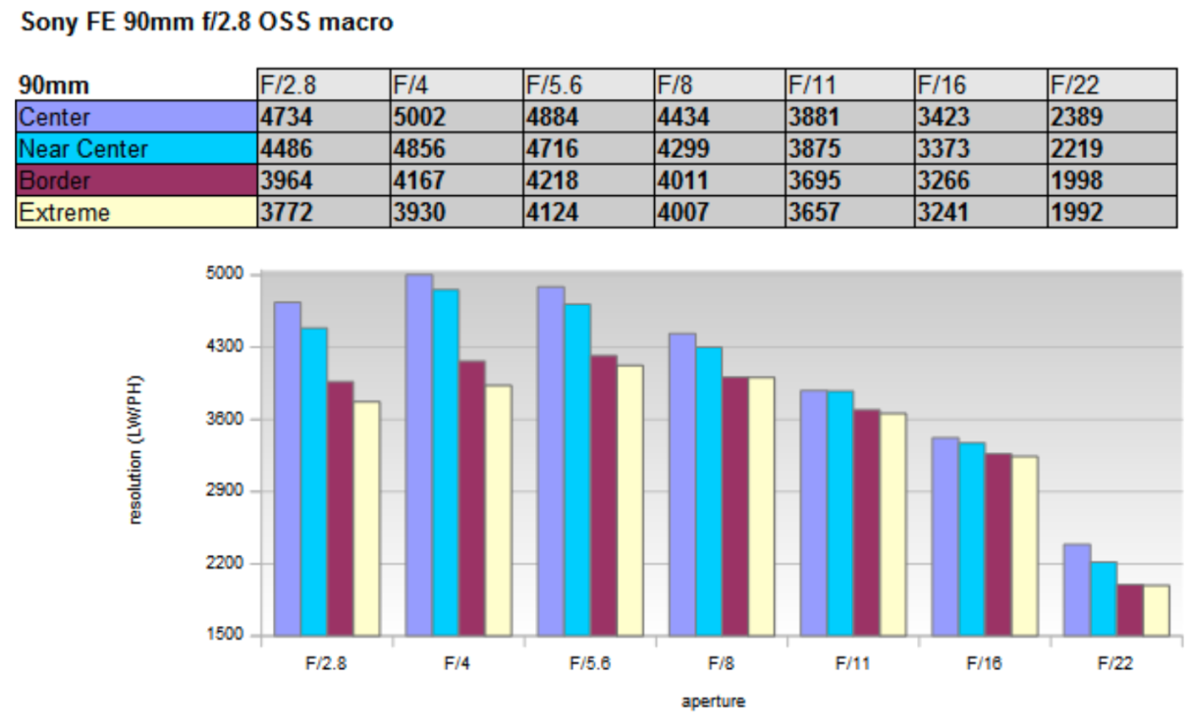
Figure Lens resolution depending on aperture. Graphs are from the website https://www.opticallimits.com/all-tests
Aperture f/10 is suggested in 5.4. step of the Protocol.
Line 182. Describe the background for the specimens, is it blue, or white or another colour? The background is better explained in your previous 2013 article.
The color of the tray should be in a color which is not present in the stained specimen. For example, to quantify the area of methylene blue and TTC (red) staining in an automated or semi-automated manner, white, red, blue, yellow, brown, colors of background should be avoided. So green would be preferable. However, color selection depends on operator preferences, who is doing image postprocessing. We like the white background and because in image postprocessing you can delete the background and thus make it completely white (RGB white code 255,255,255). Then exclude completely white color from the list of selected colors used for semiautomated analysis and cont only pale necrotic area, which is not completely white if not overexposed. For the brain and aortas, blue and green background is suitable.
We have now referred to our previous publication (Liepinsh et al, 2013) in the Representative Results section.
A tray with blue background is used for brain slice photography (background selection described in details previously⁵).
Line 183 'with objective' do you mean macro lens?
Thank you for noting this. Error is now corrected.
Line 193 turn the slices over. Around means rotate.
Thank you for noting this. Error is now corrected.
Line 203. Is 3B the frozen slice an example of suboptimal tissue prep for photography? Say so. Fig 3A, label and explain the different areas. Blue is the non ischaemic are, red is the TTC positive area at risk, White it's the TTC negative area of infarction or similar. Here is an example article with a labelled diagram that explains the different areas https://www.hindawi.com/journals/bmri/2011/195483/fig3/
We have now added an example of color segmentation in Fig 3B, representative results section:
Figure 3 Images of fresh (A), fresh segmented (B), and 24h frozen (C) cardiac slices. Heart slice (A) was analyzed using color segmentation (B) in ImageProPlus 6.3 software. TTC staining poorly discriminates viable and necrotic tissue in the frozen heart slice (C).
You want your article is to be understandable to a wider audience beyond those just doing TTC ischaemia experiments.
Line 220/1: re-occlusion of coronary arteries
Line 221: elaborate specifically the blue dye stains non ischaemic areas
Line 229. Fresh tissue, not live.
Thank you for noting this. The respective part of the manuscript is corrected/modified.
Line 232 freezins (sp)
Line 236 functioning mitochondria, not live. They are an organelle and thus cannot be 'live'
Thank you for noting this. The respective sentences of the manuscript are now corrected/modified.
Line 338. Good you say that the frozen example here is suboptimal, but you also need to say this in the figure legend. ?
Figure 3 legend is modified as follows:
Images of fresh (A) and 24h frozen (B) cardiac slices. Note how TTC staining poorly discriminates between viable and necrotic tissue in the frozen heart slice.
Line 248/9. Not clear about the lyophilization or the temperature of freezing, its it -20 or -80 degrees. What is your experience and recommendation about freezing, if no experience, then quote a reference. ?
Thank you for noting this. We have deleted this sentence as it was misleading.
Line 251: incubation means storing at warm temperature eg 37 degrees for cells, does this apply to the slices in formalin. Do you mean brain slice storage in formalin at ambient temperature? The fixed tissue will be of good microscopic quality forever, but do you mean the quality of the TTC and methylene blue staining regions? Be specific. Line 252: same, are you meaning 37 degrees formalin? Line 254. Formalin causes decolourisation of normal tissues, do you mean destaining of the methylene blue, or decolourisation of unstained tissues. In my experience, the colour of methylene blue is not changed by formalin. In fact we use methylene blue to stain formalin fixed tissues for microscopy. Do you mean diffusion of stain? ?
Storage in formalin is now decribed in a more detail in the Discussion:
Overnight storage of brain tissues in formalin (+4C) does not impair the color intensity of normal tissue and is acceptable for image acquisition. However, formalin induces swelling and destaining of heart slices. Therefore the storage of heart tissues in formalin is not recommended..
Line 265, what about compact cameras with a macro function? They can do the job without the expense and complexity of interchangeable lenses/special macro lens.
Thank you for pointing this out. We agree that any camera can be used if it fulfills the following criteria: it can be fixed on a stand, it has remote shutter/shutter delay function; it has live view function; manual mode of focus, exposure and white balance settings; lens can reach magnification of at least 1:2 and has sufficient distance to the object (to not affect the illumination of the object) at high magnification; camera has sufficient dynamic range (to make it possible to capture dark viable tissue and necrotic bright tissue with sufficient detail and color information). Cheapest setups of a new interchangeable lens camera and macro lens cost around 1000EUR/USD. It is generally the same price as for 1-2 ELISA kits. In contrast to ELISA kits, the camera-lens combo will last at least 10 years in indoor conditions on the stand.
To answer the reviewer's concerns, we have added more details on camera and lens characteristics to the Protocol texts and Discussion.
Compact cameras, which have the above-mentioned features and lens magnification of at least 1:2 also can be used for macrophotography.
Line 273 ..and manual white balance setting.
The white balance setting is now added to the respective sentence in the Discussion.
All up-to-date digital cameras have characteristics and functions necessary for macro photography, including the possibility to mount on a stand, a high number of pixels (usually >20 Mpx), live view, mirror lock-up, time-lapse features, remote shutter, and the ability to manually set camera parameters, thus ensuring a constant shutter speed, aperture, white balance, and ISO setting.
Line 285 not sure the quotes are needed around photography copy stand. This is a standard term, it has been around since the 19th century for film photography.
Corrected.
Line 289: elaborate on the recommended light source. You label Fig 2 as LED light. What colour temperature is recommended (eg 6500K, same as white of a LED computer screen), advantages of LED (not heat generating, will not heat up specimen), high CRI . Be explicit, eg do not use fluorescent light sources which flicker with AC power supply.
We don’t want to be definitive in our suggestions. If someone is buying new lights, LED is preferable. A good (up-to-date) camera can tolerate color temperatures from 6500K down to 4500K. It is possible to adapt to almost any light source if it is placed correctly and camera settings are adjusted according to the parameters of the light source. We found that for brain slices more convenient it is to use a polarizing filter, not an immersion method. Then we noticed that a circular polarizing filter cannot filter all reflections if the LED light is used. Therefore we are still using 20+ years old stand with fluorescent light sources for brain slices (it is present in our video guide). We adjusted camera settings accordingly: WB setting 5700K, exposure time 0.5s to remove any flickering.
We have now added a Note about the light sources, Protocol point 3.3:
NOTE: White LED light (color temperature 6500K) is the preferred light source to avoid light flickering by fluorescent light bulbs.
Line 293. Not blinking. Flickering light sources such as fluorescent.
Corrected.
Lines 299-302. The methods of reflection removal are an important contribution of this methods article. The method needs to be illustrated (not just the result). A photo or video including how exactly the tissue is placed between glass plates, the size of the glass, thickness, how to ensure even contact, how to deal with different thickness tissue slices causing irregular contact between slices , air bubbles etc. These are this details required for a methods article. Similarly, the article will be improved with visual elaboration of photos and or video of the immersion method. What type of container is used to immerse the specimen in - glass, acrylic? What size? How deep should the immersion fluid be? Specify the background below the container, or is it integrated into the floor of the container, how to deal with bubbles, diffusion of blue dye into the immersion solution, how to fix the tissue down so it does not float off. Describe what you have found to work well and what does not.
We are using immersion for heart slices and a polarizing filter for the brain. Since we know that many scientists are placing specimens between glass plates. We tried and found that this method of choice, however with some problems. We agree with the reviewer that using glass plates is a lot of challenges with bubbles, specimen thickness, etc. Immersion is much easier.
No specific requirements for containers except the color. Probably for easy manipulation size and depth might matter. We are using a usual weighing tray for hearts, a pet drinking tray for the brain (both are in the video), and a cover from the tips box for the aorta. The weighing tray is selected because of the appropriate size and white color, pet drinking try is selected because of blue color. We would suggest minimum immersion depth and overall size of tray in order to avoid a large buffer volume, which moves in the tray and causes floating of specimens. In a small tray you don’t need to fix specimens. At the same time, we have seen (in publications) that specimens are not fully immersed and then reflections and other artifacts appear in the images.
The color of the tray should be in a color which is not present in the stained specimen. For example, to quantify the area of methylene blue and TTC (red) staining in an automated or semi-automated manner, white, red, blue, yellow, brown, colors of background should be avoided. So green would be preferable. However, color selection depends on operator preferences, who is doing image postprocessing. We like the white background and because in image postprocessing you can delete the background and thus make it completely white (RGB white code 255,255,255). Then exclude completely white color from the list of selected colors used for semiautomated analysis and count only pale necrotic area, which is not completely white if not overexposed. For the brain and aortas, blue and green background is suitable.
If the (heart) specimen is not overstained (too much volume/concentration of methylene blue used for perfusion) and/or rinsed enough, then no problems with bubbles and diffusion of methylene blue. Therefore in the manuscript, we are stressing the point about sufficient washing of specimens. In the case of Evans blue stain diffusion is not a problem at all, but there is a higher risk of overstaining.
We have now referred to our previous publication (Liepinsh et al, 2013) in the Representative Results section.
A tray with blue background is used for brain slice photography (background selection described in details previously⁵).
We added a Note about the use of glass slides, Protocol point 3.6:
Alternative methods include placing slices between glass slides or using a polarizing filter on the lens. A circular polarizing filter is attached to the lens and is rotated until reflections in a live-view display of the camera disappear.
Line 309 water or PBS- contradicts with line 300
Corrected to buffer solution.
Line 316 is a better discussion of aperture. Refer section 5.5 where a aperture of 10 is stated without the f which does not make sense.
Protocol text corrected, f/10 added.
Discussion,
Are there other potential applications for the methods - other animal TTC ischaemia models besides rodents? could this be used in humans in the autopsy setting?
We agree that it can be useful for the photography of any specimen. Since we are mainly concerned with the poor quality of images in the experimental cardiology field, we narrowed it down to this topic.
The macro photography set up is generalisable to all laboratory experimental small animal organ photography, perhaps this may be stated as a conclusion. The article ends abruptly with RAW files without a concluding paragraph.
Thank you for pointing this out. We have now added a concluding paragraph:
Overall, this protocol describes a methodology for rat heart and brain tissue slicing and staining and provides guidelines for establishing lighting and camera setups and photography techniques for high-resolution image acquisition for further analysis. This method is applicable to all experimental small animal organ photography.
Summary is also modified:
Presented here is a protocol for standardized methodology of rodent tissue preparation after the ischemia-reperfusion experiment and guidelines for establishing lighting and camera setups for high-resolution image acquisition. This method is applicable to all experimental small animal organ photography.
Reviewer #4:
Manuscript Summary:
The method of heart and brain tissue slicing and staining are clearly described. The guidelines for establishing lighting and camera setups and photograph techniques for high-resolution image acquisition are well stated.
We thank the reviewer for the comment!
Major Concerns:
none.
Minor Concerns:
1.3: "above" the xiphoid process. Should it be "beneath?"
This part is now deleted from the manuscript because we have now deleted in vivo part of tissue preparation (references to previously published protocols and techniques provided in the Introduction) to concentrate this manuscript on imaging techniques of various tissue samples. We thank the reviewer for pointing to the terminological error. The abdominal muscles were grabbed superficially to xiphoid process with the forceps.
2.3: "buffer solution" what buffer? Can be more specific
The heart was washed with oxygenated Krebs-Henseleit solution. This part is now deleted and readers referred to previous publications:
Techniques described in this protocol can be used after both Langendorff-perfused isolated rat or mouse heart ^{6,7} and in vivo rat heart ischemia-reperfusion (IR) injury assays⁸⁻¹¹.
2.4, 4.8 and 4.9: a picture may be needed to better illustrate the steps.
Point 2.4. is now deleted, 2.4 and 2.5( former 4.8 un 4.9) are captured in the video.
3.1, 3.2 and 5.8: the last sentence need to be moved to "discussion."
The format of the Protocol section is now changed according to the Editor’s suggestions. All important explanations are now presented as NOTEs.
3.3: sentences after "At this stage" need to be moved to "discussion."
This part of the Protocol is re-written now.
NOTE: At this stage, it is possible to place the mouse heart in a small plastic bag or a 5-ml microtube in the freezer (-20ºC) for up to 5-10 min. Maximal freezing time should be determined experimentally in each laboratory. The short-term freezing of mouse heart can help a novice experimenter to cut it in 1-mm-thick slices. The freezing of rat heart is not recommended. Over-freezing must be avoided.
In addition to the edits requested by the referees, we have also made a number of minor spelling and grammatical corrections throughout the text. Overall, we believe we have adequately addressed all the concerns raised by the referees. Certainly, their suggestions have greatly improved the quality of the manuscript and we are most grateful. We are hopeful that the revised manuscript is now acceptable for publication.

Sincerely,
Prof. Maija Dambrova, on behalf of the LIOS team

