Dear Dr. Saha:

Thank you very much for your professional supports.
I am the corresponding author Yu-Mei Li of the manuscript “Direct reprogramming of melanocytes with optimization” (MS NO: JoVE62911). Thank you very much for all the comments from the editor and peer reviewers, and I have revised the manuscript based on these comments and responded point by point as following.

Sincerely yours

Yu-Mei Li

Jul. 20, 2021

Response to the editorial comments:
Comments:
1. Please take this opportunity to thoroughly proofread the manuscript to ensure that there are no spelling or grammar issues.
2. Please rephrase the Summary to clearly describe the protocol and its applications in complete sentences between 10-50 words. The word limit is exceeding in the present Summary.
3. Please revise the text to avoid the use of any personal pronouns (e.g., "we", "you", "our" etc.).
4. Please ensure that abbreviations are defined at first usage.
5. Please add more details to your protocol steps:
Line 148: Replace “Eppendorf” tube with “microcentrifuge” tube.
Step 1.2.5: Please provide more details regarding the flow cytometer measurement if this step needs to be filmed.
Step 3.1.2: Please provide a citation here regarding RNA extraction.
Step 3.2.1: Please provide a citation here regarding immunofluorescence staining
6. Please include a paragraph on the limitations of the technique in the Discussion section.
7. Please spell out the journal titles in the References.

Responses:
- According to editorial comment 1, I have proofread the manuscript and modified the spelling and grammar issues;
- According to editorial comment 2, I have revised the summary to less than 50 words;
- According to editorial comment 3, I have revised the text to avoid using of personal pronouns as far as possible;
- According to editorial comment 4, I have checked the text thoroughly to ensure that abbreviations are defined at first usage;
- According to editorial comment 5
Step 1.1.9: I have replaced “Eppendorf” tube with “microcentrifuge” tube;
Step 1.2.5: This part will not be filmed, mainly demonstrated in the form of the results picture (Figure 1);
Step 3.1.2: I have added the citation regarding RNA extraction;
Step 3.2.1: I have added the citation regarding immunofluorescence staining.
- According to editorial comment 6, I have added a paragraph on limitations of the technique;
- According to editorial comment 7, I have spelled out the journal titles in the Reference.

Response to reviewer #1
Comments:
Major Concerns:
1. Since the authors highlight their virus packing method in their manuscript, they need to specify the advantage of their concentrated virus compared with normal virus packing or non-concentrated virus. For example, does concentrated virus help to generate iMels with higher efficiency? The overnight centrifugation is not common in the usual experimental steps, is it necessary to process 16 hours? Is it better than ultracentrifuge?
2. Is there any reason or evidence to support the infection step of using MOI of 30? This is an extremely high MOI compared with others' reports.
3. In Figure 3A, they should include the group of 6F as positive control for readers to understand the gene expression change upon the withdrawal of each transcription factor.
4. In Figure 4, they should include negative control for all staining experiments.
Minor Concerns:
1. The authors should specify that they used three transcription factors to perform the direct reprogramming instead of "as few transcription factors as possible".
2. The authors should find a native speaker to modify and improve their English writing.

Responses:
Major Concerns:
- According to the major concern 1, the comparison of infection rate between unconcentrated lentivirus (1×) and concentrated lentivirus (100×) has already demonstrated in the Figure 1. Regardless of the results of fluorescence intensity or flow cytometry, the infection efficiency of adding 100 μL unconcentrated lentivirus and adding 1 μL concentrated lentivirus is about the same. Concentrated lentivirus was chosen because adding a small amount of virus fluid would yield more infected cells, since the MOI of MEF infection is relatively high and the amount of virus needed is large, concentrated lentivirus is a better choice. In addition, after our practice of overnight centrifugation, it is an effective way to carry out virus concentration. However, 16 hours is not a very fixed time, and 12-16 hours is acceptable. As for the ultracentrifuge method, we have not tried it, since our lab protocol and experiences followed from Dr. Yun-Wen Zheng, his lab optimized this practical protocol which originated from Dr. Onodera at NIH (Chiba T, Zheng YW, et al. Gastroenterology 2007;133(3):937-50. PMID: 17673212; Iwama A, Oguro H, et al. Immunity 2004;21:843-51. PMID: 15589172).

- It is true that MOI of 30 is a high infection condition, but after our exploration, it does need an MOI of 30 to achieve a relatively high infection efficiency for MEF. This conclusion was verified by flow cytometry (as shown in the figure below). Although the MOI is 30, MEF can still continue to grow (as shown in Figure 2), which may be related to the susceptibility and tolerance of different cells to the virus.
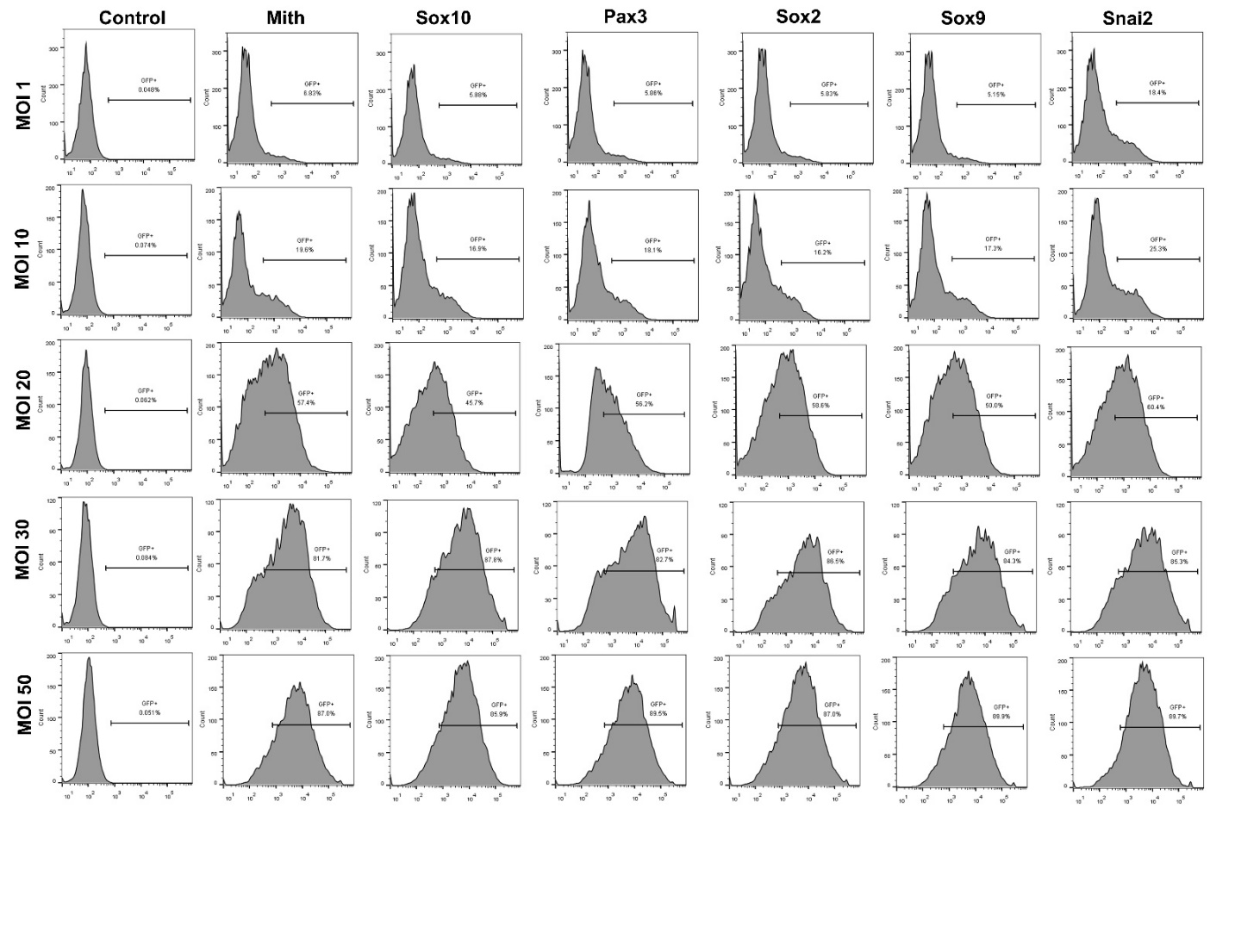
- According to the reviewer's suggestion, I have added the 6F group as a positive control in Figure 3A. Change as shown below. Figure legend has also been modified in manuscript.
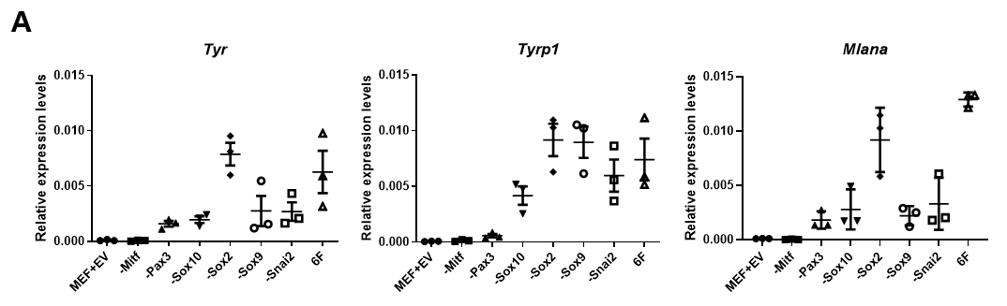

4. According to the reviewer’s suggestion, I have added MEF as a negative control and Melan-a cell line as a positive control in Figure 4B. Since the mouse melanocytes we isolated need nourishment from mouse keratinocytes to grow, we chose mouse melanocyte line (Melan-a) as the positive control in staining experiments (as shown in the figure below). Figure legend has also been modified in manuscript.
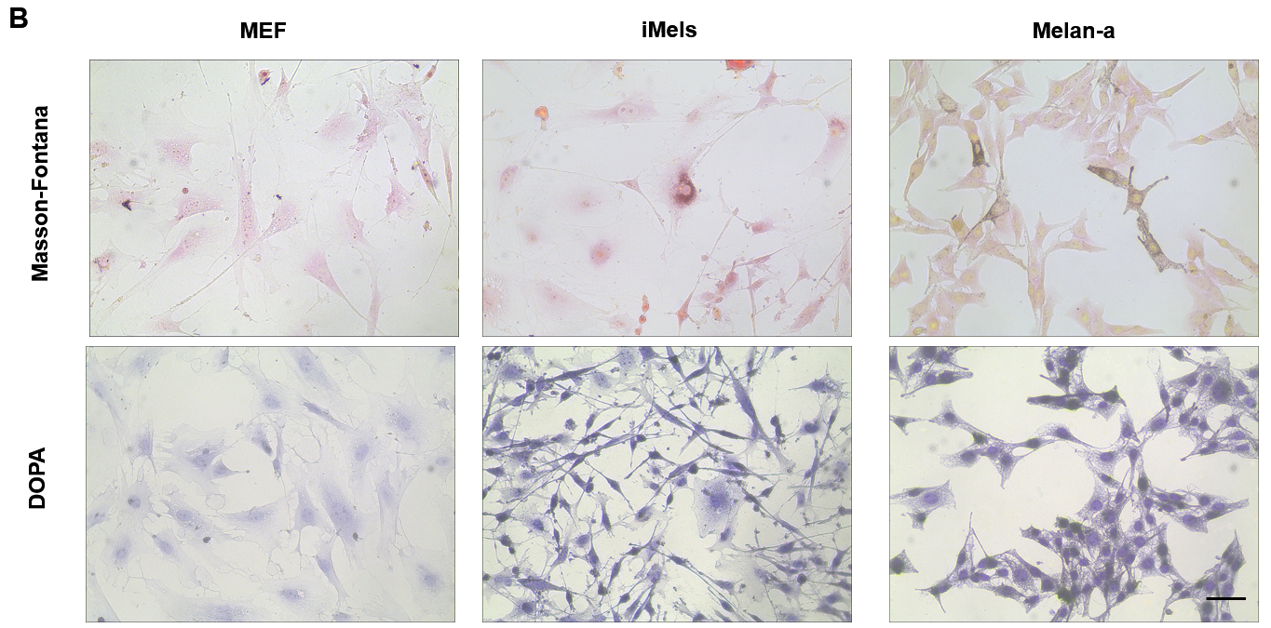

Minor Concerns:
- The description of "as few transcription factors as possible" in Summary has been deleted, and I specified the three transcription factors in the last paragraph of Introduction;
- The manuscript has been polished thoroughly by native English speaker.

To reviewer #2
Comments:
Major Concerns:
1) Throughout the text, especially in the abstract and introduction, it is not clear if the authors want to reprogram melanocytes, or reprogram skin cells to melanocytes, or anything else. Authors should clarify this clearly in the abstract and introduction.
2) The language and grammer should be corrected throughout the text. The error can lead to scientific problems.
3) It is not clear if this protocol has been published and proved in another publication. It is important for the readers to obtain such an information.

Response:
Major Concerns:
1. According to reviewer's suggestion, I have revised the title and emphasized in the Abstract and Introduction that we want to reprogram skin cells into melanocytes.
2. The language and grammar have been corrected throughout the text by native English speaker.
3. This article is the first specific protocol and different from the published paper.
It is great impact to generate melanocytes through direct reprogramming from fibroblasts. This is not the first report with three transcription factors (3TFs) of Mitf, Sox10 and Pax3 in the field (Yang R, Zheng Y, et al. Nat Commun. 2014;5:5807. PMID: 25510211), since JoVE is a methodology journal, their primary goal is to be a resource for researchers who learn new technologies conveniently. To meet this purpose, we submitted this first specific protocol for JoVE to overcome to the weak points in previous paper and supply a repeatable and practical process of the experiments.
Although with the 3TFs, our strategies are distinct different from the reports. Such as, 1) Screening. In our protocol, we used a random, fair and reasonable method, and did not prejudge that any transcription factor such as Sox10 had a special role (PMID: 25510211); 2) Transfection. The lentivirus transfection method we used has the characteristics of convenience, strong operability and stability, which is easier to promote and repeat, which different from more complicated Tyrosinase-CreER reporter system to transduce transcription factors, which made it difficult to repeat (PMID: 25510211); 3) Functional identification. We also added the staining representing melanin maturation: Masson-Fontana staining different from PMID: 25510211.
I have summarized these points in Introduction.

To reviewer #3:
Comments:
In this manuscript, Zhang et al describe their method for inducing melanocytes from mouse embryonic fibroblasts in culture. They test the role of 6 transcription factors and show that 3 are effective at inducing melanocytes from the MEFs. The manuscript is mostly clearly written (some English improvements are necessary) and the method carefully described. They include the essential factors for melanocytes in the reprogramming media. They use several genes (the pigmentation genes Tyr, Tyrp1 and Mlana) to verify that induction has taken place using qPCR and antibody staining as well as DOPA and FM staining to show pigment. In the histological stains the negative and positive controls are missing. I wonder if RNA-seq would be the most appropriate method to show that melanocytes have indeed been induced. The percentage of induced cells needs to be thouroughly discussed.

Responses:
Firstly, the same as previous 2 reviewers’ suggestions, the language has been polished thoroughly. Secondly, I have added the negative and positive controls in the histological stains (the same as reviewer #1’s major concern 4). Thirdly, RNA-seq is indeed one of the methods to prove melanocytes have been induced, but it also has limitations. RNA-seq’s function is similar to more comprehensive qPCR, but RNA-seq cannot detect the function that melanocytes can secrete melanin, so staining is also necessary. Finally, there are also some technical limitations in this protocol, such as the induced efficiency cannot be observed intuitively, perhaps CRISPR-Cas9 gene editing technique can be combined with this protocol to knock in melanocytic genes such as Tyr or Tyrp-1 in initial cells so as to observe the percentage of induced cells during the reprogramming process (I have discussed the issue in Discussion).

